Supporting Information
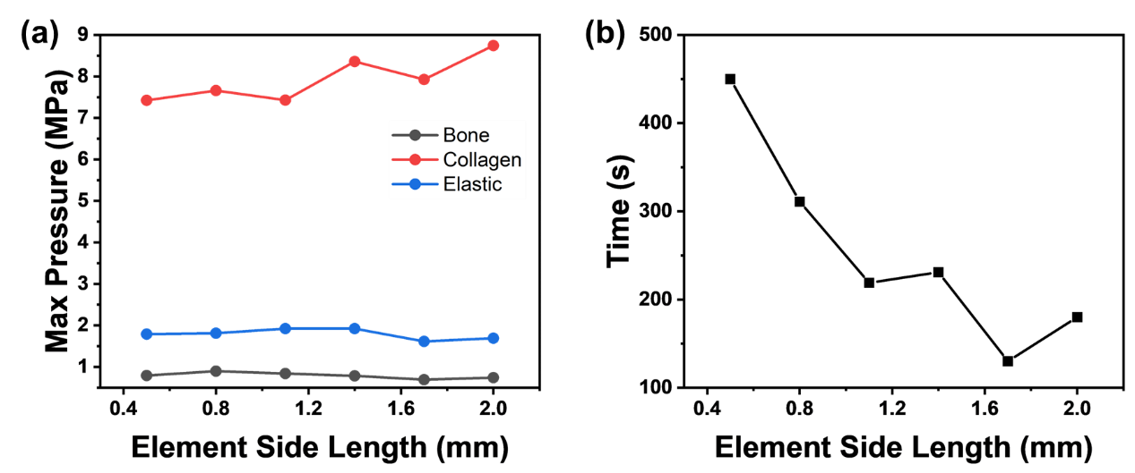
Figure S1. Mesh independence verification for tetrahedral elements of finite element analysis

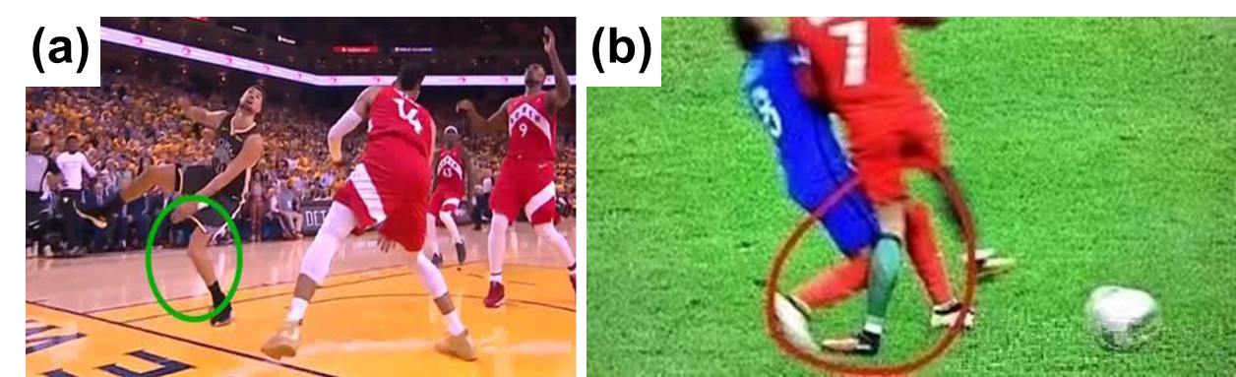
Figure S2. Photos of ACL injuries moment in the basketball and football court where often knee valgus, tibial internal rotation and anterior tibial translation were involved[1, 2]. After rough estimation, it was estimated that the ACL movements above were associated with 20~30° knee flexion, 20-30% tibial internal rotation, <15% anterior strain and < 5-10 mm shear displacement.

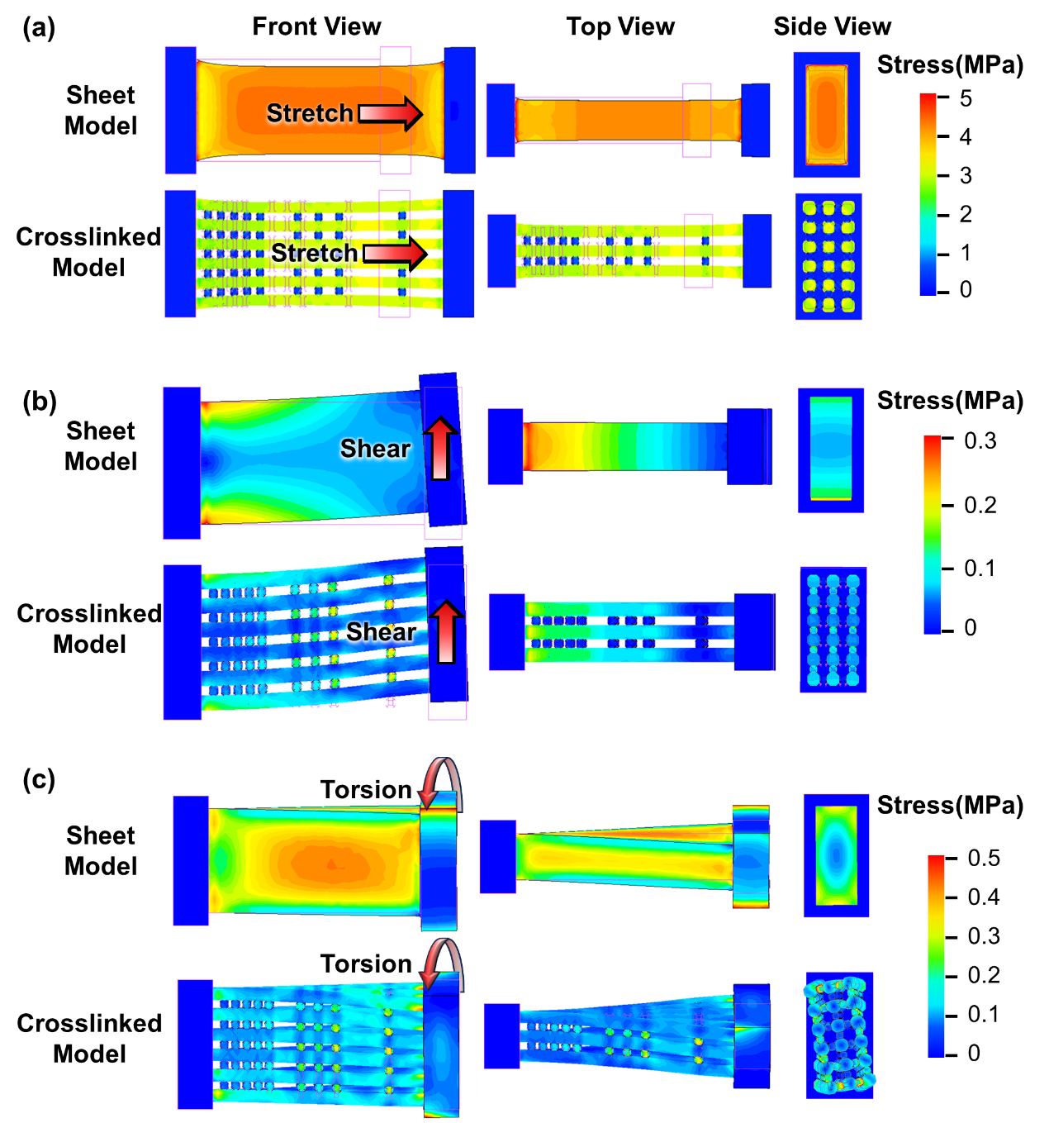
Figure S3. Finite element simulation mechanics simulation. (a) Three-view simulation results of tensile stress model; (b) Three-view simulation results of shear stress model; (c) Three-view simulation results of torsional stress model.

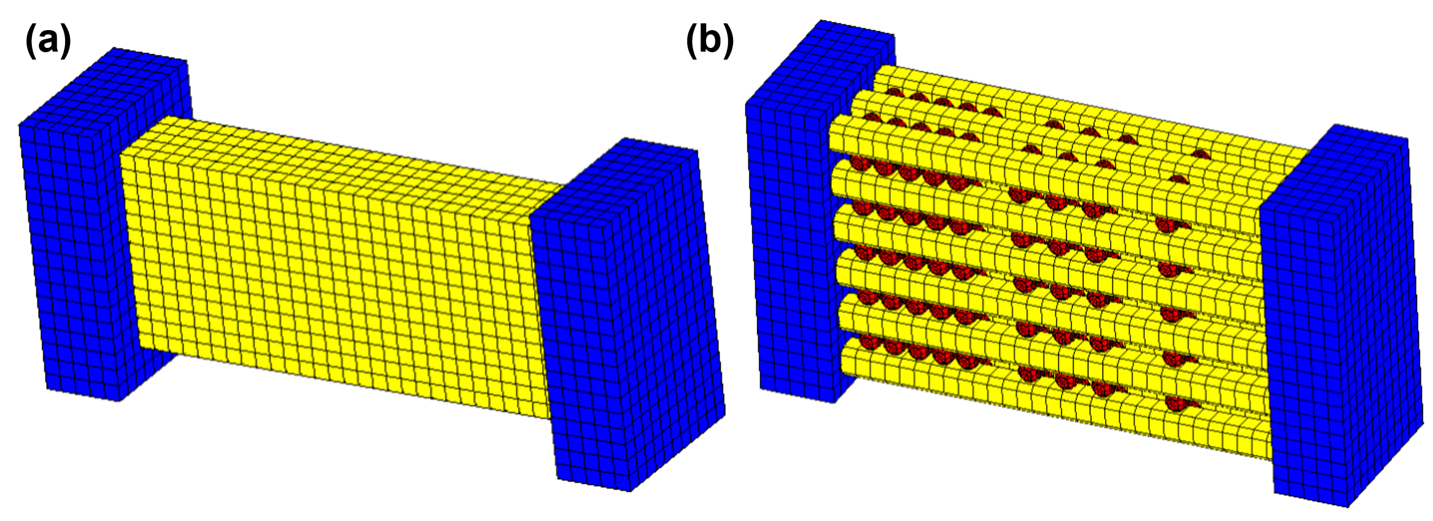
Material properties and geometric parameters of two ACL models.
Type | Crosslinked Model |  | Sheet Model | Bone
Type | Collagen | Elastin | Sheet Model | Bone
Size (μm³) | 300×20×20 | 12×12×12 | 300×126×54 | 50×172×108
Figure S4. Finite element model at the micrometer scale. (a) Three-dimensional representation of sheet Model at the micrometer scale in mesh division; (b) Three-dimensional representation of crosslinked Model at the micrometer scale in mesh division

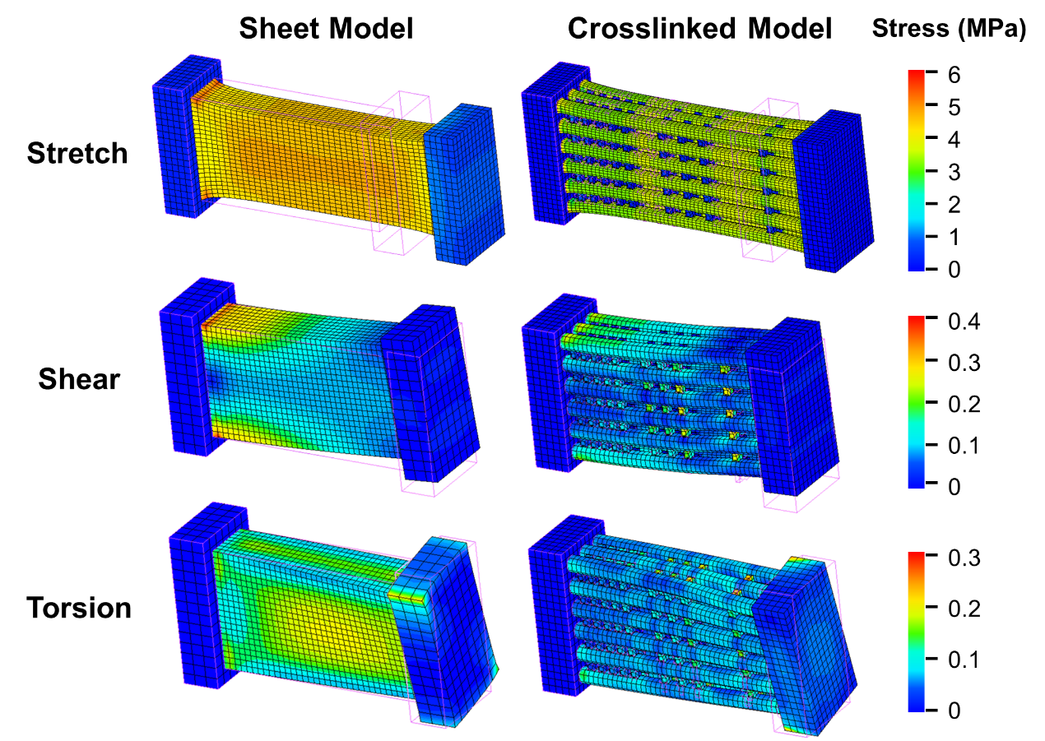
Figure S5. Three mechanical simulations of sheet model and crosslinked model at the micrometer scale

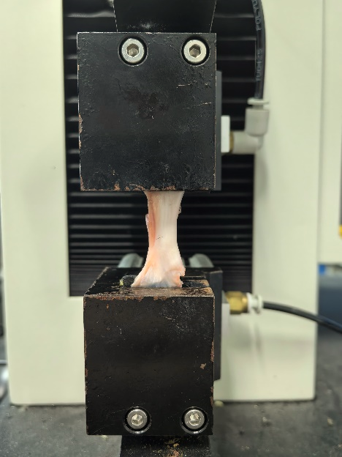
Figure S6. A photo of the mechanical test of ACL using a tensile testing machine.

References
1. Tosarelli F, Buckthorpe M, Paolo SD, Grassi A, Rodas G, Zaffagnini S, et al. Video Analysis of Anterior Cruciate Ligament Injuries in Male Professional Basketball Players: Injury Mechanisms, Situational Patterns, and Biomechanics. Orthop J Sports Med. 2024; 2024. https://doi.org/10.1177/23259671241234880.
2. Markolf KL, Du PZ,McAllister DR. Changes in knee kinematics from applied external Tibial torque: Implications for stabilizing an anterior cruciate ligament deficient knee. Clin Biomech. 2021; 81: 105230. https://doi.org/10.1016/j.clinbiomech.2020.105230.

