Descriptive Statistics with a Key variable by Cluster
The K-means clustering analysis successfully segmented Nigeria's 37 states into three statistically distinct groups based on their clean energy transition characteristics. To justify the qualitative labels assigned to these clusters, a descriptive analysis was performed, calculating the mean of each input variable for all states within a given cluster. The results, presented in Table, provide a clear quantitative justification for the chosen typologies.
Table. Descriptive Statistics with a Key variable by Cluster
Variable | Instit. Ready & Invest-Attractive (n=12) | Solar-Rich & Gov-Challenged (n=12) | Vulnerable Rural Laggards (n=13) |  | 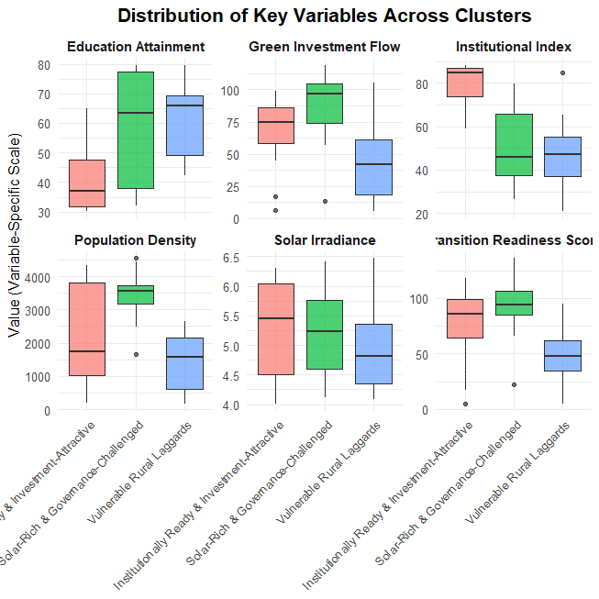
Transition Readiness Score | 87.2 | 85.1 | 70.7
Green Investment Flow | 66 | 74.5 | 63.4
Institutional Index | 79 | 59.4 | 50
Education Attainment | 72.9 | 48.3 | 35.1
Solar Irradiance | 5.1 | 4.84 | 5.27
Energy Access Deficit | 55.7 | 46.6 | 50.7
Poverty Incidence | 54.5 | 72.2 | 86.3
Rural Population Share | 57.1 | 60.2 | 62.2
Population Density | 2567 | 1884 | 2440
Grid Distance | 56.8 | 50 | 49
Mini-Grid Per Capita | 0.225 | 0.342 | 0.124
Mean Temperature | 28.1 | 28.9 | 26.1
Fig. Descriptive Box-Plot

Cluster 1: Institutionally Ready & Investment-Attractive (n=12): This cluster combines the highest institutional capacity (79) and education attainment (72.9) with strong transition readiness (87.2) and above-average green investment flow (66), despite moderate poverty (54.5) and a mid-range solar irradiance (5.1), positioning it as a governance-strong, investment-friendly group.
Cluster 2: Solar-Rich & Governance-Challenged (n=12): These areas enjoy high solar potential (4.84) and the highest green investment flow (74.5) but lag in institutional index (59.4) and education attainment (48.3), with elevated poverty (72.2) and rural population share (60.2), reflecting untapped solar advantages hindered by governance and socio-economic barriers.
Cluster 3: Vulnerable Rural Laggards (n=13): Characterized by the lowest transition readiness (70.7), institutional index (50.0), and education attainment (35.1), this group faces the highest poverty (86.3) and rural share (62.2) despite relatively high solar irradiance (5.27), marking them as socio-economically constrained regions with limited institutional readiness for clean energy transition.

