SVR-DAS: A Machine-Learning-Based Method to Create Training and Validation Datasets from Seafloor Distributed Acoustic Sensing Measurements – Supplemental Material
Autor #1: Gerardo Mendo-Perez, Research Center for Computational Earth Science, Earthquake Research Institute, The University of Tokyo, Japan, gmendo91@eri.u-tokyo.ac.jp
Autor #2: Hiromichi Nagao, Research Center for Computational Earth Science, Earthquake Research Institute, The University of Tokyo, Japan, nagaoh@eri.u-tokyo.ac.jp (Corresponding author)
Autor #3: Shinya Katoh, Research Center for Computational Earth Science, Earthquake Research Institute, The University of Tokyo, Japan, shinya-k@eri.u-tokyo.ac.jp
Autor #4: Masanao Shinohara, Research Center for Geophysical Observation and Instrumentation, Earthquake Research Institute, The University of Tokyo, Japan, mshino@eri.u-tokyo.ac.jp

Description
In the present document, we add the rest of the events obtained from SVR-DAS from February 2nd, 2022. Figure S1 shows an example of the spectrogram-based picker envelope function that is used to refine P picks of DAS data. Figures S2 – S3 shows two examples of DAS channels where there are no coincident picks of both P and S phases. These traces are from events February 28th, 2022 10:16:20 and 12:01:20. Figure S4 and S5 shows the rest of the events obtained by SVR-DAS from February 28th, 2022 where P and S models were obtained. Finally, Figure S6 shows two examples of DAS data where picking models were not obtained due to a decrease in the SNR. All reported times are in UTC format.

Figure captions
Figure S1. DAS channel (upper panel), envelope function (middle panel), and P and S labels from pickers (lower panels) associated with February 28th 10:16:20 h event.
Figure S2. DAS trace from February 28th 10:16:20 h and their associated P and S labels where non-coherent picking is present.
Figure S3. The same but for February 28th 12:01:20 h event.
Figure S4. Refined SVR models of P (red line) and S (blue lines) obtained for DAS data associated with events from February 28th, 17:01:20 UTC and 18:22:20 h.
Figure S5. Refined SVR models of P (red line) and S (blue lines) phases obtained from DAS data associated with dates February 28th, 18:48:20 h and 19:18:20 h.
Figure S6. Example of two events detected by SVR-DAS without pick models.

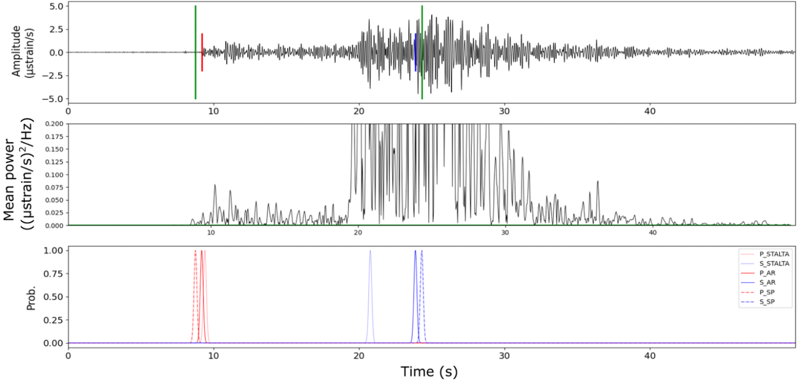

Figure S1.

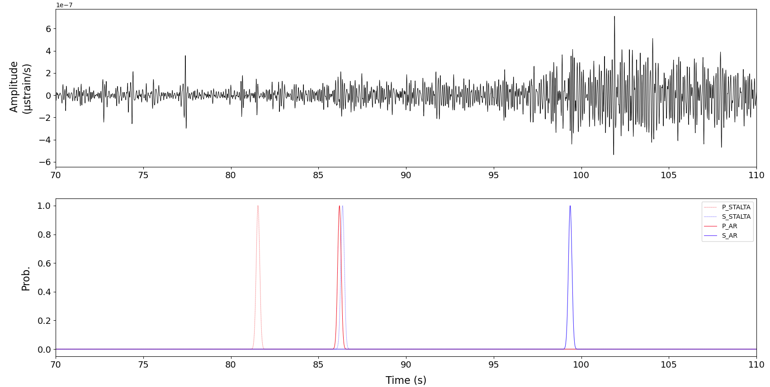

Figure S2

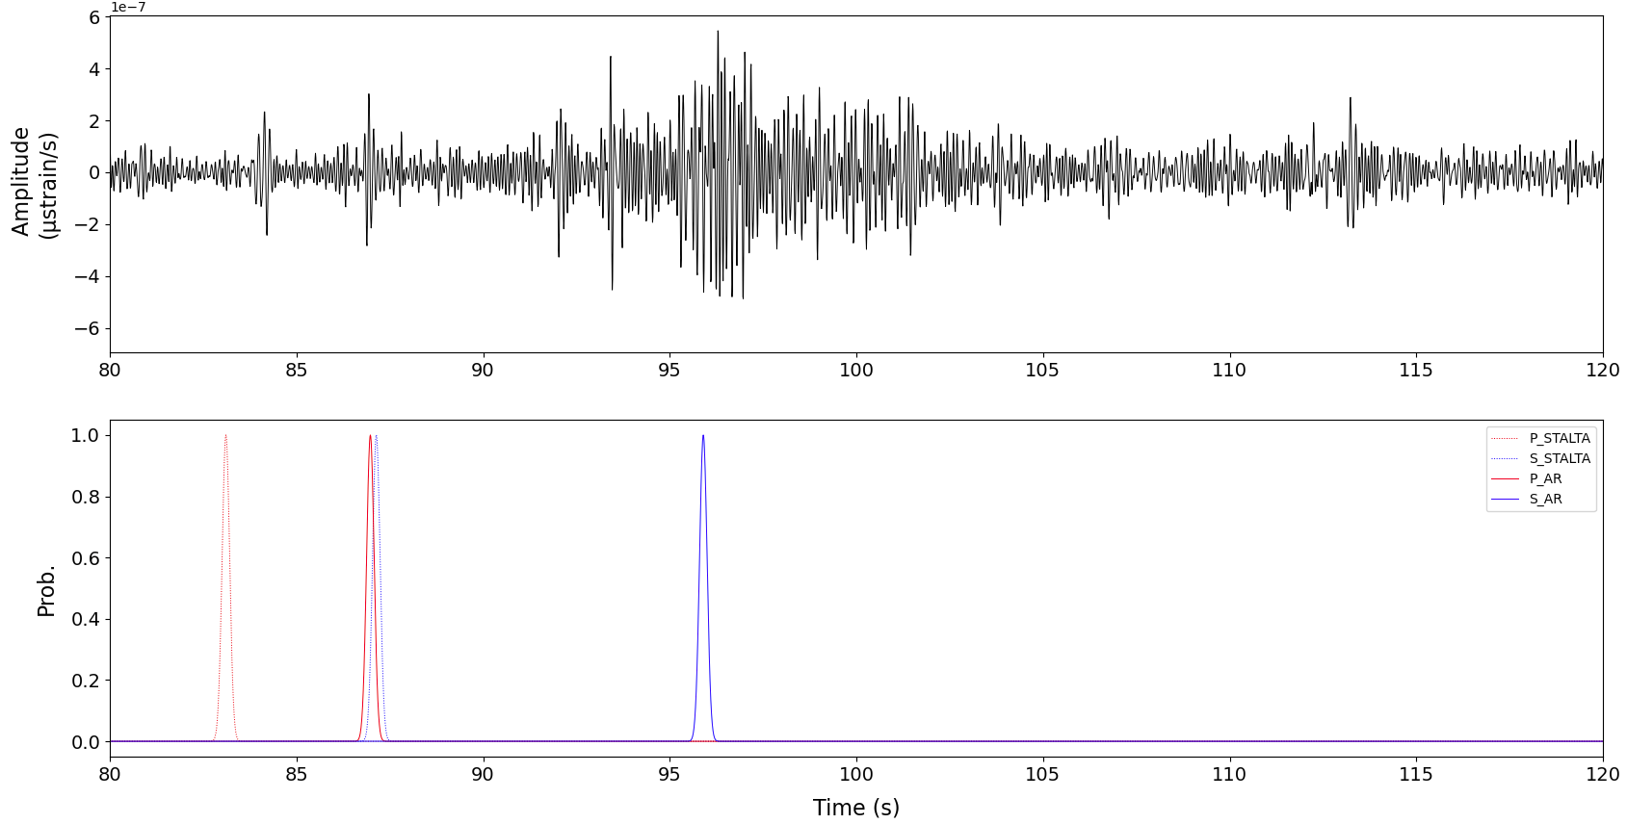

Figure S3

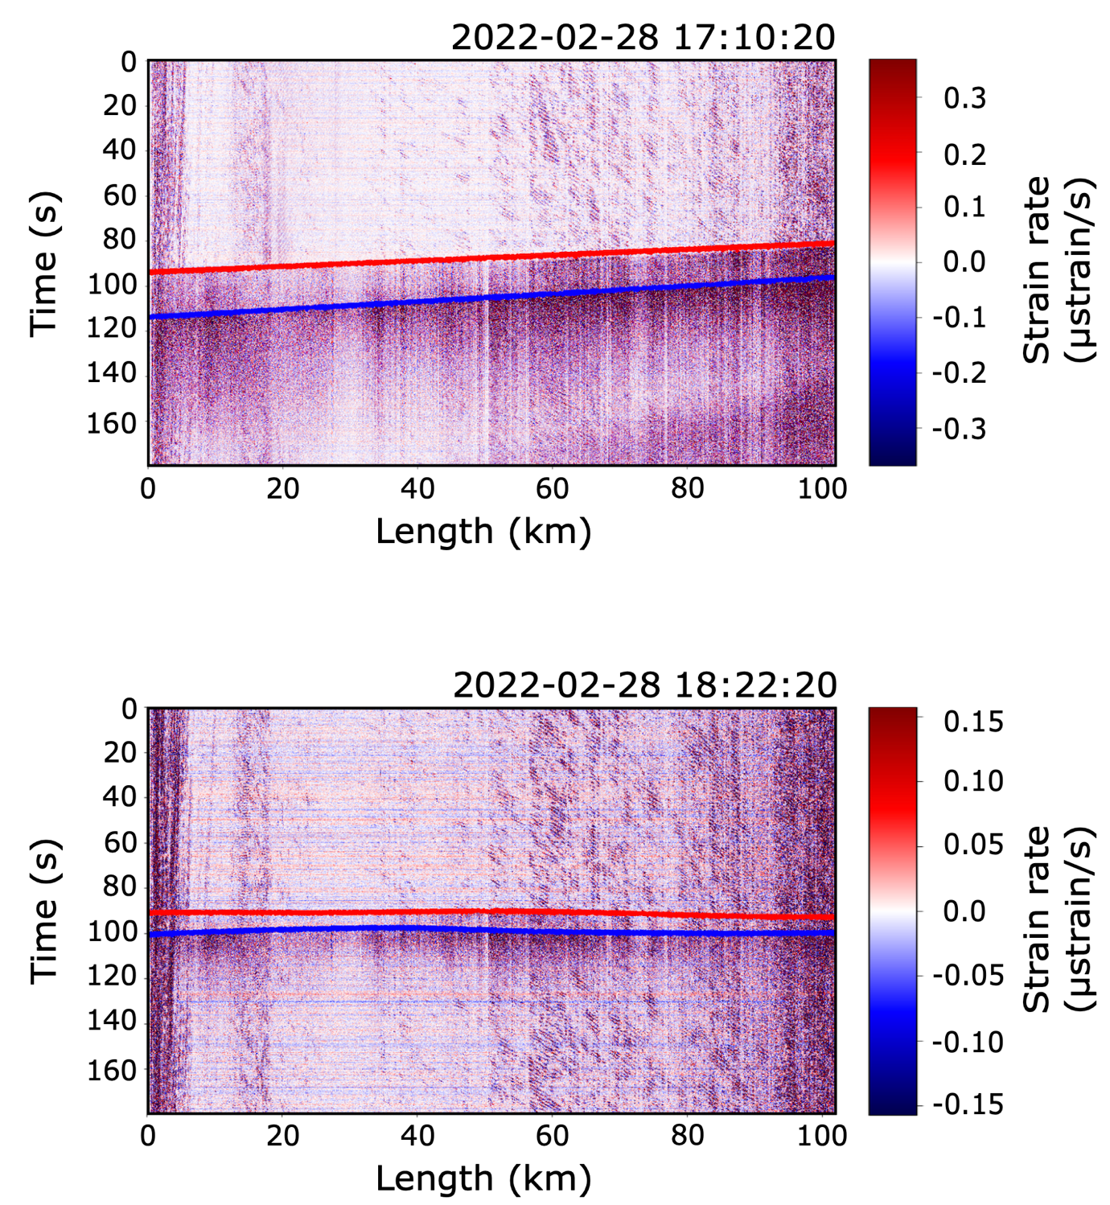

Figure S4

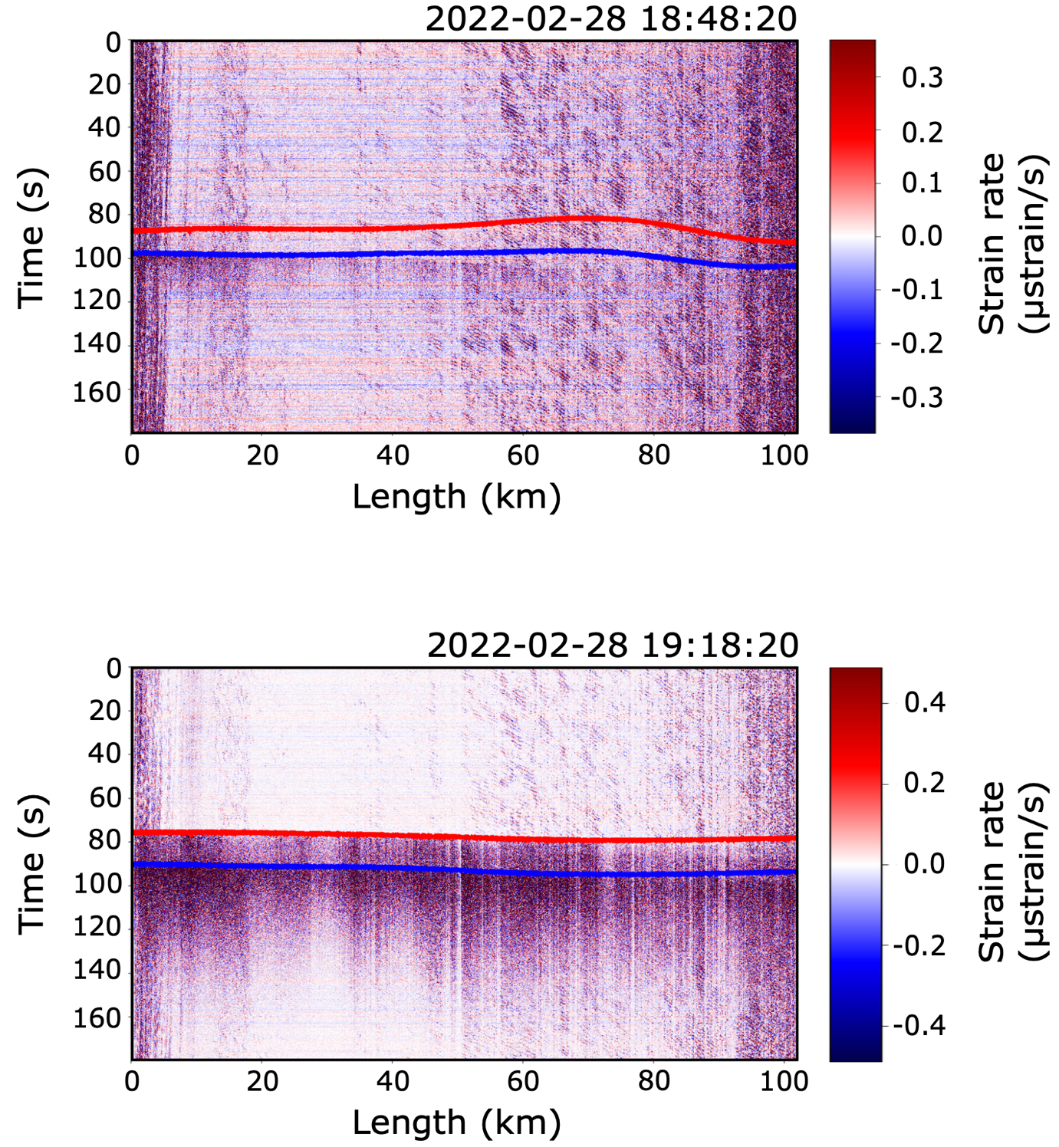

Figure S5

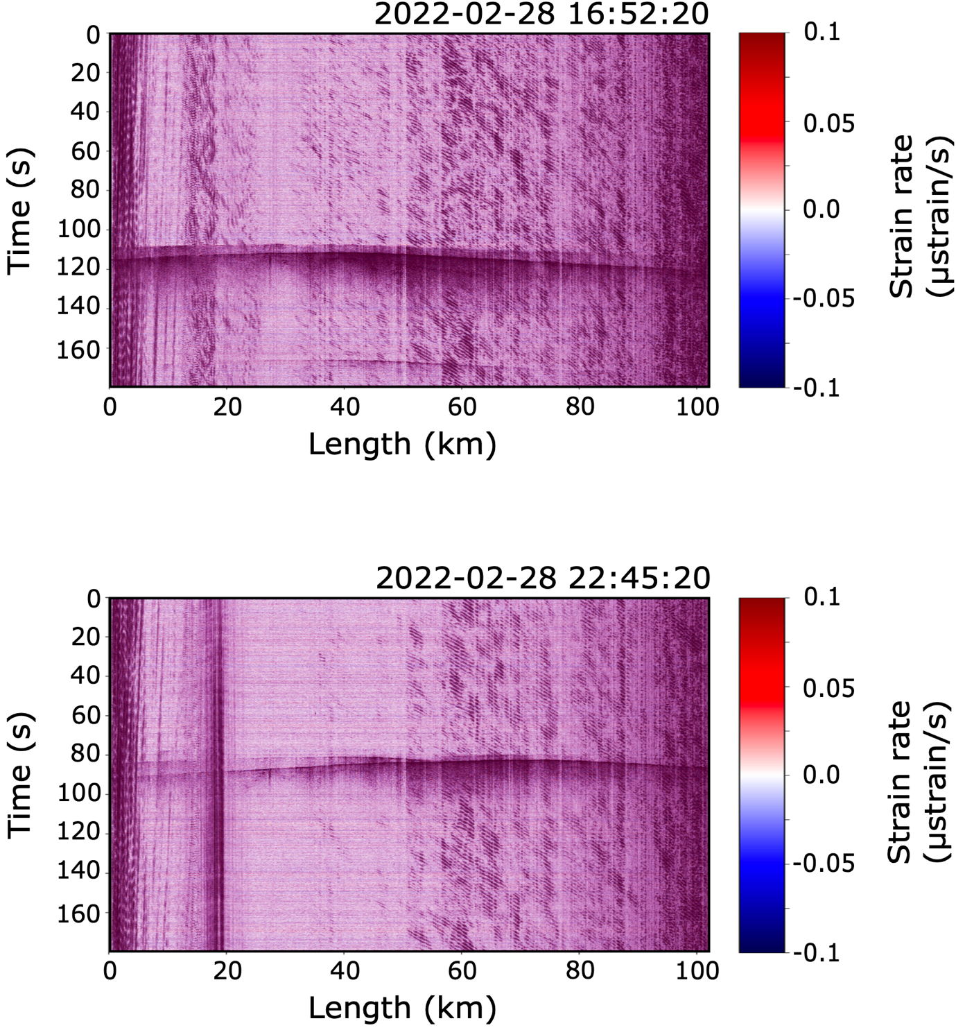

Figure S6.

