Validation of Software-Based Hearing Tests Against Clinical Audiometry: A Pilot Comparative Study
Pouya Ariamanesh; Tomasz Przewozny, MD PhD*, Izabela Gajda.

Supplementary Materials:

Results of individual synthesis:

Right Ear
- 250 Hz:
Mean threshold with audiometer = 10.4 dB; Apple = 4.13 dB.
Mean difference = 6.30 dB (Apple lower). Paired t-test showed this was highly significant (t=6.15, df=45, p<0.001). Apple systematically reported lower values than the audiometer. The difference is both statistically and clinically relevant.
Mean threshold with audiometer = 10.43 dB; MiMi = 12.61 dB.
Mean difference = -2.17 dB (MiMi higher). This was not statistically significant (t = -1.95, df=45, p=0.058), though close to significance. MiMi therefore showed closer alignment with the audiometer than Apple at this frequency.

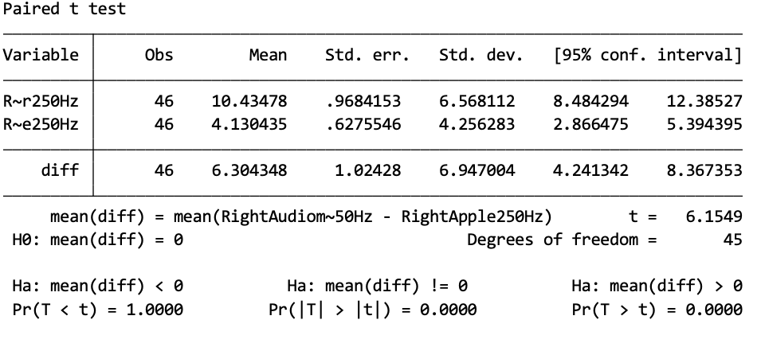
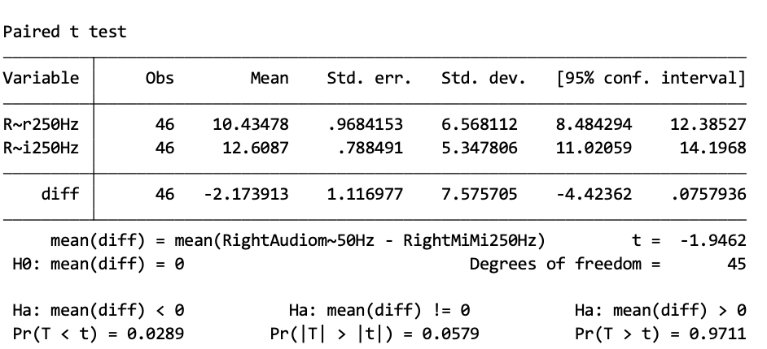

- 500 Hz:
Audiometer = 8.91 dB; Apple = 5.54 dB.
Difference = 3.37 dB (Apple lower). Significant (t=3.56, df=45, p=0.0009). Apple systematically underestimated.
Audiometer = 8.91 dB; MiMi = 14.13 dB.
Difference = -5.21 dB (MiMi higher). Highly significant (t = -4.95, df=45, p<0.001). MiMi systematically overestimated.
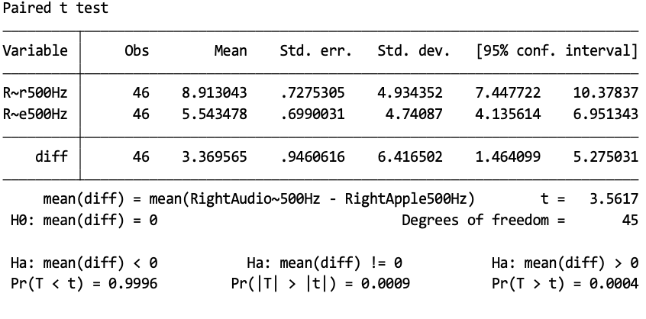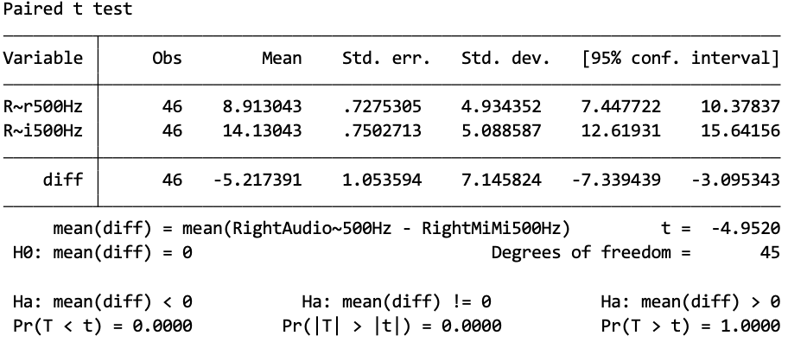
- 1,000 Hz:
Audiometer = 4.67 dB; Apple = 2.72 dB.
Difference = 1.96 dB (Apple lower). Significant (t=3.43, df=45, p=0.0013).
Audiometer = 4.67 dB; MiMi = 12.28 dB.
Difference = -7.61 dB (MiMi higher). Highly significant (t = -10.50, df=45, p<0.001). Large systematic error.
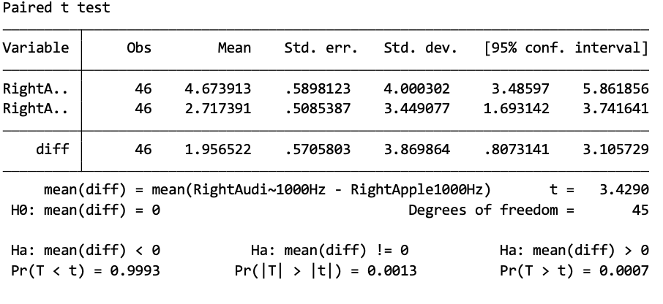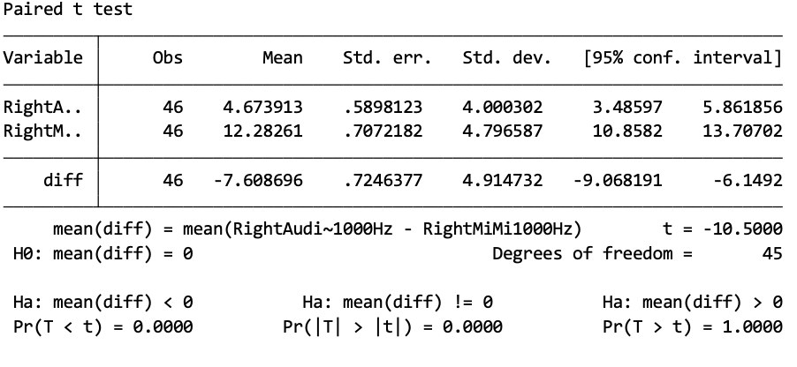
- 2,000 Hz:
Audiometer = 2.61 dB; Apple = 2.93 dB.
Difference = -0.33 dB (Apple slightly higher). Not significant (t = -0.68, df=45, p=0.497). Apple results essentially matched the audiometer.
Audiometer = 2.61 dB; MiMi = 12.17 dB.
Difference = -9.56 dB (MiMi higher). Highly significant (t = -12.11, df=45, p<0.001).
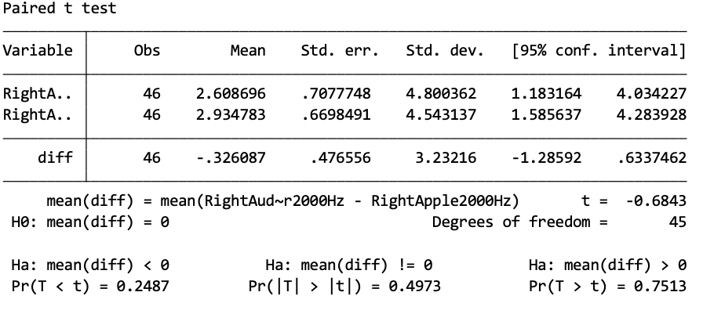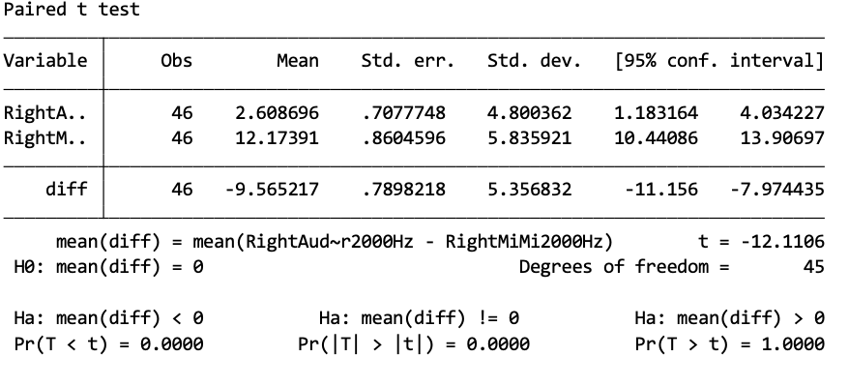
- 4,000 Hz:
Audiometer = 3.80 dB; Apple = 3.37 dB.
Difference = 0.43 dB. Not significant (t=0.64, df=45). Strong agreement.
Audiometer = 3.80 dB; MiMi = 10.65 dB.
Difference = -6.85 dB (MiMi higher). Highly significant (t = -8.93, df=45, p<0.001).
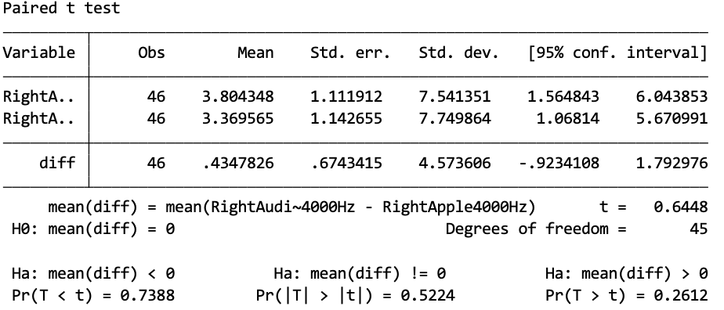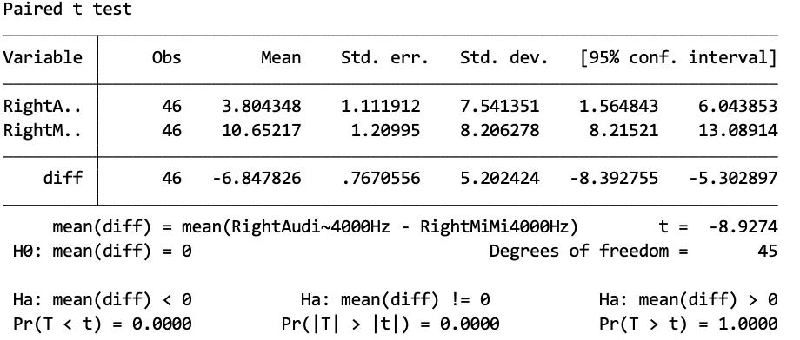
- 8,000 Hz:
Audiometer = 4.78 dB; MiMi = 8.91 dB.
Difference = -4.13 dB (MiMi higher). Significant (t = -4.04, df=45, p<0.001).
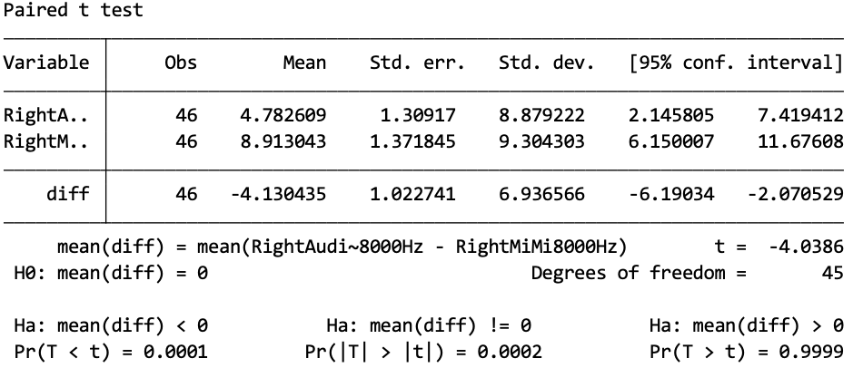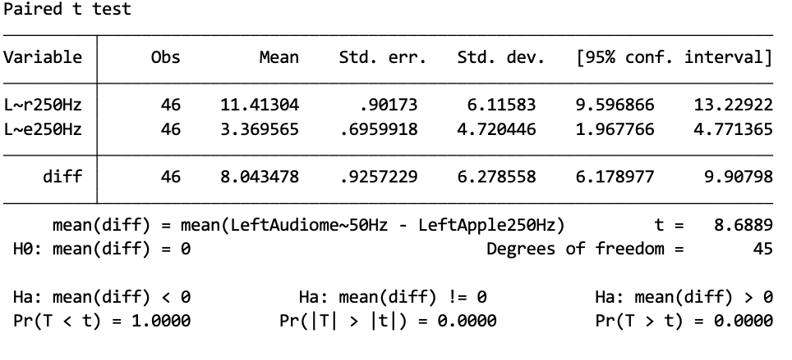

Left Ear
- 250 Hz:
Audiometer = 11.41 dB; Apple = 3.37 dB.
Difference = 8.04 dB (Apple lower). Highly significant (t=8.69, df=45).
Audiometer = 11.41 dB; MiMi = 13.15 dB.
Difference = -1.74 dB (MiMi higher). Not significant (t = -1.39, df=45, p=0.173).
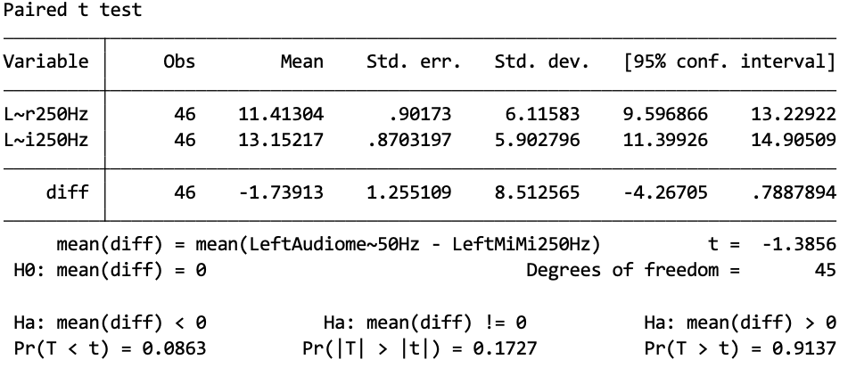

- 500 Hz:
Audiometer = 9.13 dB; Apple = 5.43 dB.
Difference = 3.70 dB (Apple lower). Significant (t=4.05, df=45, p<0.001).
Audiometer = 9.13 dB; MiMi = 14.35 dB.
Difference = -5.21 dB (MiMi higher). Significant (t = -4.20, df=45, p<0.001).
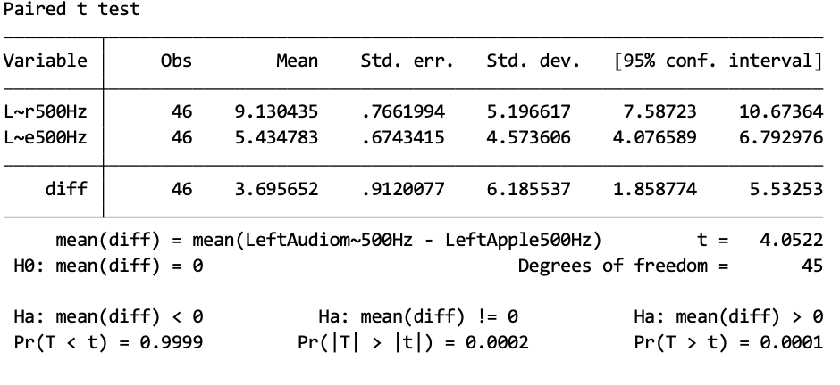
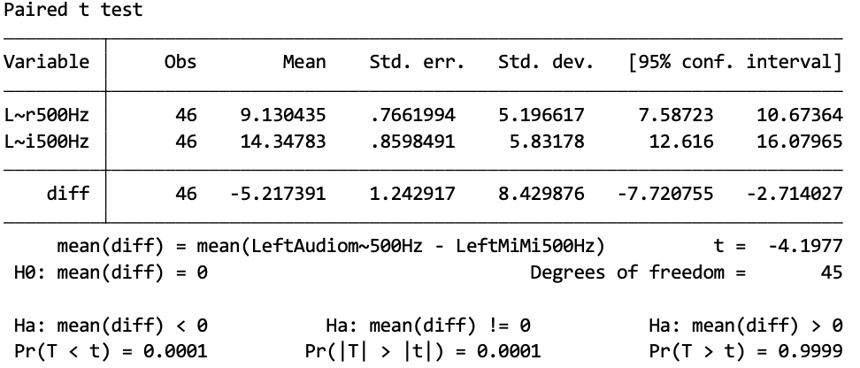
- 1,000 Hz:
Audiometer = 4.24 dB; Apple = 2.07 dB.
Difference = 2.17 dB (Apple lower). Significant (t=4.50, df=45, p<0.001).
Audiometer = 4.24 dB; MiMi = 11.41 dB.
Difference = -7.17 dB (MiMi higher). Highly significant (t = -9.70, df=45, p<0.001).
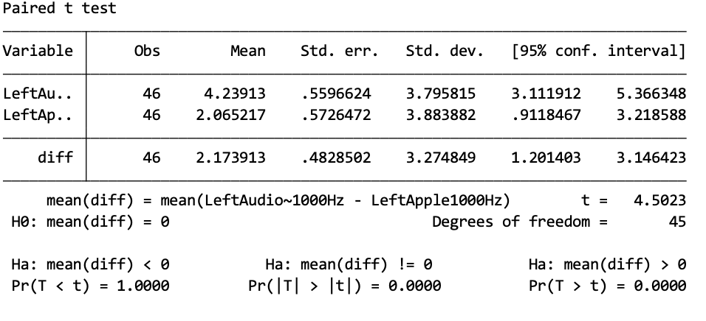
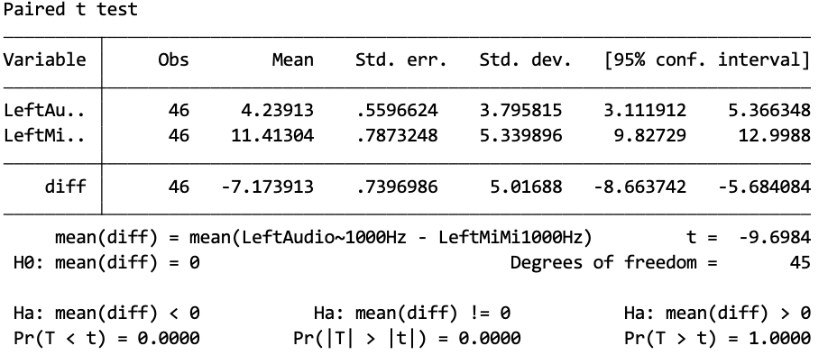
- 2,000 Hz:
Audiometer = 3.26 dB; Apple = 2.83 dB.
Difference = 0.43 dB. Not significant (t=0.73, df=45, p=0.471).
Audiometer = 3.26 dB; MiMi = 9.46 dB.
Difference = -6.20 dB (MiMi higher). Highly significant (t = -7.51, df=45, p<0.001).
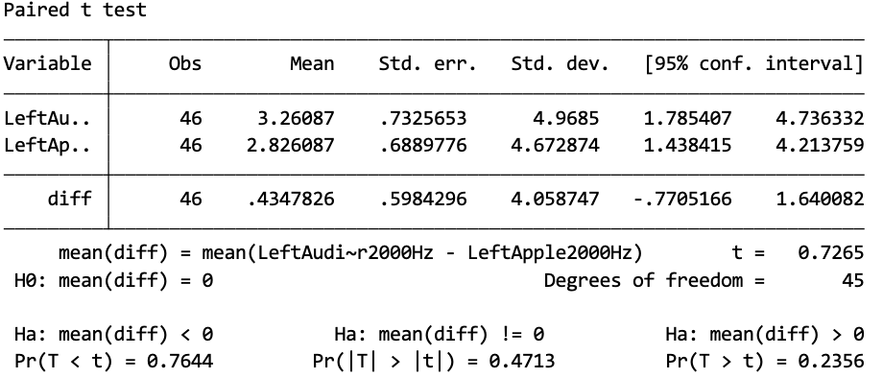
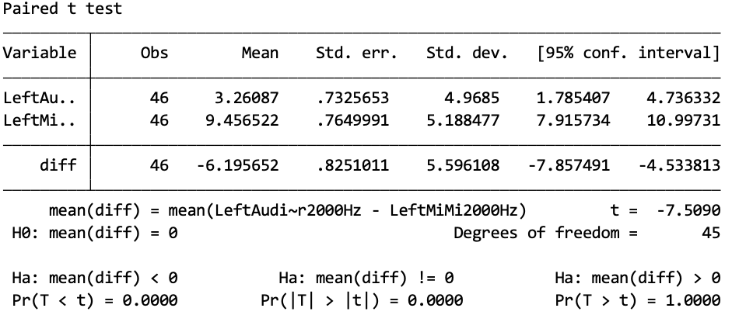
- 4,000 Hz:
Audiometer = 2.93 dB; Apple = 2.61 dB.
Difference = 0.33 dB. Not significant (t=0.68, df=45, p=0.497).
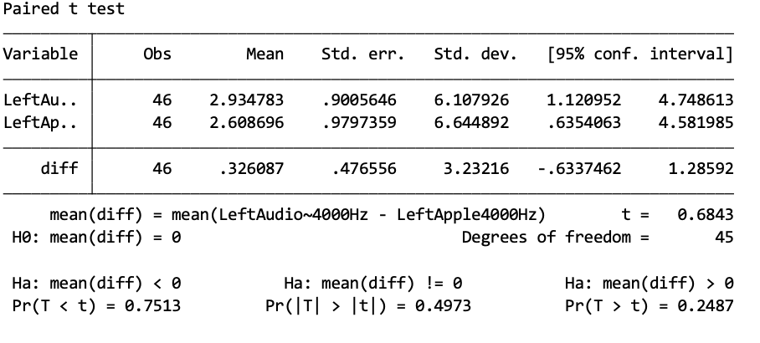
- 8,000 Hz:
Audiometer = 4.24 dB; Apple = 3.48 dB.
Difference = 0.76 dB. Not significant (t=1.27, df=45, p=0.212).
Audiometer = 4.24 dB; MiMi = 6.85 dB.
Difference = -2.61 dB (MiMi higher). Significant (t = -3.78, df=45, p=0.0005).
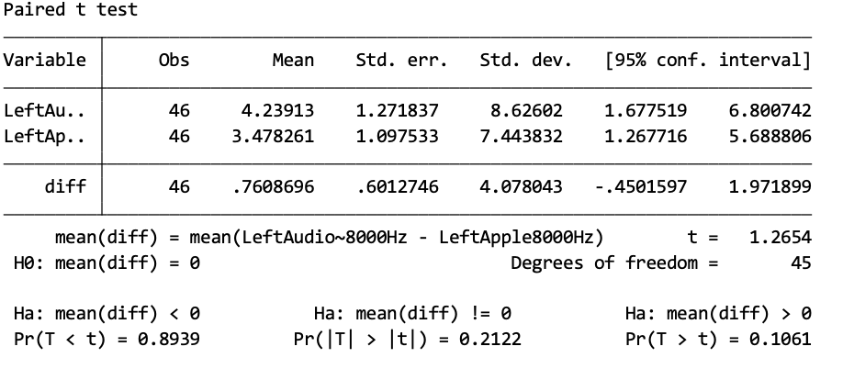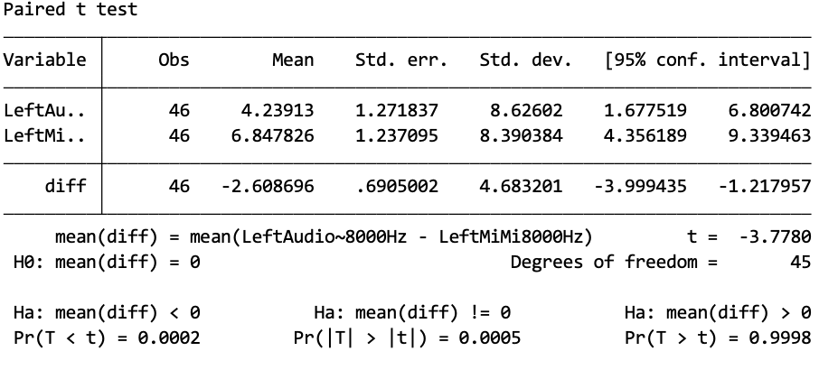

Demographic Analysis

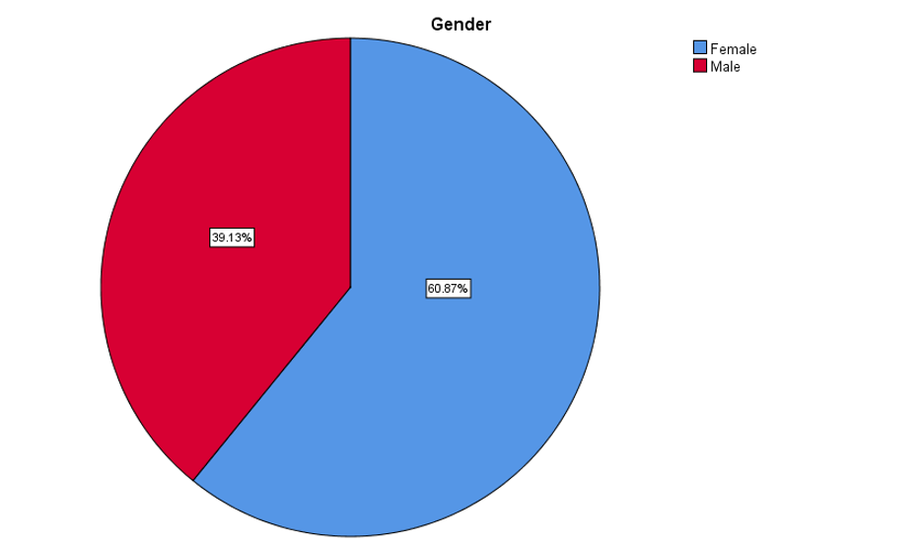

Software and Analysis
Statistical software: Stata and SPSS

Participants’ Questionnaire

Participant Information
First Name: ____________________
Last Name: ____________________
Research Code: ____________________
Age: ____________________
Gender (Male / Female / Other): ____________________
Profession: ____________________
Email Address: ____________________
1. Please indicate if you have ever had any of the following:
· ☐ Previous ear surgery
· ☐ History of ear disease
· ☐ Abnormally high levels of ear discharge
· ☐ Use of hearing aid devices
· ☐ History of sound sensitivity
· ☐ History of ototoxic medication use
· ☐ Diabetes
· ☐ Any hereditary hearing loss
· ☐ None
2. Do you or have you ever worked/lived in a noisy environment?
· ☐ Yes
· ☐ No
· ☐ Other: ________
3. Do you currently have any complaints of hearing loss?
· ☐ Yes
· ☐ No
· ☐ Other: ________
4. Are you currently sick with any infections?
· ☐ Yes
· ☐ No
· ☐ Maybe
· ☐ Other: ________
5. Are you currently suffering from any of the following?
· ☐ Fever
· ☐ Cough
· ☐ Runny nose
· ☐ Sore Throat
· ☐ None
6. Do you give us your consent to process your data? (Identity excluded in analysis)
· ☐ Yes
· ☐ No
7. Do you give consent for the examination?
· ☐ Yes
· ☐ No
8. Is the visual inspection OK?
· ☐ Yes
· ☐ No
9. Are you currently experiencing allergies, a cold, or ear/sinus infection?
· ☐ Yes
· ☐ No
10. Have you been in a loud environment (concert/construction) in the last 24 hours?
· ☐ Yes
· ☐ No

1- Email: austin.ariamanesh@gumed.edu.pl
2*- Corresponding Author; Email: tomasz.przewozny@gumed.edu.pl
3- Email: s189271@student.pg.edu.pl

