SUPPLEMENTARY MATERIAL

TWO STEPS AWAY FROM EXTINCTION: DO YOU BELIEVE?

KARINA APARECIDA SOARES DE PÁDUA, THAIS MARTINS TEIXEIRA, ALISON GONÇALVES NAZARENO
Department of Genetics, Ecology, and Evolution - Federal University of Minas Gerais, Avenida Presidente Antônio Carlos 6627, Pampulha, Belo Horizonte, MG, 31270-901, Brazil

TABLE S1 Number of samples per ontogenetic stage for Dinizia jueirana-facao G. P. Lewis & G. S. Siqueira based on diameter at breast height (DBH) for each sampled location before (BF) and after (AF) data quality filtering (i.e., removal of samples that did not meet the criteria for number of raw reads obtained from high-throughput sequencing).

 | Seedlings  (DBH < 5 cm) |  | Intermediate  (5 cm > DBH > 14 cm) |  | Reproductive adults (DBH ≥ 14 cm) |  | Reproductive adults  (DBH > 54 cm)¹ |  | Total samples
Locality | BF | AF | BF | AF | BF | AF | BF | AF | BF | AF
RNV | 21 | 21 | 34 | 34 | 61 | 59 | 12 | 12 | 116 | 114
RBS | 37 | 29 | 26 | 15 | 32 | 26 | 16 | 13 | 95 | 70
¹ Individuals with an estimated age over 120 years.

TABLE S2 Summary of ontogenetic stages included in each dataset used to investigate genetic and ecological patterns in Dinizia jueirana-facao. Stage selection was based on the focus, assumptions, and hypotheses addressed by each analysis. Seedlings: DBH < 5 cm; Intermediates: 5 cm > DBH > 14 cm; Reproductive adults: DBH ≥ 14 cm; Reproductive adults (DBH > 54 cm)¹.
Dataset | Analysis Type | Ontogenetic Stages Used | Methodological Approach
(a) | Paternity, SGS, Mating system | Seedlings and Reproductive Adults | Assumes non-overlapping generations and tests the hypothesis of recent reduction in gene flow; Explores the mating system.
(b) | Genetic Diversity, Inbreeding | Seedlings and Reproductive Adults¹ | Assumes non-overlapping generations and tests hypotheses of genetic diversity loss and increase in inbreeding due to fragmentation.
(c) | Effective Population Size (Ne), population demographic structure | Seedlings, Intermediates, and Reproductive Adults | Tests hypotheses of reduced N_{e} and demographic shifts due to fragmentation.
¹Reproductive adults (DBH > 54 cm) are individuals estimated to be over 120 years old and represent the pre-fragmentation cohort.

TABLE S3 Results of Shapiro-Wilk Normality and Kolmogorov-Smirnov tests applied to the variables DBH (Diameter at Breast Height) and Height for each ontogenetic stage of Dinizia jueirana-facao G. P. Lewis & G. S. Siqueira in two Atlantic forest fragments – Reserva Natural da Vale (RNV) and Reserva Biológica de Sooretama (RBS) – located in Espírito Santo State, Southeast Brazil. p-value > 0.05 are in bold.
 |  | Shapiro-Wilk Normality Test
 |  | DBH |  | Height
 |  | W | p-value | W | p-value
RNV | seedlings | 0.62775 | 3.924e-06 | 0.6934 | 2.281e-05
RNV | intermediates | 0.95175 | 0.1385 | 0.96231 | 0.2836
RNV | adults | 0.75325 | 9.013e-09 | 0.94848 | 0.01221
RBS | seedlings | 0.78015 | 5.324e-06 | 0.79315 | 9.518e-06
RBS | intermediates | 0.95157 | 0.2524 | 0.89615 | 0.01286
RBS | adults | 0.87798 | 0.001784 | 0.92285 | 0.02811
 |  | Kolmogorov-Smirnov Test
 |  | KS test | p-value | KS test | p-value
Seedlings | RNV vs RBS | 0.24067 | 0.1965 | 0.30116 | 0.102
Intermediates | RNV vs RBS | 0.23303 | 0.2773 | 0.16968 | 0.4611
Adults | RNV vs RBS | 0.30943 | 0.02446 | 0.27393 | 0.0427

TABLE S4 Regeneration status of Dinizia jueirana-facao G. P. Lewis & G. S. Siqueira in two Atlantic forest fragments – Reserva Natural da Vale (RNV) and Reserva Biológica de Sooretama (RBS) – located in Espírito Santo State, Southeast Brazil.
 | Area (ha) | Seedlings | Intermediates | Adults | Regeneration status
RNV | 42.99 | 0.49 | 0.79 | 1.42 | Fair
RBS | 64.81 | 0.57 | 0.40 | 0.49 | Good

TABLE S5 The effect of missing data (MD) variation on genetic parameters (H_{O} - observed heterozygosity, H_{E} - expected heterozygosity, F_{IS} - inbreeding coefficient) for each ontogenetic stage of Dinizia jueirana-facao G. P. Lewis & G. S. Siqueira in two Atlantic forest fragments – Reserva Natural da Vale (RNV) and Reserva Biológica de Sooretama (RBS) – located in Espírito Santo State, Southeast Brazil.

Seedlings – RNV
%MD | SNPs | H_{O} | 95% CI | H_{E} | 95% CI | F_{IS} | 95% CI
0% | 450 | 0.180 | 0.102 - 0.258 | 0.186 | 0.11 - 0.262 | 0.020 | -0.076 - 0.116
5% | 2,674 | 0.203 | 0.124 - 0.282 | 0.214 | 0.136 - 0.292 | 0.041 | -0.06 - 0.142
10% | 4,057 | 0.194 | 0.113 - 0.275 | 0.208 | 0.127 - 0.289 | 0.053 | -0.06 - 0.166
15% | 5,195 | 0.186 | 0.105 - 0.267 | 0.202 | 0.121 - 0.283 | 0.064 | -0.057 - 0.185
20% | 6,268 | 0.180 | 0.097 - 0.263 | 0.198 | 0.115 - 0.281 | 0.073 | -0.058 - 0.204
25% | 7,206 | 0.177 | 0.094 - 0.26 | 0.196 | 0.113 - 0.279 | 0.078 | -0.058 - 0.214
30% | 8,408 | 0.173 | 0.088 - 0.258 | 0.194 | 0.109 - 0.279 | 0.083 | -0.062 - 0.228
Reproductive adults – RNV
%MD | SNPs | H_{O} | 95% CI | H_{E} | 95% CI | F_{IS} | 95% CI
0% | 517 | 0.199 | 0.153 - 0.245 | 0.191 | 0.148 - 0.234 | -0.031 | -0.065 - 0.003
5% | 2,985 | 0.230 | 0.182 - 0.278 | 0.225 | 0.18 - 0.27 | -0.011 | -0.052 - 0.03
10% | 4,579 | 0.220 | 0.173 - 0.267 | 0.221 | 0.176 - 0.266 | 0.007 | -0.039 - 0.053
15% | 5,917 | 0.211 | 0.164 - 0.258 | 0.216 | 0.17 - 0.262 | 0.021 | -0.031 - 0.073
20% | 7,243 | 0.205 | 0.157 - 0.253 | 0.212 | 0.166 - 0.258 | 0.036 | -0.022 - 0.094
25% | 8,365 | 0.201 | 0.153 - 0.249 | 0.211 | 0.164 - 0.258 | 0.043 | -0.018 - 0.104
30% | 9,869 | 0.197 | 0.148 - 0.246 | 0.209 | 0.161 - 0.257 | 0.053 | -0.012 - 0.118

Seedlings – RBS
%MD | SNPs | H_{O} | 95% CI | H_{E} | 95% CI | F_{IS} | 95% CI
0% | 517 | 0.204 | 0.139 - 0.269 | 0.200 | 0.14 - 0.26 | -0.015 | -0.08 - 0.05
5% | 2,917 | 0.224 | 0.156 - 0.292 | 0.225 | 0.161 - 0.289 | 0.008 | -0.069 - 0.085
10% | 4,433 | 0.215 | 0.146 - 0.284 | 0.221 | 0.155 - 0.287 | 0.023 | -0.063 - 0.109
15% | 5,761 | 0.209 | 0.138 - 0.28 | 0.216 | 0.149 - 0.283 | 0.034 | -0.06 - 0.128
20% | 7,032 | 0.201 | 0.131 - 0.271 | 0.212 | 0.145 - 0.279 | 0.045 | -0.054 - 0.144
25% | 8,100 | 0.197 | 0.126 - 0.268 | 0.210 | 0.141 - 0.279 | 0.052 | -0.053 - 0.157
30% | 9,481 | 0.193 | 0.121 - 0.265 | 0.208 | 0.138 - 0.278 | 0.059 | -0.052 - 0.17
Reproductive adults – RBS
%MD | SNPs | H_{O} | 95% CI | H_{E} | 95% CI | F_{IS} | 95% CI
0% | 506 | 0.218 | 0.143 - 0.293 | 0.201 | 0.136 - 0.266 | -0.065 | -0.126 - -0.004
5% | 2,847 | 0.238 | 0.16 - 0.316 | 0.224 | 0.155 - 0.293 | -0.046 | -0.12 - 0.028
10% | 4,299 | 0.228 | 0.149 - 0.307 | 0.219 | 0.148 - 0.29 | -0.029 | -0.114 - 0.056
15% | 5,543 | 0.220 | 0.141 - 0.299 | 0.214 | 0.143 - 0.285 | -0.016 | -0.108 - 0.076
20% | 6,747 | 0.211 | 0.131 - 0.291 | 0.209 | 0.136 - 0.282 | -0.004 | -0.104 - 0.096
25% | 7,781 | 0.207 | 0.127 - 0.287 | 0.207 | 0.134 - 0.28 | 0.005 | -0.1 - 0.11
30% | 9,119 | 0.203 | 0.122 - 0.284 | 0.205 | 0.131 - 0.279 | 0.013 | -0.1 - 0.126

TABLE S6 The effect of minor allele frequency (MAF) variation on the number of single nucleotide polymorphisms (SNPs) for Dinizia jueirana-facao G. P. Lewis & G. S. Siqueira. The percentage of missing data was set at 10%.

MAF | 0.05 | 0.10 | 0.15 | 0.20 | 0.25 | 0.30 | 0.35 | 0.40 | 0.45 | 0.50
SNPs | 4,194 | 3,421 | 2,834 | 2,289 | 1,856 | 1,406 | 1,030 | 702 | 330 | 11

TABLE S7 Mean values of allelic richness (A), private allelic richness (R), and inbreeding coefficients ($F_{IS}$) presented for each ontogenetic stage of Dinizia jueirana-facao G. P. Lewis & G. S. Siqueira in two Atlantic forest fragments – Reserva Natural da Vale (RNV) and Reserva Biológica de Sooretama (RBS) – located in the Espírito Santo State, Southeast Brazil. 95% confidence intervals for each genetic parameter are also shown.

 | Site | A | 95% CI | R | 95% CI | F_{IS} | 95% CI
Adults | RNV | 1.711 | 1.705 - 1.717 | 0.197 | 0.192 - 0.202 | -0.051 | -0.21 - 0.108
Adults | RBS | 1.690 | 1.684 - 1.696 | 0.176 | 0.172 - 0.181 | -0.049 | -0.186 - 0.088
Seedlings | RNV | 1.661 | 1.655 - 1.667 | 0.164 | 0.160 - 0.168 | 0.044 | -0.061 - 0.149
Seedlings | RBS | 1.694 | 1.689 - 1.700 | 0.197 | 0.193 - 0.201 | 0.006 | -0.068 - 0.08

TABLE S8 Paternity analysis for Dinizia jueirana-facao G. P. Lewis & G. S. Siqueira in two Atlantic forest fragments – Reserva Natural da Vale (RNV) and Reserva Biológica de Sooretama (RBS) – located in Espírito Santo State, Southeast Brazil. Only parent pairs inferred with a probability higher than 95% were considered. # represents the candidate parents that were not identified in the sample. Selfing events are shown in bold.

RNV
ID - Seedlings | ID - Inferred Father | ID - Inferred Mother | Probability
pop1_102 | pop1_86 | pop1_100 | 1.0000
pop1_113 | pop1_114 | pop1_111 | 1.0000
pop1_12 | pop1_1 | pop1_8 | 1.0000
pop1_17 | #1 | #9 | 1.0000
pop1_18 | #2 | #9 | 1.0000
pop1_25 | pop1_1 | pop1_26 | 1.0000
pop1_27 | #3 | pop1_26 | 1.0000
pop1_28 | pop1_26 | pop1_26 | 1.0000
pop1_32 | pop1_26 | pop1_37 | 1.0000
pop1_34 | pop1_37 | pop1_37 | 1.0000
pop1_35 | pop1_37 | pop1_37 | 1.0000
pop1_36 | pop1_37 | pop1_37 | 1.0000
pop1_38 | pop1_37 | pop1_37 | 1.0000
pop1_39 | pop1_1 | pop1_1 | 1.0000
pop1_54 | #4 | pop1_51 | 1.0000
pop1_55 | #5 | #9 | 1.0000
pop1_59 | #5 | pop1_60 | 1.0000
pop1_7 | #6 | #10 | 1.0000
pop1_72 | #7 | #11 | 1.0000
pop1_85 | #8 | pop1_78 | 1.0000
pop1_87 | pop1_78 | pop1_86 | 1.0000

RBS
ID - Seedlings | Inferred Father | Inferred Mother | Probability
pop2_209 | #1 | pop2_217 | 1.0000
pop2_210 | pop2_231 | pop2_217 | 1.0000
pop2_212 | #2 | pop2_217 | 1.0000
pop2_213 | #3 | pop2_217 | 1.0000
pop2_218 | pop2_231 | pop2_217 | 1.0000
pop2_223 | pop2_220 | #17 | 0.6224
pop2_223 | #17 | pop2_220 | 0.3776
pop2_226 | #4 | pop2_247 | 0.9059
pop2_226 | pop2_247 | #4 | 0.0941
pop2_230 | pop2_217 | pop2_231 | 0.9093
pop2_230 | pop2_231 | pop2_217 | 0.0907
pop2_237 | #5 | pop2_232 | 1.0000
pop2_245 | #6 | pop2_250 | 1.0000
pop2_254 | pop2_264 | pop2_257 | 0.9966
pop2_260 | pop2_264 | pop2_259 | 1.0000
pop2_261 | pop2_217 | pop2_257 | 0.7131
pop2_261 | pop2_257 | pop2_217 | 0.2869
pop2_263 | #7 | #7 | 1.0000
pop2_265 | #8 | pop2_264 | 1.0000
pop2_266 | #9 | pop2_264 | 1.0000
pop2_268 | #10 | #18 | 1.0000
pop2_272 | #10 | pop2_264 | 1.0000
pop2_273 | #11 | pop2_264 | 1.0000
pop2_274 | pop2_257 | pop2_275 | 1.0000
pop2_277 | #7 | pop2_275 | 1.0000
pop2_279 | #7 | #7 | 1.0000
pop2_280 | pop2_287 | #7 | 0.9059
pop2_280 | #7 | pop2_287 | 0.0941
pop2_285 | #12 | pop2_291 | 1.0000
pop2_286 | #13 | #12 | 1.0000
pop2_288 | #5 | pop2_287 | 1.0000
pop2_289 | #14 | #12 | 1.0000
pop2_290 | #15 | pop2_291 | 1.0000
pop2_294 | #16 | #19 | 1.0000

FIGURE S1 Map showing the occurrence area (A-B) of Dinizia jueirana-facao G. P. Lewis & G. S. Siqueira in two Atlantic forest fragments – Reserva Natural da Vale (red point in C) and Reserva Biológica de Sooretama (yellow point in C) – located in Espírito Santo State, Southeast Brazil. The distance between the areas is approximately 12 kilometers.
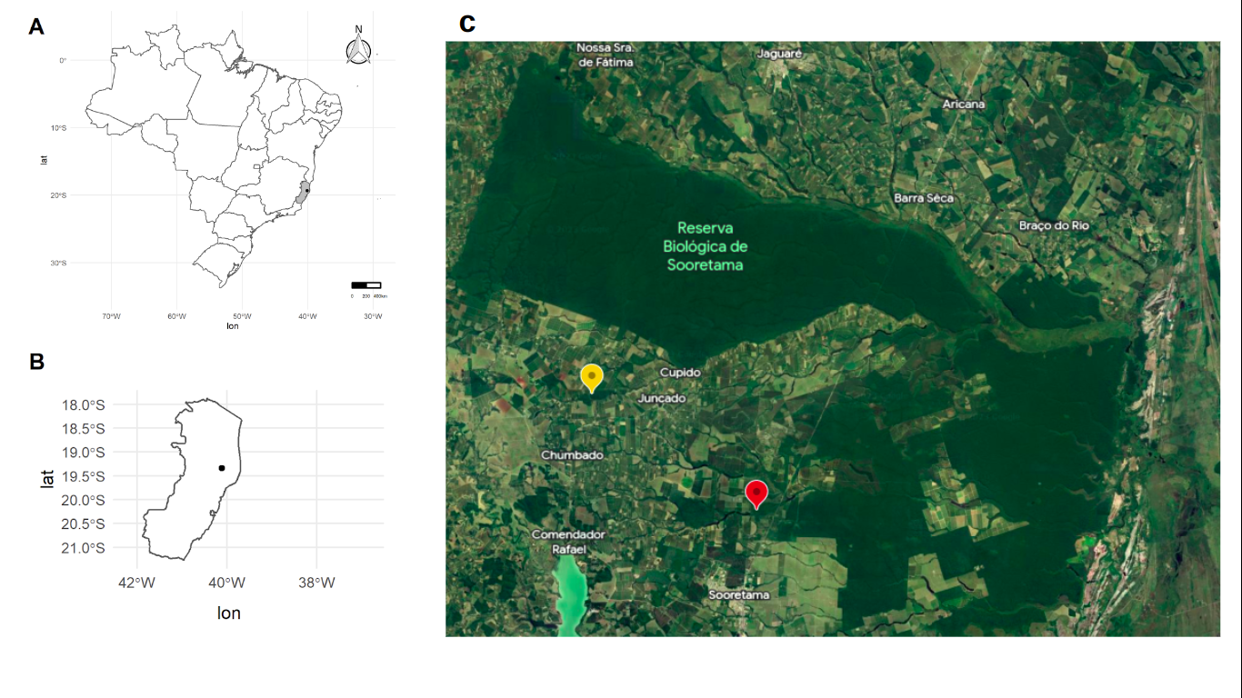

FIGURE S2 Box plot quality of reads. Center lines show the medians; box limits indicate the 25th and 75th percentiles as determined by R software; whiskers extend to 5th and 95th percentiles. (A) Number of retained reads with all samples, outliers are represented by dots. n = 211 sample points. (B) Number of retained reads by locality, outliers are represented by dots. n = 116 and 95 sample points. Samples with less than 500,000 reads were discarded from the dataset.

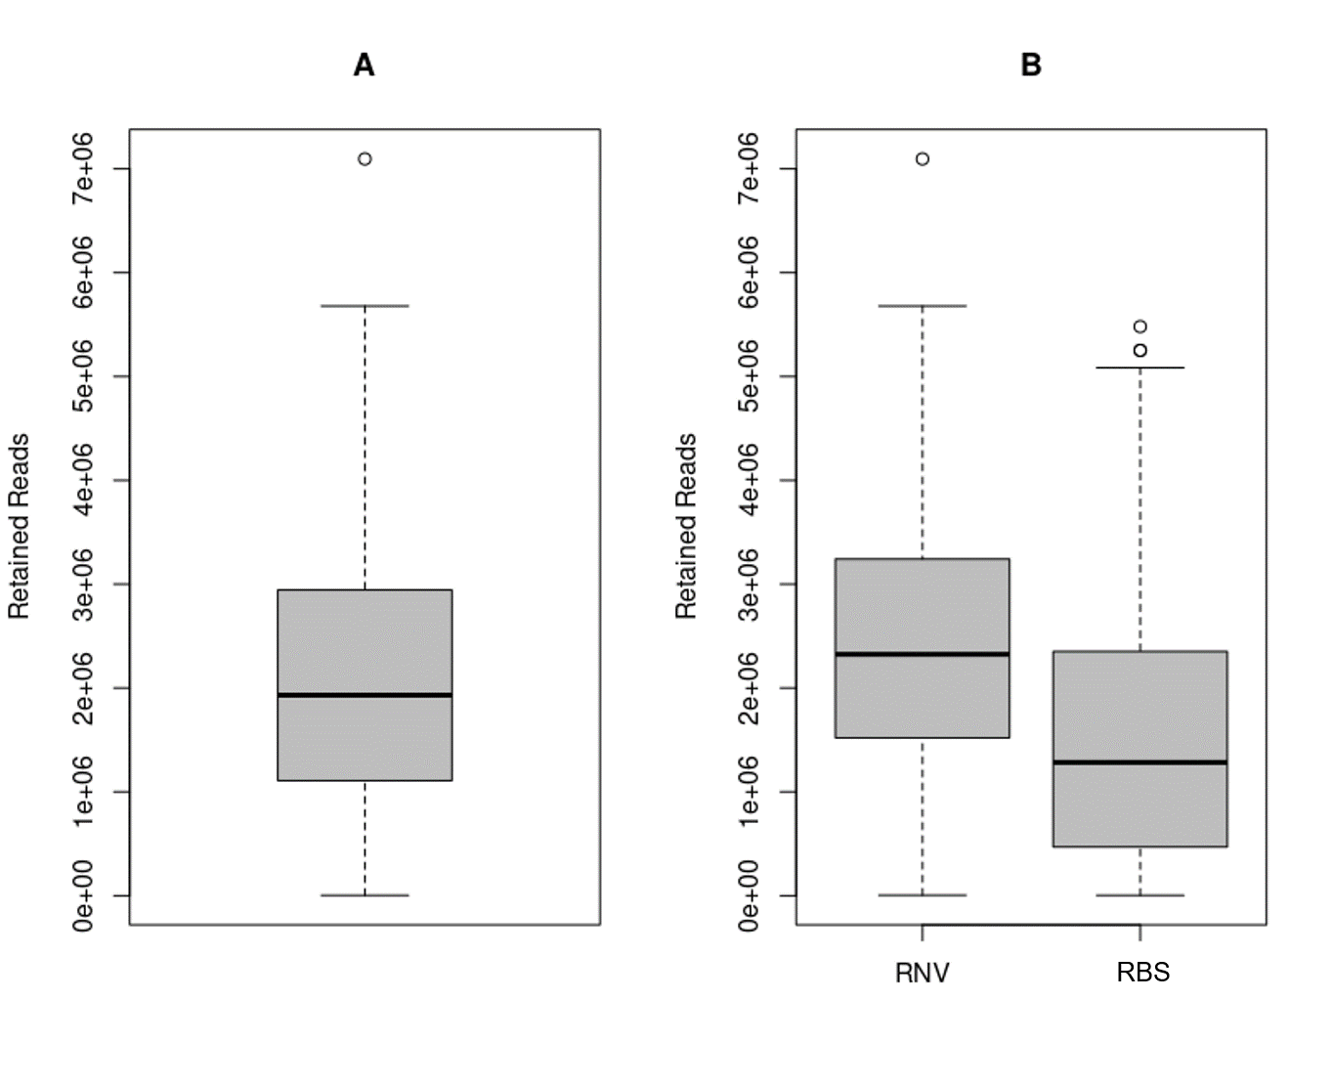
FIGURE S3 Box plots illustrating the distribution of Diameter at Breast Height (DBH) and Height for each ontogenetic stage of Dinizia jueirana-facao G. P. Lewis & G. S. Siqueira individuals in two Atlantic forest fragments: Reserva Natural da Vale (RNV) and Reserva Biológica de Sooretama (RBS). Center lines show the medians; box limits indicate the 25th and 75th percentiles as determined by R software; whiskers extend to 5th and 95th percentiles.

