Table 1 Elemental analysis of the NPs
Sample Fe (%) Cu (%) Zn (%) Mn (%) O (%) Molecular structure
Fe_{x}Cu_{y}Zn_{z}O_{k} 34 18 10 --- 38 Fe₄Cu_{1.86}Zn₁O_{15.8}

FexCuyMnzOk 35 12 --- 13 40 Fe_{3.4}Cu₁Mn_{1.05}O_{13.8}

Table 2 Optimization of reaction condition for the synthesis of pyrrole using Fe_{x}Cu_{y}Zn_{z}O_{k}
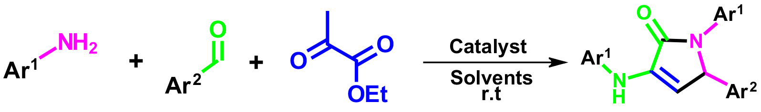
Entry | Catalyst | Solvent | Time(min) | Temp.(⁰C) | Yield (%)
1 | no catalyst | no salvent | 60 | r.t | trace
2 | no catalyst | no salvent | 120 | r.t | 30
3 | Fe_{x}Cu_{y}Zn_{z}O_{k} (5) | EtOH | 90 | r.t | 60
4 | Fe_{x}Cu_{y}Zn_{z}O_{k} (8) | EtOH | 90 | r.t | 73
5 | Fe_{x}Cu_{y}Zn_{z}O_{k} (10) | EtOH | 90 | r.t | 77
6 | Fe_{x}Cu_{y}Zn_{z}O_{k} (15) | EtOH | 90 | r.t | 77
7 | Fe_{x}Cu_{y}Zn_{z}O_{k} (20) | EtOH | 90 | r.t | 79
8 | Fe_{x}Cu_{y}Zn_{z}O_{k} (25) | EtOH | 90 | r.t | 79
9 | Fe_{x}Cu_{y}Zn_{z}O_{k} (10) | H₂O | 90 | r.t | 36
10 | Fe_{x}Cu_{y}Zn_{z}O_{k} (10) | EtOH | 90 | r.t | 47
11 | Fe_{x}Cu_{y}Zn_{z}O_{k} (10) | MeOH | 90 | r.t | 40
12 | Fe_{x}Cu_{y}Zn_{z}O_{k} (10) | CH₃CN | 90 | r.t | 75
13 | Fe_{x}Cu_{y}Zn_{z}O_{k} (10) | DCM | 90 | r.t | 56
14 | Fe_{x}Cu_{y}Zn_{z}O_{k} (10) | CH₂Cl₂ | 90 | r.t | 43
15 | Fe_{x}Cu_{y}Zn_{z}O_{k} (10) | H₂O/EtOH | 90 | r.t | 55
16 | Fe_{x}Cu_{y}Zn_{z}O_{k} (10) | H₂O/CH₃CN | 90 | r.t | 84
Reaction conditions: 4-cyanobenzaldehyde (1 mmol), 4-bromoaniline (2 mmol), ethyl pyruvate (1 mmol),
in the presence of the catalyst in a 5 ml solvent.

Table 3 Synthesis of pyrrole derivatives using Fe_{x}Cu_{y}Zn_{z}O_{k} as a catalyst
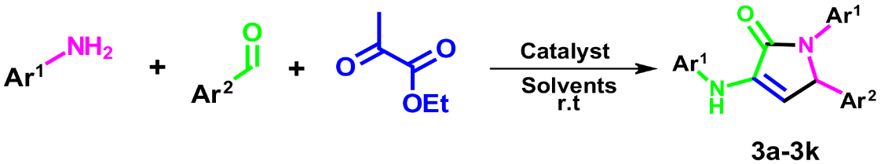

Entry Product Ar² m.p (◦C) lit m.p (◦C) Yield (%)
1 | 1,5-diphenyl-3-(phenylamino)-1,5-dihydro-2H-pyrrol-2-one (1a) | 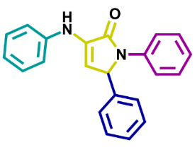 | Ref [66] | 219-220  White solid | 84
2 | 5-(pyridin-3-yl)-1-(p-tolyl)-3-(p-tolylamino)-1,5-dihydro-2H-pyrrol-2-one (1b) | 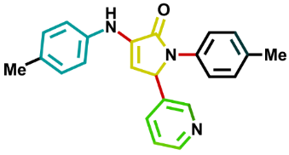 | Ref [66] | 188-189  Cream powder | 80
3 | 1-(4-bromophenyl)-3-((4-bromophenyl) amino)-5-(2-chlorophenyl)-1,5-dihydro-2H-pyrrol-2-one (1c) | 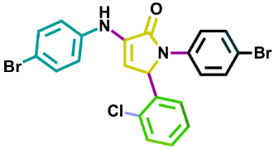 | Ref [67] | 240-242  White powder | 72
4 | 1-(4-bromophenyl)-3-((4-bromophenyl) amino)-5-(4-chlorophenyl)-1,5-dihydro-2H-pyrrol-2-one (1d) | 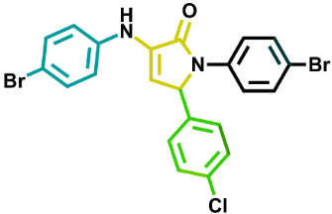 | Ref [67] | 191-193  White cream powder | 88
5 | 1-(4-bromophenyl)-3-((4-bromophenyl) amino)-5-(4-methoxyphenyl)-1,5-dihydro-2H-pyrrol-2-one (1e) | 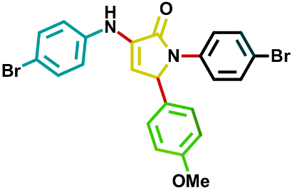 | Ref [66] | 198-200  Cream powder | 79
6 | 1-(3-chlorophenyl)-3-((3-chlorophenyl) amino)-5-(2,4-dimethylphenyl)-1,5-dihydro-2H-pyrrol-2-one (1f) | 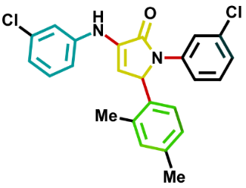 | Ref [68] | 168-170  Cream powder | 78
7 | 4-(1-(4-bromophenyl)-4-((4-bromophenyl) amino)-5-oxo-2,5-dihydro-1H-pyrrol-2yl) benzonitrile (1g) | 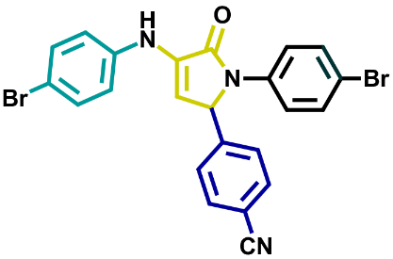 | Ref [69] | 234-236  Cream powder | 93
8 | 4-(1-(4-chlorophenyl)-4-((4-chlorophenyl) amino)-5-oxo-2,5-dihydro-1H-pyrrol-2yl) benzonitrile (1h) | 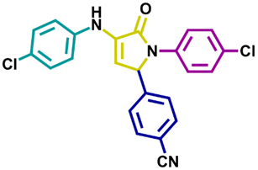 | Ref [69] | 232-234  White powder | 91
9 | 5-(3-nitrophenyl)-1-phenyl-3-(phenylamino)-1,5-dihydro-2H-pyrrol-2-one (1k) | 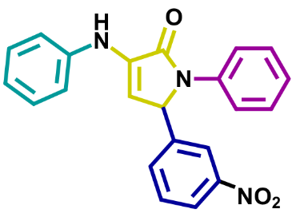 | Ref [66] | 213-214  Yellow powder | 81

Reaction conditions: aldehyde (1 mmol), aniline (2 mmol), ethyl pyruvate (1 mmol), in the presence of the
Fe_{x}Cu_{y}Zn_{z}O_{k} in a 5 ml solvent.

Table 4 Comparison of the efficiency of catalysts
Entry | Catalyst | Solvent | Tem (⁰C) | Time (h) | ref | Yield (%)
1 | Thiourea | Toluene | r.t | 18 | [70] | 48-85
2 | Fluorous imine-1,10-bis (carbothioate) | CH₃CN | r.t | 12 | [71] | 41-93
3 | PS-DETSO₃H | n-Hexane | r.t | 2 | [72] | 80-96
4 | Fe_{x}Cu_{y}Zn_{z}O_{k} | H₂O/CH₃CN | r.t | 1.5 | This work | 78-93

