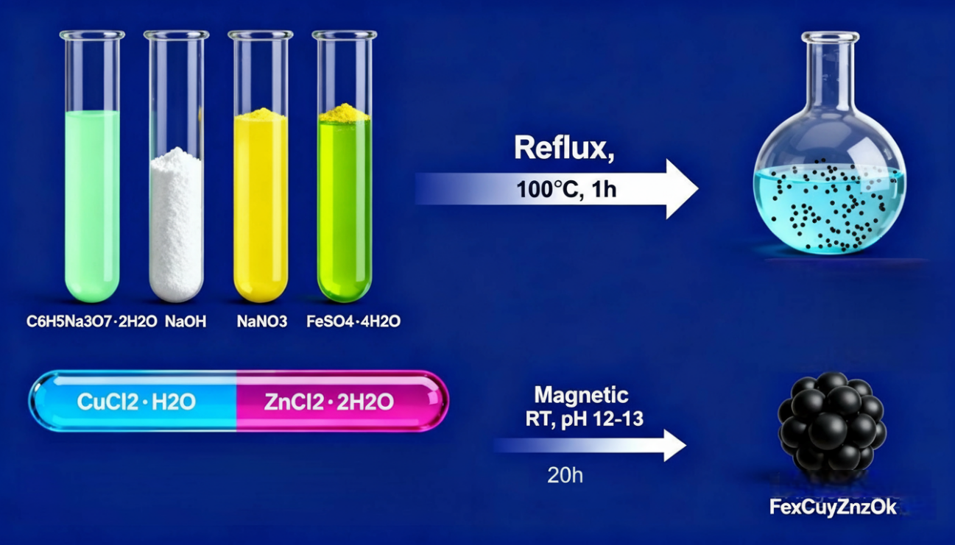
Scheme. 1 The process of constructing the NPs

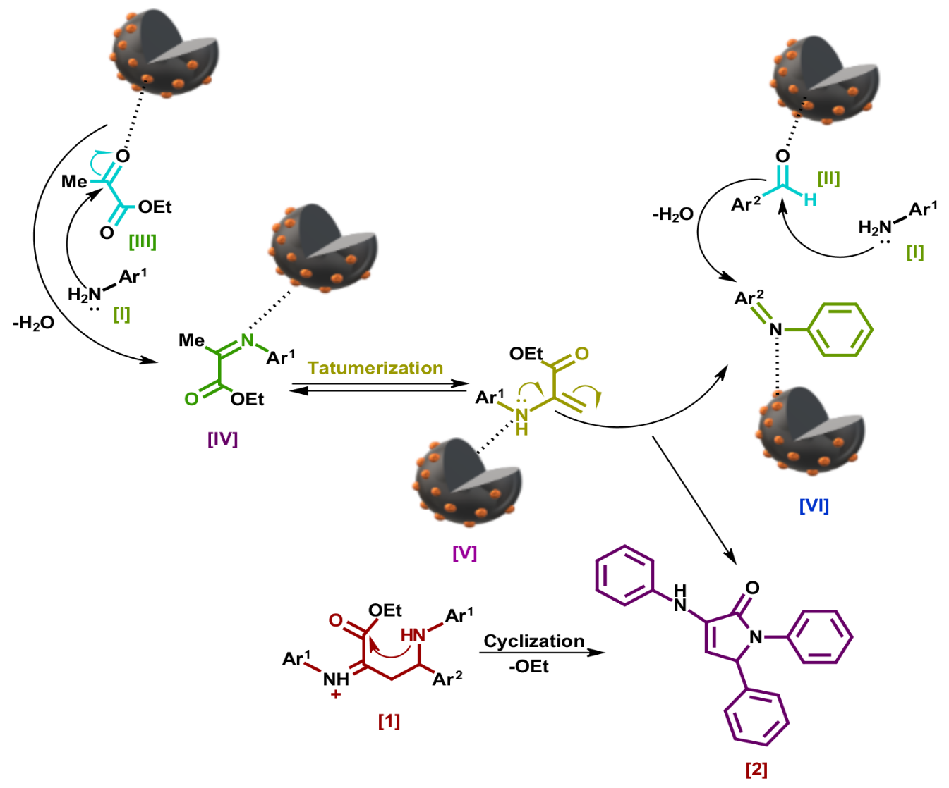
Scheme. 3 Proposed mechanism of pyrrole formation

