Eco-Friendly Magnetic Nanocatalysts: Optimized Pyrrole Synthesis via Ternary Fe_{x}Cu_{y}M_{z}O_{k} (M = Zn, Mn) Nanocomposites

Zahra Toozandehjaniª,Mostafa Gholizadeh*ª,Ehsan Esmaeilnezhad^{b}

ªDepartment of Chemistry, Faculty of Science, Ferdowsi University of Mashhad, Mashhad, I.R.Iran
^{b}Department of Petroleum Engineering,Hakim Sabzevari University ,Sabzevar.I.R.Iran

*Corresponding Author: Mostafa Gholizadeh (E-mail : m_gholizadeh@um.ac.ir)

Content of Figure
Fig. 1- EDX analysis of Fe₃O₄ (above) mapping analysis, (below) EDX spectrum 5
Fig. 2- EDX analysis of Fe_{x}Cu_{y}Zn_{z}O_{k} (above) mapping analysis, (below) EDX spectrum 6
Fig. 3-EDX analysis of Fe_{x}Cu_{y}Mn_{z}O_{k} (above) mapping analysis, (below) EDX spectrum 6
Figure 4-¹H NMR expand (300 MHz, CDCl₃) compound (1a) 8
Figure 5-¹H NMR (300 MHz, CDCl₃) of compound (1a) 8
Figure 6-¹³C NMR (75 MHz, CDCl₃) of compound (1a) 9
Figure 7-¹H NMR (300 MHz, CDCl₃) of compound (1b) 9
Figure 8-¹H NMR expand (300 MHz, CDCl₃) compound (1b) 10
Figure 9-¹³C NMR (75 MHz, CDCl₃) of compound (1b) 10
Figure 10-¹H NMR (300 MHz, CDCl3) of compound (1c) 11
Figure 11-¹H NMR expand (300 MHz, CDCl₃) compound (1c) 11
Figure 12-¹³C NMR (75 MHz, CDCl₃) of compound (1c) 12
Figure 13-¹H NMR (300 MHz, CDCl₃) of compound (1d) 12
Figure 14-¹H NMR expand (300 MHz, CDCl3) compound (1d) 13
Figure 15-¹³C NMR (75 MHz, CDCl₃) of compound (1d) 13
Figure 16-¹H NMR (300 MHz, CDCl₃) of compound (1e) 14
Figure 17-¹H NMR expand (300 MHz, CDCl₃) compound (1e) 14
Figure 18-¹³C NMR (75 MHz, CDCl₃) of compound (1e) 15
Figure 19-¹H NMR (300 MHz, CDCl₃) of compound (1f) 15
Figure 20-¹H NMR expand (300 MHz, CDCl₃) compound (1f) 16
Figure 21-¹³C NMR (75 MHz, CDCl₃) of compound (1f) 16
Figure 22-¹H NMR (300 MHz, CDCl₃) of compound (1g) 17
Figure 23-¹H NMR expand (300 MHz, CDCl₃) compound (1g) 17
Figure 24-¹³C NMR (75 MHz, CDCl₃) of compound (1g) 18
Figure 25-¹H NMR (300 MHz, CDCl₃) of compound (1h) 18
Figure 26-¹H NMR expand (300 MHz, CDCl₃) compound (1h) 19
Figure 27-¹³C NMR (75 MHz, CDCl₃) of compound (1h) 19
Figure 28-¹H NMR (300 MHz, CDCl₃) of compound (1k) 20
Figure 29-¹H NMR expand (300 MHz, CDCl₃) compound (1k) 20
Figure 30-13C NMR (75 MHz, CDCl₃) of compound (1k) 21
Figure 31-¹H NMR (300.13 MHz, CDCl₃) intermediate C 21
Figure 32-¹H NMR expand (300.13 MHz, CDCl₃) intermediate C 22
Figure 33-¹³C NMR (75 MHz, CDCl₃) intermediate C 22

1.General Information
All reagents and solvents utilized in this study were procured from commercial suppliers. The purity assessments of the products and reaction monitoring were conducted using TLC on silica gel polygram STL G/UV 254 plates and GC-FID (Agilent 6890, Santa Clara, USA) instrumentation. The melting points of the products were determined using an Electrothermal Type 9100 melting point apparatus. FT-IR spectra were obtained using an Avatar 370 FT-IR Therma Nicolet spectrometer. NMR spectra were acquired with Brucker Avance 300 and 400 MHz instruments in CDCl₃ and DMSO, employing tetramethylsilane as the internal standard, and J values are reported in Hz. Mass spectra were recorded on a CH7A Varianmat Bremem instrument at 70 eV electron impact ionization, in m/z (rel%).

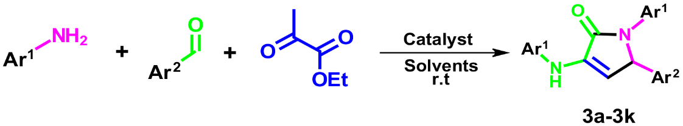

Product | Ar¹ | Ar² | m.p (◦C) lit | m.p (◦C) | Yield (%)
1a | C₆H₅ | C₆H₅ | Ref 1  White solid | 219-220 | 84
1b | 4-CH₃C₆H₃ | 3-pyridinyl | Ref 1  Cream powder | 188-189 | 80
1c | 4-Br C₆H₄ | 2-Cl C₆H₄ | Ref 3  White powder | 240-242 | 72
1d | 4-Br C₆H₄ | 4-Cl C₆H₄ | Ref 3  White cream powder | 191-193 | 88
1f | 3-Cl C₆H₄ | 2,4-CH₃ C₆H₄ | Ref 4  Cream powder | 168-170 | 78
1e | 4-Br C₆H₄ | 4-CN C₆H₄ | Ref 2  Cream powder | 234-236 | 93
1g | 4-Cl C₆H₄ | 4-CN C₆H₄ | Ref 2  White powder | 232-234 | 91
1h | C₆H₅ | 3-NO₂ C₆H₄ | Ref 1  Yellow powder | 213-214 | 81
1k | 4-Br C₆H₄ | 4-OMe C₆H₄ | Ref 1  Cream powder | 198-200 | 79
Table S- 4. Pyrrole derivatives using Fe_{x}Cu_{y}Zn_{z}O_{k} as a Catalyst

2.Characterizations
2.1. EDX analysis
Energy dispersive X-ray spectroscopy (EDX). EDX analysis reveals the elemental composition of Fe₃O₄, Fe_{x}Cu_{y}Zn_{z}O_{k}, and Fe_{x}Cu_{y}Mn_{z}O_{k} as prepared. As illustrated in Fig. 1 (a-d), the primary components of the Fe₃O₄ particles are iron (Fe), carbon (C) and oxygen (O), with weight percentages of 47.84%, 8.62% and 43.54%, respectively. Furthermore, the EDX analysis indicates that the core-shell catalyst predominantly consists of copper (Cu), zinc (Zn), manganese (Mn), iron (Fe), and oxygen (O) in varying proportions. No additional elements were detected, confirming the successful synthesis and purity of the catalyst.

Table S- 5 – EDX analysis
Nanocomposites | Fe (W%) | O (W%) | C (W%) | Cu (W%) | Zn (W%) | Mn (W%)
Fe₃O₄ | 47.84 | 43.54 | 8.62 | _____ | _____ | _____
Fe_{x}Cu_{y}Zn_{z}O_{k} | 36.00 | 40.66 | 17.48 | 4.77 | 1.09 | _____
Fe_{x}Cu_{y}Mn_{z}O_{k} | 37.95 | 40.03 | 17.12 | 3.88 | _____ | 1.02

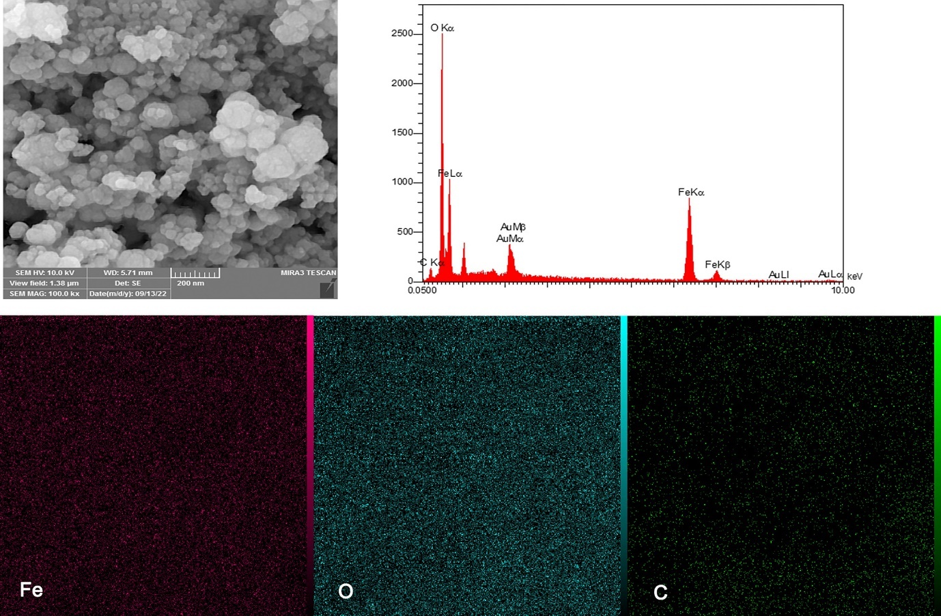
Fig. S- 1. EDX analysis of Fe3O4 (above) mapping analyis, (below) EDX spectrum

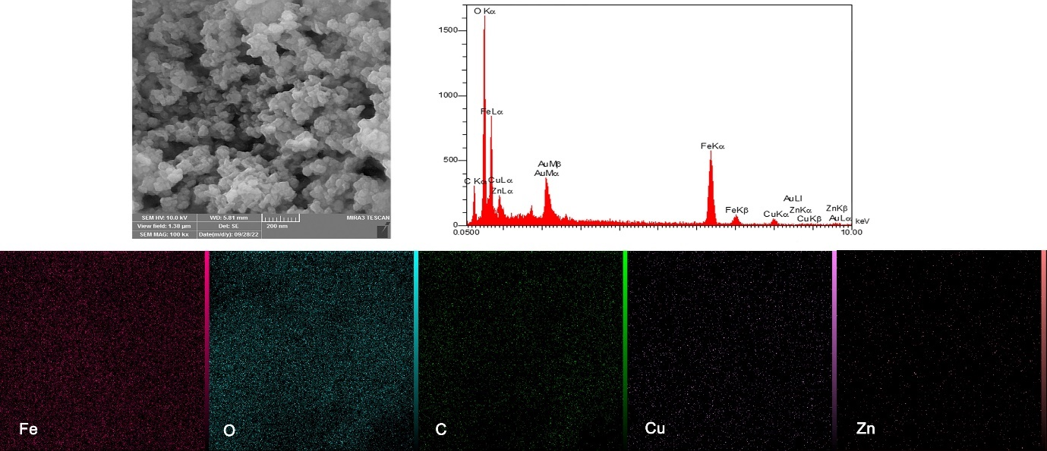
Fig.S- 2. EDX analysis of Fe_{x}Cu_{y}Zn_{z}O_{k} (above) mapping analyis, (below) EDX spectrum
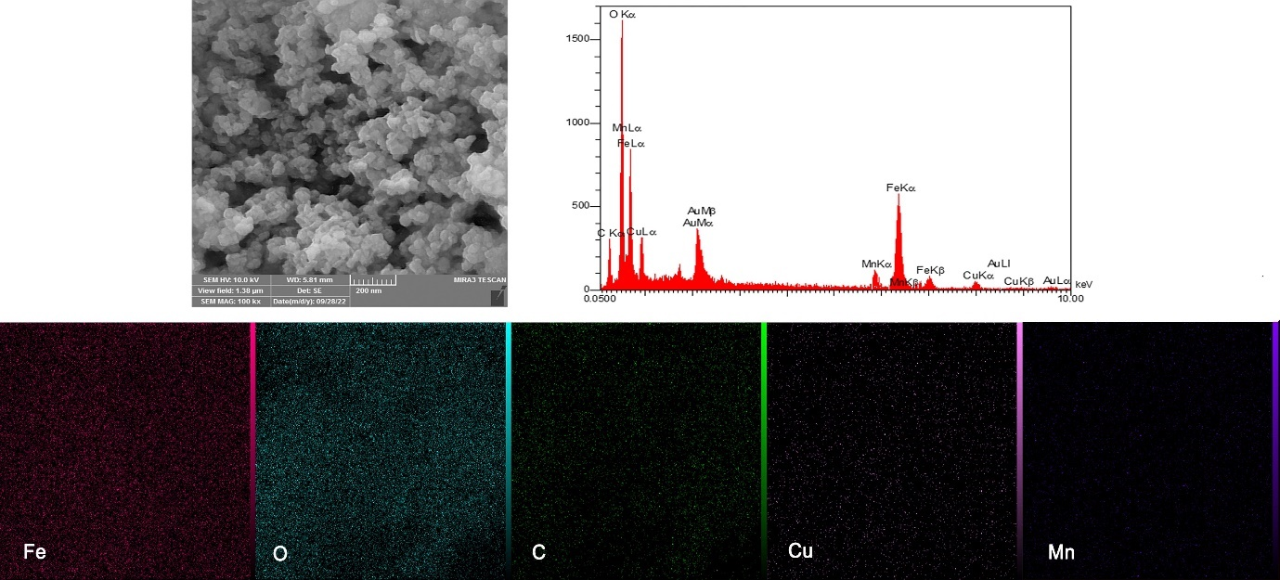
Fig.S- 3. EDX analysis of Fe_{x}Cu_{y}Mn_{z}O_{k} (above) mapping analyis, (below) EDX spectrum

2.2. NMR
1a.1,5-diphenyl-3-(phenylamino)-1,5-dihydro-2H-pyrrol-2-one (84%) ¹H NMR (300 MHz, CDCl₃) δ [ppm] 7.54 (d, J = 7.7 Hz, 2H), 7.43 – 7.27 (m, 10H), 7.23 (d, J = 4.6 Hz, 2H), 7.14 – 7.06 (m, 1H), 6.86 – 6.79 (m, 1H), 6.64 (d, J = 5.1 Hz, 1H), 5.45 (d, J = 4.5 Hz, 1H). ¹³C NMR (75 MHz, CDCl₃) δ [ppm] 163.26, 141.02, 139.99, 139.93, 134.30, 129.64, 129.27, 129.25, 128.87, 127.90, 126.25, 123.92, 123.60, 121.48, 113.03, 66.77.
1b. 5-(pyridin-3-yl)-1-(p-tolyl)-3-(p-tolylamino)-1,5-dihydro-2H-pyrrol-2-one.
(80%) ¹H NMR (300 MHz, CDCl₃) δ [ppm] 8.57 (d, J = 3.5 Hz, 1H), 8.52 – 8.47 (m, 1H), 7.75 (s, 2H), 7.34 (dd, J = 8.1, 4.7 Hz, 1H), 7.32 – 7.26 (m, 2H), 7.19 (dd, J = 20.0, 6.5 Hz, 3H), 7.10 (d, J = 9.0 Hz, 2H), 7.03 – 6.97 (m, 2H), 5.49 (d, J = 6.0 Hz, 1H), 2.35 (s, 6H). ¹³C NMR (75 MHz, CDCl₃) δ [ppm] 163.05, 150.87, 148.31, 138.48, 138.17, 135.97, 134.60, 134.41, 133.05, 132.18, 130.01, 129.83, 125.14, 122.93, 122.74, 113.10, 66.40, 20.73, 20.70.
1c.1-(4-bromophenyl)-3-((4-bromophenyl) amino)-5-(2-chlorophenyl)-1,5-dihydro-2H-pyrrol-2-one.
(72%) ¹H NMR (300 MHz, CDCl₃) δ [ppm] 7.90 (s, 1H), 7.51 – 7.35 (m, 8H), 7.35 – 7.26 (m, 3H), 7.26 (d, J = 2.9 Hz, 1H), 6.28 (d, J = 5.1 Hz, 1H), 5.46 (d, J = 5.3 Hz, 1H). ¹³C NMR (75 MHz, CDCl₃) δ [ppm] 162.86, 139.06, 138.60, 136.05, 134.41, 134.38, 132.23, 131.90, 130.75, 130.58, 129.62, 128.15, 125.47, 124.64, 119.40, 118.11, 117.35, 65.43.
1d.1-(4-bromophenyl)-3-((4-bromophenyl) amino)-5-(4-chlorophenyl)-1,5-dihydro-2H-pyrrol-2-one.
(88%) ¹H NMR (300 MHz, CDCl₃) δ [ppm] 7.75 (s, 1H), 7.50 – 7.44 (m, 4H), 7.41 – 7.35 (m, 2H), 7.30 – 7.24 (m, 6H), 6.64 (d, J = 5.1 Hz, 1H), 5.47 (d, J = 5.1 Hz, 1H). ¹³C NMR (75 MHz, CDCl₃) δ [ppm] 163.22, 139.05, 139.02, 138.08, 134.25, 132.23, 131.90, 130.17, 129.56, 125.45, 124.64, 119.40, 117.35, 113.10, 66.47.
1e. 1-(3-chlorophenyl)-3-((3-chlorophenyl) amino)-5-(2,4-dimethylphenyl)-1,5-dihydro-2H-pyrrol-2-one.
(78%) ¹H NMR (300 MHz, CDCl₃) δ [ppm] 7.82 (s, 1H), 7.53 (d, J = 4.3 Hz, 1H), 7.49 – 7.43 (m, 1H), 7.24 – 7.11 (m, 4H), 7.03 – 6.94 (m, 3H), 6.86 – 6.80 (m, 1H), 6.64 (d, J = 5.1 Hz, 1H), 5.48 (d, J = 4.6 Hz, 1H), 2.30 (s, 3H), 2.19 (s, 3H). ¹³C NMR (75 MHz, CDCl₃) δ [ppm] 162.49, 141.52, 140.66, 138.29, 136.78, 136.03, 135.07, 134.39, 134.25, 131.42, 130.31, 129.99, 128.78, 127.68, 123.69, 123.61, 122.56, 121.89, 121.75, 121.05, 117.80, 65.86, 20.92, 19.92.
1f.4-(1-(4-bromophenyl)-4-((4-bromophenyl) amino)-5-oxo-2,5-dihydro-1H-pyrrol-2yl) benzonitrile.
(93%) ¹H NMR (300 MHz, CDCl₃) δ [ppm] 7.75 (s, 1H), 7.67 – 7.61 (m, 2H), 7.51 – 7.44 (m, 6H), 7.38 (d, J = 7.2 Hz, 2H), 6.64 (d, J = 5.1 Hz, 1H), 5.47 (d, J = 5.3 Hz, 1H). ¹³C NMR (75 MHz, CDCl₃) δ [ppm] 163.22, 141.51, 139.05, 139.02, 134.25, 133.18, 132.23, 131.90, 129.38, 125.45, 124.64, 119.40, 118.10, 117.35, 113.11, 111.41, 67.33.
1g.4-(1-(4-chlorophenyl)-4-((4-chlorophenyl) amino)-5-oxo-2,5-dihydro-1H-pyrrol-2yl) benzonitrile.
(91%) ¹H NMR (300 MHz, CDCl₃) δ [ppm] 7.74 (s, 1H), 7.67 – 7.61 (m, 2H), 7.51 – 7.42 (m, 4H), 7.29 (d, J = 11.3 Hz, 4H), 7.05 (d, J = 6.7 Hz, 2H), 6.64 (d, J = 5.1 Hz, 1H), 5.47 (d, J = 4.3 Hz, 1H). ¹³C NMR (75 MHz, CDCl₃) δ [ppm] 163.33, 141.51, 139.03, 138.55, 134.25, 134.22, 133.18, 129.58, 129.49, 129.38, 128.01, 125.05, 124.52, 118.10, 113.11, 111.41, 67.34.
1h. 5-(3-nitrophenyl)-1-phenyl-3-(phenylamino)-1,5-dihydro-2H-pyrrol-2-one. (81%) ¹H NMR (300 MHz, CDCl₃) δ [ppm] 8.19 (d, J = 2.0 Hz, 1H), 8.12 – 8.06 (m, 1H), 7.68 – 7.62 (m, 1H), 7.53 (d, J = 16.4 Hz, 3H), 7.37 – 7.27 (m, 4H), 7.26 – 7.20 (m, 2H), 7.14 – 7.06 (m, 1H), 6.86 – 6.79 (m, 1H), 6.65 (d, J = 5.1 Hz, 1H), 5.55 (d, J = 0.8 Hz, 1H).¹³C NMR (75 MHz, CDCl₃) δ 163.33, 148.74, 141.02, 140.09, 139.04, 134.75, 134.33, 130.71, 129.63, 129.27, 126.25, 124.37, 123.92, 123.60, 123.20, 121.48, 113.06, 66.40.
1k.1-(4-bromophenyl)-3-((4-bromophenyl) amino)-5-(4-methoxyphenyl)-1,5-dihydro-2H-pyrrol-2-one.
(79%) ¹H NMR (300 MHz, CDCl₃) δ [ppm] 7.75 (s, 1H), 7.48 (dd, J = 8.7, 3.3 Hz, 4H), 7.41 – 7.35 (m, 2H), 7.27 (d, J = 6.8 Hz, 2H), 7.13 – 7.07 (m, 2H), 6.92 (d, J = 6.7 Hz, 2H), 6.64 (d, J = 4.9 Hz, 1H), 5.45 (d, J = 4.3 Hz, 1H), 3.80 (s, 3H). ¹³C NMR (75 MHz, CDCl₃) δ [ppm] 163.22, 159.51, 139.05, 138.95, 134.25, 133.76, 132.23, 131.90, 129.54, 125.45, 124.64, 119.40, 117.35, 114.56, 113.09, 66.74, 55.35.

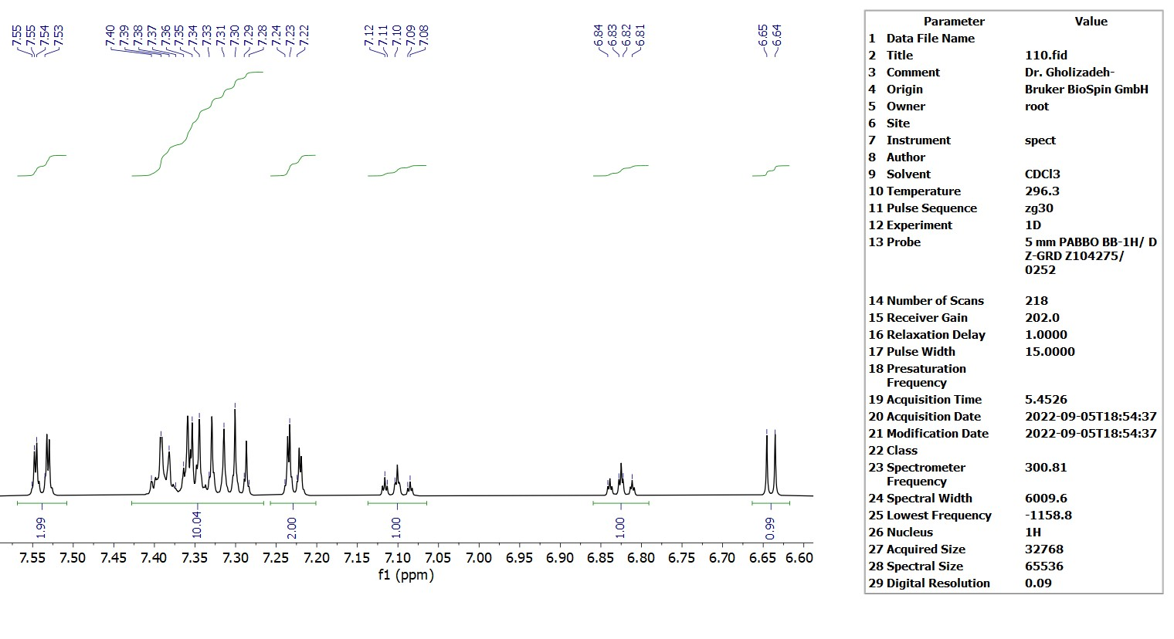
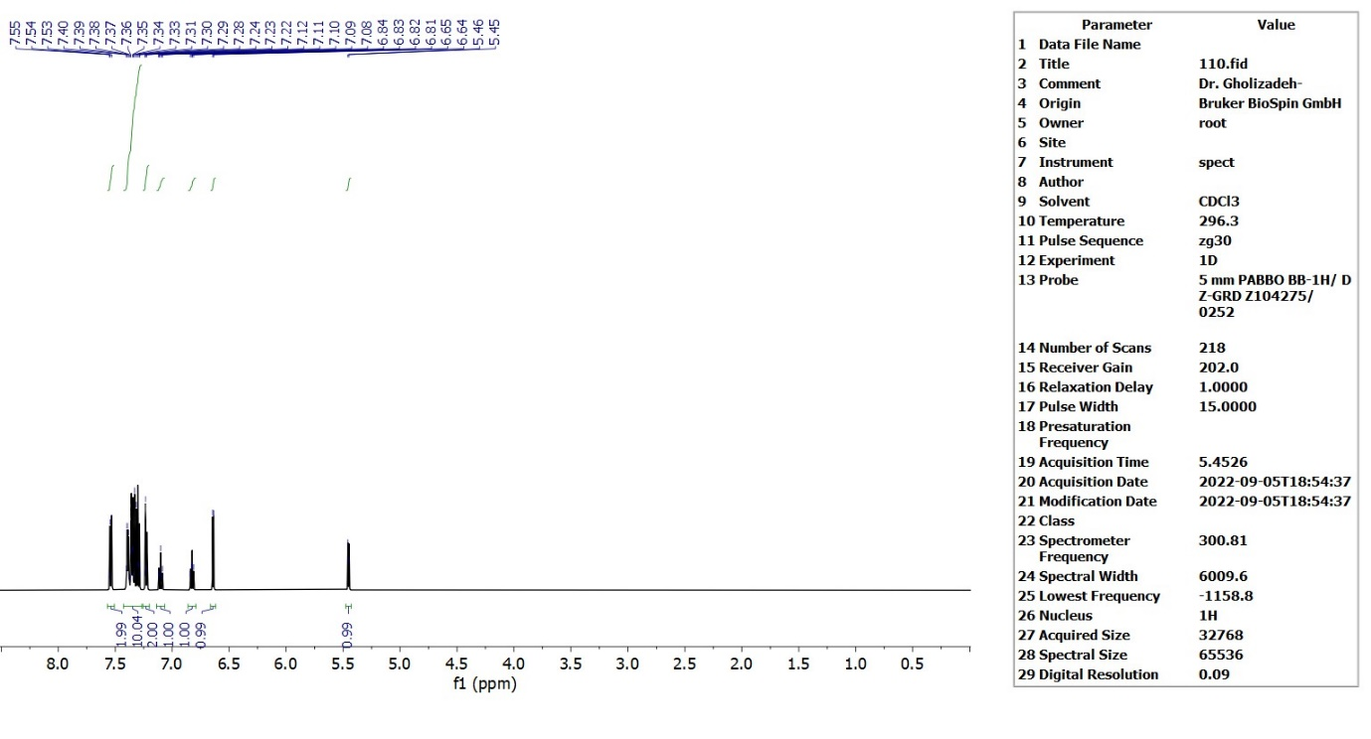
Figure 4-¹H NMR expand (300 MHz, CDCl₃) compound (1a)
Figure 5-¹H NMR (300 MHz, CDCl₃) of compound (1a)

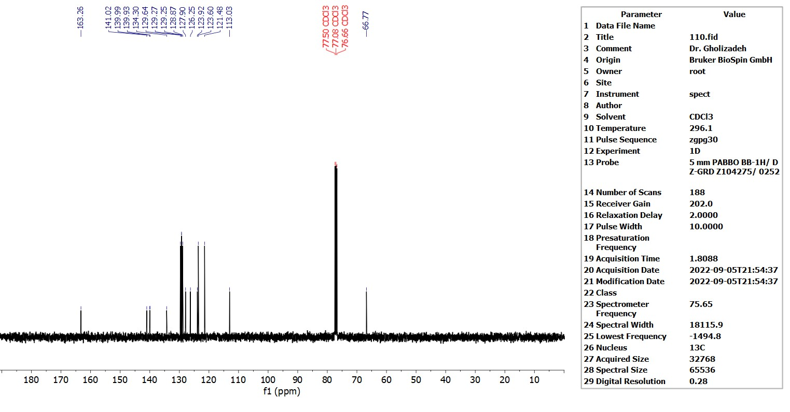
Figure 6-¹³C NMR (75 MHz, CDCl₃) of compound (1a)

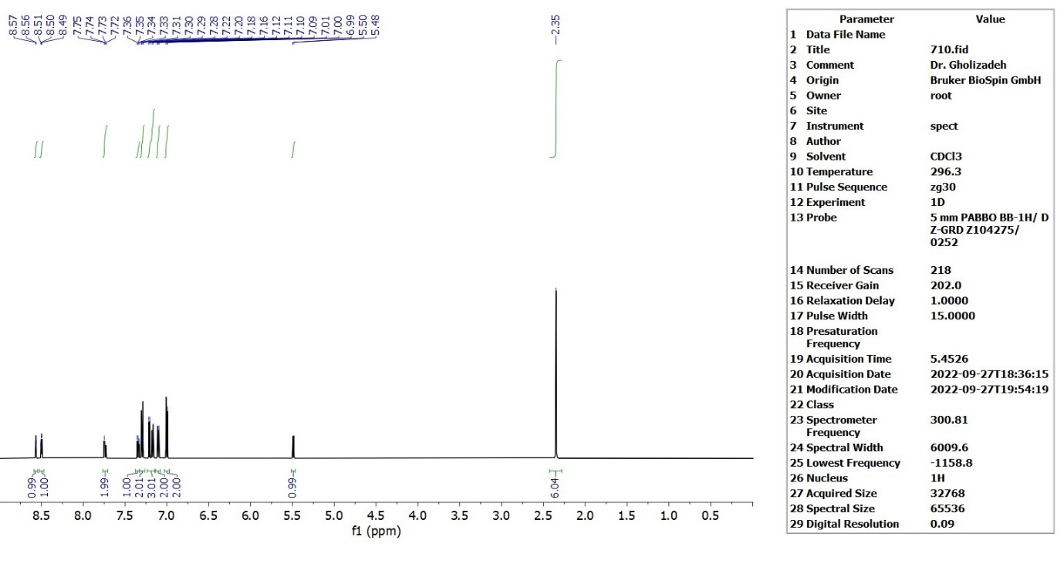
Figure 7-¹H NMR (300 MHz, CDCl₃) of compound (1b)

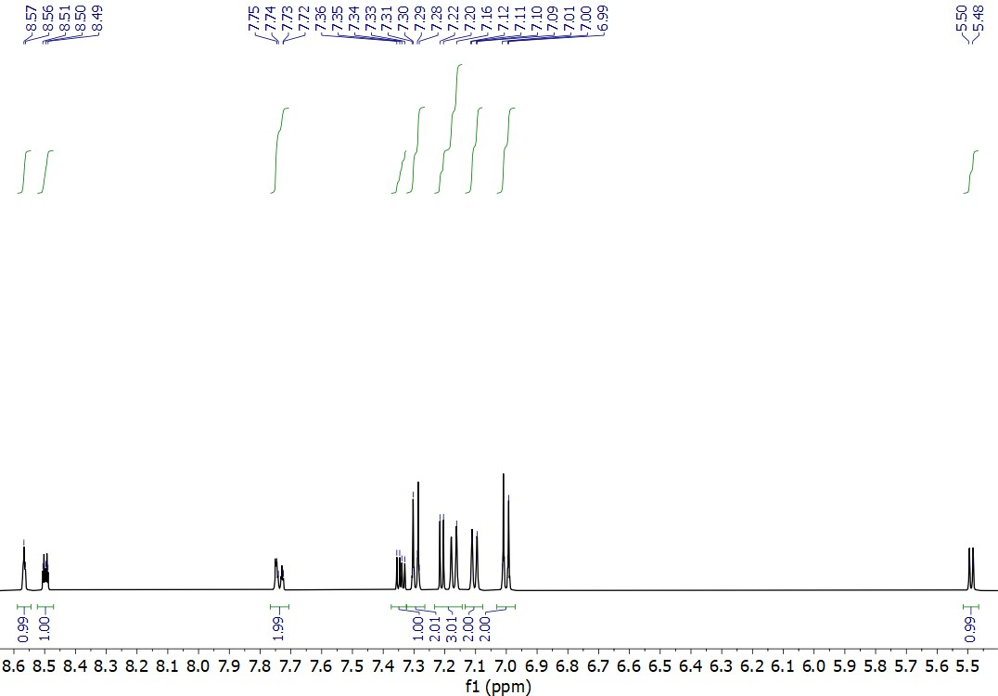
Figure 8-¹H NMR expand (300 MHz, CDCl₃) compound (1b)

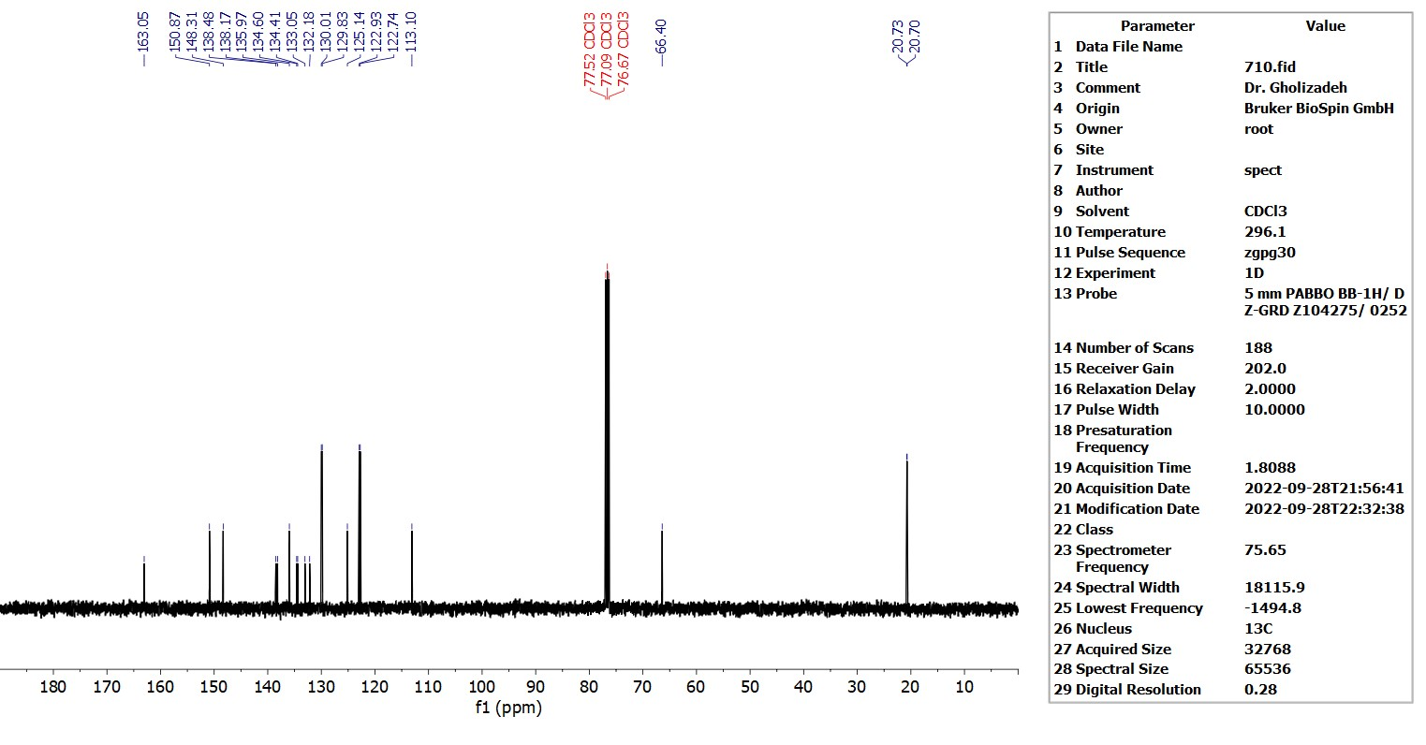
Figure 9-¹³C NMR (75 MHz, CDCl₃) of compound (1b)

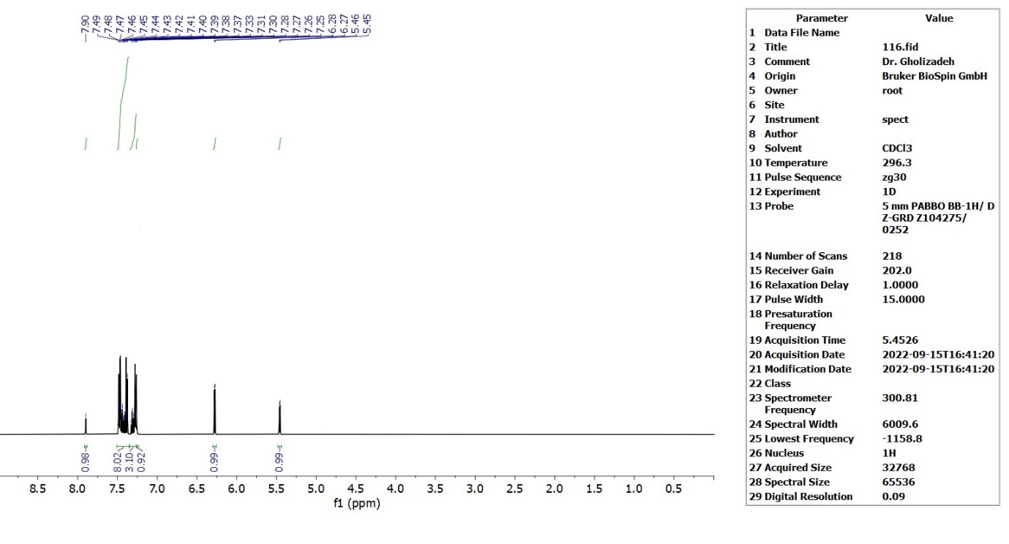
Figure 10-¹H NMR (300 MHz, CDCl3) of compound (1c)

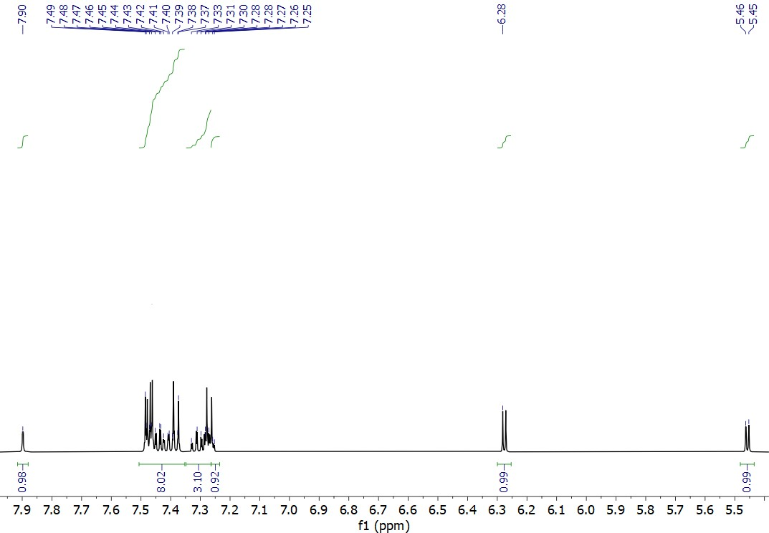
Figure 11-¹H NMR expand (300 MHz, CDCl₃) compound (1c)

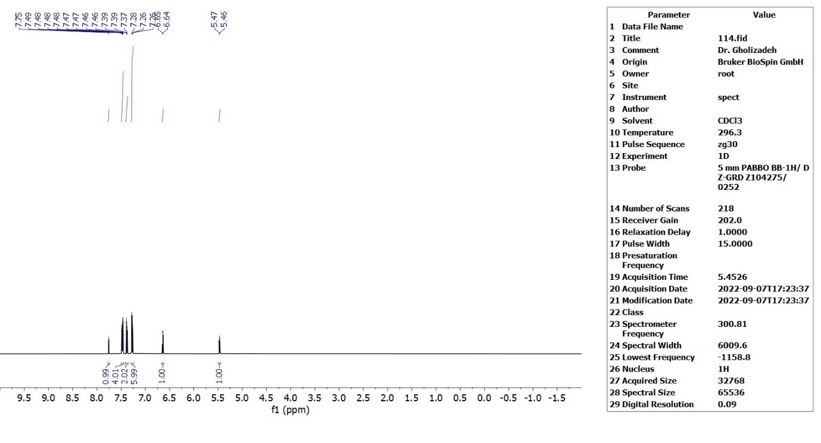
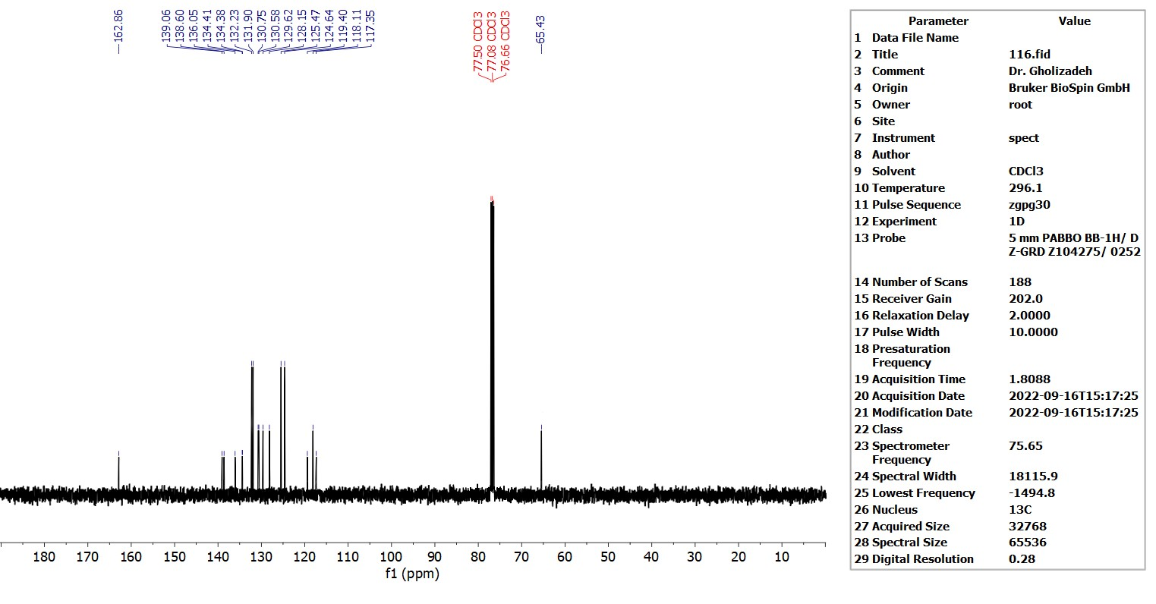
Figure 12-¹³C NMR (75 MHz, CDCl₃) of compound (1c)

Figure 13-¹H NMR (300 MHz, CDCl₃) of compound (1d)

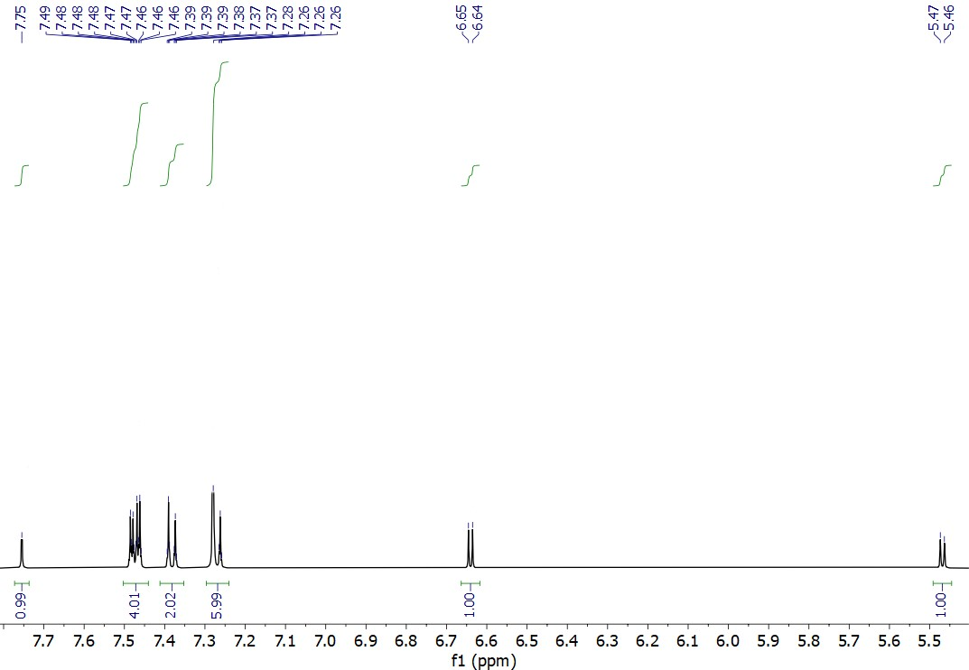
Figure 14-¹H NMR expand (300 MHz, CDCl3) compound (1d)

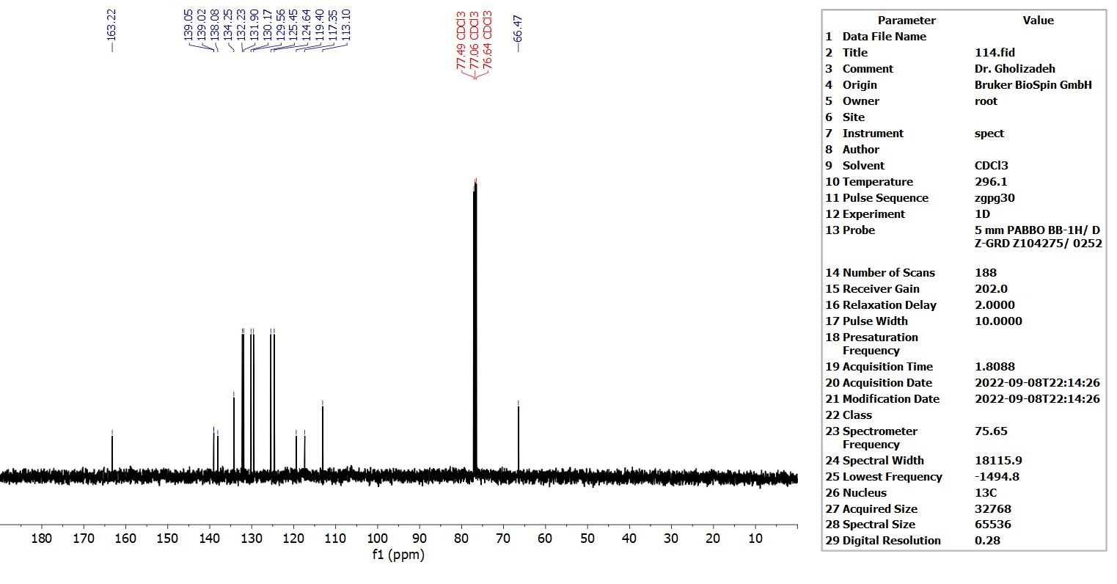
Figure 15-¹³C NMR (75 MHz, CDCl₃) of compound (1d)

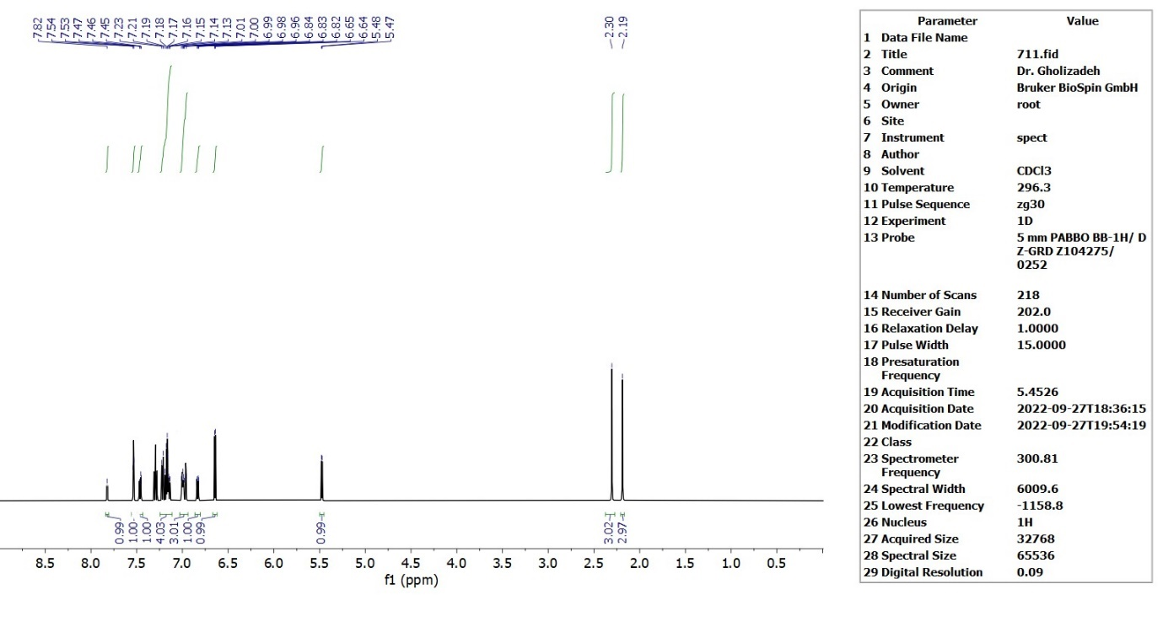
Figure 16-¹H NMR (300 MHz, CDCl₃) of compound (1e)

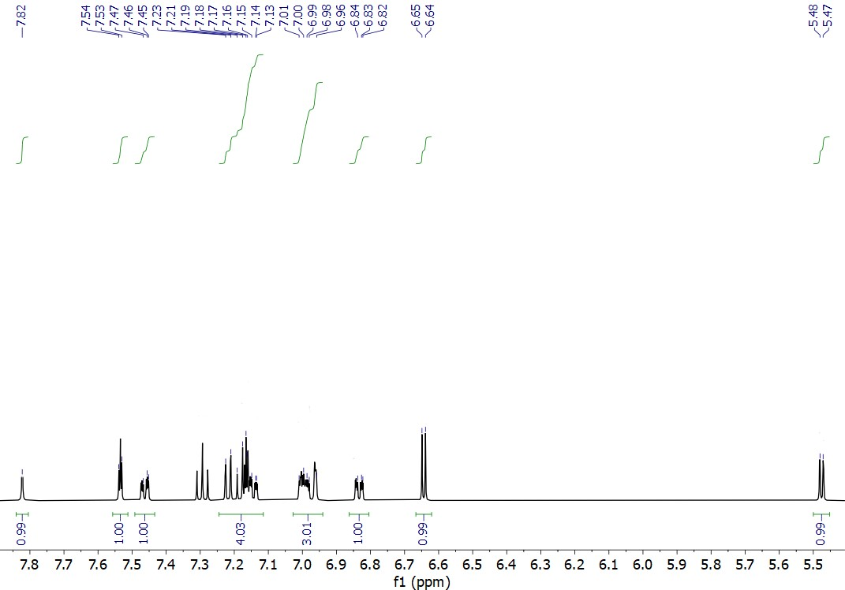
Figure 17-¹H NMR expand (300 MHz, CDCl₃) compound (1e)

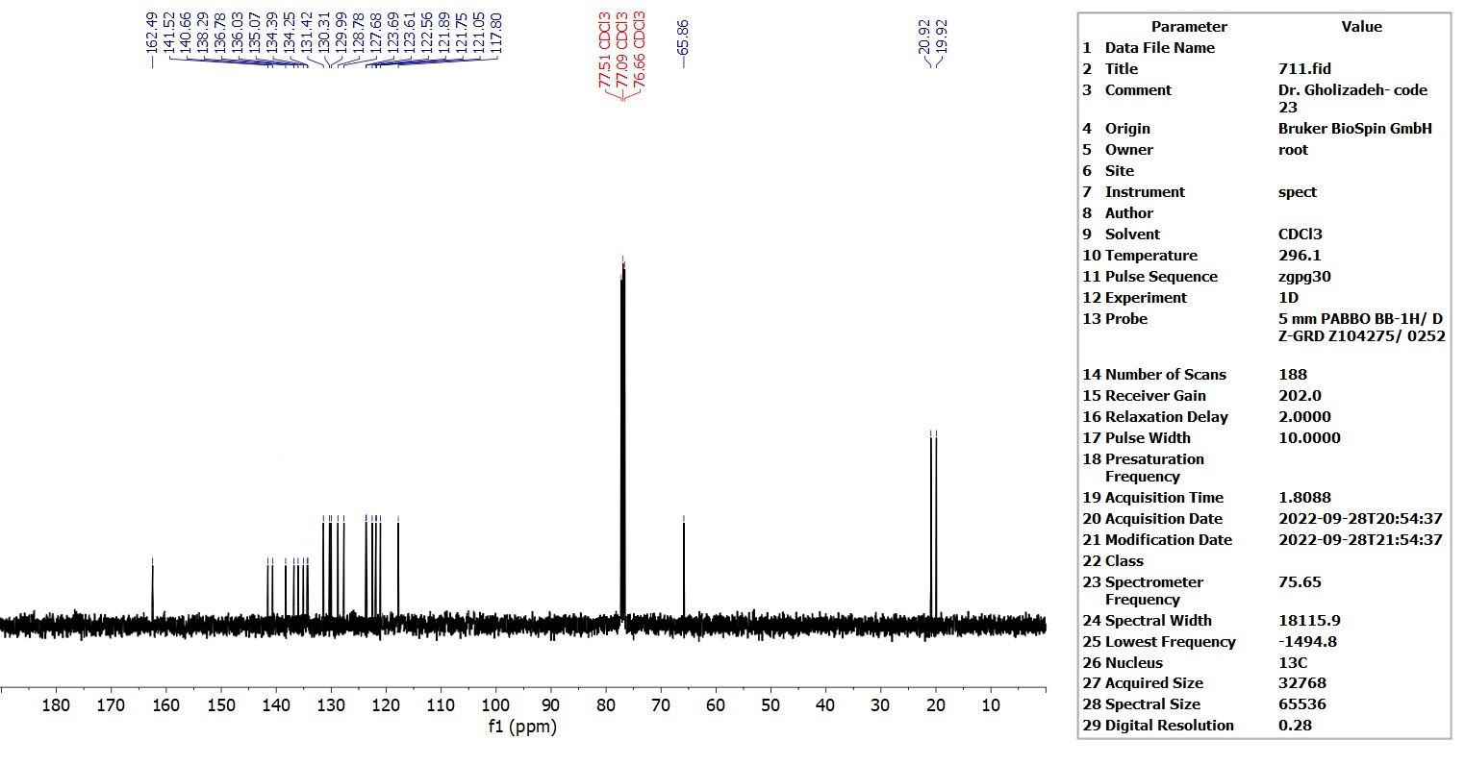
Figure 18-¹³C NMR (75 MHz, CDCl₃) of compound (1e)
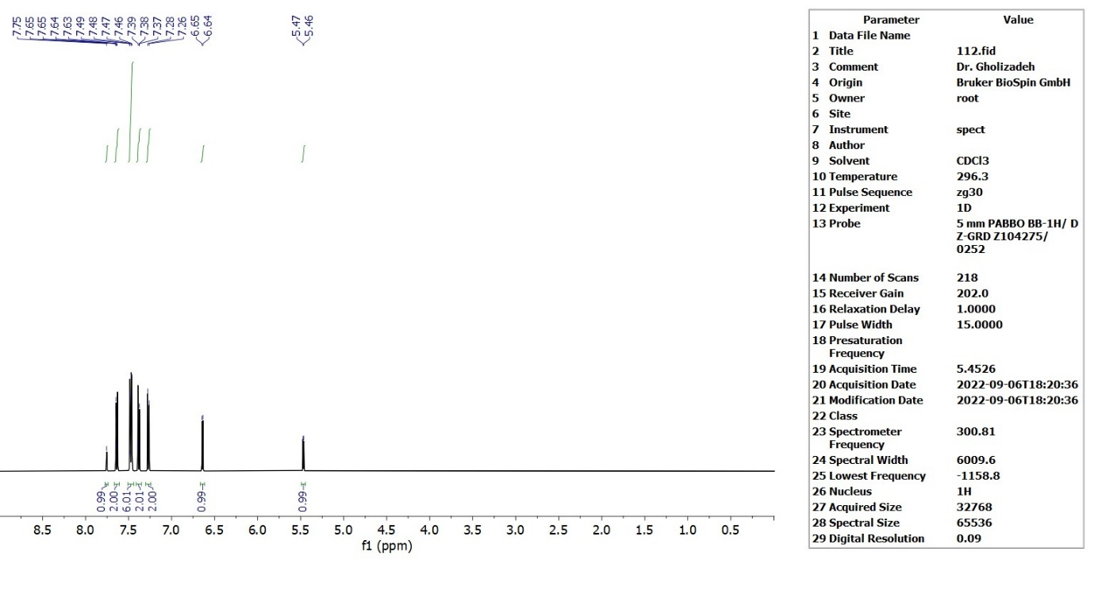
Figure 19-¹H NMR (300 MHz, CDCl₃) of compound (1f)

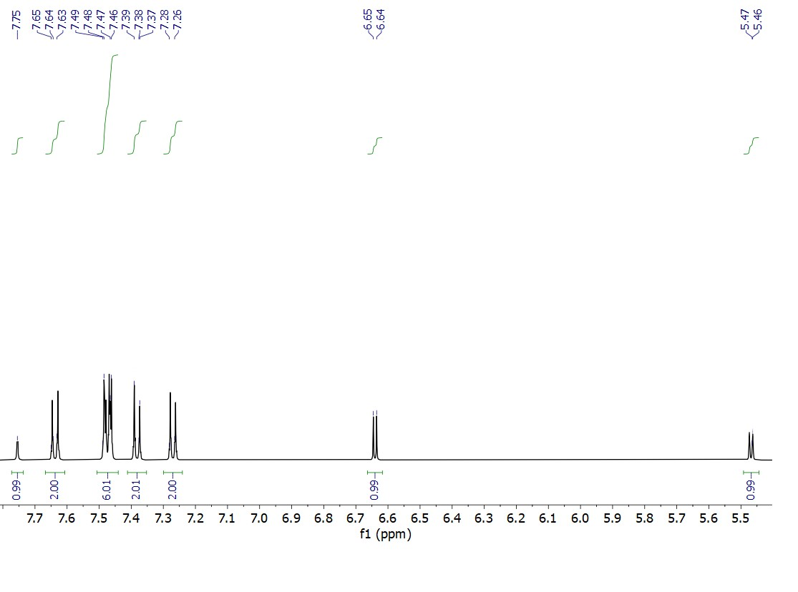
Figure 20-¹H NMR expand (300 MHz, CDCl₃) compound (1f)

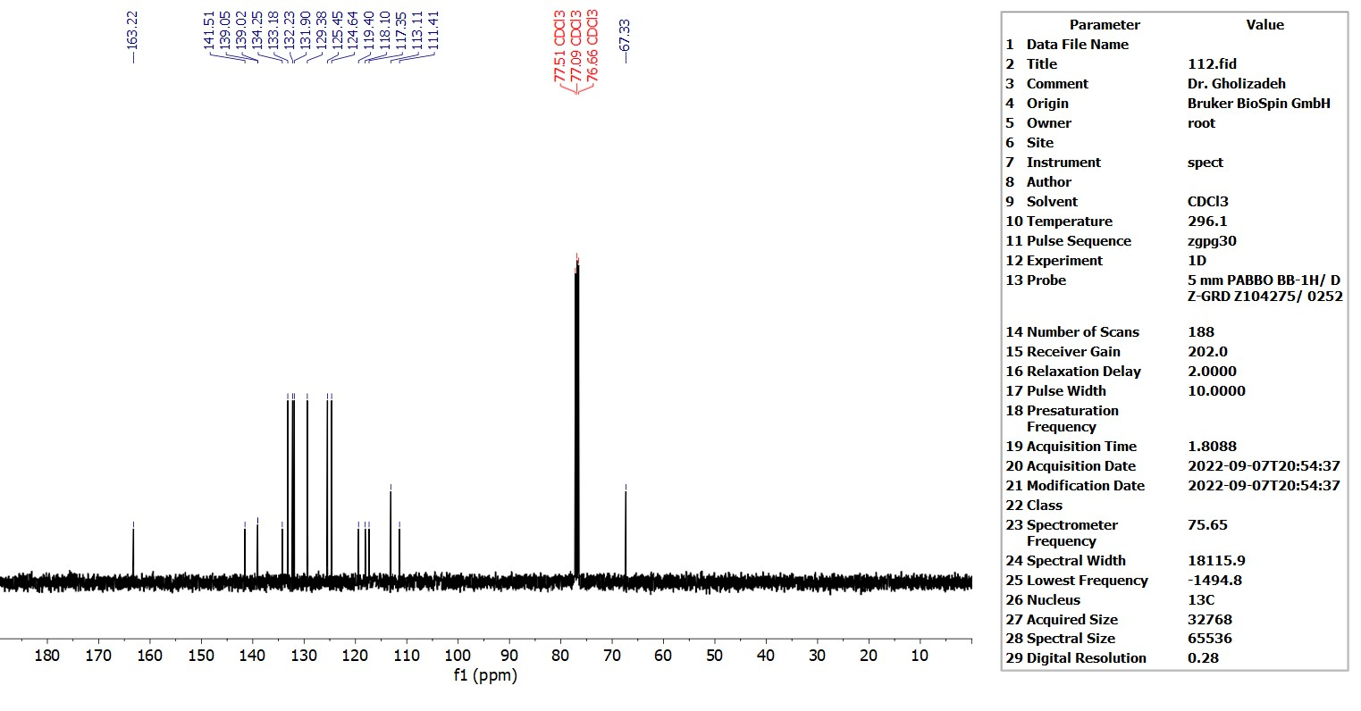
Figure 21-¹³C NMR (75 MHz, CDCl₃) of compound (1f)

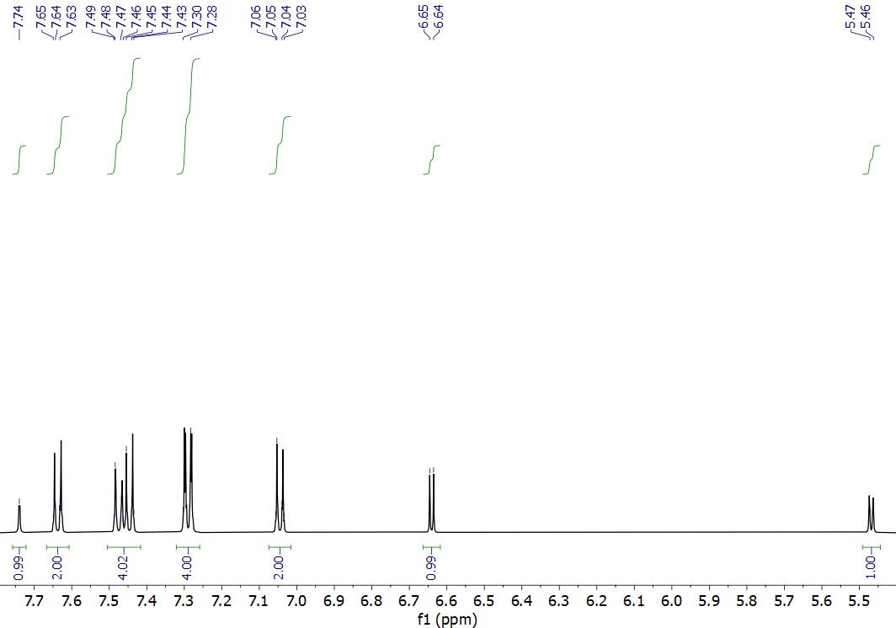
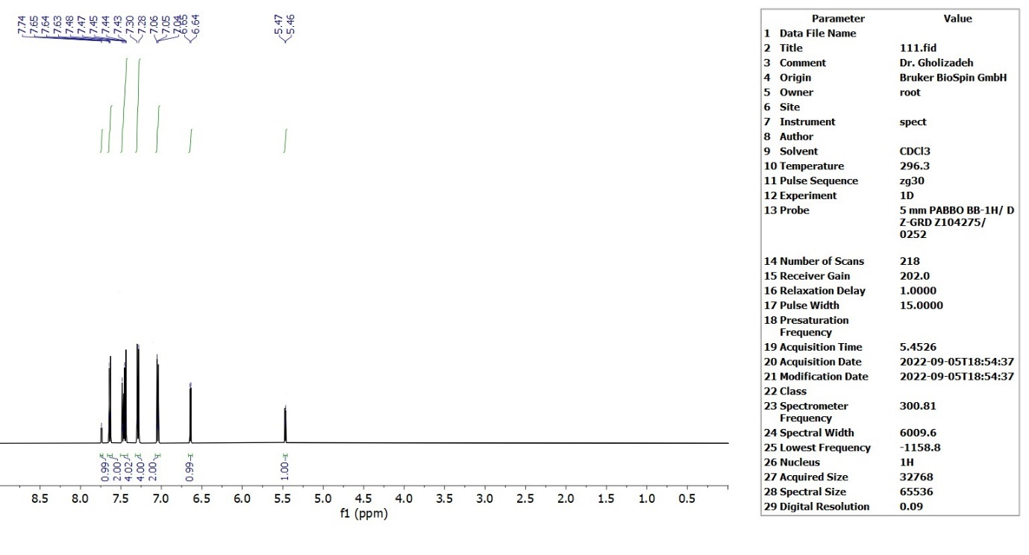
Figure 22-¹H NMR (300 MHz, CDCl₃) of compound (1g)

Figure 23-¹H NMR expand (300 MHz, CDCl₃) compound (1g)

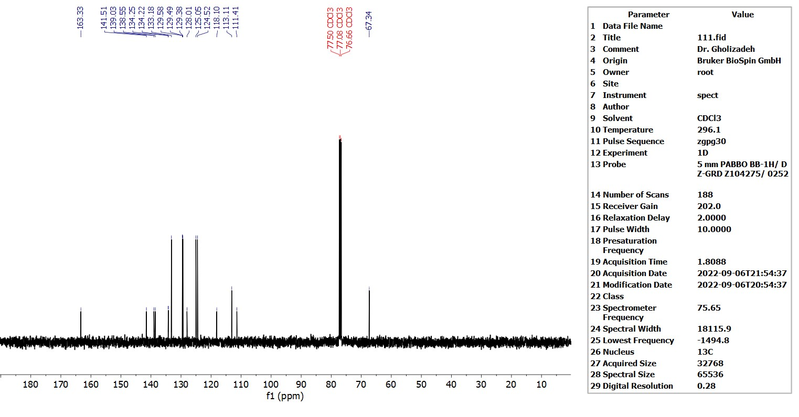
Figure 24-¹³C NMR (75 MHz, CDCl₃) of compound (1g)
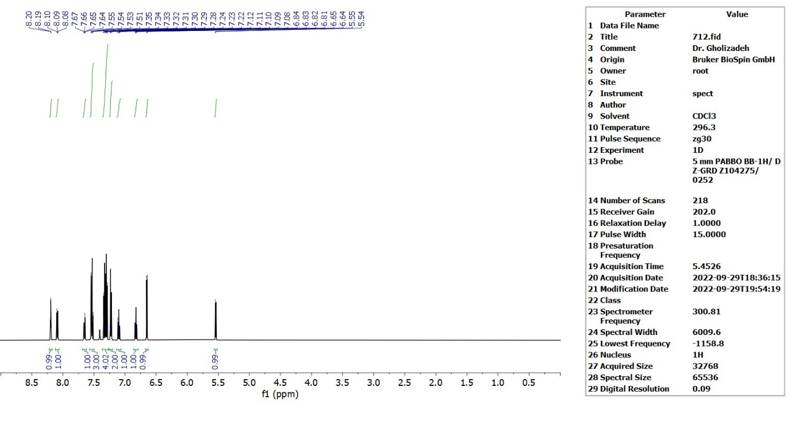
Figure 25-¹H NMR (300 MHz, CDCl₃) of compound (1h)

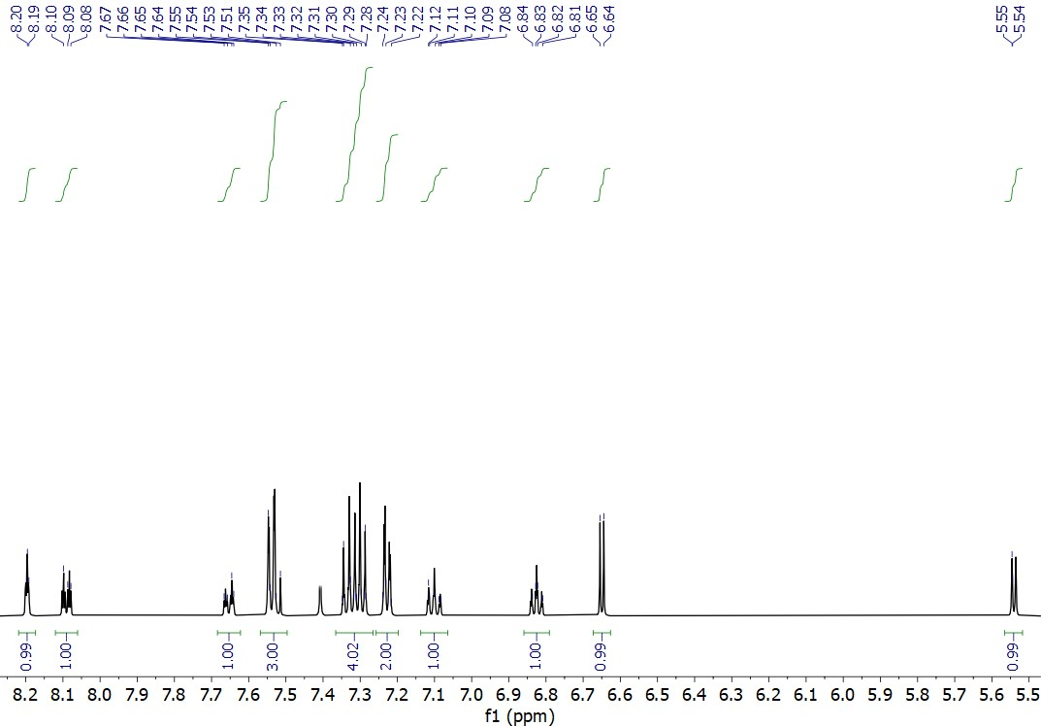
Figure 26-¹H NMR expand (300 MHz, CDCl₃) compound (1h)

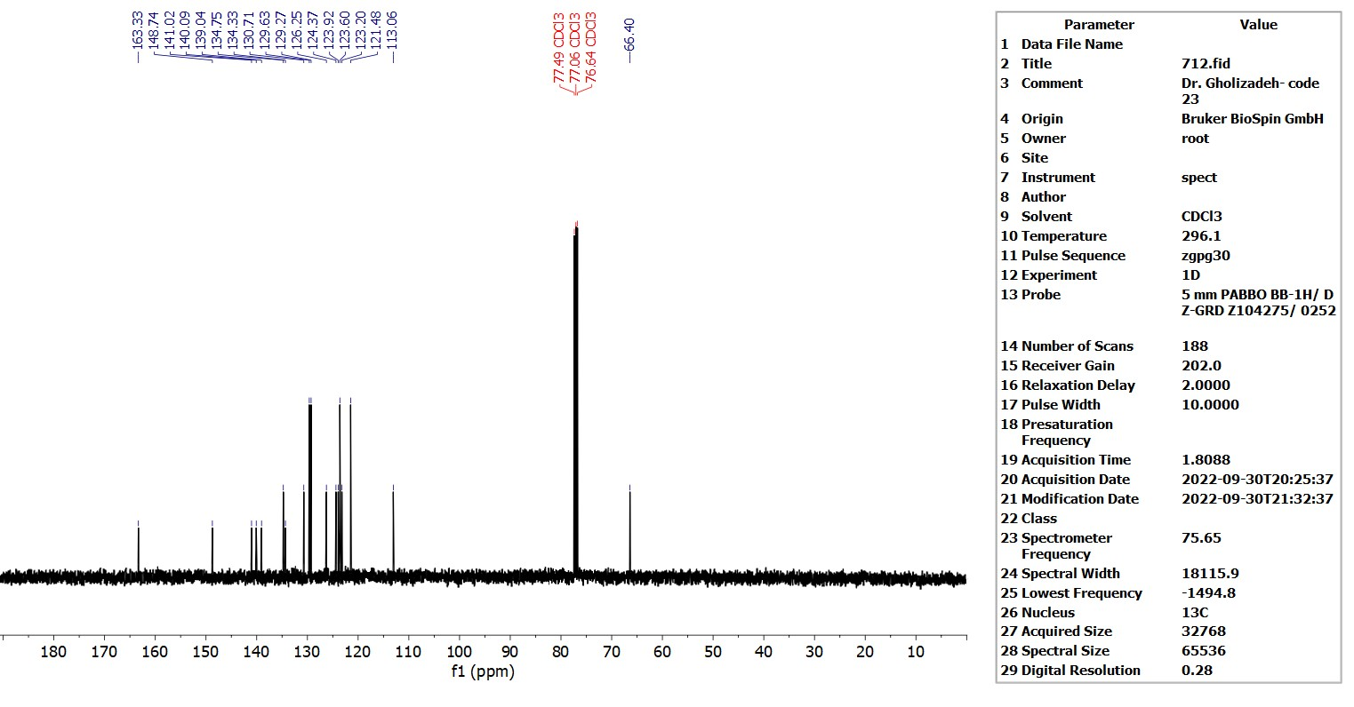
Figure 27-¹³C NMR (75 MHz, CDCl₃) of compound (1h)

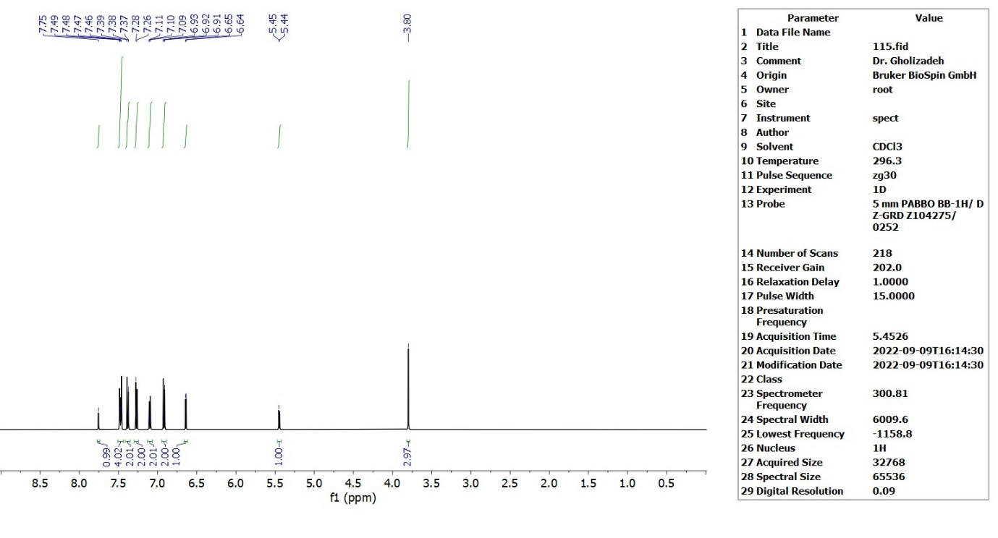
Figure 28-¹H NMR (300 MHz, CDCl₃) of compound (1k)

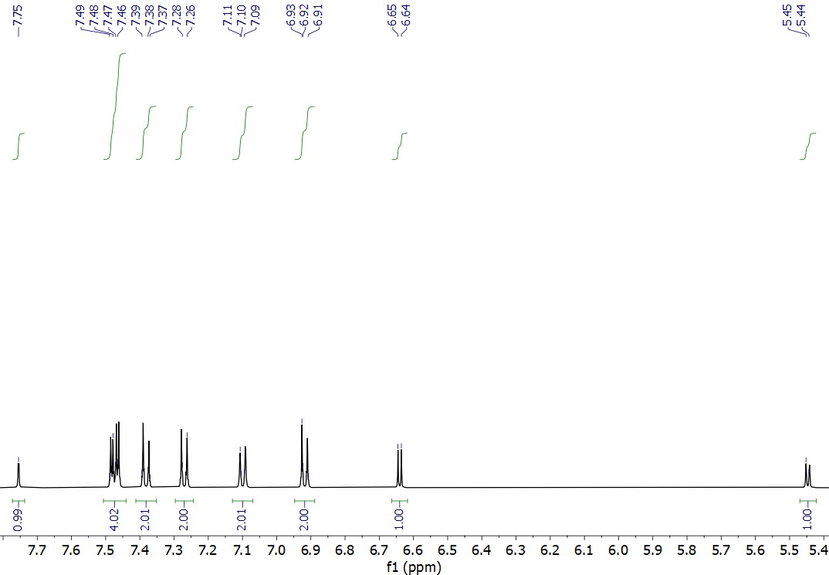

Figure 29-¹H NMR expand (300 MHz, CDCl₃) compound (1k)

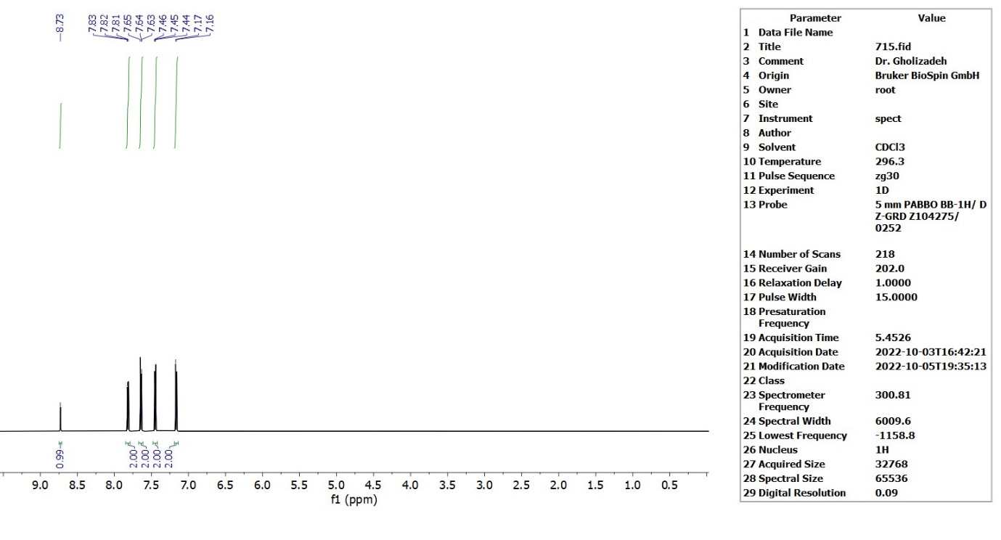
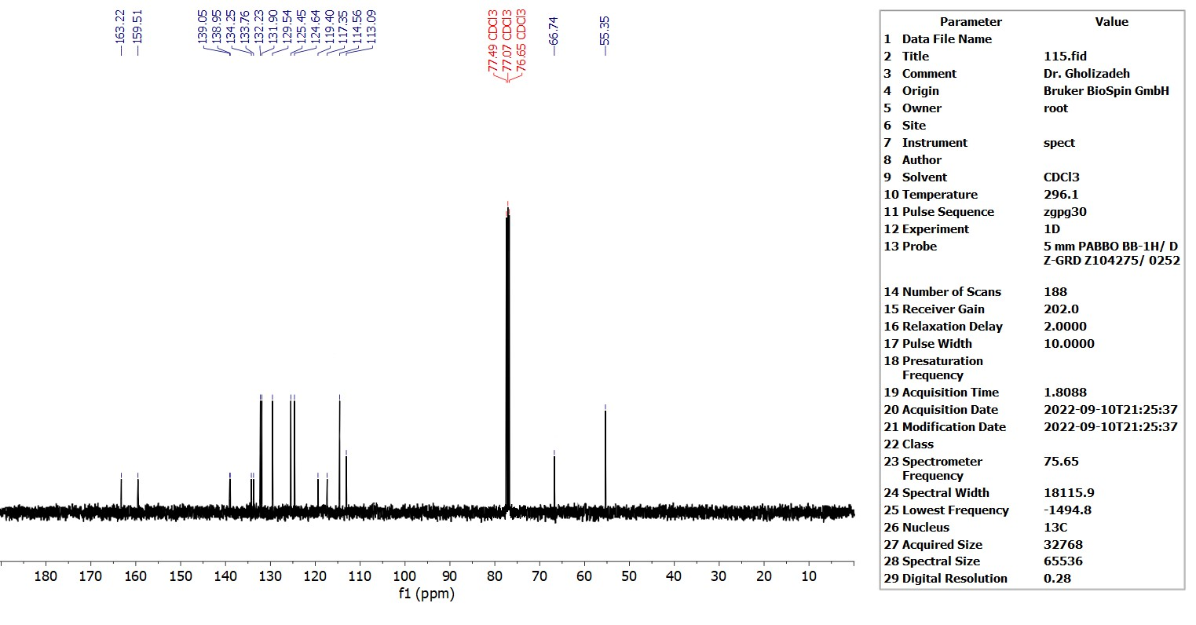
Figure 30-13C NMR (75 MHz, CDCl₃) of compound (1k)
Figure 31-¹H NMR (300.13 MHz, CDCl₃) intermediate C

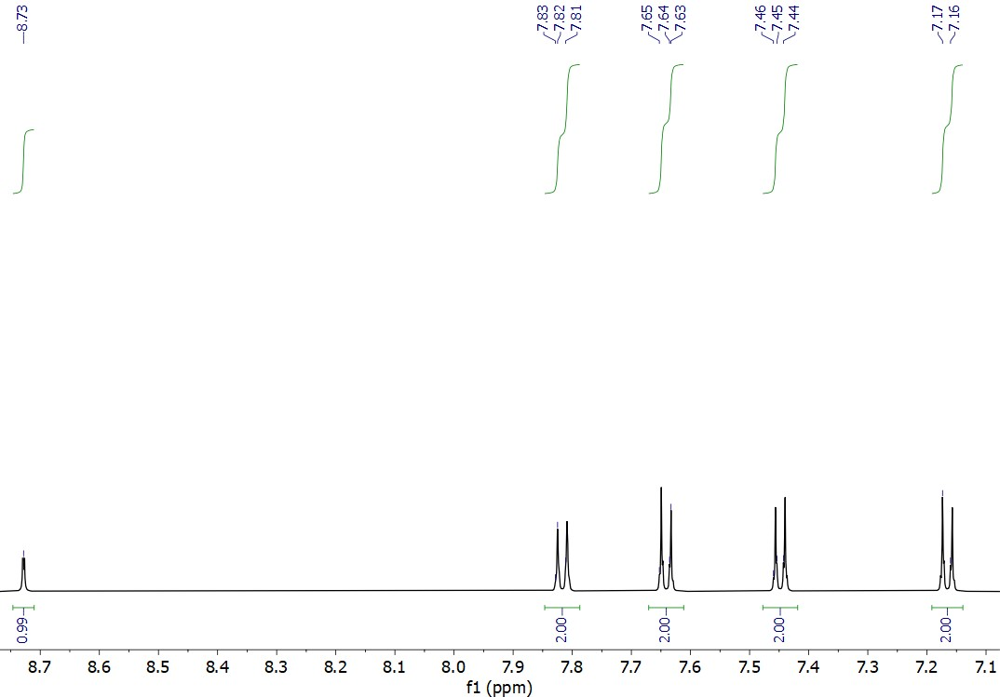

Figure 32-¹H NMR expand (300.13 MHz, CDCl₃) intermediate C

Figure 33-¹³C NMR (75 MHz, CDCl₃) intermediate C
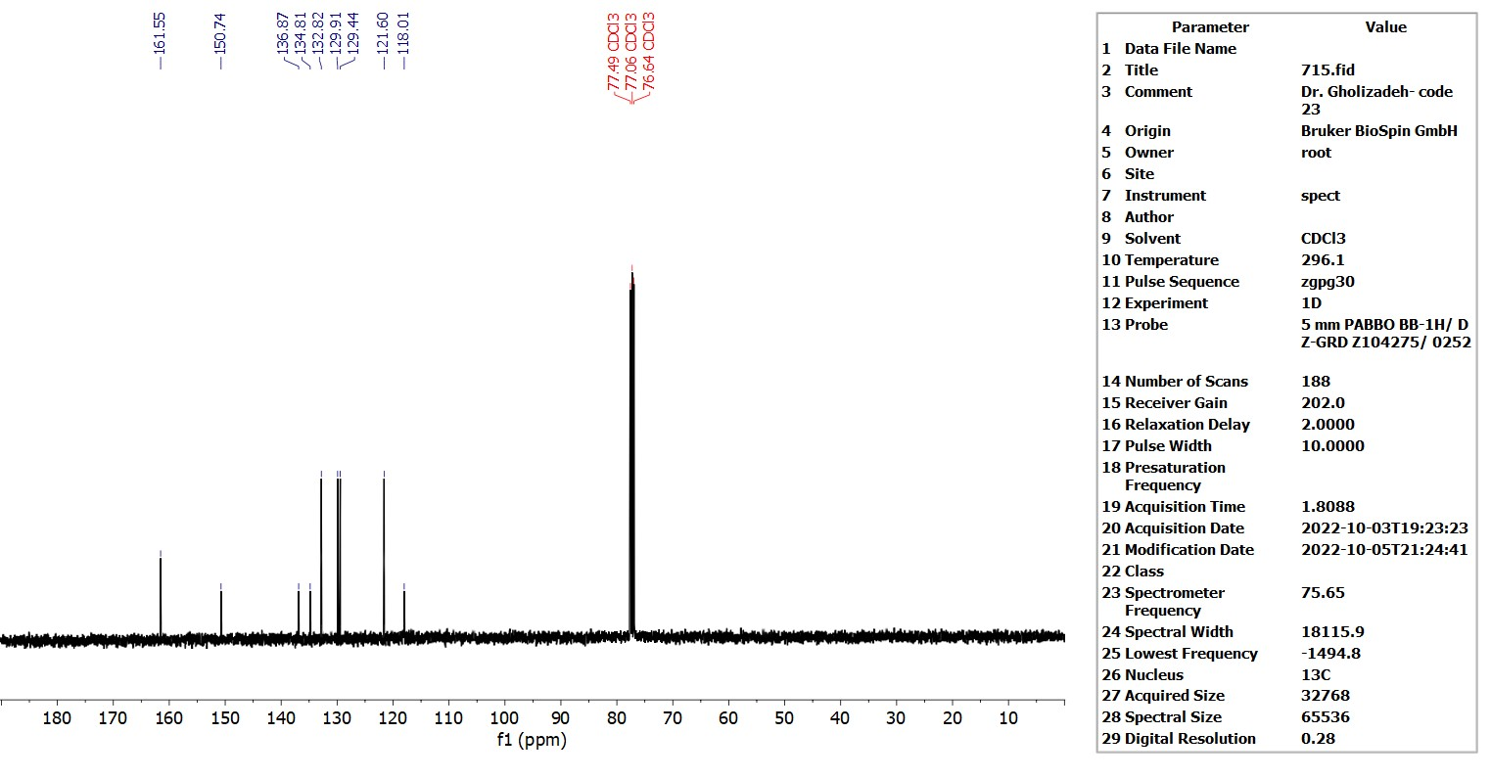

References

[1] K. Niknam and S. Mojikhalifeh, Mol Divers 18, 111 (2014).
[2] H. R. Shaterian and M. Ranjbar, Research on Chemical Intermediates 40, 2059 (2014).
[3] Y. Wu, L. Liu, D. Wang, and Y. Chen, J Heterocycl Chem 43, 949 (2006).
[4] H. Younesi, S. Asghari, G. F. Pasha, and M. Tajbakhsh, Appl Organomet Chem 37, (2023).

