Additional file 1

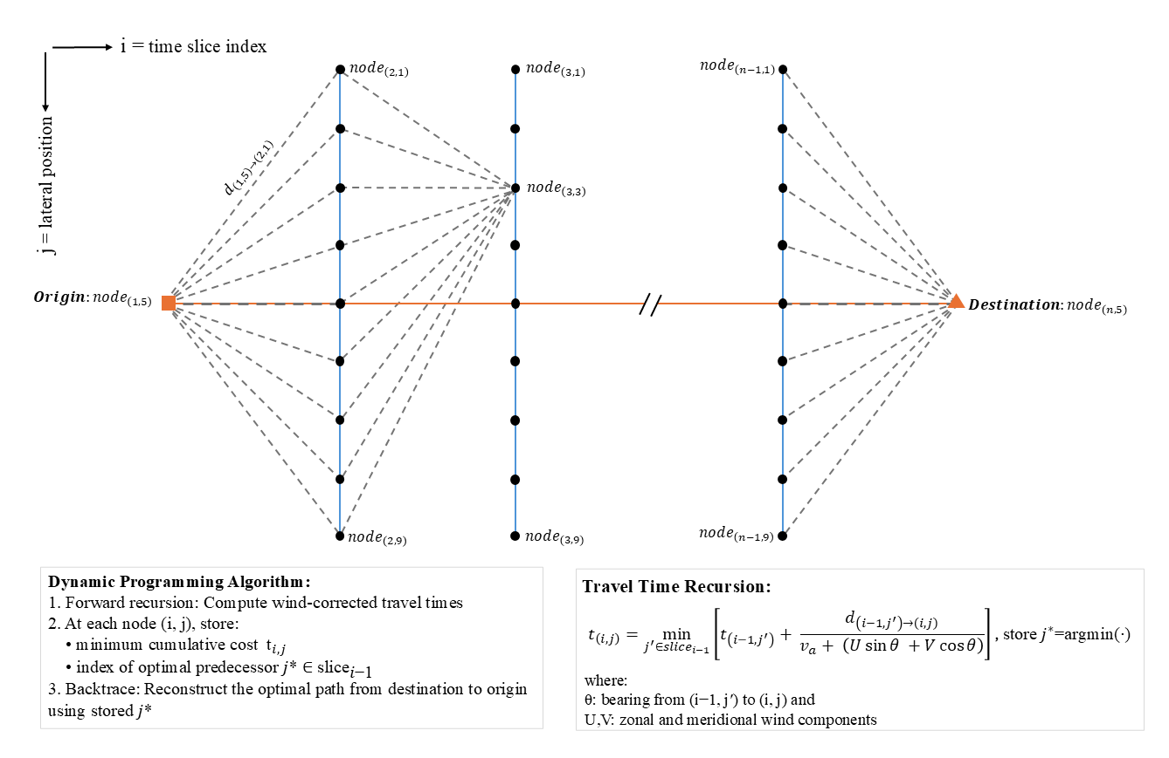
Fig. S1. Time-expanded graph used to compute global wind-optimal trajectories via dynamic programming. Nodes represent candidate positions spaced laterally at fixed intervals across discretised time slices along the great-circle arc connecting origin and destination (orange line). Transitions between adjacent time slices are evaluated based on wind-adjusted travel time, with wind vectors projected onto segment bearings. The algorithm stores cumulative cost and predecessor index at each node, and the minimum-time trajectory is recovered by backtracking from the destination.

Table S1. Simulated route types and inputs
Code | Route name | Class | Cue/knowledge | Initialisation | Update rule
GL | Geographic loxodrome | Compass | True-north bearing | Set to observed departure bearing | Fixed geographic azimuth
ML | Geomagnetic loxodrome | Compass | Magnetic north | Observed magnetic bearing | Fixed magnetic azimuth; declination-corrected hourly
MC | Magnetoclinic | Compass | Apparent inclination | Set from departure heading & field | Maintain constant apparent dip using local I,D
SC | Sun compass (time-compensated) | Compass | Solar azimuth + clock | Departure sun (SR/SS or polar ref.) | Hourly correction for seasonal shift + longitudinal drift
LW | Local wind-aligned | Compass-like | Local wind direction | Observed start | Heading = wind direction each hour
WO | Global wind-optimal | Efficiency | Future wind field | Start & end points fixed | Dynamic programming min-time
GC | Great-circle | Efficiency | Destination geometry | Start & end | Geodesic propagation

Table S2. Trajectory-similarity metrics
Metric | Symbol | Type | Definition (summary) | Range/ units | Interpretation
Median geodesic distance | MGD | Spatial | Median point-wise great-circle distance between temporally matched fixes | km (or m) | Lower = closer spatial alignment
Dynamic Time Warping | DTW | Spatio-temporal | DTW cost on coordinate sequences; allows phase/pace differences | arbitrary (km-scaled) | Lower = better path-shape match over time
Directional similarity | DIR | Directional | Mean cosine similarity of successive heading vectors | ([-1,1]) | Higher = more consistent headings

Table S3. Summary of migratory flight segment characteristics by season (values with ± are mean ± SD).
Metric | Spring | Autumn
Flight segments (n) | 1137 | 387
Initial direction (circular mean ± circular SD; ° from north) | 89 ± 89 | 232 ± 36
Duration (h) | 40 ± 36 | 35 ± 34
Cumulative distance (km) | 865 ± 537 | 733 ± 692
Straightness index | 0.86 ± 0.15 | 0.92 ± 0.08
Geomagnetic-storm exposure (% segments with Max Kp > 5) | 5.7% | 9.7%
Night-time departures (%; sun altitude < −6°) | 22.9% | 17.1%

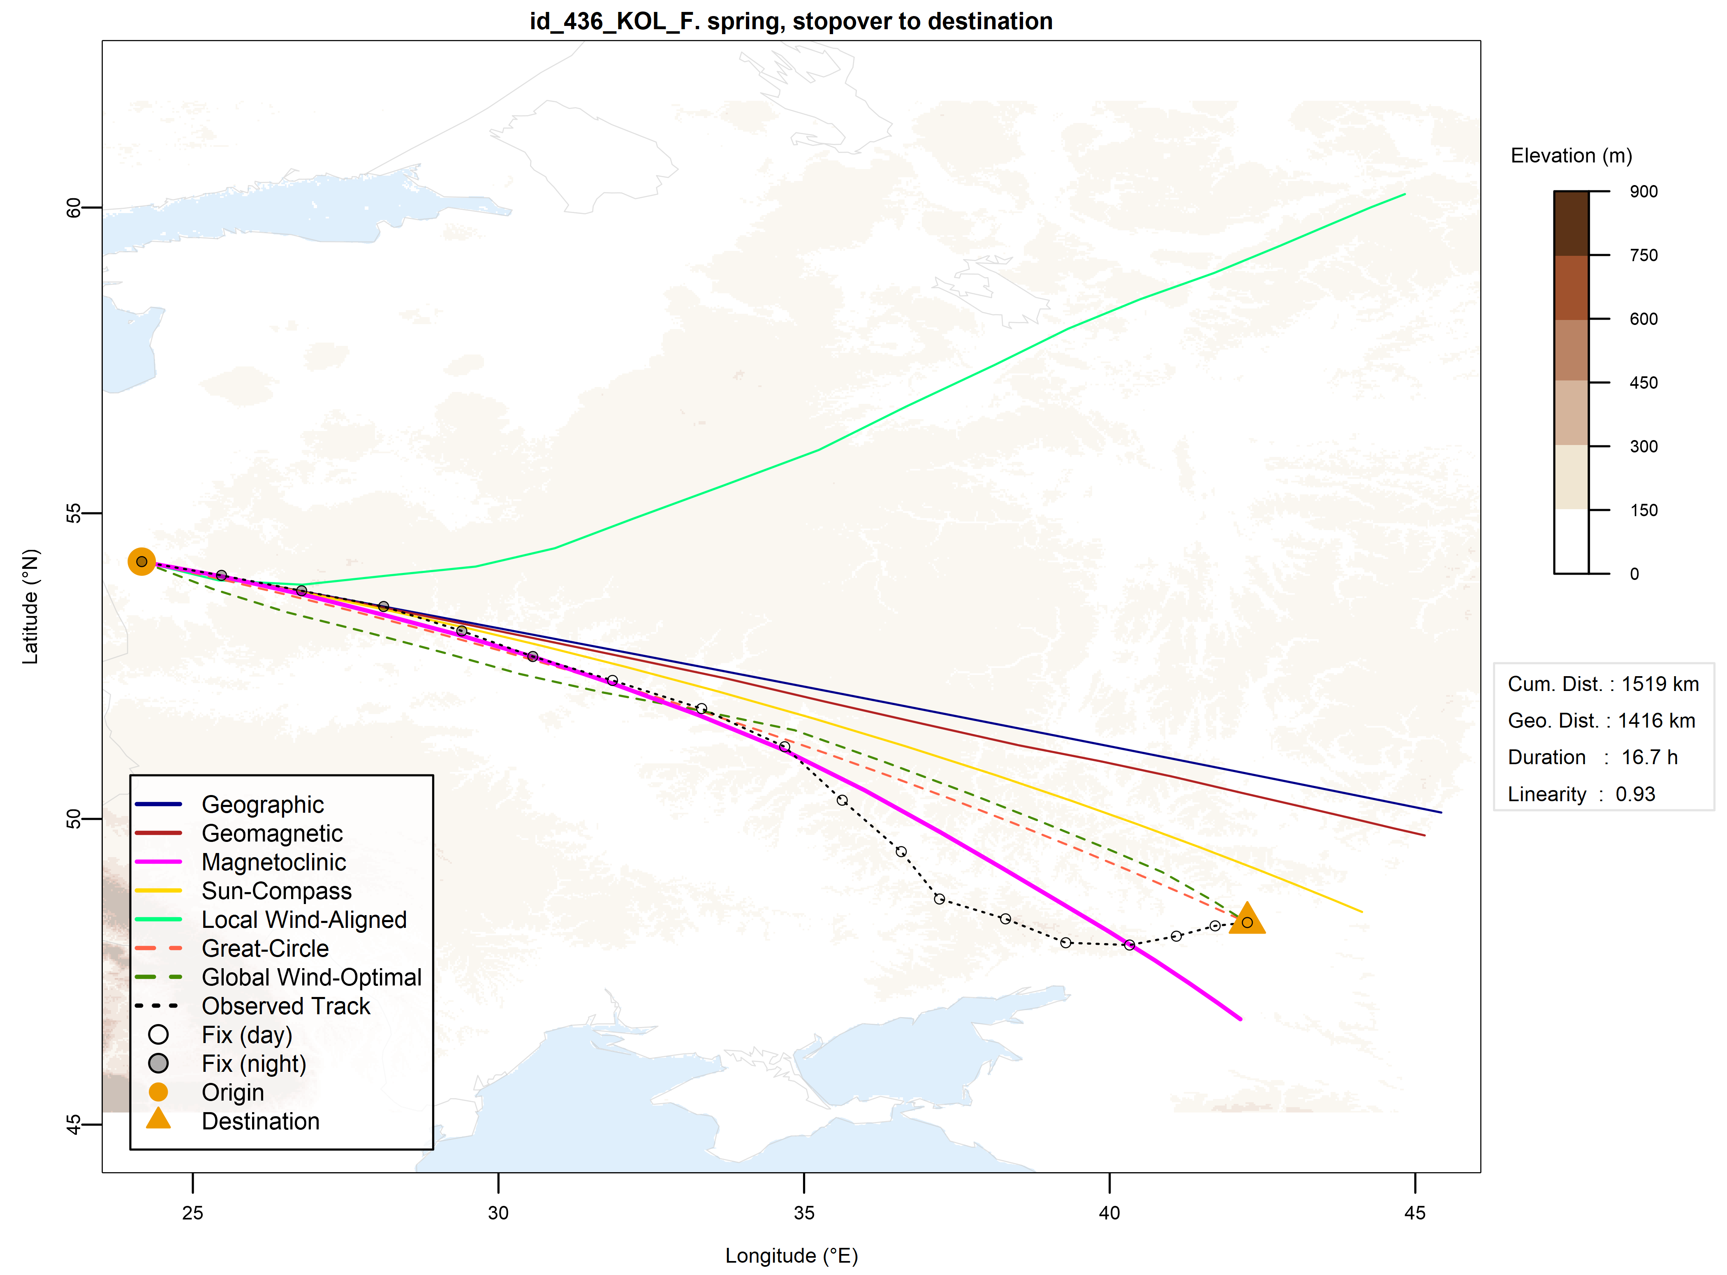
Fig. S2. Migratory segment of 1,519 km in spring, with the magnetoclinic trajectory (magenta) displaying the closest match relative to other theoretical paths. The map includes a legend explaining route and symbol types, an info box with segment-level metrics, and elevation shaded in brown.

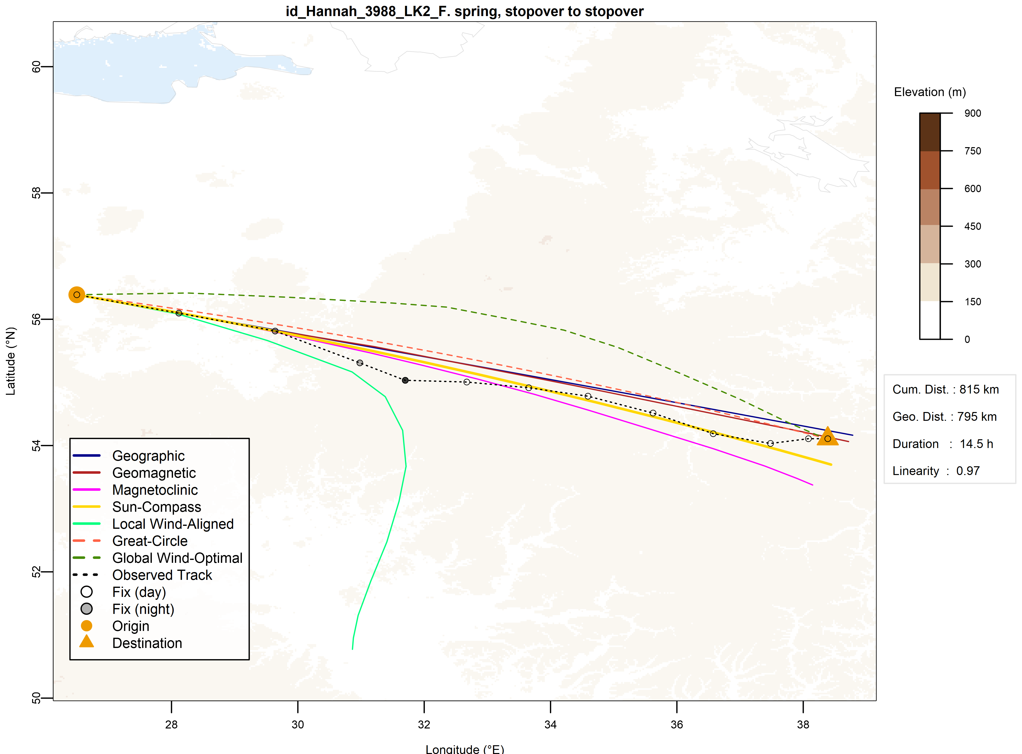
Fig. S3. Migratory segment of 815 km in spring, with the sun compass trajectory (yellow) displaying the closest match relative to other theoretical paths. The map includes a legend explaining route and symbol types, an info box with segment-level metrics, and elevation shaded in brown.

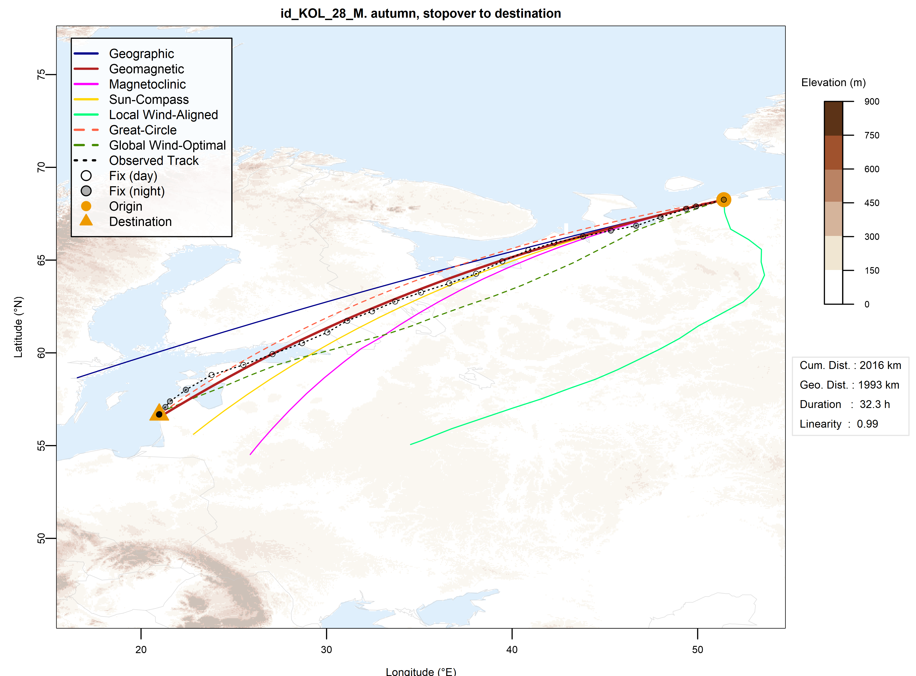
Fig. S4. Migratory segment of 2,016 km in spring, with the geomagnetic loxodrome trajectory (dark red) showing the highest alignment among all theoretical routes. The map includes a legend explaining route and symbol types, an info box with segment-level metrics, and elevation shaded in brown.

Table S4. Average improvements of best-fitting strategies over runners-up based on MGD similarity.
Best-Fitting Strategy | Top Second-Best | Top Second-Best Frequency (%) |  | Mean Improvement Over Top Second-Best |  | Mean Improvement Over All Second-Best
Best-Fitting Strategy | Top Second-Best | Autumn | Spring | Autumn | Spring | Autumn | Spring
GEO | MAG | 69.9 | 83.9 | 15.2 | 13.9 | 15.6 | 13.7
MAG | GEO | 50.8 | 60.0 | 20.7 | 17.0 | 19.8 | 16.1
MCL | Sun | 75.9 | 72.6 | 21.0 | 20.3 | 18.4 | 19.2
Sun | MCL | 38.5 | 54.8 | 11.6 | 17.9 | 13.0 | 17.9
LW | GEO | 36.7 | 40.0 | 41.2 | 40.3 | 42.3 | 37.5

Table S5. Average improvements of best-fitting strategies over runners-up based on DIR similarity.
Best-Fitting Strategy | Top Second-Best | Top Second-Best Frequency (%) |  | Mean Improvement Over Top Second-Best |  | Mean Improvement Over All Second-Best
Best-Fitting Strategy | Top Second-Best | Autumn | Spring | Autumn | Spring | Autumn | Spring
GEO | MAG | 64.2 | 86.7 | 1.9 | 2.5 | 1.9 | 2.3
MAG | GEO | 72.3 | 59.3 | 2.2 | 49.7 | 1.7 | 29.8
MCL | Sun | 85.1 | 69.1 | 1.1 | 2.3 | 1.2 | 2.8
Sun | MCL | 37.5 | 45.5 | 0.7 | 1.5 | 0.8 | 2.2
LW | GEO | 54.5 | 48.6 | 13.2 | 35.1 | 20.9 | 65.0

Table S6. Pairwise correlations of segment-level similarity scores among compass-based navigation strategies. Values are reported separately for each similarity metric. All pairwise Pearson correlations are statistically significant at p < 0.001.
Strategy Pair | DTW | MGD | DIR
Geographic – Geomagnetic | 0.96 | 0.97 | 1.00
Geographic – Magnetoclinic | 0.84 | 0.85 | 0.99
Geographic – Sun | 0.89 | 0.89 | 1.00
Geographic – Local Wind | 0.41 | 0.44 | 0.42
Geomagnetic – Magnetoclinic | 0.91 | 0.91 | 0.99
Geomagnetic – Sun | 0.95 | 0.95 | 1.00
Geomagnetic – Local Wind | 0.41 | 0.42 | 0.42
Magnetoclinic – Sun | 0.95 | 0.95 | 0.99
Magnetoclinic – Local Wind | 0.45 | 0.45 | 0.42
Sun – Local Wind | 0.42 | 0.43 | 0.42

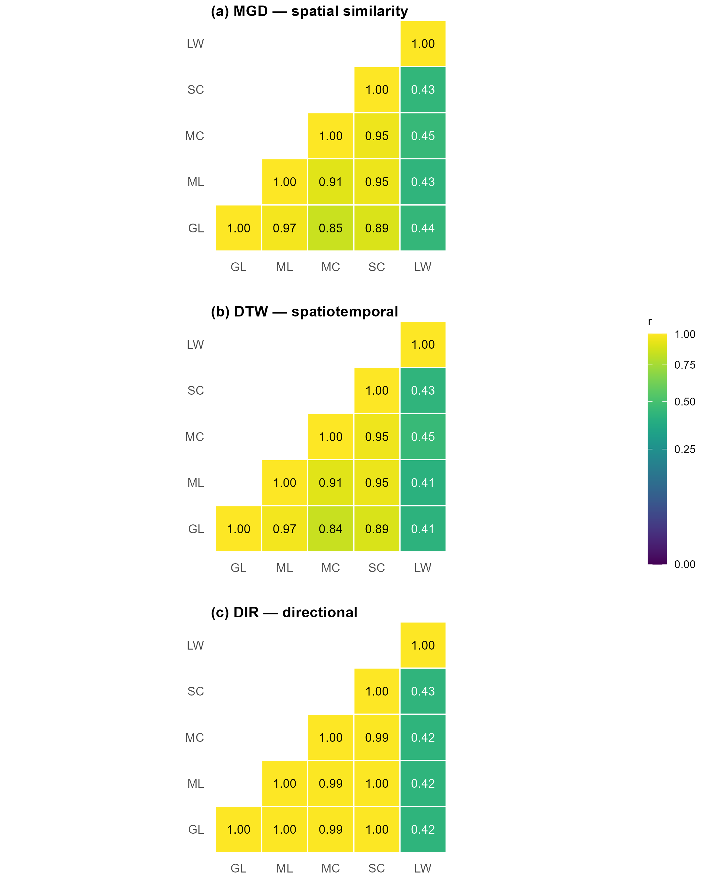
Fig. S5. Pearson correlation matrices of evaluation metrics for five compass-based route models (GL, ML, MC, SC, LW). Matrices were computed using (a) median geodesic deviation (MGD), (b) dynamic time warping (DTW), and (c) directional consistency (DIR) as similarity measures.

Table S7. Binomial logistic regression of route class (wind-optimal vs great-circle). Final model retained after stepwise AIC selection from the full additive model (n = 1,524 segments). Response variable: route class (1 = wind-optimal, 0 = great-circle). Estimates (β) are on the log-odds scale; odds ratios (OR) and 95% profile-likelihood confidence intervals (CI) are provided. Continuous predictors are expressed in native units. Reference levels: season = spring; short pause = absent. Model fit: residual deviance = 2062.9 on 1518 df; AIC = 2074.9; McFadden’s R² = 0.019; Tjur’s R² = 0.026; AUC = 0.59. Calibration was adequate (Hosmer–Lemeshow p = 0.12).
Predictor | Coding / Unit | β (SE) | z | p | OR | 95 % CI (OR)
Intercept | spring; no short pause; tailwind = 0; distance = 0 | −0.510 (0.130) | −3.93 | <0.001 | 0.60 | 0.47–0.77
Season: autumn | vs spring | 0.474 (0.121) | 3.91 | <0.001 | 1.61 | 1.27–2.04
Tailwind support | per 1 m s⁻¹ | 0.077 (0.0185) | 4.17 | <0.001 | 1.08 | 1.04–1.12
Short pause | present vs absent | 0.341 (0.121) | 2.83 | 0.0046 | 1.41 | 1.11–1.78
Great-circle distance | per 1 km | −0.000178 (0.000107) | −1.65 | 0.098 | 1.00 | 1.00–1.00
Next-stopover duration | per 1 h | −0.00239 (0.00169) | −1.41 | 0.158 | 1.00 | 0.99–1.00

Table S8. Variance inflation factors (VIF)
Predictor | VIF
Season (autumn) | 1.03
Tailwind support (m s⁻¹) | 1.12
Great-circle distance (km) | 1.10
Short pause in sustained flight | 1.20
Next-stopover duration (h) | 1.04

Table S9. Stepwise AIC selection path
Step | Predictor removed | ΔDf | ΔDeviance | Residual df | Residual deviance | AIC
— | — (full model) | — | — | 1511 | 2059.313 | 2085.313
1 | Segment type | 2 | 0.768 | 1513 | 2060.081 | 2082.081
2 | Segment duration | 1 | 0.066 | 1514 | 2060.147 | 2080.147
3 | Geomagnetic storm indicator | 1 | 0.178 | 1515 | 2060.325 | 2078.325
4 | Light at start | 1 | 0.536 | 1516 | 2060.860 | 2076.860
5 | Previous stopover duration | 1 | 0.727 | 1517 | 2061.587 | 2075.587
6 | Crosswind | 1 | 1.290 | 1518 | 2062.877 | 2074.877

Table S10. Overall fit and performance of the final multinomial logistic regression model of compass class (n = 1,524 segments). Geographic served as the baseline category. Predictors retained after stepwise AIC selection were: season, mean wind support, mean crosswind, great-circle distance, segment duration, light at start, segment type, and short pause. Continuous predictors are in native units; categorical predictors are shown relative to reference levels (spring, day, origin→stopover, short pause absent).
Statistic | Value
Residual deviance | 4342.2
AIC | 4422.2
McFadden’s R² | 0.056
Multiclass AUC (Hand–Till) | 0.643
Overall accuracy (micro-recall) | 39.0%
Macro-recall | 0.266

Table S11. Class-wise effects relative to the geographic baseline. Odds ratios (OR), 95% Wald confidence intervals, and p-values from the final multinomial model. Continuous predictors in native units; categorical predictors shown relative to reference levels (spring, day, origin→stopover, short pause absent). p-values smaller than 0.0001 are reported as “< 0.0001”.
Class | Predictor | OR | 95% CI (OR) | p
Geomagnetic | (Intercept) | 0.318 | 0.180–0.563 | < 0.0001
Geomagnetic | Season: autumn (vs spring) | 1.140 | 0.783–1.660 | 0.497936
Geomagnetic | Tailwind support (per 1 m s⁻¹) | 0.988 | 0.927–1.050 | 0.708245
Geomagnetic | Crosswind (per 1 m s⁻¹) | 1.030 | 0.931–1.140 | 0.581742
Geomagnetic | Great-circle distance (per 1 km) | 1.000 | 1.000–1.000 | 0.661195
Geomagnetic | Segment duration (per 1 h) | 1.000 | 0.994–1.010 | 0.812472
Geomagnetic | Light at start: night (vs day) | 0.782 | 0.489–1.250 | 0.303235
Geomagnetic | Segment type: stopover → destination | 0.847 | 0.508–1.410 | 0.524552
Geomagnetic | Segment type: stopover → stopover | 0.869 | 0.579–1.300 | 0.499287
Geomagnetic | Short pause: present (vs absent) | 1.030 | 0.661–1.610 | 0.887555
Magnetoclinic | (Intercept) | 1.660 | 1.050–2.630 | 0.031061
Magnetoclinic | Season: autumn (vs spring) | 0.678 | 0.493–0.934 | 0.017330
Magnetoclinic | Tailwind support (per 1 m s⁻¹) | 0.953 | 0.907–1.000 | 0.062344
Magnetoclinic | Crosswind (per 1 m s⁻¹) | 1.080 | 1.000–1.170 | 0.046130
Magnetoclinic | Great-circle distance (per 1 km) | 1.000 | 0.999–1.000 | 0.032215
Magnetoclinic | Segment duration (h) | 0.996 | 0.990–1.000 | 0.170655
Magnetoclinic | Light at start: night (vs day) | 1.750 | 1.270–2.420 | 0.000664
Magnetoclinic | Segment type: stopover → destination | 0.375 | 0.245–0.574 | < 0.0001
Magnetoclinic | Segment type: stopover → stopover | 0.457 | 0.336–0.622 | < 0.0001
Magnetoclinic | Short pause: present (vs absent) | 0.769 | 0.541–1.090 | 0.141158
Sun | (Intercept) | 0.443 | 0.263–0.747 | 0.002272
Sun | Season: autumn (vs spring) | 0.694 | 0.489–0.987 | 0.041805
Sun | Tailwind support (per 1 m s⁻¹) | 1.000 | 0.951–1.060 | 0.850773
Sun | Crosswind (per 1 m s⁻¹) | 1.010 | 0.925–1.100 | 0.821071
Sun | Great-circle distance (per 1 km) | 1.000 | 1.000–1.000 | 0.308374
Sun | Segment duration (per 1 h) | 1.000 | 0.994–1.010 | 0.923707
Sun | Light at start: night (vs day) | 0.770 | 0.514–1.150 | 0.204741
Sun | Segment type: stopover → destination | 1.190 | 0.751–1.880 | 0.458237
Sun | Segment type: stopover → stopover | 1.110 | 0.760–1.630 | 0.578548
Sun | Short pause: present (vs absent) | 0.828 | 0.561–1.220 | 0.339403
Local wind | (Intercept) | 0.197 | 0.112–0.346 | < 0.0001
Local wind | Season: autumn (vs spring) | 0.311 | 0.190–0.508 | < 0.0001
Local wind | Tailwind support (per 1 m s⁻¹) | 1.360 | 1.270–1.450 | < 0.0001
Local wind | Crosswind (per 1 m s⁻¹) | 0.774 | 0.685–0.873 | < 0.0001
Local wind | Great-circle distance (per 1 km) | 0.999 | 0.999–1.000 | 0.000250
Local wind | Segment duration (per 1 h) | 1.010 | 1.010–1.020 | < 0.0001
Local wind | Light at start: night (vs day) | 0.851 | 0.543–1.330 | 0.482819
Local wind | Segment type: stopover → destination | 1.000 | 0.598–1.680 | 0.996763
Local wind | Segment type: stopover → stopover | 1.560 | 1.060–2.300 | 0.025730
Local wind | Short pause: present (vs absent) | 2.060 | 1.280–3.320 | 0.002837

Table S12. Variance inflation factors (VIF) for candidate predictors, computed from a dummy-response linear model with the full predictor set (outcome-agnostic).
Predictor | GVIF | Df | GVIF^(1/(2·Df))
Season | 1.05 | 1 | 1.02
Tailwind support (m s⁻¹) | 1.18 | 1 | 1.09
Crosswind (m s⁻¹) | 1.06 | 1 | 1.03
Great-circle distance (km) | 1.42 | 1 | 1.19
Segment duration (h) | 1.79 | 1 | 1.34
Previous stopover duration (h) | 2.00 | 1 | 1.42
Next stopover duration (h) | 1.23 | 1 | 1.11
Geomagnetic storm | 1.07 | 1 | 1.03
Light at start | 1.09 | 1 | 1.04
Segment type (2 df) | 2.47 | 2 | 1.25
Short pause | 1.51 | 1 | 1.23

Table S13. Stepwise AIC selection path (analysis of deviance table) from the initial full multinomial model to the final retained model. Each step shows the predictor removed, associated change in deviance (ΔDeviance) and degrees of freedom (ΔDf), and the resulting residual deviance and AIC.
Step | Predictor removed | ΔDf | ΔDeviance | Residual df | Residual deviance | AIC
— | initial full model | — | — | 1472 | 4322.384 | 4426.384
2 | – Next stopover duration | 4 | 6.333351 | 1476 | 4328.717 | 4424.717
3 | – Geomagnetic storm indicator | 4 | 6.202074 | 1480 | 4334.919 | 4422.919
4 | – Previous stopover duration | 4 | 7.259030 | 1484 | 4342.179 | 4422.179

