Supplementary material

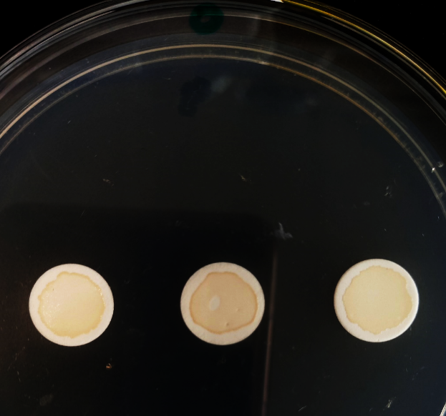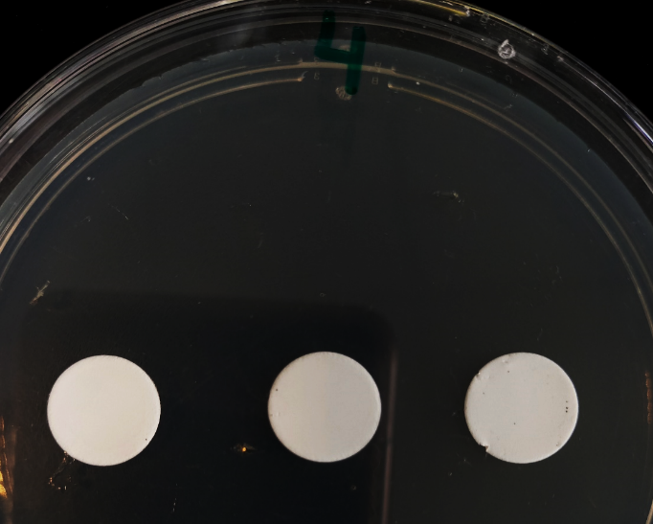
0 mg/L
4 mg/L
Supplementary figure 1: Inhibition of biofilm formation on Supor membranes placed on AgNPs-loaded MM284-agar (4 mg/L) for 24 h versus normal biofilm formation in control replicates.

Supplementary figure 2: Absence of cell survival in Supor membranes placed on AgNPs-loaded MM284-agar (4 mg/L) for 24 h versus normal cell count in control replicates.

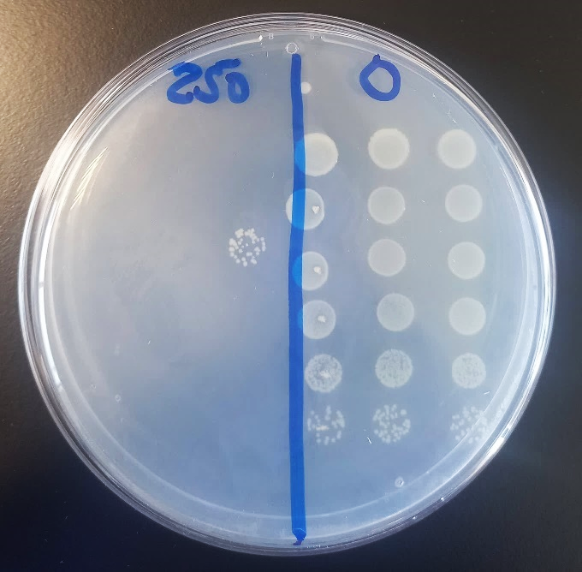
Supplementary figure 3: Planktonic cells of C. metallidurans CH34 (≈ 10⁹ CFU/mL) were deposited on Supor membranes on the top of agar plates loaded with 250 mg/L AgNPs and exposed for 24 h. Next, cells were collected from the membranes and plated for cell count. The image shows the results of the CFU count. Left: unexposed replicates. Right: replicates exposed to AgNPs.

Supplementary figure 4: Effect of biofilm age on protein content in control biofilms of C. metallidurans CH34

Supplementary table 1: Proteins representing the age-independent response of C. metallidurans CH34

Protein name | Gene name
Biopolymer transport protein ExbB | exbB1 Rmet_2278
P-type ATPase CupA (EC 3.6.3.4) | cupA Rmet_3524
N-(2-amino-2-carboxyethyl)-L-glutamate synthase (ACEGA synthase) (EC 2.5.1.140) | sbnA Rmet_1117
Biopolymer transport protein | Rmet_2279
Siderophore synthetase component protein | Rmet_1113
Phenylalanine-4-hydroxylase (EC 1.14.16.1) (Phe-4-monooxygenase) | Rmet_3533
Saccharopine dehydrogenase (NADP+,L-glutamate-forming) | Rmet_3208
Putative iron-sulfur cluster insertion protein ErpA | Rmet_414
ABC-type transporter glycine betaine/L-proline transporter, ATPase subunit, ATPase component: QAT family (EC 3.6.3.32) | Rmet_802
4-hydroxyphenylpyruvate dioxygenase, oxidoreductase protein (EC 1.13.11.27) | Rmet_4925
Predicted ornithine cyclodeaminase (EC 4.3.1.12) | Rmet_586
Urocanate hydratase (Urocanase) (EC 4.2.1.49) (Imidazolonepropionate hydrolase) | Rmet_2854
Ubiquinol oxidase subunit 2 | Rmet_948
Phasin (PHA-granule associated protein) | Rmet_1200
Siderophore biosynthesis protein | Rmet_1112
Methyltransferase (EC 2.1.1.-) | Rmet_2466
Pyruvate-flavodoxin oxidoreductase (EC 1.2.7.8) | porG Rmet_3396
phosphoenolpyruvate mutase (EC 5.4.2.9) | Rmet_1808
Histone-like DNA-binding protein | Rmet_5558
Cytochrome o ubiquinol oxidase subunit I (EC 1.9.3.1) | Rmet_949
Phasin domain-containing protein | Rmet_5124
DUF3141 domain-containing protein | Rmet_564
Urease subunit alpha (EC 3.5.1.5) (Urea amidohydrolase subunit alpha) | Rmet_961
Hydrogenase maturation factor | Rmet_1539
sulfate adenylyltransferase (EC 2.7.7.4) | Rmet_2812
Hemin-binding periplasmic protein hmuT | Rmet_5376
Methyl-accepting chemotaxis protein, sensory transducer | Rmet_5250
Chemotaxis protein CheA (EC 2.7.13.3) | Rmet_3689
Aconitate hydratase B (EC 4.2.1.3) (EC 4.2.1.99) (2-methylisocitrate dehydratase) | Rmet_5296
Large ribosomal subunit protein bL28 (50S ribosomal protein L28) | Rmet_2870
Cell division protein FtsZ | Rmet_3123
Hydrogenase maturation factor HypB | hypB2 Rmet_1536
Small ribosomal subunit protein bS6 (30S ribosomal protein S6) | rpsF Rmet_1979
Copper chaperone, heavy metal ion binding (Modular protein) | cupC Rmet_3525
Aminotransferase family protein (EC 2.6.1.-) | Rmet_2513
Large ribosomal subunit protein uL30 (50S ribosomal protein L30) | rpmD Rmet_3299
Allophanate hydrolase subunit 1 | Rmet_0062
Probable succinyl-diaminopimelate desuccinylase | dapE Rmet_1610
AtzB (Hydroxyatrazine hydrolase) (EC 3.5.99.3) | atzB Rmet_1186
Flagellin | fliC2 Rmet_5252
Methyl-accepting chemotaxis sensory transducer | Rmet_3683
Large ribosomal subunit protein bL19 (50S ribosomal protein L19) | rplS Rmet_0751
Fused isobutyryl-CoA mutase [Includes: Isobutyryl-CoA mutase (ICM) (EC 5.4.99.13); P-loop GTPase (EC 3.6.5.-) (G-protein chaperone)] | icmF sbm Rmet_0210
ATPase and specificity subunit of ClpA-ClpP ATP-dependent serine protease, chaperone activity | clpA Rmet_2892
5-methyltetrahydropteroyltriglutamate--homocysteine methyltransferase (EC 2.1.1.14) (Cobalamin-independent methionine synthase) (Methionine synthase, vitamin-B12 independent isozyme) | metE Rmet_4564
Large ribosomal subunit protein uL1 (50S ribosomal protein L1) | rplA Rmet_3337
Large ribosomal subunit protein uL10 (50S ribosomal protein L10) | rplJ Rmet_3336
Signal recognition particle protein (EC 3.6.5.4) (Fifty-four homolog) | ffh Rmet_3094
Acetylornithine deacetylase/succinyl-diaminopimelate desuccinylase related protein | Rmet_3442
Large ribosomal subunit protein uL4 (50S ribosomal protein L4) | rplD Rmet_3316
Large ribosomal subunit protein bL9 (50S ribosomal protein L9) | rplI Rmet_1976
TRAP-type mannitol/chloroaromatic compound transport system, periplasmic component | Rmet_3543
Lipoprotein (Secreted) | Rmet_3281
ABC-type transporter, periplasmic component: HAAT family | livK2 Rmet_2867
ABC-type transporter, periplasmic component | Rmet_3518
Diadenosine tetraphosphate (Ap4A) hydrolase or other HIT (Histidine triad) family hydrolase (EC 3.6.1.17) | Rmet_3238
Penicillin amidase (Peptidase S45) (EC 3.5.1.11) | Rmet_5635
Extracellular ligand-binding receptor | Rmet_1226
Extra-cytoplasmic Solute Receptor | bug Rmet_3086
4Fe-4S ferredoxin, iron-sulfur binding protein | Rmet_2764
Amidase (EC 3.5.1.4) | Rmet_4787
Glycine-zipper-containing OmpA-like membrane domain-containing protein | Rmet_1704
2-oxoadipate dioxygenase/decarboxylase (EC 1.13.11.93) (2-hydroxyglutarate synthase) | Rmet_5575
Soluble lytic murein transglycosylase (EC 3.2.1.147) | Rmet_0176
AMP-dependent synthetase and ligase (EC 6.2.1.26) | Rmet_5438
Acyl-CoA synthetase (AMP-forming)/AMP-acid ligase II (EC 6.2.1.-) | Rmet_1863
Extra-cytoplasmatic solute receptor | bug Rmet_4286
sn-glycerol-3-phosphate-binding periplasmic protein UgpB | ugpB Rmet_2055
Metallophosphoesterase | Rmet_0638
Heme-binding HmuY-like protein | Rmet_5374
Copper-binding protein | Rmet_0422
Cytochrome c oxidase subunit 2 (EC 7.1.1.9) | coxB Rmet_0261
Extra-cytoplasmic Solute Receptor | bug Rmet_3076
Microcystinase C (MlrC) | Rmet_5087
TRAP-type transporter, periplasmic component / DctP analogue | Rmet_1874
ABC-type tungstate transport system, permease component | Rmet_0895
Sulfur oxidation protein (SoxX) | soxX Rmet_3419
Deaminase-reductase (RibD domain) | Rmet_5103
Isochorismatase hydrolase | Rmet_5311
DUF4845 domain-containing protein | Rmet_2419
Protease HtpX homolog (EC 3.4.24.-) | htpX Rmet_3464
Leucine/isoleucine/valine transporter subunit, ATP-binding component of ABC superfamily | livF7 Rmet_1858
Metal-dependent amidohydrolase with the TIM-barrel fold | Rmet_4653
Isoquinoline 1-oxidoreductase subunit beta (EC 1.3.99.16) | iorB Rmet_0595
Pyruvate dehydrogenase E1 component (EC 1.2.4.1) | aceE Rmet_4263
ABC-type transporter, periplasmic component: HAAT family | Rmet_1862
Thiol-disulfide isomerase-like and thioredoxin-like protein | Rmet_0233
Phenylacetate--CoA ligase (EC 6.2.1.30) | paaK Rmet_0220
Amino-acid-binding periplasmic abc transporter protein | Rmet_0690
KDG kinase | kdgK Rmet_4769
Outer membrane biogenesis protein (YhjG-like) | Rmet_2640
Extra-cytoplasmic solute receptor protein | bug Rmet_3900
Dihydrofolate reductase (EC 1.5.1.3) | folA Rmet_2569
Amino acid ABC transporter permease | Rmet_4584
Ubiquinol-cytochrome c reductase iron-sulfur subunit (EC 7.1.1.8) | petA Rmet_3230
Extra-cytoplasmic solute receptor protein | bug Rmet_5616

