Supplementary Data

H/ACA snoRNAs and snoRNPs Dysregulation Links rRNA Modification to Glioblastoma Progression
Gabriela D. A. Guardia^{1#}, Xiufen Lei^{2#}, Christina Middle³, Morgan Roos³, Lea Damaschke ², Sreenevash Ramesh², Stella Auth², Gabriel Lucas da Fonseca², Nicole Acevedo², Frederico G. C. Oliveira^{1,4}, Nidhi Shah³, Gary Schroth³, Susanne Angelow³, Andrew Brenner⁵, Scott Kuersten^{3*}. Pedro A. F. Galante^{1*}, Luiz O. Penalva^{2,6,*}
1 - Hospital Sírio-Libanês, São Paulo, SP
2- Children’s Cancer Research Institute, UT Health San Antonio, San Antonio, TX.
3- Illumina, Inc., San Diego, CA
4- Departamento de Bioquímica, Universidade de São Paulo, SP.
5- Mays Cancer Center, UT Health San Antonio, San Antonio, TX.
6- Department of Cell Systems and Anatomy, UT Health San Antonio, San Antonio, TX.
# co- first authors
*co-senior authors

Corresponding authors: Luiz O. Penalva, Pedro A. F. Galante and Scott Kuersten

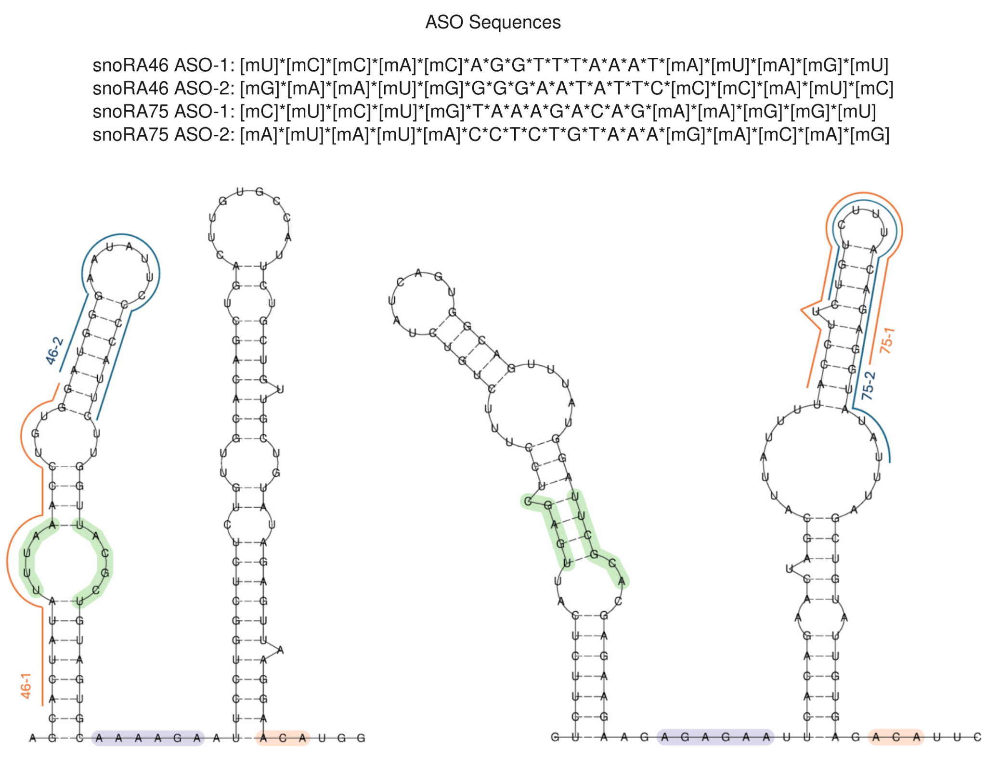
Figure S1. Sequence of ASOs used in this study.

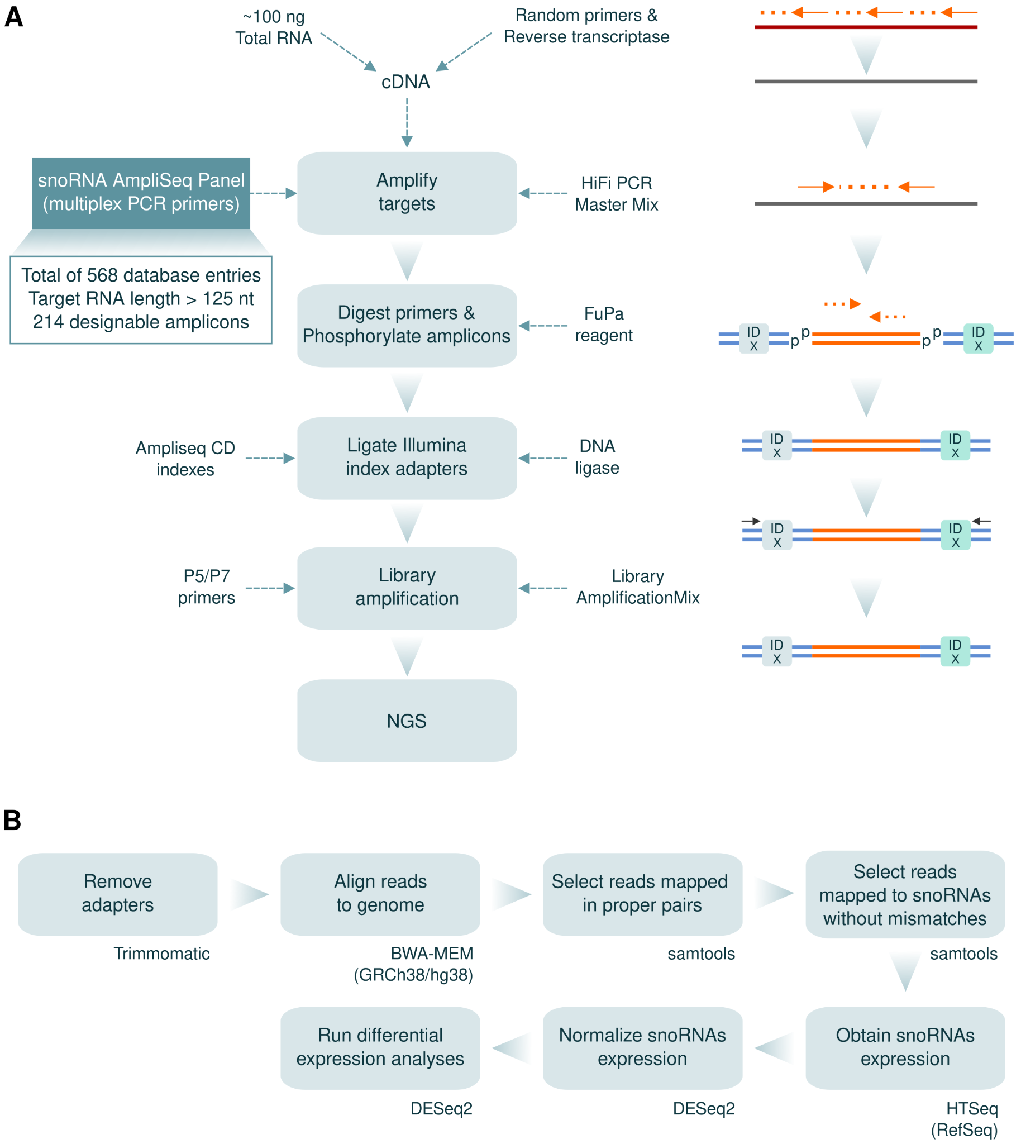
Figure S2. Schematic representation of the experimental approach and bioinformatics pipeline to assess snoRNA expression. A) Overview of the Ampliseq approach used to obtain snoRNA expression profiles. B) Bioinformatics pipeline detailing the steps to process and analyze snoRNA expression data.

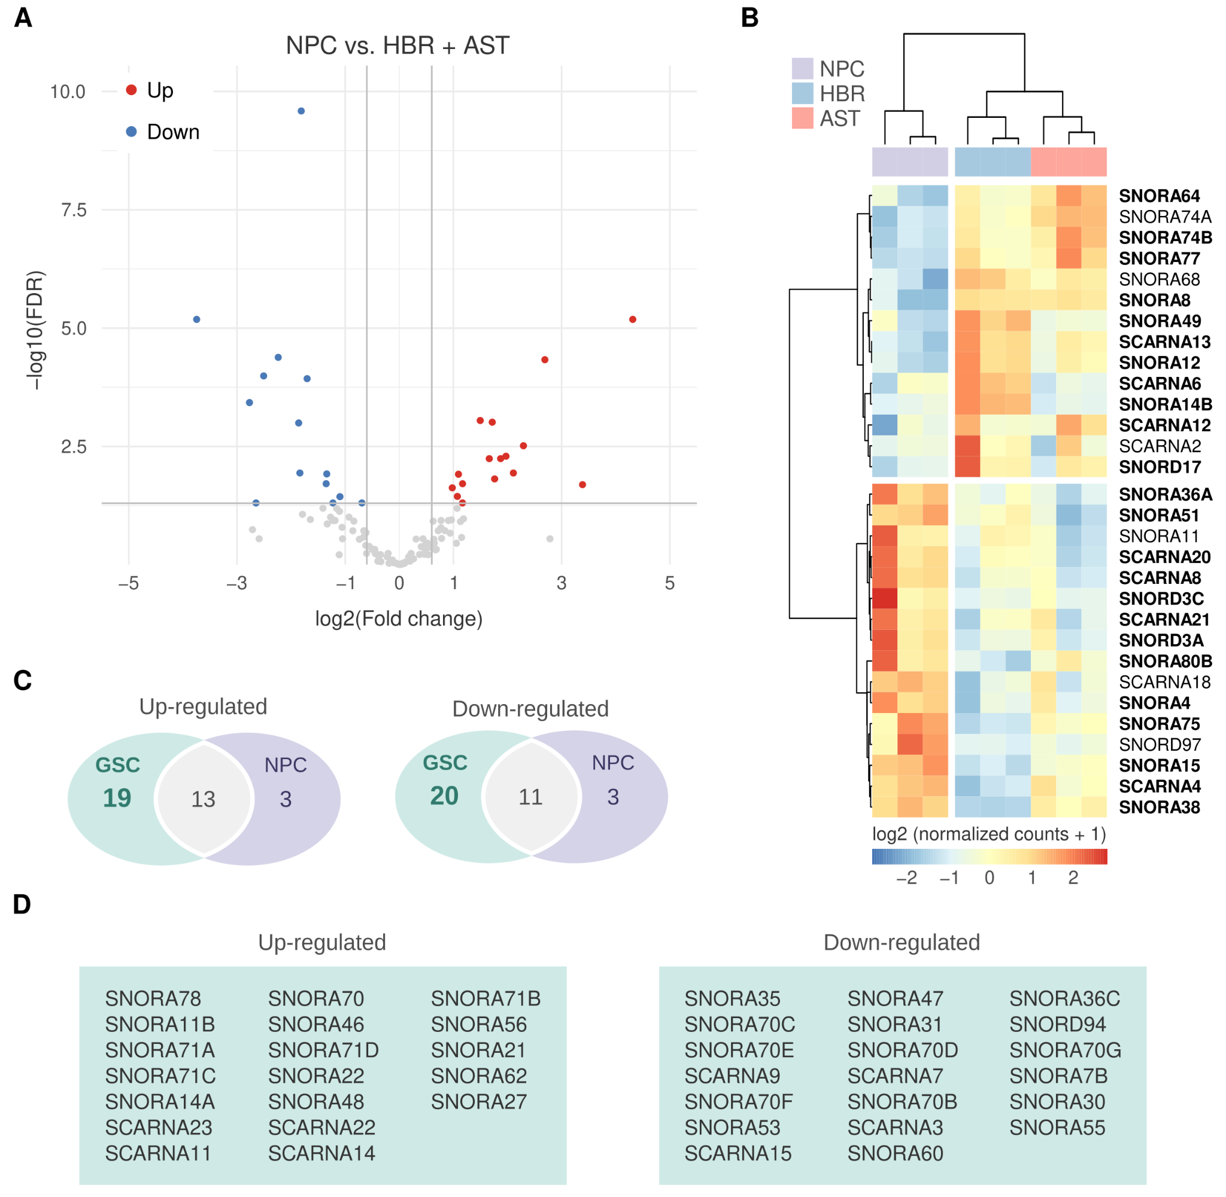
Figure S3. snoRNAs are differentially expressed in neural progenitor cells (NPCs). A) Volcano plot illustrating differentially expressed snoRNAs in NPCs vs. normal brain (astrocytes/AST and human brain/HBR). B) Heatmap showing snoRNAs differentially expressed in NPCs vs. AST + HBR cells. snoRNAs differentially expressed in both NPCs and GSCs in comparison to AST + HBR are shown in bold. C) Venn diagrams indicate the number of up or downregulated snoRNAs in NPCs and/or GSCs in comparison to AST + HBR. D) Table lists snoRNAs related to Venn diagrams.

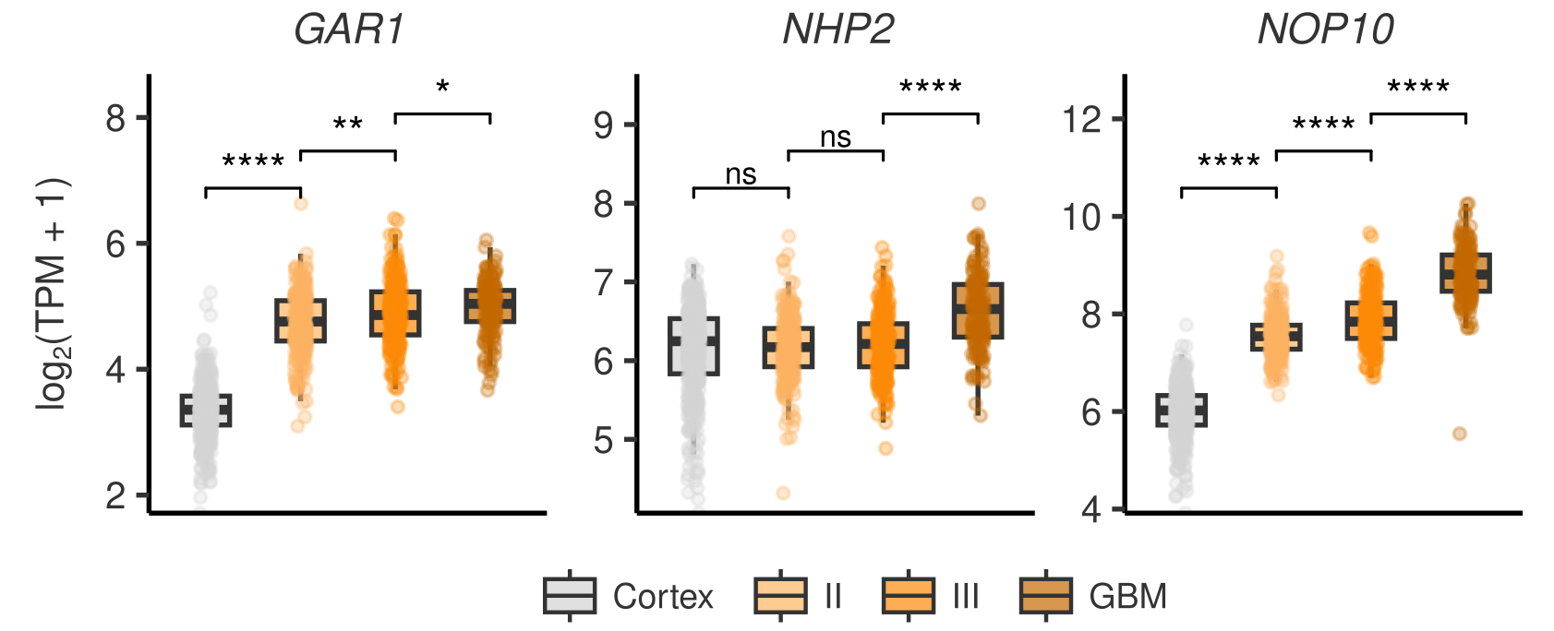
Figure S4. Factors implicated in H/ACA snoRNA processing and rRNA modification are highly expressed in GBM. Expression levels of NHP2, GAR1, and NOP10 in normal cortex, gliomas grade II and III, and glioblastoma. Statistical differences were assessed by Mann–Whitney U tests (p-value * < 0.05, ** < 0.01, *** < 0.001, **** < 0.0001).

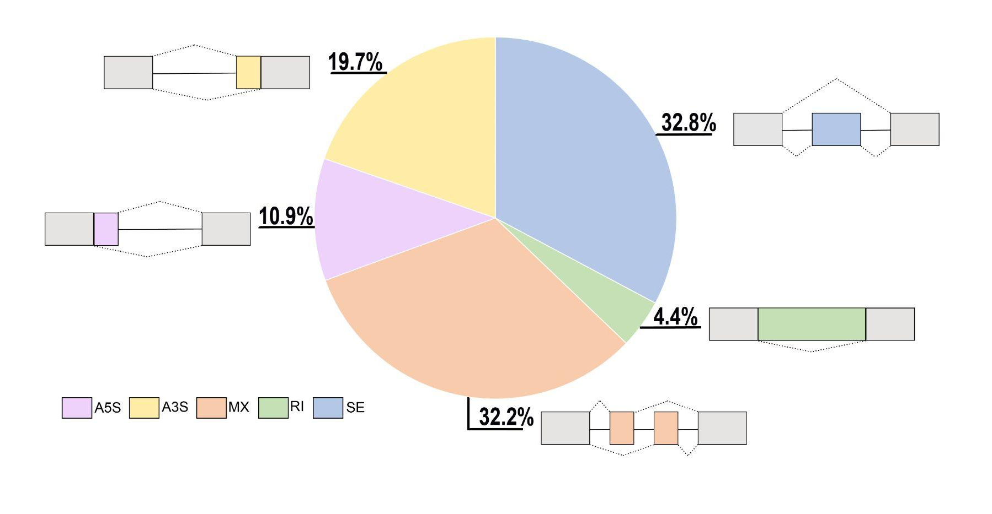
Figure S5. Impact of DKC1 knockdown on splicing. The pie chart shows the distribution of splicing events affected by a partial DKC1 knockdown in U251 cells. Abbreviations: Alternative 5’ splice site (A5S); Alternative 3’ splice site (A3S); Mutually exclusive exon (MX); Retained intron (RI); Skipping exon (SE).

Supplementary Tables
Table S1. Sequence of qRT-PCR primers used in this study.
Table S2. Information about the Ampliseq platform for snoRNAs and scaRNAs analysis.
Table S3. Genomic localization of snoRNAs and scaRNAs in the Ampliseq platform and their host genes.
Table S4. List of snoRNAs displaying altered expression in GSC and/or GBM cells and their pertinent pseudo-uridylation sites in 18S and 28S rRNA. Conserved pseudo-uridylation sites according to (1) are indicated, as well as the frequency of pseudo-uridylation for each site according to BACS analysis (2).
Table S5. List of snoRNA/scaRNAs whose expression was reduced after partial DKC1 knockdown in U251 cells.
Table S6. List of splicing alterations observed in U251 cells after partial DKC1 knockdown. A5/A3: Alternative 5'/3' Splice Sites, MX: Mutually Exclusive Exons, RI: Retained Intron, SE: Skipping Exon.
REFERENCES

1. Taoka M, Nobe Y, Yamaki Y, Sato K, Ishikawa H, Izumikawa K, et al. Landscape of the complete RNA chemical modifications in the human 80S ribosome. Nucleic Acids Res. 2018 Oct 12;46(18):9289–98.
2. Xu H, Kong L, Cheng J, Al Moussawi K, Chen X, Iqbal A, et al. Absolute quantitative and base-resolution sequencing reveals comprehensive landscape of pseudouridine across the human transcriptome. Nat Methods. 2024 Nov;21(11):2024–33.

