SUPLEMENTARY MATERIAL

Brain Activity Related to Cheating Identification: A Step Towards the Study of Corruption.
Víctor E. Olalde-Mathieu, Daniel Atilano-Barbosa, Giovanna L. Licea-Haquet, Jonatan García-Campos, Fernando A. Barrios, and Paola Hernández-Chávez.

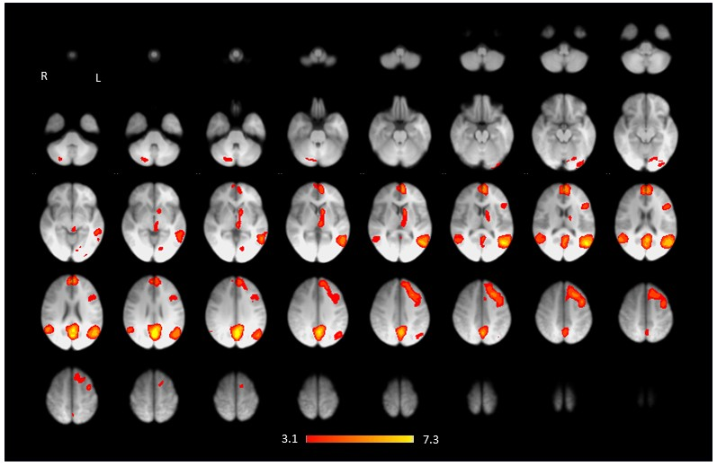
Fig. S1. Whole-brain activation map for the contrasts 1235 > 4 (axial view): Increased activation was observed in the left medial prefrontal cortex (lmPFC), bilateral temporoparietal junction (TPJ), precuneus (Pcu), left caudate nucleus (lCN), left occipital pole (lOcPole), and right cerebellar Crus I/II (rCrusI/II). Color bar indicates Z-values. L: left hemisphere; R: right hemisphere.

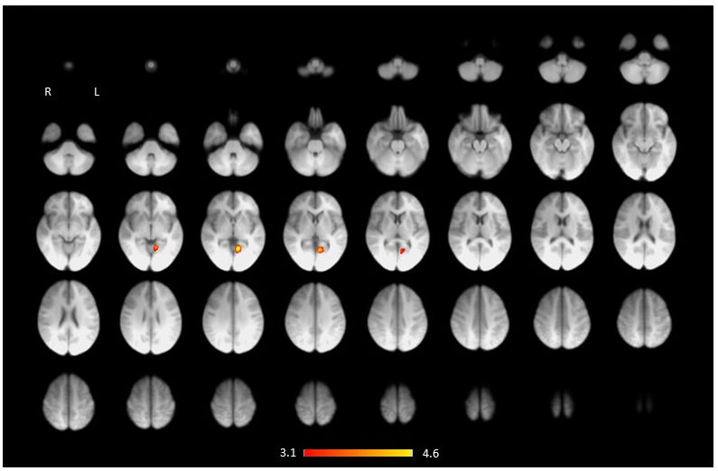
Fig. S2. Whole-brain activation maps for the contrast 1 > 235 (axial view): Increased activation was found in the precuneus and left lingual gyrus (lLing/Pcu). Color bar indicates Z-values. L: left hemisphere; R: right hemisphere.

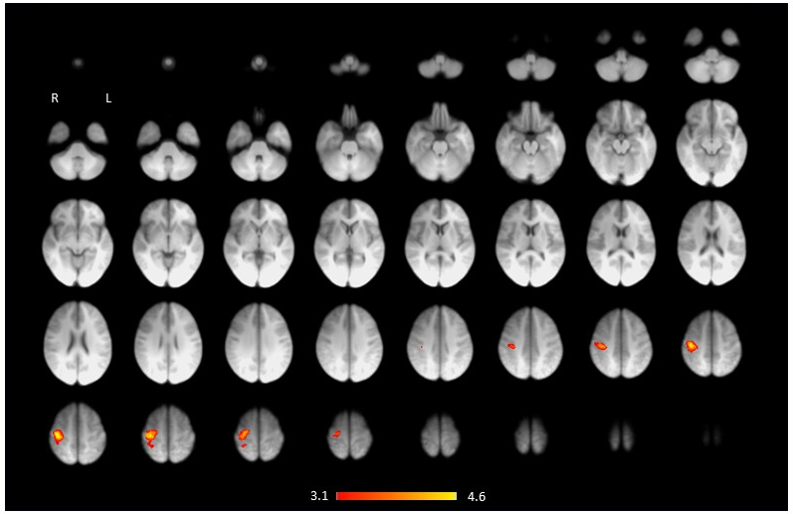
Fig. S3. Whole-brain activation maps for the contrasts 2 > 135 (axial view): Increased activation was obseved in the right posterior middle frontal gyrus (rpMFG). Color bar indicates Z-values. L: left hemisphere; R: right hemisphere.

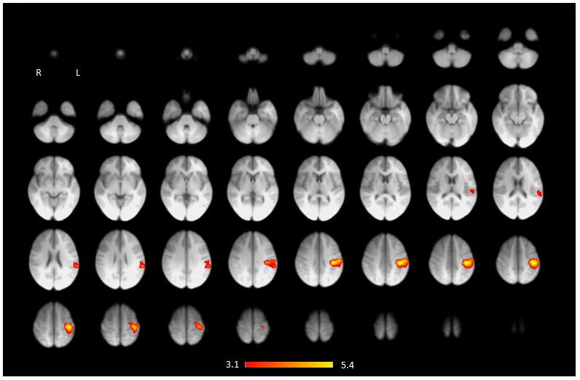
Fig. S4. Whole-brain activation maps for the contrasts 3 > 125 (axial view): Increased activation was found in the left inferior frontal gyrus (lIFG). Color bar indicates Z-values. L: left hemisphere; R: right hemisphere.

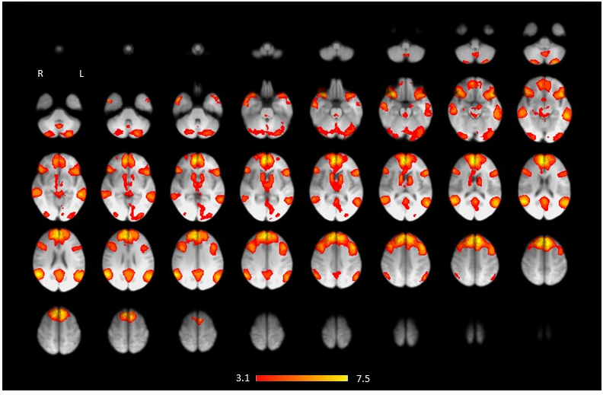
Fig. S5. Whole-brain activation maps for the main contrasts 5 > 123 (axial view): Increased activation was found in the prefrontal cortex (PFC), superior parietal cortex/right TPJ (SPC/rTPJ), superior temporal sulcus/left TPJ (STS/lTPJ), bilateral inferior frontal gyrus/anterior insula (IFG/AI), bilateral dorsolateral prefrontal cortex (dlPFC/rdlPFC), middle temporal sulcus (mTS), precuneus/posterior cingulate cortex (Pcu/PCC), and bilateral putamen. Color bar indicates Z-values. L: left hemisphere; R: right hemisphere.

