Online Supplement to:
Regional prospective whole-genome sequencing surveillance of ESBL-producing Escherichia coli and Klebsiella pneumoniae: a multicentre study on nosocomial and interhospital transmission

Supplementary Methods
- S1. Microbiology
- S2. WGS and bioinformatics
Supplementary Tables
- S1. Hospital characteristics and MDR-E practices
- S2. Sample sites of included isolates
- S3. Resistance genes in E. coli
- S4. Resistance genes in K. pneumoniae
- S5. Sequence types in E. coli
- S6. Sequence types in K. pneumoniae
- S7. Ward-level links; unrelated E. coli
- S8. Ward-level links; related E. coli
- S9. Ward-level links; unrelated K. pneumoniae
- S10. Ward-level links; related K. pneumoniae
Supplementary Figures
- S1. Epidemiological links in E. coli
- S2. Epidemiological links in E. coli excluding ST131
- S3. Epidemiological links in K. pneumoniae
- S4. Flow diagram of included isolates
- S5. Genomic relatedness thresholds
- S6. Index isolates and epidemiological links E. coli
- S7. Index isolates and epidemiological links K. pneumoniae

SUPPLEMENTARY METHODS
S1. Microbiology
Isolates were identified using the MALDI Biotyper (Bruker, Massachusetts, USA). Subsequent susceptibility testing was performed using the VITEK2 system (bioMérieux, Marcy l’Etoile, France) in four hospitals and the Phoenix M50 (BD, Franklin Lakes, USA) in Hospital A. Phenotypic ESBL isolates were characterised as isolates with a minimum inhibitory concentration (MIC) > 1mg/L for cefotaxime and/or ceftazidime and a positive ESBL disk diffusion result (consisting of four antibiotic disks containing cefotaxime, cefotaxime + clavulanic acid, ceftazidime, and ceftazidime + clavulanic acid (bioMérieux, Marcy l’Etoile, France)) (15,16). Phenotypic AmpC isolates were described as having a MIC for cefotaxime and/or ceftazidime > 1mg/ml and a cefoxitin MIC > 8mg/mL with a positive AmpC disk test (consisting of four disks with cefpodoxime, cefpodoxime + ESBL inhibitor, cefpodoxime + AmpC inhibitor and cefpodoxime + ESBL inhibitor + AmpC inhibitor (Mast Group, Bootle, UK)). Isolates with a meropenem MIC > 0.25mg/mL and/or an imipenem MIC > 1mg/mL and a positive carbapenem inactivation method (CIM) were determined to be phenotypically suspect of being a CPE.

S2. WGS and bioinformatics
Phenotypic ESBL-EcKp isolates were centrally sequenced in Hospital A, with subsequent bioinformatic analysis performed in Hospital B. WGS results were subsequently distributed to each hospital through the laboratory information system.
For WGS preparation, a suspension of each isolate was prepared, and DNA was extracted using the QIAsymphony (Qiagen, Venlo, The Netherlands). The DNA library was constructed using the Nextera XT DNA Library preparation kit, followed by sequencing on the Illumina MiSeq platform (Illumina, San Diego, USA). Reads were trimmed and assembled into a consensus sequence using de novo assembly in CLC Genomic Workbench. ESBL genes were identified when at least 99% of the length of the best-matching gene in the NCBI AMRFinderPlus database was covered, with a minimum sequence identity of 90%. Whole-genome multilocus sequence typing (wgMLST) was performed using species-specific typing schemes implemented in Ridom SeqSphere+ (Ridom, Münster, Germany). For isolates belonging to the same species, all-to-all pairwise genetic differences were calculated by counting the total number of allele differences across the wgMLST typing scheme.

SUPPLEMENTARY FIGURES
S1. Percentage of epidemiological links among genomically related versus unrelated ESBL-producing Escherichia coli isolates. Percentage of epidemiological links stratified by epidemiological category (1–4).
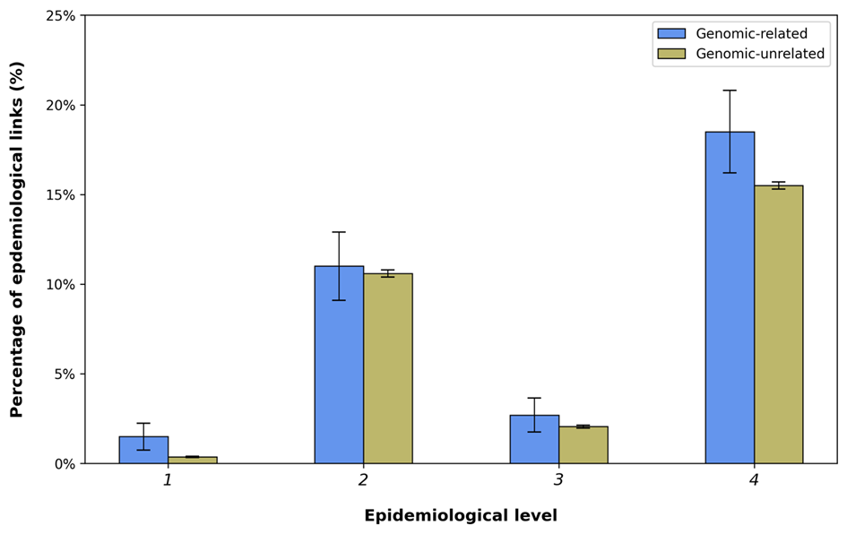
S2. Percentage of epidemiological links among genomically related versus unrelated ESBL-producing Escherichia coli isolates excluding ST131.
Percentage of epidemiological links stratified by epidemiological category (1–4), excluding ST131.
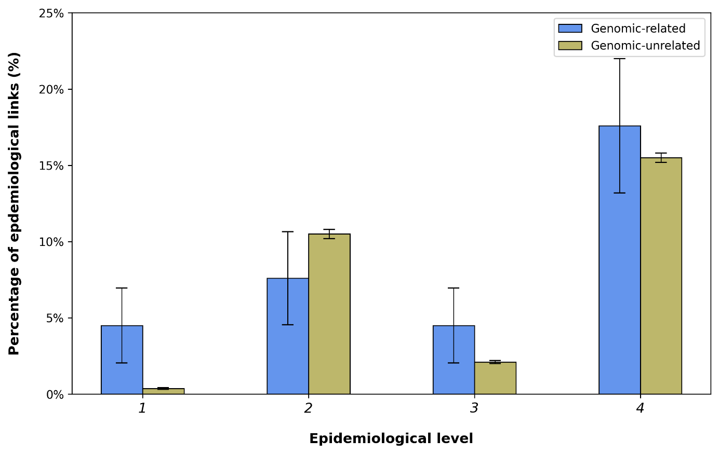
S3. Percentage of epidemiological links among genomically related versus unrelated ESBL-producing Klebsiella pneumoniae isolates. Percentage of epidemiological links stratified by epidemiological category (1–4).
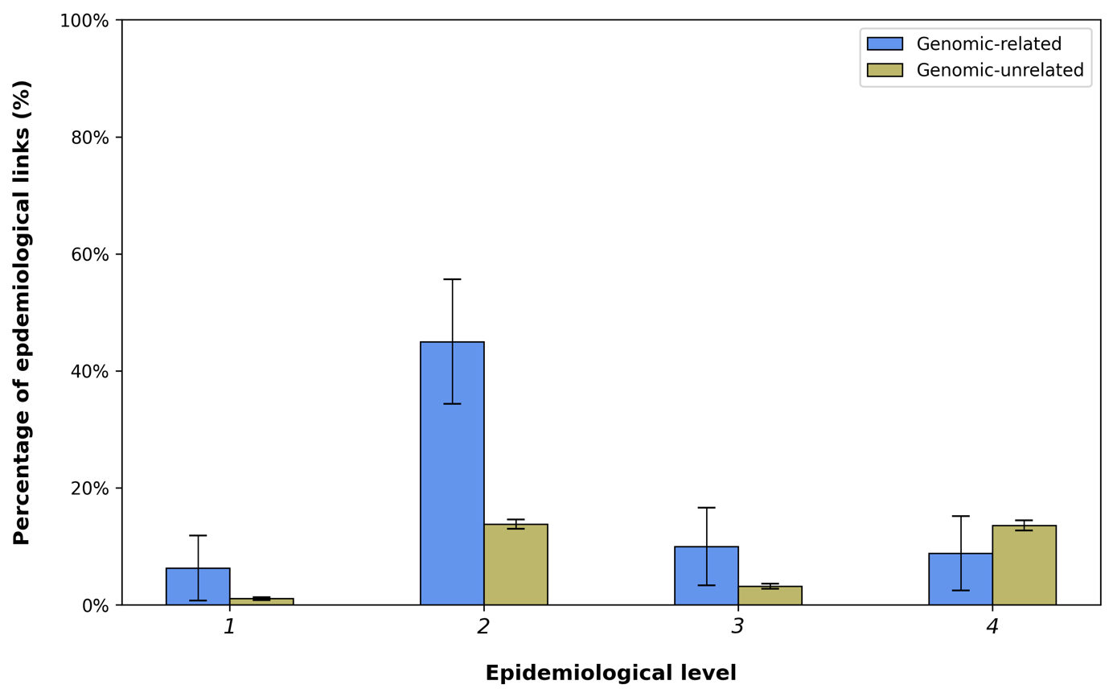

SUPPLEMENTARY TABLES
S1. Hospital characteristics and multidrug-resistant Enterobacterales (MDR-E) prevention and control practices. Overview of hospital characteristics, patient room types, and infection prevention and control practices for multidrug-resistant Enterobacterales (MDR-E) across the five participating hospitals. ESBL = extended-spectrum beta-lactamase; CPE = carbapenemase-producing Enterobacterales; MDR-E = multidrug-resistant Enterobacterales. High-risk patients were defined according to the Dutch national guideline.
Hospital | Hospital description | Beds | Rooms | MDR-E prevention practices | MDR-E control (isolation) measures
A | - Acute and subacute care  - Top clinical care in severe traumatology and neurosurgery  - Two main locations and one outpatient clinic | 596 | Both single and multi-person rooms | - Screening on admission of high-risk patients  - Screening of known MDR-carriers on admission | - ESBL: single room with private bathroom, gloves and gown  - CPE: single room with anteroom, gown, gloves, surgical mask, cap
B | - Acute and subacute care  - Top clinical care in cardiac disease and oncology  - One main location and two outpatient clinics | 572 | Only single rooms with private bathroom | - Screening on admission of high-risk patients  - Annual hospital-wide point prevalence survey | - ESBL: only standard precautions  - CPE: single room with anteroom; gown, gloves, surgical mask, cap
C | - Acute and subacute care  - One main location and two secondary locations | 336 | Both single and multi-person rooms | - Screening on admission of high-risk patients  - Weekly screening of patients hospitalized for ≥7 days | - ESBL: single room (multi-person room only by exception) with private bathroom, gloves and gown  - CPE: single room with anteroom; gown, gloves, surgical mask, cap
D | - Acute and subacute care  - Two main locations + one outpatient clinic | 857 | Both single and multi-person rooms | - Screening on admission of high-risk patients  - Annual hospital-wide point prevalence survey | - ESBL: single room with private bathroom, gloves and gown  - CPE: single room with anteroom; gown, gloves, surgical mask, cap
E | - Acute and subacute care  - One main location with separate cardiology centre and two outpatient clinics | 280 | Both single and multi-person rooms | - Screening on admission of high-risk patients  - Screening of known MDR-carriers on admission | - ESBL: single or multi-person room, gloves and gown  - CPE: single room with anteroom; gown, gloves, surgical mask, cap

S2. Clinical sample sites of included ESBL-producing Escherichia coli and Klebsiella pneumoniae isolates. Distribution of clinical and screening sample sites among the 597 included isolates. Percentages are calculated from the total number of included isolates. Non-sterile swabs include selective digestive decontamination (SDD) swabs, rectal/perianal swabs, throat swabs, and nasopharyngeal swabs.

Sample site | Number (n, %)
Blood culture | 38 (6.4%)
Deep respiratory culture (sputum or bronchoalveolar lavage (BAL)) | 15 (2.5%)
Faeces culture | 1 (0.2%)
Genital swab | 5 (0.8%)
Non-sterile swab* | 341 (57.1%)
Open wound swabs | 4 (0.7%)
Sterile culture | 15 (2.5%)
Urine culture | 178 (29.8%)

S3. Detected resistance genes among ESBL-producing Escherichia coli isolates
Distribution of ESBL genes and co-detected resistance genes among the 480 included E. coli isolates.
Resistance gene | Number (n, %)
ESBL
CTX-M | 3 (0.6)
CTX-M Class A | 1 (0.2)
CTX-M-1 | 31 (6.2)
CTX-M-3 | 10 (2.0)
CTX-M-8 | 1 (0.2)
CTX-M-9 | 4 (0.8)
CTX-M-14 | 29 (5.8)
CTX-M-15 | 274 (54.8)
CTX-M-24 | 1 (0.2)
CTX-M-27 | 75 (15.0)
CTX-M-32 | 7 (1.4)
CTX-M-55 | 23 (4.6)
CTX-M-65 | 6 (1.2)
CTX-M-143 | 1 (0.2)
CTX-M-231 | 2 (0.4)
GES | 1 (0.2)
SHV-12 | 9 (1.8)
TEM-20 | 1 (0.2)
TEM-29 | 3 (0.6)
TEM-52 | 1 (0.2)
AmpC
CMY-4 | 4 (0.8)
DHA-1 | 6 (1.2)
Carbapenemase
NDM-1 | 1 (0.2)
OXA-48 | 1 (0.2)
OXA-244 | 5 (1.0)
Total | 500

S4. Detected resistance genes among ESBL-producing Klebsiella pneumoniae isolates. Distribution of ESBL genes and co-detected resistance genes among the 117 included K. pneumoniae isolates.
Resistance gene | Number (n, %)
ESBL
CTX-M-1 | 2 (1.5)
CTX-M-3 | 4 (3.1)
CTX-M-14 | 7 (5.4)
CTX-M-15 | 96 (73.8)
CTX-M-55 | 2 (1.5)
SHV-2 | 3 (2.3)
SHV-2A | 1 (0.8)
SHV-12 | 1 (0.8)
SHV-27 | 9 (6.9)
Carbapenemase
NDM-1* | 4 (3.1)
OXA-48* | 1 (0.8)
Total | 130

S5. Sequence types of ESBL-producing Escherichia coli isolates. Distribution of multilocus sequence types (STs) among the 480 included E. coli isolates.
ST | Number (n, %)
10 | 23 (4.8)
12 | 1 (0.2)
14 | 2 (0.4)
26 | 1 (0.2)
34 | 3 (0.6)
38 | 32 (6.7)
44 | 4 (0.8)
48 | 1 (0.2)
57 | 1 (0.2)
58 | 9 (1.9)
62 | 1 (0.2)
69 | 44 (9.2)
73 | 9 (1.9)
88 | 1 (0.2)
90 | 2 (0.4)
95 | 4 (0.8)
104 | 1 (0.2)
106 | 1 (0.2)
117 | 1 (0.2)
127 | 2 (0.4)
130 | 1 (0.2)
131 | 145 (30.2)
140 | 1 (0.2)
141 | 6 (1.3)
144 | 1 (0.2)
155 | 7 (1.5)
156 | 1 (0.2)
162 | 3 (0.6)
165 | 1 (0.2)
182 | 1 (0.2)
191 | 1 (0.2)
206 | 2 (0.4)
212 | 1 (0.2)
219 | 1 (0.2)
224 | 3 (0.6)
227 | 1 (0.2)
295 | 1 (0.2)
348 | 1 (0.2)
349 | 6 (1.3)
354 | 2 (0.4)
357 | 1 (0.2)
361 | 1 (0.2)
372 | 1 (0.2)
390 | 1 (0.2)
393 | 2 (0.4)
394 | 6 (1.3)
398 | 1 (0.2)
401 | 4 (0.8)
404 | 1 (0.2)
405 | 3 (0.6)
410 | 4 (0.8)
421 | 1 (0.2)
446 | 1 (0.2)
448 | 1 (0.2)
450 | 2 (0.4)
457 | 2 (0.4)
500 | 1 (0.2)
501 | 1 (0.2)
533 | 1 (0.2)
540 | 2 (0.4)
549 | 1 (0.2)
550 | 1 (0.2)
569 | 2 (0.4)
607 | 1 (0.2)
617 | 3 (0.6)
624 | 1 (0.2)
636 | 6 (1.3)
648 | 7 (1.5)
665 | 1 (0.2)
683 | 1 (0.2)
714 | 1 (0.2)
744 | 6 (1.3)
746 | 1 (0.2)
773 | 1 (0.2)
847 | 1 (0.2)
906 | 1 (0.2)
978 | 2 (0.4)
998 | 2 (0.4)
1139 | 1 (0.2)
1141 | 1 (0.2)
1146 | 1 (0.2)
1163 | 1 (0.2)
1193 | 22 (4.6)
1284 | 1 (0.2)
1312 | 3 (0.6)
1314 | 1 (0.2)
1584 | 1 (0.2)
1598 | 1 (0.2)
1618 | 1 (0.2)
1643 | 1 (0.2)
1716 | 1 (0.2)
1722 | 5 (1.0)
1968 | 2 (0.4)
2179 | 3 (0.6)
2599 | 1 (0.2)
3018 | 1 (0.2)
3268 | 1 (0.2)
3672 | 1 (0.2)
3764 | 1 (0.2)
4040 | 1 (0.2)
4406 | 1 (0.2)
4674 | 1 (0.2)
6143 | 1 (0.2)
6148 | 1 (0.2)
6914 | 1 (0.2)
7120 | 1 (0.2)
7469 | 1 (0.2)
9697 | 1 (0.2)
10320 | 3 (0.6)
12779 | 1 (0.2)
13169 | 2 (0.4)
13730 | 1 (0.2)
13823 | 1 (0.2)
None | 7 (1.5)
Total | 480

S6. Sequence types of ESBL-producing Klebsiella pneumoniae isolates. Distribution of multilocus sequence types (STs) among the 117 included K. pneumoniae isolates.
ST | Number (n, %)
4 | 1 (0.9)
6 | 1 (0.9)
14 | 2 (1.7)
15 | 4 (3.4)
16 | 1 (0.9)
22 | 1 (0.9)
30 | 1 (0.9)
35 | 1 (0.9)
37 | 4 (3.4)
39 | 2 (1.7)
45 | 5 (4.3)
48 | 1 (0.9)
101 | 2 (1.7)
147 | 3 (2.6)
152 | 2 (1.7)
179 | 1 (0.9)
215 | 1 (0.9)
219 | 3 (2.6)
268 | 1 (0.9)
273 | 1 (0.9)
277 | 1 (0.9)
280 | 1 (0.9)
307 | 21 (17.9)
323 | 1 (0.9)
336 | 2 (1.7)
348 | 2 (1.7)
353 | 1 (0.9)
391 | 1 (0.9)
392 | 2 (1.7)
395 | 2 (1.7)
423 | 1 (0.9)
429 | 1 (0.9)
432 | 2 (1.7)
469 | 1 (0.9)
552 | 1 (0.9)
557 | 1 (0.9)
571 | 1 (0.9)
628 | 2 (1.7)
661 | 2 (1.7)
664 | 1 (0.9)
716 | 1 (0.9)
723 | 2 (1.7)
873 | 1 (0.9)
896 | 1 (0.9)
929 | 1 (0.9)
985 | 2 (1.7)
1017 | 1 (0.9)
1083 | 1 (0.9)
1119 | 1 (0.9)
1456 | 1 (0.9)
1484 | 1 (0.9)
1779 | 1 (0.9)
2096 | 2 (1.7)
2176 | 1 (0.9)
2459 | 1 (0.9)
2469 | 1 (0.9)
2525 | 1 (0.9)
2703 | 1 (0.9)
3345 | 1 (0.9)
3504 | 1 (0.9)
4023 | 1 (0.9)
4083 | 2 (1.7)
4240 | 2 (1.7)
4988 | 1 (0.9)
None | 3 (2.6)
Total | 117

Supplementary Table S7. Ward-level epidemiological links among genomically unrelated ESBL-producing Escherichia coli isolates.
Frequency of ward-level links detected across hospitals for genomically unrelated E. coli isolate pairs (>43 allele differences).
Hospital | Ward | Number of ward-related link | Relative frequency
A | A_OR1 | 3128 | 0,1815
B | B_AAW | 1642 | 0,0953
C | C_AAW | 1307 | 0,0759
B | B_PSY | 1076 | 0,0624
B | B_ICU | 627 | 0,0364
C | C_INT | 462 | 0,0268
A | A_INT1 | 432 | 0,0251
B | B_INT | 348 | 0,0202
A | A_GAS1 | 340 | 0,0197
A | A_PUL3 | 324 | 0,0188
C | C_SUR | 296 | 0,0172
B | B_GAS | 252 | 0,0146
D | D_URB | 251 | 0,0146
A | A_INT2 | 243 | 0,0141
A | A_CAR1 | 231 | 0,0134
B | B_CAR1 | 231 | 0,0134
A | A_ORT1 | 230 | 0,0133
A | A_GAS2 | 206 | 0,012
A | A_GUR | 189 | 0,011
A | A_NSUR3 | 189 | 0,011
B | B_ORT1 | 190 | 0,011
A | A_SUR1 | 186 | 0,0108
A | A_ICU2 | 170 | 0,0099
B | B_SUR2 | 171 | 0,0099
D | D_GAS1 | 170 | 0,0099
A | A_ONC1 | 168 | 0,0098
B | B_PUL | 152 | 0,0088
B | B_SUR1 | 152 | 0,0088
C | C_MAT | 145 | 0,0084
B | B_GER | 132 | 0,0077
A | A_PUL2 | 120 | 0,007
A | A_SUR5 | 120 | 0,007
B | B_SUR3 | 120 | 0,007
A | A_SUR2 | 119 | 0,0069
E | E_PUL | 118 | 0,0068
D | D_SUR1 | 113 | 0,0066
A | A_CAR2 | 105 | 0,0061
A | A_ICU1 | 105 | 0,0061
A | A_ICU3 | 105 | 0,0061
A | A_NSUR1 | 105 | 0,0061
B | B_CTC | 105 | 0,0061
C | C_CAR | 104 | 0,006
A | A_GER | 101 | 0,0059
C | C_PED | 96 | 0,0056
A | A_CCU | 91 | 0,0053
C | C_ONC | 91 | 0,0053
B | B_CCU | 90 | 0,0052
C | C_ICU | 89 | 0,0052
D | D_CAR1 | 90 | 0,0052
A | A_OR2 | 85 | 0,0049
D | D_PUL4 | 78 | 0,0045
A | A_NEU1 | 76 | 0,0044
D | D_ICU2 | 76 | 0,0044
B | B_NEU1 | 66 | 0,0038
B | B_OR | 65 | 0,0038
D | D_INT1 | 63 | 0,0037
B | B_ECU | 55 | 0,0032
D | D_GER2 | 53 | 0,0031
B | B_CAR2 | 45 | 0,0026
B | B_GUR | 45 | 0,0026
B | B_ONC2 | 45 | 0,0026
C | C_NEU | 45 | 0,0026
D | D_ONC1 | 45 | 0,0026
E | E_ICU | 45 | 0,0026
A | A_ICU4 | 36 | 0,0021
B | B_DAY | 36 | 0,0021
C | C_CCU | 36 | 0,0021
D | D_NEU1 | 36 | 0,0021
D | D_NEU2 | 36 | 0,0021
D | D_PUL3 | 36 | 0,0021
B | B_ONC1 | 34 | 0,002
D | D_PUL1 | 35 | 0,002
B | B_MAT2 | 28 | 0,0016
A | A_COH | 21 | 0,0012
A | A_ICU5 | 21 | 0,0012
A | A_MAT1 | 20 | 0,0012
A | A_PUL1 | 21 | 0,0012
C | C_PUL | 21 | 0,0012
D | D_END | 21 | 0,0012
E | E_SUO | 21 | 0,0012
A | A_MAT2 | 15 | 0,0009
A | A_NEU3 | 15 | 0,0009
A | A_SUR3 | 15 | 0,0009
A | A_SUR4 | 15 | 0,0009
D | D_INT2 | 15 | 0,0009
D | D_SUR4 | 15 | 0,0009
E | E_INT | 15 | 0,0009
A | A_ORT2 | 14 | 0,0008
D | D_ICU1 | 14 | 0,0008
D | D_CAR2 | 10 | 0,0006
D | D_GAS2 | 10 | 0,0006
D | D_SPG | 10 | 0,0006
D | D_SUR5 | 10 | 0,0006
A | A_ONC2 | 5 | 0,0003
B | B_MAT1 | 6 | 0,0003
D | D_ORT1 | 6 | 0,0003
D | D_ORT2 | 6 | 0,0003
D | D_PUL2 | 6 | 0,0003
E | E_DAY | 6 | 0,0003
A | A_MAT3 | 3 | 0,0002
A | A_PSY1 | 3 | 0,0002
B | B_AAW2 | 3 | 0,0002
B | B_PED | 3 | 0,0002
D | D_GER1 | 3 | 0,0002
D | D_ICU3 | 3 | 0,0002
D | D_ICU4 | 3 | 0,0002
D | D_SUR2 | 3 | 0,0002
E | E_NEU | 3 | 0,0002
A | A_DAY | 1 | 0,0001
A | A_MAT4 | 1 | 0,0001
A | A_PSY2 | 1 | 0,0001
A | A_SUR6 | 1 | 0,0001
A | A_SUR7 | 1 | 0,0001
B | B_22 | 1 | 0,0001
B | B_32 | 1 | 0,0001
B | B_37 | 1 | 0,0001
B | B_57 | 1 | 0,0001
B | B_ICU2 | 1 | 0,0001
B | B_NEU2 | 1 | 0,0001
C | C_DAY | 1 | 0,0001
D | D_DAY1 | 1 | 0,0001
D | D_DAY2 | 1 | 0,0001
D | D_DIA | 1 | 0,0001
D | D_MAT | 1 | 0,0001
D | D_NEU3 | 1 | 0,0001
D | D_ONC2 | 1 | 0,0001
D | D_PSY | 1 | 0,0001
D | D_SUR3 | 1 | 0,0001
D | D_SUR6 | 1 | 0,0001
D | D_SUR7 | 1 | 0,0001

S8. Ward-level epidemiological links among genomically related ESBL-producing Escherichia coli isolates. Frequency of ward-level links detected across hospitals for genomically related E. coli isolate pairs (≤43 allele differences).
Hospital | Ward | Number of ward-related links | Relative frequency
A | A_OR1 | 32 | 0,1693
C | C_AAW | 19 | 0,1005
A | A_GAS1 | 11 | 0,0582
B | B_AAW | 11 | 0,0582
A | A_INT2 | 10 | 0,0529
C | C_PED | 9 | 0,0476
C | C_MAT | 8 | 0,0423
D | D_SUR1 | 7 | 0,037
A | A_OR2 | 6 | 0,0317
B | B_PSY | 5 | 0,0265
A | A_GAS2 | 4 | 0,0212
A | A_GER | 4 | 0,0212
A | A_SUR1 | 4 | 0,0212
B | B_GER | 4 | 0,0212
C | C_SUR | 4 | 0,0212
A | A_INT1 | 3 | 0,0159
A | A_ONC1 | 3 | 0,0159
B | B_ICU | 3 | 0,0159
B | B_INT | 3 | 0,0159
C | C_INT | 3 | 0,0159
D | D_INT1 | 3 | 0,0159
A | A_NEU1 | 2 | 0,0106
B | B_ONC1 | 2 | 0,0106
C | C_ICU | 2 | 0,0106
D | D_GER2 | 2 | 0,0106
D | D_ICU2 | 2 | 0,0106
D | D_URB | 2 | 0,0106
E | E_PUL | 2 | 0,0106
A | A_GUR | 1 | 0,0053
A | A_ICU2 | 1 | 0,0053
A | A_MAT1 | 1 | 0,0053
A | A_NSUR3 | 1 | 0,0053
A | A_ONC2 | 1 | 0,0053
A | A_ORT1 | 1 | 0,0053
A | A_ORT2 | 1 | 0,0053
A | A_PUL3 | 1 | 0,0053
A | A_SUR2 | 1 | 0,0053
B | B_CCU | 1 | 0,0053
B | B_GAS | 1 | 0,0053
B | B_OR | 1 | 0,0053
B | B_PUL | 1 | 0,0053
B | B_SUR1 | 1 | 0,0053
C | C_CAR | 1 | 0,0053
D | D_CAR1 | 1 | 0,0053
D | D_GAS1 | 1 | 0,0053
D | D_ICU1 | 1 | 0,0053
D | D_PUL1 | 1 | 0,0053

S9. Ward-level epidemiological links among genomically unrelated ESBL-producing Klebsiella pneumoniae isolates. Frequency of ward-level links detected across hospitals for genomically unrelated K. pneumoniae isolate pairs (>22 allele differences).
Hospital | Ward | Number of ward-related links | Relative frequency
A | A_OR1 | 279 | 0,1744
C | C_AAW | 153 | 0,0956
A | A_INT1 | 123 | 0,0769
B | B_AAW | 104 | 0,065
A | A_INT2 | 87 | 0,0544
A | A_SUR2 | 73 | 0,0456
B | B_INT | 55 | 0,0344
C | C_INT | 55 | 0,0344
B | B_PSY | 54 | 0,0338
A | A_GUR | 44 | 0,0275
B | B_OR | 35 | 0,0219
A | A_GAS1 | 25 | 0,0156
A | A_GAS2 | 25 | 0,0156
A | A_ORT1 | 21 | 0,0131
A | A_SUR5 | 21 | 0,0131
B | B_ORT1 | 21 | 0,0131
B | B_SUR1 | 21 | 0,0131
C | C_CAR | 21 | 0,0131
C | C_SUR | 21 | 0,0131
A | A_PUL3 | 20 | 0,0125
C | C_NEU | 20 | 0,0125
A | A_GER | 15 | 0,0094
A | A_OR2 | 15 | 0,0094
A | A_PUL2 | 15 | 0,0094
B | B_ICU | 15 | 0,0094
E | E_INT | 15 | 0,0094
E | E_PUL | 15 | 0,0094
A | A_ICU1 | 14 | 0,0088
A | A_ONC1 | 14 | 0,0088
B | B_GUR | 14 | 0,0088
A | A_NEU3 | 10 | 0,0062
B | B_GAS | 10 | 0,0062
B | B_SUR3 | 10 | 0,0062
C | C_CCU | 10 | 0,0062
E | E_ICU | 10 | 0,0062
A | A_SUR1 | 9 | 0,0056
A | A_ICU2 | 7 | 0,0044
A | A_CAR2 | 6 | 0,0038
A | A_COH | 6 | 0,0038
A | A_NSUR3 | 6 | 0,0038
B | B_CAR1 | 6 | 0,0038
B | B_PUL | 6 | 0,0038
B | B_SUR2 | 6 | 0,0038
C | C_ICU | 6 | 0,0038
D | D_PUL4 | 6 | 0,0038
A | A_ICU3 | 5 | 0,0031
A | A_MAT1 | 3 | 0,0019
B | B_CAR2 | 3 | 0,0019
B | B_CCU | 3 | 0,0019
B | B_CTC | 3 | 0,0019
B | B_ECU | 3 | 0,0019
B | B_NEU1 | 3 | 0,0019
B | B_ONC1 | 3 | 0,0019
C | C_ONC | 3 | 0,0019
C | C_PUL | 3 | 0,0019
D | D_END | 3 | 0,0019
D | D_GAS1 | 3 | 0,0019
D | D_INT1 | 3 | 0,0019
D | D_SUR1 | 3 | 0,0019
D | D_URB | 3 | 0,0019
E | E_DAY | 3 | 0,0019
A | A_ICU4 | 2 | 0,0012
A | A_PSY1 | 2 | 0,0012
A | A_CAR1 | 1 | 0,0006
A | A_CCU | 1 | 0,0006
A | A_DAY | 1 | 0,0006
A | A_MAT2 | 1 | 0,0006
A | A_NEU1 | 1 | 0,0006
A | A_ORT2 | 1 | 0,0006
A | A_PSY2 | 1 | 0,0006
A | A_PUL1 | 1 | 0,0006
A | A_SUR3 | 1 | 0,0006
A | A_SUR4 | 1 | 0,0006
B | B_AAW2 | 1 | 0,0006
B | B_DAY | 1 | 0,0006
B | B_ORT2 | 1 | 0,0006
D | D_GER2 | 1 | 0,0006
D | D_INT2 | 1 | 0,0006
D | D_PUL1 | 1 | 0,0006
D | D_PUL2 | 1 | 0,0006
D | D_PUL3 | 1 | 0,0006
D | D_SUR2 | 1 | 0,0006
D | D_SUR3 | 1 | 0,0006
E | E_NEU | 1 | 0,0006
E | E_SUO | 1 | 0,0006

S10. Ward-level epidemiological links among genomically related ESBL-producing Klebsiella pneumoniae isolates. Frequency of ward-level links detected across hospitals for genomically related K. pneumoniae isolate pairs (≤22 allele differences).
Hospital | Ward | Number of ward-related links | Relative frequency
A | A_OR1 | 21 | 0,3182
A | A_INT1 | 13 | 0,197
A | A_SUR2 | 5 | 0,0758
A | A_INT2 | 4 | 0,0606
A | A_GAS1 | 3 | 0,0455
A | A_GAS2 | 3 | 0,0455
A | A_ICU2 | 3 | 0,0455
A | A_GUR | 1 | 0,0152
A | A_ICU1 | 1 | 0,0152
A | A_ICU3 | 1 | 0,0152
A | A_ICU4 | 1 | 0,0152
A | A_NSUR1 | 1 | 0,0152
A | A_ONC1 | 1 | 0,0152
A | A_PSY1 | 1 | 0,0152
A | A_PUL3 | 1 | 0,0152
A | A_SUR1 | 1 | 0,0152
B | B_AAW | 1 | 0,0152
B | B_GUR | 1 | 0,0152
B | B_OR | 1 | 0,0152
B | B_PSY | 1 | 0,0152
C | C_NEU | 1 | 0,0152

