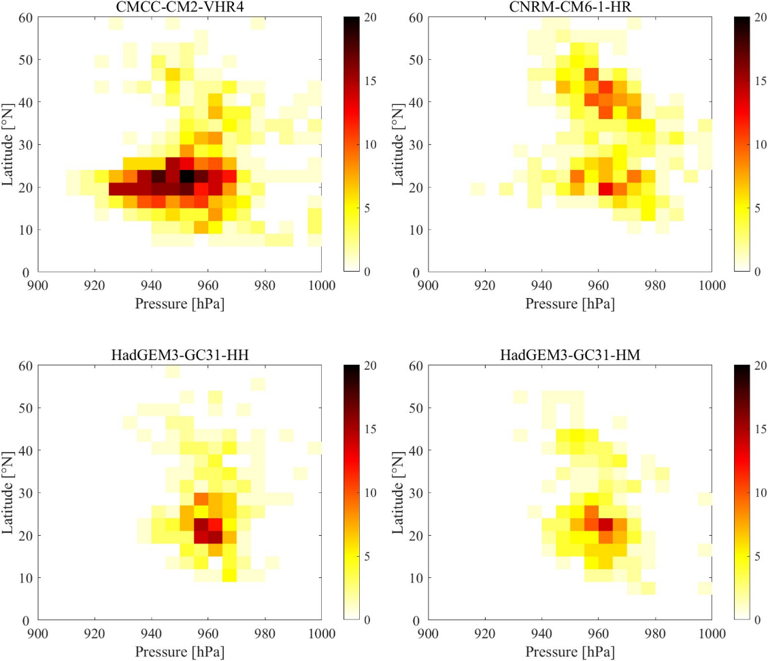
Appendix A
Figure A-1: Frequency of strong typhoons as a function of SLP and latitude in the WNP based HighResMIP of Atmosphere-Ocean Coupled Global Climate Model by TRACK method extraction

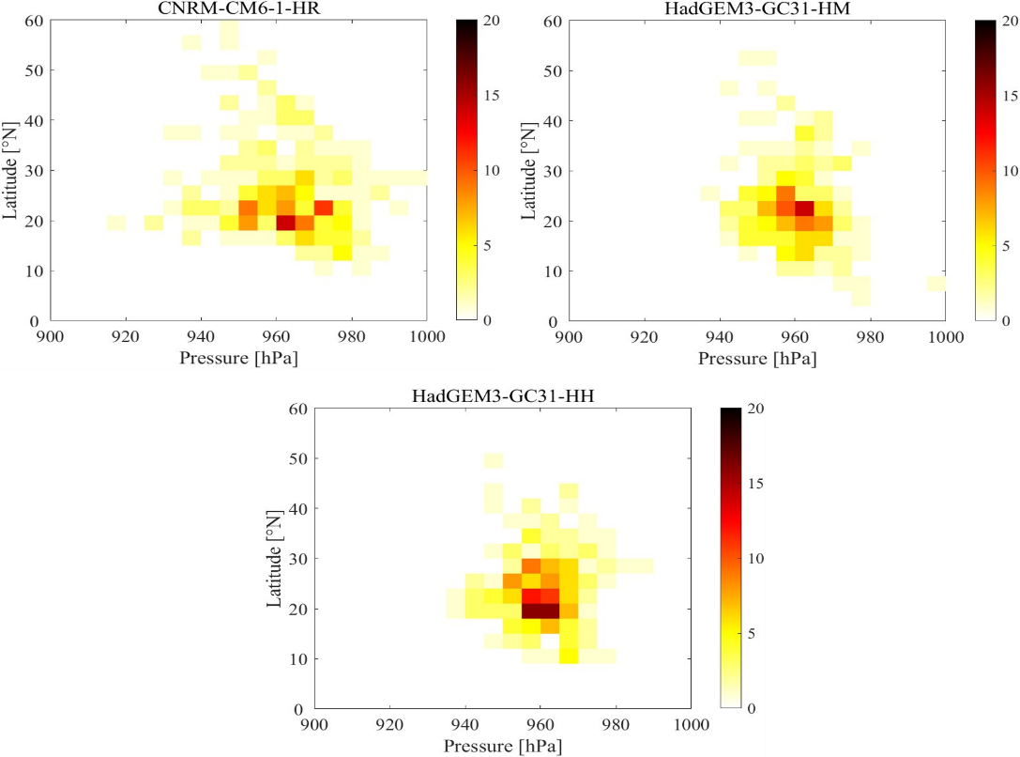
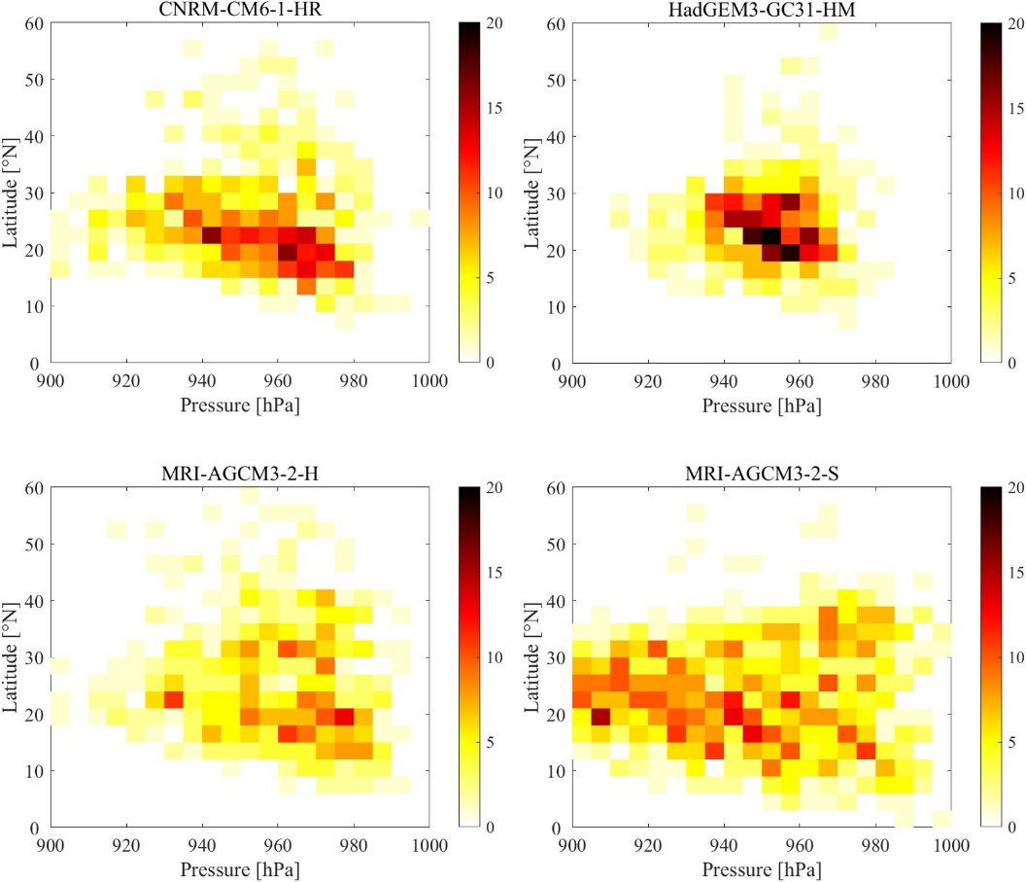
Figure A-2: Frequency of strong typhoons as a function of SLP and latitude in the WNP based on HighResMIP of by TempestExtremes method extraction
(b): Atmosphere-Ocean Coupled Global Climate Model
(a): Atmospheric Global Climate Model

