Fig. S1. Viable cross using STS-induced male flowers. A genetic cannabis female plant (XX) treated with silver thiosulfate (STS) to produce induced male flowers was used as the pollen donor and crossed with an untreated female plant (XX). The cross yielded viable seed that germinated normally.

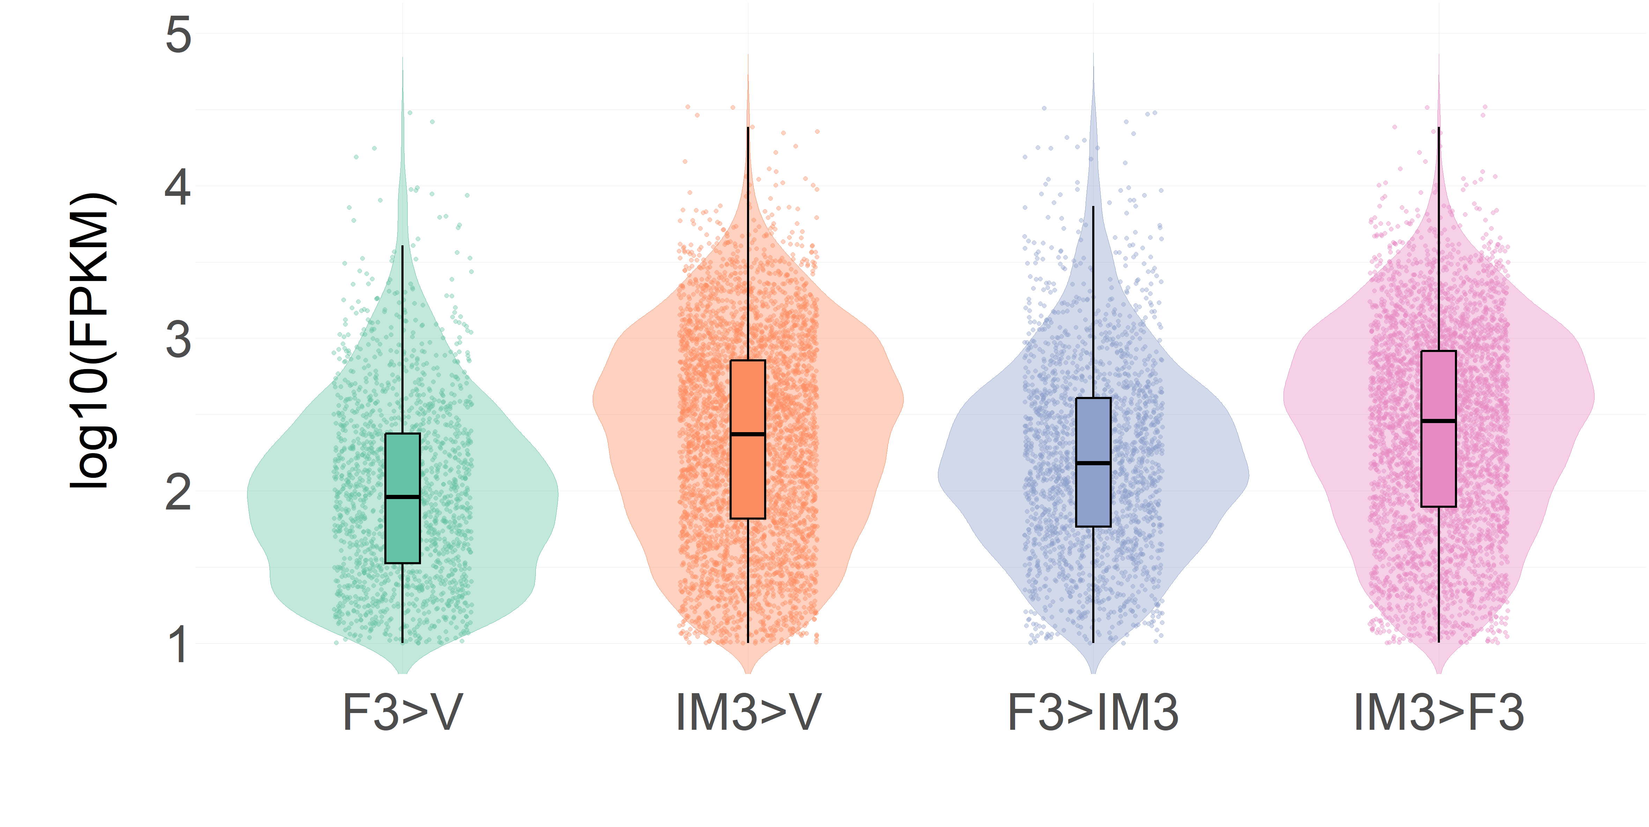

Fig. S2. Violin plot of differential gene expression in vegetative, female, and induced male Cannabis sativa. Violin plot showing the distribution of gene expression values (log₁₀-transformed FPKM) for differentially expressed genes (DEGs) in vegetative (V), female (F), and induced male (IM) Cannabis plants at three weeks post flower initiation. Four pairwise comparisons were analyzed: F3 > V, IM3 > V, F3 > IM3, and IM3 > F3. DEGs were defined as genes with FPKM > 1, |log₂ fold change| > 1, and p-value < 0.05. Overlaid black boxplots represent the interquartile range (IQR), with bold horizontal lines indicating the median. Violin shapes are filled, and scatter points are colored according to treatment group. The Y-axis represents log₁₀-transformed FPKM values.

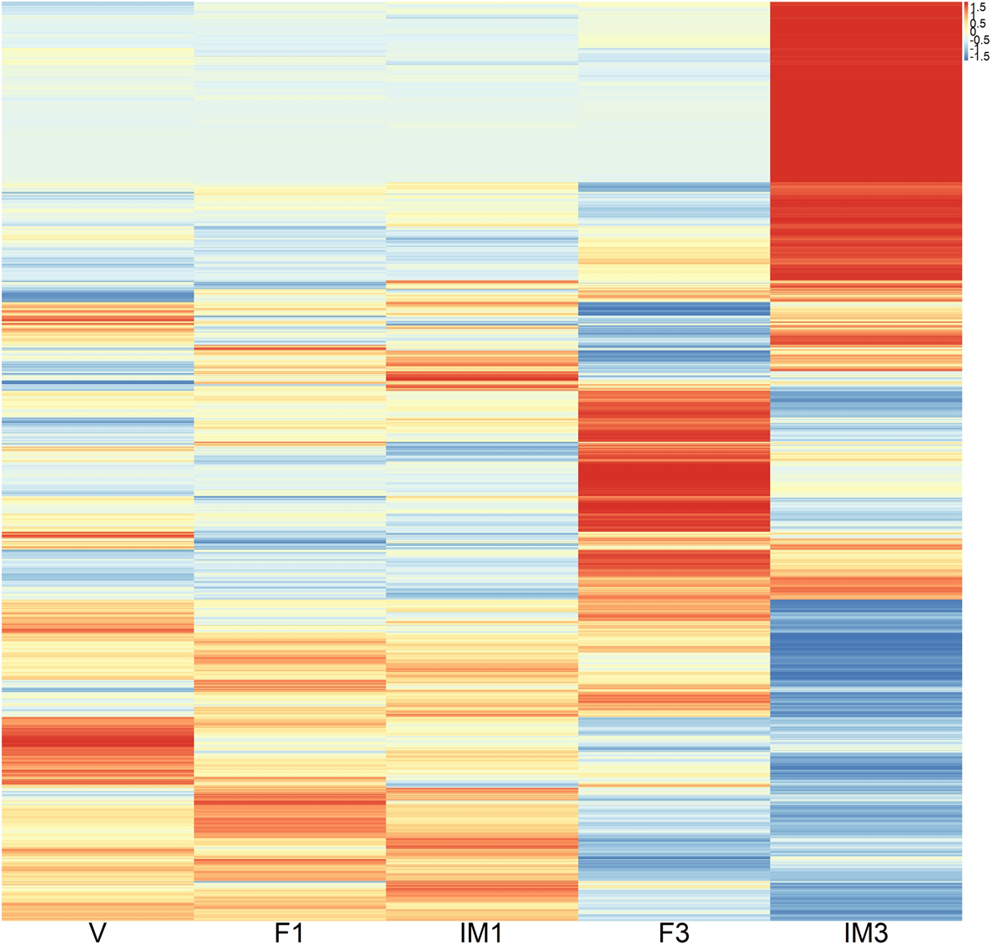
Fig. S3. Heatmap clustering analysis of total gene expression in vegetative (V), female (F), and induced male (IM) Cannabis plants at one- and three-weeks post flower initiation. A total of 18,312 genes with expression levels of FPKM > 1 were included in the analysis.

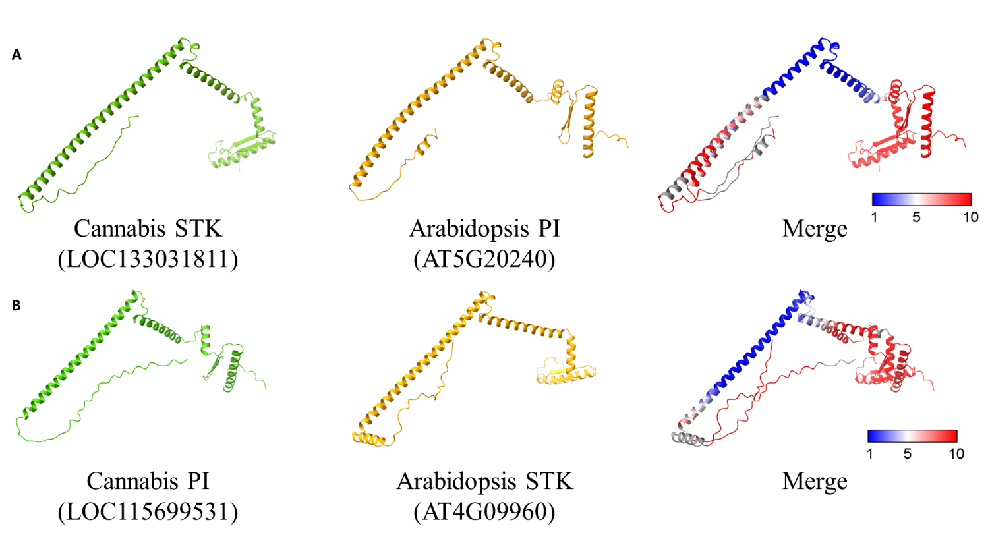
Fig. S4. Structural comparison of PISTILLATA (PI) and SEEDSTICK (STK) proteins in Cannabis sativa and Arabidopsis thaliana. Predicted structures of Cannabis PI and STK (via AlphaFold2) were compared with their Arabidopsis counterparts obtained from the AlphaFold database. (A) Structural alignment of Cannabis STK with Arabidopsis PI. (B) Structural alignment of Cannabis PI with Arabidopsis STK. The colour scale represents RMSD values from pairwise structural alignment.

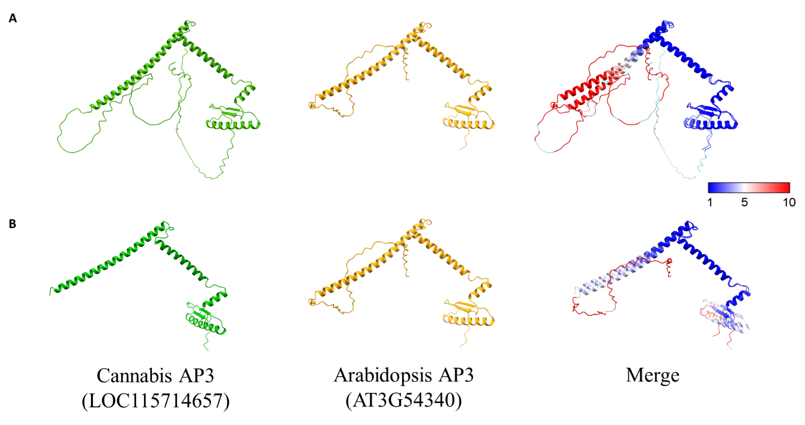
Fig. S5. Structural comparison of APETALA3 (AP3) proteins in Cannabis sativa and Arabidopsis thaliana. The predicted structure of Cannabis AP3 (using AlphaFold2) was compared with the Arabidopsis AP3 structure obtained from the AlphaFold database. (A) Structural comparison of the full-length proteins. (B) Structural comparison of Cannabis AP3 (residues 50–224 amino acids, including only the MADS and K domains) with the full-length Arabidopsis AP3 protein. The colour scale represents RMSD values from the pairwise structural alignment.

Table S5. A list of PI, STK, and SHP1 proteins used for the phylogenetic tree. Species marked in red indicate validated proteins.
Gene | Species | Accession number | Validated reference
PI | Alpinia hainanensis | AY621156 | (Li et al., 2022; Song et al., 2010)
PI | Arabidopsis thaliana | AT5G20240 | (Goto and Meyerowitz, 1994)
PI | Aristolochia fimbriata | ALV83436.1 | (You et al., 2022)
PI | Asparagus officinalis L. | AB103465 | (Park et al., 2004)
PI | Cannabis sativa | LOC115699531
PI | Carica papaya L. | EF562500 | (Ackerman et al., 2008)
PI | Cucumis sativus | AF043255 | (Park et al., 2004)
PI | Eschscholzia californica | ABN55897.1 | (You et al., 2022)
PI | Euptelea pleiosperma | ADC79697.1 | (You et al., 2022)
PI | Fagopyrum esculentum | OM032616.1 | (You et al., 2022)
PI | Lilium longiflorum | AEI88009.1 | (You et al., 2022)
PI | Liriodendron tulipifera | AIE44761.1 | (You et al., 2022)
PI | Magnolia wufengensis | AFM75882.1 | (You et al., 2022)
PI | Medicago truncatula | ACJ36229.1 | (You et al., 2022)
PI | Petunia x hybrida | M91190 | (Park et al., 2004)
PI | Spinacia oleracea | AY604515 | (Pfent et al., 2005)
PI | Vitis vinifera | DQ988043 | (Poupin et al., 2007)
STK | Arabidopsis thaliana | AT4G09960 | (Rounsley et al., 1995)
STK | Aristolochia fimbriata | ALV83434 | (Ma et al., 2019)
STK | Asparagus virgatus | BAD83772 | (Ma et al., 2019)
STK | Cannabis sativa | LOC133031811
STK | Cucumis sativus | AAC08529 | (Ma et al., 2019)
STK | Eschscholzia californica | AAZ53207 | (Ma et al., 2019)
STK | Euptelea pleiosperma | QDF82829 | (Ma et al., 2019)
STK | Lilium longiflorum | AAS01766 | (Ma et al., 2019)
STK | Liriodendron chinense | QDF82820 | (Ma et al., 2019)
STK | Magnolia wufengensis | QDF82828 | (Ma et al., 2019)
STK | Petunia x hybrida | CAA57311 | (Ma et al., 2019)
STK | Vitis vinifera | AUJ18467 | (Ma et al., 2019)
SHP1 | Arabidopsis thaliana | AT3G58780 | (Pinyopich et al., 2003)
SHP1 | Cannabis sativa | LOC115698701
SHP1 | Medicago ruthenica | JX297568 | (Fourquin et al., 2013)

References
Ackerman, C.M., Yu, Q., Kim, S., Paull, R.E., Moore, P.H., Ming, R., 2008. B-class MADS-box genes in trioecious papaya: Two paleoAP3 paralogs, CpTM6-1 and CpTM6-2, and a PI ortholog CpPI. Planta 227, 741–753. https://doi.org/10.1007/s00425-007-0653-5
Fourquin, C., del Cerro, C., Victoria, F.C., Vialette-Guiraud, A., de Oliveira, A.C., Ferrándiz, C., 2013. A change in SHATTERPROOF protein lies at the origin of a fruit morphological novelty and a new strategy for seed dispersal in Medicago genus. Plant Physiol 162, 907–917. https://doi.org/10.1104/pp.113.217570
Goto, K., Meyerowitz, E.M., 1994. Function and regulation of the Arabidopsis floral homeotic gene PISTILLATA. Genes Dev 8, pp.1548-1560. https://doi.org/10.1101/gad.8.13.1548
Li, X., Kuang, Y., Ye, Y., Chen, Z., Zhang, M., 2022. Diverse function of the PISTILLATA, APETALA 3, and AGAMOUS-like MADS-box genes involved in the floral development in Alpinia hainanensis (Zingiberaceae). Gene 839. https://doi.org/10.1016/j.gene.2022.146732
Ma, J., Deng, S., Jia, Z., Sang, Z., Zhu, Z., Zhou, C., Ma, L., Chen, F., 2019. Conservation and divergence of ancestral AGAMOUS/SEEDSTICK subfamily genes from the basal angiosperm Magnolia wufengensis. Tree Physiol 40, 90–107. https://doi.org/10.1093/treephys/tpz091
Park, J.-H., Ishikawa, Y., Ochiai, T., Kanno, A., Kameya, T., 2004. Two GLOBOSA-Like Genes are Expressed in Second and Third Whorls of Homochlamydeous Flowers in Asparagus officinalis L, Plant Cell Physiol.
Pfent, C., Pobursky, K.J., Sather, D.N., Golenberg, E.M., 2005. Characterization of SpAPETALA3 and SpPISTILLATA, B class floral identity genes in Spinacia oleracea, and their relationship to sexual dimorphism. Dev Genes Evol 215, 132–142. https://doi.org/10.1007/s00427-004-0459-4
Pinyopich, A., Ditta, G.S., Savidge, B., Liljegren, S.J., Baumann, E., Wisman, E., Yanofsky, M.F., 2003. Assessing the redundancy of MADS-box genes during carpel and ovule development. Nature 424. https://doi.org/10.1038/nature01741
Poupin, M.J., Federici, F., Medina, C., Matus, J.T., Timmermann, T., Arce-Johnson, P., 2007. Isolation of the three grape sub-lineages of B-class MADS-box TM6, PISTILLATA and APETALA3 genes which are differentially expressed during flower and fruit development. Gene 404, 10–24. https://doi.org/10.1016/j.gene.2007.08.005
Rounsley, S.D., Ditta, G.S., Yanofsky’, M.F., 1995. Diverse Roles for MADS Box Genes in Arabidopsis Development, The Plant Cell. American Society of Plant Physiologists.
Song, J.J., Ma, W., Tang, Y.J., Chen, Z.Y., Liao, J.P., 2010. Isolation and characterization of three MADS-box Genes from Alpinia hainanensis (Zingiberaceae). Plant Mol Biol Report 28, 264–276. https://doi.org/10.1007/s11105-009-0147-7
You, W., Chen, X., Zeng, L., Ma, Z., Liu, Z., 2022. Characterization of PISTILLATA-like Genes and Their Promoters from the Distyly Fagopyrum esculentum. Plants 11. https://doi.org/10.3390/plants11081047

