Figure S1
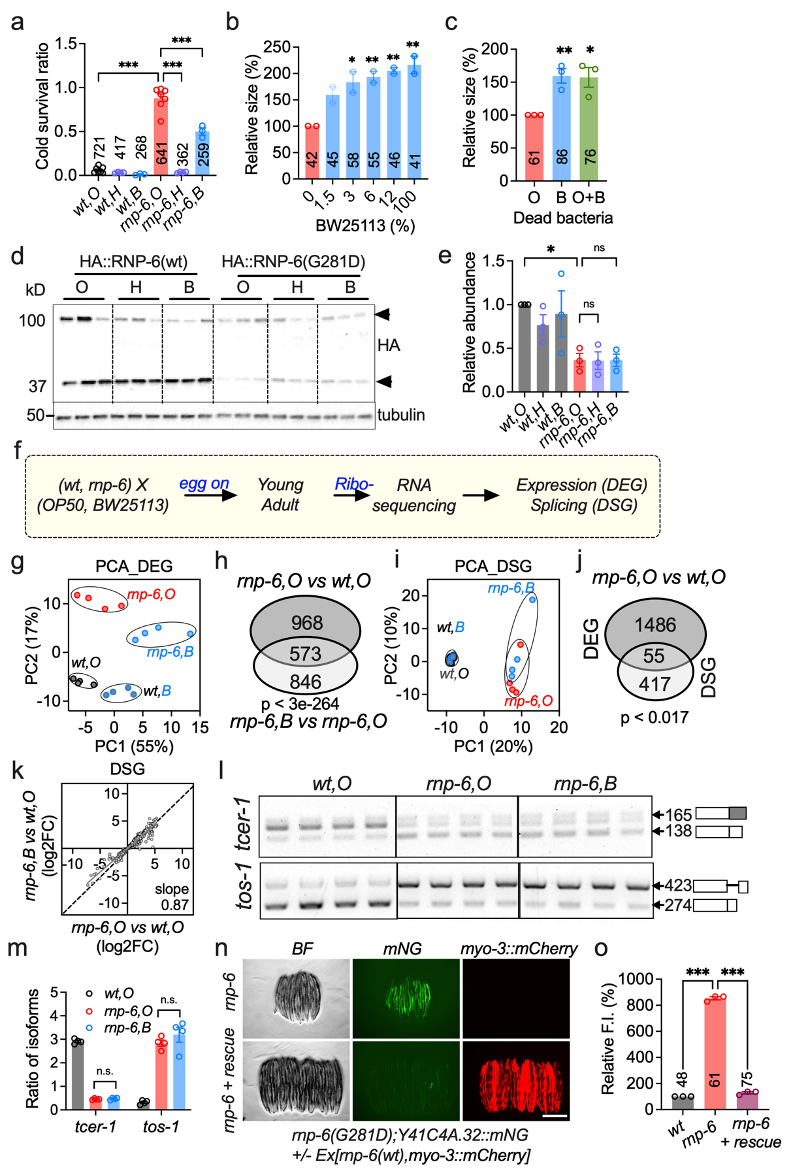
Figure S1. A bacterial E. coli K12 diet mitigates developmental defects in an rnp-6/VRJS C. elegans model. a, Assessment of cold tolerance in worms fed E. coli K12 strains; bars represent the ratio of alive to dead worms per genotype and diet after cold shock (n = 3–7). b, Evaluation of BW25113 dilution effects on worm body size (n = 2). c, Body size of rnp-6 mutant worms fed UV-killed BW25113 and OP50-BW25113 (ratio 1:1) mixture (n = 3). d–e, Total RNP-6 protein abundance in response to K12 diets. The total amounts of two predominant RNP-6 isoforms (as denoted by arrowheads) were quantified (n = 3). f, Overview of RNA sequencing experimental design. Ribo-, ribosomal RNA depletion. g, Principal component analysis of differentially expressed genes (DEG), four biological replicates were analyzed for each condition. h, Venn diagram of DEGs changed by rnp-6 mutation on OP50 and BW25113. i, Principal component analysis of differentially spliced genes (DSG). j, Overlap between DEGs and DSGs, shown by Venn diagram. k, Effect of BW25113 E. coli on alternative splicing; shown are 638 events significantly altered by rnp-6(G281D) on OP50. l–m, RT-PCR splicing analyses of tos-1 and tcer-1 (n = 4). n–o, Effect of rnp-6(wt) overexpression on Y41C4A.32::mNG reporter expression. myo-3::mCherry co-injection marker indicates transgenic animals (n = 3, scale bar: 500 μm). Data are presented as mean ± s.e.m. unless otherwise indicated; “n” denotes experimental replicates, with animal counts summarized in each respective bar. Statistical significance was determined using one-way ANOVA with Dunnett’s multiple comparisons (a, b, c, e, m, o). All the source data for figures are provided in supplementary tables.
Figure S2
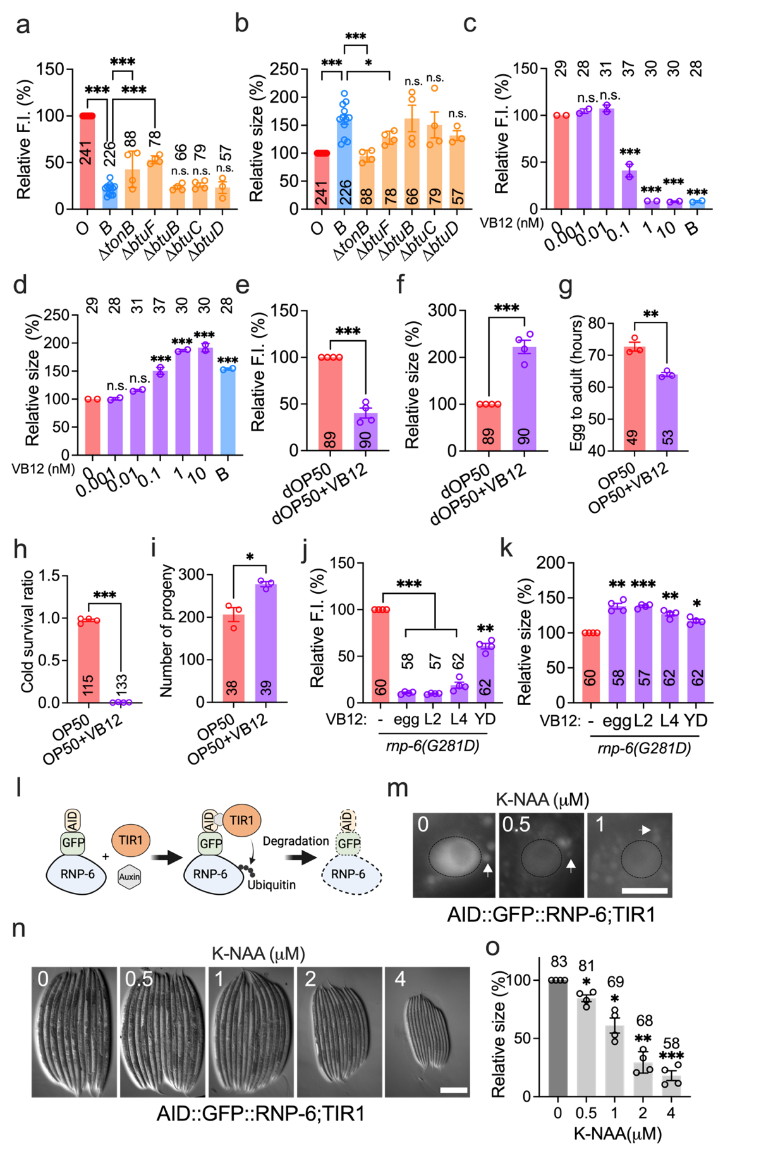
Figure S2. A complementary two-way genetic screen identifies vitamin B₁₂ as an alleviator of rnp-6(G281D) mutant defects. a–b, Effects of alternative vitamin B₁₂ transporters on Y41C4A.32 reporter expression (a) and body size (b) in rnp-6(G281D) mutants (n = 4–12). c–d, Dose-response effects of vitamin VB12 supplementation on rnp-6(G281D) phenotypes (n = 2). e–f, Impact of VB12 supplementation in rnp-6(G281D) mutants fed UV-killed OP50 (n = 4). g–i, Effects of VB12 supplementation on developmental rate (g, n = 3), cold tolerance (h, n = 4), and brood size (i, n = 3). j–k, Effects of VB12 supplementation administered from distinct developmental stages on Y41C4A.32 reporter expression (j) and body size (k) in rnp-6(G281D) mutants (n = 4). Worms were imaged on day 2 of adulthood. l, Schematic illustrating the RNP-6 inducible degradation system. The image was made in BioRender. m, Effects of K-NAA supplementation on GFP::RNP-6 fluorescence intensity on OP50 (scale bar: 10 μm). The nuclei of the intestine are indicated with circles. The arrows indicate gut autofluorescent granules. n–o, Impact of various K-NAA concentrations on worm body size on OP50 (n = 4, scale bar: 200 μm). The final concentration of VB12 is 1 nM unless otherwise noted. Statistical significance was determined using one-way ANOVA with Dunnett’s multiple comparisons. Significance is represented as *P < 0.05, **P < 0.01, ***P < 0.001, n.s.: not significant.
Figure S3
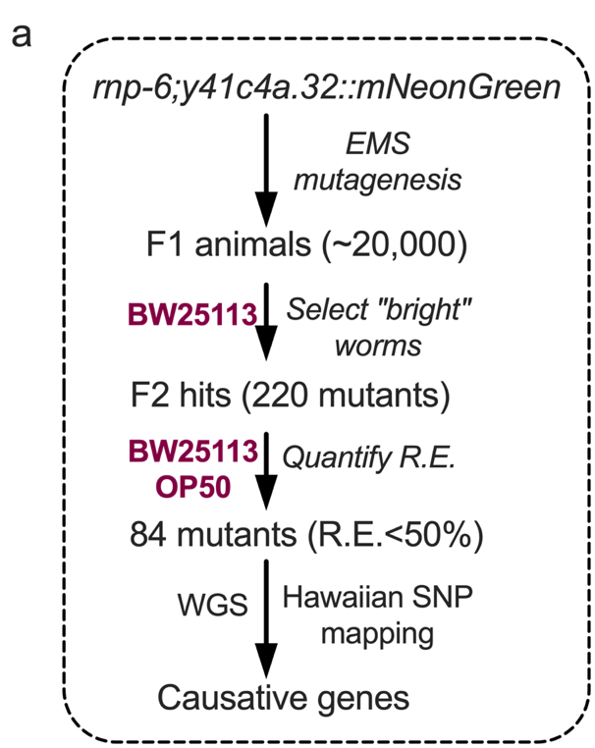
Figure S3. Vitamin B₁₂ alleviates rnp-6(G281D) mutant defects via methionine metabolism pathways. a, Schematic of EMS mutagenesis screen for host factors. R.E. (rescue efficacy) = (Fluorescent intensity on OP50 - Fluorescent intensity on BW25113)/ Fluorescent intensity on OP50.

Figure S4
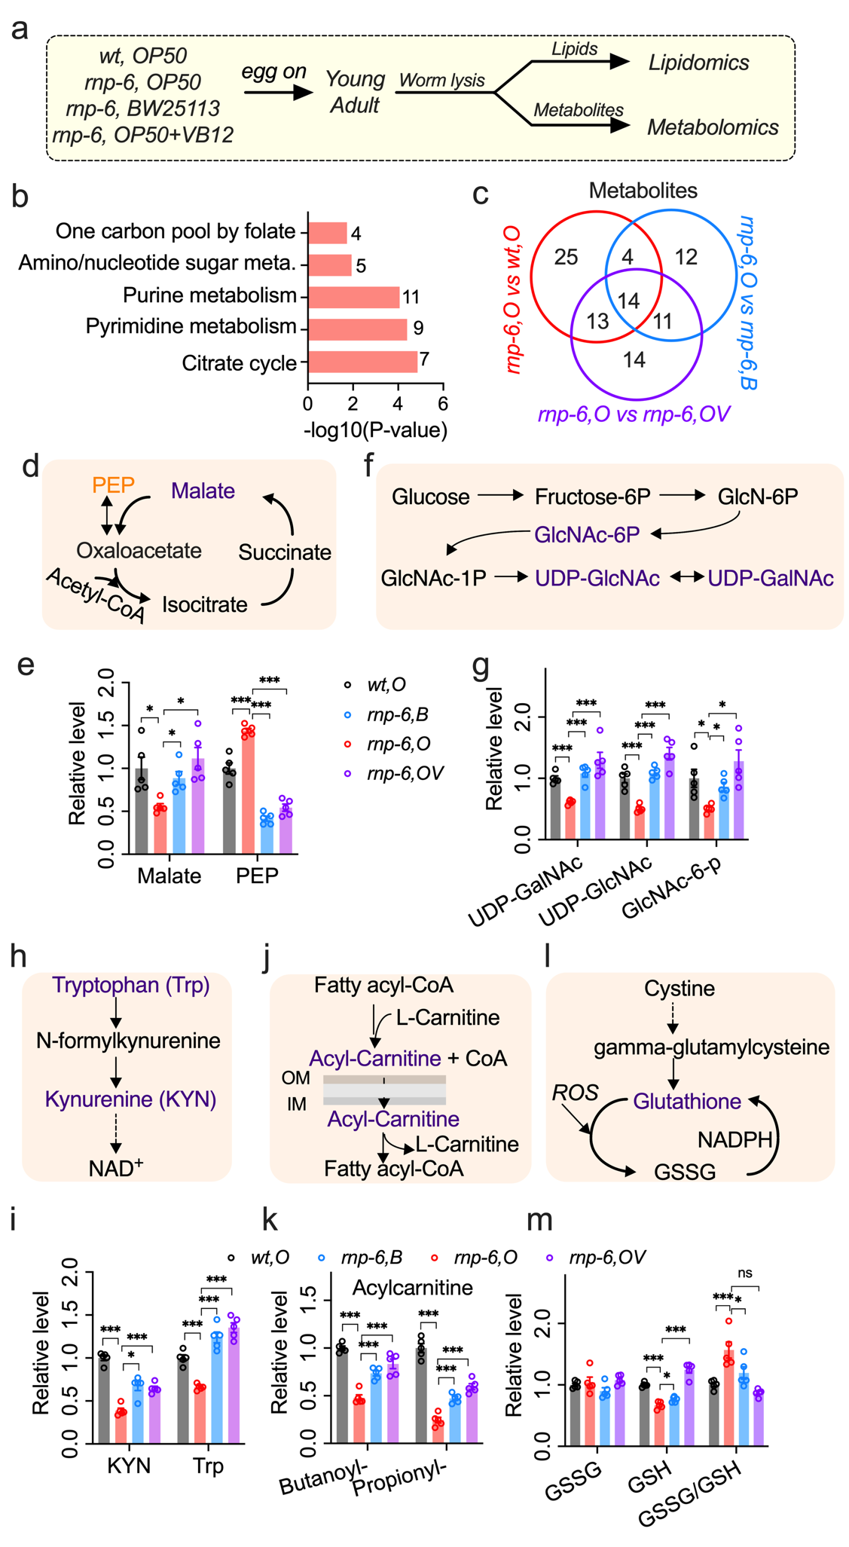
Figure S4. Vitamin B₁₂ restores methylation potential and phosphatidylcholine metabolism in rnp-6 mutants. a, Workflow for metabolomic and lipidomic analyses. Five replicates per condition. b, MetaboAnalyst-based pathway analysis of metabolites significantly altered in rnp-6(G281D) mutants. c, Venn diagram of significantly altered metabolites. Simplified schematics and abundance changes are shown for the following pathways: d–e, tricarboxylic acid (TCA) cycle; f–g, amino sugar and nucleotide sugar metabolism; h–i, kynurenine pathway; j–k, mitochondrial fatty acid metabolism; l–m, glutathione metabolism. Statistical significance was determined using one-way ANOVA with Dunnett’s multiple comparisons. Significance is represented as *P < 0.05, **P < 0.01, ***P < 0.001, n.s.: not significant.

Figure S5
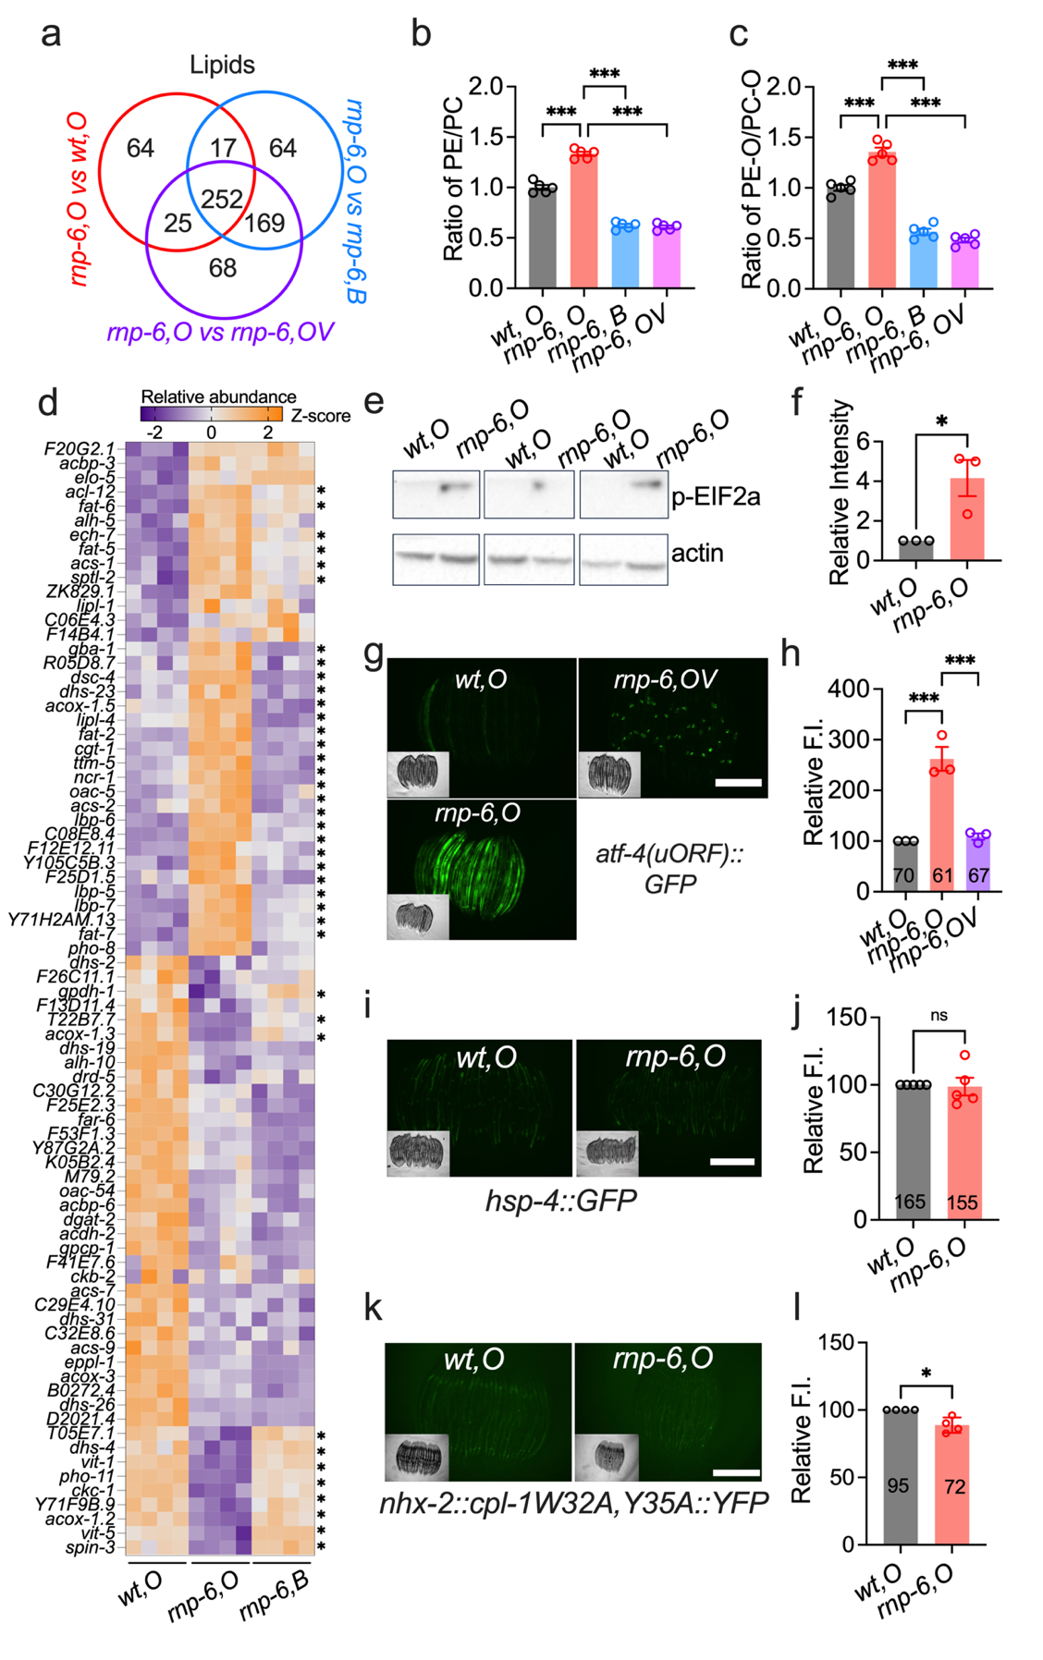
Figure S5. Vitamin B₁₂ restores phosphatidylcholine metabolism and the integrated stress response in rnp-6 mutants. a, Venn diagram of significantly altered lipid species. b, Ratio of phosphatidylethanolamine (PE) to phosphatidylcholine (PC) changes. c, Ratio of ether-linked PE (PE-O) to ether-linked PC (PC-O) changes. d, Heat map of differentially expressed genes (DEGs) associated with lipid metabolism; “*” denotes genes significantly restored by BW25113 diet. e–f, Western blot analysis of eIF2α phosphorylation in rnp-6 mutants, with three biological replicates analyzed (n = 3). g–h, Representative images and quantification of ISR reporter strain atf-4(uORF)::GFP expression (scale bar: 500 μm). i–j, Representative images and quantification of unfolded protein response of the endoplasmic reticulum (UPR^{ER}) reporter strain hsp-4::GFP expression (n = 5, scale bar: 500 μm). k–l, Representative images and quantification of CPL-1 reporter strain cpl-1W32A,Y35A::YFP expression (n = 4, scale bar: 500 μm). Statistical significance was determined using unpaired t-test (f, j, l) and one-way ANOVA with Dunnett’s multiple comparisons (h). Significance is represented as *P < 0.05, **P < 0.01, ***P < 0.001, n.s.: not significant.
Figure S6
Figure S6. rnp-6 mutant defects are primarily caused by aberrant splicing of transcription factor nhr-114. a, Gene set enrichment analysis of differentially spliced genes involved in metabolism, performed with WormCat 2.0. b–c, Quantification of Y41C4A.32::mNG fluorescence intensity and worm body size after nhr-114 RNAi (n = 5) treatment. d, Quantification of nhr-114 intron 4 retention in rbm-39(S294L) mutants from RNAseq data. n=3. e, Venn diagram illustrating differentially expressed genes in the nhr-114 deletion mutant and the rnp-6 mutant. f, Venn diagram illustrating genes that are differentially spliced. g, Wormcat gene set enrichment analysis of the overlapped genes in (e). h, Venn diagram of differentially expressed genes significantly rescued by either VB12 supplementation in nhr-114 deletion mutants or BW25113 diet in rnp-6 mutants. i–j, RT-PCR analysis of nhr-114 intron 4 retention in different nhr-114 gene editing mutants. nhr-114(+) results in almost complete intron retention; one biological replicate for rnp-6; nhr-114(i4+) was excluded from quantification due to technical failure (n = 3–4). Statistical significance was determined using unpaired t-test (b, c) and one-way ANOVA with Dunnett’s multiple comparisons (d, i). Significance is represented as *P < 0.05, **P < 0.01, ***P < 0.001, n.s.: not significant.
Figure S7
Figure S7. prp-19 inhibition dysregulates metabolism. a, Volcano plot of differentially expressed genes caused by prp-19 RNAi. The red and green dots indicate Y41C4A.32 and nhr-114, respectively. b, Wormcat enrichment analysis of differentially expressed genes. c, Heatmap of differentially expressed genes related to 1CC and phospholipid metabolism. d, Pie chart of differentially spliced genes caused by prp-19 RNAi. e, Wormcat enrichment analysis of differentially spliced genes. f, Heatmap of differentially spliced genes related to 1CC and phospholipid metabolism. g, Representative images of Y41C4A.32::mNG upon prp-19 RNAi treatment (scale bar: 500 μm). h, Quantification of Y41C4A.32::mNG fluorescent intensity upon prp-19 RNAi treatment. i, Quantification of body size upon prp-19 RNAi treatment. j-k, Quantification of nhr-114 intron 4 retention and expression levels in ARD worms, analyzed by RNA-seq (n = 4). Statistical significance was determined using unpaired t-test (j, k) and one-way ANOVA with Dunnett’s multiple comparisons (h, i). Significance is represented as *P < 0.05, **P < 0.01, ***P < 0.001, n.s.: not significant.
Figure S8

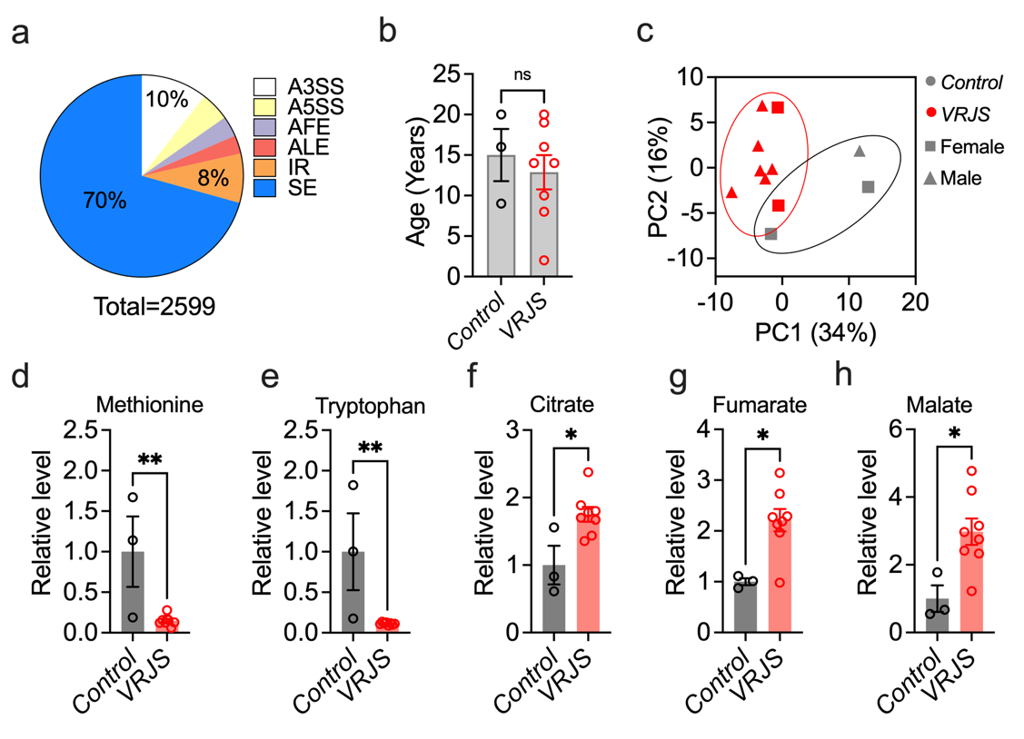
Figure S8. PUF60 deficiency impairs 1CC and phospholipid metabolism in human cells. a, Pie chart displaying differentially spliced events in the siPUF60-treated PC9 cell line. b, Age distribution of individuals for blood samples. c, PCA analysis of metabolomic and lipidomic data. d-h, The relative abundance of methionine (d), tryptophan (e), citrate (f), fumarate (g) and malate (h) in VRJS patient plasma. Statistical significance was determined using unpaired t-test Significance is represented as *P < 0.05, **P < 0.01, ***P < 0.001, n.s.: not significant.

Figure S9

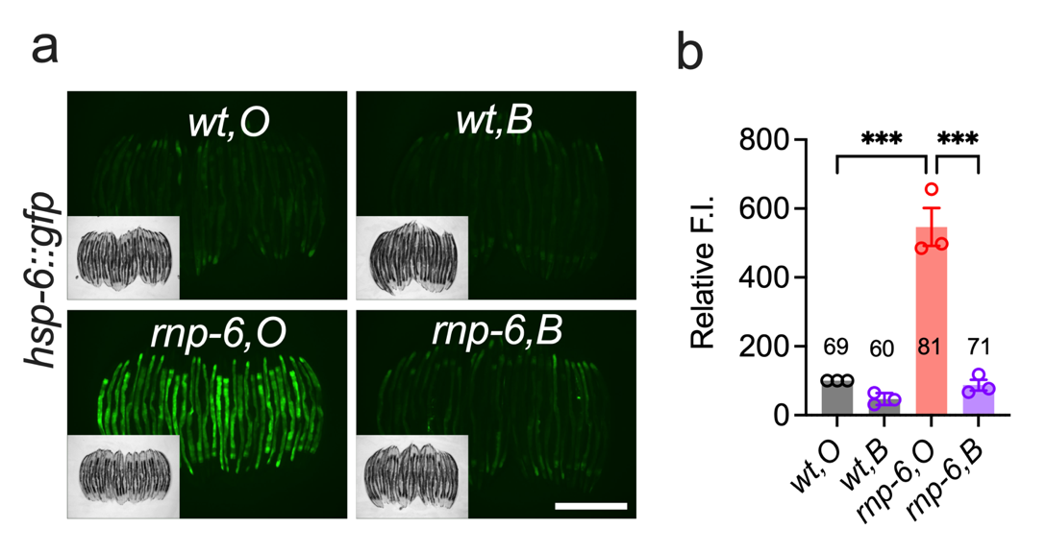

Figure S9. E. coli BW25113 alleviates mitochondrial stress in rnp-6(G281D) mutants. a, Representative images of hsp-6::gfp expression in rnp-6 mutants. Scale bar, 500 μm. n=3. b, Quantification of hsp-6::gfp fluorescent intensity. One-way ANOVA with Dunnett’s multiple comparison test was used for statistical analysis. ***P < 0.001.

