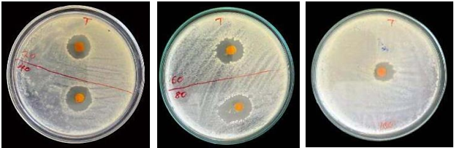
A
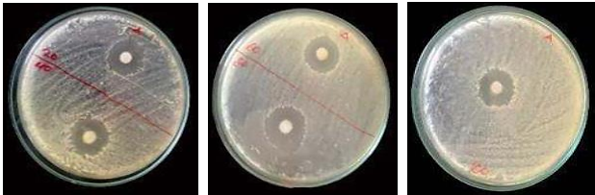
B
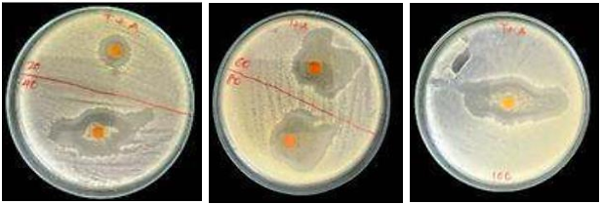

C
Plate 1: Antimicrobial activity against S. aureus at different concentrations (20, 40, 60, 80 and 100mg/ml) of A (turmeric extract), B (ampicillin), and C (combination of turmeric extract and ampicillin).

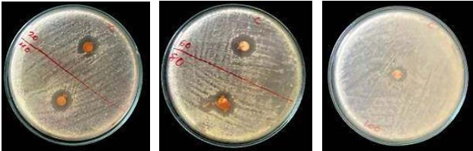
A

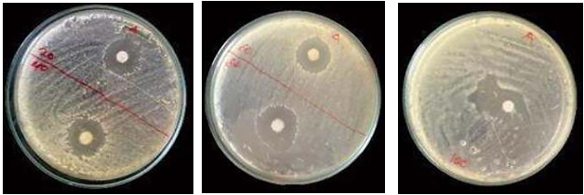
B
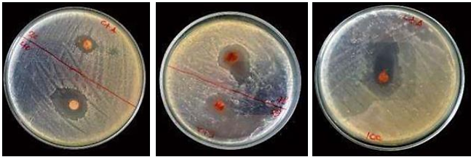
C
Plate 2: Antimicrobial activity against E. coli at different concentrations (20, 40, 60, 80 and 100mg/ml) of A (cinnamon extract), B (ampicillin) and C (combination of cinnamon extract and ampicillin).

