Additional File 1
Table 1: Checklist of Questionnaire Content: Individual Information, active TB disease Symptoms and procedural questions
Type of question | Question | Response
Procedural question* | Surveillance Unit corresponding to the place where the patient lives | Open-ended
Procedural question* | Screening place | Multiple choice
Procedural question* | Team who’s filling the questionnaire | Open-ended
Procedural question* | Name and surname | Open-ended
Procedural question* | ID number** | Open-ended
Demographics | Age | Open-ended
Demographics | Sex | Multiple choice
Demographics | Phone number | Open-ended
Demographics | Patient’s risk group | Multiple choice
Demographics | Does the patient have any additional risk factors, such as chronic respiratory disease, diabetes, smoking, malnutrition, chronic renal insufficiency, immunodeficiency, advanced age, or pregnancy? | Multiple choice
Demographics | Country of origin | Multiple choice
Demographics | When did you come to Catalonia/Barcelona? | MM/YYYY
Demographics | Since you are in Barcelona, how many times have you travelled to your country of origin? | Open-ended
TB symptoms | Do you have any symptoms? | Yes/No
TB symptoms | Which of the following symptoms have you experienced in the past two weeks?
TB symptoms | Cough for more than 2 weeks | Yes/No
TB symptoms | Subfebrile temperature or fever | Yes/No
TB symptoms | Night sweats | Yes/No
TB symptoms | Weight loss | Yes/No
TB symptoms | Chills | Yes/No
TB symptoms | When did these symptoms start? | DD/MM/YYYY
Procedural question* | Is this patient being referred to the TB Unit? | Yes/No
Procedural question* | TB Unit responsible for the TB patient. | Open-ended
Procedural question* | Has the individual been referred for an additional diagnostic session for a CXR scan? | Yes/No
Procedural question* | Has the CXR been performed? | Yes/No
Procedural question* | CXR result | Open-ended
Procedural question* | Has the patient been diagnosed with TB? | Yes/No
Procedural question* | Has any microbiological sampling been made? (ZN, culture, GeneXpert®) | Yes/No
Procedural question* | Has the TB been microbiologically confirmed? | Yes/No
Procedural question* | Has additional microbiological sampling been done for other infectious diseases | Multiple choice
Procedural question* | Has this patient previously received TB treatment? | Yes/No
Procedural question* | If yes, when did the treatment start? | DD/MM/YYYY
Procedural question* | Did this treatment finish successfully? | Yes/No
Procedural question* | If TB is confirmed, has a contact study been conducted? | Yes/No
Procedural question* | If the study of the contacts was made, how many people have been screened? | Open-ended
*Depending on the procedure, the questions are completed either by interviewers or by employees of the Public Health Agency of Barcelona.
**The ID number requested refers to any available identifier provided by the respondent, such as a national ID, passport number, or any other relevant identification number.
CXR: chest X-ray, TB: tuberculosis, ZN: Ziehl–Neelsen stain.
Questions related to TB symptoms were developed according to the WHO-recommended sequential positive serial screening algorithm [1]. Additional demographic and procedural items were designed by the working group and adapted to the local context

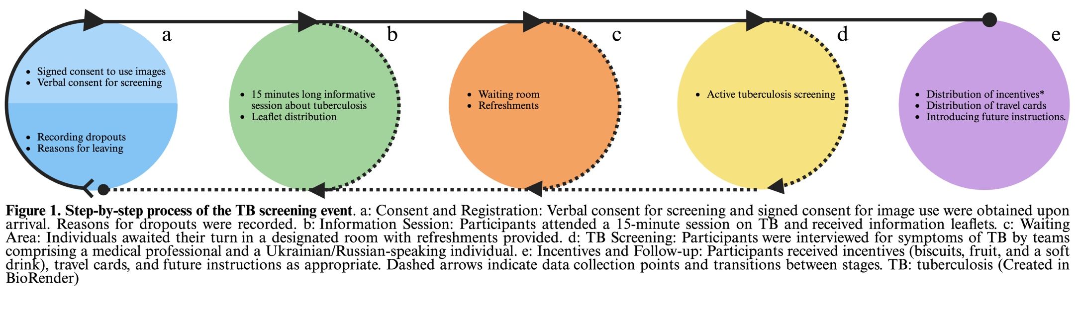

References:
- WHO operational handbook on tuberculosis. Module 2: screening - systematic screening for tuberculosis disease. Geneva: World Health Organization; 2021. Licence: CC BY-NC-SA 3.0 IGO. Available at: https://www.who.int/publications/i/item/9789240022614

