Ionic Complex Engineered Topologically Reconfigurable Salt-Resistant Hydrogels with Simultaneously Enhanced Swelling and Mechanical Properties
Lingling Ren¹, Guoxuan Ma¹, Zheng Wang¹, Shuang Liu¹, Haoran Cheng²*, David A. Weitz³, Liyuan Zhang¹*
1 State Key Laboratory of Deep Oil and Gas, Shandong Key Laboratory of Oil and Gas Field Chemistry, School of Petroleum Engineering, China University of Petroleum (East China), Qingdao 266580, China;
2 College of Chemical Engineering, Qingdao University Science and Technology, Qingdao 266042, China.
3 School of Engineering and Applied Sciences, Department of Physics, Harvard University, Cambridge, Massachusetts 02138, United States.

Address correspondence to: liyuanzhang@upc.edu.cn , chenghaoran@qust.edu.cn

Experimental
Materials
Acrylamide (AM, 99%),2-Acrylamide-2-methylpropanesulfonic acid (AMPS, 98%), 1-vinylimidazole (99%), 1,3-propane sultone (99%), acetonitrile (99%), Poly(ethylene glycol) diacrylate 700 (PEGDA700), mineral oil (25cSt), methyl blue, and Sudan III are purchased from Aladdin. α-Ketoglutaric acid (KA, 98%) is obtained from Macklin. All chemicals and reagents are used as received.
Preparation of zwitterionic monomers
The zwitterionic monomers (sulfobetaine vinylimidazole, SBVI) are synthesized by quaternization reaction following the modified procedures reported in the literature. Vinylimidazole (0.2M) and 1,3-propane sultone (0.25M) are dissolved in acetonitrile. The mixture is thoroughly stirred, followed by purging with nitrogen gas to remove oxygen from the solution. Then, the flask is sealed and allowed to react at 40 °C for 24 h. After the reaction, the resulting precipitate is collected, washed with alcohol, and dried at 45 °C in the oven.
Preparation of the single-network hydrogels
Taking the single-network AMPS (S_{AMPS}) hydrogel as an example, appropriate amounts of AMPS were dissolved in deionized water, followed by the addition of the crosslinker PEGDA700 and the initiator KA. The mixture was thoroughly mixed to obtain the prepolymer solution of the single-network hydrogels. This prepolymer solution was then injected into a custom-made glass mold and irradiated under a 365 nm ultraviolet lamp for 30 minutes to complete the polymerization reaction. The detailed preparation formula of the single-network hydrogels is shown in Table S1. Other single-network hydrogels (S_{AM-SBVI} and S_{AM-AMPS-SBVI}) are prepared following the same procedure.
Table S1. The detailed preparation formula of the single-network hydrogels
AMPS/g | KA/g | PEGDA/g
2.07 | 0.01 | 0.0084
2.07 | 0.01 | 0.041
2.07 | 0.01 | 0.062
2.07 | 0.01 | 0.082
Preparation of topologically reconfigurable salt-resistant DN hydrogels
The Topologically Reconfigurable Salt-Resistant Hydrogels are engineered with a microphase-separated double-network structure and fabricated through a two-step soaking method involving free radical polymerization. The detailed preparation formula for the topologically reconfigurable salt-resistant hydrogels is provided in Supplementary Table 3. In brief, the preparation of the first network follows the same procedure as that of the single-network hydrogels. Subsequently, the first network hydrogel is precisely cut into gel pieces of uniform shape and mass using a dumbbell-shaped spline. These pieces are then immersed in a specific amount of the second network prepolymer solution, which consists of monomers AM and SBVI, minimal crosslinker PEGDA700, and initiator KA. After the hydrogels have fully absorbed the second network prepolymer, they are irradiated under a 365 nm ultraviolet lamp for 40 minutes to obtain the Topologically Reconfigurable Salt-Resistant Hydrogels (D_{AMPS/AM-SBVI}). The detailed preparation formula of the DN hydrogels is shown in Table S2.
Table S2. The detailed preparation formula of the DN hydrogels
The first network |  |  | The second network
AMPS/g | KA/g | PEGDA/g | AM/g | SBVI/g | KA/g | PEGDA/g
2.07 | 0.01 | 0.062 | 7.1 | 3 | 0.015 | 0.008
2.07 | 0.01 | 0.062 | 7.1 | 3 | 0.015 | 0.015
2.07 | 0.01 | 0.062 | 7.1 | 3 | 0.015 | 0.03
2.07 | 0.01 | 0.062 | 7.1 | 3 | 0.015 | 0.06
2.07 | 0.01 | 0.062 | 7.1 | 3 | 0.015 | 0.09
2.07 | 0.01 | 0.062 | 7.1 | 3 | 0.015 | 0.12
2.07 | 0.01 | 0.062 | 7.1 | 1 | 0.015 | 0.015
2.07 | 0.01 | 0.062 | 7.1 | 2 | 0.015 | 0.015
2.07 | 0.01 | 0.062 | 7.1 | 4 | 0.015 | 0.015
2.07 | 0.01 | 0.062 | 7.1 | 5 | 0.015 | 0.015
Chemical and structural characterizations
Fourier transform infrared spectroscopy (FTIR) is used to analyze molecular composition, functional groups, and chemical bonding within the hydrogel. FTIR spectra of the dry hydrogel samples are recorded using IR Tracer 100. The measured specimens are prepared by the KBr-disk method, and the spectra in the wavenumber range of 4000-400 cm⁻¹ are collected with a resolution of 4 cm⁻¹. All the experiments are carried out at ambient temperature. X-ray photoelectron spectroscopy (XPS) is used to provide information on the chemical states of the elements. The hydrogel samples are first vacuum-dried for the XPS using a Thermo Fisher Escalab Xi+. The analysis chamber is maintained at a vacuum level of 3 × 10⁻⁹ mbar, and the excitation source is Al Kα radiation (hv = 1486.68 eV). The operating voltage is 15 kV, with a filament current of 10 mA, and signal accumulation is performed over 6 cycles. The pass energy is set to 50 eV, with a step size of 0.05 eV. Charging correction is applied using the C 1s binding energy of 284.80 eV as the reference. Scanning electron microscopy (SEM) is utilized to investigate the surface network structure of the hydrogels. The cross-sectional morphologies of the freeze-dried bulk hydrogel are sputtered with a layer of gold and then observed by ThermoFisher Scientific Apreo 2S+. The accelerating voltage is 5 kV. Thermogravimetric analysis (TGA) is utilized by TG 209 F3 Tarsusto to analyze the mass change of hydrogels at different temperatures, helping to determine their thermal decomposition temperature and stability.
Rheological test
Rheological measurements are performed using a HAKKE MARS III to analyze the viscoelastic behavior of the hydrogels. Disc-shaped hydrogel samples are tested at 25 °C using a parallel-plate geometry with a 2 mm gap. The storage modulus (G') and loss modulus (G'') are measured as a function of frequency, ranging from 0.1 to 100 rad/s, at a constant strain amplitude of 1%.
Mechanical property test
Dumbbell-shaped hydrogel specimens are fabricated to assess their tensile properties. A universal testing machine (CTS-E05) is utilized to measure the mechanical strength of the hydrogels. Tensile tests are performed at a constant crosshead speed of 20 mm/min, with the tensile strength and tensile strain recorded at the point of fracture. The modulus (stiffness) is determined as the slope of the stress-strain curve at a strain of 5%, while the toughness is calculated as the integral of the stress-strain curve.
Swelling kinetic
The hydrogel specimens are cut into uniform shape and volume using an 8 mm punch, and then incubated in a specific distilled water or brine solution at different temperatures. The water content (W_{r}) and the swelling ratio (S_{r}) are used as measures of swelling kinetics at different time intervals. The W_{r} and S_{r} are obtained by the following equation:
$W_{r}=\frac{M_{t}−M_{0}}{M_{0}}$ (Q1)
$S_{r}=\frac{V_{t}−V_{0}}{V_{0}}$ (Q2)
M₀ is the initial mass of the dried samples; M_{t} is the mass of the swollen hydrogels at different time intervals; V₀ is the initial volume of the dried samples; M_{t} is the volume of the swollen hydrogels at different time intervals.
Degradation kinetics
The hydrogel specimens are cut into uniform shapes and volumes using an 8 mm punch and then incubated in either distilled water or a specific brine solution until they reach full swelling. The G', G'', and the remained mass fraction (F_{r}) are used as measures to evaluate the degradation efficiency at each time point. The F_{r} is obtained by the following equation:
$F_{r}=\frac{F_{t}}{F_{0}}∗100$ (Q3)
F₀ is the initial mass of the fully swollen hydrogels; F_{t} is the remaining mass of the swollen hydrogels after vacuum-drying at different time intervals.
Laboratory core-flooding test
The dried bulk hydrogels are ground into particles of ~50 meshes for the laboratory core-flooding test to evaluate the plugging performance of the hydrogels. The cores were drilled to a depth of 5 cm with a hole diameter of 1 cm, simulating the channels created during water flooding. The procedure begins with the core saturation using formation oil (Sudan III-stained mineral oil) by a vacuum pressure saturation device, followed by the injection of simulated formation brine supporting Table S3 at a constant flow rate of 1 mL/min, referred to as the first water flooding stage. The water permeability K₁ is calculated by Darcy's law at this time. Then, hydrogel particles of two pore volumes are injected into the core at a constant flow rate of 0.5 mL/min until the hydrogels flow through the outlet and the injection pressure is stable. Finally, simulated formation brine was injected into the core again at a constant flow rate of 1 mL/min until the replacement pressure was stabilized for a period of time. The water permeability K₂ is calculated by Darcy's law at this time. During the displacement process, the pressure changes during the experiment are recorded in real time. Then, the core holders are kept in an oven at 80 °C for one month. After the degradation of the hydrogel, simulated formation brine is injected again into the core at a constant flow rate of 1 mL/min until the displacement pressure stabilizes for a period of time. The water permeability K₃ is calculated by Darcy's law at this time. The fundamental formation parameters of the cores are shown in Table S4.
Table S3. Formula of the simulated formation brine
Ionic types | Na⁺ | Ca²⁺ | Mg²⁺ | Cl⁻ | Total
Concentration (*10³ mg) | 58.07 | 12.02 | 4.86 | 125.00 | 200
Table S4. The fundamental formation parameters of cores
Core | Length (cm) | Diameter (cm) | Porosity (%)
1 | 7.002 | 2.528 | 29.91
2 | 6.992 | 2.524 | 29.13
The plugging efficiency (P_{e}) is obtained by the following equation:
$P_{e}=(1−\frac{K_{2}}{K_{1}})∗100\%$ (Q4)
The core damage ratio (D_{r}) is obtained by the following equation:
$D_{r}=(1−\frac{K_{3}}{K_{1}})∗100\%$ (Q5)
Table S5. Displacement test results.
Core state | Before injection | After injection | After degradation
Flow rate (mL/min) | 1 | 0.5 | 1
Pressure drop (MPa) | 0.02 | 2.51 | 0.06
Permeability (mD) | 120.6 | 0.962 | 40.2
Density functional theory calculations
The electronic structure DMol3 package of Materials Studio 2023 is utilized to perform all of the Density Functional Theory (DFT) computations. The exchange-correlation energies are calculated using the generalized gradient approximation (GGA) with the Perdew-Burke-Ernzerhof (PBE) functional. The basis set used is the double numerical plus polarization function (DNP). In all calculations, the van der Waals forces are accounted for using the DFT-D within TS's scheme. The binding energy is defined as follows:
$E_{b}=E_{t}−E_{1}−E_{2}$ (Q6)
Where E_{t} is the total energy of the whole system, E₁ is the total energy of component 1, and E₂ is the total energy of component 2.
Supporting figures
Figure S1. Systematic optimization of the ratio of monomers for hydrogels. (A) The stress-strain of the as-prepared hydrogels with different ratios. (B) The stress-strain of the water-swollen hydrogels with different ratios. (C) The stress-strain of the brine-swollen hydrogels with different ratios. (D) The toughness of water-swollen hydrogels and bine-swollen hydrogels with different ratios.
Figure S2. Pictures demonstrating the swelling behavior of S_{AMPS} and S_{AM-SBVI} after swelling in distilled water.
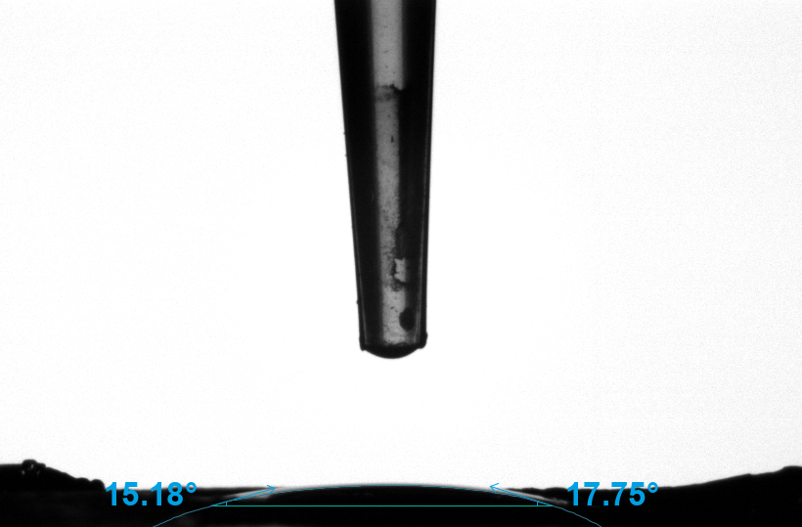
Figure S3. Pictures demonstrating the contact angle of hydrogels after swelling in distilled water.
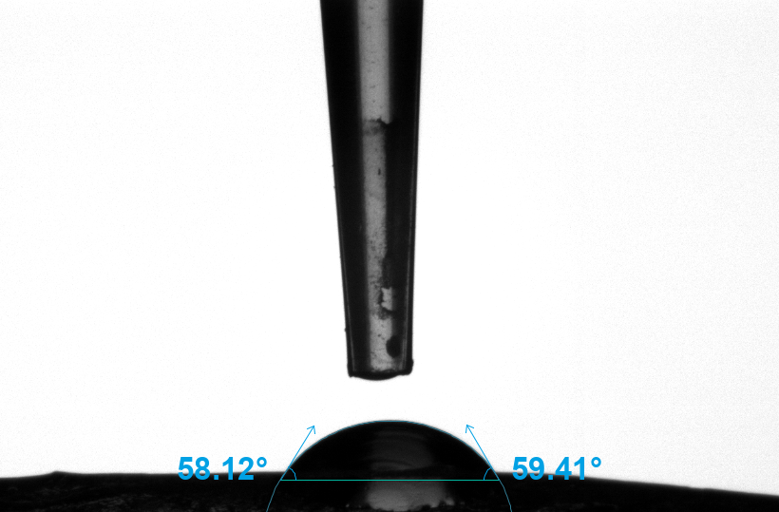
Figure S4. Pictures demonstrating the contact angle of hydrogels after swelling in brine.
Figure S5. Images demonstrating the reversible optical switching of D_{AMPS/AM-SBVI}, transitioning between opaque in water and transparent in brine.
Figure S6. Microstructural images illustrating the contrasting optical properties of S_{AM-SBVI}, appearing opaque in water but transparent in brine at the microscale.
Figure S7. Summary of the testing methodology of hydrogel property changes with degradation.

