Antibody | Commercial supplier | Catalogue # | 2° antibody
GAPDH | Calbiochem | CB1001 | Mouse
mnSOD | Stressgen Biotechnologies | SOD-111 | Rabbit
NRF-2 | GeneTex | GTX103322 | Rabbit
HMGB1 | Cell Signaling Technology | 6393 | Rabbit
PARP1 | Cell Signaling Technology | 9542 | Rabbit
p-p65 | Cell Signaling Technology | 3033 | Rabbit
p-p38 | Cell Signaling Technology | 9211 | Rabbit
β-actin | Cell Signaling Technology | 4970 | Rabbit
S6K | Cell Signaling Technology | 9202S | Rabbit
p-4E-BP1 | Cell Signaling Technology | 2855 | Rabbit
BCAT1 | Thermo Fisher Scientific | PA5-120441 | Rabbit
BCKDH | Thermo Fisher Scientific | A700-060 | Rabbit
PDH3 | Novus Biologicals | NB1000-139 | Rabbit
Table 1. List of primary antibodies.
Rat primers
Gene | Forward | Reverse | Probe
18s | CGGCTACCACATCCAAGGA | CCAATTACAGGGCCTCGAAA | CGCGCAAATTACCCACTCCCGA
SOD2 | CACCGAGGAGAAGTACCACGA | GAACTTCAGTGCAGGCTGAAGA | CCTGAGTTGTAACATCTCCCTTGGCCAG
NRF-2 | AGCCCAGCACATCCAGACA | TGTCTCTGCCAAAAGCTGCAT | TCAGCTACTCCCAGGTTGCCCACATTC
iNOS | CTATCTCCATTCTACTACTACCAGATCGA | CCTGGGCCTCAGCTTCTCAT | CCCTGGAAGACCCACATC TGGCAG
Arg-1 | AGCTGGGAATTGGCAAAGTG | TCCAGTCCATCAACATCAAAACTC | AATGGGCCTTTTCTTCCTTCCCAGCAG
IL-1b | ACCCTGCAGCTGGAGAGTGT | TTGACTTCTATCTTGTTGAAGACAAACC | CCCAAACAATACCCAAAGAAGAAGATGGAAAAG
IL-6 | CCGGAGAGGAGACTTCACAGA | AGAATTGCCATTGCACAACTCTT | ACCACTTCACAAGTCGGAGGCTTAATTACA
IL-10 | TGCAGGACTTTAAGGGTTACTTGG | CAGGGAATTCAAATGCTCCTTG | TCTCTGCCTGGGGCATCACTTCTACCA
TNF-α | GTAGCCCACGTCGTAGCAAAC | AGTTGGTTGTCTTTGAGATCCATG | CGCTGGCTCAGCCACTCCAGC
BCKDH | CACGATCTGATTGG CATTGG | AGCGTCACTTCGTCA CCATTT | CCTACCGCCTGAGGG ATCTGCGT
BCAT1 | GAAGAACGCATTGC AGAAGCT | GGCCGGACCTCAACATGA | TCAAACTCCGGCAGAGTGGTCCTCA
HIF-1 | GCTTCGCTGCGTGTTTTGT | GTGACCATGAGGAAATGAGAGAAAT | TCCCCTTTCTCACTGGGCCATTTCTGT
MCP-1 | TGTCTCAGCCAGATGCAGTTAAT | CCGACTCATTGGGATCATCTT | CCCCACTCACCTGCTGCTACTCATTCA
NLRP3 | GTGCGTGGGACTGAAGCAT | CTGACAACACGCAGATGTGAGA | AGCAGCTGACCAACCAGAGTTTCTGCA
CAS-1 | CGGAGTTTCCTACTGAATCTTTTAACA | GAAAGACAAGCCCAAGGTTATCA | ACCACTCCTTGTTTCTCTCCACGGCA
BCAT2 | CCTATTCCCTGGCG TCTATGTG | TGGCTCTCTGGTCAC CTGAAC | CTCCAACTTCAAGGC GGCAGACCTC
CD11b | TTCCCTGTCAGCGTGGTCTT | TGCTCAGTGCGACAGACACTT | CCCAGGTCACCTTCTCCCAGAACCTCT
Table 2. List of primers and probes

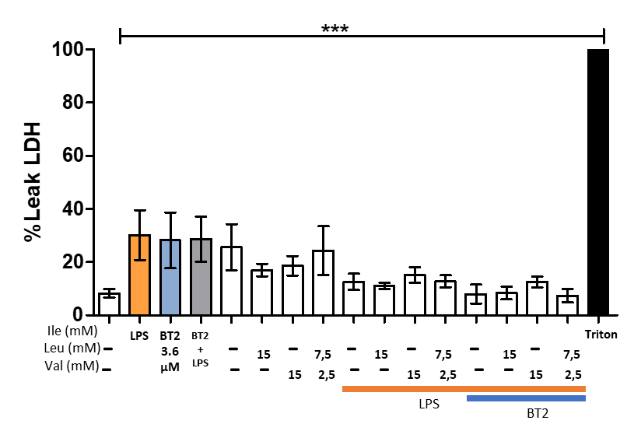
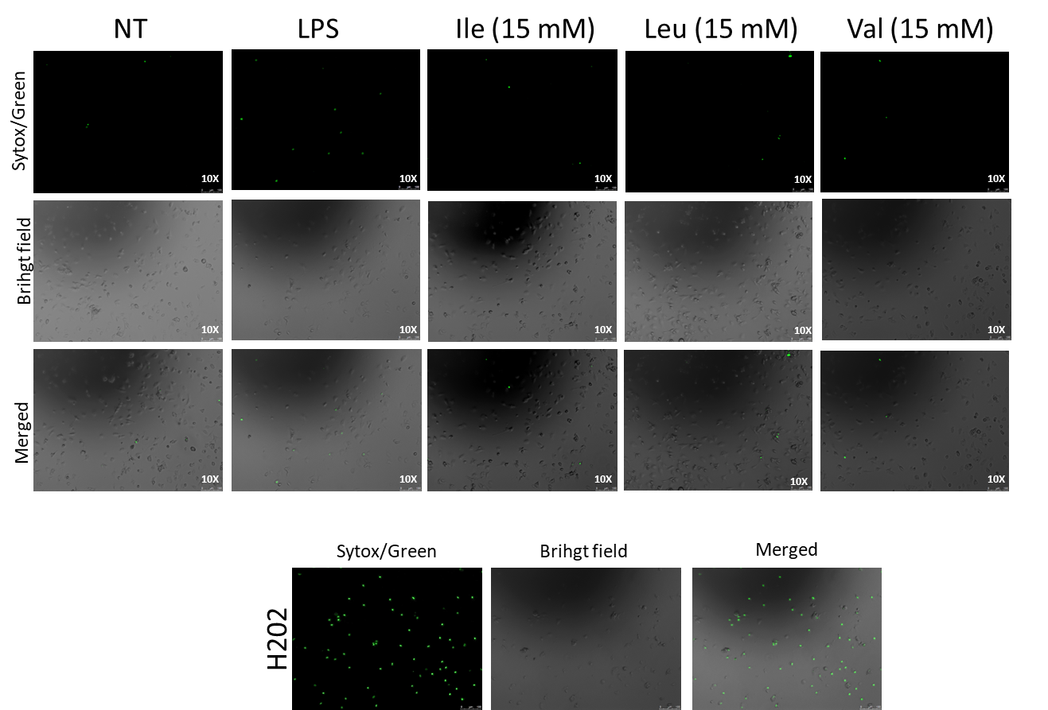
Supplementary Figure 1. BCAA effects on cell survival. Primary RLMs were incubated with LPS (100 ng/mL) alone or with 15 mM of individual BCAAs (Ile, Leu, Val). A) Representative images using Sytox green solution observed under a fluorescent microscope (10x). As a positive control for cell death, hydrogen peroxide was added in one well 10 minutes prior to the conclusion of the experiment. B) LDH release was calculated as the percentage of the activity of LDH released in the medium vs. the total LDH activity. Triton X-100 was used as a positive control for total LDH leakage. Data are mean ± SEM of n = 4. Statistical analysis was performed using one-way ANOVA followed by Tukey’s post hoc test. Significance compared with LPS alone is indicated as p < 0.05 (*), p < 0.01 (**), p < 0.001 (***), and p < 0.0001 (****). Abbreviations: BCAA, branched-chain amino acids; Ile, isoleucine; Leu, leucine; Val, valine; LPS, lipopolysaccharide.
10µM
10µM
B)
A)

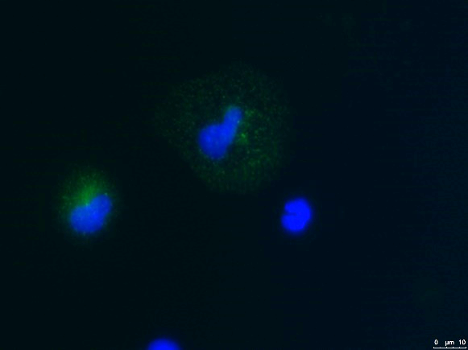
A)
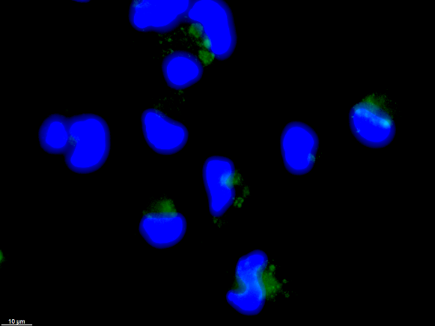
B)

Supplementary Figure 2. Expression of classical macrophage markers in resident liver macrophages (RLMs). RLMs were seeded on glass coverslips, fixed with 4% paraformaldehyde, permeabilized, and blocked prior to immunostaining. Cells were incubated with primary antibodies against CD163 (green, panel A) or CD68 (green, panel B), followed by Alexa Fluor–conjugated secondary antibodies. Nuclei were counterstained with DAPI (blue). Coverslips were mounted in fluorescence medium and imaged using a Leica DMI6000 fluorescence microscope at 60× magnification
Supplementary Figure 3. Gene expression of BCAA-metabolizing enzymes in liver cell populations. Quantitative PCR analysis of the fold change expression of BCAT1, BCAT2, and BCKDH in hepatocytes (HEP), stellate cells (HSC), liver sinusoidal endothelial cells (LSECs), and resident liver macrophages (RLMs). Data are presented as average Ct values and are mean ± SEM of n = 3-4. BCAT1, Branched-chain amino acid transaminase 1; BCAT2, Branched-chain amino acid transaminase 2; BCKDH, Branched-chain α-ketoacid dehydrogenase.

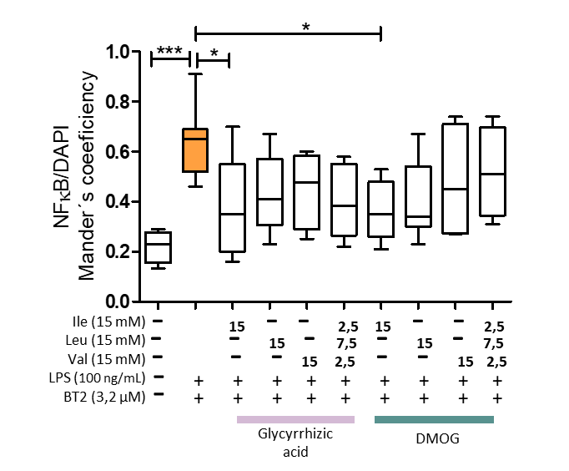
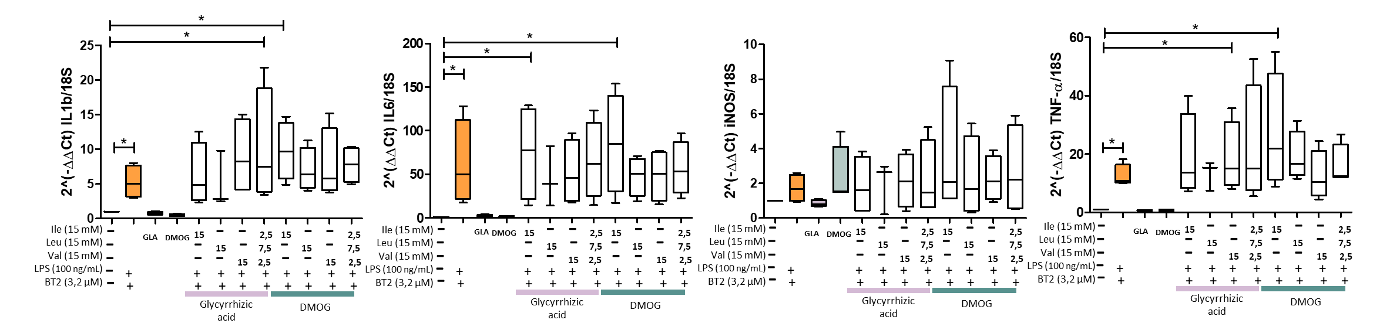
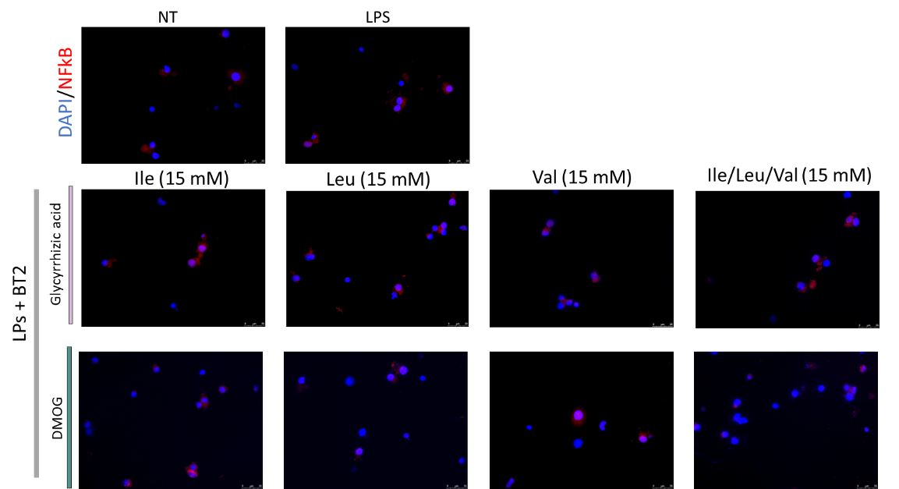
B)
C)
A)
Supplementary Figure 4. Gene expression and NF-kB expression after DMOG and glycyrrhizic acid treatment. RLMs treated with BCAAs (alone or as a mixture), LPS (100 ng/mL), and BT2 with the HMGB1 (Gla) or the HIF1α (DMOG) inhibitor. A) mRNA expression (fold-change, 2^–ΔΔCt) of M1 (CD11b, MCP1, IL-1β, IL-6, iNOS, TNFα, HIF-1α) and M2 (IL-10, Arginase-1) phenotype-related genes. B-C) NF-κB nuclear translocation. Immunofluorescence staining of NF-κB (red) and nuclei (DAPI, blue) (B) and quantification of colocalization using Manders’ coefficient(C). Scale bar = 40 µm. Data are mean ± SEM of n = 4. Statistical analysis was performed using one-way ANOVA followed by Tukey’s post hoc test. Significance compared with LPS alone is indicated as p < 0.05 (*), p < 0.01 (**), p < 0.001 (***). Abbreviations: BCAA, branched-chain amino acids; Ile, isoleucine; Leu, leucine; Val, valine or combination (2:1:1 ratio) in the presence of LPS and BT2 with glycyrrhizic acid or DMOG. A) mRNA expression of pro-; LPS, lipopolysaccharide; TNFα, tumor necrosis factor alpha; iNOS, inducible nitric oxide synthase; IL, interleukin; BT2, 3,6-dichlorobenzothiophene-2-carboxylic acid.

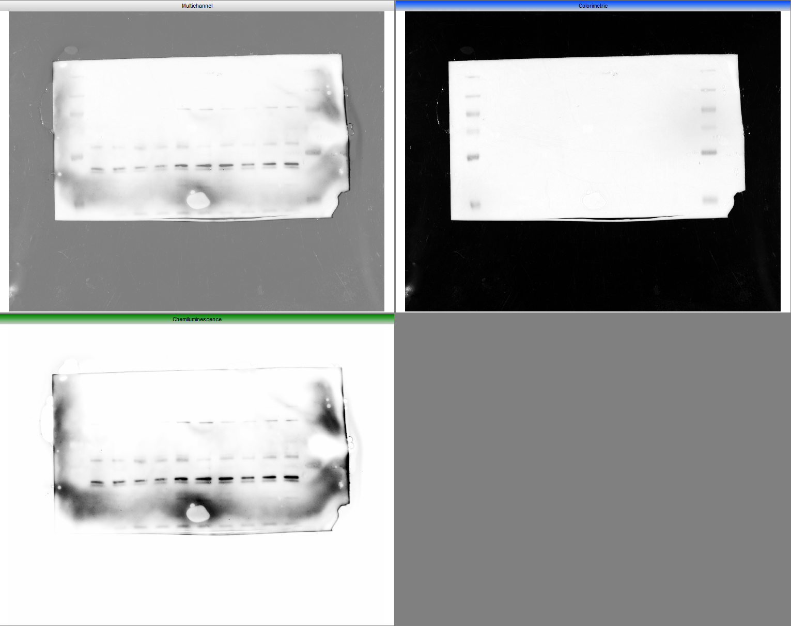
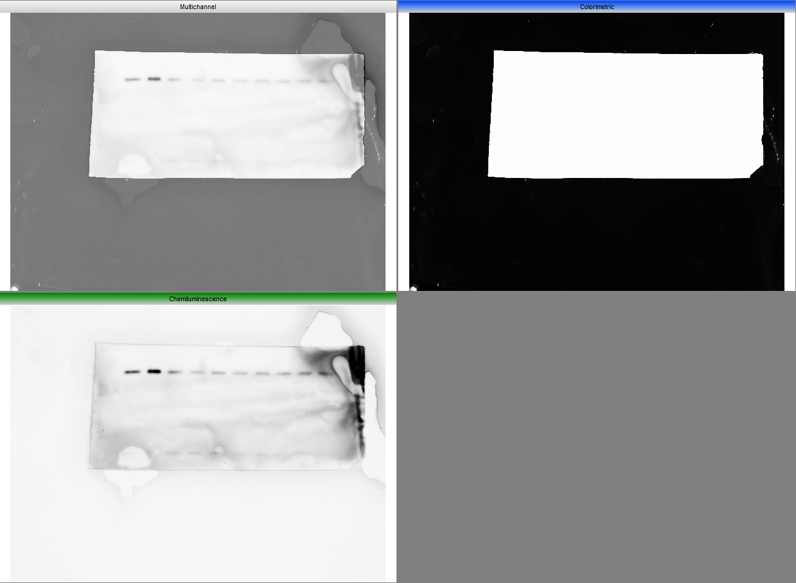
BCAT1 ~45 kDa
GAPDH ~45 kDa

BCKDH ~65 kDa

Western blots Figure 1. Primary rat RLMs were pre-treated with BCAAs (Ile, leu, val) alone or as a mixture (1:2:1 ratio) (15 mM) for 2 h and then co-treated with LPS (100 ng/mL) for 4 h. This figure shows the protein bands of BCAT1, BCKDH and GAPDH in complete western blot membranes. IBCAT1 shows multiple banding but only the one closer to the reported molecular weight was consider.
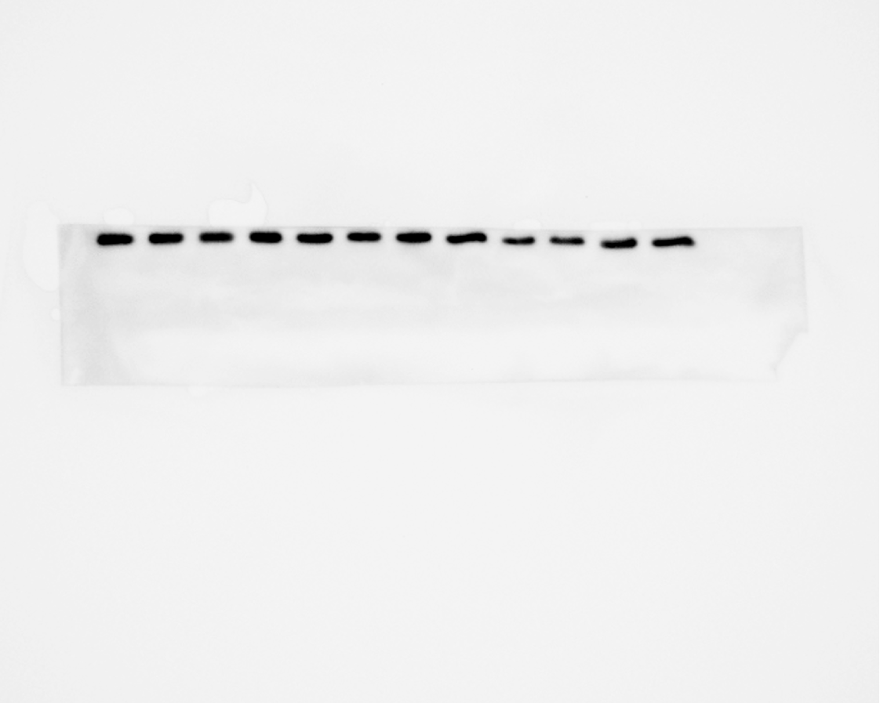
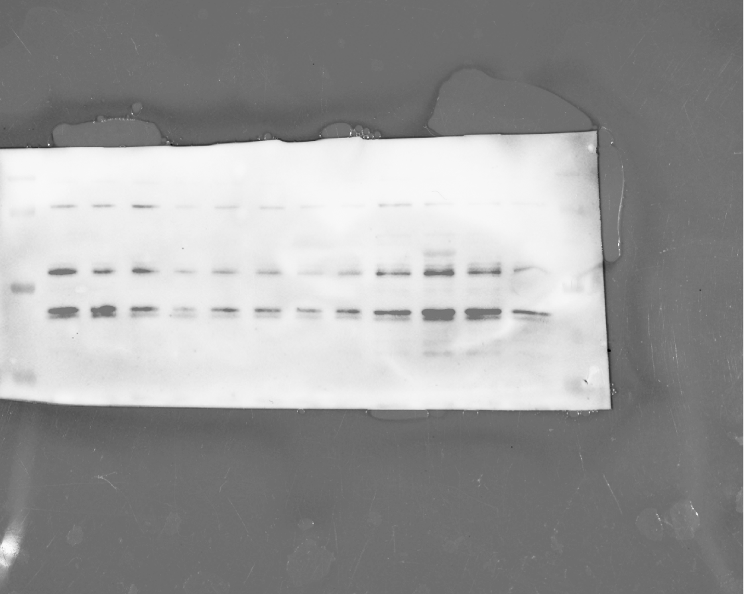
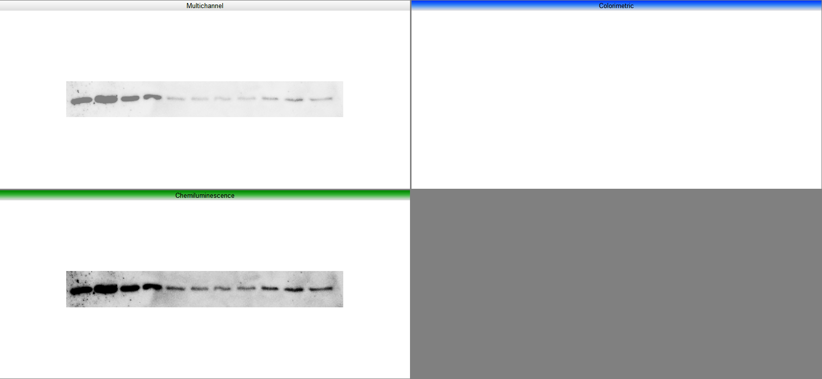
BCAT1 ~45 kDa

β-actin ~45 kDa
BCKDH ~65 kDa

Western blots Figure 3. Primary rat RLMs were pre-treated with BT2 for 30 minutes and then added BCAAs (Ile, leu, val) alone or as a mixture (1:2:1 ratio) (15 mM) for 2 h and then co-treated with LPS (100 ng/mL). This figure shows the protein bands of BCAT1, BCKDH and β-actin in complete western blot membranes. IBCAT1 shows multiple banding but only the one closer to the reported molecular weight was consider.

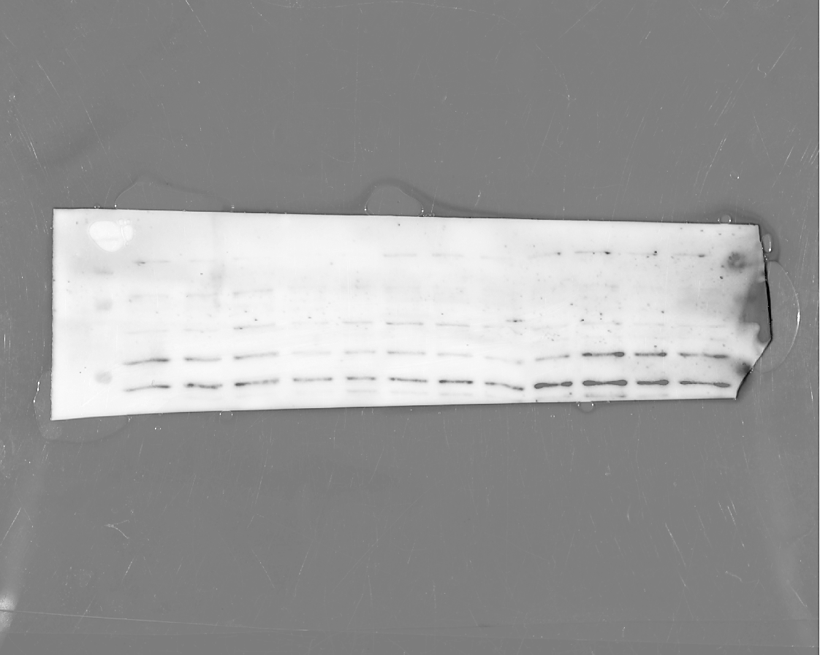
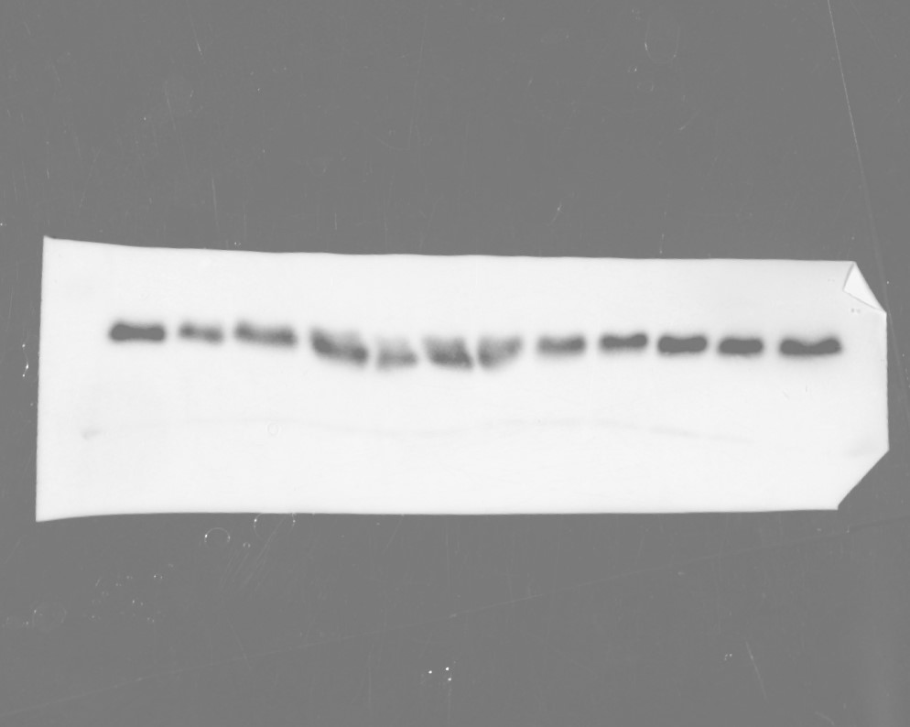
NRF2 ~65-110 kDa
MnSOD ~25 kDa
β-actin ~45 kDa
GAPDH
Western blots Figure 5. Primary rat RLMs were pre-treated with BT2 for 30 minutes and then added BCAAs (Ile, leu, val) alone or as a mixture (1:2:1 ratio) (15 mM) for 2 h and then co-treated with LPS (100 ng/mL). This figure shows the protein bands of NRF2, MnSOD (SOD2) and β-actin in complete western blot membranes. IBCAT1 shows multiple banding but only the one closer to the reported molecular weight was consider.

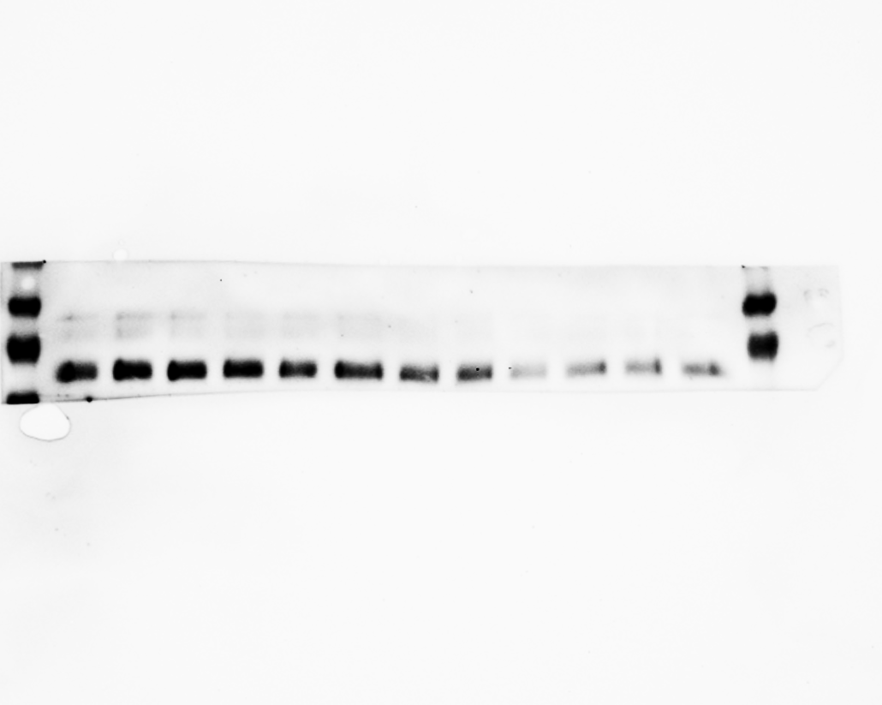
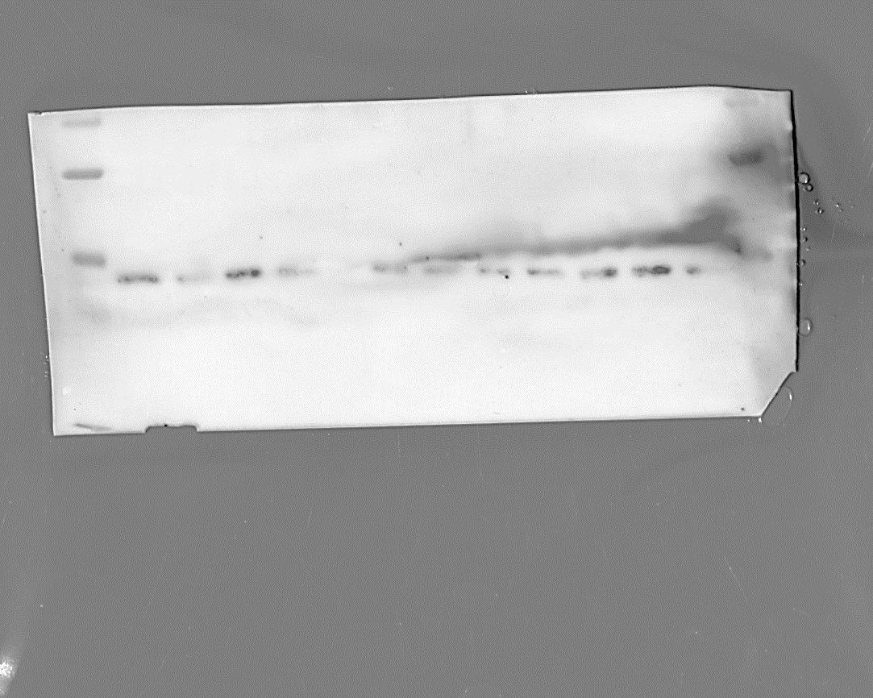
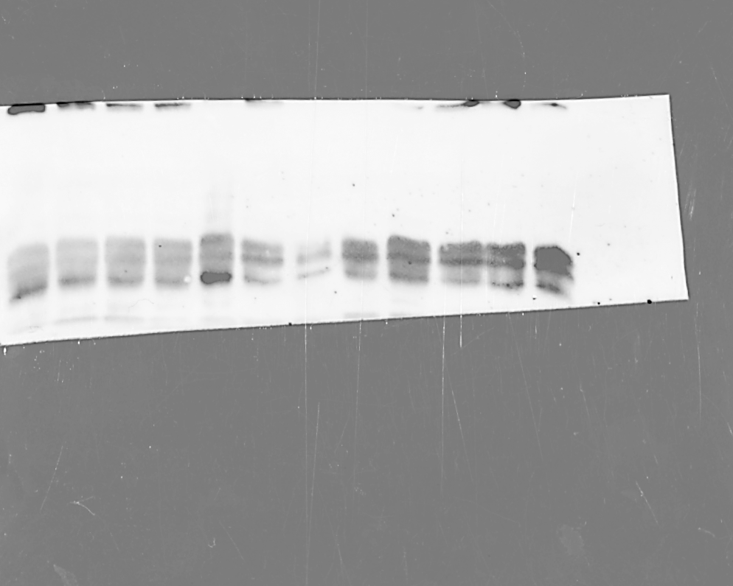
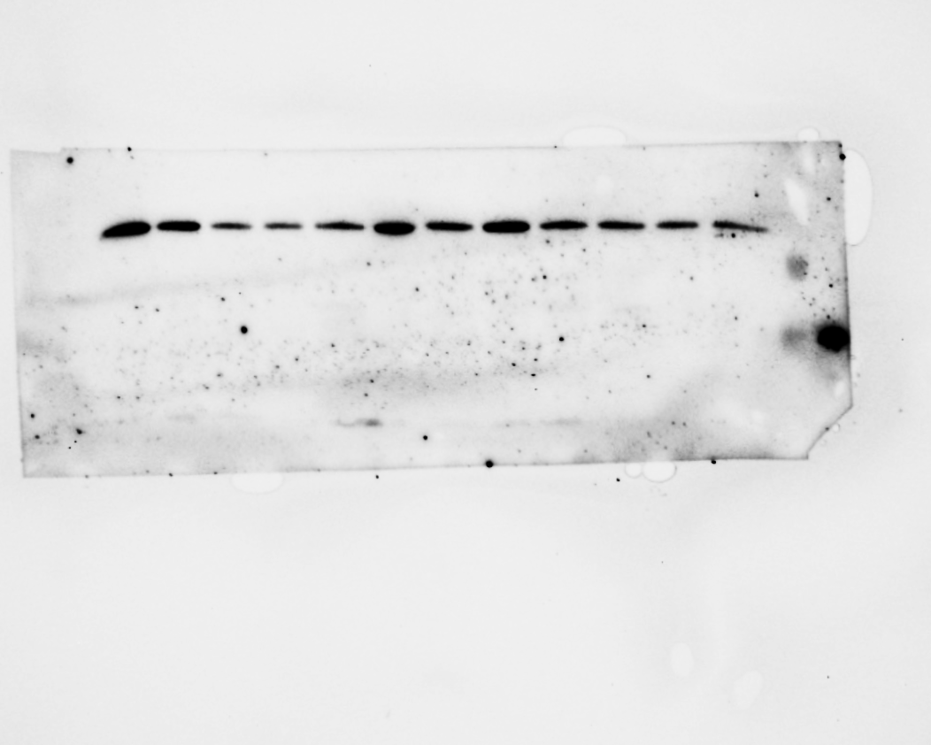
HMGB1 ~30 kDa
GAPDH ~45 kDa
Supernatant HMGB1 ~20 kDa
PDH3 ~100 kDa
S6k ~70 kDa
GAPDH ~45 kDa
4E-BP ~15 kDa
GAPDH ~45 kDa
C)
B)
A)
Western blots Figure 6. Primary rat RLMs were pre-treated with BT2 for 30 minutes and then added BCAAs (Ile, leu, val) alone or as a mixture (1:2:1 ratio) (15 mM) for 2 h and then co-treated with LPS (100 ng/mL). This figure shows the protein bands of mTOR-related proteins 4E-BP, S6K and GAPDH (A), HIF-1α regulatory protein PDH3 and GAPDH (B) and HMGB1 in whole cell and supernatant (C).
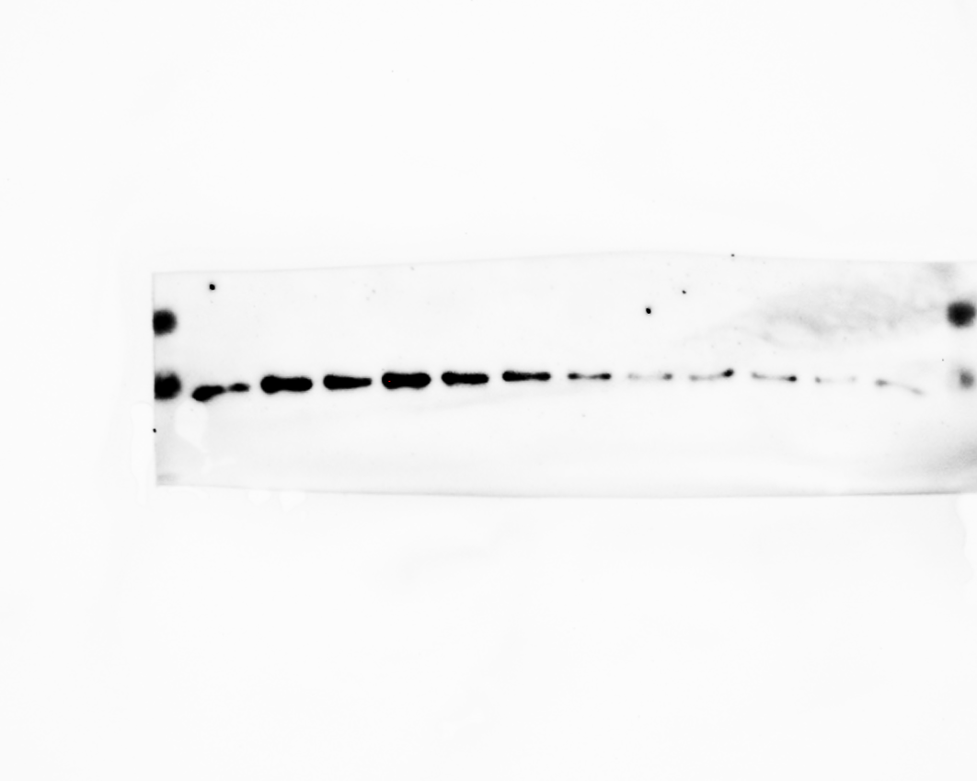
HMGB1 ~30 kDa
GAPDH ~45 kDa

Figure 7. Inhibition of HIF1α and HMGB1 modulates the effects of BCAAs in BT2-LPS-stimulated RLMs. RLMs treated with BCAAs (alone or as a mixture), LPS (100 ng/mL), and BT2 with the HMGB1 (Gla) or the HIF1α (DMOG) inhibitor. This figure shows the protein bands of HMGB1 and GAPDH.

