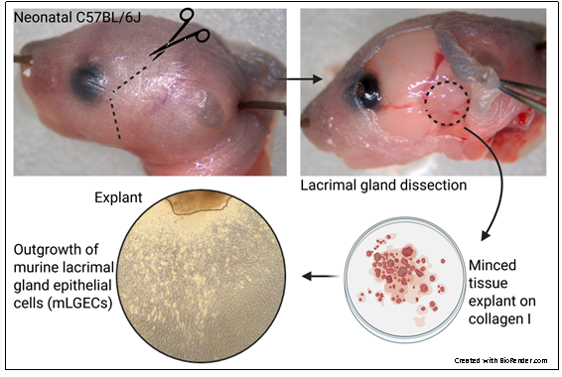
Supplementary Figure 1. Isolation and culture of murine lacrimal gland epithelial cells (mLGECs). The lacrimal gland was dissected from neonatal C57BL/6J mice (indicated by dashed line) and carefully excised. The isolated tissue was minced into small fragments and cultured on collagen I-coated plates. Outgrowth of murine lacrimal gland epithelial cells was observed from the explanted tissue after 1-3 days in culture.

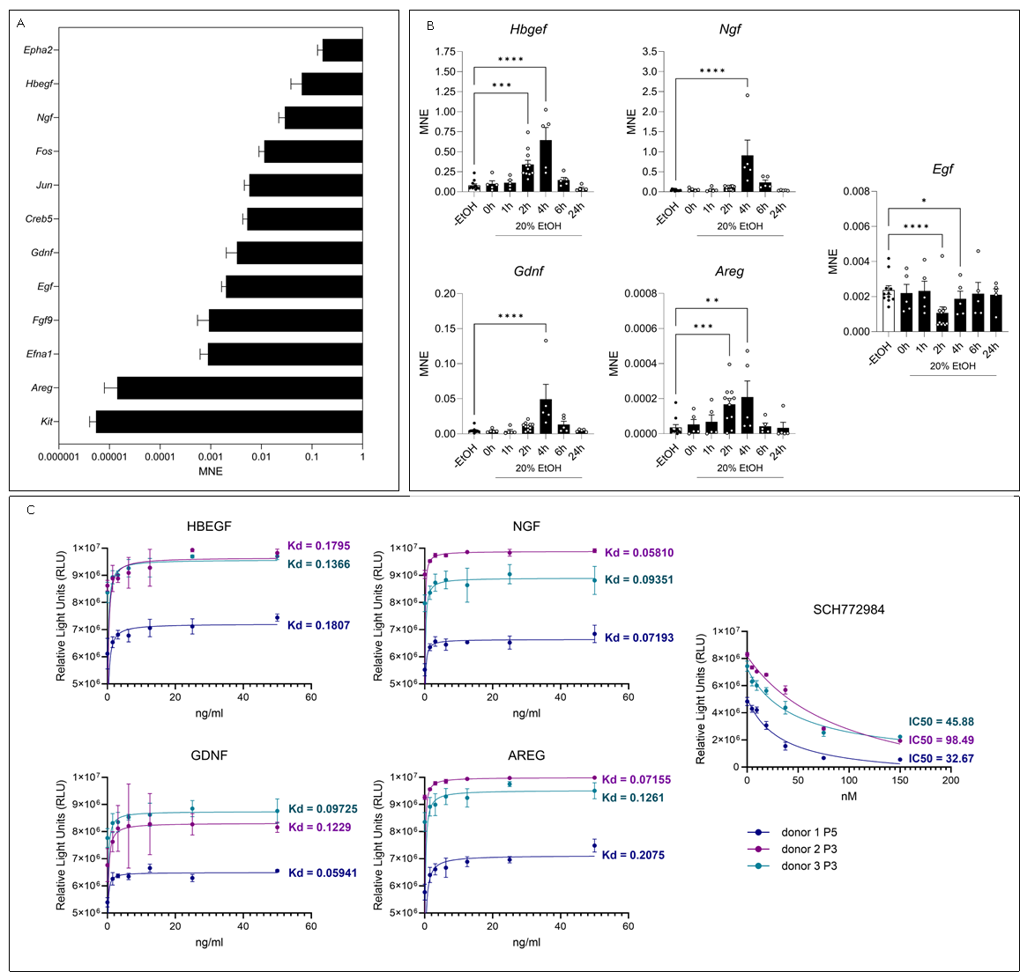
Supplementary Figure 2. Additional analysis of differentially expressed genes in the classical MAPK signaling pathway after ethanol-induced injury.
(A) Comparison of mean normalized expression (MNE) values of examined MAPK pathway genes in untreated mLGECs. Epha2, Hbegf, and Ngf showed relatively high basal expression, whereas Areg and Kit exhibited low baseline levels. (B) Relative gene expression of Hbegf, Ngf, Gdnf, Areg, and Egf within 24 hours after acute ethanol injury. Hbegf and Areg were rapidly induced, Ngf and Gdnf peaked at 4 hours, while Egf was significantly downregulated. Data are mean ± SEM; n > 5 biological replicates; two-way ANOVA with Dunnett’s multiple comparisons test. (C) Dose–response analyses of HBEGF, NGF, GDNF, and AREG as well as the MAPK inhibitor SCH772984 on mLGEC viability. Growth factors showed high-affinity activity (Kd < 1 ng/ml, saturation at 12.5 ng/ml), and SCH772984 exhibited non-cytotoxic inhibition (IC₅₀ 32.7–98.5 nM). Nonlinear regression was performed using a hyperbolic one-site binding model (X = concentration). Bars show means with individual data points; each point represents the mean of technical triplicates for one donor.

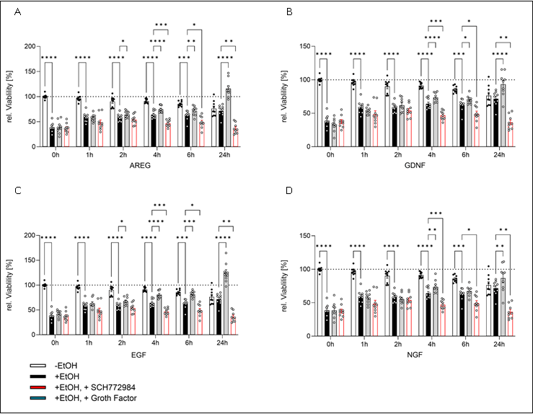
Supplementary Figure 3. Growth factor-induced regeneration following acute ethanol injury.
(A–D) Relative viability/ intracellular ATP of mLGECs with or without 20% ethanol injury followed by EGF-free medium incubation, supplemented with (A) AREG (12.5 ng/ml), (B) GDNF (12.5 ng/ml), (C) EGF (12.5 ng/ml) or (D) NGF (12.5 ng/ml) over 24 hours. n = 9 biological replicates. Data are mean ± SEM; two-way ANOVA with Dunnett’s multiple comparisons test; *p ≤ 0.05, **p ≤ 0.01, ***p ≤ 0.001, ****p ≤ 0.0001.
Supplemental Table 1. Differentially expressed genes associated with structural, contractile, stress, and metabolic responses identified in Figure 1A.
Gene | Full name | log2FC | padj | stat
Structural and contractile genes
Acta1 | actin, alpha 1 | -10.60 | 0.00e+00 | -50.51
Mef2c | myocyte enhancer factor 2 C | -6.13 | 0.00e+00 | -35.73
Mylpf | myosin light chain, phosphorylatable | -9.51 | 0.00e+00 | -34.53
Creb5 | cAMP responsive element binding protein 5 | -5.39 | 2.87e-253 | -34.20
Eno3 | enolase 3 | -6.20 | 0.00e+00 | -33.93
Stress- and immune-related genes
Spp1 | secreted phosphoprotein 1 | 9.63 | 0.00e+00 | 57.77
Cxcl5 | C-X-C motif chemokine ligand 5 | 11.26 | 0.00e+00 | 38.65
Serpine1 | serpin family E member 1 | 7.29 | 0.00e+00 | 38.05
Brinp3 | BMP/retinoic acid inducible neural specific 3 | 10.02 | 8.14e-234 | 32.86
Inflammatory and stress response genes
Ptx3 | pentraxin 3 | 5.62 | 0.00e+00 | 41.39
Sgk1 | serum/glucocorticoid regulated kinase 1 | 3.86 | 0.00e+00 | 40.86
Hormonal and metabolic response genes
Emb | embigin | 5.17 | 0.00e+00 | 53.59
Vdr | vitamin D receptor | 5.01 | 1.07e-286 | 36.39
Cyp1b1 | cytochrome P450 family 1 subfamily B member 1 | 4.90 | 6.72e-233 | 32.80
List of representative significantly regulated genes from the RNA-seq comparison between native murine lacrimal gland tissue (mLG) and primary lacrimal gland epithelial cells (mLGECs). Genes are grouped by functional category, and values indicate the log₂ fold change, adjusted p value (padj), and Wald test statistic (stat).

Supplemental Table 2. Differentially expressed genes associated with stress, immune, and regenerative responses identified in Figure 4A.
Gene | Full name | log2FC | padj | stat
Stress- and autophagy-related genes
Fnip1 | folliculin interacting protein 1 | +2.20 | 1.62e−215 | +22.07
Ndrg1 | N-myc downstream regulated gene 1 | +2.39 | 4.94e−180 | +19.04
Sqstm1 | sequestosome 1 | +1.68 | 2.13e−157 | +17.56
Immune and interferon-related genes
Ccl5 | C-C motif chemokine ligand 5 | +4.94 | 1.12e−172 | +18.71
Ifit1 | interferon induced protein with tetratricopeptide repeats 1 | +4.01 | 2.89e−160 | +17.18
Repair and regeneration-associated genes
Klf5 | Kruppel-like factor 5 | +3.77 | 7.56e−158 | +17.53
Hbegf | heparin-binding EGF-like growth factor | +2.69 | 1.23e−155 | +17.13
Transcriptional and developmental regulator
Id3 | inhibitor of DNA binding 3 | −1.41 | 3.64e−153 | −17.42
List of representative significantly regulated genes from the RNA-seq comparison between untreated (−EtOH) and 20 % ethanol-treated (+EtOH) primary murine lacrimal gland epithelial cells (mLGECs) two hours after exposure. Genes are grouped by functional category, and values indicate the log₂ fold change, adjusted p-value (padj), and Wald test statistic (stat).

