Supplementary Information
Enhanced Inverse Compton Scattering via Spontaneous Focusing induced by Coated Plasma Mirror

Authors
Xichen Hu^{1,7}, Mingyang Zhu^{1,7}, Pengpei Xie³, Bingjun Li³, Huitong Zhai¹, Bingzhan Shi¹, Hui Zeng¹, Tianbing Wang³, Yifei Li^{2,∗}, Jinguang Wang², Wenchao Yan^{1,4}, Jie Feng^{1,4}, Yanfei Li³, Xin Lu^{2,5,6}, Liming Chen^{1,4,∗}

¹State Key Laboratory of Dark Matter Physics, Key Laboratory for Laser Plasmas (MoE), School of Physics and Astronomy, Shanghai Jiao Tong University, Shanghai 200240, China
²Beijing National Laboratory of Condensed Matter Physics, Institute of Physics, Chinese Academy of Sciences, Beijing 100190, China
³Department of Nuclear Science and Technology, School of Energy and Power Engineering, Xi’an Jiaotong University, Xi’an 710049, China
⁴IFSA Collaborative Innovation Center, Shanghai Jiao Tong University, Shanghai 200240, China
⁵School of Physical Sciences, University of Chinese Academy of Sciences, Beijing 100049, China
⁶Songshan Lake Materials Laboratory, Dongguan, Guangdong 523808, China
⁷These authors contributed equally: Xichen Hu, Mingyang Zhu
∗ Corresponding author: lmchen@sjtu.edu.cn; yflx@iphy.ac.cn

Content
Ⅰ. Electron Acceleration
Ⅱ. Radiation

Ⅰ. Electron Acceleration
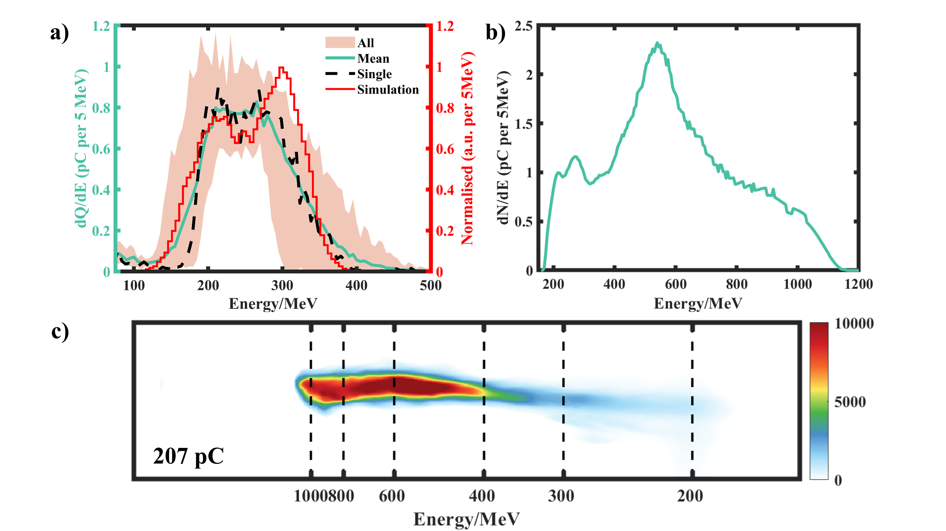
Fig S1. Electron spectra. (a) Electron acceleration driven by a 100-TW laser. Spectra from 20 shots are shown (highlighted shading), together with their average spectrum (green) and a representative shot (black dashed line). For comparison, the normalized spectrum of the electron beam at the plasma exit from PIC simulations is also shown (red). (b) Electron acceleration driven by a 400-TW laser. The spectrum corresponding to the typical shot is shown in (c), with a total charge of about 207 pC.

Ⅱ. Radiation

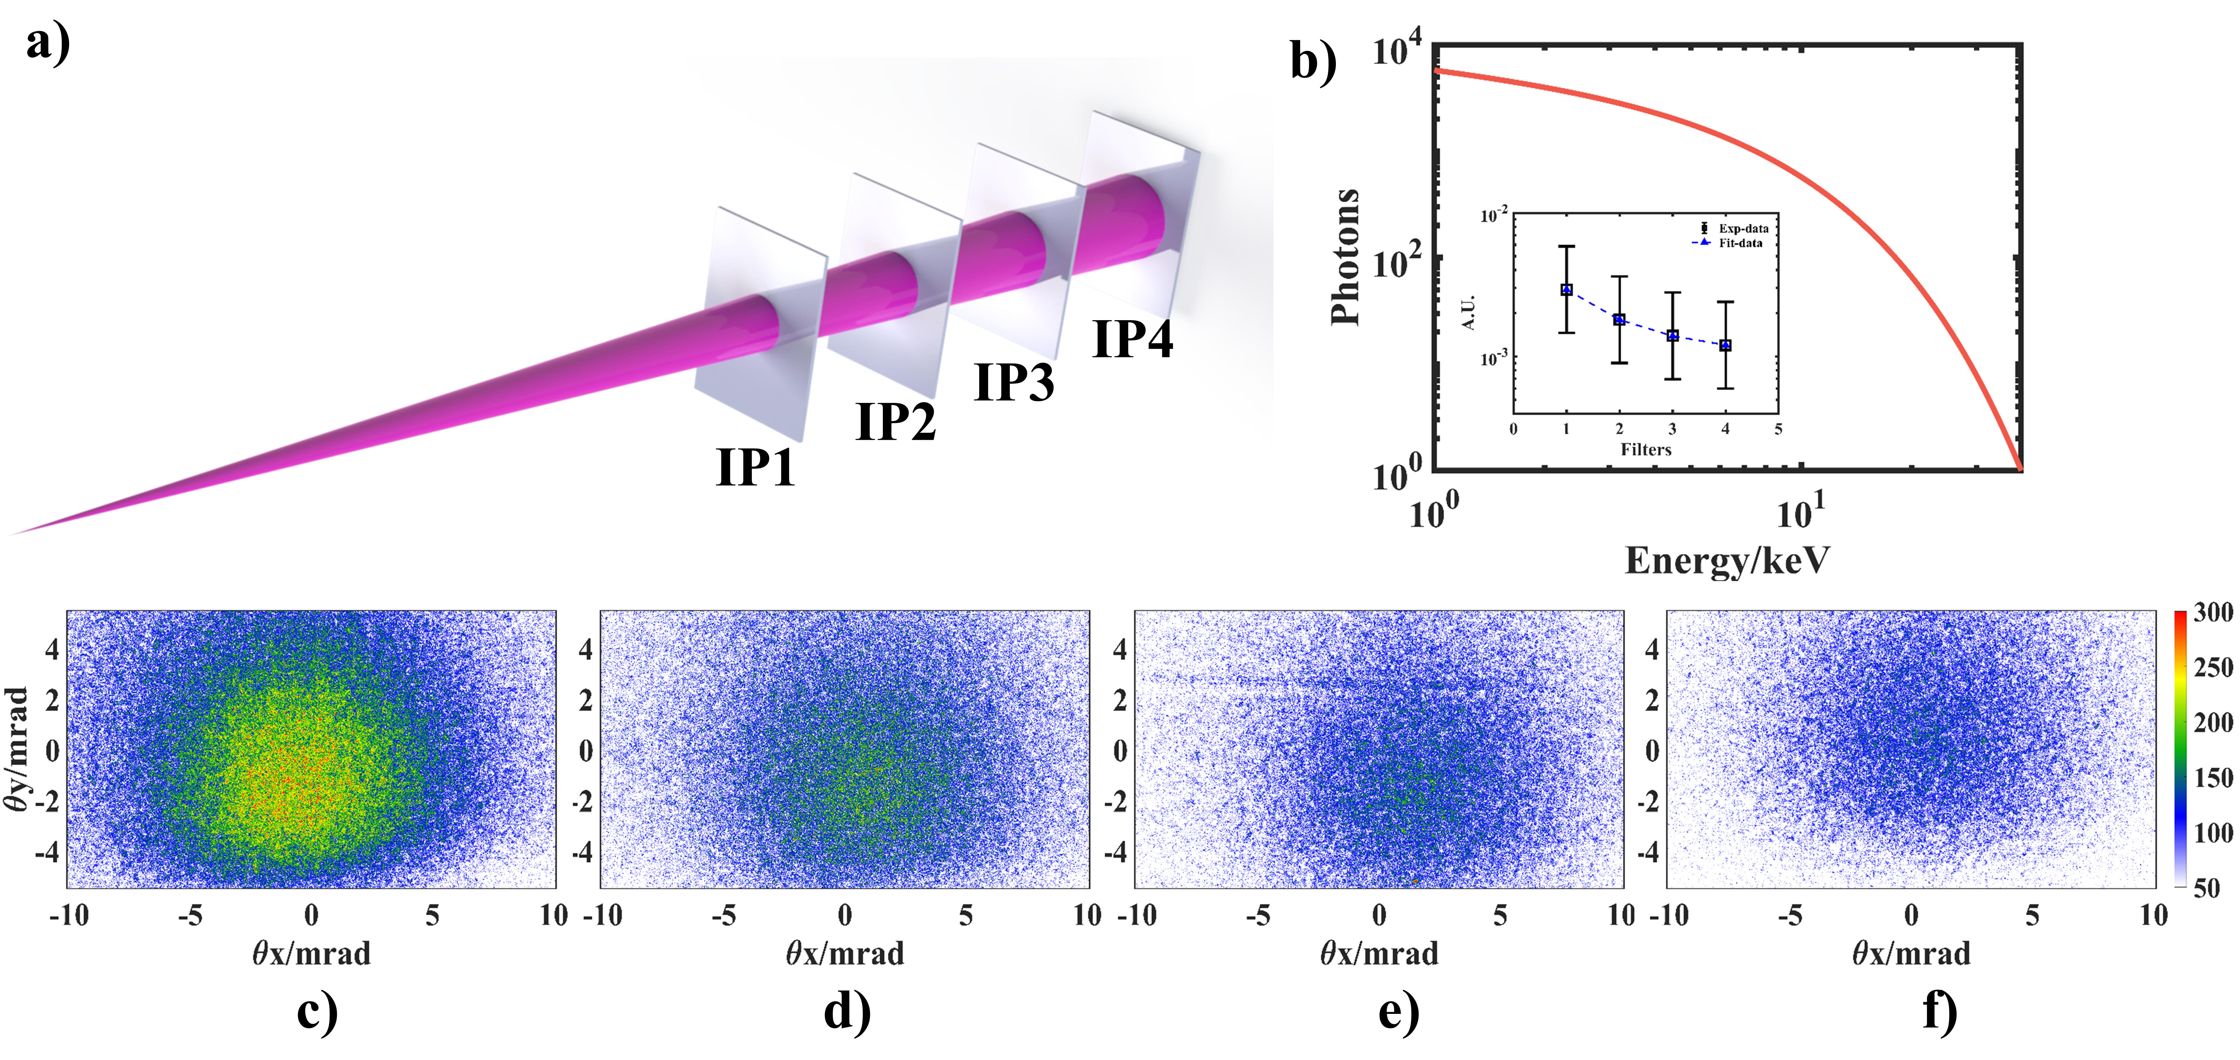
Fig S2. Betatron radiation without plasma mirror. (a) Schematic of the stack used for betatron radiation measurements. The setup employed four MS-IPs separated by 5 cm, each covered on the front surface with a 14-µm aluminum foil for light shielding. (b) Measured betatron radiation spectrum. The spectral analysis ^{1, 2} model includes two components: betatron radiation $\frac{dN}{dE}∝ E^{-1}{\left(\frac{E}{E_{c}}\right)}^{2} K_{2/3}^{2}\left(\frac{E}{E_{c}}\right)$and bremsstrahlung radiation $\frac{dN}{dE}∝ exp\left(-\frac{E}{E_{T}}\right)$. By propagating a theoretical distribution through the filters used in the experiment and accounting for the calibrated IP response efficiency ³, the calculated photon signal intensities $T_{i}$ for each filter are obtained. The characteristic energies $(E_{c},E_{T})$ are retrieved via least-squares fitting by minimizing $\sum_{i}{{\left(T_{i}-D_{i}\right)}^{2}}$, where $D_{i}$ denotes the corresponding measured photon signal intensity ⁴. (c–f) Grayscale signal intensities recorded on the four IPs with a spatial resolution of 50 µm. From these data, the total photon number is estimated to be 2.15×10⁵, which is sufficiently small compared with the photon yield obtained with a plasma mirror.

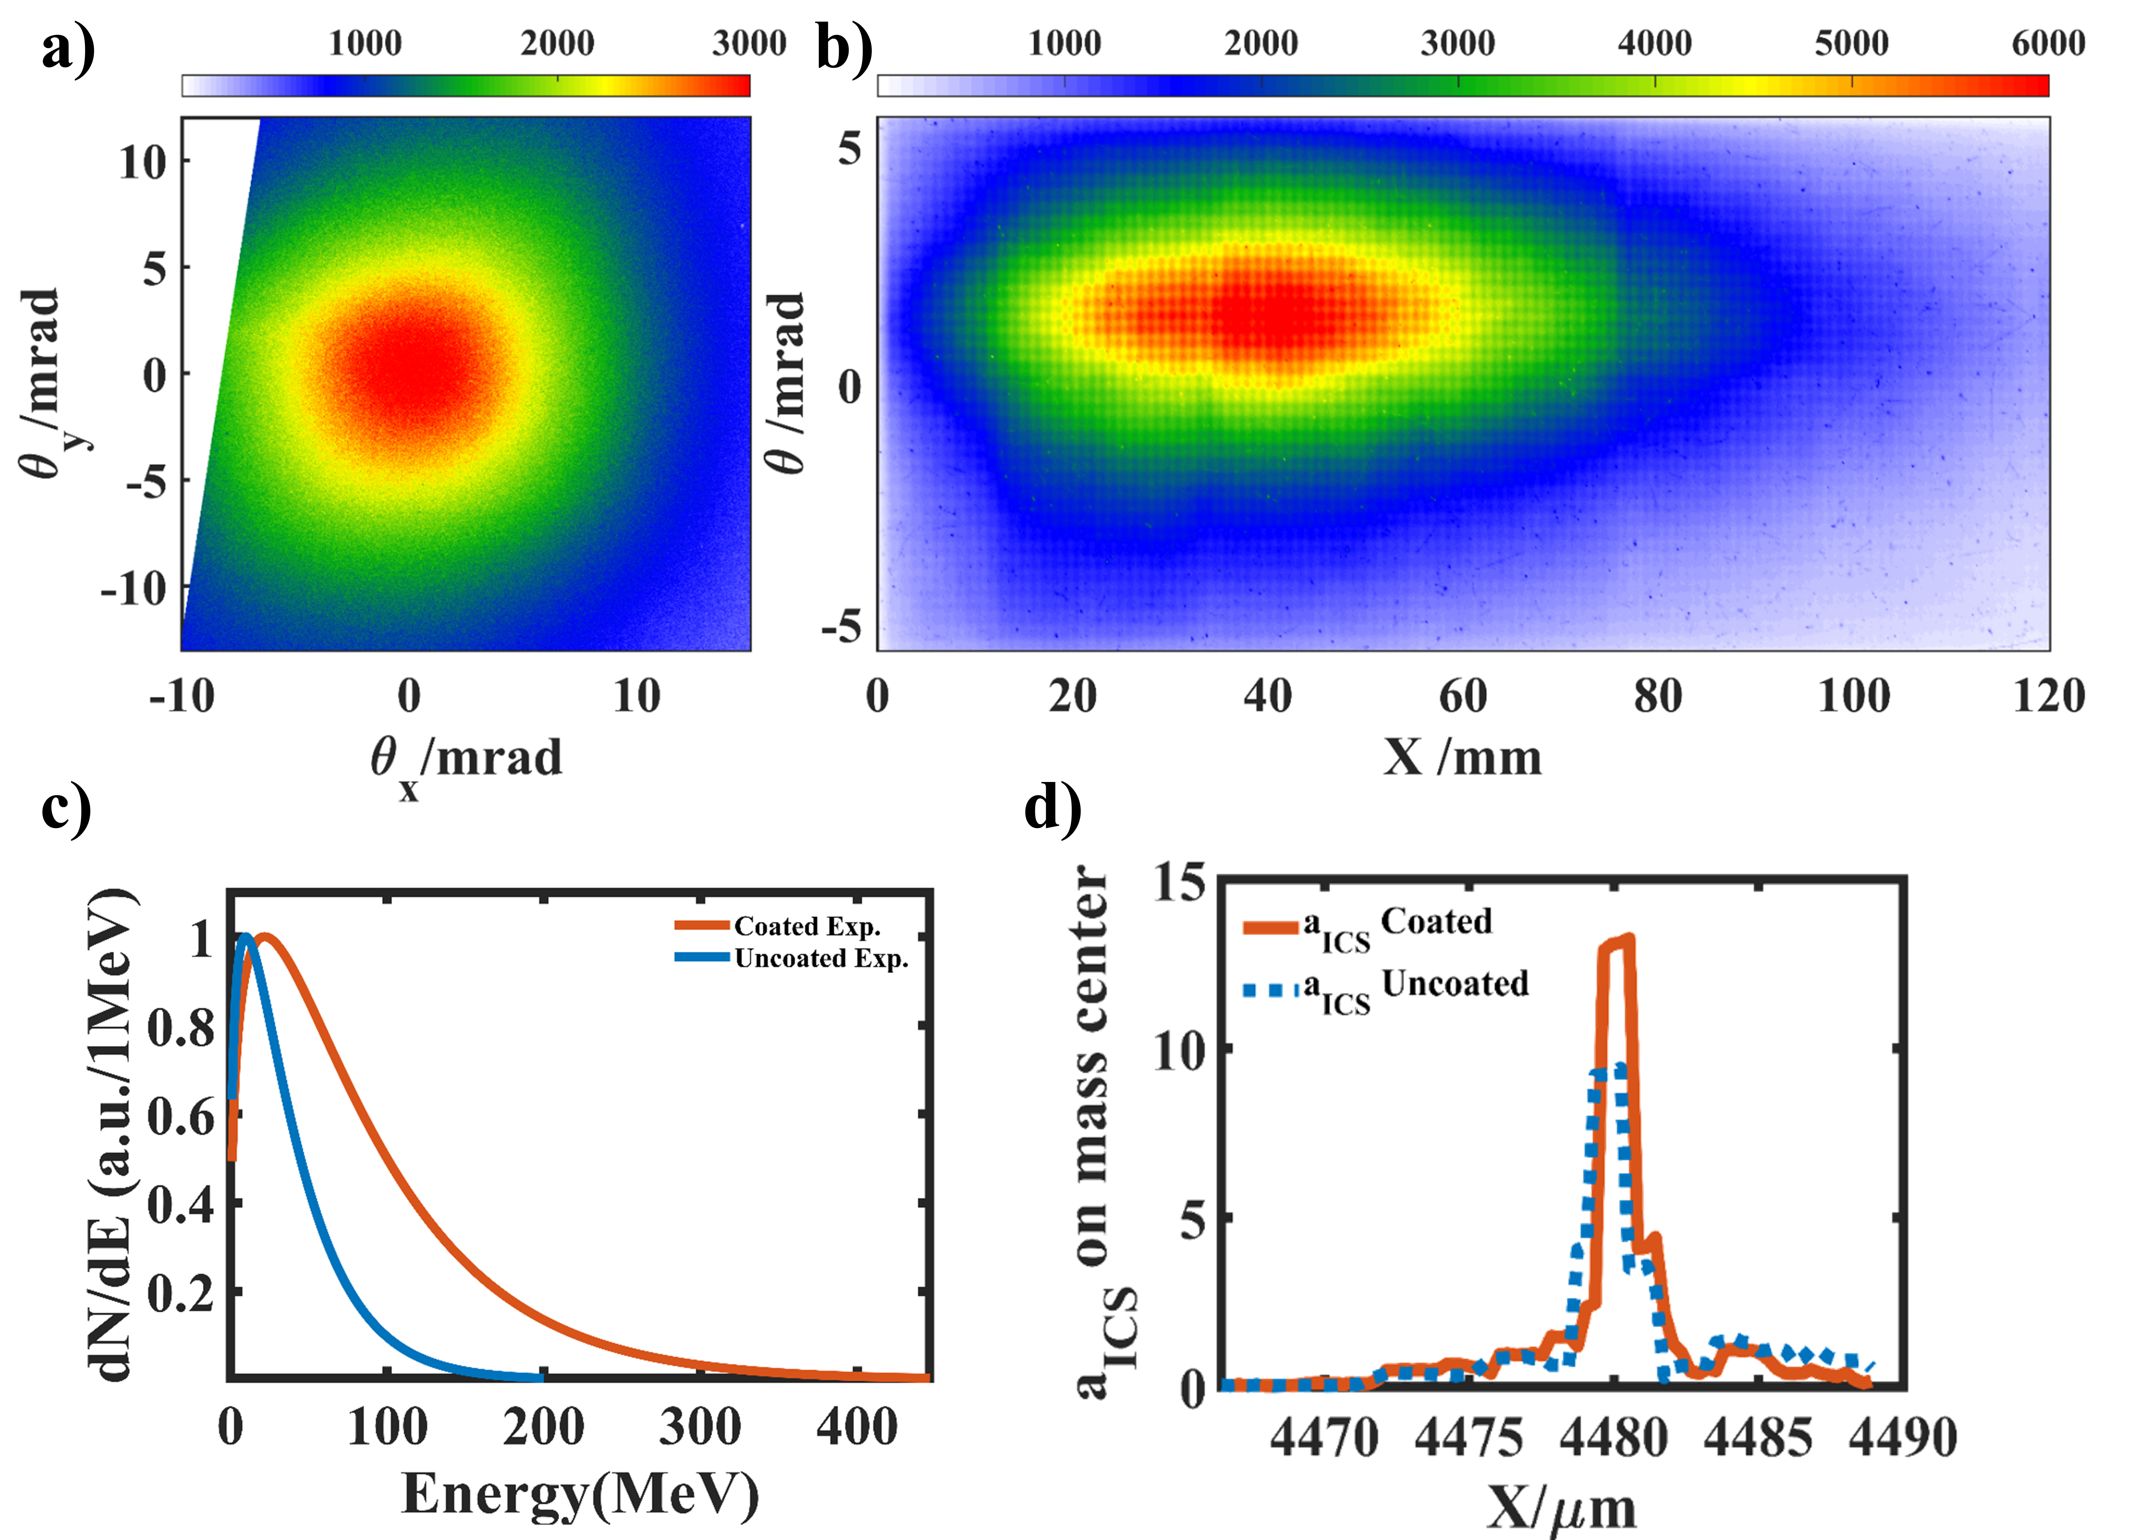
Fig S3. ICS Radiation diagnostics and Simulation of Interaction Intensity at 400 TW. (a) Radiation profile on IP. (b) Luminescence distribution on the calorimeter-like LYSO scintillator. (c) Experimentally measured radiation spectra for coated and uncoated PMs from LYSO. (d) Evolution of the interaction strength in the 400 TW case from PIC simulations.

Reference

1. Hannasch A, Laso Garcia A, LaBerge M, Zgadzaj R, Köhler A, Couperus Cabadağ JP, et al. Compact spectroscopy of keV to MeV X-rays from a laser wakefield accelerator. Sci. Rep. 11, 14368 (2021).

2. Li YF, Feng J, Tan JH, Wang JG, Li DZ, Dong KG, et al. Electron beam and betatron x-ray generation in a hybrid electron accelerator driven by high intensity picosecond laser pulses. High Energy Density Phys. 37, 100859 (2020).

3. Bonnet T, Comet M, Denis-Petit D, Gobet F, Hannachi F, Tarisien M, et al. Response functions of imaging plates to photons, electrons and 4He particles. Review of Scientific Instruments 84, 103510 (2013).

4. Albert F, Lemos N, Shaw JL, Pollock BB, Goyon C, Schumaker W, et al. Observation of Betatron X-Ray Radiation in a Self-Modulated Laser Wakefield Accelerator Driven with Picosecond Laser Pulses. Phys. Rev. Lett. 118, 134801 (2017).

