Table S1. The list of PCR/ChIP-PCR primers and siRNAs sequences.
Real-time PCR primer sequences (human)
Gene | Forward Primer | Reverse Primer
GAPDH | 5’- CTTTGTCAAGCTCATTTCCTGG -3' | 5’- TCTTCCTCTTGTGCTCTTGC -3'
MELTF-AS1 | 5’- CCGCTAGCTGCAAATTGCTT -3' | 5’- TTGGGTGACAGAGGCCAATC -3
DUSP5 | 5’- CCTGAGTGTTGCGTGGATGT -3' | 5’- CCTGAGTGTTGCGTGGATGT -3'
U6 | 5'-CTCGCTTCGGCAGCACA -3' | 5'- AACGCTTCACGAATTTGCGT -3'
CHIP-QPCR primer sequences (human)
MELTF-AS1 CHIP -1 | 5’- CAAAACAGCACAAGGCCCTC -3' | 5’- GGCCAACTCCGAGGAATGAA -3'
MELTF-AS1 CHIP -2 | 5’- TGGGTGGATGCATCTGTGAC -3' | 5’- ATTGTTAGCCTGGCTGGGAC -3'
MELTF-AS1 CHIP -3 | 5’- TTTCCATCCATGTGTCCCCG -3' | 5’- AGGTGGCTTCTGGATTTGGG -3'
MELTF-AS1 siRNA sequence (human)
1# sense 5’-CCGCUAGCUGCAAAUUGCUUUACAU -3’, antisense 5’- AUGUAAAGCAAUUUGCAGCUAGCGG -3’

Table S2. Related antibody information and description.
Muscle | Blocking RT 1h | 1st Ab 4°C O/N | 1st Ab dilution | 1st Ab Vendor | 2nd Ab RT 2h | 2nd Ab dilution | 2nd Ab Vendor | Transfer on ice | Wash
DUSP5 | 5% nonfat milk | 5% BSA | 1:500 | Proteintech #30256-1-AP | 5% BSA | Anti-Rabbit IgG,1:20000 | PROTEINTECH SA00001-2 | 0.45um 400mA, 60min | Wash 3 times after 1st and 2nd Abs, 5 min each time
GAPDH | 5% nonfat milk | 5% BSA | 1:1000 | Proteintech #10494-1-AP | 5% BSA | Anti-Rabbit IgG,1:20000 | PROTEINTECH SA00001-2 | 0.45um 200mA, 60min | Wash 3 times after 1st and 2nd Abs, 5 min each time

File S3: Uncut original western membrane imagines.
Figure2E
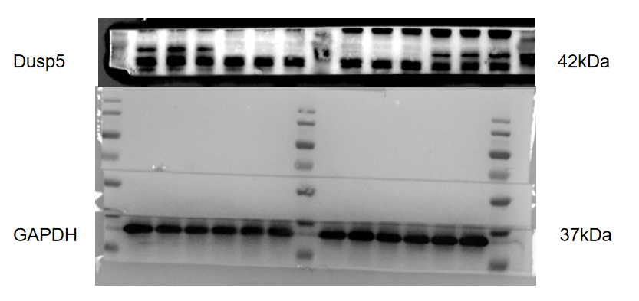

Figure3D

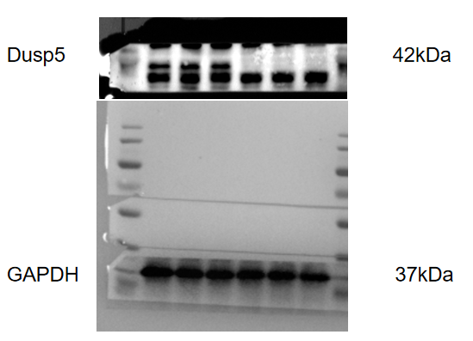

Figure3F

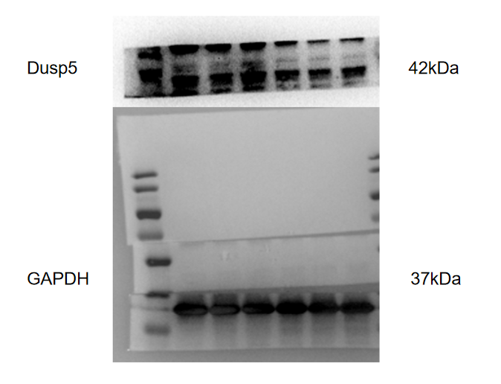

Table S4. Clinical characteristics of Patients with PE and Normal Pregnancies.
Variable | PE(n=3) | Control(n=3) | p Value (PE versus Control)
Maternal age(year) | 30.19±5.003 | 29.97±5.357 | p﹥0.05
Maternal weight(kg) | 74.87±11.531 | 73.49±8.135 | p﹥0.05
Systolic blood pressure(mmHg) | 149.43±16.451 | 126±8.529 | p﹤0.01
Diastolic blood pressure(mmHg) | 101.34±10.869 | 74.33±8.445 | p﹤0.05
Gestational week(wk) | 35.57±4.381 | 38.41±1.421 | p﹤0.01
Body weight of infant(g) | 2169.57±762.698 | 3065.07±377.707 | p﹤0.01

