Microbial Communication Drives Division of Labor in SynComs for Herbicides Degradation

Yuxiao Zhang¹, Jack A. Gilbert^{2,3}, Li Nie¹, Yumeng Zhang¹, Ping Huang¹, Weijie Luo^{1,4}, Xiyuan Xu^{1,4}, Ru Sun^{1,4}, Kaixiang Shi⁵, Xihui Xu⁶, Ningyi Zhou⁷, Jiabao Zhang¹, Haiyan Chu^{1,4,}*

¹State Key Laboratory of Soil and Sustainable Agriculture, Institute of Soil Science, Chinese Academy of Sciences, Nanjing, 211135, China
²Department of Pediatrics, School of Medicine, University of California San Diego, La Jolla, 92093, USA
³Scripps Institution of Oceanography, University of California San Diego, La Jolla, 92023, USA
⁴University of Chinese Academy of Sciences, Beijing, 101408, China
⁵National Key Laboratory of Agricultural Microbiology, College of Life Science and Technology, Huazhong Agricultural University, Wuhan, 430070, China
⁶College of Life Sciences, Nanjing Agricultural University, Nanjing, 210095, China
⁷School of Life Sciences and Biotechnology, Shanghai Jiao Tong University, Shanghai, 200240, China

* Corresponding author:
Haiyan Chu, State Key Laboratory of Soil and Sustainable Agriculture, Institute of Soil Science, Chinese Academy of Sciences, Nanjing, 211135, China.
Email: hychu@issas.ac.cn

Methods
Soil sampling and strain enrichment
Each site measured 100 m × 100 m, with samples collected from a depth of 20 cm. Within each site, five subplots (10 m×10 m) were established, and non-rhizosphere soil samples were collected using a five-point mixed sampling method. Samples from each subplot were combined into one composite sample per site. The black soil zone spans from the foothills and hilly areas of the Lesser and Greater Khingan Mountains to the Songnen Plain, which is predominantly used for cultivating maize, soybean, and spring wheat¹⁻³. The black soil experiences a temperate semi-humid continental monsoon climate, with mean annual temperatures ranging from –5.5 °C to 13 °C and annual precipitation between 530 and 630 nm.
SEM analysis
Samples of cells were collected and then centrifuged at 12,000 rpm for 5 min, and the precipitates were washed 3 times with ddH₂O. Samples were immobilized by 2.5% glutaraldehyde solution for 12 h and then centrifuged (12,000 rpm, 5 min). The precipitates were washed 3 times with ddH₂O. Gradient dehydration with an ethanol sequence consisting of 30%, 50%, 70%, 85%, and 90% ethanol once each, and 100% ethanol twice. Each sample was dehydrated for 15 min and centrifuged at 12,000 rpm for 5 min to remove supernatants. A part of precipitates was freeze-dried using a freeze drier for 24 h and used for SEM^{4, 5}.
Herbicides concentration determination
HPLC-MS was used to detect the content of herbicides in this study^{4, 6}. Freeze-dried soil was sieved, and 10 g of sieved soil was accurately weighed into a 50 mL centrifuge tube. 5 mL of pure water and 20 mL of acetonitrile containing 0.5% acetic acid were added, and the sample was extracted by shaking for 1 h and ultrasonic extraction for 30 min after soaking overnight. 2.5 g of sodium chloride was added into the centrifuge tube, and the extracted sample was shaken for 1 min. Then the sample was centrifuged at 5,000 rpm for 3 min, and the supernatant was collected in a sample bottle. 1.5 mL of the supernatant was collected through 0.22 μm organic filter membrane and put into the injection bottle for measurement. The mobile phase A was 0.2% formic acid (v/v) in water, and the mobile phase B was methanol with a flow rate of 0.3 mL/min at a column temperature of 35 ℃ and an injection volume of 10 μL.
Proteomic processing and analysis
Briefly, an appropriate amount of sample was treated with Reagent ① (Extract) and subjected to low-temperature non-contact ultrasonication for 10 minutes. After high-speed centrifugation (14,000 rpm, 10 min), the supernatant containing soluble proteins was collected. Peptide separation was carried out using a Vanquish Neo chromatography system (Thermo Scientific) equipped with a uPAC High Throughput column (75 μm × 55 cm, Thermo Scientific, USA). Mobile phase A consisted of water with 2% acetonitrile and 0.1% formic acid, and mobile phase B contained 80% acetonitrile with 0.1% formic acid. The total chromatographic runtime was 8 minutes. Data acquisition was performed using Compass HyStar software (Bruker, Germany). Separated peptides were analyzed using a timsTOF Ultra2 mass spectrometer (Bruker, Germany) operated in positive ion mode with an ion source voltage of 4.5 kV. The mass spectrometry scanning range was set to 100–1700 m/z.
Search parameters were configured as follows: peptide length 7–52; enzyme: trypsin/P; maximum missed cleavages: 2; variable modifications: oxidation (M) and acetyl (protein N-terminus); fixed modification: carbamidomethyl (C); protein FDR ≤ 0.01; peptide FDR ≤ 0.01; peptide confidence ≥ 99%; XIC width ≤ 75 ppm. Protein quantification was performed using the MaxLFQ algorithm. Differential expression was assessed using a t-test; proteins with a p-value < 0.05 and a fold change (FC) > 1.2 were considered differentially expressed.
Real-time quantitative PCR
Genomic DNA was removed through digestion with RNase-free DNase I (Takara) at 37 °C, followed by the addition of 50 mM EDTA. The enzymatic reaction was terminated by heat inactivation at 65 °C for 10 minutes. cDNA was synthesized using a RevertAid First Strand cDNA Synthesis Kit (Thermo Scientific). After quantifying RNA concentration with a spectrophotometer (NanoDrop 2000, Thermo Scientific), 300 ng of total RNA was reverse-transcribed into cDNA.
Key metabolites detection
To assess biofilm formation, cells from different growth phases were collected and washed twice with phosphate-buffered saline (PBS, pH 7.2). The suspensions were adjusted to an optical density of 0.8 at 600 nm. Aliquots of 20 µL from each suspension were inoculated into 200 µL of fresh medium and incubated for 36 h. After incubation, the cultures were gently rinsed three times with PBS and dried at 60 °C for 30 min. Biofilms were stained with 100 µL of 1% (v/v) crystal violet (CV) solution for 15 minutes at room temperature. Unbound dye was removed by washing three times with PBS, and the samples were heat-fixed at 65 °C for 60 minutes. The stained biofilms were eluted with 200 µL of 33% acetic acid, and biofilm mass was quantified by measuring the absorbance at 595 nm.
ATP and NADH extraction and measurement: Cells from respective growth phases were harvested by centrifugation at 12,000 rpm for 5 min at 4 °C. The pellets were resuspended in 1 mL of buffer containing 0.4 M perchloric acid and 1.0 mM EDTA, followed by ultrasonication on ice for 5 min. Intact cells and debris were removed by subsequent centrifugation (12,000 rpm, 5 min, 4 °C). The supernatant was neutralized to pH 7.0 using 1 M K₂CO₃ and filtered through a 0.22 μm membrane.
Metabolomic analysis
The mixture was subjected to low-temperature ultrasonic extraction for 30 minutes (5 °C, 40 kHz), incubated at −20 °C for 30 minutes, and centrifuged at 13,000 rpm for 15 minutes at 4 °C. The supernatant was collected, dried under a nitrogen stream, and reconstituted in 100 µL of reconstitution solution (acetonitrile:water = 1:1, v/v). After another round of low-temperature ultrasonication (5 °C, 40 kHz, 5 min), the sample was centrifuged again (13,000 rpm, 10 min, 4 °C). The final supernatant was transferred to an LC vial with an insert for instrumental analysis.
Metabolite separation and detection were performed using a UHPLC-Orbitrap Exploris 240 system (Thermo Fisher Scientific) operated by Meiji Biotechnology Co., Ltd. (Shanghai, China). Chromatographic separation was achieved on an HSST3 column (100 mm × 2.1 mm i.d., 1.8 µm) with a column temperature of 40 °C. The mobile phases consisted of (A) water/acetonitrile (95:5, v/v) with 0.1% formic acid and (B) acetonitrile/isopropanol/water (47.5:47.5:5, v/v/v) with 0.1% formic acid. The flow rate was set to 0.40 mL/min. Mass spectrometry detection was carried out in both positive and negative ion modes with a scanning range of m/z 70–1050. The ion spray voltages were 3500 V (positive) and –3000 V (negative). Sheath gas and auxiliary gas were set to 50 arb and 13 arb, respectively; the ion transfer tube temperature was 450 °C; and collision energy was cycled at 20, 40, and 60 eV.
Maize growth parameters measurement
Three biologically uniform replicates per treatment were selected for analysis. Plant height was measured from the base to the highest natural point of the shoot; root length was measured from the base to the longest root tip. The fourth fully expanded leaf from the apex was used for photosynthetic measurements. Net photosynthetic rate (Pn) was measured between 9:30 and 11:30 AM using a portable gas exchange system (LI-6400 XT, LI-COR, USA) at 30 °C, 380 µmol·mol⁻¹ CO₂, and 37–42% relative humidity⁷. The actual quantum yield of photosystem II (ΦPSII = (Fm′ − F′)/Fm′) was determined using a Hansatech FMS 300 chlorophyll fluorometer⁸.
Leaf tissues were deveined, and roots were collected for vitality assessment. Rhizosphere soil was sampled within 2 mm of the root surface, carefully removing root fragments, and stored at 4 °C and 28 °C for enzyme activity and metagenomic analyses, respectively. All samples for biomass, physiological indices, soil properties, and metagenomics were processed in parallel with one-to-one correspondence for subsequent correlation analysis.
Leaf and root samples (0.5 g) were homogenized in an ice-cold mortar with 10 mL of 50 mM sodium phosphate buffer (pH 7.8). The homogenate was centrifuged at 10,000 rpm for 10 minutes at 4 °C. The supernatant was collected as a crude enzyme extract for assays of soluble protein⁹, malondialdehyde (MDA)¹⁰, and proline content¹¹. Soluble sugar content in leaves and roots was determined using the anthrone method, and chlorophyll content was measured according to Ni et al. (2009)¹². Root activity was assessed using the triphenyl tetrazolium chloride (TTC) reduction method.
Soil enzyme activities, including β-galactosidase, α-glucosidase, β-glucosidase, phosphatase, and urease, were measured colorimetrically. Protease and dehydrogenase activities were determined using modified ninhydrin and triphenyl tetrazolium chloride methods, respectively. MDA content was quantified according to Heath and Packer (1968).
Metagenomic Analysis
Genomic DNA was extracted using the FastPure Stool DNA Isolation Kit (Magnetic bead) (MJYH, Shanghai, China). DNA concentration and purity were assessed spectrophotometrically, and integrity was evaluated via 1% agarose gel electrophoresis. The DNA was fragmented using a Covaris M220 system (Geneco, China) to an average size of ~350 bp for paired-end (PE) library construction.

Reference
- Xuan, F. et al. Mapping crop type in Northeast China during 2013–2021 using automatic sampling and tile-based image classification. Int. J. Appl. Earth ObS. 117 (2023).
- Fang, H. Y., Sun, L. Y., Qi, D. L. & Cai, Q. G. Using 137Cs technique to quantify soil erosion and deposition rates in an agricultural catchment in the black soil region, Northeast China, Geomorphology 169-170, 142-150 (2012).
- Xu, X. Z., Xu, Y., Chen, S. C., Xu, S. G. & Zhang, H. W. Soil loss and conservation in the black soil region of Northeast China: a retrospective study. Environ. Sci. Policy 13(8), 793-800 (2010).
- Zhang, Y. et al. SynCom-mediated herbicide degradation activates microbial carbon metabolism in soils. iMeta e70058 (2025).
- Zhang, Y., Xu, Q., Wang, G. & Shi, K. Mixed Enterobacter and Klebsiella bacteria enhance soybean biological nitrogen fixation ability when combined with rhizobia inoculation. Soil Biol. Biochem. 184, 109100 (2023).
- Zhang, Y., Xu, Z., Chen, Z. & Wang, G. Simultaneous degradation of triazophos, methamidophos and carbofuran pesticides in wastewater using an Enterobacter bacterial bioreactor and analysis of toxicity and biosafety. Chemosphere 261, 128054 (2020).
- Nounjan, N., Siangliw, J. L., Toojinda, T., Chadchawan, S. & Theerakulpisut, P. Salt-responsive mechanisms in chromosome segment substitution lines of rice (Oryza sativa L. cv. KDML105). Plant Physiol. Biochem. 103, 96–105 (2016).
- Genty, B., Briantais, J. M. & Baker, N. R. The relationship between quantum yield of photosynthetic electron transport and quenching of chlorophyll fluorescence. Biochim. Biophys. Acta 990, 87–92 (1989).
- Bradford, M. M. A rapid and sensitive method for the quantitation microgram quantities of protein utilizing the principle of protein-dye binding. Anal. Biochem. 72, 248–254 (1976).
- Heath, R. L. & Packer, L. Photoperoxidation in isolated chloroplasts. l. Kinetics and stoichiometry of fatty acid peroxidation. Arch. Biochem. Biophys. 125, 189–198 (1968).
- Bates, L. S., Waldren, R. P. & Teare, I. D. Rapid determination of free proline for water-stress studies. Plant Soil 39, 205–207 (1973).
- Ni, Z., Kim, E. D. & Chen, Z. J. Chlorophyll and starch assays. Protoc. Exch. Nature 12 (2009).

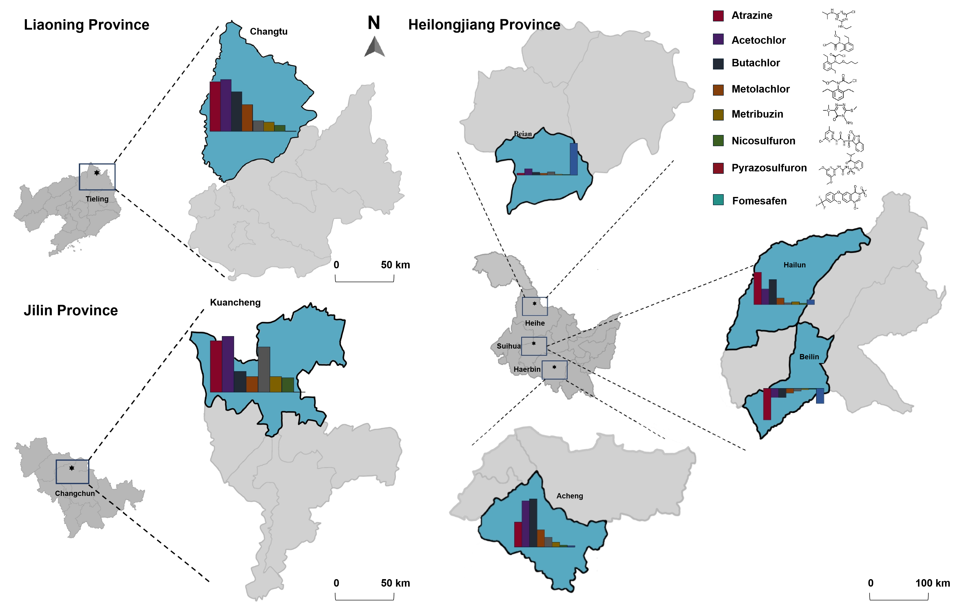
Figure S1 Map of soil sample collection sites and distribution of herbicide residues.
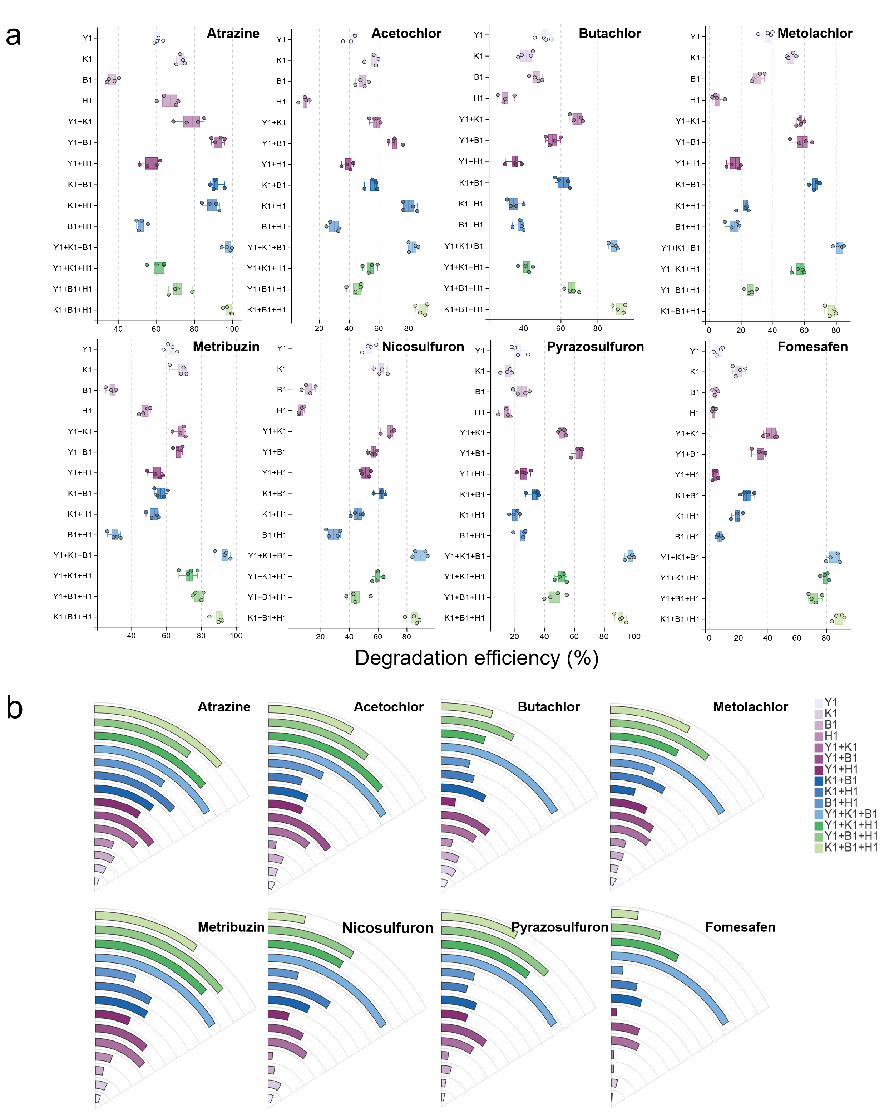
Figure S2 Degradation capabilities (a) and resistances (MICs)(b) for 8 herbicides by individual strains and SynComs.
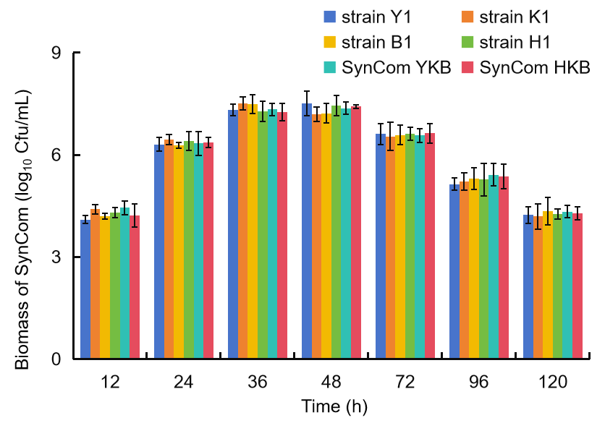
Figure S3 Overall biomass levels in monocultures and SynComs systems.
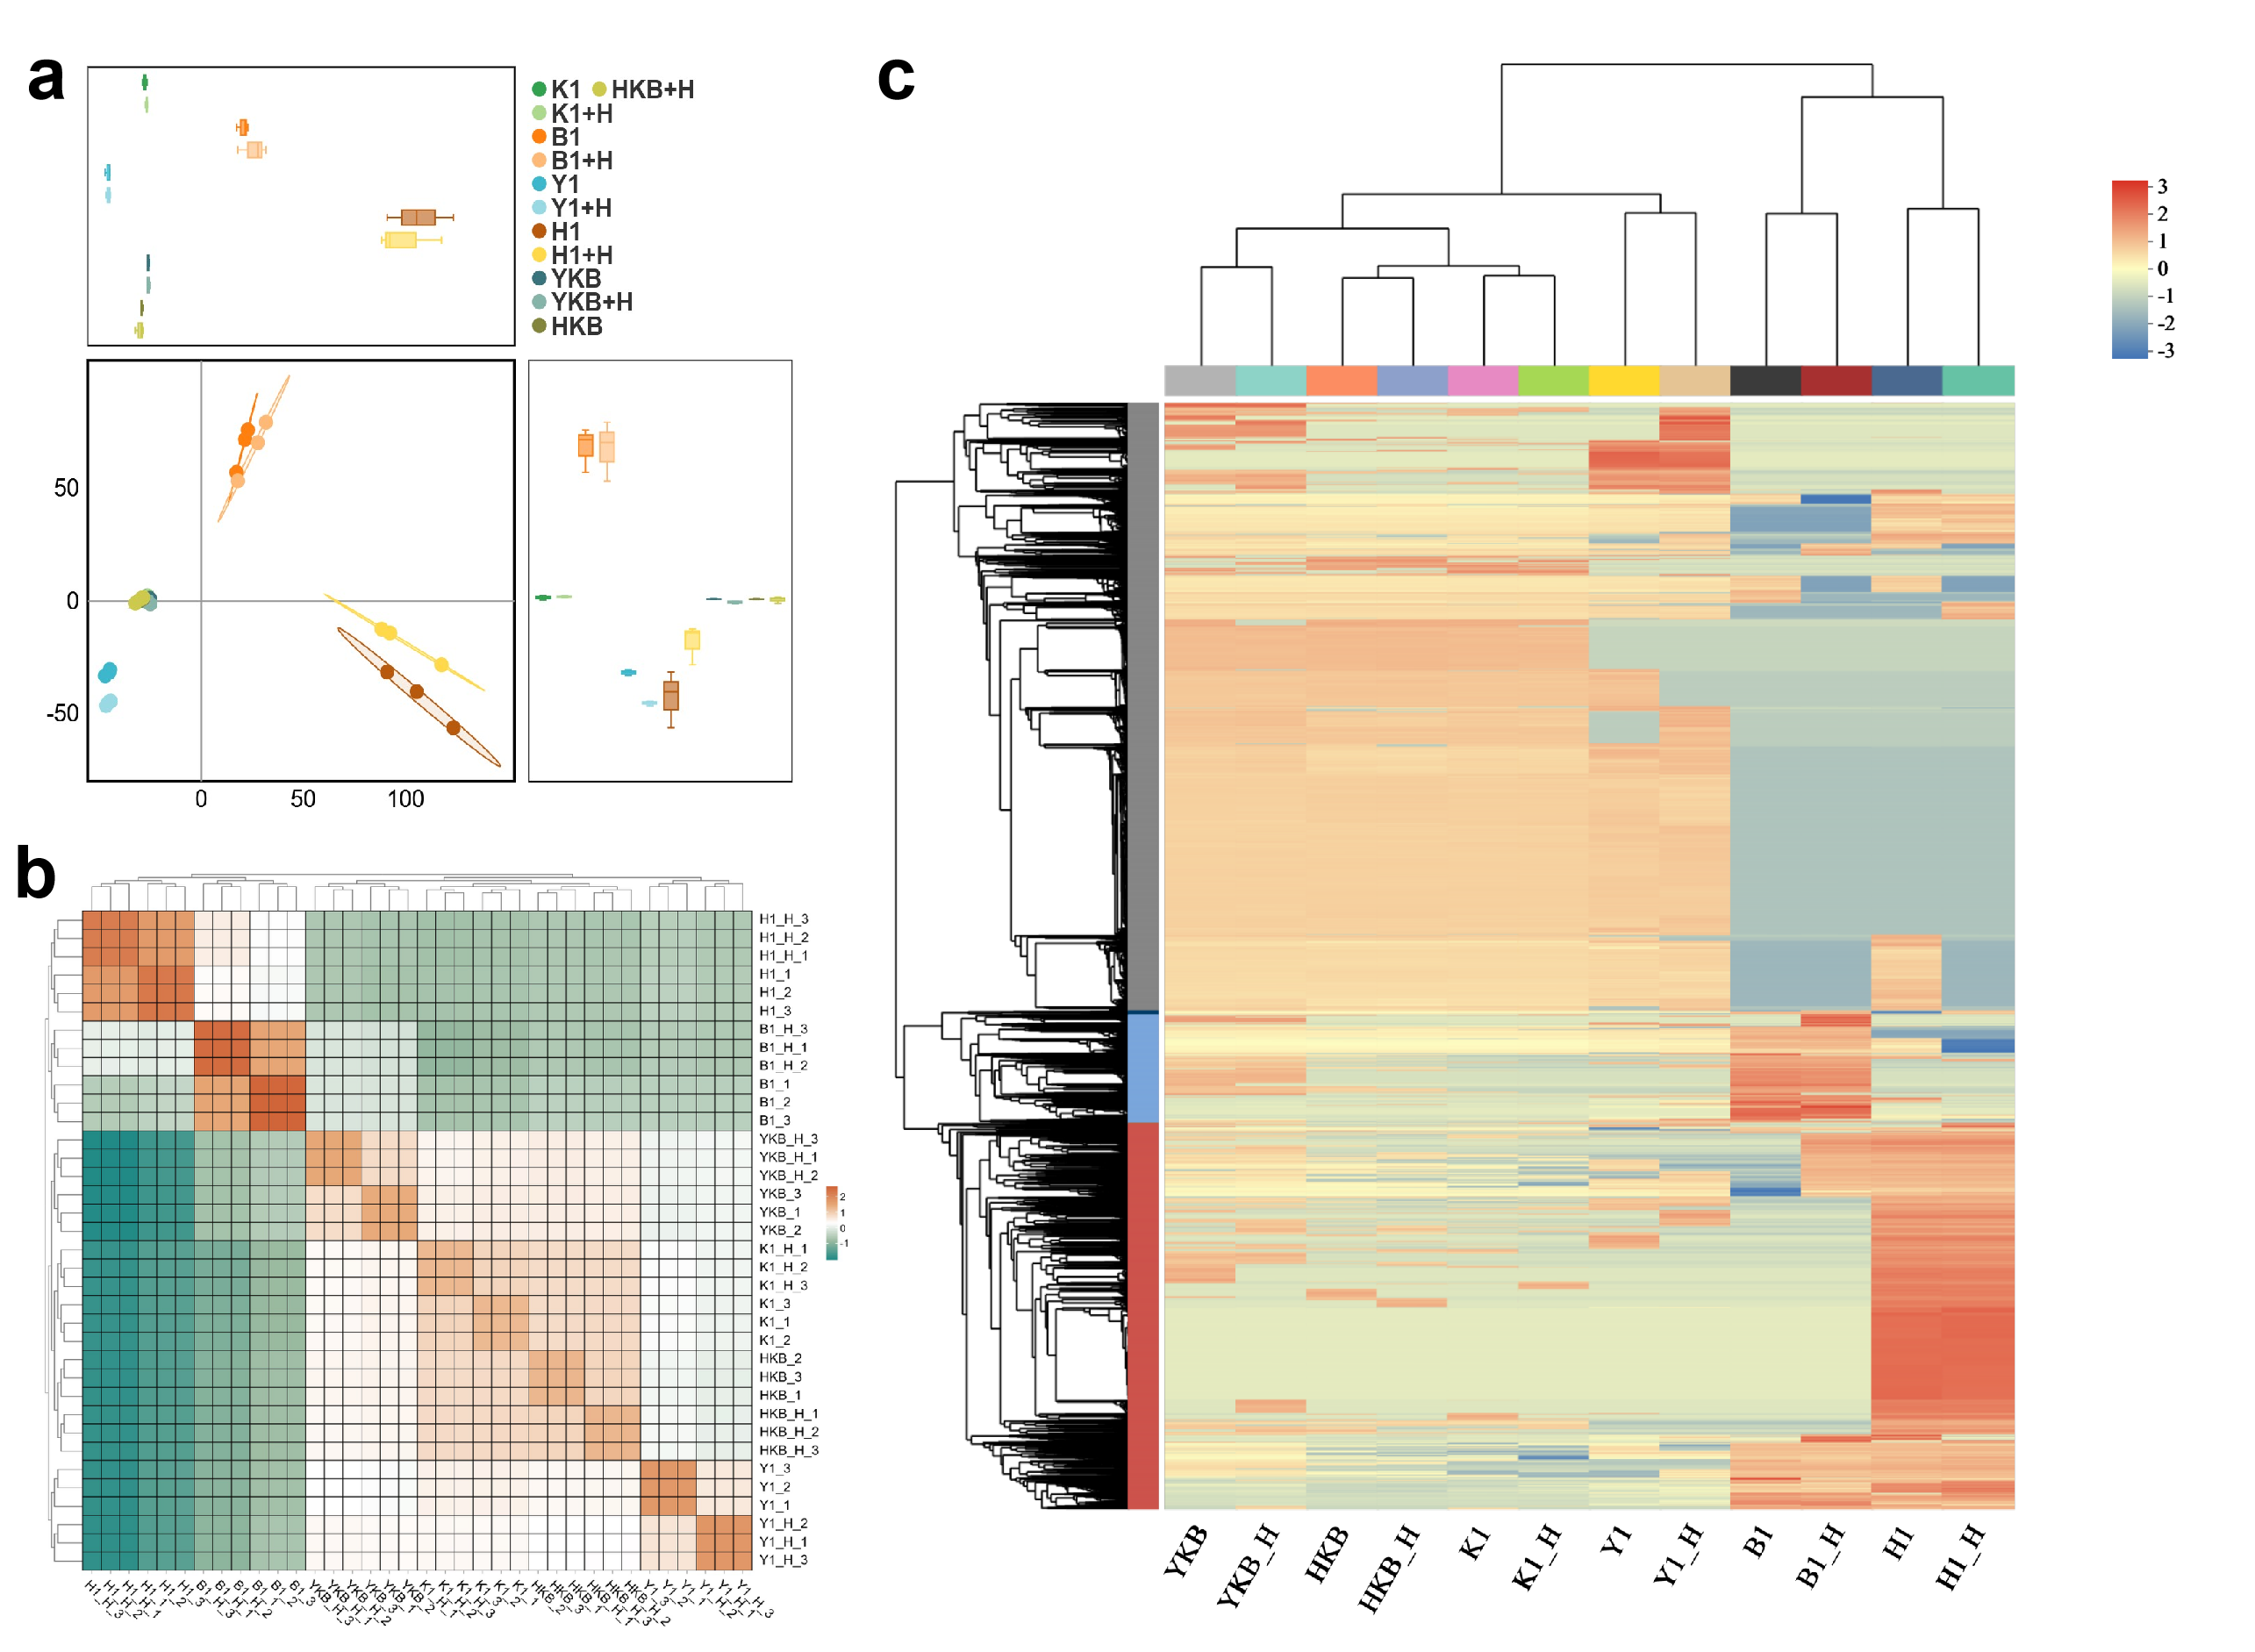
Figure S4 Comparative proteomic analysis of treatment groups. (a) The similarity among samples by principal component analysis (PCA). Closer proximity indicates higher similarity. (b) Pairwise correlation matrix between samples. Each cell represents the correlation coefficient between two samples, with color intensity denoting the strength of correlation. (c) Hierarchical clustering of protein expression patterns. Each column represents a treatment group, and each row represents individual proteins. The color scale reflects relative expression levels of proteins within each group. The left dendrogram shows protein clustering: shorter branches indicate similar expression patterns. The top dendrogram shows sample clustering: shorter branches denote similar proteomic profiles across all proteins.

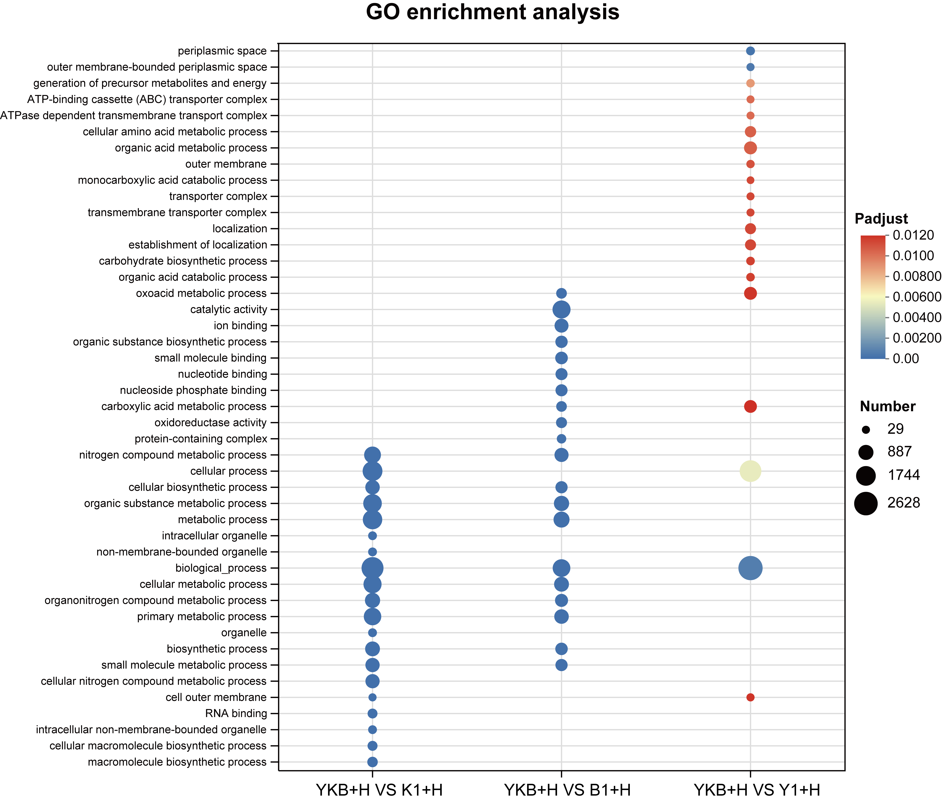
Figure S5 Protein GO enrichment analysis of SynCom YKB and monocultures under the exposure of herbicides.
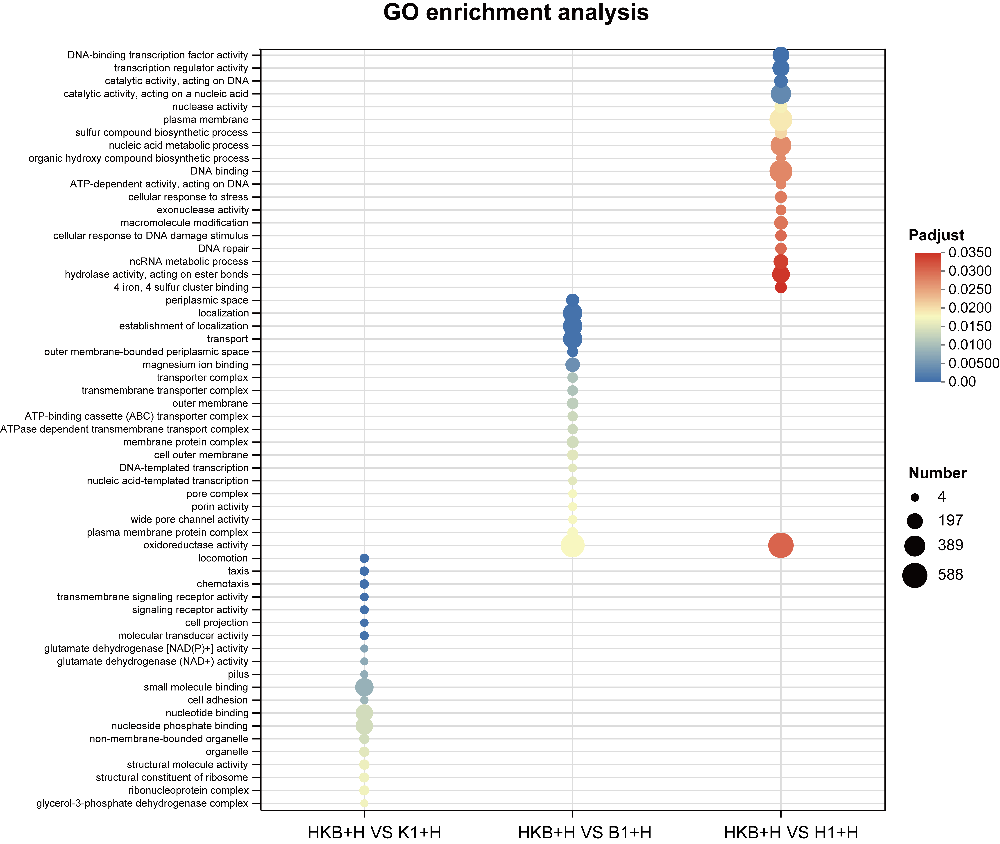
Figure S6 Protein GO enrichment analysis of SynCom HKB and monocultures under the exposure of herbicides.
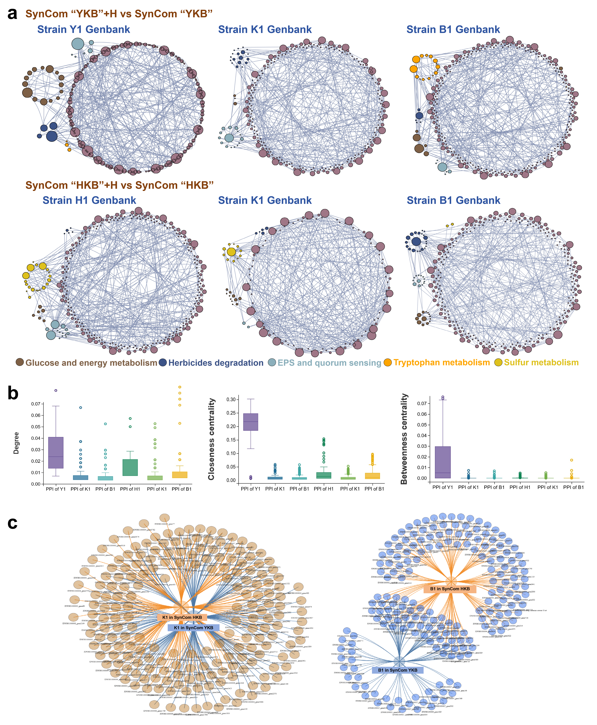
Figure S7 Enriched protein interaction networks in SynComs members exposed to herbicides. (a) Protein-protein interaction (PPI) networks of members exposed to herbicides. Nodes represent enriched proteins, and edges represent protein interactions. Node size scales proportionally to its degree centrality, where larger nodes indicate higher functional importance. (b) Unique node-level topological features of the different networks, specifically the degree, betweenness, and closeness centrality. (c) Differences and similarities in the enriched proteins annotated by strains K1 and B1 in the two SynComs systems.
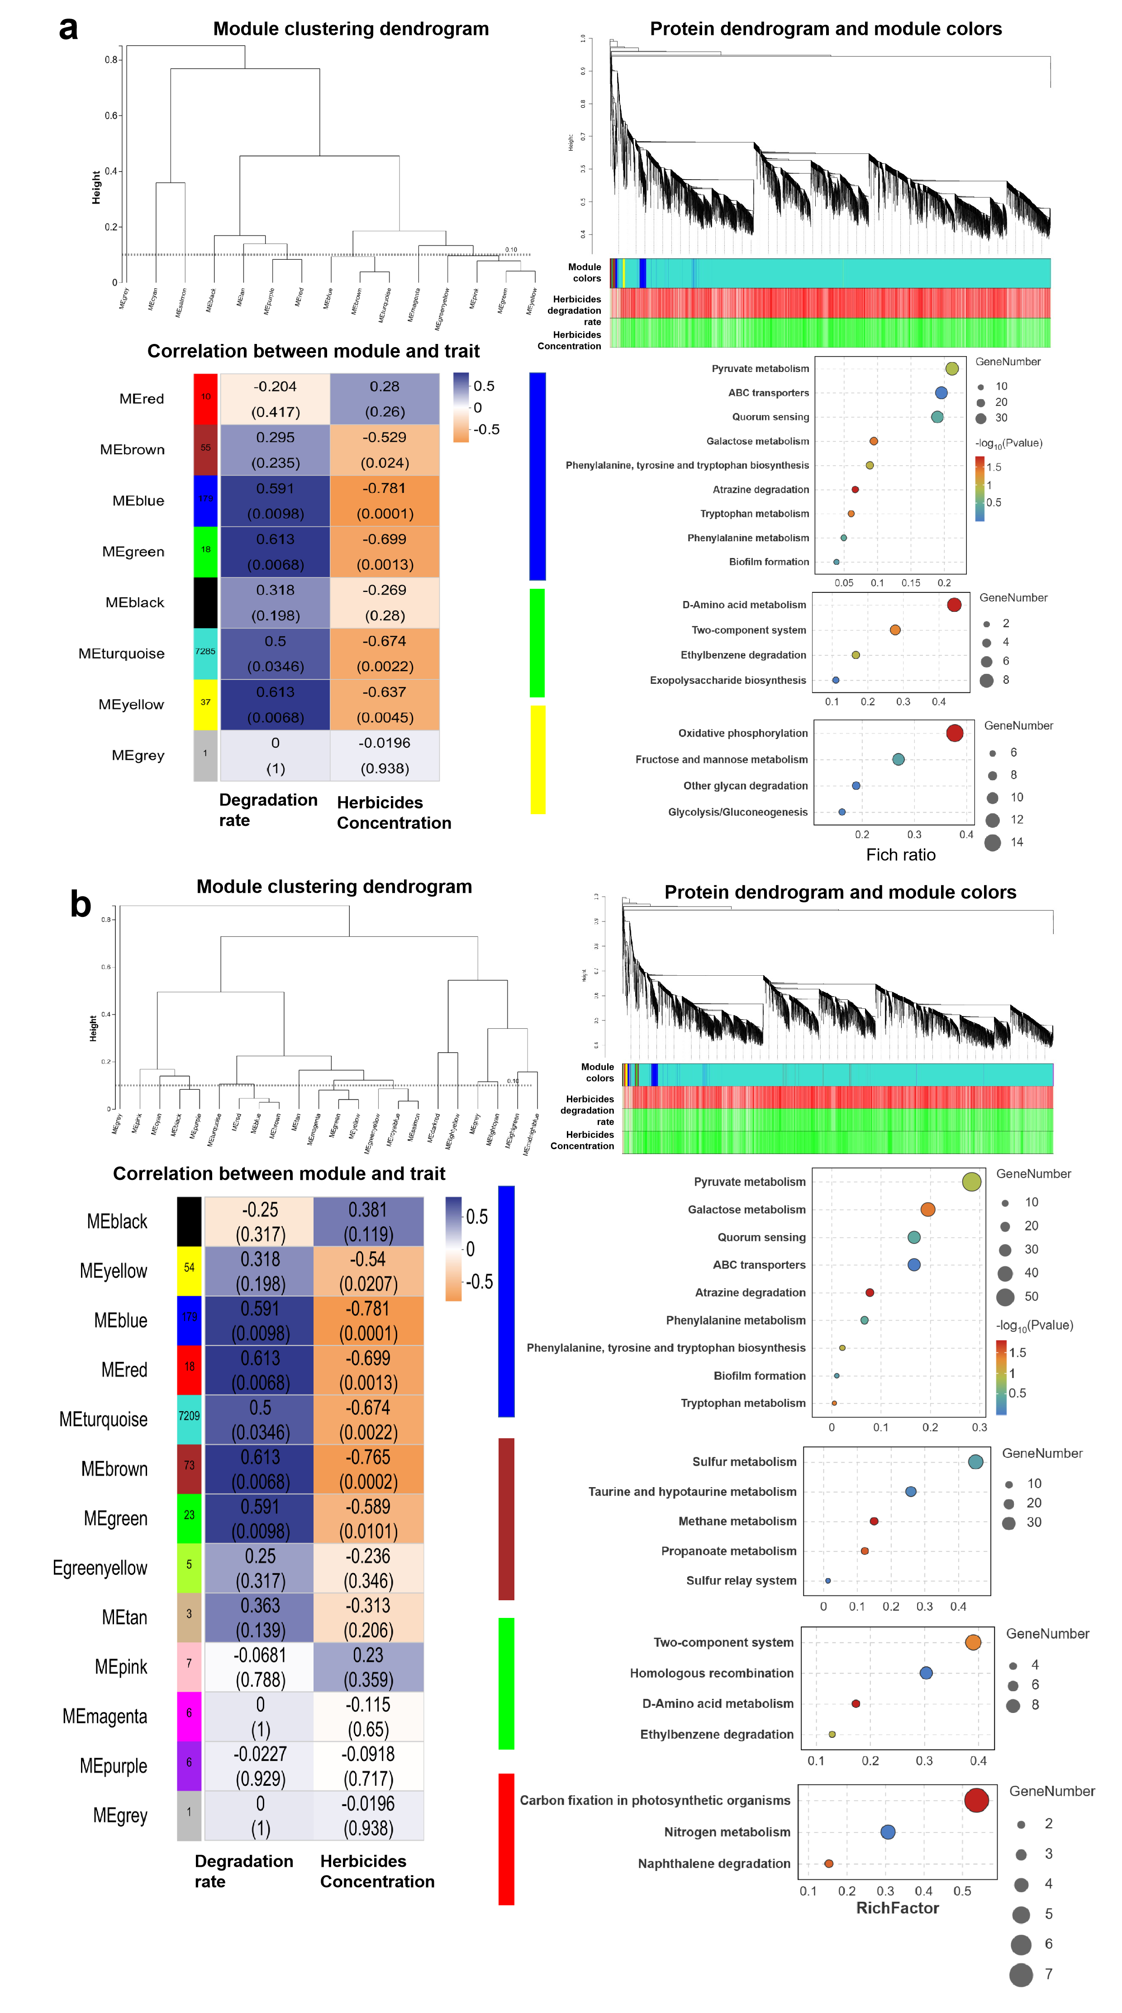
Figure S8 Weighted gene co-expression network analysis (WGCNA) of SynComs YKB (a) and HKB (b). Correlation coefficients were calculated using the Spearman method, and the top 30 nodes with the highest connectivity within each module were selected for analysis. Modules significantly positively correlated with herbicide degradation ability were selected for KEGG enrichment analysis.
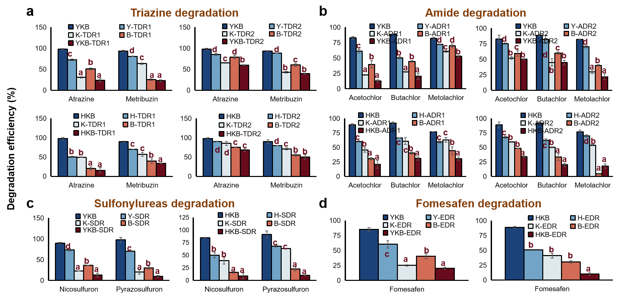
Figure S9 Impact of herbicide-degradation genes interference on herbicide degradation efficiencies in SynComs system. YKB and HKB: Control group. Y-R: interference key genes on strain Y1. K-R: interference key genes on strain K1. B-R: interference key genes on strain B1. H-R: interference key genes on strain H1. YKB-R: interference key genes on all members. HKB-R: interference key genes on all members.
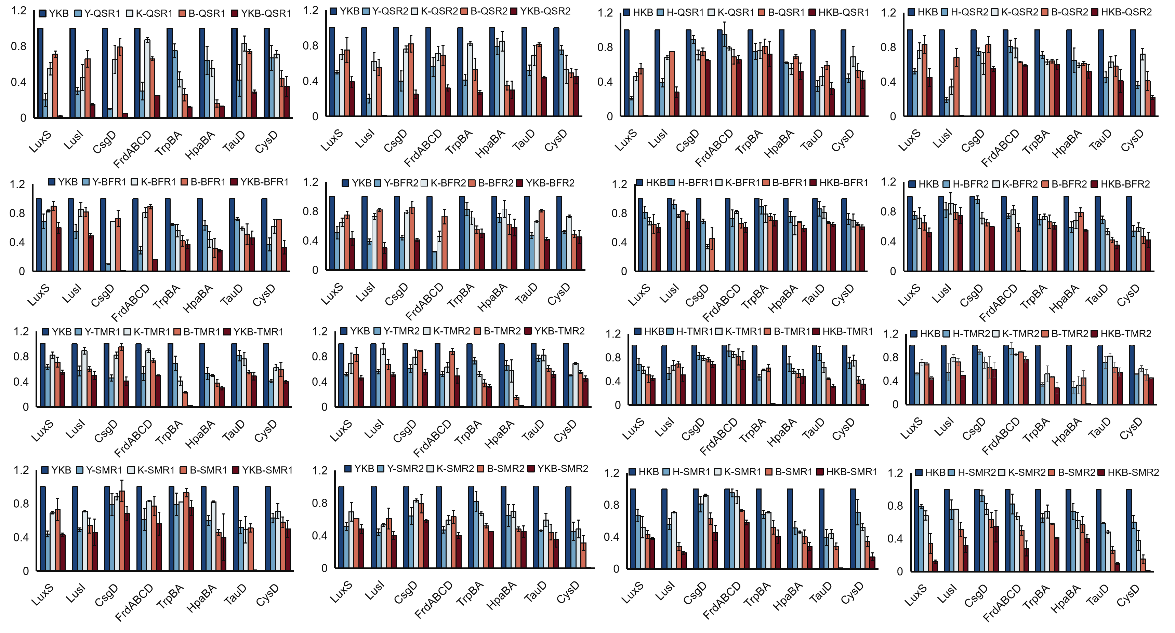
Figure S10 Impact of key metabolic pathways interference on expression levels of key functional genes in SynComs system. YKB and HKB: Control group. Y-R: interference key genes on strain Y1. K-R: interference key genes on strain K1. B-R: interference key genes on strain B1. H-R: interference key genes on strain H1. YKB-R: interference key genes on all members. HKB-R: interference key genes on all members.

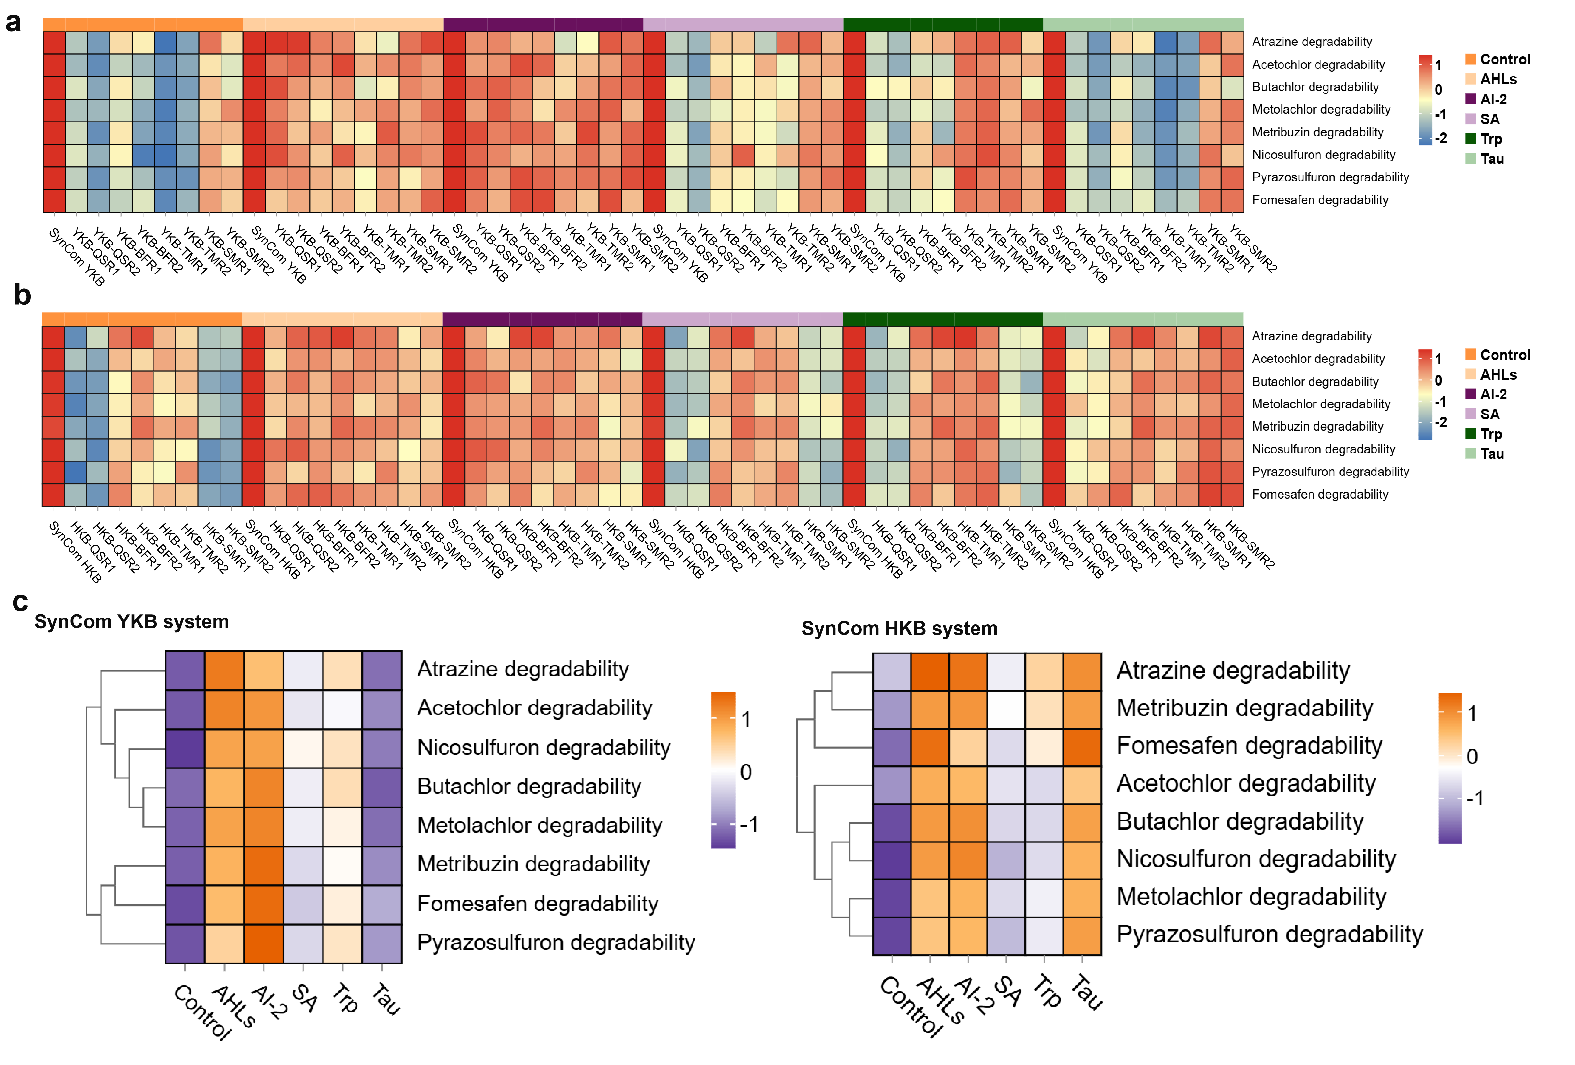
Figure S11 Resilience capacities of exogenous key metabolic on herbicides degradability in SynComs RNAi strains. (a-b) Herbicides degradability resilience in SynCom YKB (a) and HKB (b) systems with the addition of key exogenous metabolites. (c) Meta-analysis of herbicides degradability resilience in SynComs systems with the addition of key exogenous metabolites.
Figure S12 Reporter-based assessment of biotoxicity dynamics. Quantification of residual biotoxicity during herbicides degradation across treatment groups via measurement of β-galactosidase activity, and higher activity indicates elevated intracellular biotoxicity.

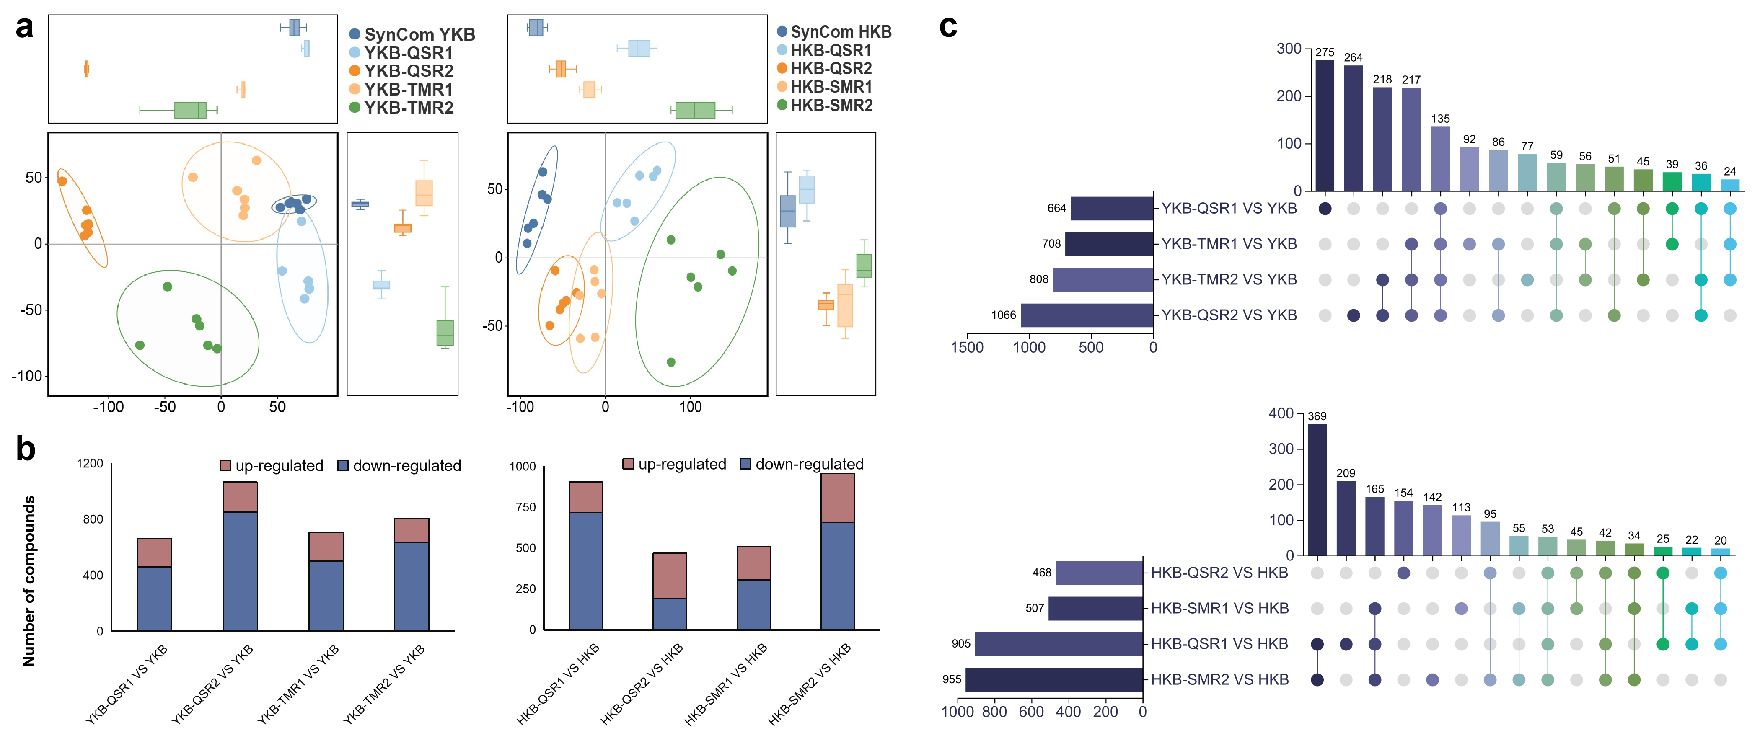
Figure S13 Metabolomics analysis of key interference systems in SynComs. (a) PCA analysis of wild and interference systems. (b) Significantly different metabolites between interference systems and wild-type systems. Red indicates up-regulated metabolites, and blue indicates down-regulated metabolites. (c) Upset plot showing shared and unique metabolites between different interference systems and wild-type systems.
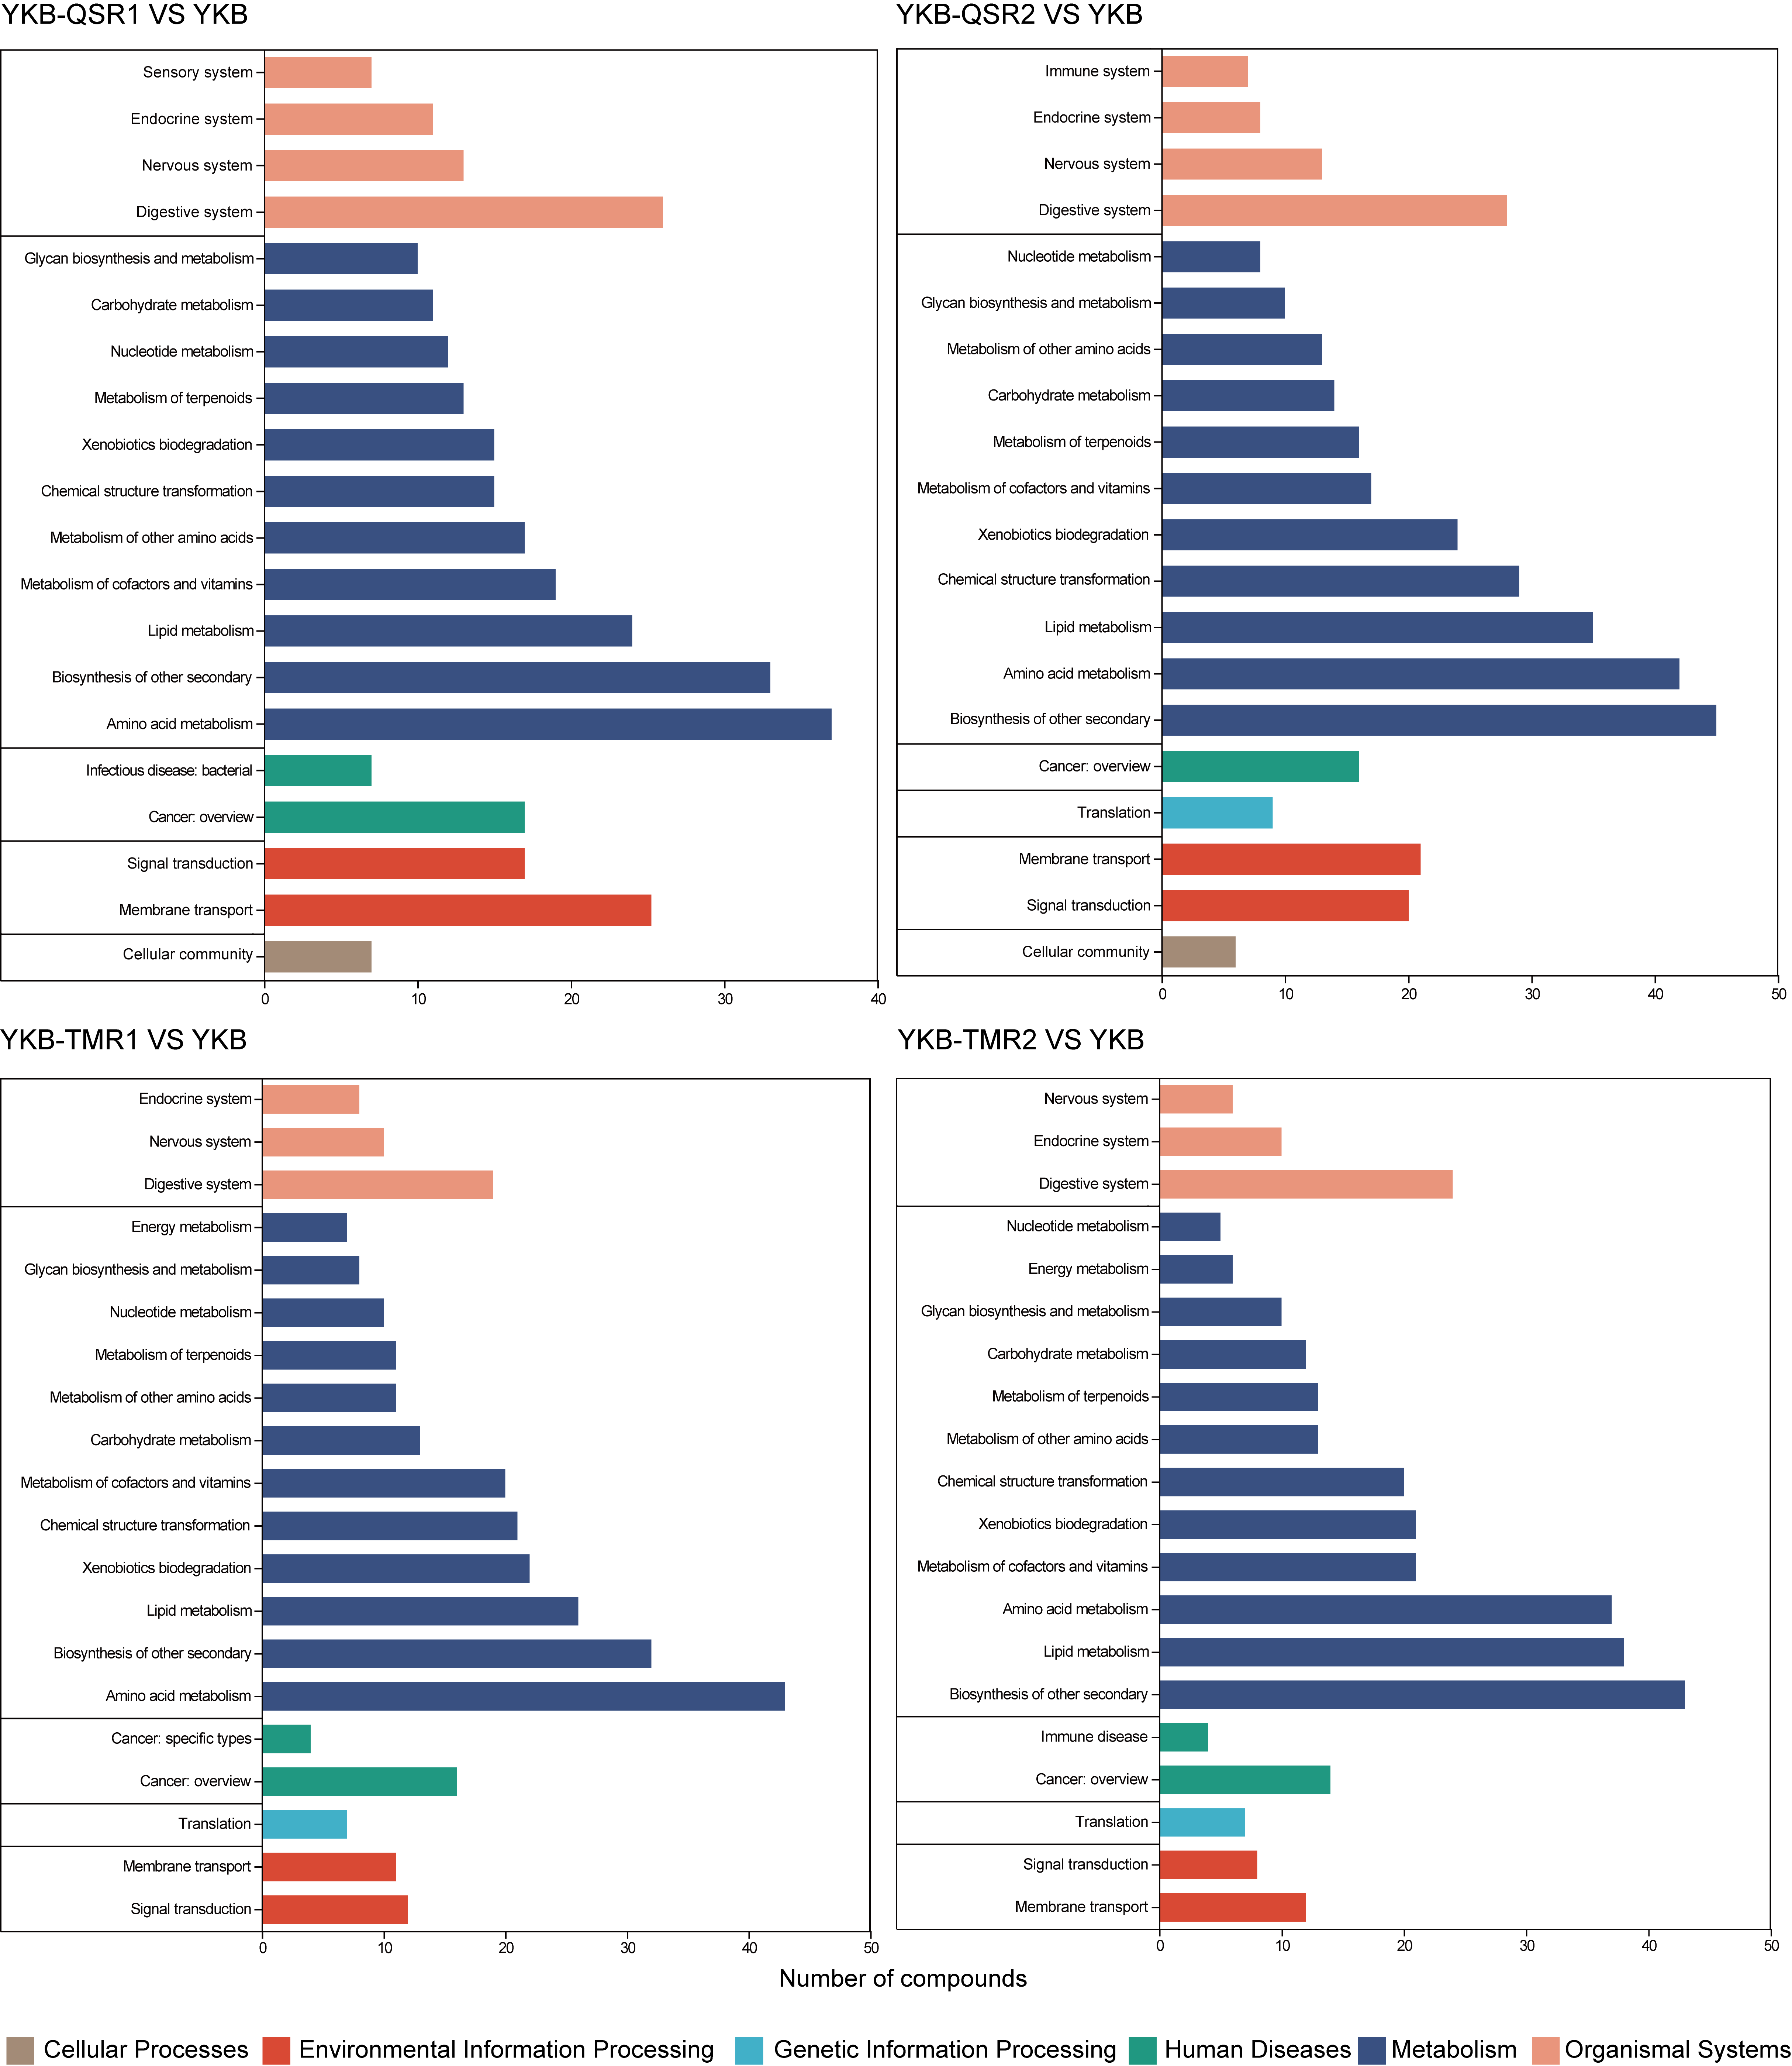
Figure S14 KEGG classification and number of differentially metabolites compared with SynCom YKB in different interference systems.
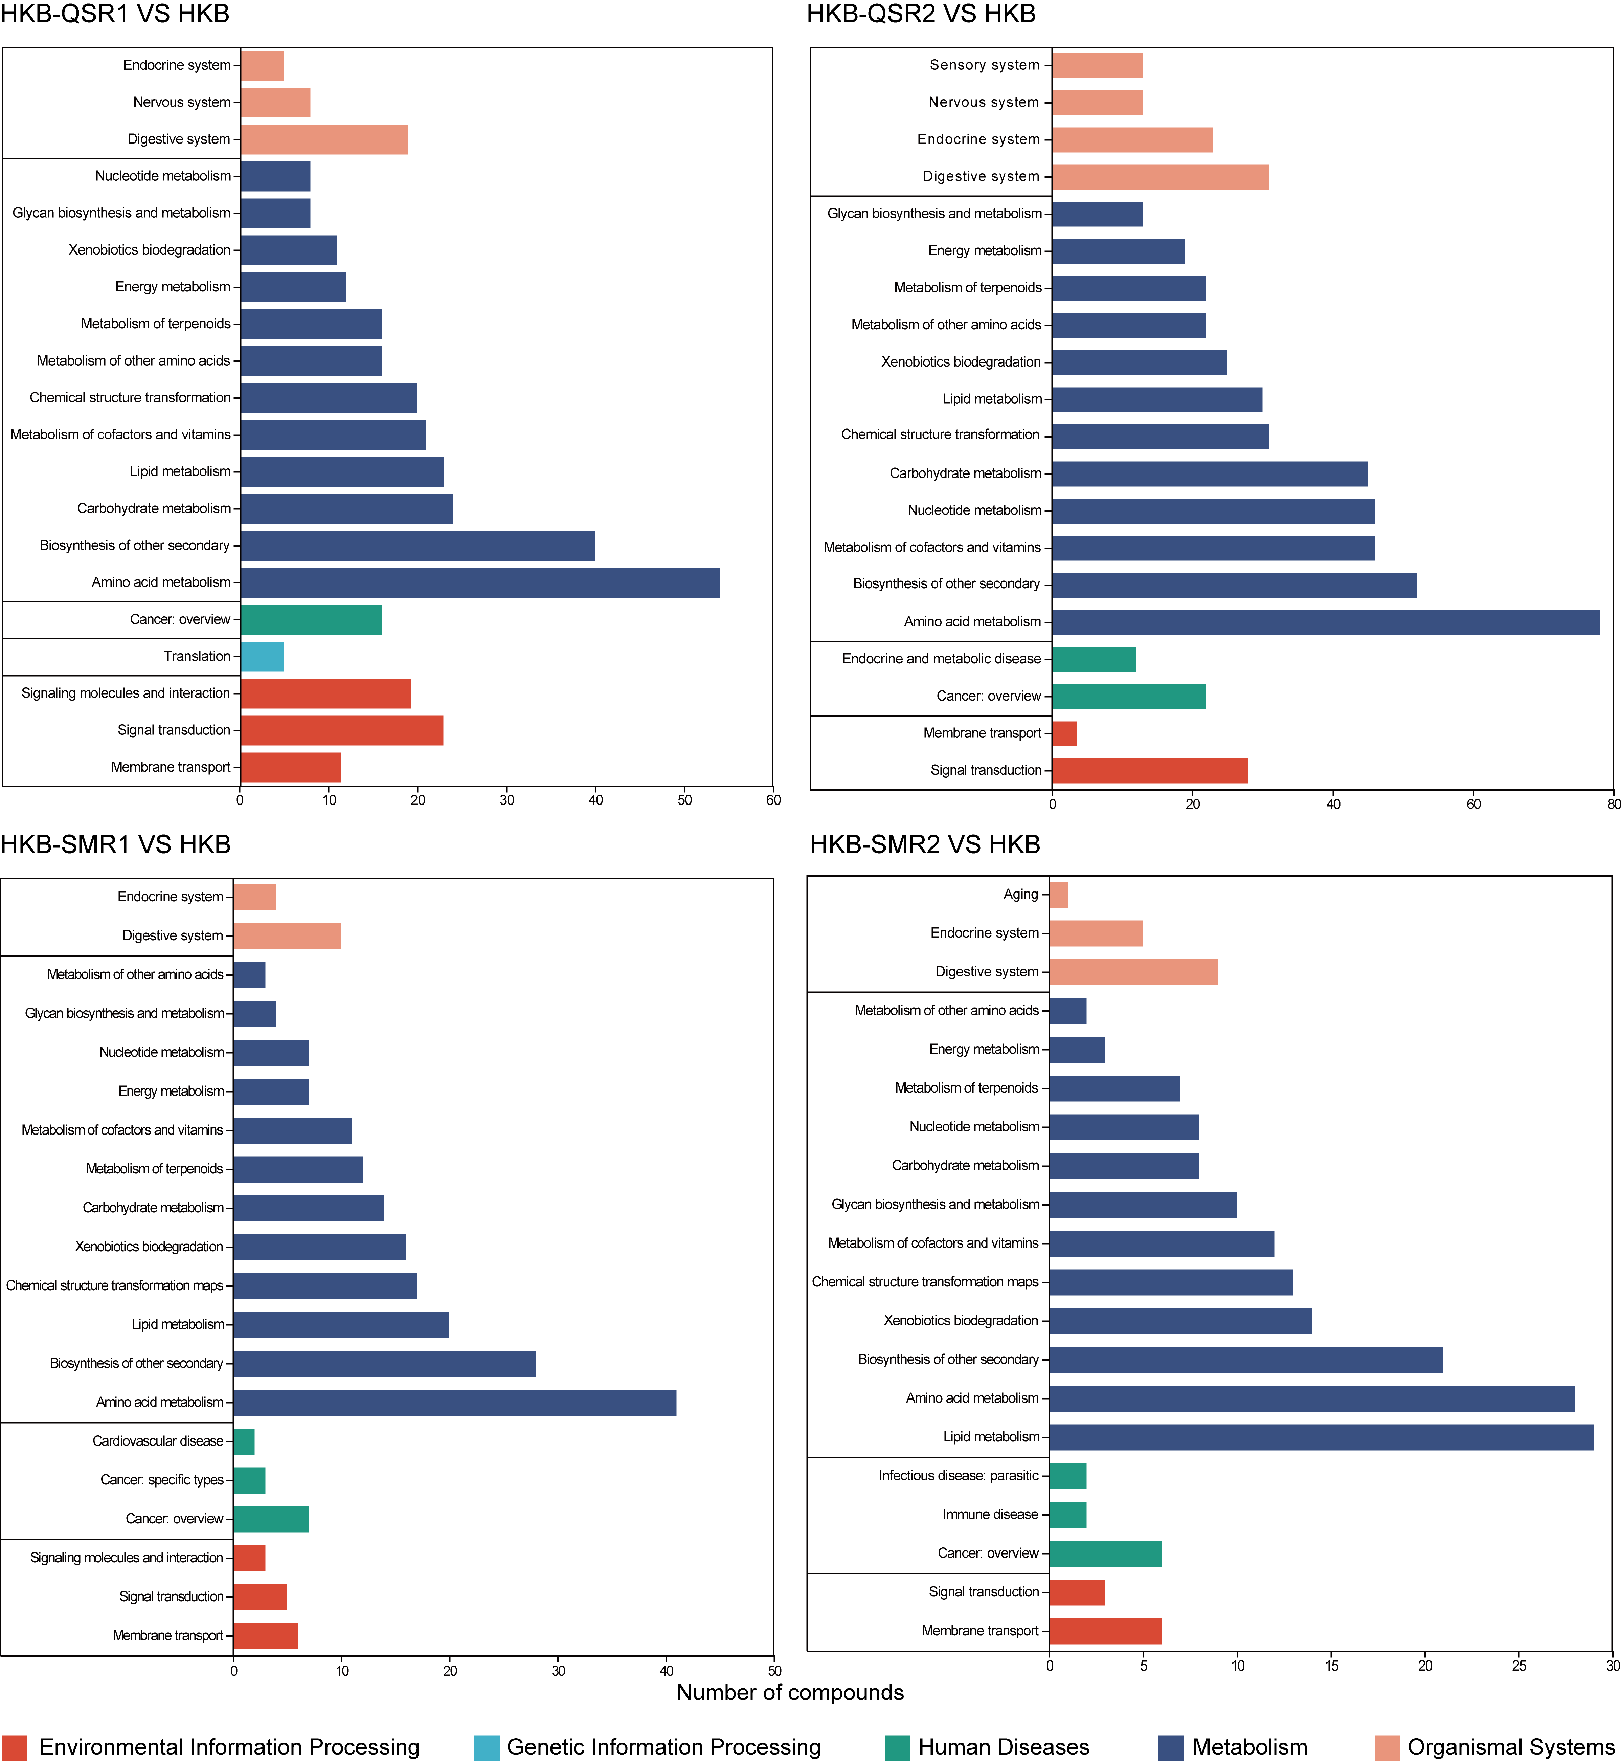
Figure S15 KEGG classification and number of differentially metabolites compared with SynCom HKB in different interference systems.
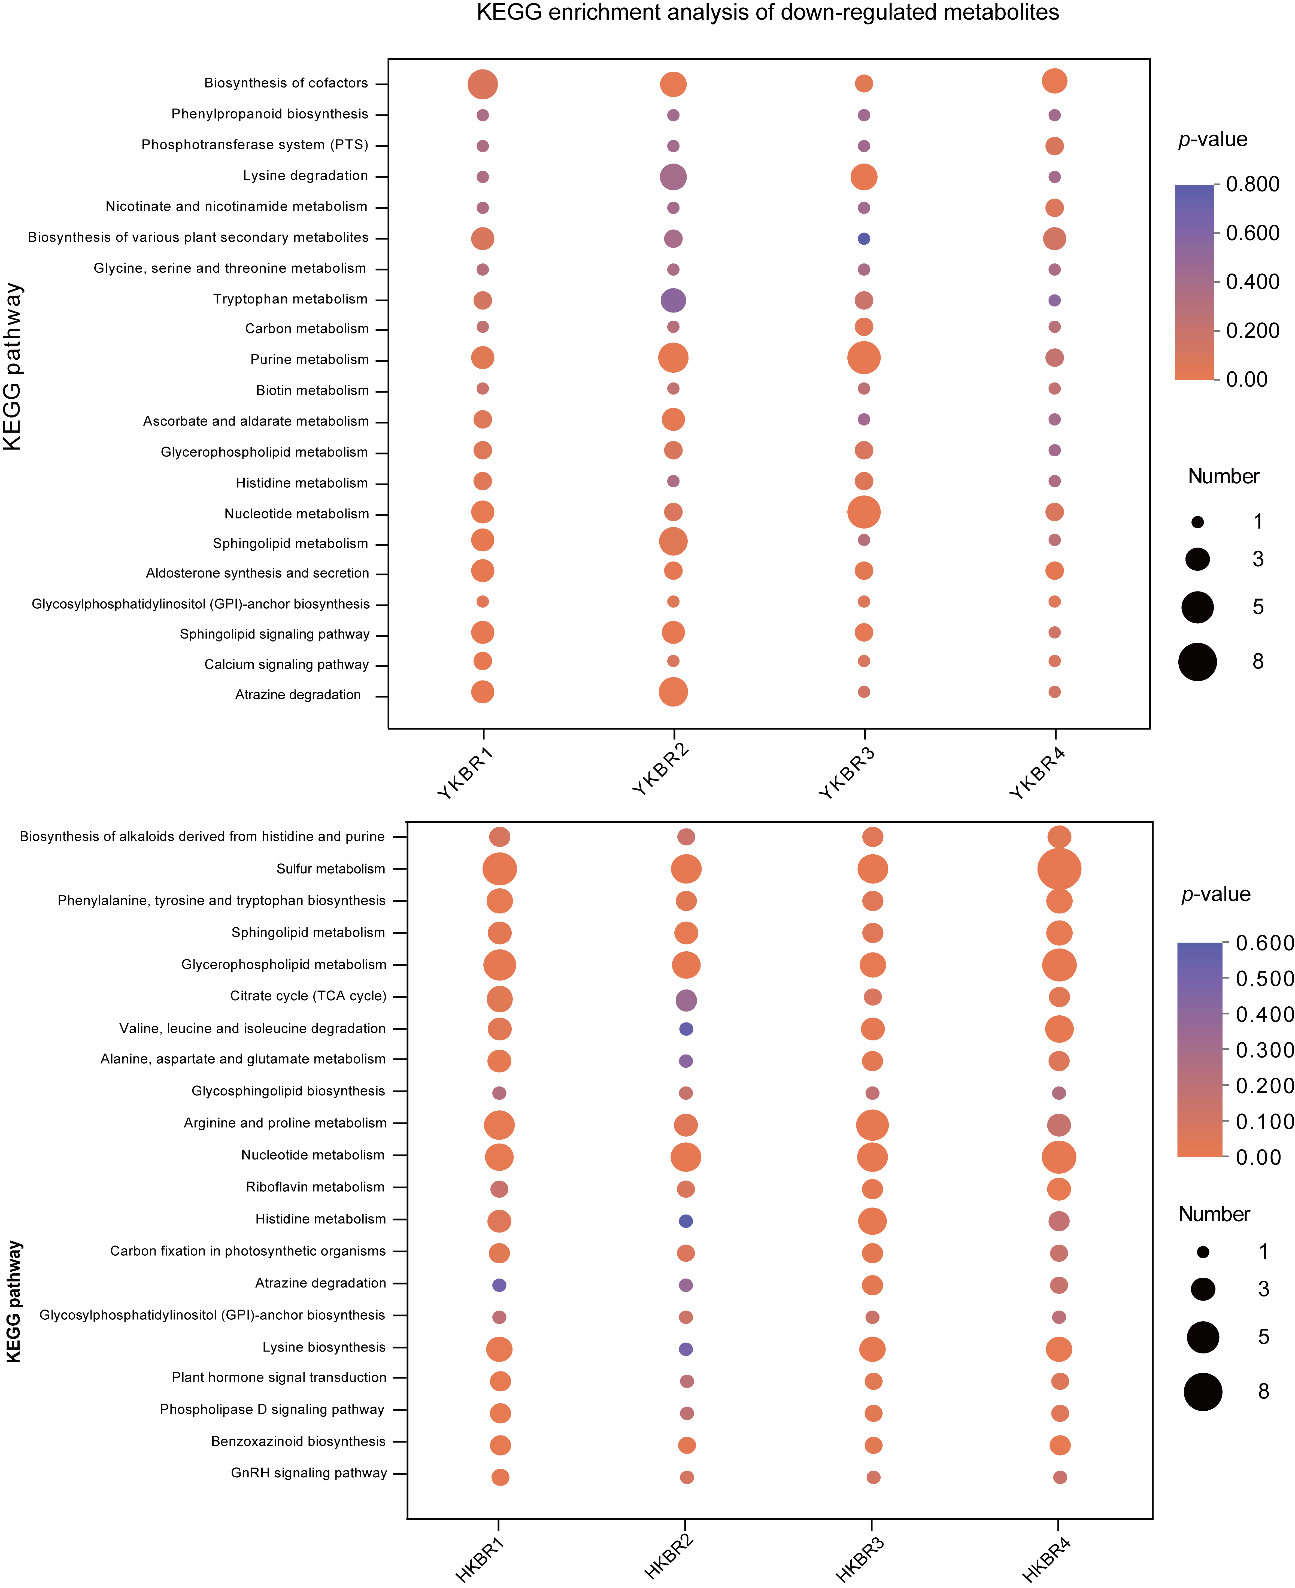
Figure S16 Comparison of KEGG enrichment of down-regulated differentially expressed metabolic pathways in interference systems.
Figure S17 KEGG enrichment analysis network diagrams in SynCom YKB interference systems. Red represents KEGG pathways, and blue represents metabolites. The size represents the number of metabolites in the pathway.
Figure S18 KEGG enrichment analysis network diagrams in SynCom HKB interference systems. Red represents KEGG pathways, and blue represents metabolites. The size represents the number of metabolites in the pathway.

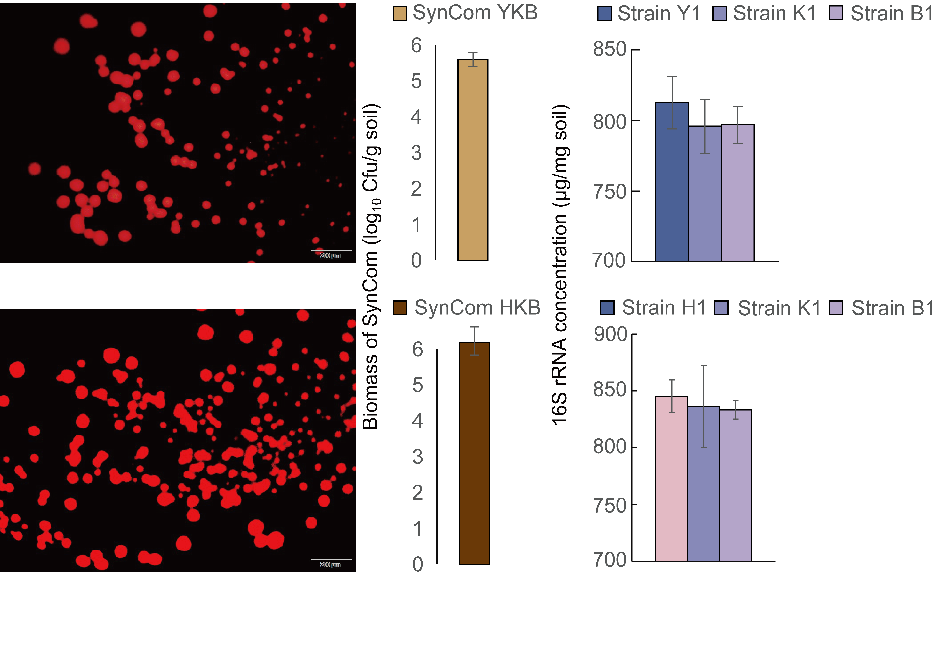
Figure S19 Colonisation status of the synthetic microbial community in black soil after 21 days.

Figure S20 Enzyme activities in rhizosphere black soil among different treatment groups.
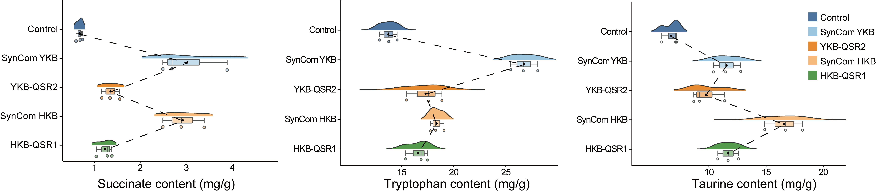
Figure S21 Differences in the content of key metabolites, succinate, tryptophan and taurine, in soils from different treatment groups.
Figure S22 Linear regression analysis between β-diversity of taxonomic in metagenomics and environmental factors in maize pot culture. R² is the coefficient of determination, representing the proportion of variation explained by the regression line.
Figure S23 Linear regression analysis between β-diversity of KEGG pathway in metagenomics and environmental factors in maize pot culture. R² is the coefficient of determination, representing the proportion of variation explained by the regression line.
Figure S24 Correlations between environmental factors and metagenomic profiles in different treatment groups. (a) Mantel test analysis of taxonomic composition and environmental factors in different treatment groups. The community distance matrix algorithm was bray-curits. The environmental factor matrix algorithm was euclidean, and the correlation coefficient was Spearman. The network lines represent the correlation between communities and environmental factors, and the heat map represents the correlation between environmental factors. The thickness of the lines indicates the strength of the correlation between the community and environmental factors, calculated using Mantel’s r. Different colors in the heatmap represent positive or negative correlations, with darker colors indicating stronger correlations. The asterisks in the color blocks indicate significance: * 0.01< p ≤ 0.05, ** 0.001< p ≤0.01, *** p ≤ 0.001. (b) The explanatory power of environmental factors on microbial community and functional differences by Variance Partitioning Analysis (VPA). Residuals represent the remaining explanatory power that cannot be explained by the above environmental factors.
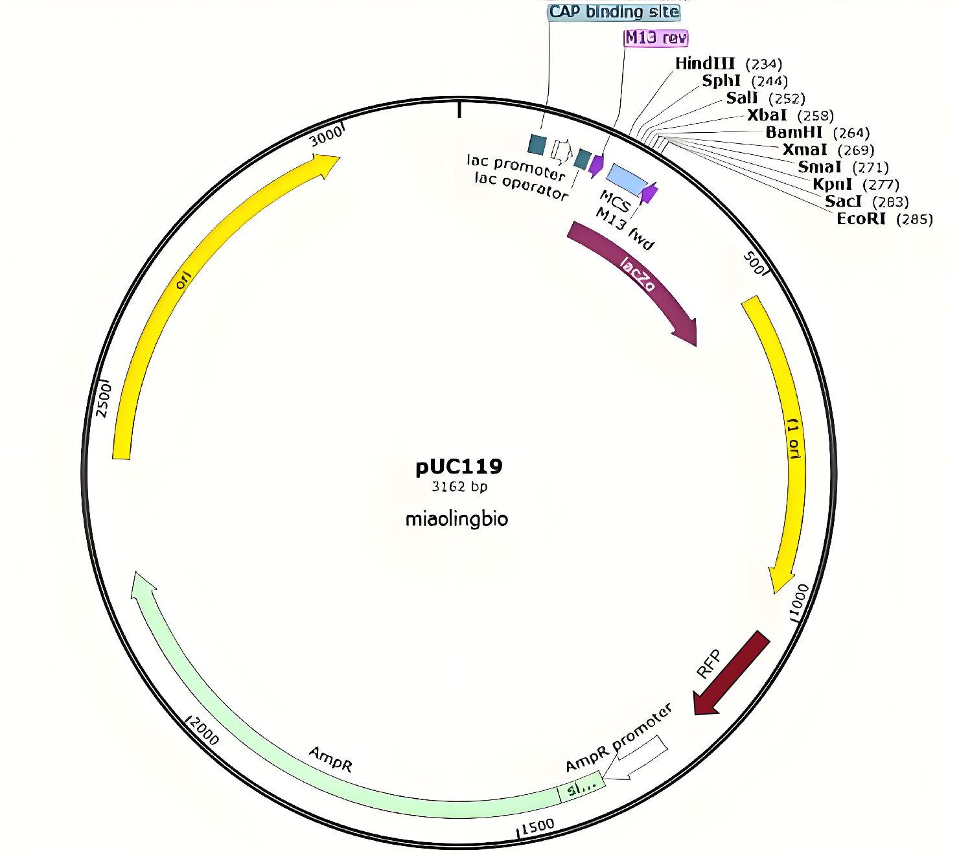
Figure S25 Schematic map of plasmid pUC119 for RNA interference.
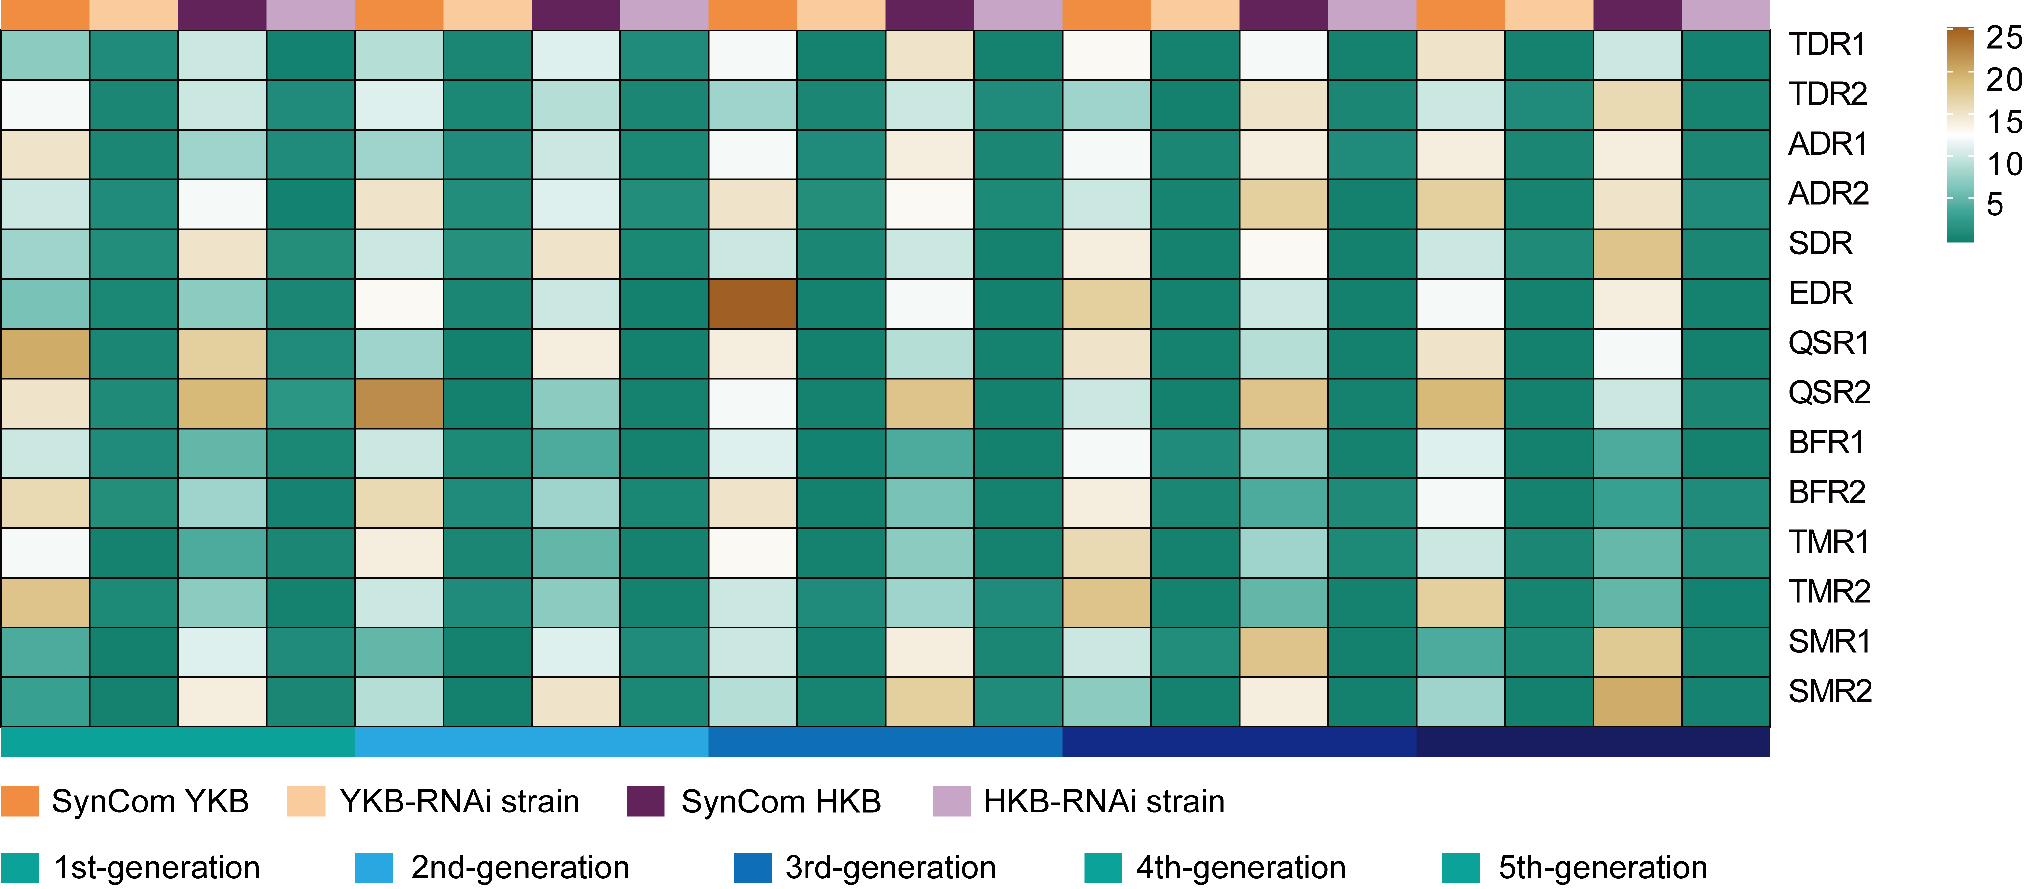
Figure S26 Validation of the expression level of the target gene in 5 generations of interference strains.
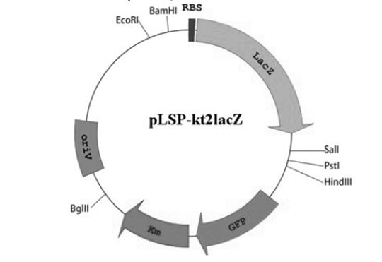
Figure S27 Schematic map of plasmid pLSP kt2lacZ for Reporter gene.
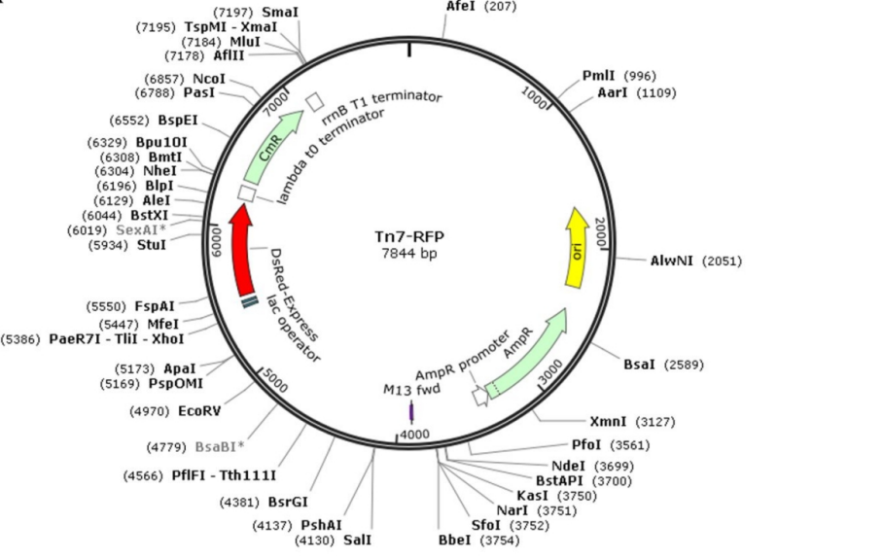
Figure S28 Schematic map of plasmid pTn7-RFP for Fluorescent labeling.

Table S1 Categories and functions of QS signaling molecules

Categories | Source | Regulatory system | Regulatory target | Functionality
AHLs | Gram-negative bacteria | LuxI/LuxR | LuxR family, Gram-negative bacteria | Biofilm formation, EPS production, granular sludge formation, microbial metabolic activity, etc.
AI-2 | Gram-positive bacteria and Gram-negative bacteria | Pfs/LuxS | Gram-positive bacteria and Gram-negative bacteria | Inter-species communication among microorganisms, biofilm formation, metabolic functions, bioluminescence, and swarming behavior, etc.
AIP | Gram-positive bacteria | Two-component control system | Gram-positive bacteria | Inter-species communication among microorganisms, virulence, antibacterial properties, etc.
AI-3 | Gut microbiota | LuxS | E.coli | Transcription activation of E. coli virulence genes, etc.
PQS | Pseudomonas sp. | 4Q control system | Pseudomonas aeruginosa | Biofilm formation, denitrification process, transport system, etc.

Table S2 Collection sites information of soil samples for functional strain isolation.

 | Changtu (CT) | Kuancheng (KC) | Acheng (AC) | Beilin (BL) | Hailun (HL) | Beian (BA)
Longitude E | 123.85 | 125.56 | 127.04 | 126.77 | 126.50 | 126.49
Latitude N | 42.71 | 42.20 | 45.56 | 46.64 | 47.39 | 48.32
Soil properties (g/kg)
TC | 13.21 | 16.72 | 22.48 | 28.65 | 31.19 | 35.67
DOC | 0.03 | 0.06 | 0.08 | 0.09 | 0.09 | 0.11
TN | 1.52 | 1.19 | 2.35 | 2.79 | 2.91 | 3.26
DON | 0.03 | 0.05 | 0.07 | 0.13 | 0.14 | 0.17
TP | 0.47 | 0.51 | 0.82 | 1.02 | 1.24 | 1.41
TK | 22.31 | 24.69 | 26.20 | 19.25 | 25.83 | 30.27
Herbicides (mg/L)
Atrazine | 92.51±4.625 | 86.67±4.334 | 66.51±3.325 | 85.81±4.290 | 83.64±4.182 | 5.457±0.273
Acetochlor | 98.82±4.941 | 94.18±4.709 | 122.9±6.149 | 41.23±2.062 | 24.32±1.216 | 17.17±0.858
Butachlor | 73.73±3.687 | 34.85±1.743 | 127.4±6.374 | 66.02±3.301 | 24.43±1.222 | 7.783±0.389
Metolachlor | 49.81±2.491 | 26.07±1.304 | 45.67±2.283 | 17.32±0.866 | 12.66±0.633 | 5.013±0.251
Metribuzin | 19.99±0.999 | 76.00±3.800 | 26.18±1.309 | 4.902±0.245 | 7.699±0.385 | 8.815±0.441
Nicosulfuron | 17.49±0.874 | 27.21±1.361 | 12.83±0.614 | 7.441±0.372 | 3.803±0.190 | 2.438±0.122
Pyrazosulfuron | 11.25±0.563 | 23.70±1.185 | 5.575±0.279 | 3.960±0.198 | 2.083±0.104 | 1.825±0.090
Fomesafen | 0.687±0.344 | 0.353±0.018 | 4.176±0.209 | 13.08±0.654 | 41.32±2.066 | 84.41±4.220

Table S3 Herbicide degradation capability by single strains and mixed bacterial communities.
Number | Species | Herbicides degradation efficiencies (%)
 |  | Atrazine | Acetochlor | Butachlor | Metolachlor | Metribuzin | Nicosulfuron | Pyrazosulfuron | Fomesafen
B1 | Pseudomonas sp. | 40.4 | 53.3 | 50.6 | 35.9 | 31.1 | 16.7 | 27.3 | 6.18
B2 | Pseudomonas sp. | 12.7 | 21.5 | 15.8 | 19.1 | 20.6 | 14.2 | 18.6 | 2.82
B3 | Pseudomonas sp. | 21.1 | 15.9 | 27.7 | 18.8 | 35.1 | 17.2 | 20.5 | 3.16
B4 | Pseudomonas sp. | 15.5 | 18.7 | 2.46 | 19.5 | 37.3 | 4.75 | 15.4 | 2.97
B5 | Pseudomonas sp. | 36.7 | 41.2 | 24.8 | 39.9 | 32.3 | 15.8 | 13.2 | 2.44
R1 | Ralstonia sp. | 15.7 | 10.6 | 18.6 | 22.5 | 15.1 | 27.8 | 36.4 | 0.52
R2 | Ralstonia sp. | 26.2 | 15.7 | 22.2 | 19.4 | 37.7 | 11.4 | 17.9 | 3.45
R5 | Ralstonia sp. | 30.5 | 35.7 | 17.6 | 51.7 | 19.9 | 36.1 | 14.1 | 10.5
R6 | Ralstonia sp. | 18.3 | 12.2 | 10.2 | 5.66 | 18.1 | 5.11 | 11.7 | 0.58
H1 | Bacillus sp. | 71.6 | 13.5 | 35.2 | 10.7 | 50.9 | 8.85 | 14.6 | 4.63
H3 | Bacillus sp. | 17.9 | 12.4 | 5.71 | 12.9 | 11.7 | 15.5 | 5.25 | 1.78
H4 | Bacillus sp. | 25.4 | 3.28 | 17.4 | 0.53 | 17.9 | 6.05 | 1.42 | 19.5
H6 | Bacillus sp. | 39.1 | 32.8 | 17.9 | 15.2 | 22.4 | 19.2 | 40.5 | 13.2
L3 | Klebsiella sp. | 58.4 | 41.4 | 27.8 | 29.5 | 34.8 | 19.5 | 12.1 | 1.55
L5 | Klebsiella sp. | 14.8 | 10.6 | 5.88 | 14.2 | 7.93 | 5.88 | 1.86 | 0.51
E2 | Enterobacter sp. | 35.5 | 30.7 | 37.1 | 12.2 | 10.5 | 30.3 | 15.7 | 2.74
E3 | Enterobacter sp. | 52.4 | 27.3 | 15.5 | 33.7 | 10.6 | 25.4 | 10.7 | 1.23
E4 | Enterobacter sp. | 10.6 | 5.57 | 18.7 | 5.85 | 14.9 | 10.9 | 11.3 | 6.13
K1 | Acinetobacter sp. | 75.6 | 59.8 | 45.8 | 55.8 | 71.5 | 66.9 | 18.2 | 24.6
K3 | Acinetobacter sp. | 18.7 | 12.6 | 10.2 | 24.4 | 18.4 | 2.07 | 15.9 | 5.01
S2 | Serratia sp. | 23.2 | 17.4 | 10.2 | 15.6 | 11.6 | 15.5 | 2.78 | 0.99
M1 | Massilia sp. | 36.1 | 20.1 | 30.4 | 15.6 | 28.5 | 36.1 | 15.6 | 1.55
M2 | Massilia sp. | 22.3 | 11.5 | 5.76 | 15.2 | 7.88 | 10.9 | 15.2 | 1.77
D1 | Brevundimonas sp. | 19.3 | 2.98 | 15.6 | 16.6 | 20.5 | 14.4 | 13.8 | 1.19
Y1 | Comamonas sp. | 63.6 | 43.9 | 55.9 | 40.6 | 66.2 | 58.8 | 29.1 | 9.23
F2 | Flavobacterium sp. | 20.3 | 10.2 | 8.62 | 15.4 | 25.9 | 13.7 | 5.51 | 1.85
O2 | Bryobacter sp. | 11.5 | 5.18 | 8.95 | 9.79 | 12.6 | 14.1 | 13.6 | 1.02
U1 | Burkholderia sp. | 18.9 | 8.06 | 20.9 | 15.9 | 7.03 | 4.64 | 1.97 | 0.53
C2 | Sphingobium sp. | 24.4 | 20.5 | 11.5 | 17.1 | 4.51 | 8.28 | 1.52 | 0.22
Y1+K1 | / | 85.2 | 61.3 | 72.5 | 60.7 | 71.1 | 71.3 | 54.2 | 46.2
Y1+B1 | / | 96.1 | 76.2 | 60.3 | 65.1 | 69.3 | 59.6 | 63.3 | 38.5
Y1+H1 | / | 62.8 | 42.9 | 39.1 | 20.5 | 58.2 | 55.1 | 30.8 | 6.15
K1+B1 | / | 96.3 | 59.4 | 65.2 | 70.4 | 60.9 | 65.3 | 36.2 | 30.8
K1+H1 | / | 93.2 | 85.8 | 40.6 | 25.4 | 55.7 | 49.8 | 23.6 | 23.1
B1+H1 | / | 55.6 | 33.1 | 45.8 | 19.2 | 33.8 | 33.9 | 28.6 | 9.23
K1+B5 | / | 41.2 | 37.5 | 25.8 | 12.7 | 24.2 | 30.5 | 27.9 | 10.1
K1+L3 | / | 55.1 | 27.4 | 24.2 | 15.8 | 25.6 | 32.8 | 25.5 | 13.5
K1+M1 | / | 37.5 | 41.2 | 32.6 | 19.4 | 20.4 | 41.5 | 22.4 | 15.1
B1+H6 | / | 47.2 | 16.3 | 33.9 | 29.7 | 15.6 | 26.2 | 17.5 | 5.48
H1+M1 | / | 30.7 | 46.2 | 10.1 | 22.1 | 10.5 | 30.2 | 24.3 | 4.58
H1+E3 | / | 35.9 | 20.1 | 34.9 | 19.7 | 16.6 | 23.1 | 12.2 | 8.29
B5+H6 | / | 39.8 | 25.3 | 17.5 | 36.3 | 12.9 | 39.9 | 15.6 | 7.28
B5+E3 | / | 40.2 | 10.1 | 18.4 | 20.4 | 30.7 | 19.4 | 40.3 | 19.9
R6+L3 | / | 20.3 | 30.6 | 15.4 | 40.9 | 28.4 | 39.7 | 21.8 | 15.1
R6+M1 | / | 48.1 | 33.2 | 19.2 | 26.1 | 37.3 | 10.9 | 21.7 | 8.94
H6+E2 | / | 50.5 | 21.3 | 12.5 | 8.53 | 18.8 | 22.7 | 17.8 | 10.5
L3+M1 | / | 23.6 | 29.1 | 37.6 | 41.3 | 19.2 | 15.4 | 7.66 | 19.3
E2+M1 | / | 37.8 | 18.7 | 22.8 | 17.1 | 19.2 | 24.9 | 13.6 | 20.7
Y1+K1+B1 | / | 99.8 | 86.5 | 91.6 | 85.7 | 96.8 | 94.6 | 99.2 | 89.3
Y1+K1+H1 | / | 64.1 | 59.2 | 70.1 | 60.9 | 67.2 | 63.9 | 55.1 | 82.1
Y1+B1+H1 | / | 79.3 | 48.3 | 75.4 | 30.4 | 80.2 | 44.3 | 55.8 | 77.3
K1+B1+H1 | / | 99.9 | 92.6 | 95.4 | 80.2 | 91.4 | 88.9 | 95.2 | 92.6
K1+B5+L3 | / | 63.4 | 71.8 | 55.3 | 41.9 | 39.9 | 27.3 | 29.2 | 48.4
K1+H6+E2 | / | 49.2 | 62.9 | 37.8 | 55.3 | 49.1 | 58.3 | 47.1 | 26.4
B5+H6+E3 | / | 77.2 | 32.5 | 49.4 | 37.8 | 21.5 | 38.6 | 62.3 | 35.2
Y1+K1+B5+L3 | / | 69.8 | 61.1 | 62.6 | 34.4 | 58.1 | 42.1 | 49.4 | 60.3
Y1+K1+B1+L3 | / | 95.5 | 73.7 | 82.6 | 86.6 | 90.5 | 89.8 | 93.3 | 71.8
Y1+B5+H6+E3 | / | 58.6 | 59.1 | 62.4 | 71.6 | 36.5 | 47.5 | 50.1 | 59.8
K1+B5+H6+E3 | / | 53.8 | 59.3 | 33.6 | 45.3 | 60.9 | 18.5 | 44.8 | 29.5
H1+K1+B1+L3 | / | 83.4 | 90.4 | 91.4 | 72.1 | 73.5 | 79.8 | 85.5 | 83.6
Y1+K1+B1+B5+L3 | / | 87.2 | 79.7 | 83.2 | 86.2 | 90.7 | 92.1 | 93.9 | 80.6
Y1+K1+B1+H6+E3 | / | 91.1 | 73.9 | 85.5 | 70.6 | 83.3 | 81.8 | 90.7 | 85.2
H1+K1+B1+B5+H6 | / | 76.6 | 88.1 | 79.3 | 81.7 | 71.5 | 82.4 | 90.3 | 78.7
Other combinations |  | < 50

Table S4 The different expression of key proteins between monoculture and co-cultured conditions in SynCom YKB system.
Protein description | Log2 FC | P-adjust | Function
YKB+H VS Y1+H
Zinc ABC transporter substrate-binding protein ZnuA | 7.649 | 0.0042 | Inorganic ion transport and metabolism
Iron uptake system protein EfeO | 2.682 | 0.1266
Glucans biosynthesis protein MdoG | 6.416 | 0.0514 | Energy production and conversion
NAD-dependent succinate-semialdehyde dehydrogenase Ssd | 5.834 | 0.0319
Sugar PTS system EIIA component Crr | 5.162 | 0.0785
Glucose-1-phosphatase Agp | 4.576 | 0.0007
Aldose 1-epimerase GalM | 3.099 | 0.2380
L-lactate dehydrogenase Ldh | 2.965 | 0.0559
Succinyl-CoA synthetase SucDC | 2.539 | 0.0083
2-oxoacid ferredoxin oxidoreductase subunit alpha OorA | -2.615 | 0.0116
Succinate dehydrogenase flavoprotein FrdABCD | 5.569 | 0.2862 | Biofilm formation
Putative colanic acid biosynthesis glycosyltransferase WcaI | 5.492 | 0.0114
N-acetyl-D-mannosaminouronosyltransferase WecG | 4.313 | 0.0186
S-ribosylhomocysteine lyase LuxS | 4.961 | 0.4826 | Quorun sensing
LuxR family transcriptional regulator LuxR | 4.616 | 0.0017
Acyl homoserine lactone synthase LuxI | 4.173 | 0.0109
LysR family transcriptional regulator OxyR | 4.019 | 0.0492
LysR family transcriptional regulator, glycine cleavage system Transcriptional activator GcvA | 3.186 | 0.3162
LuxR family transcriptional regulator, csgAB operon transcriptional Regulatory protein CsgD | 2.739 | 0.3616
Atrazine chlorohydrolase AtzA | 8.132 | 0.1379 | Trazine degradation
Hydroxydechloroatrazine ethylaminohydrolase AtzB | 4.958 | 0.0093
YKB+H VS K1+H
Atrazine chlorohydrolase AtzA | 7.281 | 0.0658 | Trazine degradation
Hydroxydechloroatrazine ethylaminohydrolase AtzB | 6.416 | 0.0435
N-isopropylammelide isopropylaminohydrolase AtzC | 4.817 | 0.0272
Atrazine monooxygenase ThcBCD | 3.674 | 0.0918
Isopropylmalate isomerase MeaA | 5.834 | 0.0009 | Amide degradation
Isopropylmalate dehydratase MeaB | 4.721 | 0.0077
Cytochrome P450 oxygenase system EthBAD | 4.697 | 0.0294
Ferredoxin Cnd | -3.165 | 0.0613
2,4-dichlorophenoxyacetate dioxygenase TfdA | 4.295 | 0.0204 | Metribuzin degradation
Manganese ABC transporter MntAD | 3.151 | 0.2757 | Sulfonylureas degradation
Carboxylesterase CarE | 2.863 | 0.0098
Cytochrome P450 hydroxylase sytem Box AB | 2.713 | 0.0033
Nitroreductase DnrA | 4.359 | 0.1301 | Ether degradation
S-ribosylhomocysteine lyase LuxS | 6.917 | 0.0126
Acyl homoserine lactone synthase LuxI | 6.622 | 0.0215
AI-2 ABC transporter periplasmic binding protein LsrB | 6.102 | 0.0170 | Quorun sensing
LuxR family transcriptional regulator LuxR | 3.174 | 0.0029
YKB+H VS B1+H
Tryptophan synthase TrpBA | 7.269 | 0.0056 | Tryptophan metabolism
Acetyl-CoA acyltransferase FadA | 6.155 | 0.0770
Indolepyruvate decarboxylase IpdC | 4.25 | 0.0022
Phosphate acetyltransferase | 4.189 | 0.1220
4-hydroxyphenylacetate-3-monooxygenase HpaBA | 3.243 | 0.0007
3-oxoadipyl-CoA thiolase IaaA | -2.719 | 0.0166
AI-2 transport system permease protein LsrCD | 6.129 | 0.1696 | Quorun sensing
AI-2 ABC transporter periplasmic binding protein LsrB | 4.302 | 0.0170
Acyl homoserine lactone synthase LuxI | 4.295 | 0.2596
S-ribosylhomocysteine lyase LuxS | 4.290 | 0.0018
Two-component system QseBC | 4.287 | 0.0032
Carboxylesterase CarE | 4.11 | 0.0584 | Sulfonylureas degradation
Cytochrome P450 hydroxylase sytem BoxAB | 3.091 | 0.0199
Nitroreductase DnrA | 2.988 | 0.4480 | Ether degradation

Table S5 The different expression of key proteins between monoculture and co-cultured conditions in SynCom HKB system.
Protein description | Log2 FC | P-adjust | Function
HKB+H VS H1+H
Zinc ABC transporter substrate-binding protein ZnuA | 6.523 | 0.0010 | Inorganic ion transport and metabolism
Fur family transcriptional regulator, zinc uptake regulator Sur | 4.504 | 0.0025
Iron uptake system protein EfeO | 4.131 | 0.0106
Glucans biosynthesis protein MdoG | 5.387 | 0.0001 | Energy production and conversion
NAD-dependent succinate-semialdehyde dehydrogenase Ssd | 4.192 | 0.0030
Sugar PTS system EIIA component Crr | 3.314 | 0.0038
Taurine transport system substrate-binding protein TauA | 6.782 | 0.0043 | Sulfur metabolism
Taurine-pyruvate aminotransferase Tpa | 5.146 | 0.0039
Phosphoadenosine phosphosulfate reductase CysH | 4.033 | 0.0072
Adenylylsulfate kinase CysC | 3.181 | 0.0004
Sulfite reductase (NADPH) flavoprotein alpha-component CysJ | 3.135 | 0.0007
Sulfate adenylyltransferase Sat | 2.937 | 0.0036
Taurine dioxygenase TauD | 2.546 | 0.0047
S-ribosylhomocysteine lyase LuxS | 5.195 | 0.0025 | Quorun sensing
Autoinducer-2 ABC transporter periplasmic binding protein LsrB | 4.181 | 0.0033
LuxR family transcriptional regulator LuxR | 4.035 | 0.0444
Atrazine chlorohydrolase AtzA | 8.797 | 0.0158 | Trazine degradation
Hydroxydechloroatrazine ethylaminohydrolase AtzB | 5.717 | 0.0193
HKB+H VS K1+H
Taurine-pyruvate aminotransferase Tpa | 7.317 | 0.0104 | Sulfur metabolism
Phosphoadenosine phosphosulfate reductase CysH | 3.589 | 0.0207
Adenylylsulfate kinase CysC | 3.247 | 0.0011
Taurine dioxygenase TauD | 3.082 | 0.0002
Sulfite reductase (NADPH) flavoprotein alpha-component CysJ | 2.893 | 0.0015
Sulfate adenylyltransferase Sat | 2.712 | 0.0003
Atrazine chlorohydrolase AtzA | 7.664 | 0.0084 | Trazine degradation
Hydroxydechloroatrazine ethylaminohydrolase AtzB | 6.638 | 0.0199
N-isopropylammelide isopropylaminohydrolase AtzC | 4.535 | 0.0216
Isopropylmalate isomerase MeaA | 5.607 | 0.0196 | Amide degradation
Isopropylmalate dehydratase MeaB | 3.476 | 0.0185
Cytochrome P450 oxygenase system EthBAD | 2.409 | 0.00256
Carboxylesterase CarE | 5.863 | 0.1125 | Sulfonylureas degradation
Nitroreductase DnrA | 3.359 | 0.0012 | Ether degradation
3-hydroxyacyl-CoA dehydrogenase FadJ | 7.124 | 0.0028 | Pyruvate metabolism
3-hydroxybutyryl-CoA dehydrogenase PaaH | 6.328 | 0.0021
Pyruvate-ferredoxin/flavodoxin oxidoreductase Por | 4.085 | 0.0020
Long-chain fatty acid transporter FadL | 3.766 | 0.0011
Hydroxyphenylacetate 3-monooxygenase, oxygenase component HpaBA | 3.129 | 0.0124
AI-2 ABC transporter periplasmic binding protein LsrB | 5.302 | 0.0001 | Quorun sensing
LuxR family transcriptional regulator LuxR | 4.295 | 0.0176
Two-component system QseBC | 3.187 | 0.0017
HKB+H VS B1+H
Taurine transport system substrate-binding protein TauA | 3.825 | 0.0015 | Sulfur metabolism
Taurine dioxygenase TauD | 8.173 | 0.0133
Atrazine chlorohydrolase AtzA | 9.127 | 0.0195 | Trazine degradation
Hydroxydechloroatrazine ethylaminohydrolase AtzB | 4.352 | 0.0179
N-isopropylammelide isopropylaminohydrolase AtzC | 3.141 | 0.0372
Atrazine monooxygenase ThcBCD | 2.753 | 0.0048
Isopropylmalate isomerase MeaA | 3.195 | 0.0281 | Amide degradation
Isopropylmalate dehydratase MeaB | 2.537 | 0.0400
Cytochrome P450 oxygenase system EthBAD | 2.471 | 0.0009
Ferredoxin Cnd | 2.058 | 0.0491
2,4-dichlorophenoxyacetate dioxygenase TfdA | 6.174 | 0.0017 | Metribuzin degradation
Carboxylesterase CarE | 4.369 | 0.0314 | Sulfonylureas degradation
Nitroreductase DnrA | 2.833 | 0.0283 | Ether degradation
Pyruvate kinase Pyk | 7.153 | 0.0287 | Pyruvate metabolism
Succinate dehydrogenase subunit C FrdC | 5.114 | 0.0170
Malate dehydrogenase MaeA | 3.069 | 0.0015
Pyruvate dehydrogenase E2 component PdhC | 2.448 | 0.0036
S-ribosylhomocysteine lyase LuxS | 5.395 | 0.0268 | Quorun sensing
Acyl homoserine lactone synthase LuxI | 5.173 | 0.0021

Table S6 Information on RNAi strains

RNAi gene name | Gene Description | RNAi strain number
atzAB | Triazine degradation | TDR1
tfdA |  | TDR2
meaAB | Amide degradation | ADR1
ethBAD |  | ADR2
carE | Sulfonylureas degradation | SDR
dnrA | Ether degradation | EDR
luxS | Quorum sensing | QSR1
luxI |  | QSR2
csgD | Biofilm formation | BFR1
frdA |  | BFR2
trpBA | Tryptophan metabolism | TMR1
hpaBA |  | TMR2
tauD | Sulfur metabolism | SMR1
cysD |  | SMR2

Table S7 Effect of interference with key herbicide degradation enzymes on the level of herbicides degradation

 | Atrazine | Acetochlor | Butachlor | Metolachlor | Metribuzin | Nicosulfuron | Pyrazosulfuron | Fomesafen
SynCom"YKB" | 97.65±0.52 | 82.83±0.41 | 88.75±0.66 | 82.00±0.72 | 93.15±1.24 | 89.40±0.83 | 97.50±1.13 | 85.08±0.75
YKB-TDR1 | 23.69±0.73*** | 79.16±1.26 | 80.26±1.15 | 69.37±0.89 | 22.81±1.15*** | 66.38±2.11** | 88.53±2.19 | 79.34±1.52
YKB-TDR2 | 59.82±1.22*** | 70.64±0.82 | 82.15±0.33 | 72.79±1.12 | 39.55±0.99*** | 75.13±1.76 | 90.13±0.38 | 68.82±2.37
YKB-ADR1 | 83.57±1.53 | 12.83±1.44*** | 20.37±1.91*** | 52.83±1.67*** | 71.16±1.72** | 80.59±1.08 | 75.26±1.64** | 75.63±0.93
YKB-ADR2 | 90.18±0.59 | 50.16±2.39*** | 44.53±1.24*** | 21.69±1.42*** | 88.93±1.55 | 85.44±2.22 | 85.63±1.88 | 81.12±0.84
YKB-SDR | 76.91±0.73** | 63.58±1.71** | 72.18±0.68 | 59.83±0.59*** | 69.52±1.67** | 12.77±1.96*** | 10.24±2.08*** | 60.28±1.15**
YKB-EDR | 91.46±1.06 | 69.37±0.63 | 60.96±1.54** | 70.22±2.08 | 75.34±2.19 | 69.66±0.52** | 76.38±1.69** | 20.14±2.64***
 | Atrazine | Acetochlor | Butachlor | Metolachlor | Metribuzin | Nicosulfuron | Pyrazosulfuron | Fomesafen
SynCom"HKB" | 97.98±2.26 | 88.98±1.16 | 92.00±2.28 | 77.00±2.11 | 89.58±2.15 | 84.98±2.31 | 91.25±2.647 | 88.65±2.07
HKB-TDR1 | 15.59±1.19*** | 60.51±2.23** | 85.51±1.18 | 60.28±0.93 | 33.75±0.67*** | 71.24±1.17 | 83.39±1.51 | 72.25±1.52
HKB-TDR2 | 68.24±2.17** | 73.26±0.93 | 62.37±0.36** | 63.34±1.17 | 50.18±1.93*** | 66.59±1.52 | 75.82±3.09 | 80.13±0.96
HKB-ADR1 | 73.79±2.09** | 20.83±1.14*** | 30.89±1.94*** | 30.69±1.80*** | 80.63±0.54 | 80.16±0.64 | 81.19±2.83 | 82.92±2.31
HKB-ADR2 | 85.68±0.93 | 33.66±1.65*** | 19.83±0.26*** | 17.76±2.25*** | 77.19±1.66 | 73.45±1.91 | 80.66±1.72 | 75.66±1.19
HKB-SDR | 67.15±1.66** | 79.25±2.27 | 90.05±3.37 | 70.23±1.34 | 85.24±2.81 | 8.92±2.83*** | 10.25±2.11*** | 59.37±1.58***
HKB-EDR | 79.83±1.74 | 81.87±1.88 | 81.22±1.15 | 65.88±0.86 | 73.32±1.77 | 74.33±3.15 | 63.57±0.99** | 10.06±0.74***

Table S8 Effect of interference with key functional enzymes on the level of herbicides degradation and metabolites accumulation
 | Herbicides degradation efficiency (%) | Biofilm concentration (A595) | ATP concentration (mg/g protein) | NADH concentration (mg/g protein) | Succinate concentration (mg/L) | Tryptophan concentration (mg/mL) | Taurine concentration (mg/mL)
SynCom"YKB" | 100±1.2 | 10.1±0.9 | 3.1±0.02 | 8.9±0.5 | 1.6±0.2 | 23.7±1.1 | 8.6±1.2
YKB-QSR1 | 53.2±0.9*** | 2.9±0.1*** | 0.8±0.01*** | 1.5±0.1*** | 1.1±0.1** | 15.6±0.5** | 3.4±0.5***
YKB-QSR2 | 41.9±1.5*** | 5.7±0.3*** | 1.1±0.01*** | 0.8±0.2*** | 0.9±0.05*** | 8.8±0.9*** | 1.9±0.1***
YKB-BFR1 | 72.8±2.1 | 0.8±0.01*** | 2.7±0.03 | 5.5±0.3** | 0.5±0.04*** | 18.9±1.3** | 5.6±0.3**
YKB-BFR2 | 69.2±1.1** | 1.5±0.05*** | 2.5±0.04 | 6.7±0.1 | 0.8±0.02*** | 20.1±2.5 | 7.1±0.5
YKB-TMR1 | 32.8±0.3*** | 6.7±0.5** | 0.3±0.01*** | 0.6±0.05*** | 1.2±0.1** | 2.5±0.2*** | 6.8±0.2
YKB-TMR2 | 44.5±0.9*** | 8.2±0.7 | 0.1±0.02*** | 3.3±0.1*** | 1.3±0.05 | 3.8±0.4*** | 7.5±0.6
YKB-SMR1 | 79.3±1.4 | 6.2±0.8** | 0.9±0.03*** | 2.6±0.2*** | 0.1±0.04*** | 8.9±0.9*** | 1.3±0.1***
YKB-SMR2 | 61.6±1.7** | 5.3±0.2*** | 1.7±0.04** | 2.2±0.1*** | 0.4±0.01*** | 17.6±1.2 | 2.2±0.05***
 | Herbicides degradation efficiency (%) | Biofilm concentration (A595) | ATP concentration (mg/g protein) | NADH concentration (mg/g protein) | Succinate concentration (mg/L) | Tryptophan concentration (mg/mL) | Taurine concentration (mg/mL)
SynCom"HKB" | 100±2.4 | 4.1±0.2 | 2.5±0.1 | 14.2±1.1 | 0.9±0.05 | 16.1±1.5 | 14.3±1.5
HKB-QSR1 | 22.9±1.1*** | 2.8±0.1** | 0.2±0.02*** | 5.6±0.2*** | 0.1±0.01*** | 12.5±2.2** | 0.4±0.2***
HKB-QSR2 | 46.5±1.3*** | 1.9±0.05*** | 0.7±0.03*** | 2.7±0.1*** | 0.4±0.02*** | 8.1±0.9*** | 2.4±0.2***
HKB-BFR1 | 85.9±2.7 | 0.2±0.01*** | 1.5±0.2*** | 10.5±1.3** | 0.7±0.01 | 14.2±1.6 | 8.5±1.3***
HKB-BFR2 | 94.3±2.5 | 0.6±0.03*** | 1.7±0.1** | 12.7±2.5 | 0.6±0.02 | 13.9±1.4 | 6.7±0.8***
HKB-TMR1 | 71.6±1.6 | 3.3±0.2 | 0.4±0.05*** | 3.2±0.3*** | 0.6±0.02 | 0.5±0.05*** | 10.9±1.2**
HKB-TMR2 | 65.2±1.0** | 2.7±0.1** | 0.3±0.01*** | 1.9±0.1*** | 0.7±0.03 | 1.6±0.2*** | 12.2±1.5
HKB-SMR1 | 39.9±0.9*** | 1.1±0.01*** | 0.2±0.01*** | 2.6±0.5*** | 0.2±0.01*** | 8.7±1.1*** | 3.4±0.1***
HKB-SMR2 | 42.1±0.5*** | 1.5±0.02*** | 0.6±0.03*** | 4.3±0.3*** | 0.1±0.01*** | 13.5±0.9 | 0.7±0.1***

Table S9 Primers and RNA interference sequences designed in this study.
Primer | Sequence (5’-3’) | Description
27 F | AGAGTTTGATCCTGGCTCAG | For strain Verification
1492R | GGTTACCTTGTTACGACTT | For strain Verification
Y1-16S F | GCAGCAGTGGGGAATTTTGG | For biomass analysis
Y1-16S R | TTAGCCCCAGGCTTTTCGTT | For biomass analysis
K1-16S F | ATCTGGCCTAACACTGACGC | For biomass analysis
K1-16S R | CTAAAGCCTCAAAGGCCCCA | For biomass analysis
B1-16S F | AATACAGAGGGTGCAAGCGT | For biomass analysis
B1-16S R | TGGATGCAGTTCCCAGGTTG | For biomass analysis
H1-16S F | ACCTAACCAGAAAGCCACGG | For biomass analysis
H1-16S R | ACTTAAGAAACCGCCTGCGA | For biomass analysis
Tac promoter | TGACAATTAATCATCGGCTCGTATAATGT | For RNAi analysis
Y1: TDR1 | Tac + TACGGAACGAAAAGCCTGGG | For RNAi analysis
K1: TDR1 | Tac + CAGCTCGTGTCGTGAGATGT | For RNAi analysis
B1: TDR1 | Tac + TTGCGCTATCAGATGAGCCT | For RNAi analysis
H1: TDR1 | Tac + TTGCTCCCTGATGTTAGCGG | For RNAi analysis
Y1: TDR2 | Tac + AATACGTAGGGTGCAAGCGT | For RNAi analysis
K1: TDR2 | Tac + CCAGCGAGTAATGTCGGGAA | For RNAi analysis
B1: TDR2 | Tac + CAAGGCGACGATCCGTAACT | For RNAi analysis
H1: TDR2 | Tac + TAACACGTGGGTAACCTGCC | For RNAi analysis
Y1: ADR1 | Tac + CGGCTGATGGCAGATTAGGT | For RNAi analysis
K1: ADR1 | Tac + GCAACGCGAAGAACCTTACC | For RNAi analysis
B1: ADR1 | Tac + GGAATCTGCCTGGTAGTGGG | For RNAi analysis
H1: ADR1 | Tac + GTGAGCCGTTACCTCACCAA | For RNAi analysis
Y1: ADR2 | Tac + CCCTCGGGTTGTAAACTGCT | For RNAi analysis
K1: ADR2 | Tac + GGTGCCTTCGGGAACTTACA | For RNAi analysis
B1: ADR2 | Tac + GAGAAAGCAGGGGACCTTCG | For RNAi analysis
H1: ADR2 | Tac + GGAGCTTGCTCCCTGATGTT | For RNAi analysis
Y1: SDR | Tac + CGGAACGTGCCTAGTAGTGG | For RNAi analysis
K1: SDR | Tac + CAGGGGATCTTCGGACCTTG | For RNAi analysis
B1: SDR | Tac + ACTGAGAGATGGTCCAGACT | For RNAi analysis
H1: SDR | Tac + TGAGCCGTTACCTCACCAAC | For RNAi analysis
Y1: EDR | Tac + ATACGTAGGGTGCAAGCGTT | For RNAi analysis
K1: EDR | Tac + TTCGATGCAACGCGAAGAAC | For RNAi analysis
B1: EDR | Tac + TAATGGCTCACCAAGGCGAC | For RNAi analysis
H1: EDR | Tac + TTGGTGAGGTAACGGCTCAC | For RNAi analysis
Y1: QSR1 | Tac + AACGAAAAGCCTGGGGCTAA | For RNAi analysis
K1: QSR1 | Tac + CGAAAGCATGGGGAGCAAAC | For RNAi analysis
B1: QSR1 | Tac + CTGGAACTTAGTCACGGTCC | For RNAi analysis
H1: QSR1 | Tac + TTCAAATAGGGCGGCACCTT | For RNAi analysis
Y1: QSR2 | Tac + ATGAAAGCAGGGGACCTTCG | For RNAi analysis
K1: QSR2 | Tac + AGATGGATTGGTGCCTTCGG | For RNAi analysis
B1: QSR2 | Tac + CCGCGGTAATACAGAGGGTG | For RNAi analysis
H1: QSR2 | Tac + GACGAAAGTCTGACGGAGCA | For RNAi analysis
Y1: BFR1 | Tac + GAACGTGCCTAGTAGTGGGG | For RNAi analysis
K1: BFR1 | Tac + ACGCGAAGAACCTTACCTGG | For RNAi analysis
B1: BFR1 | Tac + GGAGAAAGCAGGGGACCTTC | For RNAi analysis
H1: BFR1 | Tac + TAACACGTGGGTAACCTGCC | For RNAi analysis
Y1: BFR2 | Tac + TCTTCGGATGCTGACGAGTG | For RNAi analysis
K1: BFR2 | Tac + AGCGGGTCTGAGAGGATGAT | For RNAi analysis
B1: BFR2 | Tac + CTGAGACACGGTCCAGACTC | For RNAi analysis
H1: BFR2 | Tac + GTGAGGTAACGGCTCACCAA | For RNAi analysis
Y1: TMR1 | Tac + GTGGCGAACGGGTGAGTAAT | For RNAi analysis
K1: TMR1 | Tac + CGAAAGCATGGGGAGCAAAC | For RNAi analysis
B1: TMR1 | Tac + AACGCTTGCACCCTCTGTAT | For RNAi analysis
H1: TMR1 | Tac + TTGCTCCCTGATGTTAGCGG | For RNAi analysis
Y1: TMR2 | Tac + AGGCAGCAGTGGGGAATTTT | For RNAi analysis
K1: TMR2 | Tac + ACGCGAAGAACCTTACCTGG | For RNAi analysis
B1: TMR2 | Tac + CACTGGAACTGAGACACGGT | For RNAi analysis
H1: TMR2 | Tac + CTGCACTCAAGTTCCCCAGT | For RNAi analysis
Y1: SMR1 | Tac + AAGCCTGCGATCTGTAGCTG | For RNAi analysis
K1: SMR1 | Tac + ATCTGGCCTAACACTGACGC | For RNAi analysis
B1: SMR1 | Tac + TGGATGCAGTTCCCAGGTTG | For RNAi analysis
H1: SMR1 | Tac + TGAACCGCATGGTTCAGACA | For RNAi analysis
Y1: SMR2 | Tac + CGGCTGATGGCAGATTAGGT | For RNAi analysis
K1: SMR2 | Tac + TGGTGCCTTCGGGAACTTAC | For RNAi analysis
B1: SMR2 | Tac + CCGGTGCTTATTCTGTCGGT | For RNAi analysis
H1: SMR2 | Tac + CGAGCCCTTTACGCCCAATA | For RNAi analysis

Table S10 Basic information on herbicides used in this study
Herbicide | Chemical formula | Molecular weight | Herbicide species | Semi-lethal dose (LD50-rat)
Atrazine | C₈H₁₄ClN₅ | 215.68 | Triazine herbicides | 3000 mg/kg
Acetochlor | C₁₄H₂₀ClNO₂ | 269.77 | Amide herbicides | 763 mg/kg
Butachlor | C₁₇H₂₆ClNO₂ | 311.85 | Amide herbicides | 2000 mg/kg
Metolachlor | C₁₅H₂₂ClNO₂ | 283.80 | Amide herbicides | 2780 mg/kg
Metribuzin | C₇H₁₄N₄OS | 214.29 | Triazine herbicides | 2200 mg/kg
Nicosulfuron | C₁₅H₁₈N₆O₆S | 410.41 | Sulfonylureas herbicides | 1000 mg/kg
Pyrazosulfuron | C₁₄H₁₈N₆O₇S | 414.4 | Sulfonylureas herbicides | 5000 mg/kg
Fomesafen | C₁₅H₁₀ClF₃N₂O₆S | 438.76 | Ether herbicides | 3160 mg/kg

Table S11 Soil sample information for the pot experiment.
Geographical attributes |  | Soil properties (g/kg)
Longitude E | Latitude N | TC | DOC | TN | DON | TP | TK
126.82 | 45.86 | 26.83 | 0.08 | 2.77 | 0.09 | 0.96 | 23.37
Herbicides (mg/L)
Atrazine | Acetochlor | Butachlor | Metolachlor | Metribuzin | Nicosulfuron | Pyrazosulfuron | Fomesafen
70.19±4.86 | 109.5±5.14 | 77.95±3.52 | 30.69±4.33 | 17.62±1.64 | 6.72±0.89 | 5.93±1.07 | 11.27±1.34

