Supporting information

Fluorescent Molecularly Imprinted Polymer Sensor Prepared Using Mesoporous Silica as Carrier for Sensitive and Accurate Detection of Bisphenol A

Yanming Shao ^{a*}, Xuan Rong ª, Huanhuan Zhao ª, Huanran Feng ^{b}, Wenli Ma ª, Wenli Peng ª, Guohao Gao ª, Xianyu Yang ª, Ziwei Jiao ª

a College of Chemistry and Chemical Engineering, Key Laboratory of Auxiliary Chemistry and Technology for Chemical Industry, Ministry of Education, Shaanxi Key Laboratory of Chemical Additives for Industry, Shaanxi University of Science and Technology, Xi’an, Shaanxi 710021, People’s Republic of China
b Interdisciplinary Research Center of Smart Sensors, Key Laboratory of Artificial Olfaction of Shaanxi Higher Education Institutes, Shaanxi Key Laboratory of High-Orbits-Electron Materials and Protection Technology for Aerospace, School of Advanced Materials and Nanotechnology, Xidian University, Shaanxi, 710126, People’s Republic of China
Details of figures
Fig. S1 Schematic illustration of the synthesis of (propargyl 4-cyanopentanate) dithiobenzoate
Fig. S2 Schematic illustration of the synthesis of N-allyl-4-ethylenediamine-1, 8-naphthalimide
Fig. S3 ¹H NMR spectra of 3-azidopropyltriethoxysilane
Fig. S4 ¹H NMR Spectra of (4-cyanopentanoic acid) dithiobenzoate
Fig. S5 ¹H NMR spectra of (propargyl 4-cyanopentanate) dithiobenzoate
Fig. S6 ¹H NMR Spectra of N-Allyl-1, 8-naphthalimide
Fig. S7 ¹H NMR spectra of N-allyl-4-ethylenediamine-1, 8-naphthalimide
Fig. S8 STEM image (A) and C, N, O, Si S element distribution maps of FMIP
Fig. S9 Excitation spectra (a, c) and emission spectra (b, d) of N-allyl-4-ethylenediamine-1, 8-naphthalimide and FMIP
Fig. S10 UV absorption spectra of BPA (a) and fluorescence emission spectra of N-allyl-4-ethylenediamine-1, 8-naphthalimide (b) (A). Schematic diagrams for N-allyl-4-ethylenediamine-1, 8-naphthalimide fluorescence quenching mechanism (B) and molecular orbital theory (C)

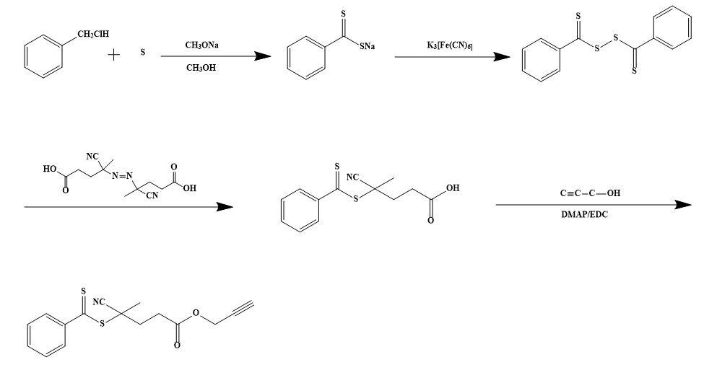
Fig. S1 Schematic illustration of the synthesis of (propargyl 4-cyanopentanate) dithiobenzoate
Fig. S2 Schematic illustration of the synthesis of N-allyl-4-ethylenediamine-1, 8-naphthalimide
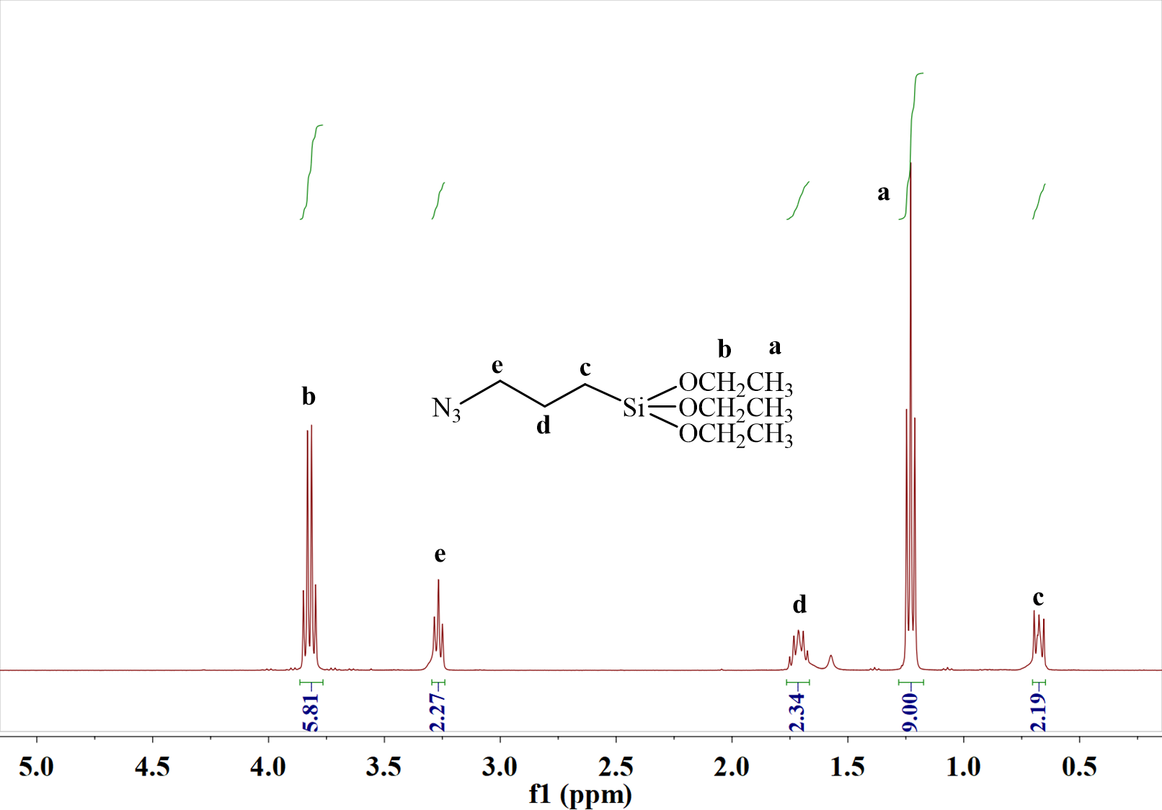
Fig. S3 ¹H NMR spectra of 3-azidopropyltriethoxysilane
3-azidopropyltriethoxysilane: ¹H NMR (400 MHz, CDCl₃) δ 3.82 (q, J = 7.0 Hz, 6H), 3.27 (m, J = 7.0 Hz, 2H), 1.76 ~ 1.67 (m, 2H), 1.23 (t, J = 7.0 Hz, 9H), 0.70 ~ 0.65 (m, 2H).
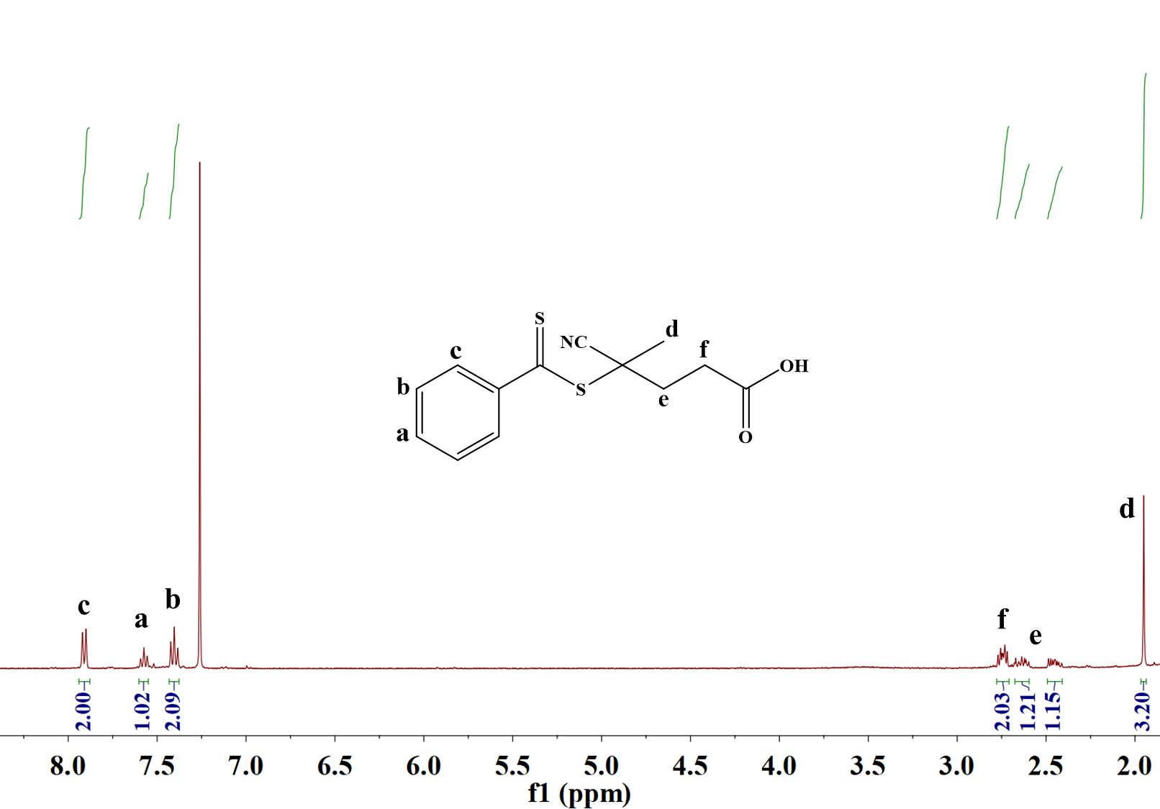
Fig. S4 ¹H NMR Spectra of (4-cyanopentanoic acid) dithiobenzoate
(4-cyanopentanoic acid) dithiobenzoate: ¹H NMR (400 MHz, CDCl₃) δ 7.95 ~ 7.88 (m, 2H), 7.57 (t, J = 7.5 Hz, 1H), 7.40 (t, J = 7.8 Hz, 2H), 2.74 (dt, J = 8.8, 5.6 Hz, 2H), 2.68 ~ 2.60 (m, 1H), 2.49 ~ 2.40 (m, 1H), 1.95 (s, 3H).
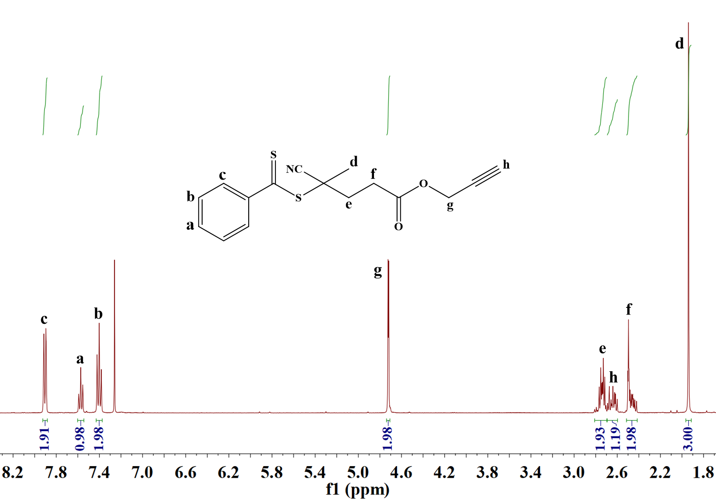
Fig. S5 ¹H NMR spectra of (propargyl 4-cyanopentanate) dithiobenzoate
(propargyl 4-cyanopentanate) dithiobenzoate: ¹H NMR (400 MHz, CDCl₃) δ 7.92 ~ 7.88 (m, 2H), 7.60 ~ 7.54 (m, 1H), 7.43 ~ 7.37 (m, 2H), 4.72 (d, J = 2.4 Hz, 2H), 2.81 ~ 2.70 (m, 2H), 2.69 ~ 2.60 (m, 1H), 2.51 ~ 2.41 (m, 2H), 1.94 (s, 3H).
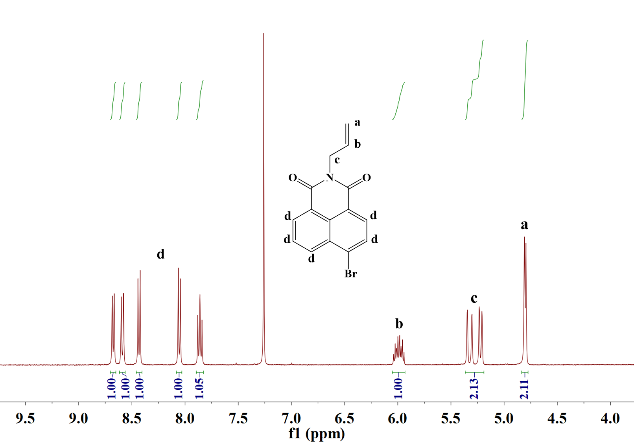
Fig. S6 ¹H NMR Spectra of N-Allyl-1, 8-naphthalimide
N-Allyl-1, 8-naphthalimide: ¹H NMR (400 MHz, CDCl₃) 8.68 (dd, J = 7.3, 1.1 Hz, 1H), 8.59 (d, J = 8.5 Hz, 1H), 8.43 (d, J = 7.9 Hz, 1H), 8.05 (d, J = 7.9 Hz, 1H), 7.86 (dd, J = 8.5, 7.3 Hz, 1H), 5.99 (ddt, J = 16.2, 11.3, 5.7 Hz, 1H), 5.37 ~ 5.19 (m, 2H), 4.80 (dt, J = 5.7, 1.5 Hz, 2H).

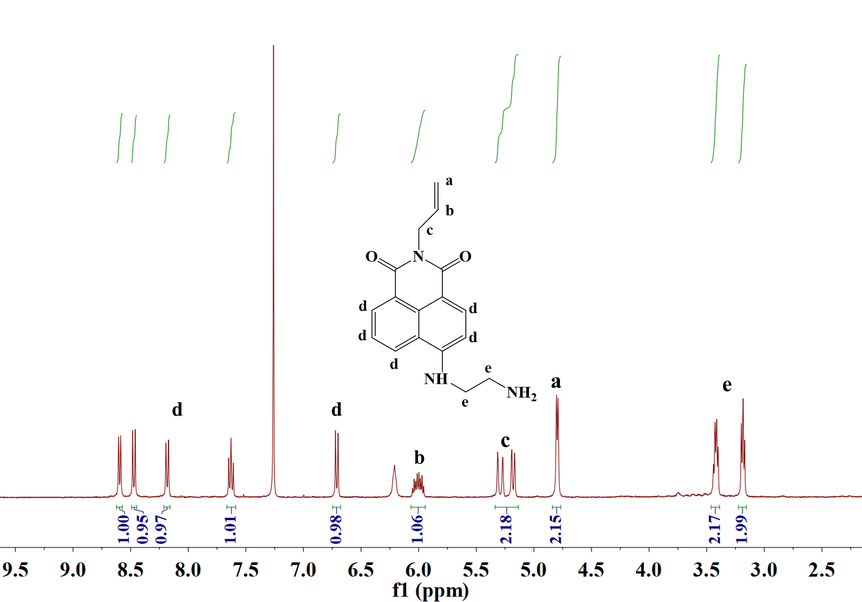
Fig. S7 ¹H NMR spectra of N-allyl-4-ethylenediamine-1, 8-naphthalimide
N-Allyl-4-ethylenediamine-1, 8-naphthalimide: ¹H NMR (400 MHz, CDCl₃) 8.60 (d, J = 7.3 Hz, 1H), 8.47 (d, J = 8.4 Hz, 1H), 8.18 (d, J = 8.4 Hz, 1H), 7.63 (t, J = 7.9 Hz, 1H), 6.71 (d, J = 8.4 Hz, 1H), 6.01 (ddt, J = 16.1, 10.7, 5.6 Hz, 1H), 5.34 ~ 5.13 (m, 2H), 4.80 (d, J = 5.4 Hz, 2H), 3.42 (q, J = 5.3 Hz, 2H), 3.18 (t, J = 5.8 Hz, 2H)

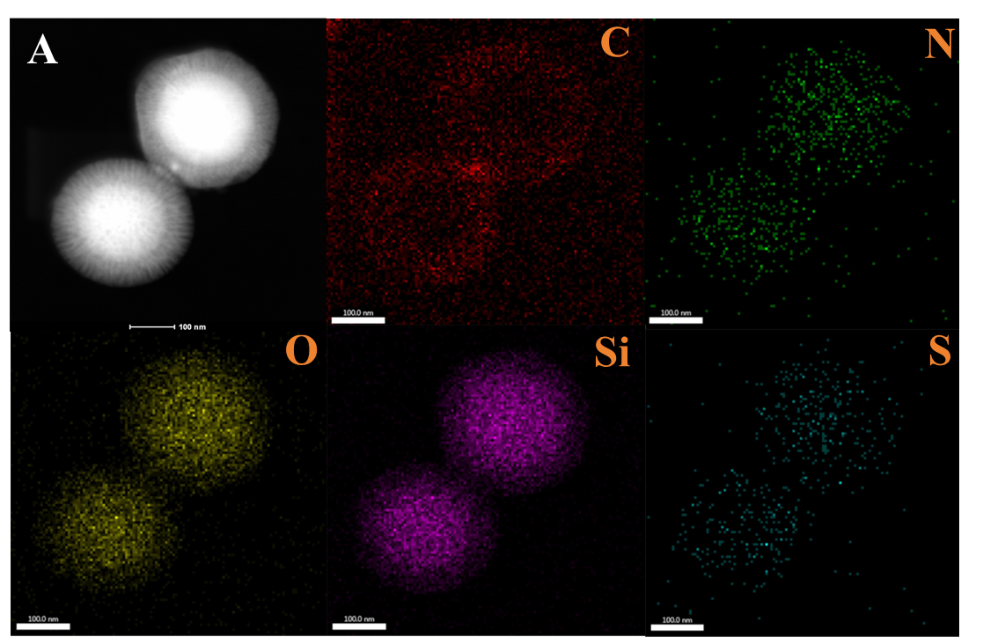
Fig. S8 STEM image (A) and C, N, O, Si S element distribution maps of FMIP
Fig. S9 Excitation spectra (a, c) and emission spectra (b, d) of N-allyl-4-ethylenediamine-1, 8-naphthalimide and FMIP
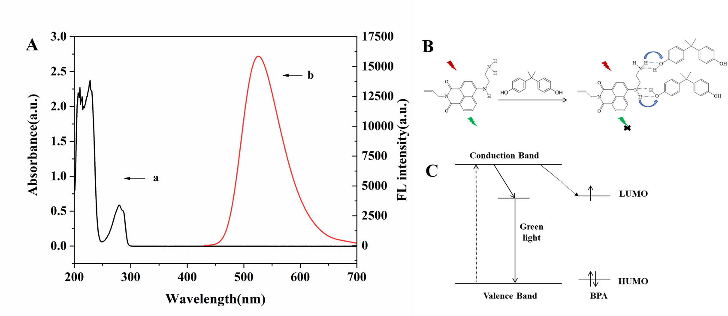
Fig. S10 UV absorption spectra of BPA (a) and fluorescence emission spectra of N-allyl-4-ethylenediamine-1, 8-naphthalimide (b) (A). Schematic diagrams for N-allyl-4-ethylenediamine-1, 8-naphthalimide fluorescence quenching mechanism (B) and molecular orbital theory (C)

*Corresponding author. E-mail: shaoyanming@sust.edu.cn

