Supplementary Figure-01
Size attenuated copper doped zirconia nanoparticles enhances in vitro antimicrobial properties
Nishakavya S, Agnishwar Girigoswami, Deepa R, Divya A, Ajith S, Koyeli Girigoswami*
Medical Bionanotechnology, Faculty of Allied Health Sciences, Chettinad Hospital and Research Institute, Chettinad Academy of Research and Education, Chettinad Health City, Rajiv Gandhi Salai, Kelambakkam, Tamilnadu-603103, India.
a | b
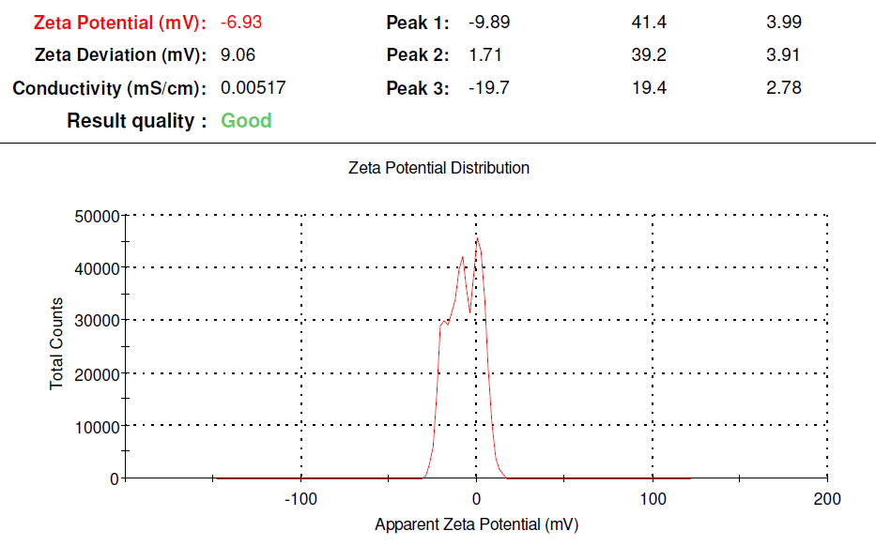  c | 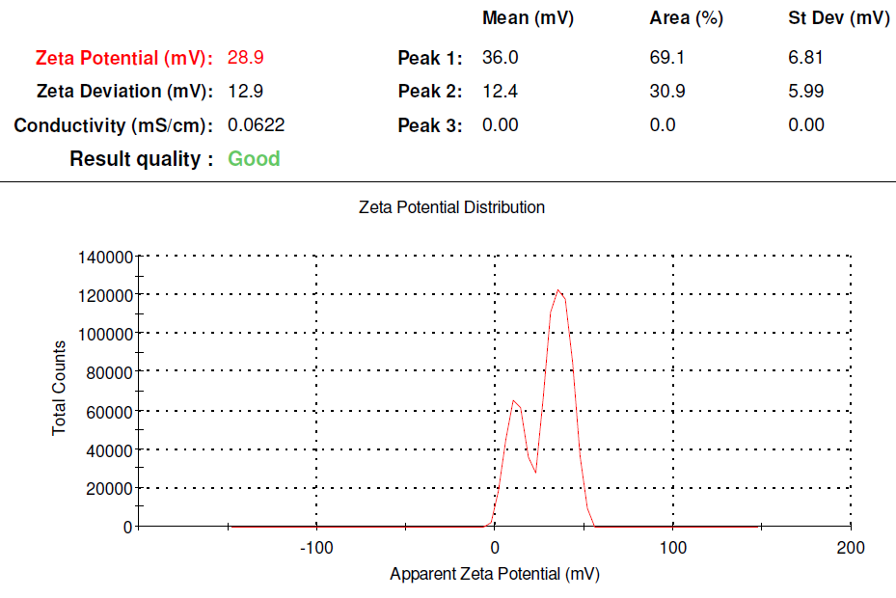  d
e | f
Figure S1. The hydrodynamic diameter (a) and (b), zeta potential (c) and (d) and XRD pattern (e) and (f) of ZrO₂ and Cu-ZrO₂ nanoparticles respectively.

