Supplementary Material

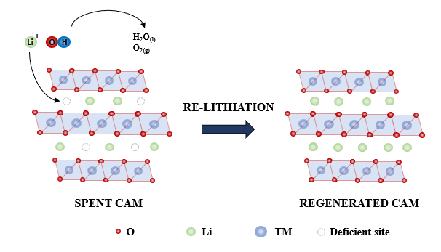
Figure S1. Illustration of the re-lithiation reaction mechanism.

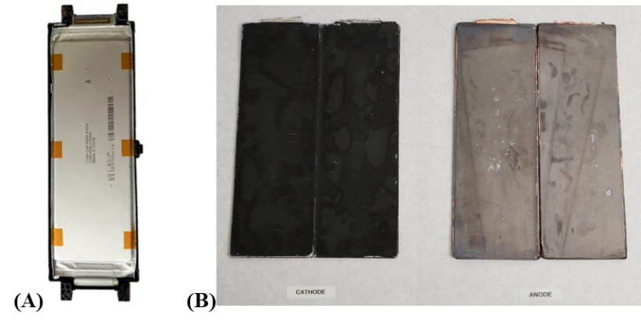

Figure S2. (A) LG Chem E63B cell; (B) Cathode and anode foils after manual disassembling. Source: Photo by the author.

Table S1. Experimental conditions for the hydrothermal tests.

Test | LiOH Concentration (M) | Temperature (°C) | Time (h)
1 | 4.0 | 160 | 2
2 | 4.0 | 160 | 1
3 | 4.0 | 220 | 2
4 | 4.0 | 220 | 1
5 | 2.0 | 160 | 2
6 | 2.0 | 160 | 1
7 | 2.0 | 220 | 2
8 | 2.0 | 220 | 1
9 | 0.5 | 160 | 2
10 | 0.5 | 160 | 1
11 | 0.5 | 220 | 2
12 | 0.5 | 220 | 1

Figure S3. XRD results of the spent CAM and (simulated) diffraction pattern of the α-NaFeO₂ structure.

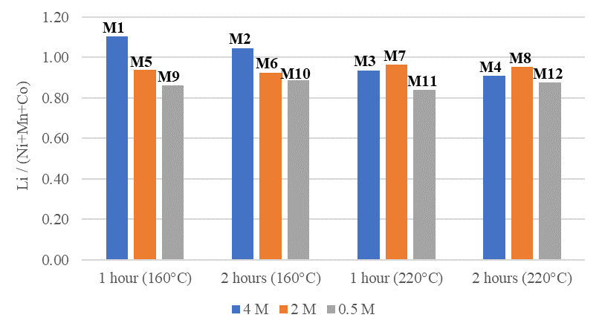
Figure S4. Composition of the regenerated cathode material.

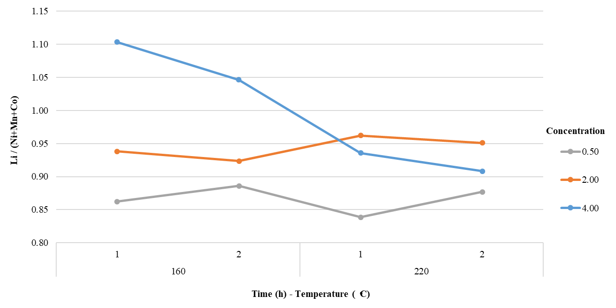
Figure S5. Interaction effect between concentration - temperature and time

