Supplementary Materials for

The macroscopic limit to synchronization of cellular clocks in single cells of Neurospora crassa

Authors: Jia Hwei Cheong^{1,8}, Xiao Qiu^{2,8}, Yang Liu¹, Ahmad Al-Omari³, James Griffith^{4,5}, Heinz-Bernd Schüttler⁶, Leidong Mao^{7*}, Jonathan Arnold^{4*}

⁸Both authors have contributed equally to this work.

Affiliations:

¹Chemistry Department, University of Georgia, Athens, GA 30602.

²Institute of Bioinformatics, University of Georgia, Athens, GA 30602.

³Department of biomedical Systems and Informatics Engineering, Yarmouk University, Irbid, Jordan 21163

⁴ Genetics Department, University of Georgia, Athens, GA 30602

⁵College of Agricultural and Environmental Sciences, University of Georgia, Athens, GA 30602.

⁶Department of Physics and Astronomy, University of Georgia, Athens, GA 30602.

⁷ School of Electrical and Computer Engineering, College of Engineering, University of Georgia, Athens, GA 30602.

*Corresponding authors: Jonathan Arnold, arnold@uga.edu; Leidong Mao, mao@uga.edu

Correspondence to arnold@uga.edu and mao@uga.edu

This pdf includes:

Table S1
Fig. S1, S2, S3, S4, S5, S6, and caption for video S1.

Other supplementary materials include:

Video S1

Table S1 The rate constants for the quorum sensing (column 3) are similar to isolated single cells¹ (column 2) and those at the macroscopic limit of 10⁷cells per ml² (column 4)
Parameter | Initial Parameter values from published ensemble (column 4) computed by Parallel tempering for D/D experiment¹ | Best parameter values from model ensemble computed by microwell D/D experiment under quorum sensing model | Initial Parameter values from published ensemble (column 3) computed by Parallel tempering for D/D experiment²
Number of communicating cells | 1 | 240 | ~10⁷ cells/ml
A | 2.56E−10 | 6.852861E-03 | 0.0313
Ā | 1.589532708 | 1.013056E-01 | 0.1108
S1 | 80.12566921 | 3.352361E+01 | 0.000420
S3 | 0.400641074 | 1.708023E-03 | 5.47E-5
S4 | 8,316.020583 | 1.932607E+01 | 1.252
D1 | 1.294999006 | 1.195490E+00 | 6.607
D3 | 4.382612039 | 1.855057E+00 | 0.798
C1 | 0.000932789 | 1.685434E-03 | 1.047
L1 | 4.777735371 | 4.268960E+01 | 94.39
L3 | 0.665600817 | 5.283324E+00 | 63.93
D4 | 0.08474029 | 5.428893E-01 | 0.00451
D6 | 0.193685712 | 5.775316E-01 | 0.205
D7 | 2.130911791 | 4.301660E-02 | 0.135
D8 | 0.007744621 | 6.586861E-05 | 0.0122
C2 | 1.515554675 | 3.583455E+00 | 3.322
P | 2.72E−09 | 9.845228E+01 | 0.2233
A_{c} | 1.86E−08 | 1.109814E+01 | 0.1293
B_{c} | 2.581096866 | 9.345902E-01 | 0.6091
S_{c} | 61.51499414 | 1.458434E-03 | 2.572
L_{c} | 1.61524392 | 1.256038E-08 | 3.664
D_{cr} | 0.150810052 | 6.049845E+01 | 0.579
D_{cp} | 0.54063952 | 3.940957E-01 | 0.5536
K_{S1} | -- | 4.612788E+09 | --
C4 | -- | 2.646258E+00 | --
η | -- | 1.445784E-05 | --
η_{ext} | -- | 4.094524E-01 | --
D9 | -- | 2.150455E+01 | --
D10 | -- | 3.057320E-08 | --

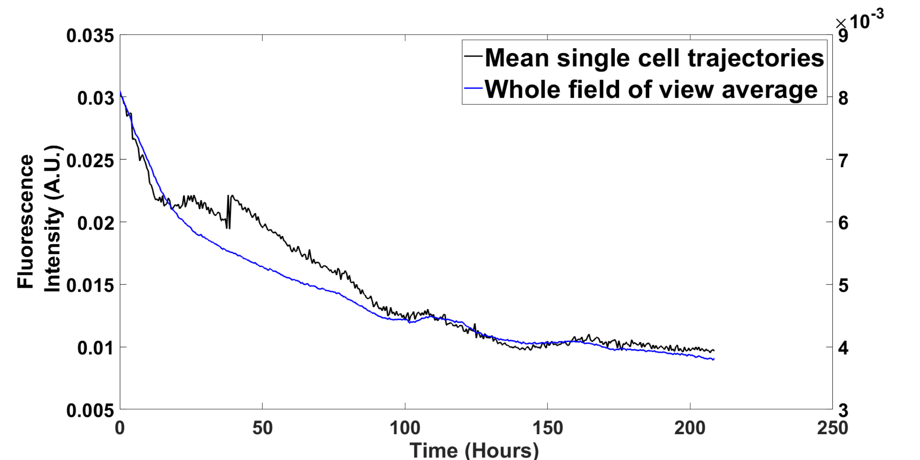
Fig. S1 Mean single cell trajectories from the chamber microfluidic device tracked the whole field of view average intensity very well. The plots were created in MATLAB_R2020B (https://www.mathworks.com/products/matlab.html).

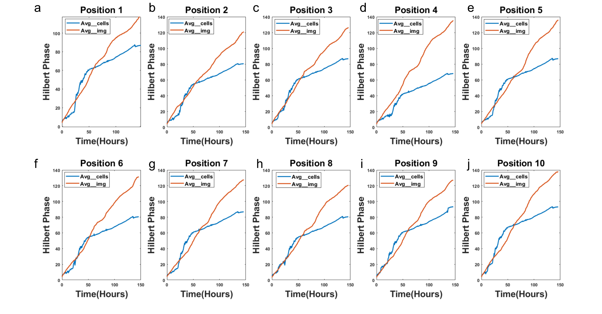
Fig. S2 Average Phase of single cells tracks phase of a field of view across 10 fields of view in the big chamber device. The strain is MFNC9 (see Materials and Methods). Cells were grown in media 5 (see Materials and Methods) to block cell division. Fluorescence was measured every half hour over 10 days. The plots were created in MATLAB_R2020B (https://www.mathworks.com/products/matlab.html).

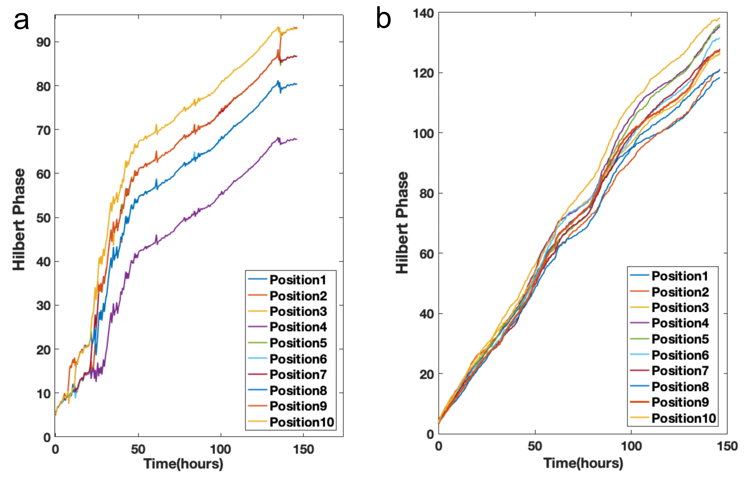
Fig. S3 While the phase curves do track each other, they also fan out over time. The Hilbert phase curves from single cell trajectories were computed as described earlier³. (a) average of image (b) average of cells tracked. Single cell tracking was done with CellProfiler⁴. The plots were created in MATLAB_R2020B (https://www.mathworks.com/products/matlab.html).

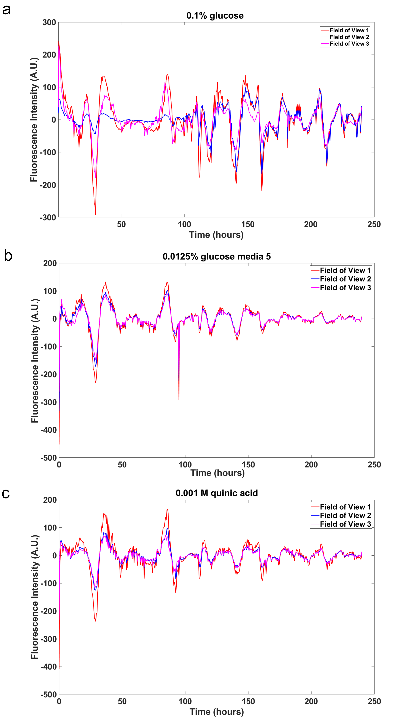
Fig. S4 The fields of view in the big chamber device are highly synchronous in different media: (a) 0.1% glucose; (b) 0.0125% glucose; (c) 0.001 M quinic acid. The plots were created in MATLAB_R2020B (https://www.mathworks.com/products/matlab.html).
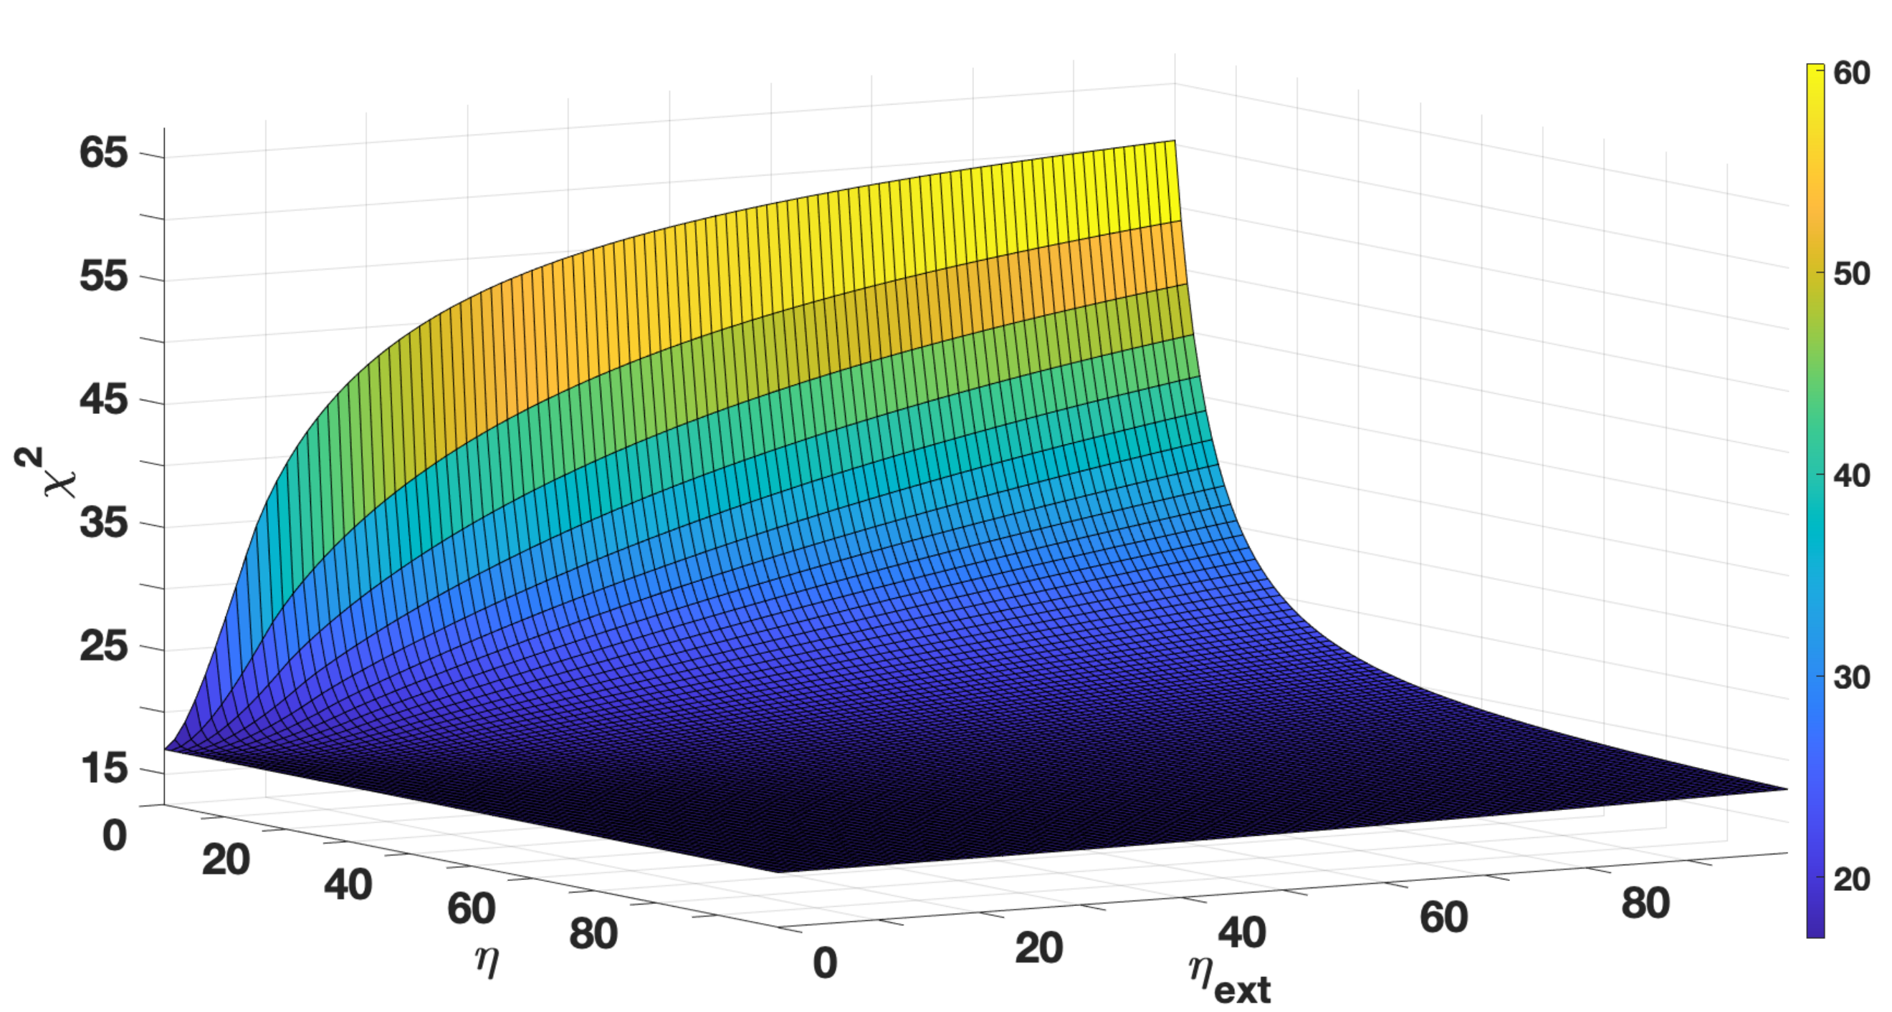
Fig. S5 There is limited information about the diffusion parameters ($η$ and $η_{ext}$) for communication under the quorum sensing model as indicated by the chi-squared statistic surface as a function of $η$ and $η_{ext}.$For example, the surface is nearly flat with respect to $η_{ext}$. There is more information about $η$ – the surface increases sharply for $η_{ext}$around ~20 or below. Other parameters are set at their best values with respect to the chi-squared statistic in supplement Table S1. The plots were created in MATLAB_R2020B (https://www.mathworks.com/products/matlab.html).

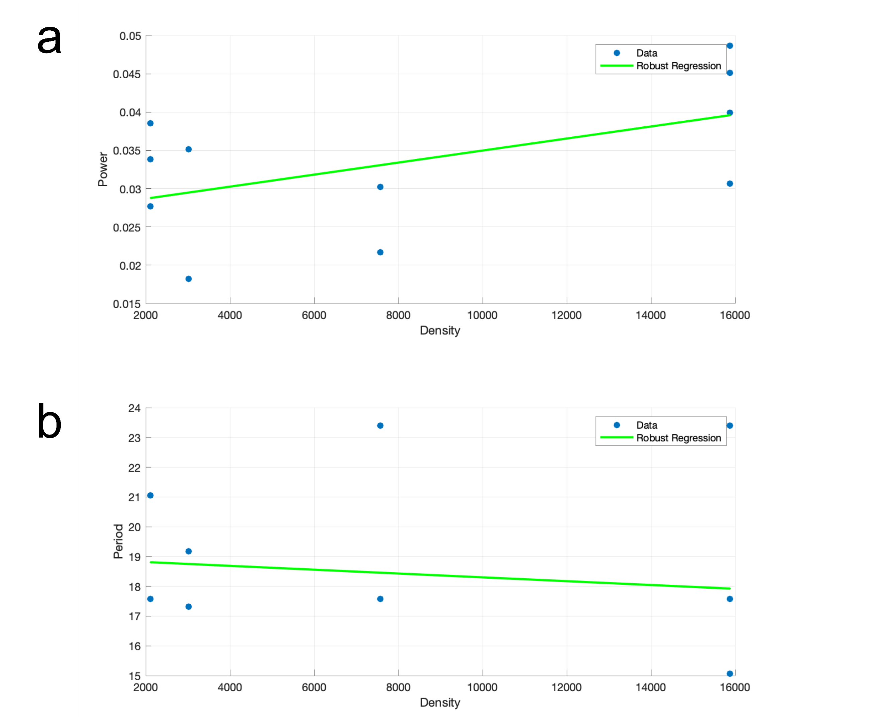
Fig. S6 Relation between average Amplitude and Period of cell(s) in wells to Density in microwell device in Fig 11. (a) Robust Regression of amplitude (as measured by the maximum in the periodogram) on number of cells for each microwell chamber using an M-estimator⁶⁴ from 3 separate microwell experiments. The predicted regression line is amplitude = 0.03 + (7.86 $±$ 4.12)(10⁻⁷) x density (t₁₅ = 1.9088, P = 0.04). At least 5,000 cells were tracked in each microwell experiment. (b) Robust Regression of Period on number of cells for each microwell chamber using an M-estimator⁶⁴ from 3 separate microwell experiments. The slope of the predicted regression line is not significantly different from zero (t₁₅ = -1.236, P = 0.55). At least 5,000 cells were tracked in each microwell experiment. All t-tests were one sided as in Fig. 11 for the sake of comparison to Fig. 11b.

References
1 Caranica, C., Al-Omari, A., Schuttler, H.-B. & Arnold, J. Identifying a clock stochastic network with light entrainment for single cells of Neurospora crassa by ensemble methods. Nature Scientific Reports 19, 15168 (2020).
2 Dong, W. et al. Systems biology of the clock in Neurospora crassa. PloS one 3, e3105 (2008).
3 Caranica, C. et al. What is phase in cellular clocks? Yale Journal of Biology and Medicine 92, 169-178 (2019).
4 McQuin, C. et al. CellProfiler 3.0: Next-generation image processing for biology. PLOS Biology 16, e2005970, doi:10.1371/journal.pbio.2005970 (2018).
5 Yu, Y. et al. A genetic network for the clock of Neurospora crassa. Proc Natl Acad Sci USA 104, 2809-2814 (2007).

