Appendix A: IRB Approval

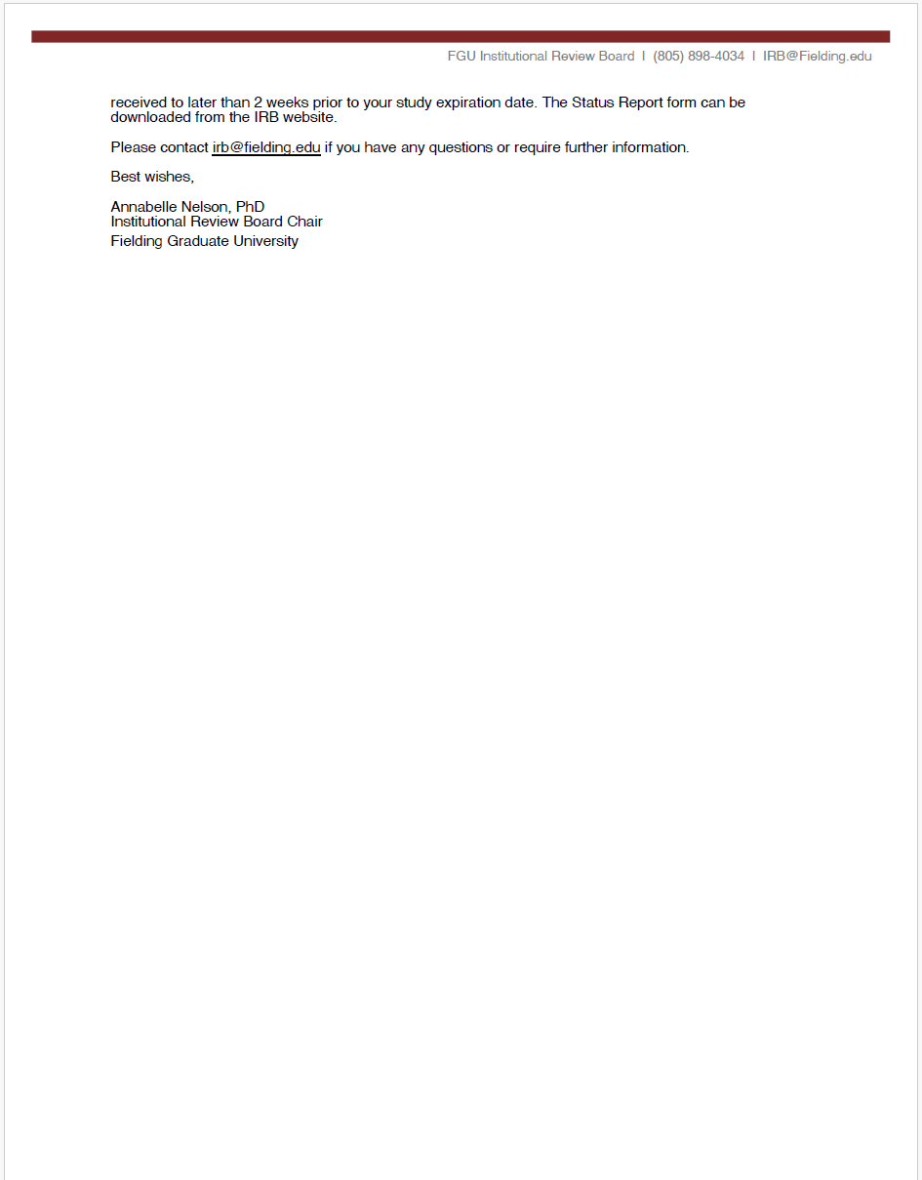

Appendix B: G*Power 3 Power Analysis Settings
Figure B1
G*Power 3 Power Analysis Settings

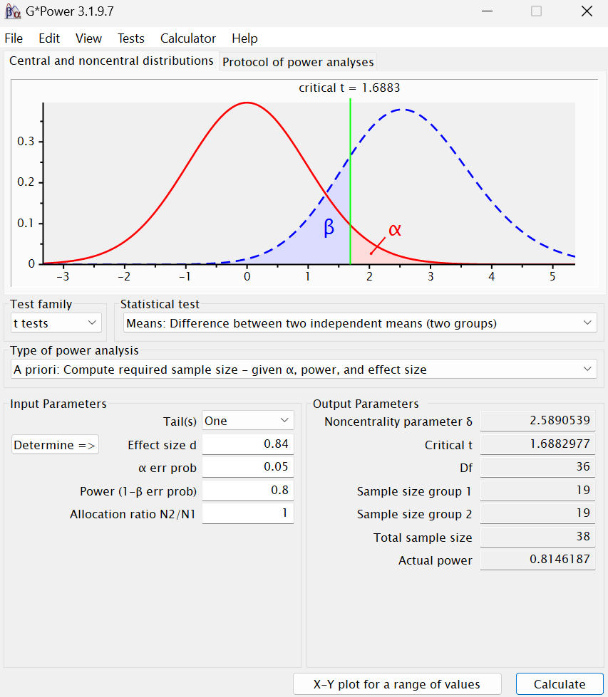
Appendix C: Prolific Matches and Screeners
Figure C1
Prolific Matches and Screeners

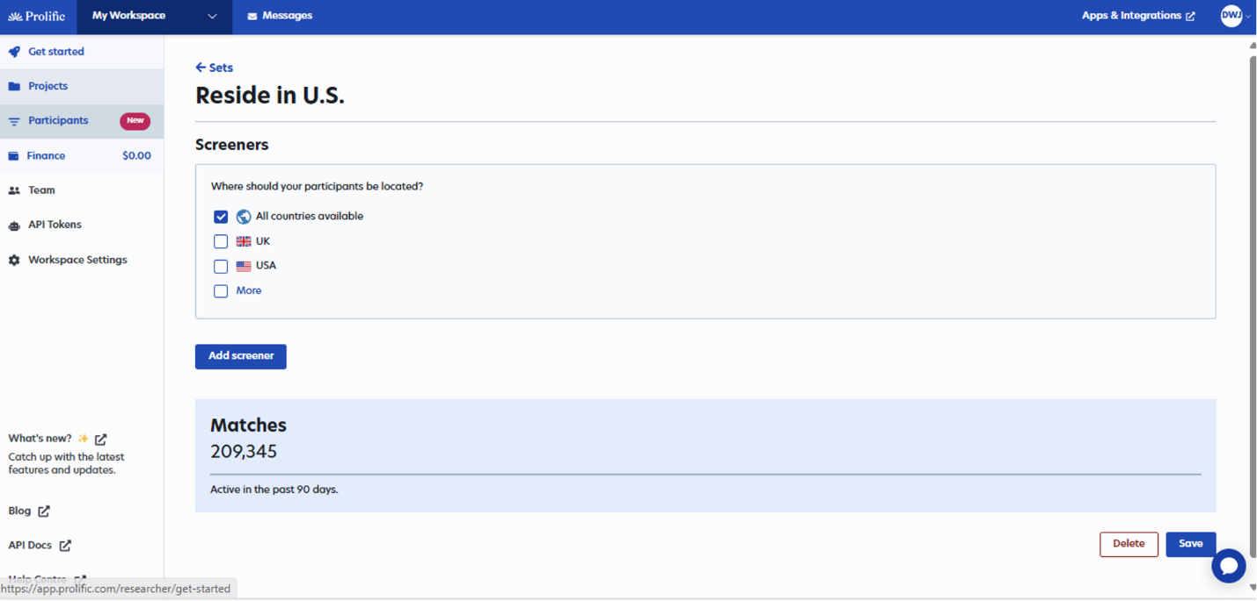
Note: Prolific matches before screeners.

Figure C2
Prolific Matches and Screeners Continued
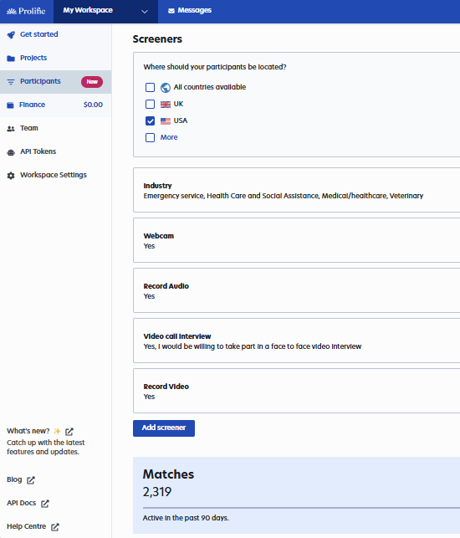
Note: Inclusion/ exclusion criteria (screeners) reduced the potential participant matches from 209,345 participants to 2,319 participants.
Appendix D: Prolific Study Description

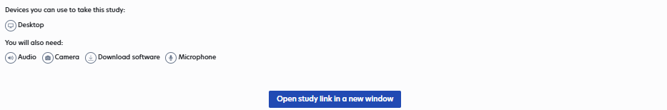

Note: The time and payment were reduced to 15 minutes and $3.75 for the actual study.

Appendix E: Informed Consent
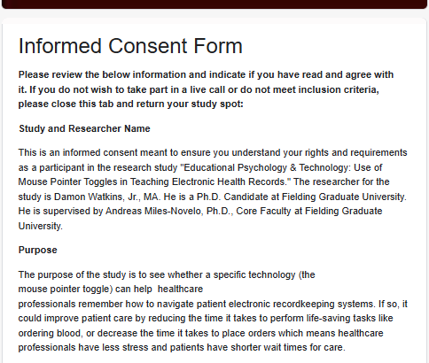
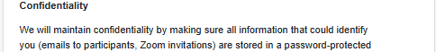
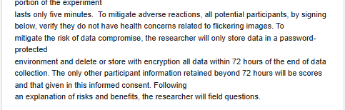
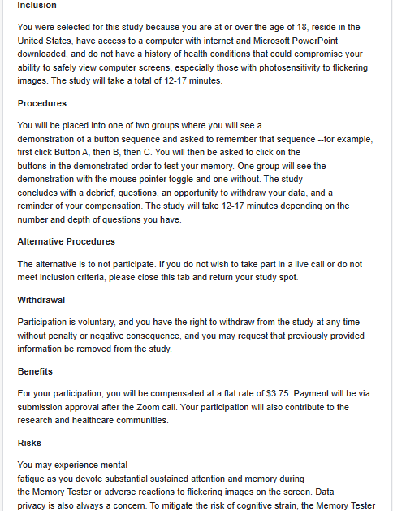
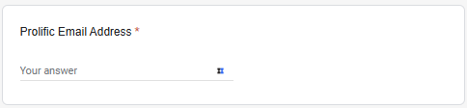
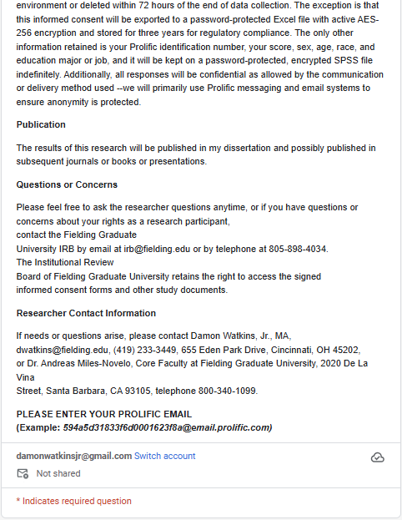

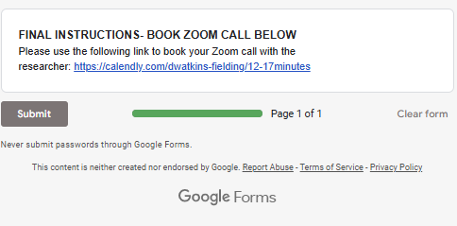
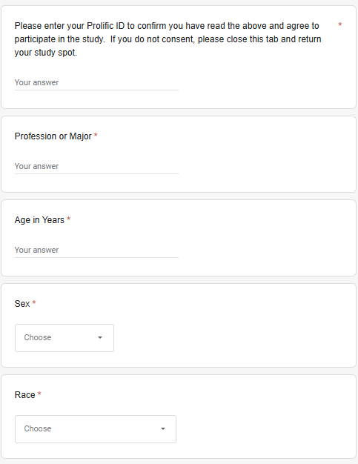
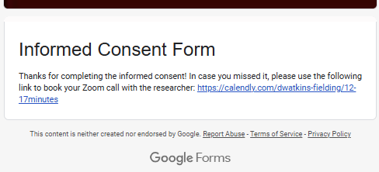
Note: the informed consent outlines all relevant information concerning the study. The benefit, a flat rate payment of $3.75 for 15 minutes, was deemed “great” by Prolific. The consent mentions risks and mitigations, but the repetition of certain mitigations is not mentioned: to mitigate the risk of adverse reaction to flickering images (the MPT) participants were not only warned about photosensitivity in the informed consent but also the Prolific page and the Memory Tester. To reduce the risk of a data breach, all data was not only encrypted or deleted, but all participants were also asked to anonymize their data by using their Prolific IDs and emails in lieu of their proper name and email on the informed consent, Calendly, and Zoom.

Appendix F: Researcher Study Checklist
Before Zoom Call
- Receive Calendly notification
- Verify participant sent informed consent
- Send participant Zoom invite via Prolific email
  - DO NOT approve their payment until the Zoom meeting concludes
Send Zoom Meeting Confirmation

Hello!

This email reconfirms your Zoom meeting information. Payment will be approved after attending the Zoom call. Zoom information (Please change your Zoom name to your Prolific ID for anonymity and have the ID available for the call):

Wednesday, July 17, 2024 TOMORROW
07:00pm - 07:17pm Eastern Time
57qb618b8e26d6869196c3bb
EMAIL
57qb618b8e26d6869196c3bb@email.prolific.com
LOCATION
This is a Zoom web conference.
Additional details to join this meeting
Attendees can join this meeting from a computer.
https://fielding-edu.zoom.us/j/88936105462

This is a one-on-one slot with you and me; please let me know if you need to reschedule; otherwise, thank you for your participation, and I look forward to our call!
Start
Hello, my name is Damon. How was your day?
- Instruct the participant to share their screen.
- Post a link to the Memory Tester PowerPoint in the Zoom chat: Mouse Toggle Memory Tester II- With Cursor.pptx
- Participant click on the link
- Participant verify their computer or speaker volume is on high as to ensure they can hear the prompts and demonstration in the PowerPoint.
- Inform the participant of their test group name and number (i.e. Group One: Verbal or Group Two: Verbal and Toggle)
- Instruct the subject to begin the Memory Tester by clicking the slide show view in the bottom right of the PowerPoint. Have the subject press the right arrow on their keyboard, at which point the PowerPoint will proceed to the second slide. From there, the PowerPoint is programmed to give the participant prompts and transition automatically.

Finish
- Thank you for your time and participation
- Restate the study purpose and hypotheses:
  - The purpose of the study is to see whether a specific technology (the mouse pointer toggle) can help healthcare professionals remember how to navigate patient electronic recordkeeping systems. If so, it could improve patient care by reducing the time it takes to perform life-saving tasks like ordering blood, or decrease the time it takes to place orders which means healthcare professionals have less stress and patients have shorter wait times for care. The hypothesis is the mouse pointer toggle will improve learning outcomes.
- Your payment will be approved within 24-72 hours
- You do have the option to withdraw data. Would you like to withdraw your data?
- What questions do you have?
- Last thing, if you could please verify your Prolific ID by placing it in the chat

After Zoom call
- Enter score
- Confirm participant payment
Send if Zoom Meeting is Missed
Hi,
I noticed we missed our video call on Thursday, July 4, 2024, from 8:00 AM to 8:17 AM.
If you’d like to reschedule, please use this Calendly link: https://calendly.com/dwatkins-fielding/12-17minutes
If you’re unable to reschedule, no worries! Have a great weekend!
Warm regards,
Damon

Appendix G: Mouse Pointer Toggle Memory Tester

Access the Memory Tester by clicking or copying and pasting to a web browser the below link:
https://1drv.ms/p/c/a4255c68a7d94792/EZJH2adoXCUggKTlLgAAAAABwEHQIVvaguo2u21ytV1_OA
Figure G1
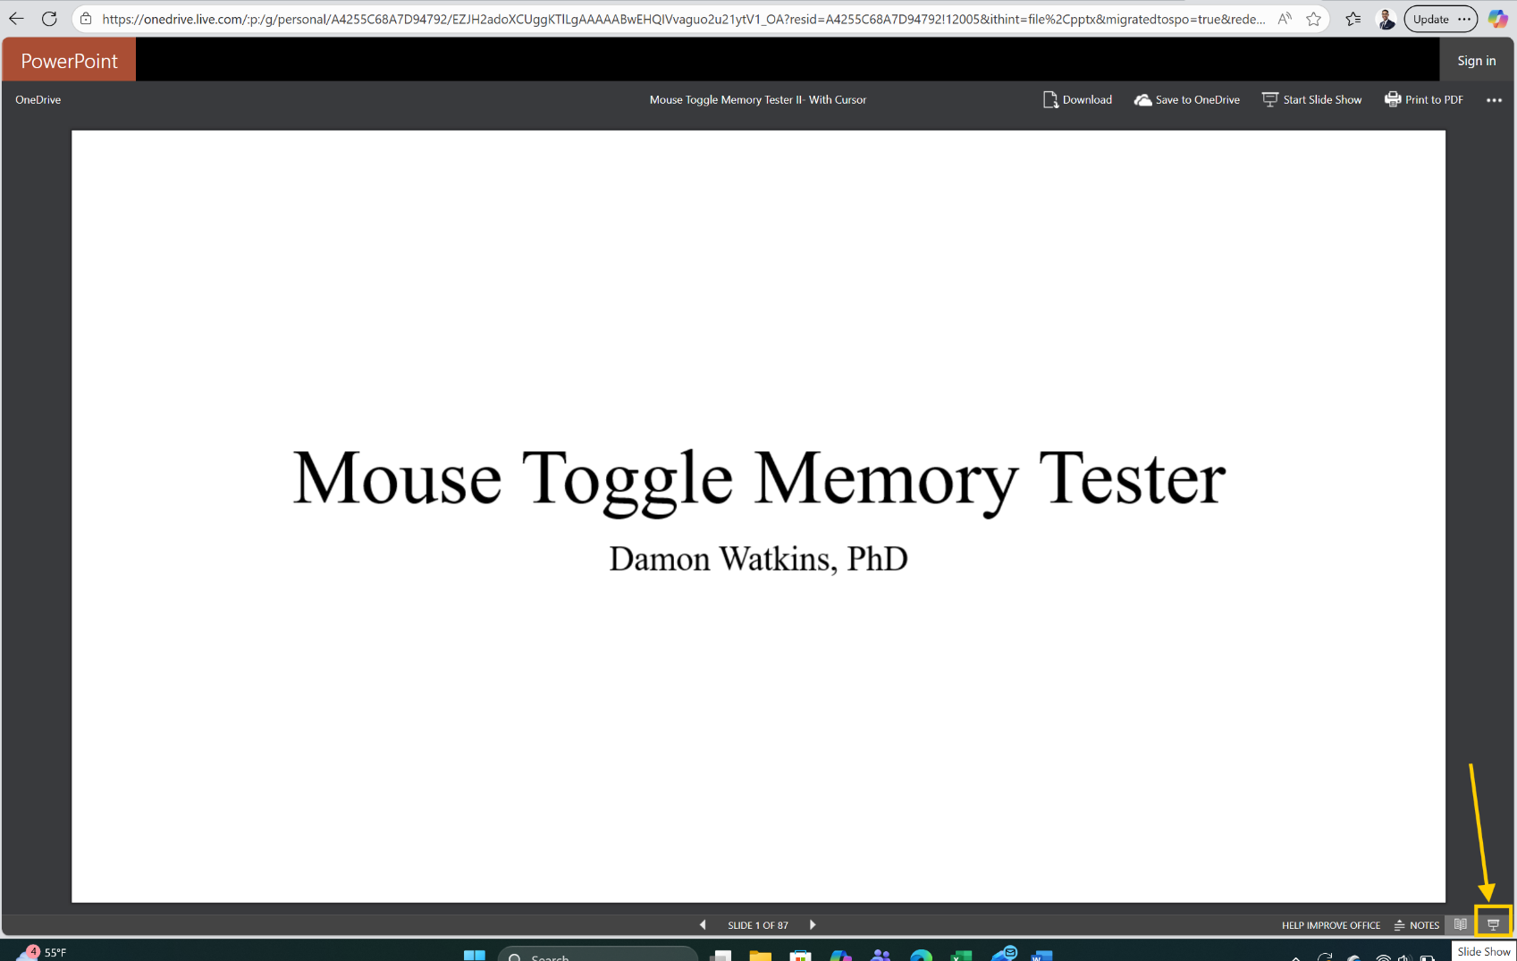
Beginning the Memory Tester

Note: Select the Slide Show tab and press the right arrow on the keyboard to begin.
Appendix H: SPSS Variables
Figure H1
SPSS Variables

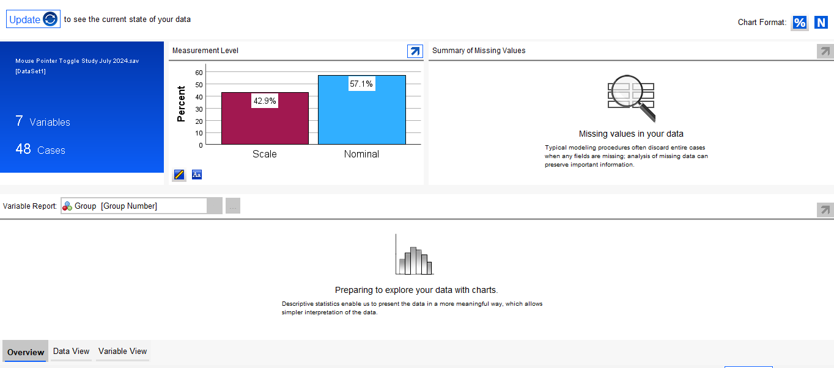
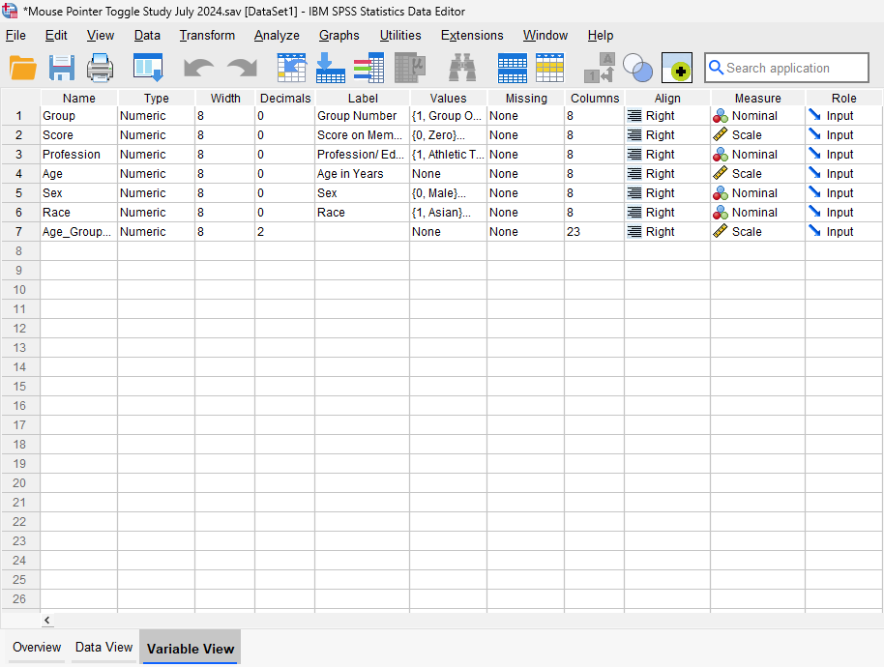
Note: Line seven was unused—the sample size was insufficient to do the desired exploratory test.
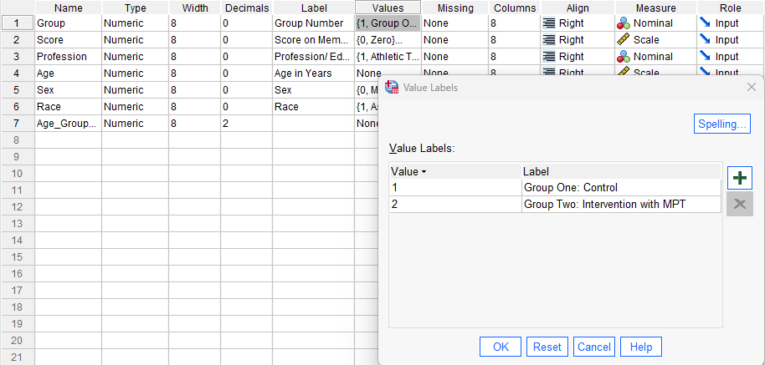
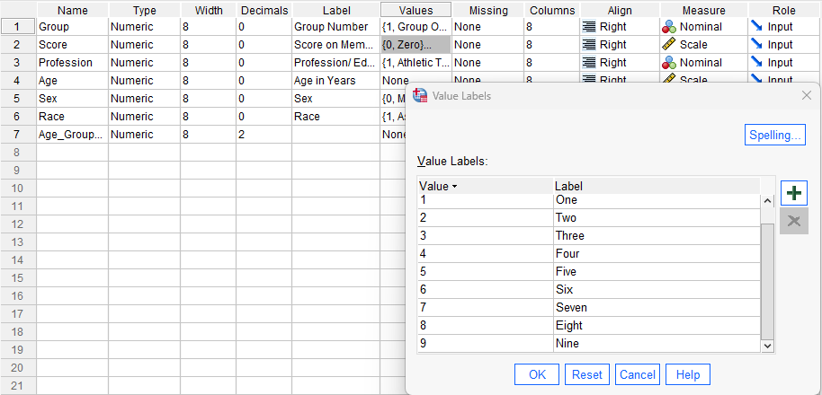
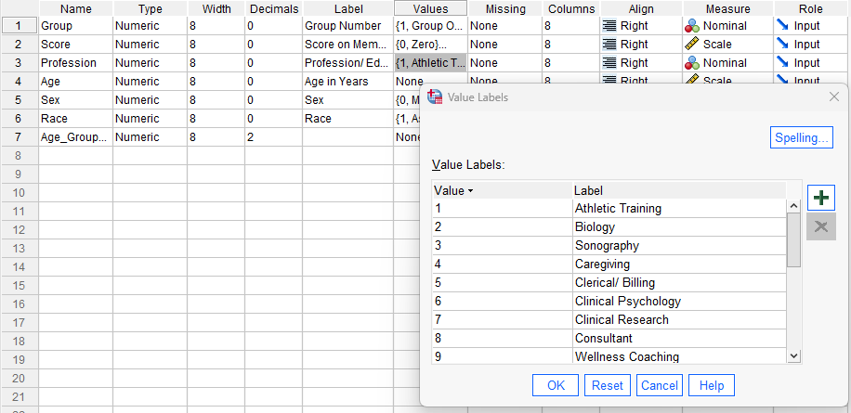
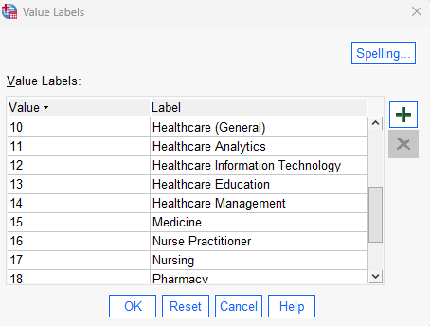
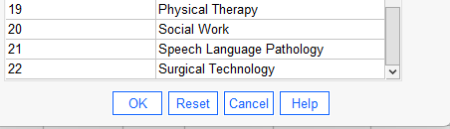
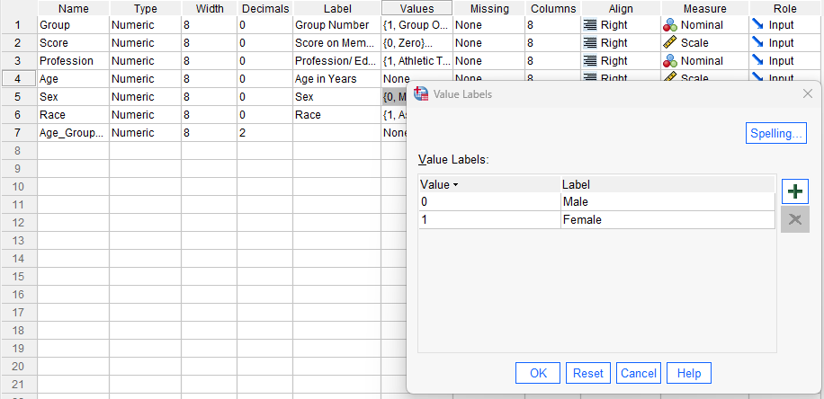
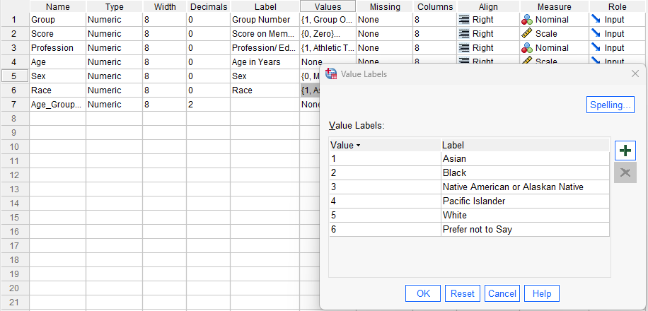

Appendix I: Scrubbed Data
Table I1
Scrubbed Data

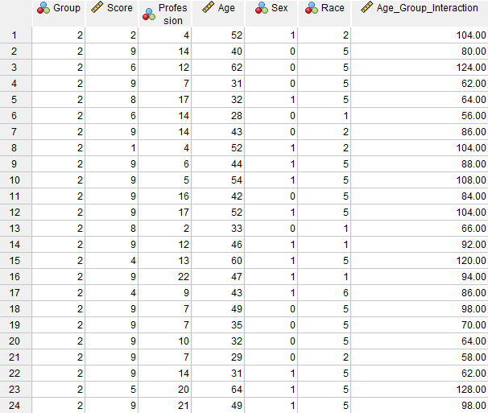

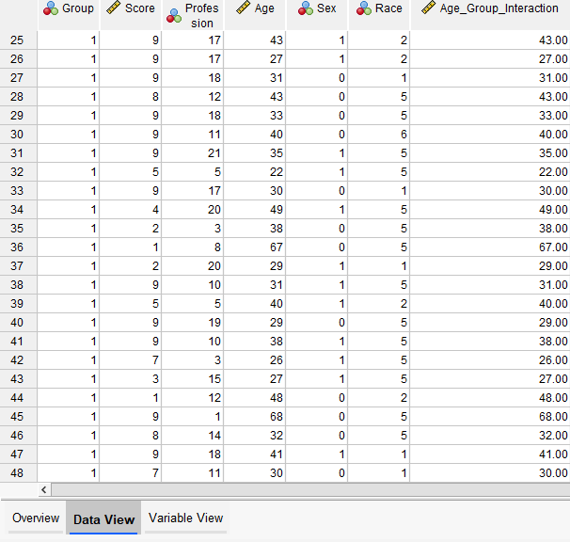

Appendix J: Professions and Education Majors Represented
Table J1
Professions and Education Majors Represented

 | Profession/Major | Frequency | Percent
 | Athletic Training | 1 | 2.1
 | Biology | 1 | 2.1
 | Caregiving | 2 | 4.2
 | Clerical/ Billing | 3 | 6.3
 | Clinical Psychology | 1 | 2.1
 | Clinical Research | 4 | 8.3
 | Consultant Services | 1 | 2.1
 | Healthcare (General) | 3 | 6.3
 | Healthcare Analytics | 2 | 4.2
 | Healthcare Information Technology | 4 | 8.3
 | Healthcare Education | 1 | 2.1
 | Healthcare Management | 5 | 10.2
 | Profession/Major | Frequency | Percent
 | Medicine  Nurse Practitioner | 1  1 | 2.1  2.1
 | Nursing | 5 | 10.2
 | Pharmacy | 3 | 6.3
 | Physical Therapy | 1 | 2.1
 | Social Work | 3 | 6.3
 | Sonography | 2 | 4.2
 | Speech-Language Pathology | 2 | 4.2
 | Surgical Technology | 1 | 2.1
 | Wellness Coaching | 1 | 2.1
Total | - | 48 | 100.0
Note: Distribution of participant jobs by specialty is shown. “Nurse Practitioners” was used to describe persons with training in advanced practice nursing. Modes were management and nursing. Percentages adjusted due to rounding.

Appendix K: Sensitivity Analysis
Figure K1
Sensitivity Analysis

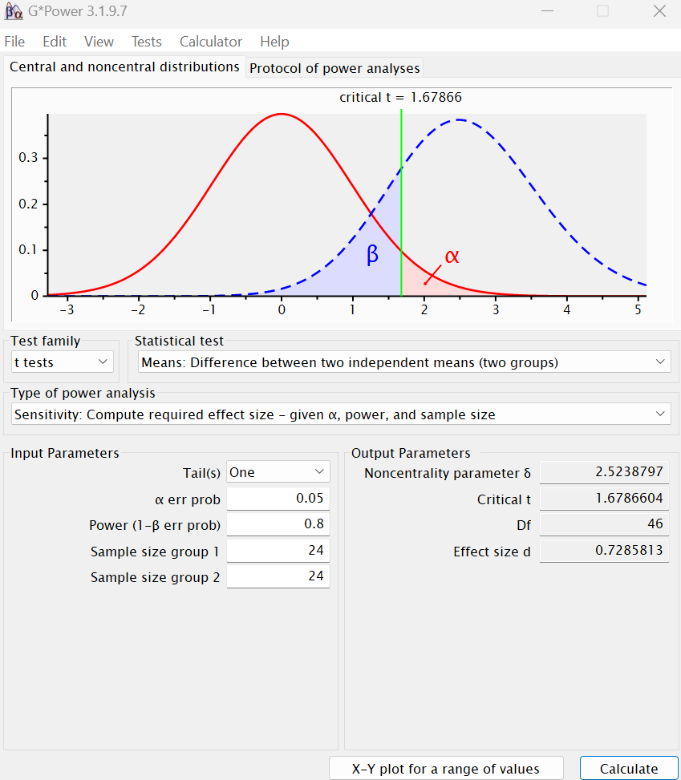
Note: The analysis shows a required large effect size of .73.
Appendix L: Levene’s Test for Equality of Variances
Table L1
Levene’s Test for Equality of Variances

 |  | F | Sig. | t | df
Score on Memory Tester | Equal σ2 Assumed  Equal σ2 not Assumed | 1.77  - | .19  - | .95  .95 | 46  44.61

Note: Levene’s Test for Equality of Variances.

Appendix M: Group Statistics for Independent Samples t test
Table M1
Group Statistics for Independent Samples t test

 | Group | N | Mean | Std. Deviation | Std. Error Mean
Score on Memory Tester | Group One: Control  Group Two: Intervention | 24  24 | 6.7  7.5 | 3  2.5 | .6  .5

Note: Mean, standard deviation, and standard error by group.

Appendix N: Effect Size and Confidence Interval
 |  |  |  | 95% CI
 |  | Standardizer | Point Estimate | Lower | Upper
Score on Memory Tester | Cohen’s d  Hedge’s Correction  Glass’s Delta | 2.74  2.79  2.98 | .27  .27  .25 | .3  .29  .32 | .84  .83  .82

Note: The confidence interval was 95%. The effect size for Cohen's d was small at .27.

Appendix O: Segmented Piecewise Regression RStudio Code

# Install segmented package (only run this once)
install.packages("segmented")

# Load the package
library(segmented)

# Enter your data here
age <- c(52, 40, 62, 31, 32, 28, 43, 52, 44, 54, 42, 52, 33, 46, 60, 47, 43, 49, 35, 32, 29, 31, 64, 49, 43, 27, 31, 43, 33, 40, 35, 22, 30, 49, 38, 67, 29, 31, 40, 29, 38, 26, 27, 48, 68, 32, 41, 30)
score <- c(2, 9, 6, 9, 8, 6, 9, 1, 9, 9, 9, 9, 8, 9, 4, 9, 4, 9, 9, 9, 9, 9, 5, 9, 9, 9, 9, 8, 9, 9, 9, 5, 9, 4, 2, 1, 2, 9, 5, 9, 9, 7, 3, 1, 9,8, 9, 7)

# Create dataframe
df <- data.frame(age, score)

# Fit base linear model
lm_base <- lm(score ~ age, data = df)

# Fit segmented (piecewise) regression
seg_model <- segmented(lm_base, seg.Z = ~age)

# View results
summary(seg_model)

# Plot the segmented model
plot(seg_model)

