Appendix

Formulas

FATox g/min = 1.67 * Vo2 [L/min] – 1.67 * VCo2 [L/min]
CHOox g/min = 4.55 * Vo2 [L/min] – 3.21 * VCo2 [L/min]

Table 1: Comparison of pulmonary function tests between those with long COVID and controls.

Pulmonary function test | Long COVID (n=50) | Controls (n=45) | p-value
FEV1, Liters | 3.1+/-0.83 | 2.70+/-0.94 | 0.13
FEV1% | 89.3+/-17.5 | 80.5+/-20.2 | 0.10
FVC | 3.8+/1.0 | 3.5+/-0.99 | 0.34
FVC% | 85.7+/-19.7 | 79.1+/-15.9 | 0.13
FEV1/FVC | 81.5+/-10.1 | 75.2+/-8.0 | 0.20
TLC | 5.65+/-1.1 | 5.79+/-1.3 | 0.80
TLC% | 86.8+/-4.5 | 84+/-17.5 | 0.68
DLCO | 22.5+/-3.6 | 21.5+/-5.1 | 0.74

Figure 1: Pulmonary diagnosis of patients in the control group

Table 2: Characteristics of the long COVID group (n=50)
Characteristics
Prior COVID pneumonia, % | 6
Residual lung disease, % | 4
Mean modified COVID-19 Yorkshire rehabilitation scale, SD | 25.4+/-3.1
Mean COMPASS-31, SD | 42.7+/-20.0
Severe fatigue, % | 58
Severe post-exertional malaise, % | 42

Table 3: Comparison of dysfunctional breathing between long COVID patients and controls.

Measure | Long COVID (n=50) | Controls (n=45) | p-value
VE/V̇CO₂ | 33.1+/-3.6 | 33.7+/-4.1 | 0.63
ETCO2 | 31.7+/-3.3 | 32.2+/-4.3 | 0.66

Table 4: CPET characteristics area under the receiver operating curves
CPET characteristic | aROC | 95% Confidence interval
CPET peak carbohydrate at rest | 57 | 40-75
CPET peak fat at rest | 24 | 0-38
CPET peak carbohydrate on exertion | 51 | 35-68
CPET peak fat on exertion | 43 | 35-68
Peak V̇O₂ | 55 | 38-73
Resting RER | 54 | 37-70
Breathing reserve | 73 | 56-90
V̇O₂ at anaerobic threshold | 50 | 31-68
Using carbohydrate instead of fat at rest | 76 | 63-88

Figure 2: Receiver operating characteristic curve for using carbohydrates rather than fat at rest.
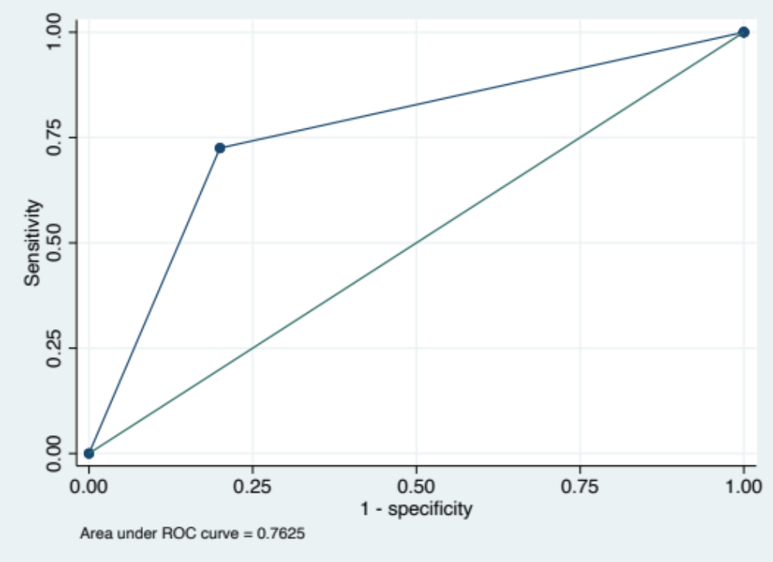
Figure 3: Comparison of the use carbohydrates (A) and fat (B) during the resting potion of the CPET between long COVID patients with moderate and severe fatigue
- **p=0.005 B) ns p=0.09
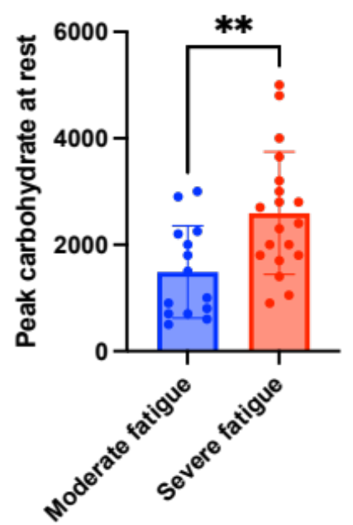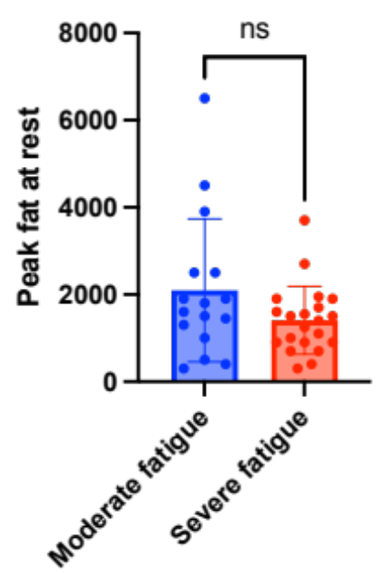

Figure 4: Comparison of the use carbohydrates (A) and fat (B) during the resting potion of the CPET between long COVID patients with moderate and severe post-exertional malaise.
- *p=0.01 B) * p=0.03
