Extended Data Figures

Extended Data Figure 1 | Golden Gate assembly scheme for constructing archaeal lipid biosynthetic pathways. See Supplementary Table 1 for plasmid details.
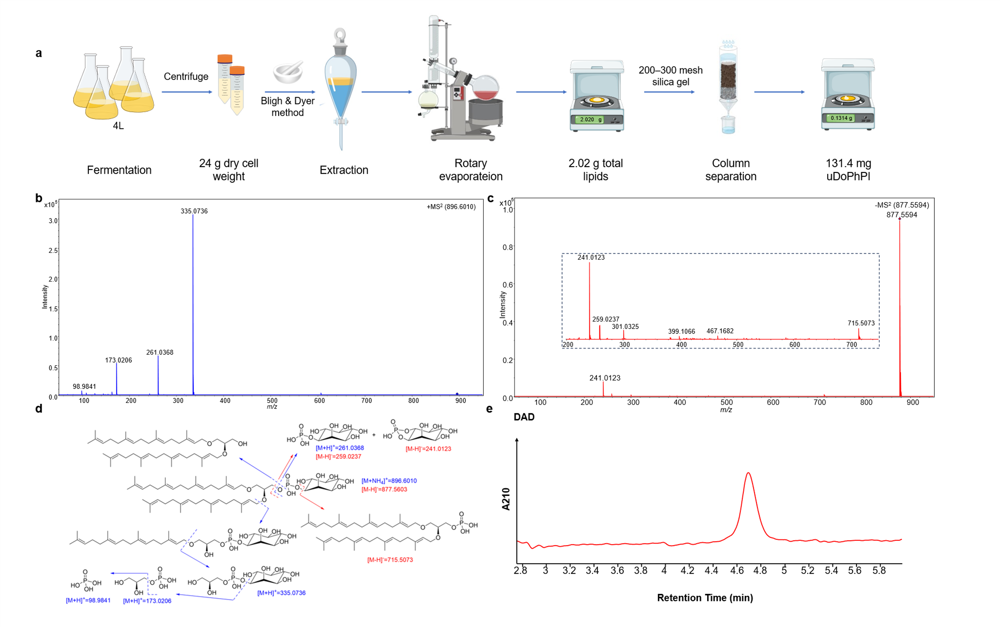
Extended Data Figure 2 | Purification and characterization of uDoPhPI by HR-MS and HPLC. (a) The workflow shows sequential steps from fermentation through solvent extraction, rotary evaporation, silica gel column chromatography, and lyophilization. (b) HR-MS/MS fragmentation pattern in positive ESI mode (precursor ion [M+NH₄]⁺; theor. m/z 896.6011; obs. m/z 896.6010; Δ = - 0.11 ppm). (c) HR-MS/MS fragmentation in negative ESI mode (m/z 877.5594). (d) Proposed fragmentation pathways showing major cleavage sites. (e) HPLC chromatogram with UV detection at 210 nm showing purity of 96.8%.
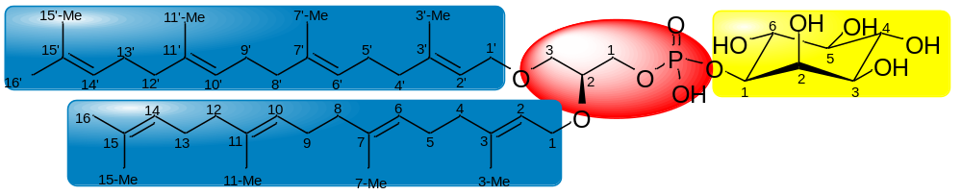

Moiety | ¹H NMR δ (ppm) |  | ¹³C NMR δ (ppm)
Inositol
C₁ | 3.93 | br d (J=9.0 Hz) | 76.35
C₂ | 4.23 | br s | 71.37
C₃ | 3.48 | br d (J=9.6 Hz) | 71.16
C₄ | 3.68 | t-like (J=9.6 Hz) | 72.32
C₅ | 3.31 | t-like (J=9.6 Hz) | 74.28
C₆ | 3.80 | t-like (J=9.1 Hz) | 71.60
Glycerol
C₁ | 3.99, 3.93 | overlapped | 65.21
C₂ | 3.70 | overlapped | 76.76
C₃ | 3.55, 3.50 | overlapped | 69.33
GGPP
C₁/C_{1'} | 4.16/4.06 | d-like (J=6.0 Hz) | 66.56/67.68
C₂/C_{2'} | 5.34/5.32 | t-like (J=7.0 Hz) | 120.48/120.35
C₃/C_{3'} | - | - | 140.52/140.35
C₄/C_{4'} | 2.03, 1.97 | overlapped | 39.55
C₅/C_{5'} | 2.07, 2.01 | overlapped | 26.52/26.49
C₆/C_{6'} | 5.11 | overlapped | 123.62
C₇/C_{7'} | - | - | 135.20
C₈/C_{8'} | 2.03, 1.97 | overlapped | 39.55
C₉/C_{9'} | 2.07, 2.01 | overlapped | 26.37
C₁₀/C_{10'} | 5.11 | overlapped | 124.02
C₁₁/C_{11'} | - | - | 134.75
C₁₂/C_{12'} | 2.03, 1.97 | overlapped | 39.55
C₁₃/C_{13'} | 2.07, 2.01 | overlapped | 26.57
C₁₄/C_{14'} | 5.11 | overlapped | 124.21
C₁₅/C_{15'} | - | - | 131.01
C₁₆/C_{16'} | 1.68 | s | 25.39
C₃-Me/C_{3'}-Me | 1.66 | s | 16.19
C₇-Me/C_{7'}-Me | 1.60 | s | 15.71
C₁₁-Me/C_{11'}-Me | 1.60 | s | 15.71
C₁₅-Me/C_{15'}-Me | 1.60 | s | 17.37

Extended Data Figure 3 | ¹H and ¹³C chemical shift assignment of uDoPhPI. See Supplementary Fig. 1 for detailed NMR spectral assignment.
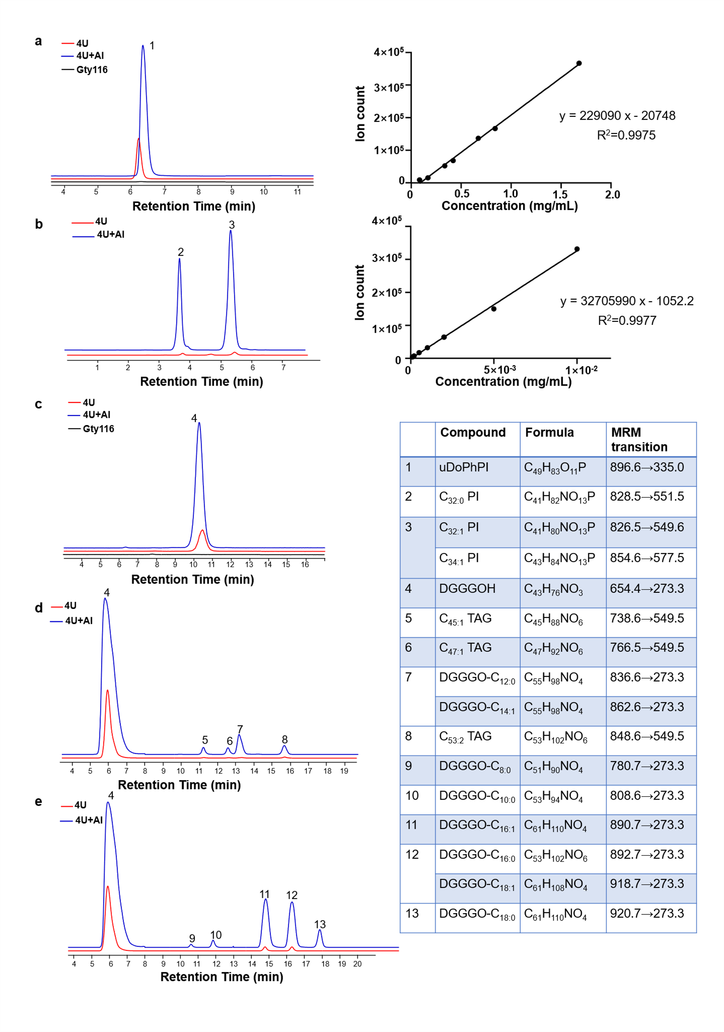
Extended Data Figure 4 | Representative LC-MS/MS MRM chromatograms for lipid quantification. (a) uDoPhPI detection and calibration using purified standard. (b) Yeast PI detection and calibration using C_{34:1} PI standard. (c) Archaeal DGGGOH (1000-fold dilution). (d) Yeast TAGs. (e) Hybrid DGGGO-FAs. Peak identifies and MRM transitions are detailed in the table inset.

Extended Data Figure 5 | Impact of pathway engineering on cellular lipid profiles. Fold changes in lipid abundance relative to the 4U baseline strain, quantified by LC-MS/MS MRM. Individual panels show: (a) Yeast C_{34:1} PI, C_{32:0} PI, and C_{32:1} PI. (b) Yeast C_{45:1} TAG, C_{47:1} TAG, and C_{53:2} TAG. (c) Archaeal DGGGOH. (d) Hybrid DGGGO-acyl esters with varying chain lengths (C_{8:0}, C_{18:1}, C_{10:0}, C_{12:0}, C_{14:1}, C_{16:0}, C_{16:1}, C_{18:0}). Data represent mean ± SEM from three independent biological replicates. Statistical significance was determined by one-way ANOVA: **p < 0.01 (relative to 4U).
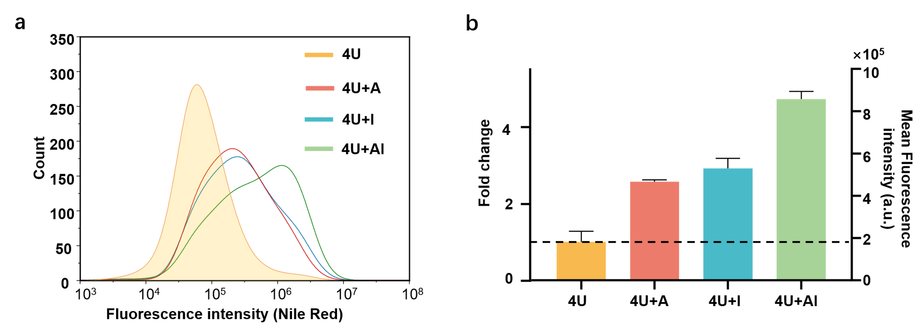
Extended Data Figure 6 | Flow cytometric analysis of neutral lipid accumulation in engineered yeast strains. (a) Representative histograms of Nile Red fluorescence intensity in 4U, 4U+A, 4U+I, and 4U+AI strains. (b) Mean fluorescence intensity quantification. Data represent mean ± SEM from two independent biological replicates.

