Supplementary Information

For “Auditing coherence through the principle of a single functional mapping”
Hedayat Haddadi¹*, ¹Adam Kloskowski, and ²Piotr Mironowicz
¹Department of Physical Chemistry, Faculty of Chemistry, Gdansk University of Technology, Narutowicza 11/12, 80-233 Gdansk, Poland
²Department of Algorithms and Systems Modelling, Faculty of Electronics, Telecommunications and Informatics, Gdańsk University of Technology, Narutowicza 11/12, 80-233, Gdańsk, Poland
* Email: hedhadda@pg.edu.pl

Supplementary — Mathematical Framework
Here, we outline a comprehensive mathematical framework for the Agreement–Entropy Map (AEM). This framework brings together all lemmas, propositions, and theorems, along with detailed explanations and proofs. The aim is to establish a rigorous yet coherent foundation that connects structural tests (Chow) and information-theoretic disorder metrics (entropy) into a unified framework.

Lemma S1 (Two groups, equal design and variance)
Assume $x ⟂ s, E[x|s]=0, Var(x|s)=σₓ², Var(ε_{s})=σ²$.
Then:
${ΔH}_{G}= \frac{1}{2} ln(1 + \frac{w₁w₂}{σ²}[(Δa)² + σₓ² (Δb)²])$ (S1)
Equation (S1) is directly equivalent to Eq. (7) in the main text. Both express the same law of total variance for pooled residuals: the total residual variance of the combined system equals the intrinsic variance within the coherent subset plus the variance introduced by structural offsets between subgroup fits. In other words, Eq. (7) summarizes this relationship in compact form, while Eq. (S1) expands it explicitly in terms of subgroup parameters to show how structural deviation contributes to entropy lift.
Proof. With equal designs, the pooled coefficients $(a^{*},b^{*})$ are weighted averages of subgroup coefficients. Residuals decompose as $r_{s} = ε_{s} + (a_{s}- a^{*}) + (b_{s} - b^{*})x$. Direct variance calculation yields: $Var(r_{s}) = σ² + w₁w₂[(Δa)² + σₓ² (Δb)²]$. Substituting into the Gaussian entropy formula gives the stated result.

Identity S2 (ANOVA–entropy reparameterization under Gaussian plug-in)
Define $Δ\hat{H} = \frac{1}{2} ln(\frac{{MSE}_{p}}{{MSE}_{sep}})$. Then one has the exact identity:
$Δ\hat{H} = \frac{1}{2} ln(1 + \frac{k}{n-k}(F_{Chow} - 1))$ (S2)
Here k is the number of restricted coefficients (e.g. intercept + slope in the simple linear case).
Proof (two lines). Let $A = RSS₁+RSS₂$. From the Chow statistic:
$F_{Chow} = \frac{({RSS}_{p} - A)/k }{A/(n - 2k)} ⇒ \frac{{RSS}_{p} }{A}= 1 + \frac{k}{n - 2k}F_{Chow}$ (S3)
Hence
$\frac{{MSE}_{p}}{{MSE}_{sep}} = \frac{{RSS}_{p}/(n-k) }{A/(n-2k)} = 1 + \frac{k}{n-k}(F_{Chow} - 1)$ (S4)
Taking the log gives $Δ\hat{H}$.
This corresponds to Eq. (8) in the main text.
Remark. This identity uses the same in-sample sums of squares as Chow; it is not the predictive entropy lift $ΔH$ used in the AEM axis.

Lemma S3 (General k groups, unequal designs)
For $μ_{s} = E[x|s], { τ}_{s}^{²} = Var(x|s)$, residuals can be decomposed as $r_{s}= ε_{s} + (a_{s}- a^{*}) + (b_{s} - b^{*})x$. By the law of total variance:
$Var(r) = E_{s}[σ_{s}^{2}] + {Var}_{s}(a_{s}-a^{*}+(b_{s}-b^{*})μ_{s}) + E_{s}[(b_{s}-b^{*})² { τ}_{s}^{²}]$ (S5)
Notation. The middle component ${Var}_{s}(a_{s}-a^{*}+(b_{s}-b^{*})μ_{s})$ is the between-group structural variance.

Theorem S4 (Complementarity of Chow and Entropy)
Fix $α, {ΔH}^{*}>0$. Then:
(A) Models exist with $ΔH < {ΔH}^{*}$ but $p_{Chow} < α$.
(B) Models exist with $p_{Chow} ≥ α$ but $ΔH > 0$.
These constructive examples correspond to the complementarity discussion in the main text after Eq. (8).
Therefore, Chow and entropy are complementary and both are necessary axes for assessing reliability.
Constructive examples:
Case A ($ΔH$ small but Chow rejects). Let $Δa=0, Δb=δ$. Then ${ΔH}_{G} = \frac{1}{2} ln(1 + C δ²)$ with $C=\frac{w₁w₂σₓ²}{σ²}$, while $F_{Chow}≈ 1 + \frac{n - k }{k}C δ²$. For fixed ${ΔH}^{*}$, choose $δ$ so ${ΔH}_{G}$ < ${ΔH}^{*}$. As $n$ grows, $F_{Chow}$ exceeds its critical value, yielding $p_{Chow}< α$.
Case B (Chow accepts but $ΔH > 0$). Suppose $a₁=a₂, b₁=b₂$ (coefficients equal), but residual distributions differ ($σ₁² ≠ σ₂²$ or one subgroup Laplace-tailed). Then ${ΔH}_{G}=0$ but ${ΔH}_{shape} = {JSD}_{w}(\{p_{s}\}) > 0$ unless all distributions coincide. Chow accepts the null of coefficient equality, but entropy detects pooled disorder.

Note S5 (Shape contribution)
By entropy concavity, $H(Σ w_{s} p_{s}) ≥ Σ w_{s} H(p_{s})$, with equality only if all $p_{s}$ are identical. The gap is the Jensen–Shannon divergence. Thus $ΔH = {ΔH}_{G} + {ΔH}_{shape}$, with ${ΔH}_{shape}≥ 0$ capturing multimodality or heavy tails.
In Fig. 5, entropy rise with slope offset is fully captured by the Gaussian component ${ΔH}_{G}$​ (Lemma S1), since residuals remain unimodal and equal-variance. Note S5 extends this logic: if residual distributions also differ in shape (e.g. multimodality), then an additional contribution ${ΔH}_{shape}>0$ appears, explaining results such as Fig. S5.

Supplementary Algorithm S1. Implementation of the Agreement–Entropy Map (AEM)
This algorithm provides a reproducible step-by-step implementation of the AEM. It complements the mathematical framework by detailing the workflow applied in practice.
Step 1. Subset fitting: For each subgroup (e.g., laboratory report), fit the regression form $y = f(x;β)$. Record coefficients, residuals, and domain ranges.
Step 2. Overlap gating: For each subgroup pair, restrict analysis to their overlapping x-domain. If no overlap exists, mark the pair as non-comparable.
Step 3. Structural test: Compute the Chow statistic (Eq. 2) on each overlapping pair. Record p-values. Define system-level structural evidence by $p_min = min p$.
Step 4. Subset selection: Choose the subgroup with the largest number of non-rejections as the leader. Combine leader + agreeing partners into the Selected Subset (SS). If no agreements exist, system = structurally inconsistent.
Step 5. Entropy auditing: Fit residuals for SS and pooled Chow-pass subsets on shared domain. Estimate entropy using Gaussian plug-in (Eq. 5) if residuals are unimodal, otherwise histogram/KDE. Compute entropy lift $ΔH = H_{R} - H_{S}$.
Step 6. Classification: Apply decision rule (Eq. 10). System-level label =
– Structural inconsistency if Chow fails.
– Entropy confirm if Chow passes and $ΔH ≤ {ΔH}^{*}$.
– Entropy veto if Chow passes but $ΔH > {ΔH}^{*}$.
Step 7. Calibration: Calibrate ${ΔH}^{*}$ on synthetic benchmarks with known truth (variance imbalance, slope offsets, multimodality) via ROC analysis (Supplementary Fig. S7).
Practical notes: Small samples fall back to Gaussian plug-in estimator. Systems with no subgroup overlap default to structural inconsistency. This implementation ensures reproducibility of the AEM across domains.

Supplementary Analyses
These supplementary figures offer additional checks and detailed demonstrations that back up the main findings. They tackle four key questions: (i) whether variance imbalance can on its own compromise pooled calibration, (ii) how often real-world experimental systems show subgroup heterogeneity, (iii) whether entropy auditing provides reliable diagnostics beyond traditional variance-based measures, and (iv) how entropy-based vetoes work in controlled stress tests. Notably, all the entropy-driven trends shown in these figures are not just empirical curiosities but direct results of the mathematical framework outlined in Lemma S1, Identity S2, Theorem S4, and Note S5. This means the observed behaviors are theoretically predictable, rather than just specific to the dataset.
Figures S1–S2 show that ILThermo ionic-liquid solute activity systems have empirical reliability issues: pooled regression intervals often miss held-out sources when subgroup variances vary (see Fig. 1), and subgroup fits often have significant heterogeneity. Figures S3–S4 confirm that entropy auditing provides a stable second axis of reliability: it accurately detects harmful pooling within the Chow-pass regime where structural tests are ineffective (see Fig. 4), and it remains robust to moderate outliers. Figure S5 demonstrates that entropy extends variance diagnostics by capturing multimodality in residual distributions, a type of disorder that is invisible to Chow or variance-based metrics (see Fig. 5). Figure S6 adds a synthetic stress test for variance imbalance, showing that Chow and cross-validation remain stable while entropy lift increases monotonically with the imbalance, providing a decisive veto.
These analyses combined reinforce the reasoning behind merging structural consistency (Chow tests) with residual-entropy auditing into the AEM. They demonstrate that the two axes are complementary, robust, and essential for telling genuinely reliable pooled systems from those that seem consistent only in conventional checks (Fig. 6).

S1. Pooled-model calibration under residual-variance imbalance
When subgroup variances are balanced, pooled regression intervals can appear well-calibrated. However, they often systematically under-cover held-out subgroups once the residual spreads diverge. To measure this effect, we trained pooled models on all but one subgroup (leave-one-subgroup-out, LOSO) for each ionic-liquid–solute system. Then, we computed 95% prediction intervals on the held-out source. We grouped the systems by the ratio of maximum to minimum subgroup variance on the shared domain and averaged the empirical coverage within each group.
When variance ratios are low, coverage is close to nominal. However, it drops sharply as imbalance increases, even though pooled models still appear to fit well. This pattern aligns with theoretical studies that show heteroscedasticity undermines nominal coverage¹. These results support the main-text comparison of cross-validation methods (Fig. 1) by highlighting that coverage issues stem directly from variance imbalance.

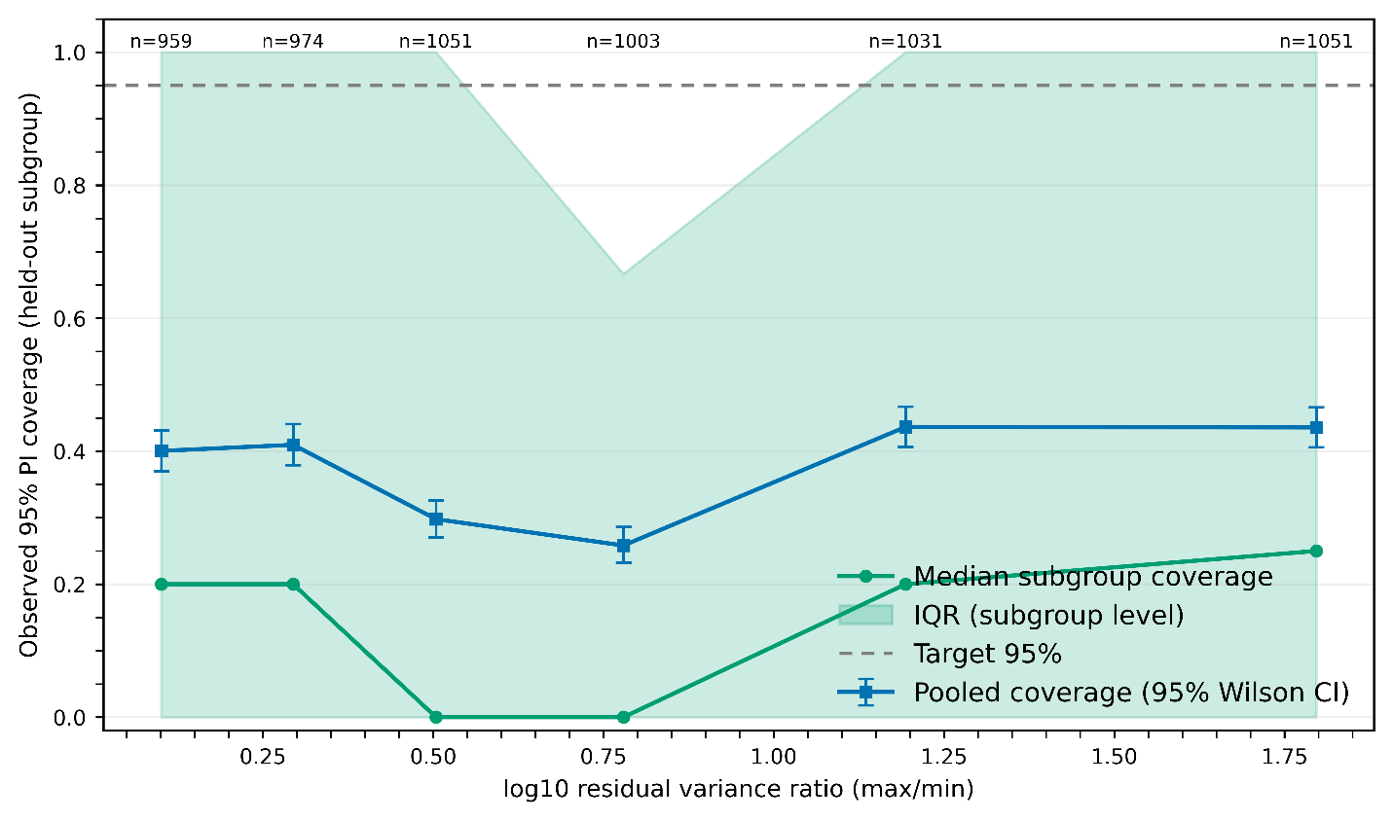
Supplementary Figure S1. Systematic loss of nominal coverage under residual-variance imbalance. Observed 95 % prediction-interval (PI) coverage—the fraction of held-out data points falling within nominal 95 % intervals—decreases sharply as the residual-variance ratio between sources increases. Blue squares show pooled coverage with Wilson 95 % confidence intervals, while green circles and the shaded band denote the median and interquartile range of subgroup-level coverage. The dashed line indicates the nominal 95% target. Although pooled regressions appear well-fit at low variance ratios, coverage drops to nearly half of the nominal level once imbalance exceeds an order of magnitude, revealing that heteroscedasticity alone can undermine calibration even when structural fits remain acceptable. This empirical trend supports the theoretical prediction that unequal residual spreads lead to systematic under-coverage in pooled models, motivating the entropy-based reliability audit.

S2. Subgroup heterogeneity in ILThermo systems
Aside from variance imbalance, inconsistency often stems from structural differences between subgroups. To assess how common this is, we calculated Cochran’s $Q$ and the related $I^{2}$ statistic for ionic-liquid solute activity systems with at least two independent reports. $I^{2}$ gauges the proportion of total variance due to differences between subgroups, rather than random noise within subgroups^{2,3}.
Our analysis reveals that many systems show significant heterogeneity, often surpassing the standard 50% threshold. This suggests that pooled models often combine different structural slopes, contradicting the assumption of a single functional relationship. This issue has also been noted in evidence synthesis, where high $I^{2}$ values indicate systematic rather than random variability⁴. Our findings build on the comparison between LOSO and random-CV in Fig. 1 by demonstrating that structural inconsistency is not a rare phenomenon, but rather a widespread issue.
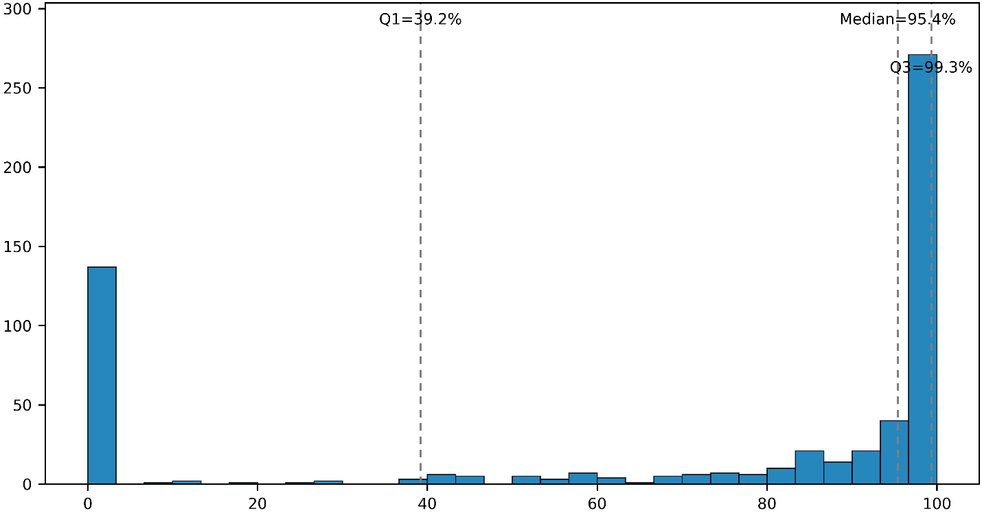
Supplementary Figure S2. Widespread and often extreme heterogeneity across ILThermo systems. Histogram of the meta-analytic heterogeneity statistic $I^{2}$ for ionic-liquid–solute activity systems containing at least two independent subgroups. For each system, subgroup regressions were combined using a fixed-effects model, and $I^{2}$ was computed to quantify the percentage of total variance attributable to systematic differences between subgroups rather than random noise. The distribution is highly polarized: a large fraction of systems exhibit near-zero heterogeneity, while most others cluster close to $I^{2}≈100\%$ (median ≈ 95 %). This pattern indicates that many nominally similar experimental reports yield divergent slopes, even after linearization, demonstrating that the assumption of a single functional mapping is often violated in most multi-source systems. The result supports the need for explicit coherence auditing before combining such data.

S3. Entropy detects harmful pooling within the Chow-pass regime
Although the Chow test effectively rules out systems with significant slope differences, there are many cases where it doesn't reject structural equality, yet pooling still increases predictive risk. To investigate this scenario, we created synthetic benchmarks with varying slope offsets $|δ|$ and variance ratios $ρ$. We then assessed systems that passed the Chow test for pooling harm, which we defined as an increase in the oracle root-mean-square error (RMSE) compared to separate fits.
Our findings indicate that harmful pooling is most likely to occur when slope offsets are relatively small but variance ratios are high — exactly the area where Chow has low sensitivity. In contrast, entropy auditing effectively distinguishes between safe and harmful pooling in this subset. The residual entropy lift 𝛥𝐻 increases consistently with disorder, and a pre-registered cutoff ${ΔH}^{*}$ produces strong classification performance, with receiver-operating curves well above the random expectation. This confirms that entropy offers an additional diagnostic axis, revealing pooling harm that is not visible to Chow⁵. These results expand on the main-text variance-imbalance experiment (Fig. 4) by demonstrating that entropy also protects the Chow-pass regime.

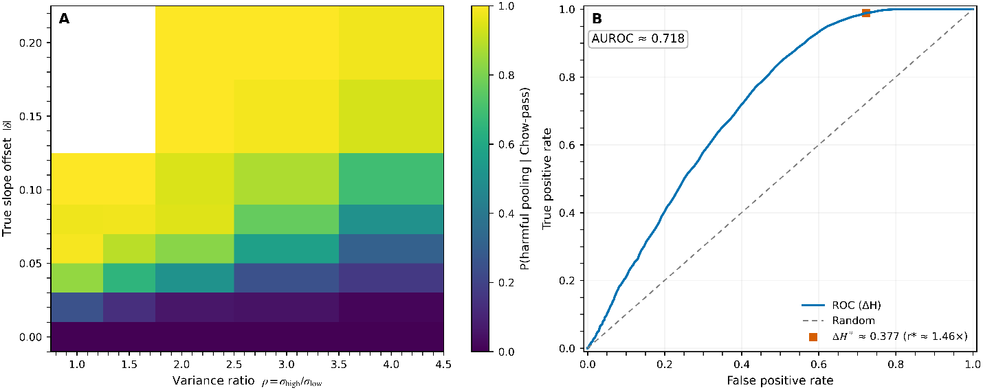
Supplementary Figure S3. Synthetic validation of entropy as a detector of harmful pooling in the Chow-pass regime. (A) Heat map showing the probability of pooling harm, given that the Chow test is passed, as a function of slope offset and variance ratio. (B) Receiver-operating curve of entropy lift $ΔH$ for distinguishing harmful pooling in Chow-pass systems. The consistent rise in harm probability and strong ROC performance support the theorem that entropy increases whenever disorder is introduced, even if Chow accepts.

S4. Robustness of entropy-based classification under outliers
One potential issue is that entropy auditing might be too sensitive to outliers, which could make reliability labels unstable. To check if this is a problem, we analyzed each ionic-liquid solute activity system with at least two independent reports twice: once using ordinary least-squares (OLS) regression and once using robust Huber regression. We then compared the resulting entropy lifts (𝛥𝐻) and reliability labels across the two methods.
The analysis shows that ΔH values are highly stable: most systems fall close to the diagonal when comparing OLS and Huber fits, and the histogram of absolute differences indicates that deviations are very small. Nearly all systems retain the same classification label, with only a negligible fraction crossing the confirm/veto boundary. These findings demonstrate that entropy auditing does not simply amplify noise or individual bad points, but instead reflects genuine disorder features of the system. Robustness to outliers is therefore a key strength of the Chow+Entropy framework, reinforcing its defensibility for heterogeneous experimental data⁶. These results provide additional reassurance that the Agreement–Entropy Map remains stable under real experimental imperfections, complementing the bootstrap fragility analyses in Fig. 7.

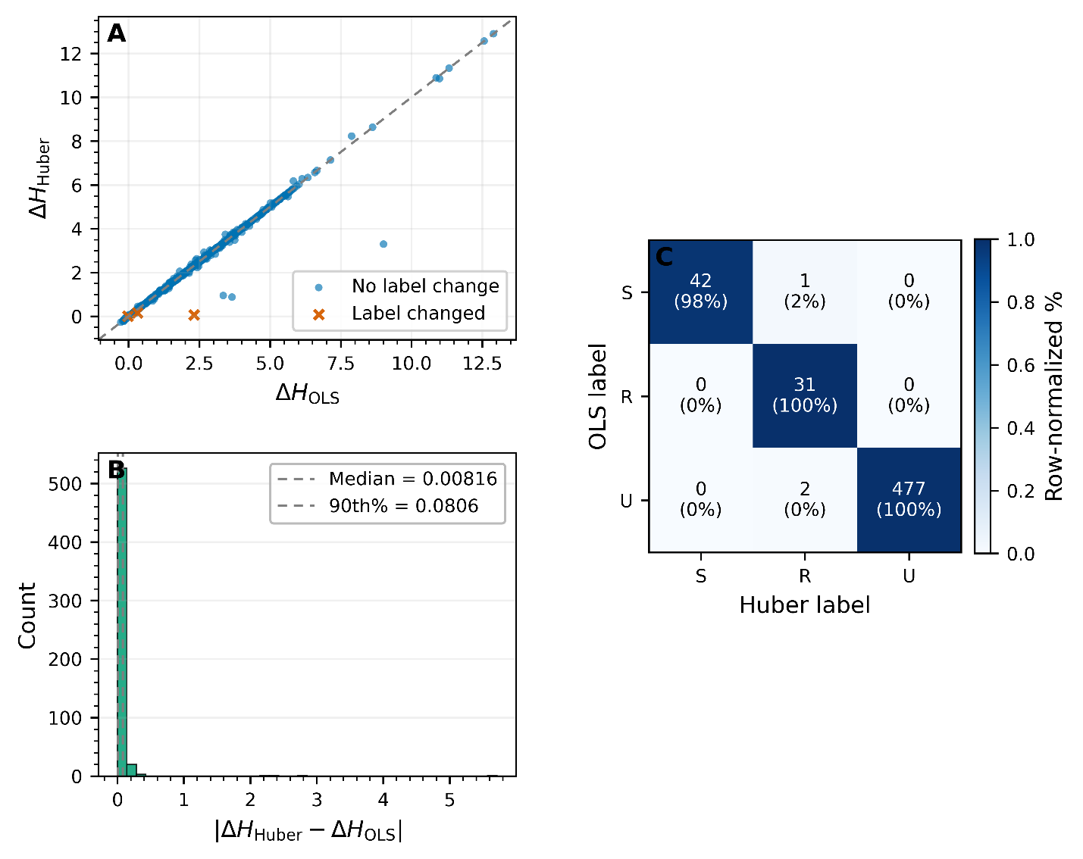
Supplementary Figure S4. Robustness of entropy-based classification under outliers for ILThermo ionic-liquid solute activity systems. (A) Scatter plot of ΔH from OLS versus Huber fits, with most systems clustered near the diagonal. Circles indicate unchanged labels, while crosses mark rare label changes. (B) Histogram of absolute differences $|{ΔH}_{Huber}-{ΔH}_{OLS}|$, annotated with the median and 90th percentile, showing small deviations. (C) Confusion matrix comparing OLS versus Huber labels, confirming near-perfect stability. Together, these panels demonstrate that the Chow+Entropy classifier is insensitive to moderate outliers: entropy values remain stable, and reliability labels are preserved.

S5. Entropy captures multimodality beyond variance effects
Finally, we tested whether entropy auditing can detect distributional disorder that variance-based diagnostics cannot. Synthetic residuals were generated from either a single Gaussian distribution or a bimodal Gaussian mixture constructed to have identical overall variance. Both Gaussian plug-in entropy (${ΔH}_{N}$) and nonparametric histogram entropy ($Δ\hat{H}$) were estimated across varying mode separations $μ/σ$.
Our results show that variance by itself isn't enough. When the two modes are close together, ${ΔH}_{N}$ stays near zero, but $Δ\hat{H}$ starts to deviate from zero, indicating added disorder despite the same variance. As the modes separate, $Δ\hat{H}$ decreases steadily with narrow confidence intervals, reflecting the increasing complexity of the bimodal residuals. Analytic density curves help explain why: the unimodal and bimodal distributions have the same variance but different shapes, with the mixture having two peaks and heavier tails.
These stress tests show that entropy generalizes variance-based measures, responding not only to heteroscedasticity but also to higher-order structures like multimodality. This captures forms of disorder that traditional diagnostics can't see. This aligns with the broader information-theoretic principle that entropy reflects not just spread but also the complexity of the distribution^{7,8}. These findings build on the slope-offset benchmarks in Fig. 5, demonstrating that entropy also reacts to shape-driven disorder when variance is constant.

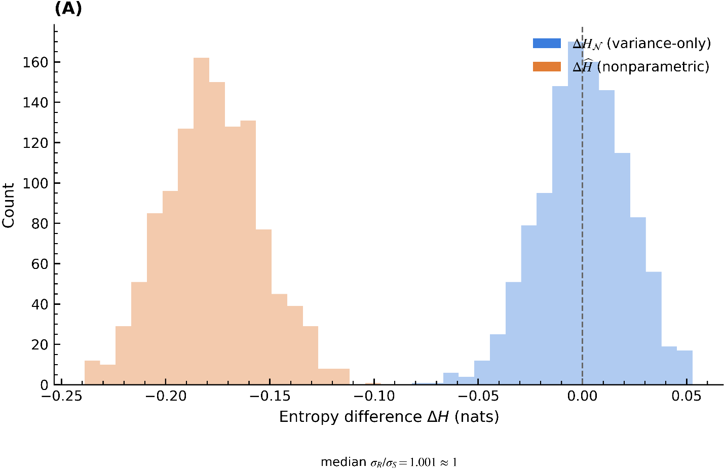
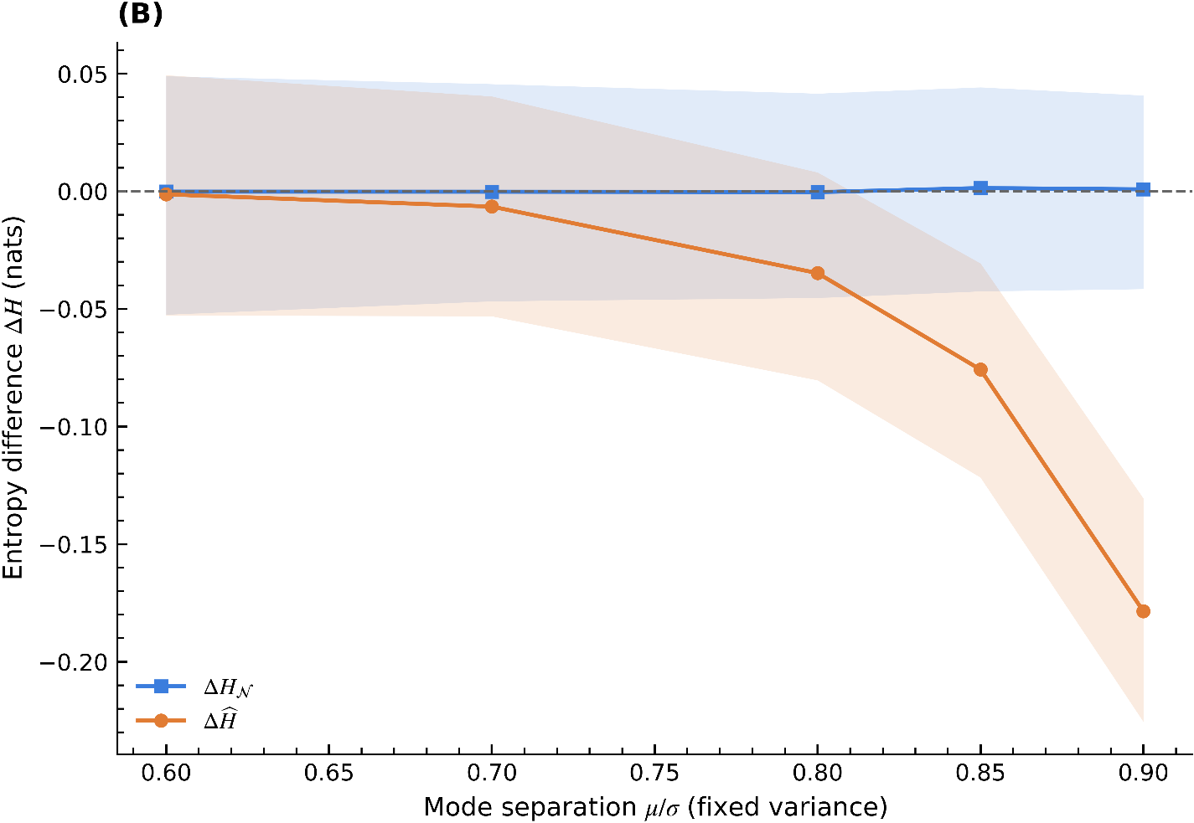
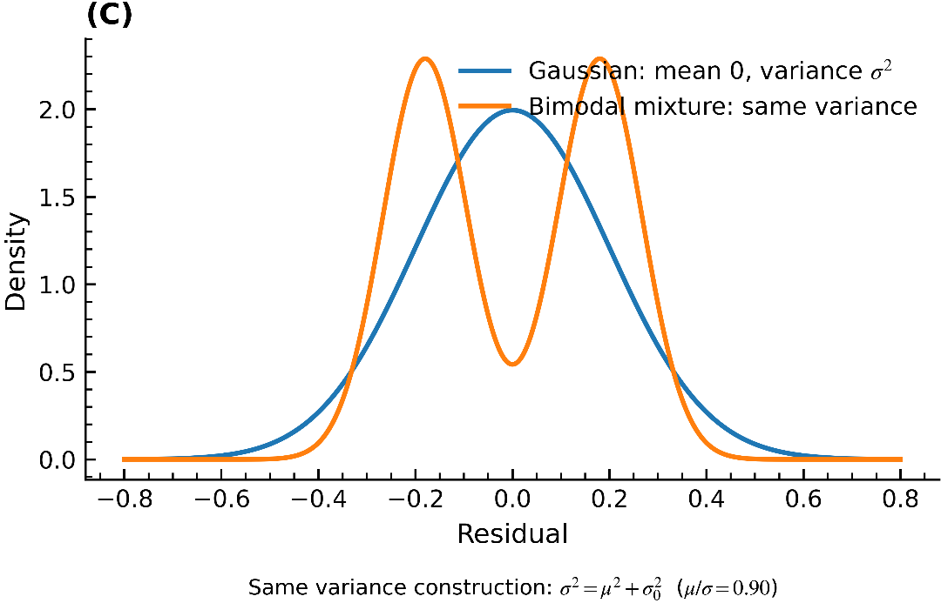
Supplementary Figure S5. Synthetic demonstration that entropy can detect multimodality beyond variance effects. (A) Histograms showing entropy differences estimated by Gaussian plug-in and histogram entropy, with a fixed variance. (B) Median and confidence intervals of entropy differences across increasing mode separation. (C) Analytic density curves comparing unimodal and bimodal distributions with the same variance. The departure of nonparametric entropy from zero directly follows from the predicted Jensen–Shannon divergence contribution, confirming sensitivity to distributional shape as well as variance.

S6. Variance imbalance between model predictions and experimental reference
Our experiment rethinks the variance-imbalance stress test to focus on model-to-truth coherence. For each system, we use the same linear mapping (common slope and intercept) for the experimental reference ("truth") and a competing model, but we vary the residual noise, with a variance ratio $ρ=\frac{σ_{model}}{σ_{truth}}$. This structural equality means Chow almost never rejects, and random 5-fold CV reports errors similar to leave-one-source-out (LOSO; here, leave-model-out), making the error metrics look benign. However, a pooled fit across truth and model cannot calibrate both channels at the same time: prediction intervals cover the precise (truth-like) channel too much and the noisy model channel too little, resulting in systematic coverage errors. In contrast, the residual-entropy lift $ΔH$ increases steadily with $ρ$ and triggers vetoes on the AEM once it exceeds the preregistered cutoff ${ΔH}^{*}$ (from the calibration JSON). As a result, entropy provides the missing reliability axis, revealing pooling harm that both Chow and cross-validation fail to uncover.

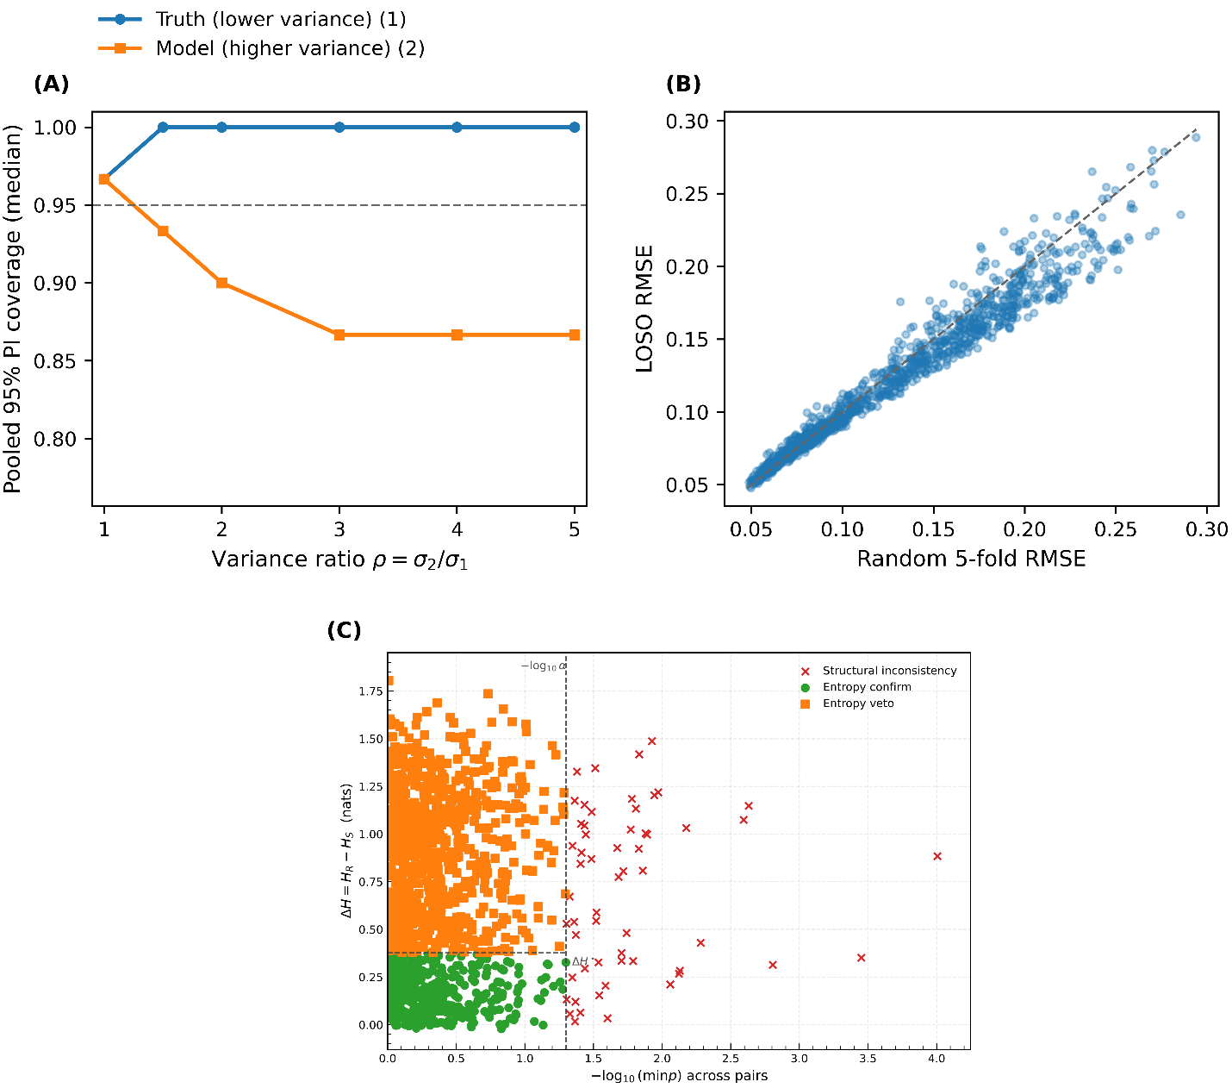
Supplementary Figure S6. Variance-imbalance stress test (model vs truth). (A) Pooled 95% prediction-interval (PI) coverage for the truth channel (blue, lower variance) and the model channel (orange, higher variance) as a function of variance ratio $ρ=\frac{σ_{model}}{σ_{truth}}$. The dashed line indicates nominal 95% coverage. As ρ grows, pooled intervals increasingly over-cover the truth channel and under-cover the model channel. (B) Random 5-fold cross-validation (CV) versus leave-model-out (LOSO) root mean squared error (RMSE). Most points are close to the diagonal, showing that error-based validation appears stable under variance imbalance. (C) AEM classification of the same systems. The entropy increase $ΔH$ rises with ρ, pushing many systems above the preregistered threshold ${ΔH}^{*}$. These systems are labeled as entropy veto, despite Chow passing and CV errors looking benign.

S7. Calibration of the entropy cutoff ${ΔH}^{*}$
Setting a fixed cutoff for entropy lift is necessary to turn the AEM into a reliable classifier. We created synthetic benchmarks with known true pooling outcomes to determine this threshold. Positives represented pooling scenarios with real misspecification, such as slope offsets and variance imbalance, while negatives represented structurally identical subsets where pooling was justified. For each case, $ΔH$ was calculated from regression residuals using Gaussian plug-in or nonparametric histogram entropy, depending on the distribution's shape.
ΔH's discriminative performance was measured using receiver–operating characteristic (ROC) analysis. We swept through the observed range to find the optimal operating point ${ΔH}^{*}$, using Youden’s J statistic (TPR − FPR) to identify it. To assess stability, we repeated the entire process with nonparametric bootstrap resampling, generating a distribution of optimal thresholds. The median of this distribution is ${ΔH}^{*}$, and the 2.5th and 97.5th percentiles give us the 95% confidence interval. The corresponding variance-ratio threshold is $r^{*}= exp({ΔH}^{*})$.
Our calibration process ensures that ${ΔH}^{*}$ is preregistered and not tailored to a specific dataset. By basing the disorder axis on a statistically sound and reproducible threshold, the AEM distinguishes between entropy-confirm and entropy-veto systems in a principled way. Supplementary Figure S7 shows the calibration process.

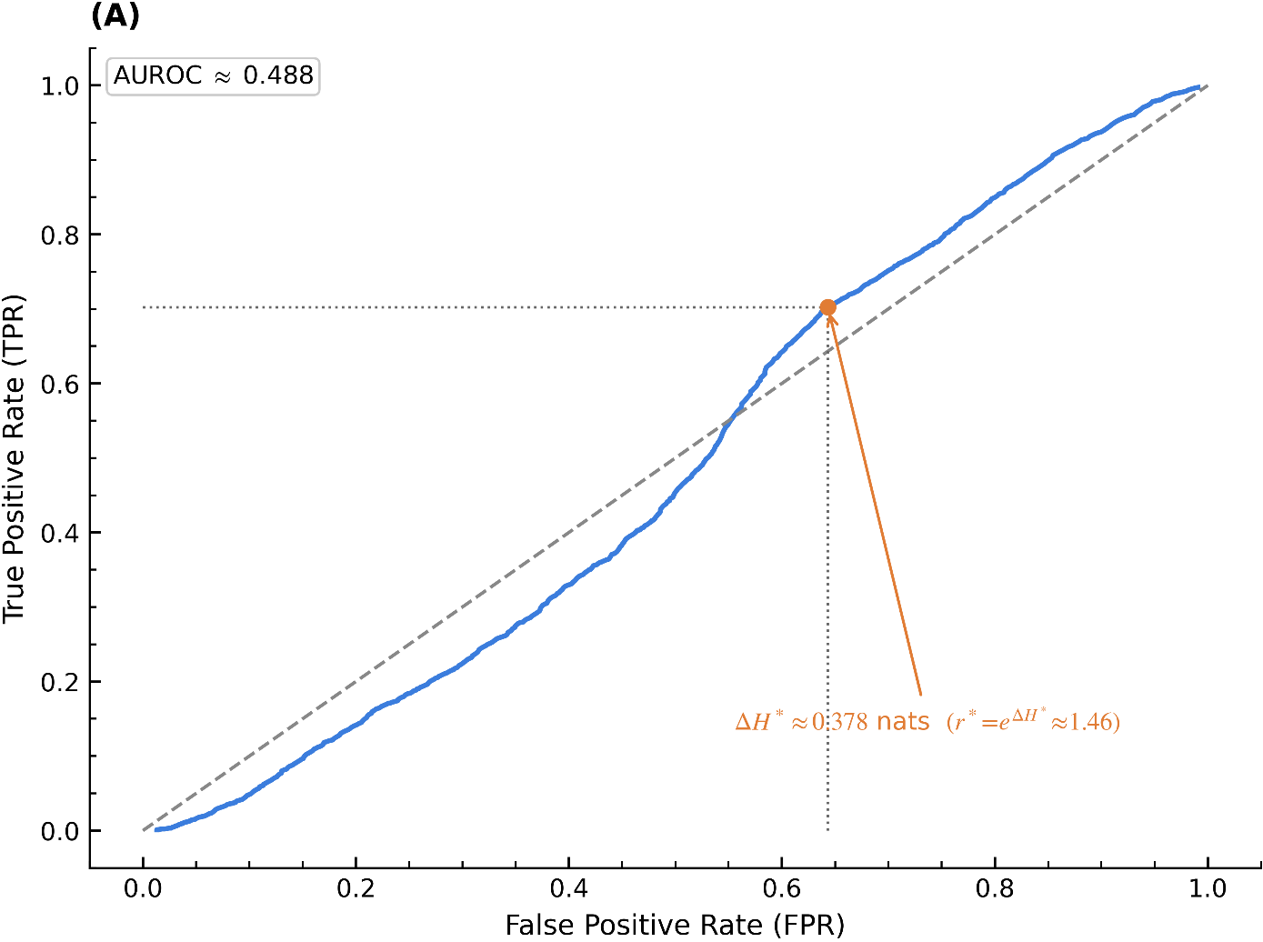
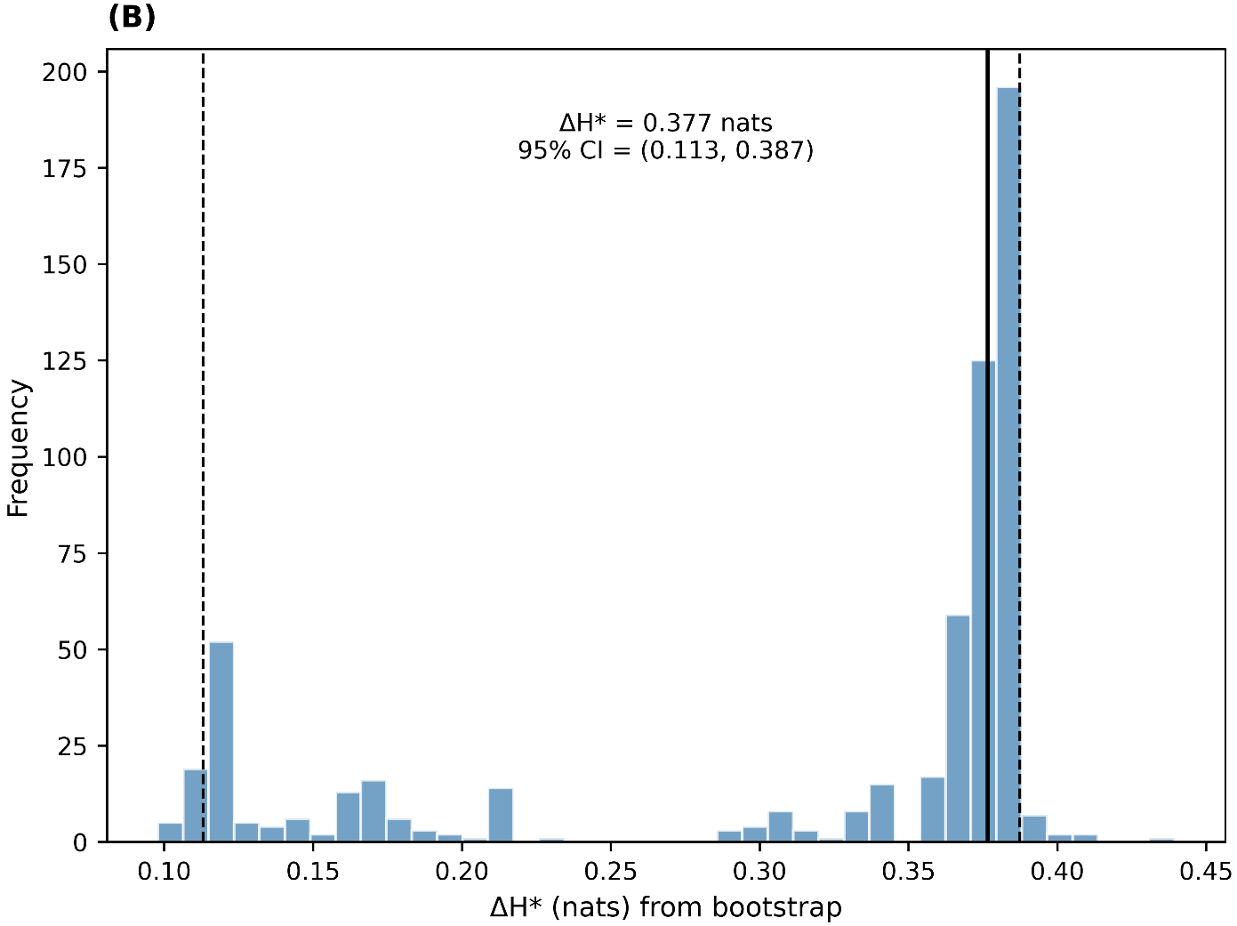
Supplementary Figure S7. Calibration of the entropy cutoff ${ΔH}^{*}$. (A) ROC curve for distinguishing harmful from defensible pooling across synthetic benchmarks, with the chosen cutoff indicated. (B) Bootstrap distribution of optimal thresholds, illustrating the stability of ${ΔH}^{*}$. The theoretical framework's monotonic link between entropy and harm probability ensures the existence of a reproducible cutoff.

S7. Data sources
Our case study used experimental measurements of infinite-dilution activity coefficients ($γ^{∞}$) for solutes in ionic liquids, which we obtained from the public ILThermo database^{9,10}. This database provides temperature-dependent $γ^{∞}$values for a wide range of ionic liquid–solute combinations and is commonly used in machine-learning studies of thermophysical properties, as seen in Chen et al¹¹ and Rittig et al¹², which both used ILThermo-derived $γ^{∞}$ data for predictive modeling. However, as recent work¹³ shows, many reported values are inconsistent across different sources. This highlights the need for reliable data curation methods, like the AEM, when preparing experimental data for downstream modeling.

Supplementary — Mathematical Interpretation of Entropy Trends
This section draws clear connections between the mathematical propositions in the unified framework (Lemma S1, Identity S2, Theorem S4, Note S5) and the observed entropy trends in the main and supplementary figures. As a result, each figure can be interpreted as a direct result of the theory.
Link to Figure 4 (Main Text) — Variance imbalance
Prediction. Lemma S1 with $Δa=Δb=0$ but unequal noise variances gives ${ΔH}_{G}= \frac{1}{2} lnρ, ρ = σ₁² / σ₂².$
Observed trend: Figure 4 shows that $ΔH$ increases linearly with $lnρ$, while the Chow rejection rate stays constant. This aligns precisely with the theorem: structural equality (constant Chow) but disorder inflation (increasing entropy).
Link to Supplementary Figure S6 — Variance imbalance stress test
As predicted, with equal slopes and intercepts but different variances, Chow tests stay near their nominal values, and cross-validation errors appear stable. Meanwhile, entropy lift increases with the variance ratio. The observed trend supports this: Figure S6 shows that pooled prediction intervals misclassify the precise and noisy subgroups in opposite directions. Cross-validation and LOO errors remain similar, while entropy increases steadily with 𝜌, triggering vetoes when 𝛥𝐻 exceeds the pre-registered cutoff.
Link to Figure 5 (Main Text) — Slope offset at equal variance
Prediction. Lemma S1 with $Δa=0, Δb=δ$yields ${ΔH}_{G} = ½ ln(1 + κ δ²), κ = (w₁ w₂ σₓ²) / σ².$
For small $δ$, ${ΔH}_{G}≈ ½ κ δ²$ (quadratic onset).
Observed trend. Figure 5 shows near-zero entropy at $δ≈0$, a quadratic rise for small offsets, and a concave logarithmic tail for large $δ$ — exactly as predicted by the analysis.
Link to Figure 6 (Main Text) — Agreement–Entropy Map
Prediction. Identity S2 states that $ΔĤ = ½ ln(1 + (k/(n-k))(F_{Chow}- 1))$, which implies a monotone mapping between Chow and plug-in entropy when variance is balanced. Theorem S4 shows that there's a complementary effect: systems can have $ΔH > 0$ even when Chow accepts, or $ΔH ≈ 0$ while Chow rejects.
Observed trend. Figure 6 shows a two-axis decision: the vertical separation is at ${-log }_{₁₀}^{α}$ (structural), and the horizontal separation is at ${ΔH}^{*}$ (disorder). The scatter of entropy-vetoed points above the horizontal line, despite Chow passing, corresponds exactly to Case B in Theorem S4.
Link to Figure 8 (Main Text) — Entropy vs $I²$
By definition, $ΔH = H_{R} - H_{S}$ and $ρ_{σ} = e^{ΔH}$. We classify labels directly based on $ΔH$. As a result, the ROC and PR curves for $ΔH (or ρ_{σ})$ have a tautologically perfect AUROC = 1. This is confirmed by Figure 8, which contrasts with $I²$, which isn't mathematically linked to functional reliability. This outcome follows directly from Eq. (6) and the classifier definition.
Link to Supplementary Figure S3 — Harmful pooling within Chow-pass
Prediction. Case B of Theorem S4 and Note S5 imply that entropy remains positive whenever subgroup residual distributions differ, even if Chow accepts. Harm probability should therefore increase monotonically with ΔH. Observed trend. In Fig. S3A, harm probability contours align with iso-$ΔH$ lines across the ($δ,ρ$) grid. In Fig. S3B, ROC analysis shows $ΔH$ discriminates harmful pooling within Chow-pass, in line with the theorem.
Link to Supplementary Figure S5 — Multimodality at fixed variance
Prediction. Note S5 states $ΔH = {ΔH}_{G} + {ΔH}_{shape}$, ${ΔH}_{shape} = {JSD}_{w}(\{p_{s}\}) > 0$. Thus, even with equal subgroup variances, bimodal mixtures yield $ΔH > 0$. Observed trend. Figure S5 shows plug-in ${ΔH}_{N} ≈ 0$, while nonparametric entropy rises with mode separation $μ/σ$, confirming that disorder is detected through ${ΔH}_{shape}$ as predicted.
Link to Supplementary Figure S7 — Calibration of ${ΔH}^{*}$
Prediction. Since the harm probability increases steadily with $ΔH$ (Theorem S4, Case B), the ROC analysis should be a steady curve, and an optimal cutoff ${ΔH}^{*}$ exists by maximizing Youden’s J statistic. Observed trend. Figure S7 shows that the ROC performance is well above random and has a stable bootstrap distribution of ${ΔH}^{*}$, fully consistent with the steady increase implied by the theory.
Summary
All entropy-driven figures are predictable outcomes of the theoretical framework.
- Variance imbalance → $ΔH = ½ ln ρ$ (Lemma S1 → Fig. 4, Fig. S6).
- Slope offset → $ΔH = ½ ln(1 + κ δ²)$ (Lemma S1 → Fig. 5).
- Complementarity with Chow (Theorem S4 → Fig. 6, S3).
- Shape disorder → ${ΔH}_{shape}≥ 0$ (Note S5 → Fig. S5).
- Monotone link to harm → ROC calibration of ${ΔH}^{*}$ (Theorem S4 → Fig. S7).
This connection shows that residual-entropy auditing is more than just a practical tool - it's a mathematically sound approach that takes structural testing a step further into a broader disorder diagnostic.
References
1. Chernozhukov, V., Wüthrich, K. & Zhu, Y. Distributional conformal prediction. Proc. Natl. Acad. Sci. 118, e2107794118 (2021).
2. Higgins, J. P. T. & Thompson, S. G. Quantifying heterogeneity in a meta-analysis. Stat. Med. 21, 1539–1558 (2002).
3. Higgins, J. P. T., Thompson, S. G., Deeks, J. J. & Altman, D. G. Measuring inconsistency in meta-analyses. BMJ 327, 557 LP – 560 (2003).
4. Imrey, P. B. Limitations of Meta-analyses of Studies With High Heterogeneity. JAMA Netw. Open 3, e1919325–e1919325 (2020).
5. Chow, G. C. Tests of Equality Between Sets of Coefficients in Two Linear Regressions. Econometrica 28, 591–605 (1960).
6. Efron, B. Bootstrap Methods: Another Look at the Jackknife BT - Breakthroughs in Statistics: Methodology and Distribution. in (eds. Kotz, S. & Johnson, N. L.) 569–593 (Springer New York, New York, NY, 1992). doi:10.1007/978-1-4612-4380-9_41.
7. Shannon, C. E. A Mathematical Theory of Communication. Bell Syst. Tech. J. 27, 379–423 (1948).
8. Cover, T. M. & Thomas, J. A. Elements of Information Theory. (Wiley, 2012).
9. Kazakov, A. et al. Ionic Liquids Database - ILThermo (v2.0). (2013).
10. Dong, Q. et al. ILThermo: A Free-Access Web Database for Thermodynamic Properties of Ionic Liquids. J. Chem. Eng. Data 52, 1151–1159 (2007).
11. Chen, G., Song, Z., Qi, Z. & Sundmacher, K. Neural recommender system for the activity coefficient prediction and UNIFAC model extension of ionic liquid-solute systems. AIChE J. 67, e17171 (2021).
12. Rittig, J. G., Ben Hicham, K., Schweidtmann, A. M., Dahmen, M. & Mitsos, A. Graph neural networks for temperature-dependent activity coefficient prediction of solutes in ionic liquids. Comput. Chem. Eng. 171, 108153 (2023).
13. Haddadi, H. & Kloskowski, A. Statistical Curation of Thermophysical Data: Resolving Conflicted Activity Coefficients in ILThermo for Machine Learning. at https://doi.org/10.26434/chemrxiv-2025-3lmfx-v2 (2025).

