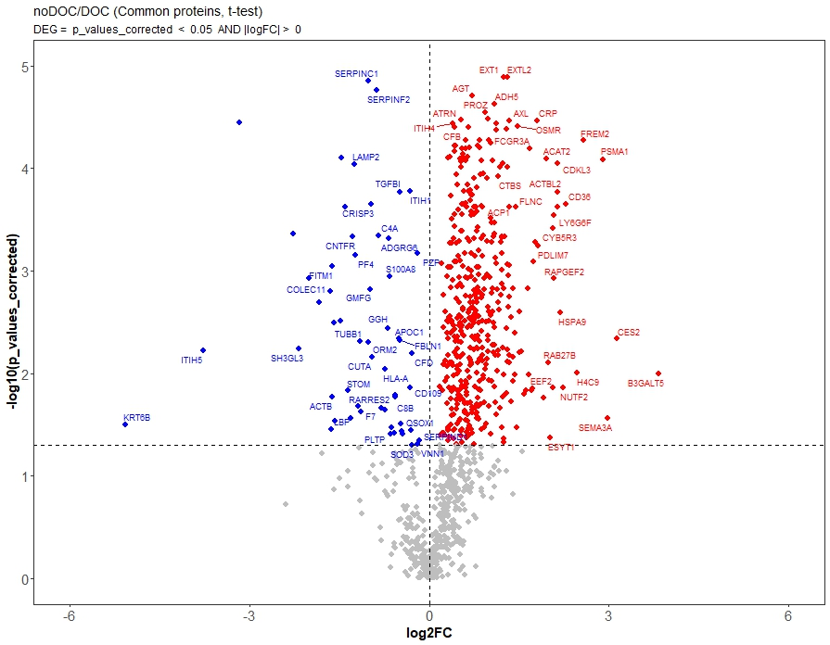
Supplementary Figure 1. Volcano plot of common protein groups identified with and without DOC. Only proteins with at least four observations were included in the analysis. Data were log₂-transformed and differences between groups were assessed using a two-sample t-test. The x-axis represents the log₂ fold change and the y-axis shows the –log₁₀ p-values.

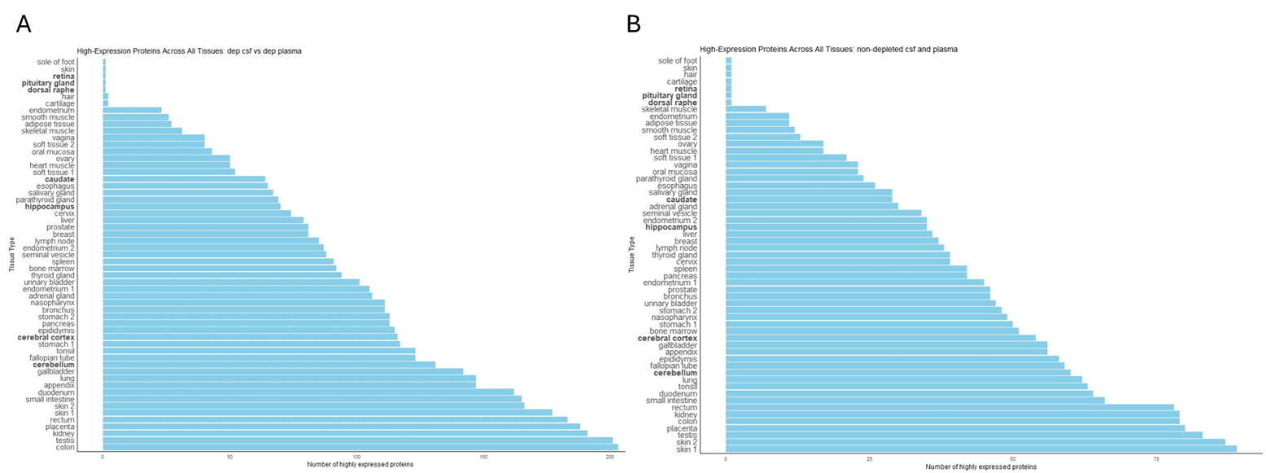
Supplementary Figure 2. Overall tissue distribution of overlapping proteins in depleted CSF and plasma (A) and non-depleted CSF and plasma (B). Brain tissues are shown in bold.

Supplementary Figure 3. Completeness curves for CSF and plasma proteins, respectively, in the ALS cohort.

