Supplementary Material

Table S1: Missingness table

Variables | Missing data  n (%)
Age, years | 39 (7)
Anticoagulant use | 14 (3)
History of penile fracture | 11 (2)
Causes | 4 (1)
Symptoms | 35 (6)
Time to consultation, hours | 22 (4)
Surgeon experience | 8 (2)
Surgery duration | 234 (45)
Size of lesion | 220 (42)
Lesion side | 52 (10)
Lesion position | 54 (10)
Associated urethral lesion | 12 (2)
Surgical approach | 16 (3)
Associated posthectomy | 22 (4)
Drain placement | 19 (4)
Postoperative complications | 70 (13)
Symptoms at 1 month | 193 (37)
Symptoms at 3 months | 350 (67)

Legend:
Summary of variable-level missingness among 519 patients included in the multicenter penile fracture cohort.

Table S2: Analysis of postoperative complications and follow-up restricted to the no-degloving approach.

 | Total  (n=165) | Drain  (n = 23) | No drain  (n =138) | p-value
Length of surgery | 55 [40-74] | 90 [67-101] | 50 [40-64] | < 0.01
Length of stay | 1 [1-2] | 2 [2-3] | 1 [1-2] | < 0.01
Postoperative complication, n (%)  Total  Surgical site infection  General infection  Hematoma  Local (wound dehiscence, oedema, ect)  Other | 16 (10)  4 (3)  2 (1)  1 (1)  2 (1)  2 (1) | 6 (26)  2 (8)  /  /  2 (8)  / | 9 (7)  2 (2)  2 (2)  1 (1)  /  2 (2) | < 0.01
Severe complication (Clavien–Dindo ≥ III) | 8 (6) | 4 (16) | 4 (3) | 0.02
At 1 month, n = 102 (68%)  At least one symptom  Pain  Sexual pain  Penile curvature  Palpable plaque  Erectile dysfunction  Urethral stenosis | 60 (59)  8 (8)  23 (23)  17 (17)  34 (34)  19 (19)  1 (1) | 13 (81)  2 (12)  8 (50)  3 (19)  3 (19)  4 (25)  1 (6) | 47 (54)  6 (7)  7 (8)  14 (16)  31 (36)  15 (17)  / | 0.047  0.45  < 0.01  0.81  0.18  0.48  0.16

Legend:
Comparison of operative characteristics, early complications, and follow-up outcomes between the drain and no-drain groups among patients managed with a non-degloving approach (n = 165).

Table S3: Postoperative early (within 30 days) surgical-site complications (hematoma, surgical-site infection, or wound dehiscence)

 | Total  (n=519) | Drain  (n =158) | No drain  (n =342) | p-value
Postoperative complication, n (%)  Total surgical-site complications  Surgical site infection  Hematoma  Wound dehiscence) | 31 (6)  11 (4)  6 (1)  14 (3) | 13 (10)  6 (4)  2 (2)  5 (3) | 18 (5)  5 (1)  4 (1)  9 (3) | 0.7

Legend:
Frequency of surgical-site complications—including hematoma, surgical-site infection, and wound dehiscence—in the drain and no-drain groups. Multivariable logistic regression adjusted for surgical approach and urethral injury showed no significant association between drain placement and surgical-site complications (OR = 1.49; 95% CI 0.63–3.46; p = 0.35).

Table S4: Sensitivity analysis without peroperatory infirmed fracture: (n= 40)

 | Total  (n=468) | Drain  (n =153) | No drain  (n =304) | p
Postoperative complication, n (%)  Total  Surgical site infection  General infection  Hematoma  Local (wound dehiscence, oedema, ect)  Other | 45 (10)  9(2)  7 (2)  6 (1)  22 (5)  2 (0.5) | 18 (12)  6 (4)  3 (2)  2 (1)  7 (4)  / | 27 (9)  3 (1)  3 (2)  4 (1)  14 (5)  2 (1) | 0.42

Legend:
Postoperative complications in the subset of 468 patients with intraoperatively confirmed corpus cavernosum rupture. Comparison of complication types between the drain and no-drain groups showed no significant difference (p = 0.42). The number of intraoperatively unconfirmed fractures was 5 (3%) in the drain group versus 33 (9%) in the no-drain group.

Figure S1: Drain placement across calendar periods.

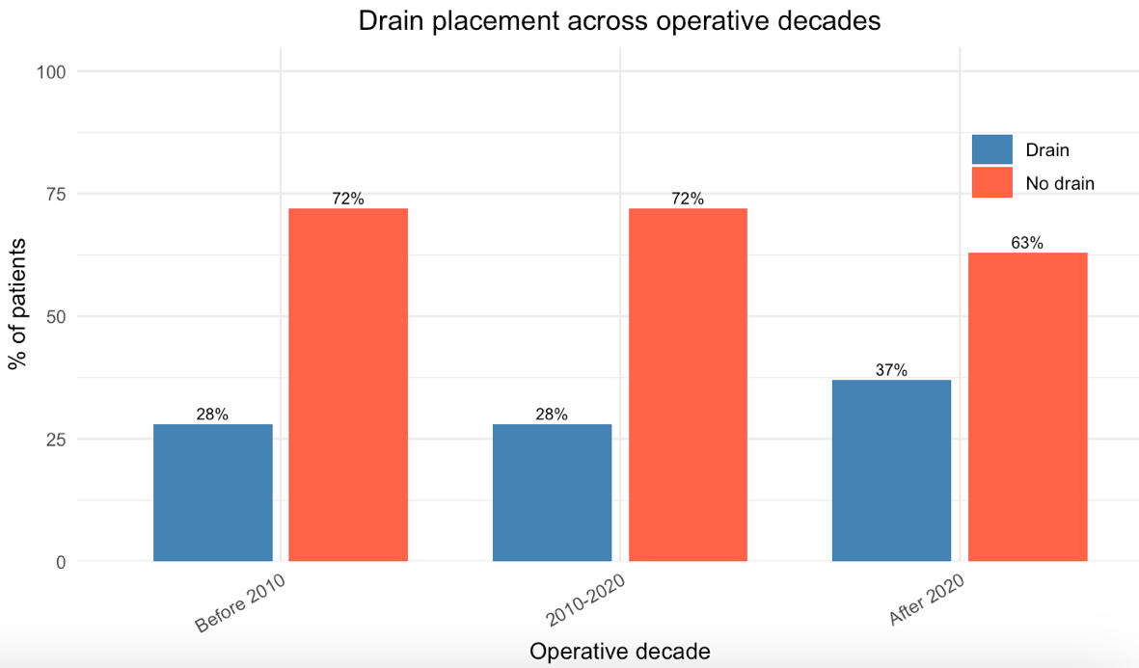
Chi-squared test: p = 0.14

Legend:
Distribution of intra-operative drain placement over three operative decades (before 2010, 2010–2020, and after 2020). Drain use remained stable across time (p = 0.14, chi-squared test).

