Supplementary Information for
Unstable climate for 50,000 years after Chicxulub impact: evidence from Antarctica
Supplementary Note

1. Section photograph

We conducted geological sampling at the Filo Negro section (James Ross Basin), Seymour Island, Antarctica, in the austral summer of 2024. The section photograph is shown in Supplementary Fig. 1.

2. Sediment provenance stability assessment for CIA

To ensure that variations in CIA values reflect weathering intensity rather than shifts in sediment provenance, we examined rare-earth element (REE) patterns, which provide robust provenance indicators owing to their stability during weathering and post-depositional processes¹. The uniformity of chondrite-normalised REE pattern (Supplementary Fig. 2) indicates that sedimentary REE patterns reflect the upper continental crust exposed to weathering and erosion². The REE patterns in the studied profile are also characterised by LREE enrichment, flat HREE distributions, and a negative Eu anomaly, being parallel to the average REE pattern of the upper continental crust. Consequently, the observed variations in weathering proxies cannot be attributed to changes in provenance. Instead, they record genuine shifts in weathering dynamics, confirming that the source area remained consistent over the period studied.

The A–CN–K diagram is a valuable tool for evaluating potassium (K) metasomatism, a common post-burial alteration process that involves the addition of K to weathered residues, typically expressed as illitization of clay minerals or the secondary formation of K-feldspar, with a trend toward the K apex (lower right corner)³. In this study, no trend toward the K apex in the A-CN-K diagram for samples from the López de Bertodano Formation is observed (Supplementary Fig. 3), providing no evidence for K metasomatism.

CIA can serve as a robust paleoweathering proxy for the López de Bertodano Formation in the Filo Negro section (James Ross Basin), Seymour Island.

Supplementary Figures

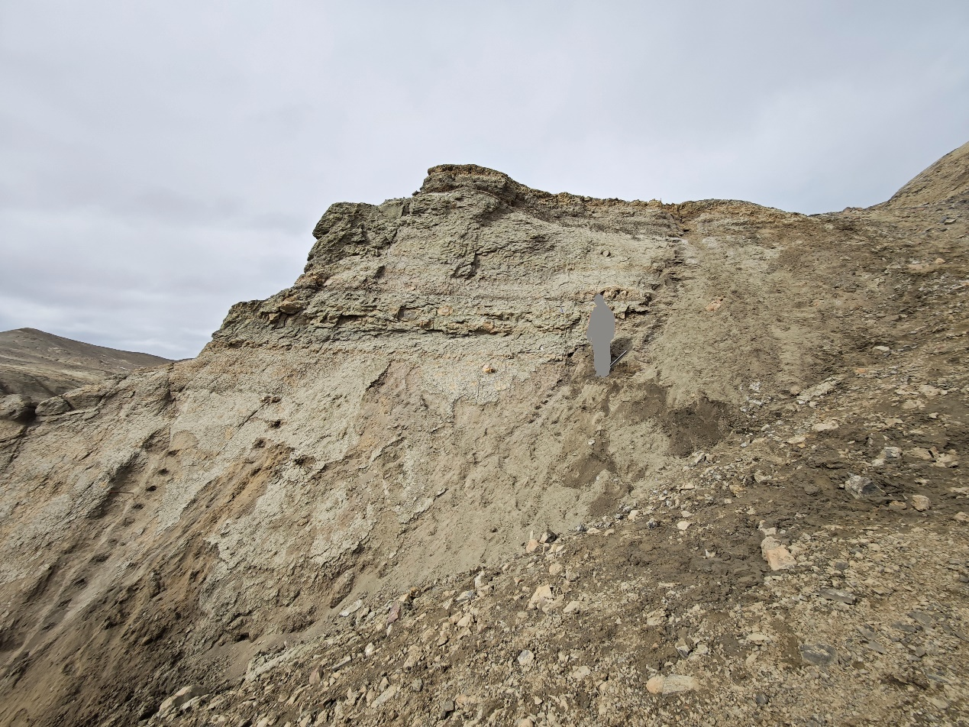
Supplementary Fig. 1. Outcrop photograph of the Filo Negro section (James Ross Basin), Seymour Island.

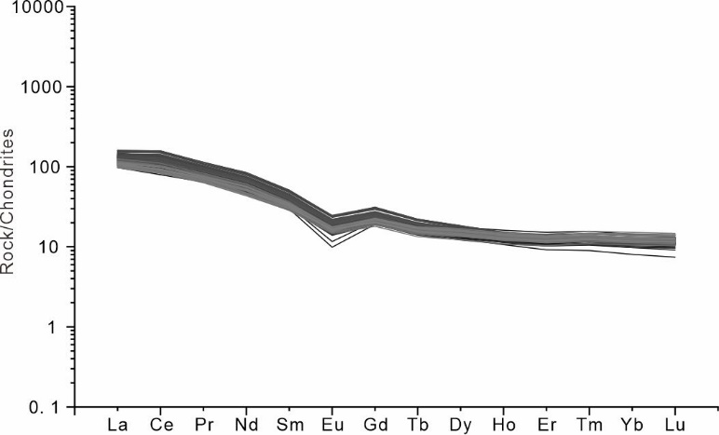
Supplementary Fig. 2. Chondrite-normalised REE diagram. The chondritic data are from Taylor and McLennan². Source data are available in the Supplementary Data Set.

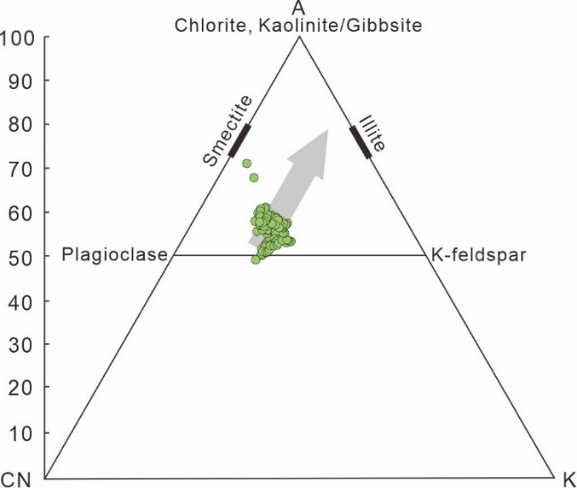
Supplementary Fig. 3. The A–CN–K diagram for samples from the López de Bertodano Formation. The grey arrow represents the main weathering trend in subparallel with the A-CN line, suggesting that removing Ca and Na dominates silicate weathering, and K-bearing minerals remain less attacked. A = Al₂O₃, CN = CaO*+Na₂O, K = K₂O. Source data are available in the Source Data.

References

1. McLennan, S. M. in Geochemistry and mineralogy of rare earth elements (eds Bruce, R. L. & McKay, G. A.) 169–200 (De Gruyter, 1989).

2. Taylor, S. R. & McLennan, S. M. The continental crust: its composition and evolution (Blackwell Scientific Publications, 1985).

3. Fedo, C. M., Wayne Nesbitt, H. & Young, G. M. Unraveling the effects of potassium metasomatism in sedimentary rocks and paleosols, with implications for paleoweathering conditions and provenance. Geology 23, 921–924 (1995).

