Supplementary Information

Graphene Oxide-Based Layered Bulk Material Reinforced by Amorphous/Crystalline Heterophase Platelets and Multiscale Interface Crosslinking
Ke Chen¹, Xuke Tang¹, Binbin Jia¹, Cezhou Chao², Junyu Hou¹, Leiting Dong^{2,}*, Yan Wei^{3,}*, Ting-Hui Xiao⁴, Keisuke Goda^{4,5,6}, and Lin Guo^{1,}*
- Beijing Advanced Innovation Center for Biomedical Engineering, Key Laboratory of Bio-Inspired Smart Interfacial Science and Technology of Ministry of Education, School of Chemistry, Beihang University (BUAA), Beijing 100191, China.
- School of Aeronautic Science and Engineering, Beihang University (BUAA), Beijing 100191, China.
- Department of Geriatric Dentistry, NMPA Key Laboratory for Dental Materials, National Engineering Laboratory for Digital and Material Technology of Stomatology, Beijing Laboratory of Biomedical Materials, Peking University School and Hospital of Stomatology, Peking University, Beijing 100081, China.
- Department of Chemistry, The University of Tokyo, Tokyo 113-0033, Japan.
- Institute of Technological Sciences, Wuhan University, Hubei 430072, China.
- Department of Bioengineering, University of California, Los Angeles, California 90095, United States.
These authors contributed equally: Ke Chen, Xuke Tang, Binbin Jia, Cezhou Chao
Email: guolin@buaa.edu.cn, ltdong@buaa.edu.cn, kqweiyan@bjmu.edu.cn

Table of Contents
Experimental materials and methods S1
Materials S1
Methods S1
Treatment of natural nacre shells S1
Preparation of graphene oxide (GO) S2
Preparation of microporous amorphous/crystalline leaf-like MnO₂ hexagon (A/C-LMH) nanosheets S2
Preparation of regenerated silk fibroin (rSF) S3
Preparation of reaction solutions S3
Fabrication of 2D nanocomposite films S4
Fabrication of pure GO bulk material S5
Fabrication of pure SA bulk material S5
Multi-scaled simulation methodologies S6
Instruments and characterization S7
Supplementary Figures (Supplementary Figs 1–28) S9
Supplementary Tables (Supplementary Tables 1–6) S48
Supplementary References S57

Experimental materials and methods

Materials
Graphite powder with particle size <20 μm was used as received from Alfa Aesar. KMnO₄, H₂SO₄, NaOH, C₂H₅OH, K₂S₂O₈, acetone, H₂O₂, HCl, Na₂CO₃, and Na₂B₄O₇·H₂O were purchased from Beijing Chemical Works (analytical grade, Beijing, China). P₂O₅, NaOCl, Sodium alginate (SA), LiBr, NaH₂PO₂·H₂O, and sodium borate were purchased from Aladdin. Silk cocoons were purchased from Jiangsu province (China). Ultrapure doubly deionized water (resistivity >18.2 MΩ cm) was obtained from a synergy ultraviolet water purification system (Millipore Corporation). All the reagents were used without further purification.

Methods

Treatment of natural nacre shells
We acquired two kinds of shell, abalone and scallop, from a formal seafood market (we removed the meat). Both shells were rubbed with abrasive papers to remove the outmost layer of cuticle and residual dirt. Pieces of the two shells were cut to nearly 2 × 2 × 1 mm³ samples. These samples were then soaked in the solution with added detergent for further cleaning at 37 °C and with stirring for 24 h. To deproteinate these samples, we submerged them into 5wt.% NaOCl solution for 72 h with the NaOCl solution changed daily, subsequently rinsed them in Hank’s Balanced Salt Solution, and finally centrifuged them with deionized water to remove residual NaOCl¹.

Preparation of graphene oxide (GO)
GO was made following the modified Hummers method^{2–4}. In a typical process, 9.0 g of natural graphite flakes were subjected to pre-oxidation treatment by being stirred vigorously for 6 hours at 80 °C in a mixture of K₂S₂O₈ (7.5 g), P₂O₅ (7.5 g), and H₂SO₄ (45 ml). The pre-oxidized graphite powder (about 10.5 g) was dried overnight before further oxidative treatment by stirring it in a mixture of 360 ml of H₂SO₄ and 45 g of KMnO₄ in an ice bath. Notably, KMnO₄ was slowly added with vigorous stirring to avoid the temperature rising above 20 °C. The solution was then transferred to a 35 ± 3 °C water bath and stirred for about 1 hour before 750 ml of water was added. We added 2100 ml of warm water and 60 ml of H₂O₂ (30 wt.%) to reduce KMnO₄ and MnO₂ to MnSO₄. The color of the blend solution turned to dark greenish yellow during the reduction. Then the warm solution was filtered. The GO slurry collected from the membrane was then washed with 2250 ml of 2 M HCl, and purified GO was collected at the tube bottom after centrifugation. The purified GO slurry was then placed in a refrigerator to obtain the frozen GO sample. Subsequently, the frozen GO sample was freeze-dried to obtain the purified GO as raw material.

Preparation of microporous amorphous/crystalline leaf-like MnO₂ hexagon (A/C-LMH) nanosheets
In a typical synthesis, 40 mg NaH₂PO₂·H₂O and 50 mg KMnO₄ were dissolved in 100 ml deionized water, respectively. Afterwards, the KMnO₄ solution was slowly added to NaH₂PO₄ solution through a constant pressure titration funnel maintained at 35 °C for 0.5 h. The precipitate was collected after centrifugation, carefully washed with water to clean out remnant salt. The purified A/C-LMH slurry was then placed in a refrigerator to obtain the frozen A/C-LMH sample. Subsequently, the frozen A/C-LMH sample was freeze-dried to obtain the purified A/C-LMH powder as raw material. For comparison, crystalline MnO₂ nanosheets were also prepared by annealing A/C-LMH powers at 400 °C.

Preparation of regenerated silk fibroin (rSF)
Bombyx mori silk cocoons (5 g) were boiled for 30 min in an aqueous solution of Na₂CO₃ (2 L, 0.02 M) and then rinsed thoroughly with water to remove the glue-like sericin⁵. After drying overnight at room temperature, the degummed silk fibroin was dissolved in a 9.3 M LiBr solution at 60 °C for 4 h and then dialyzed in a cellulose tube (molecular weight cut off (MWCO) = 3500) against distilled water to remove the salt impurities. Then it was centrifuged at 9000 rpm for 20 min to remove the undissolved impurities. The purified regenerated silk fibroin (rSF) slurry was then placed in a refrigerator to obtain the frozen rSF sample. Subsequently, the frozen rSF sample was freeze-dried to obtain the purified rSF as raw material.

Preparation of reaction solutions
Before preparing the reaction solutions, we first made stock solutions for the inorganic nanosheets (GO and A/C-LMH), polymers (SA and rSF), and borate. The purified GO was dispersed in deionized water, stirred for 2h, and then subjected to ultrasound for 1 min to the GO solution (1 mg ml⁻¹). A/C-LMH nanosheets were dispersed in deionized water and stirred overnight to obtain a transparent AL-LMH nanosheets dispersion (5 mg ml⁻¹). SA powder was dissolved in deionized water and stirred overnight to form an aqueous SA solution (0.3 wt.%). rSF powder was dissolved in deionized water and stirred overnight to form an aqueous rSF solution (1 mg ml⁻¹). And sodium borate was also dissolved in deionized water under slow stirring to form an aqueous solution (1 mg ml⁻¹). Then, the above stock solutions were added to deionized water in order (That is, GO solution, AL-LMH dispersion, SA solution, rSF solution and borate solution) to prepare various reaction solutions with different weight percentages of nanosheets and polymers. The mixed solution was sonicated for 15 min with 100 W power to obtain homogeneous reaction solutions. Specifically, for the reaction solutions containing borate, borate was added after all other components.

Fabrication of 2D nanocomposite films
Multiple layered nanocomposite films (from binary to quinary) were successfully prepared by evaporating the reaction solutions of the diluted colloidal GO dispersions and different types of aqueous additives (binary: amorphous/crystalline MnO₂, rSF, and SA; ternary: MnO₂/rSF, MnO₂/SA, and rSF/SA; quaternary: MnO₂/rSF/B, MnO₂/SA/B, and MnO₂/rSF/SA) at 60 °C. First, the reaction solution (Supplementary Table 1) was mixed together by vigorous stirring for ~1 h, followed by ultrasonic treatment for 30 min. Then, the achieved solution was assembled by a simple ESA technique to form the quaternary 2D film. During the assembly process, accurately controlling the volume of the mixed solution obtained a sample with ideal thickness (~20 µm). For the optimization of mechanical properties, nanocomposite films with different reinforcing agent concentrations could be achieved by adjusting the mass percentage of the aqueous reinforcing agent solution to colloidal GO dispersions. For comparison, pure GO, pure SA and binary crystalline/crystalline GO/MnO₂ films were also prepared by the same method. After evaporation, these 2D specimens were dried until the films could be peeled off for analysis.

Fabrication of pure GO bulk material
To assemble pure GO bulk material, the thin GO films were firstly prepared through a simple ESA technique by using 1 mg ml⁻¹ GO aqueous dispersion. During the assembling process, the thickness of these films should be made identical by accurately controlling the volume of GO aqueous dispersion. Then a large amount of GO films were glued by a thin layer of deionized water and rolled to obtain the pre-bulk GO material. Finally, the material was compacted by using a hot-pressing process with a pressure of 25 MPa and under 40 °C for ~48 h.

Fabrication of pure SA bulk material
To assemble the pure SA bulk, 5 wt% SA solution was carefully poured into several 5 cm × 5 cm × 1 cm molds and placed in a 40 °C oven for water evaporation. Then the SA thin laminas were laminated together after being slightly wetted with deionized water. The resultant pure SA bulk material was achieved by placing the wet SA bulk in the ambient temperature for drying ~24 h.

Multi-scaled simulation methodologies
Molecular dynamics (MD) simulations in molecular scale were used to characterize the interfacial interactions between the A/C-LMH nanosheet and the GO nanosheet in the nanocomposite film, in order to investigate the interface strength in the A/C-LMH/GO hetero-phase. For the sake of simplicity, the interface interactions in amorphous-MnO₂/GO system and crystalline-MnO₂/GO system are calculated separately in Large-scale Atomic/Molecular Massively Parallel Simulator (LAMMPS). To construct the interface systems of amorphous-MnO₂/GO and crystalline-MnO₂/GO, consistence valence Force field (CVFF) is adopted to model interatomic interactions in GO⁶, while the Matsui and Akaogi (MA) potential is used to describe the interatomic potentials in amorphous-MnO₂ and crystalline-MnO₂⁷. Based on the CVFF forcefield, our monolayer GO nanosheet model with stoichiometries of C₁₀O₁(OH)₁ was firstly constructed according to our previous work, selected as a unit cell (19.5 × 17.6 × 6.4 Å), as shown in Supplementary Fig. 24a (left). Furthermore, amorphous MnO₂ structural model in the amorphous-MnO₂/GO interface system, selected as an amorphous MnO₂ unit cell (20.7 × 17.1 × 18.3 Å), was achieved by a melt-and-quench procedure (three-layered δ-MnO₂ nanosheets were melted from 300 K to 4000 K at 1.85 × 10¹⁴ K·s⁻¹ under the nosé-hoover NVT ensemble; then quenching at 1.85 × 10¹⁴ K·s⁻¹ was applied to the three-layered δ-MnO₂ nanosheets until 300 K; the final amorphous MnO₂ simulation model was equilibrated under the nosé-hoover NPT ensemble at 300 K with a constant pressure of 1 bar)⁸, as shown in Supplementary Fig. 24a (middle). For comparison, a monolayer δ-MnO₂ model was also constructed in the crystalline-MnO₂/GO interface system⁹, selected as a crystalline-MnO₂ unit cell (21.2 × 18.1 × 7.0 Å), as shown in Supplementary Fig. 24a (right). In addition, the nonbonded Van der Waals interactions between MnO₂ and GO is characterized by 12-6 Lennard-Jones potential¹⁰.
Finite element (FE) models in micro-nano scales were established using the commercial software ABAQUS/CAE. In the simulation at the nanoscale, two hetero-phase structures (800 nm × 200 nm (for uniaxial tension) and 2100 nm × 100 nm (for three-point bending)) are adopted in the 2D nanocomposite film, respectively, as shown in Supplementary Figs. 25 and 26. The hetero-phase structure in the FE model contains an orderly staggered arrangement of sheets glued by the thin layer of biopolymer, which is modeled as the zero-thickness interface based on a cohesive zone model with a bilinear traction-separation law. Notably, the hard hetero-phase is assumed as a linear elastic material without failure behavior for simplification purpose, because the interface sliding and sheet pull out are dominant dominating in the fracture of the nanocomposite films when the aspect ratio of sheets is extremely large in our experiments. In the simulation at the microscopic scale, a laminate composite structure (4 mm × 0.2 mm) under three-point bending is modeled in the GML bulk, as shown in Supplementary Fig. 27. The polymer-based interlayers between the films were modeled as a zero-thickness interlayer in the FE simulations, based on the cohesive zone model with a bilinear traction-separation law. In addition, the detailed geometric information and mechanical parameters of hierarchical structures of GML bulk are shown in Supplementary Tables 4 and 5.

Instruments and characterization
These bulk samples were cut by a cutting machine (Micracut 151, Kemet). The hot-pressing process was performed by a small hot press. Evaporating dishes (25 cm × 25 cm) were used to assemble these 2D films. The evaporation assembly process was performed using a blast air oven from Tianjin Central Electric Furnace Limited by Share Ltd. (Tianjin, China).
The samples were coated with ultrathin gold to reduce charging effects prior to SEM imaging. SEM images were taken by the FEI QuantaTM 250 FEG at an acceleration voltage of 5 kV and a working distance of ~6–9 mm. EDS mappings were generated using a field emission JEOL 7500F with an accelerating voltage of 20 kV. Transmission electron microscopy (TEM) and high-angle annular dark-field scanning transmission electron microscopy (HADDF-STEM) images were obtained using an FEI TITAN G2 instrument at 60-300 kV. The UV-vis spectrum was characterized by a UV-vis-NIR spectrophotometer (UV-3600, Shimadzu). Atomic force microscopy (AFM) was performed by a Bruker Dimension Icon. The Raman spectroscopy measurements were performed using a LabRAM HR800 (Horiba JobinYvon) with a 633-nm wavelength incident laser. High-resolution Raman imaging of post-indentation residual stress fields was obtained using a 633 nm laser source and a × 20 objective lens. An integration time of 0.5 s and pixel size of 0.3 µm were used for acquisition. The spectrometer was calibrated using a silicon wafer sample. X-ray diffraction (XRD) experiments were carried out with a Shimadzu Lab XRD-6000 X-ray diffractometer using Cu-Kα radiation. The wide-angle XRD patterns and SAXS patterns were performed using a Nanostar Bruker X-ray diffractometer. Fourier transform infrared spectroscopy (FTIR) was collected using a Thermo Nicolet Nexus-470 FTIR instrument.

Supplementary Figures (Supplementary Figs 1–28)
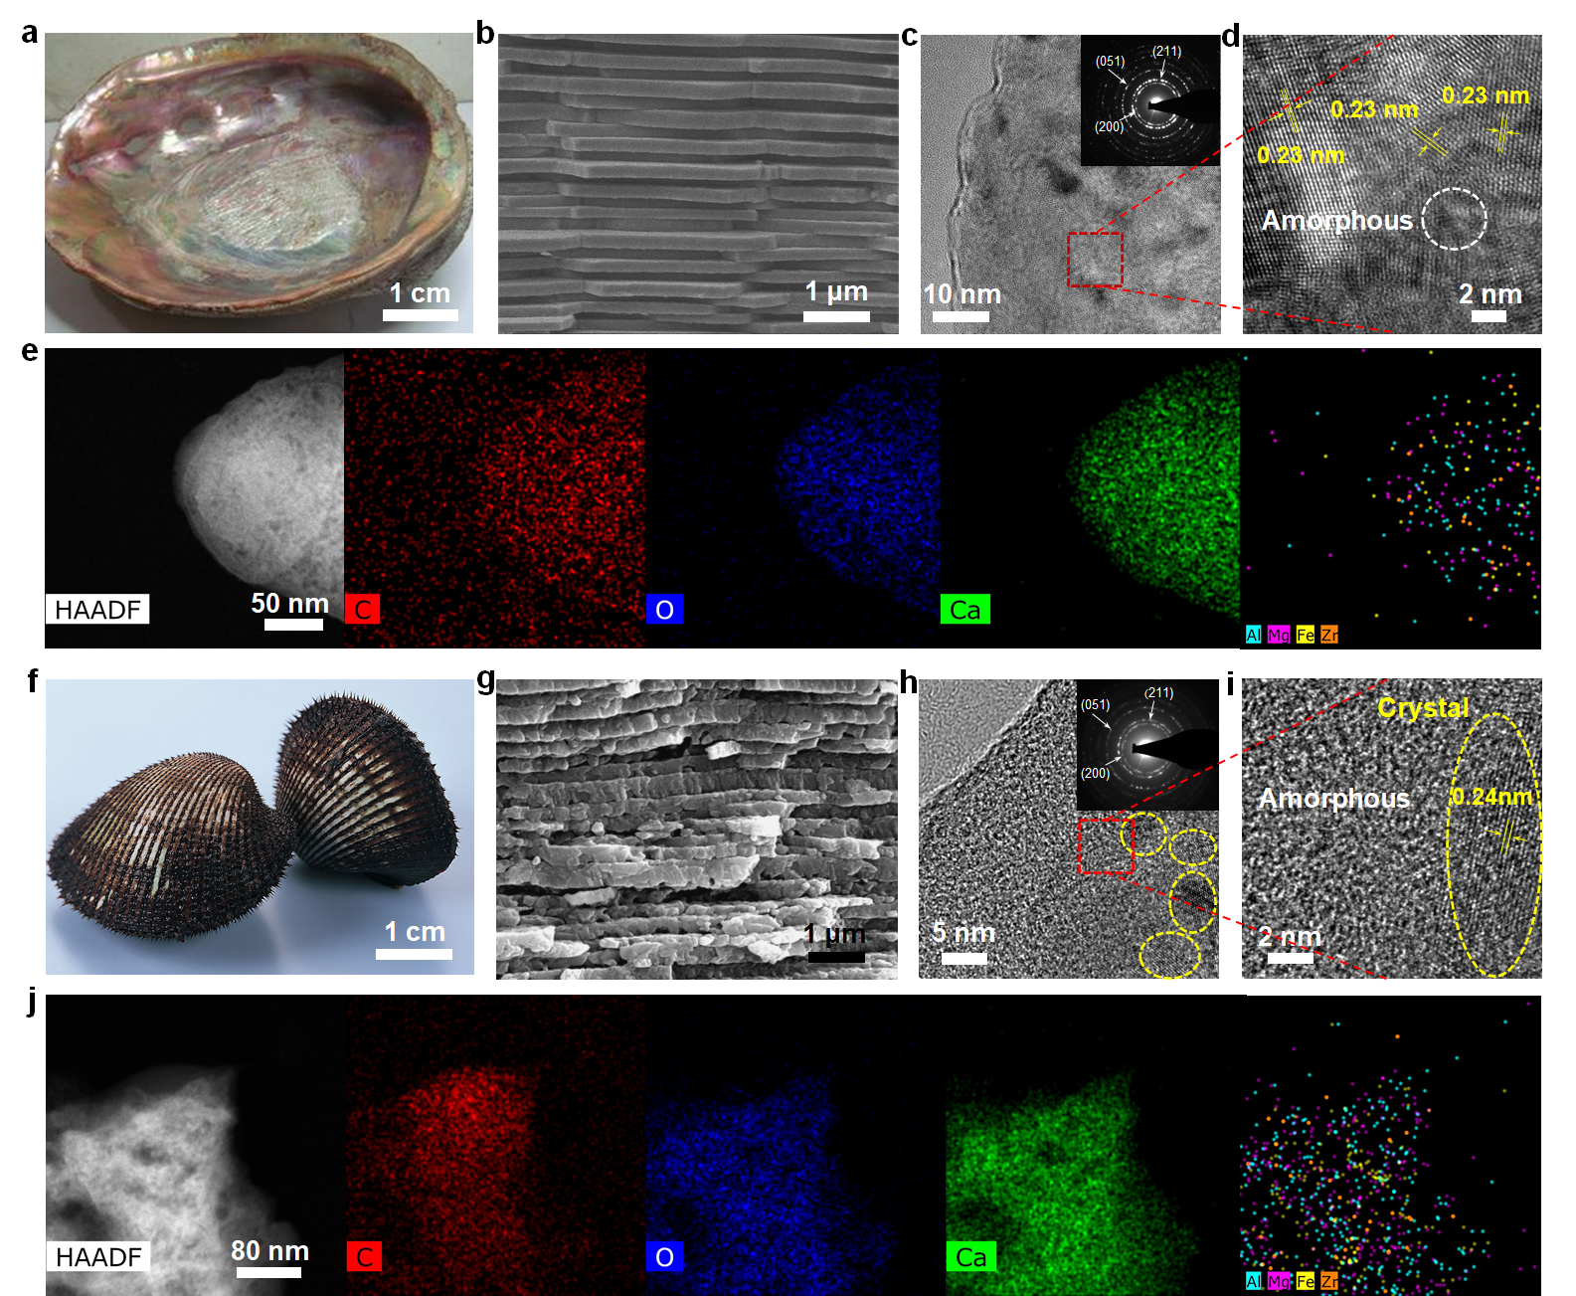
Supplementary Figure 1 | Multi-component, hierarchically amorphous/crystalline heterophase structural feature of natural nacre from abalone mollusk (Haliotis rufescens, a–e) and clamshell (Scapharca subcrenata, f–j). (a,f) Digital photos of Haliotis rufescens and Scapharca subcrenata. (b,g) Cross-sections of Haliotis rufescens and Scapharca subcrenata, respectively, indicating the ordered mineral platelets as ‘bricks’. (c,h) Transmission electron microscope (TEM) images of nacre nanograins. Inset, the selected area diffraction pattern exhibiting the polycrystalline characteristic pattern of the aragonite. Some nanocrystals are outlined with dashed lines and the interplanar distances of (051), (200), (211) planes of the aragonite are observed. (d,i) Higher-resolution TEM images of nacre nanograins, corresponding to the selected area (red rectangular area in (c)), showing the amorphous/crystalline heterophase structural regions. (e,j) High-angle annular dark field (HAADF) images and scanning transmission electron microscopy (STEM) elemental maps of nacre nanograins: various elemental constituents.

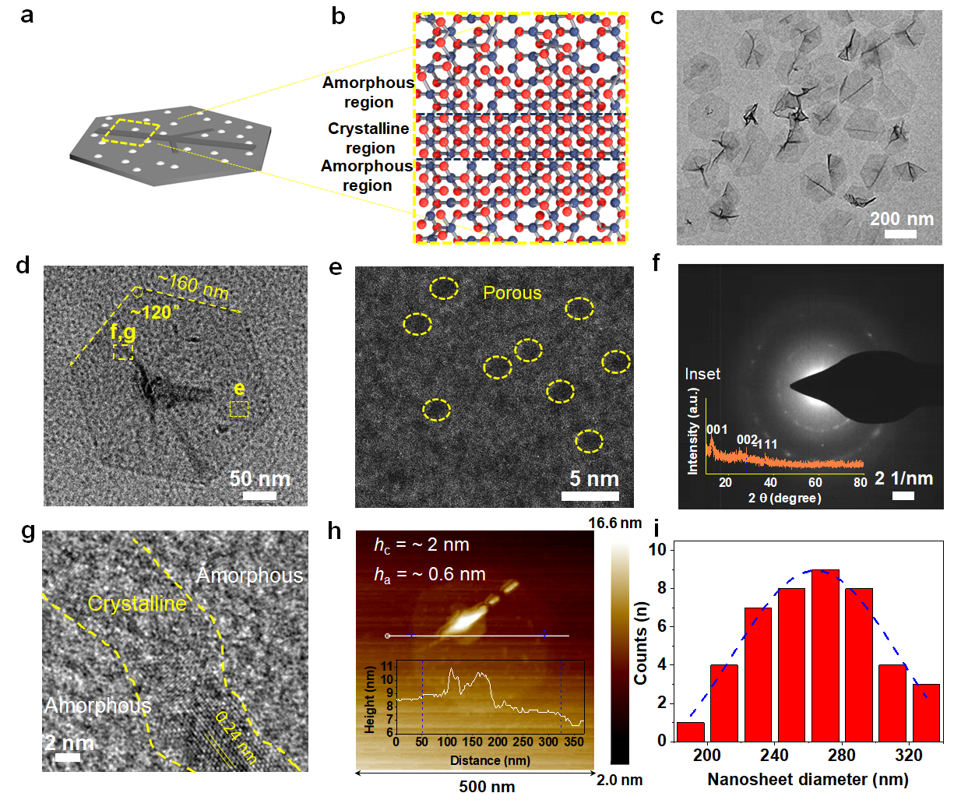
Supplementary Figure 2 | Characterization of amorphous/crystalline leaf-like MnO₂ hexagon (A/C-LMH) nanosheets. (a) Schematic of a single A/C-LMH nanosheet. (b) A molecular ball-and-stick model of A/C-LMH nanosheet (Dark blue: Mn; Red, O), vividly indicating amorphous region and crystalline region. (c) Low-magnified TEM image exhibiting regular 2D morphology of A/C-LMH nanosheets at a large scale. (d) Magnified TEM image of a single A/C-LMH nanosheet exhibiting a diameter of about 320 nm and vein-like skeleton structure embedded at the center. (e) The high-angle annular dark-field scanning transmission electron microscopy (HADDF-STEM) image of a small part of the single A/C-LMH nanosheet, selected as the corresponding area of (d, a yellow box on the right), showing the 1-2 nm dense microporous structure. (f,g) The selected area electron diffraction (SAED) pattern with the diffuse ring combined with polycrystalline rings (f) selected as the corresponding area of (d, a yellow box on the left), and high-resolution TEM image (g) exhibiting a large area of amorphous nature as mixed with a small area of crystalline phase (surrounded by the yellow imaginary line) of MnO₂ in the selected region (d, a yellow box on the left), like a leaf (Inset: characteristic XRD pattern of A/C-LMH nanosheets, confirming the coexistence of amorphous/crystalline phase again). The vein-like skeleton structure is crystalline as a support, where the identified spacing of 0.24 nm can be due to the (-111) facets of MnO₂, which is consistent with the XRD result, and the microporous mesophyll-like nanosheet is amorphous. (h) Atomic force microscope (AFM) image showing A/C-LMH nanosheet deposited on a mica sheet, inset: the section analysis of A/C-LMH nanosheet, showing the thicknesses of skeleton-like support and surrounding amorphous monolayer are ~2 nm and ~0.6 nm, respectively. (i) Statistical result of the diameters of A/C-LMH nanosheets in c, exhibiting a diameter of about 280 nm.

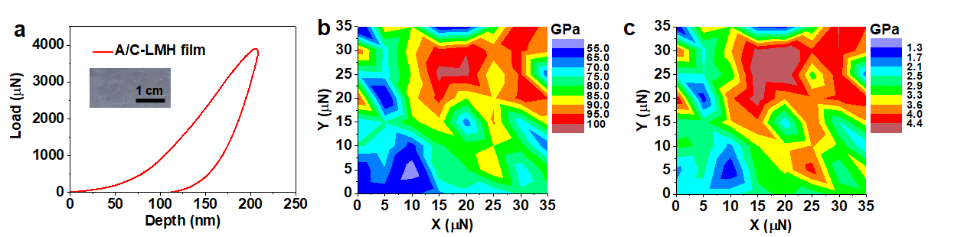
Supplementary Figure 3 | Micromechanical properties of the pure A/C-LMH film derived from assembling A/C-LMH nanosheets on a glass slide, performed by static nanoindentation tests in the atmospheric condition under the displacement control mode (200 nm) for obtaining the nanoindent Young’s modulus (E_{n}) and hardness (H). (a) Typical partial loading-unloading curve. Inset is a photograph of the A/C-LMH film on a glass slide, showing a light gray color. (b,c) The contour maps of E_{n} and H dispersion (35 μm × 35 μm), respectively. The values in E_{n} and H of the A/C-LMH film is 80.3 ± 13.2 GPa and 3.2 ± 0.9 GPa, respectively.

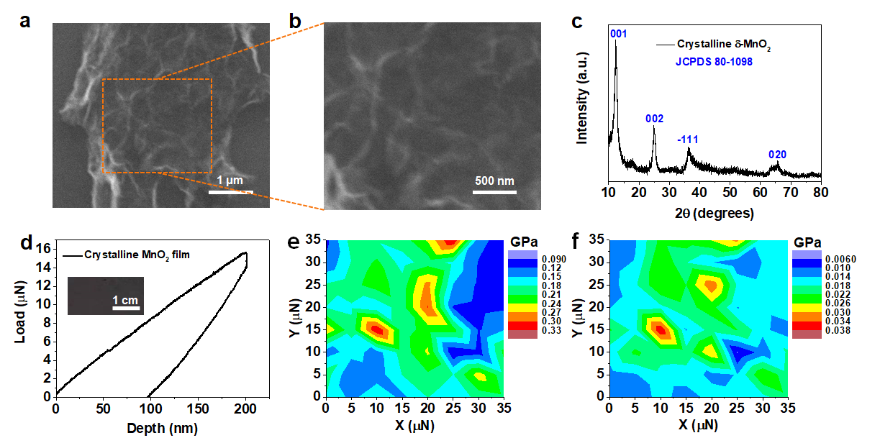
Supplementary Figure 4 | Structural characterization of the prepared crystalline MnO₂ nanosheets obtained from thermal treatment of A/C-LMH nanosheets at 400 °C, and micromechanical properties of the crystalline MnO₂ film derived from assembling fully crystalline MnO₂ nanosheets on a glass slide. (a,b) SEM morphology images of the crystalline MnO₂ nanosheets, showing characteristics of lamellar stacking and aggregation. (c) Characteristic XRD pattern of the MnO₂ nanosheets a, indicating a fully crystalline nature, consistent with characteristic diffraction peak positions of δ-MnO₂ (JCPDS 80-1098). (d) Partial loading-unloading curve. Inset is a photograph of the crystalline MnO₂ film on a glass slide, showing a dark gray color. (e,f) The contour maps of E_{n} and H dispersion (35 μm × 35 μm), respectively. The values in E_{n} and H of the crystalline MnO₂ film is 0.13 ± 0.3 GPa and 0.014 ± 0.007 GPa, respectively.

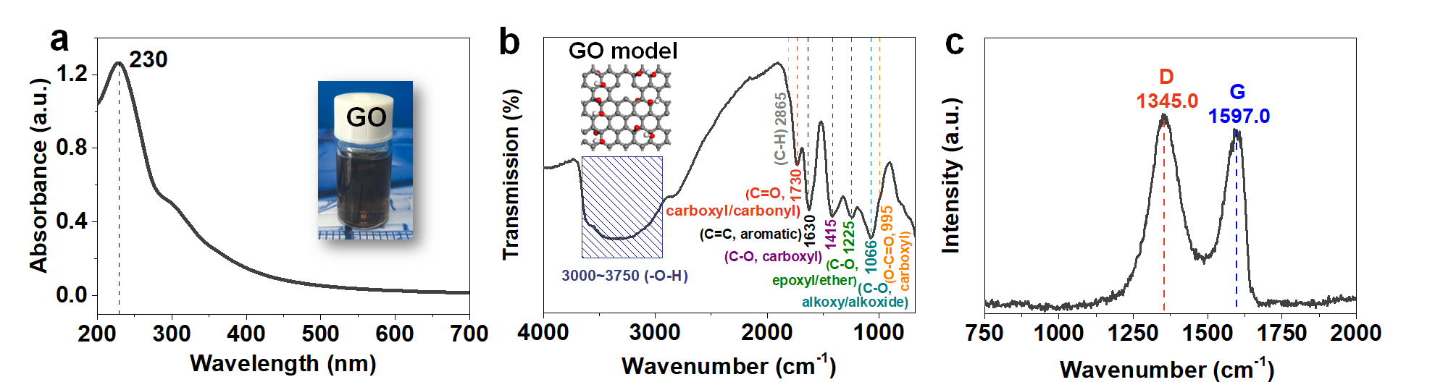
Supplementary Figure 5 | Characterization of GO nanosheets. (a) The UV-vis spectra of aqueous GO suspension (1 mg ml⁻¹) and its corresponding photograph (inset). (b) Fourier transformation infrared (FTIR) spectra. Inset: molecular ball-and-stick mould of GO nanosheet (White, H; gray, C; red, O). (c) Raman spectra obtained from dispersed GO sheets with a 633 nm wavelength incident laser, indicating the two characteristic peaks at 1597 and 1345 cm⁻¹.
The UV-vis spectrum exhibits that, in an aqueous solution, the characteristic absorption peak of GO nanosheets is located at about 230 nm, as shown in Supplementary Fig. 5a, nearly consistent with previous reported values^{4,11}. Using Fourier transformed infrared (FTIR) spectra, Supplementary Fig. 5b shows the characteristic bands of pure GO wavenumbers of 3000–3750, 2865, 1735, 1621/1608, 1420, 1222, 1050, and 975 cm⁻¹, corresponding to –O-H (hydroxyl), C-H (carbon hydrogen), C=O (carboxyl/carbonyl), C=C (aromatic for GO), C-O (carboyl), C-O (epoxy/ether), C-O (alkoxy/alkoxide), and O-C=O (carboxyl)¹²⁻¹⁴, respectively; Raman spectrum of GO shows the D band at about 1345 cm⁻¹ and the G band at 1596 cm⁻¹ (Supplementary Fig. 5c), with ratio of integrated peak intensity I_{D}/I_{G} = 1.5, consistent with the previous results¹⁵.

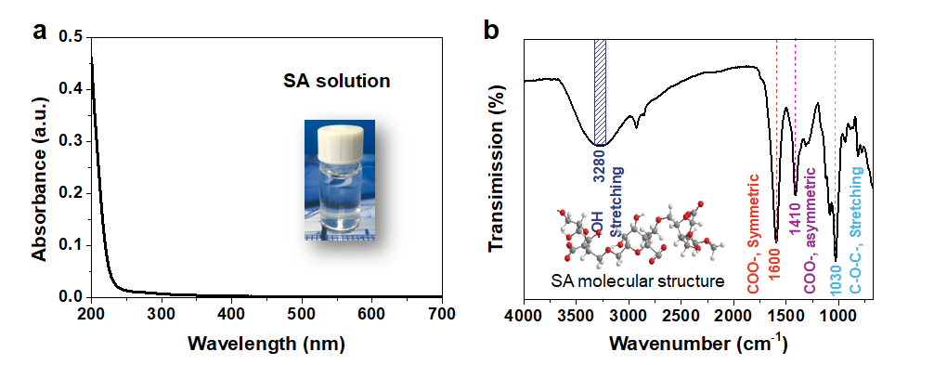
Supplementary Figure 6 | Characterization of SA biopolymer. (a) The UV-vis spectra of the aqueous SA solution, demonstrating that there is no absorption peak for SA molecules in the wavelength region from 200 to 700 nm, coincident with our previous report¹⁴. Inset: the photograph of the aqueous transparent SA solution. (b) FTIR spectrum showing the characteristic bands of neat SA centered at wavenumbers of about 3280, 1600/1410, and 1030 cm⁻¹, corresponding to -O-H (hydroxyl) stretching vibration, C-O (carbonyl) symmetric/asymmetric stretching vibration, and O-C=O (carboxyl) stretching vibration, respectively¹⁶. Inset: molecular ball-and-stick model of SA molecule (White, H; gray, C; red, O).

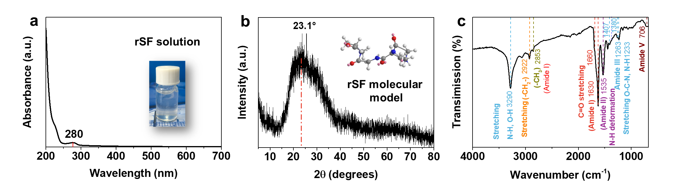
Supplementary Figure 7 | Characterization of regenerated SF (rSF) through the regular LiBr solvent reported previously¹⁷. (a) The UV-vis spectra of aqueous rSF suspension showing the maximum absorption peak at 280 nm, which is consistent with the previous report¹⁸, and its corresponding photograph (inset). (b) XRD pattern of rSF, indicating that our regenerated SF is low intensity at 2θ = 23° and no well-developed crystalline structure is present¹⁹. Inset: molecular ball-and-stick model of rSF molecule (White, H; gray, C; red, O; blue: N). (c) FTIR spectra.
As shown in Supplementary Fig. 7c, four types of vibrational peaks are associated with the amide groups in the protein of rSF. Amide I (1628 cm⁻¹) and amide II (1535 cm⁻¹) bands are attributed to the C=O stretching and N-H deformation, respectively. The frequencies at which these vibrations occur are affected by the conformation of the molecule²⁰. It was reported that the two types of peaks associated with the amide I vibrations were obtained from regenerated silk films. A peak at 1660 cm⁻¹ is due to the random coil nature of the molecule, and a band at 1630 cm⁻¹ is assigned to β-sheet conformation²¹. The amide III band (1230–1260 cm⁻¹) can be attributed to the stretching vibrations of O-C-N and N-H bonds. The peak (1230 cm⁻¹) at the lower frequency is assigned to the amorphous character in this case. The peak at 1260 cm⁻¹ can be attributed to crystallinity in silk.
As for our rSF, the absorbance peak at 1234 cm⁻¹ can be attributed to the amide III vibration. This peak is as broad as the combination of 1230 and 1260 cm⁻¹, but an obvious vibration for the crystalline regions is not present. Therefore, the shift of the amorphous peak toward the crystalline peak exhibits that some β structure may be present. Bellamy reported that the methyl symmetrical deformation peak occurred at 1380 cm⁻¹ while the methylene vibration occurred at 1408–1412 cm⁻¹ when it was adjacent to a carbonyl unit²². The methyl deformation can be attributed to alanine and the methylene can be due to the glycine units. The conformation of fibroin apparently affects these two vibrations. Bellamy suggested a peak at 1385 cm⁻¹ occurred due to the ‘angular’ methyls²². In our rSF, there is only a weak peak at 1406 cm⁻¹, suggesting the absence of orientation and crystallization. However, the absorbance bands (Amide III) at 1233 and 1263 cm⁻¹ further exhibit that our rSF has crystalline and amorphous regions, consistent with our XRD result (Supplementary Fig. 7b). The band (Amide V) at 699 cm⁻¹ can be assigned to crystallinity as reported by Bhatt and Ahirrao²¹. The band occurs at 706 cm⁻¹ in rSF, which is closer to the crystalline absorbance of 699 cm⁻¹. Our analysis shows that our rSF fibers have an amorphous and crystalline nature.

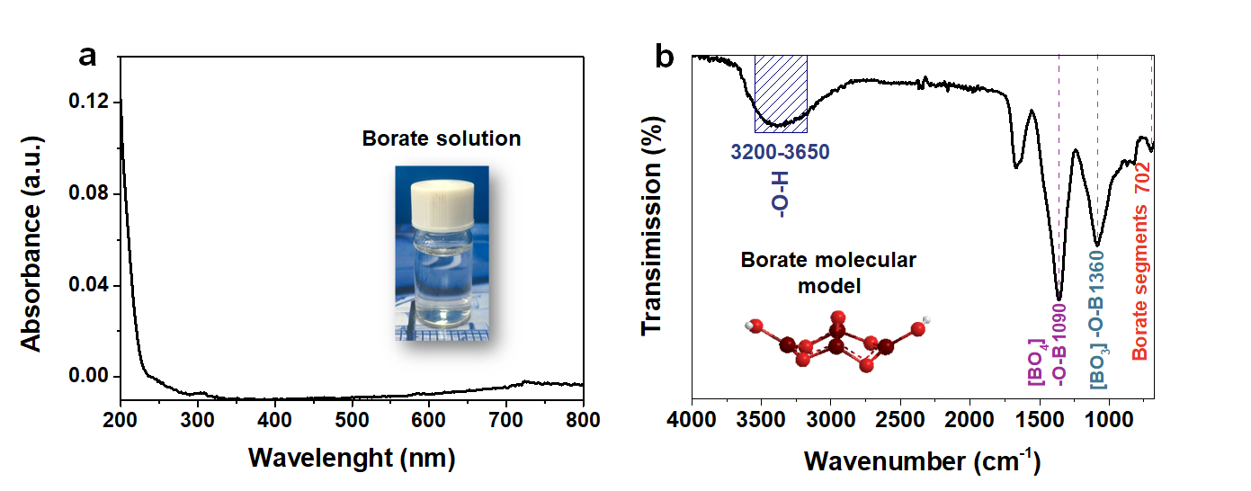
Supplementary Figure 8 | Characterization of borate. (a) The UV-vis spectra of aqueous borate solution, showing the maximum absorption peak at about 304 nm, and its corresponding photograph (inset). (b) FTIR spectra. While the strong absorption band located at ~1360 cm⁻¹ is due to the asymmetric stretching vibration of the [BO₃] triangle, the wide strong peak in the center of ~1090 cm⁻¹ is the stretching vibration of B-O bonds in a [BO₄] tetrahedron. The small peak at ~702 cm⁻¹ can be due to the result of the symmetrical bending vibration of the B-O-B in the [BO₃]²³. Inset: molecular ball-and-stick model of borate ion (White, H; red, O; Wine: B)

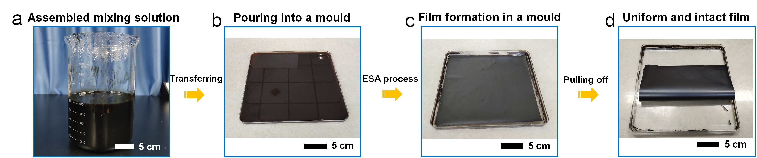
Supplementary Figure 9 | Preparation process of a large-area layered nanocomposite film by a simple evaporation-assisted self-assembly technique. (a) An assembled mixing solution (e.g., unary (GO, SA), binary (GO/MnO₂, GO/rSF, and GO/SA), ternary (GO/MnO₂/rSF, GO/MnO₂/SA, and GO/rSF/SA), quaternary (GO/MnO₂/rSF/B, GO/MnO₂/SA/B, and GO/MnO₂/rSF/SA), and quinary (GO/MnO₂/rSF/SA/B)). (b) The assembled mixing solution in a large evaporating dish (25 cm × 25 cm). (c) The film formation in a large evaporating dish. (d) The large-area, uniform and intact 2D film for assembling graphene oxide/manganese dioxide-based layered (GML) bulk form.

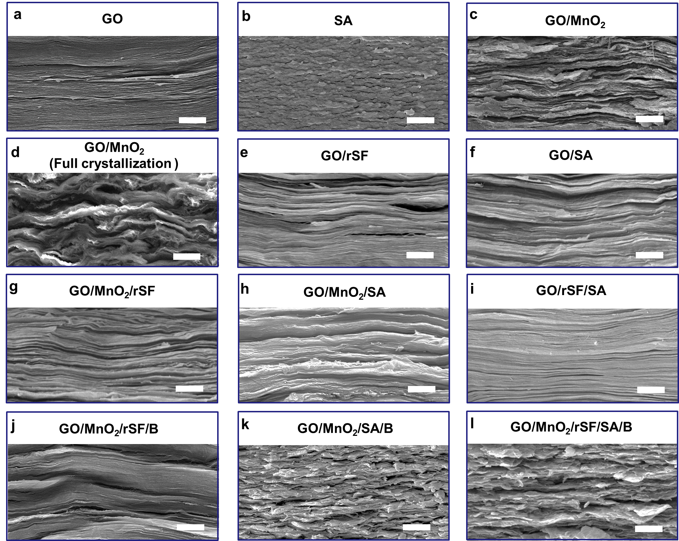
Supplementary Figure 10 | SEM images of cross-section morphologies of the as-fabricated layered 2D nanocomposite films. (a) GO. (b) SA. (c) GO/MnO₂ (75.0-25.0). (c) GO/MnO₂ (75.0-25.0, full crystallization). (e) GO/rSF (99.6-0.4). (f) GO/SA (99.1-0.9). (g) GO/MnO₂/rSF (74.4-24.7-0.9). (h) GO/MnO₂/SA (74.0-24.6-1.4). (i) GO/rSF/SA (99.0-0.4-0.6). (j) GO/MnO₂/rSF/B (74.2-24.7-0.9-0.2). (k) GO/MnO₂/rSF/SA (74.2-24.8-0.5-0.5). (l) GO/MnO₂/rSF/SA/B (74.1-24.8-0.3-0.5-0.3). These characterization results show the interlaced lamellar arrangement in these nanocomposite films. Scale bars, 2.5 μm.

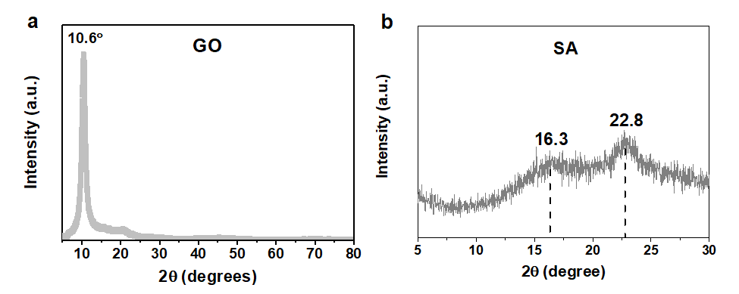
Supplementary Figure 11 | The X-ray diffraction (XRD) pattern of pure films. (a) The XRD pattern of pure GO film, corresponding to the diffraction peak position of 2θ = 10.6° (the d-spacing value of 8.3 Å). (b) The XRD pattern of pure SA film, showing characteristic diffraction peaks at 2θ = 16.3° and 22.8°, consistent with the XRD result of pure chitosan²⁴.

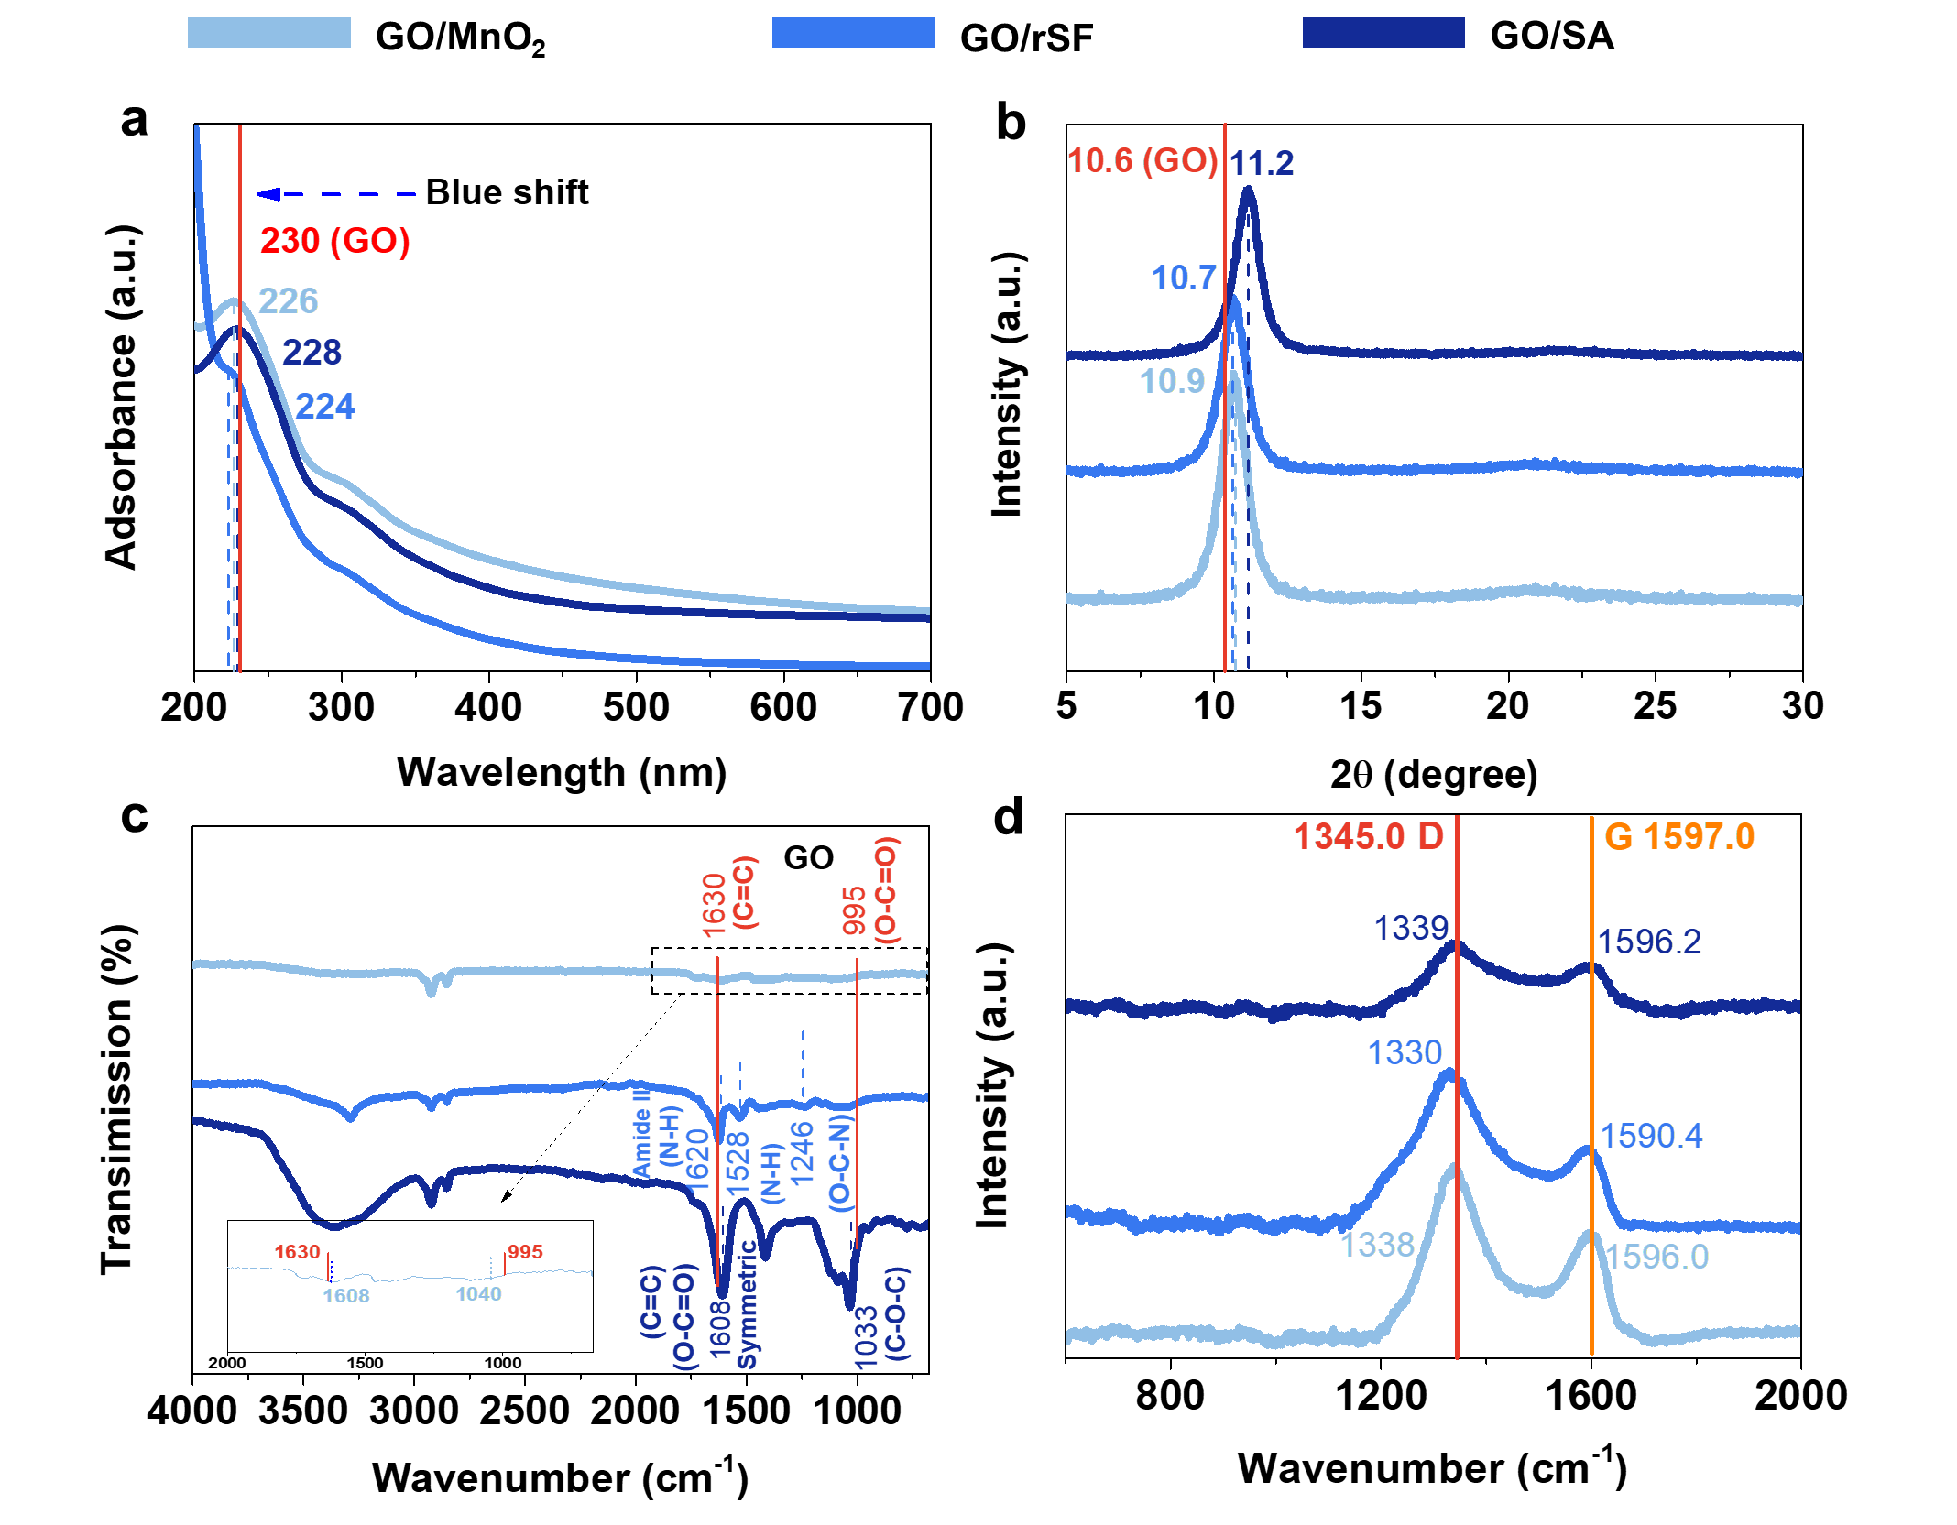
Supplementary Figure 12 | Characterization of binary nanocomposite films, including GO/MnO₂ (75.0-25.0), GO/rSF (99.6-0.4), and GO/SA (99.1-0.9). (a) The UV-vis spectra. The position of the absorbance peak at 230 nm in pure GO is represented by a vertical, solid line. (b) XRD patterns. The position of the diffraction peak at 2θ = 10.6° in pure GO film is represented by a vertical, solid line. (c) FTIR spectra. Some characteristic peak positions in pure GO film are expressed by vertical, solid lines. (d) Raman spectra. The positions of the typical G (1597 cm⁻¹) and D (1345 cm⁻¹) bands in pure GO, consistent with the previously reported result²⁵, are indicated by the vertical, solid lines.

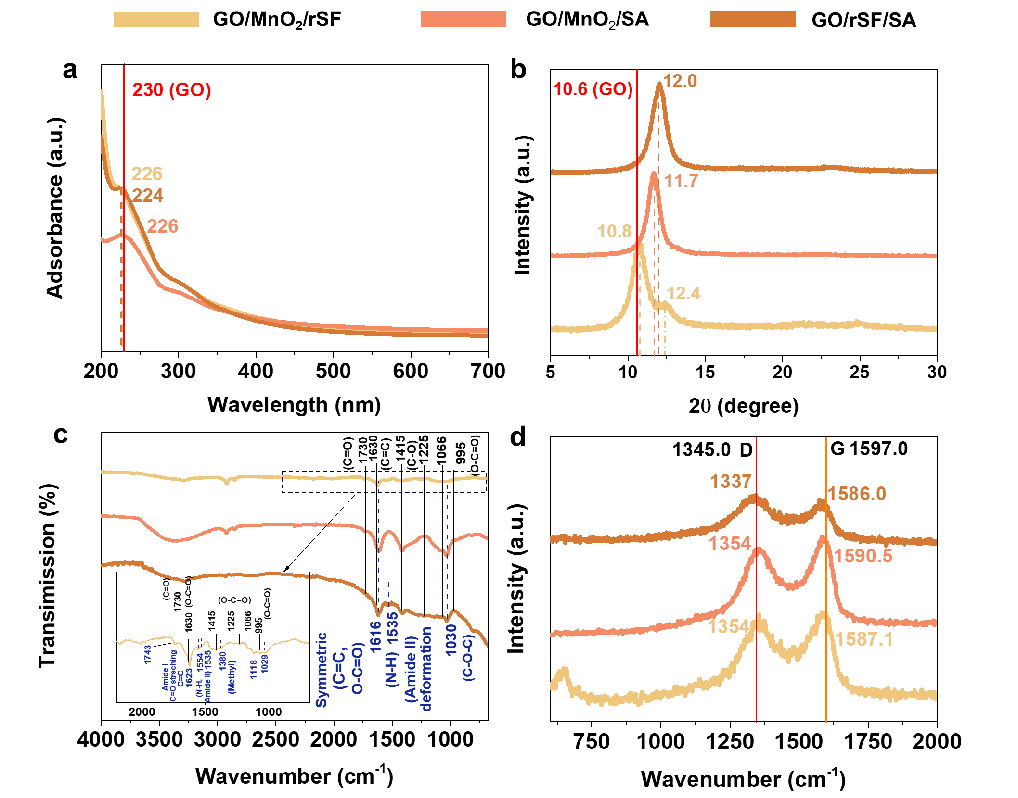
Supplementary Figure 13 | Characterization of ternary nanocomposite films, including GO/MnO₂/rSF (74.4-24.7-0.9), GO/MnO₂/SA (74.0-24.6-1.4), and GO/rSF/SA (99.0-0.4-0.6). (a) The UV-vis spectra. The position of the absorbance peak at 230 nm in pure GO is represented by a vertical, solid line. (b) XRD patterns. The position of the diffraction peak at 2θ = 10.6° in pure GO film is represented by a vertical, solid line. (c) FTIR spectra. Some characteristic peak positions in pure GO film are expressed by vertical, solid lines. (d) Raman spectra. The positions of the typical G (1597 cm⁻¹) and D (1345 cm⁻¹) bands in pure GO are indicated by the vertical, solid lines.

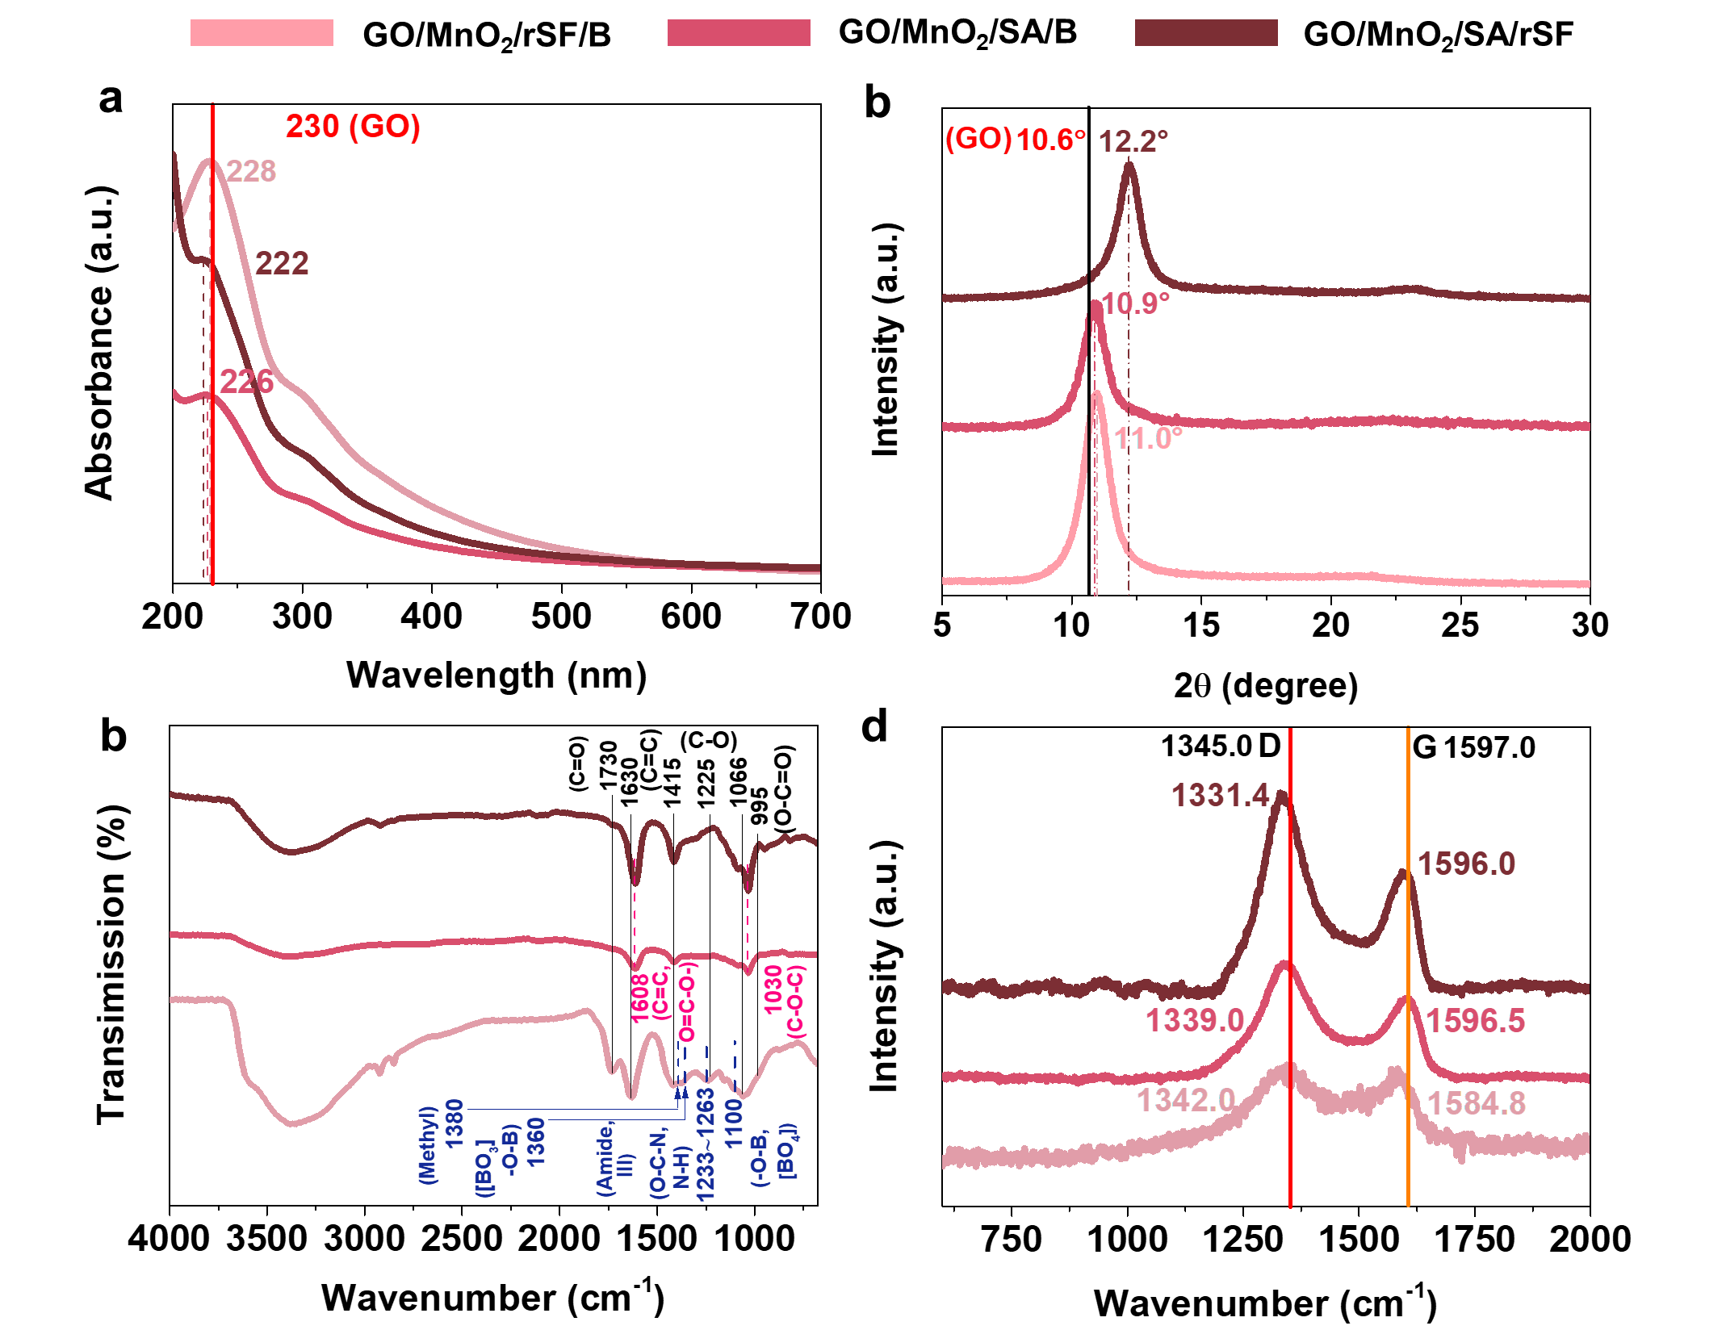
Supplementary Figure 14 | Characterization of quaternary nanocomposite films, including GO/MnO₂/rSF/B (74.2-24.7-0.9-0.2), GO/MnO₂/SA/B (74.2-24.8-0.5-0.5), and GO/MnO₂/SA/rSF (74.2-24.8-0.5-0.3). (a) The UV-vis spectra. The position of the absorbance peak at 230 nm in pure GO is represented by a vertical, solid line. (b) XRD patterns. The position of the diffraction peak at 2θ = 10.6° in pure GO film is represented by a vertical, solid line. (c) FTIR spectra. These characteristic peak positions in pure GO film are expressed by vertical, solid lines. (d) Raman spectra. The positions of the typical G (1597 cm⁻¹) and D (1345 cm⁻¹) bands in pure GO are indicated by the vertical, solid lines.

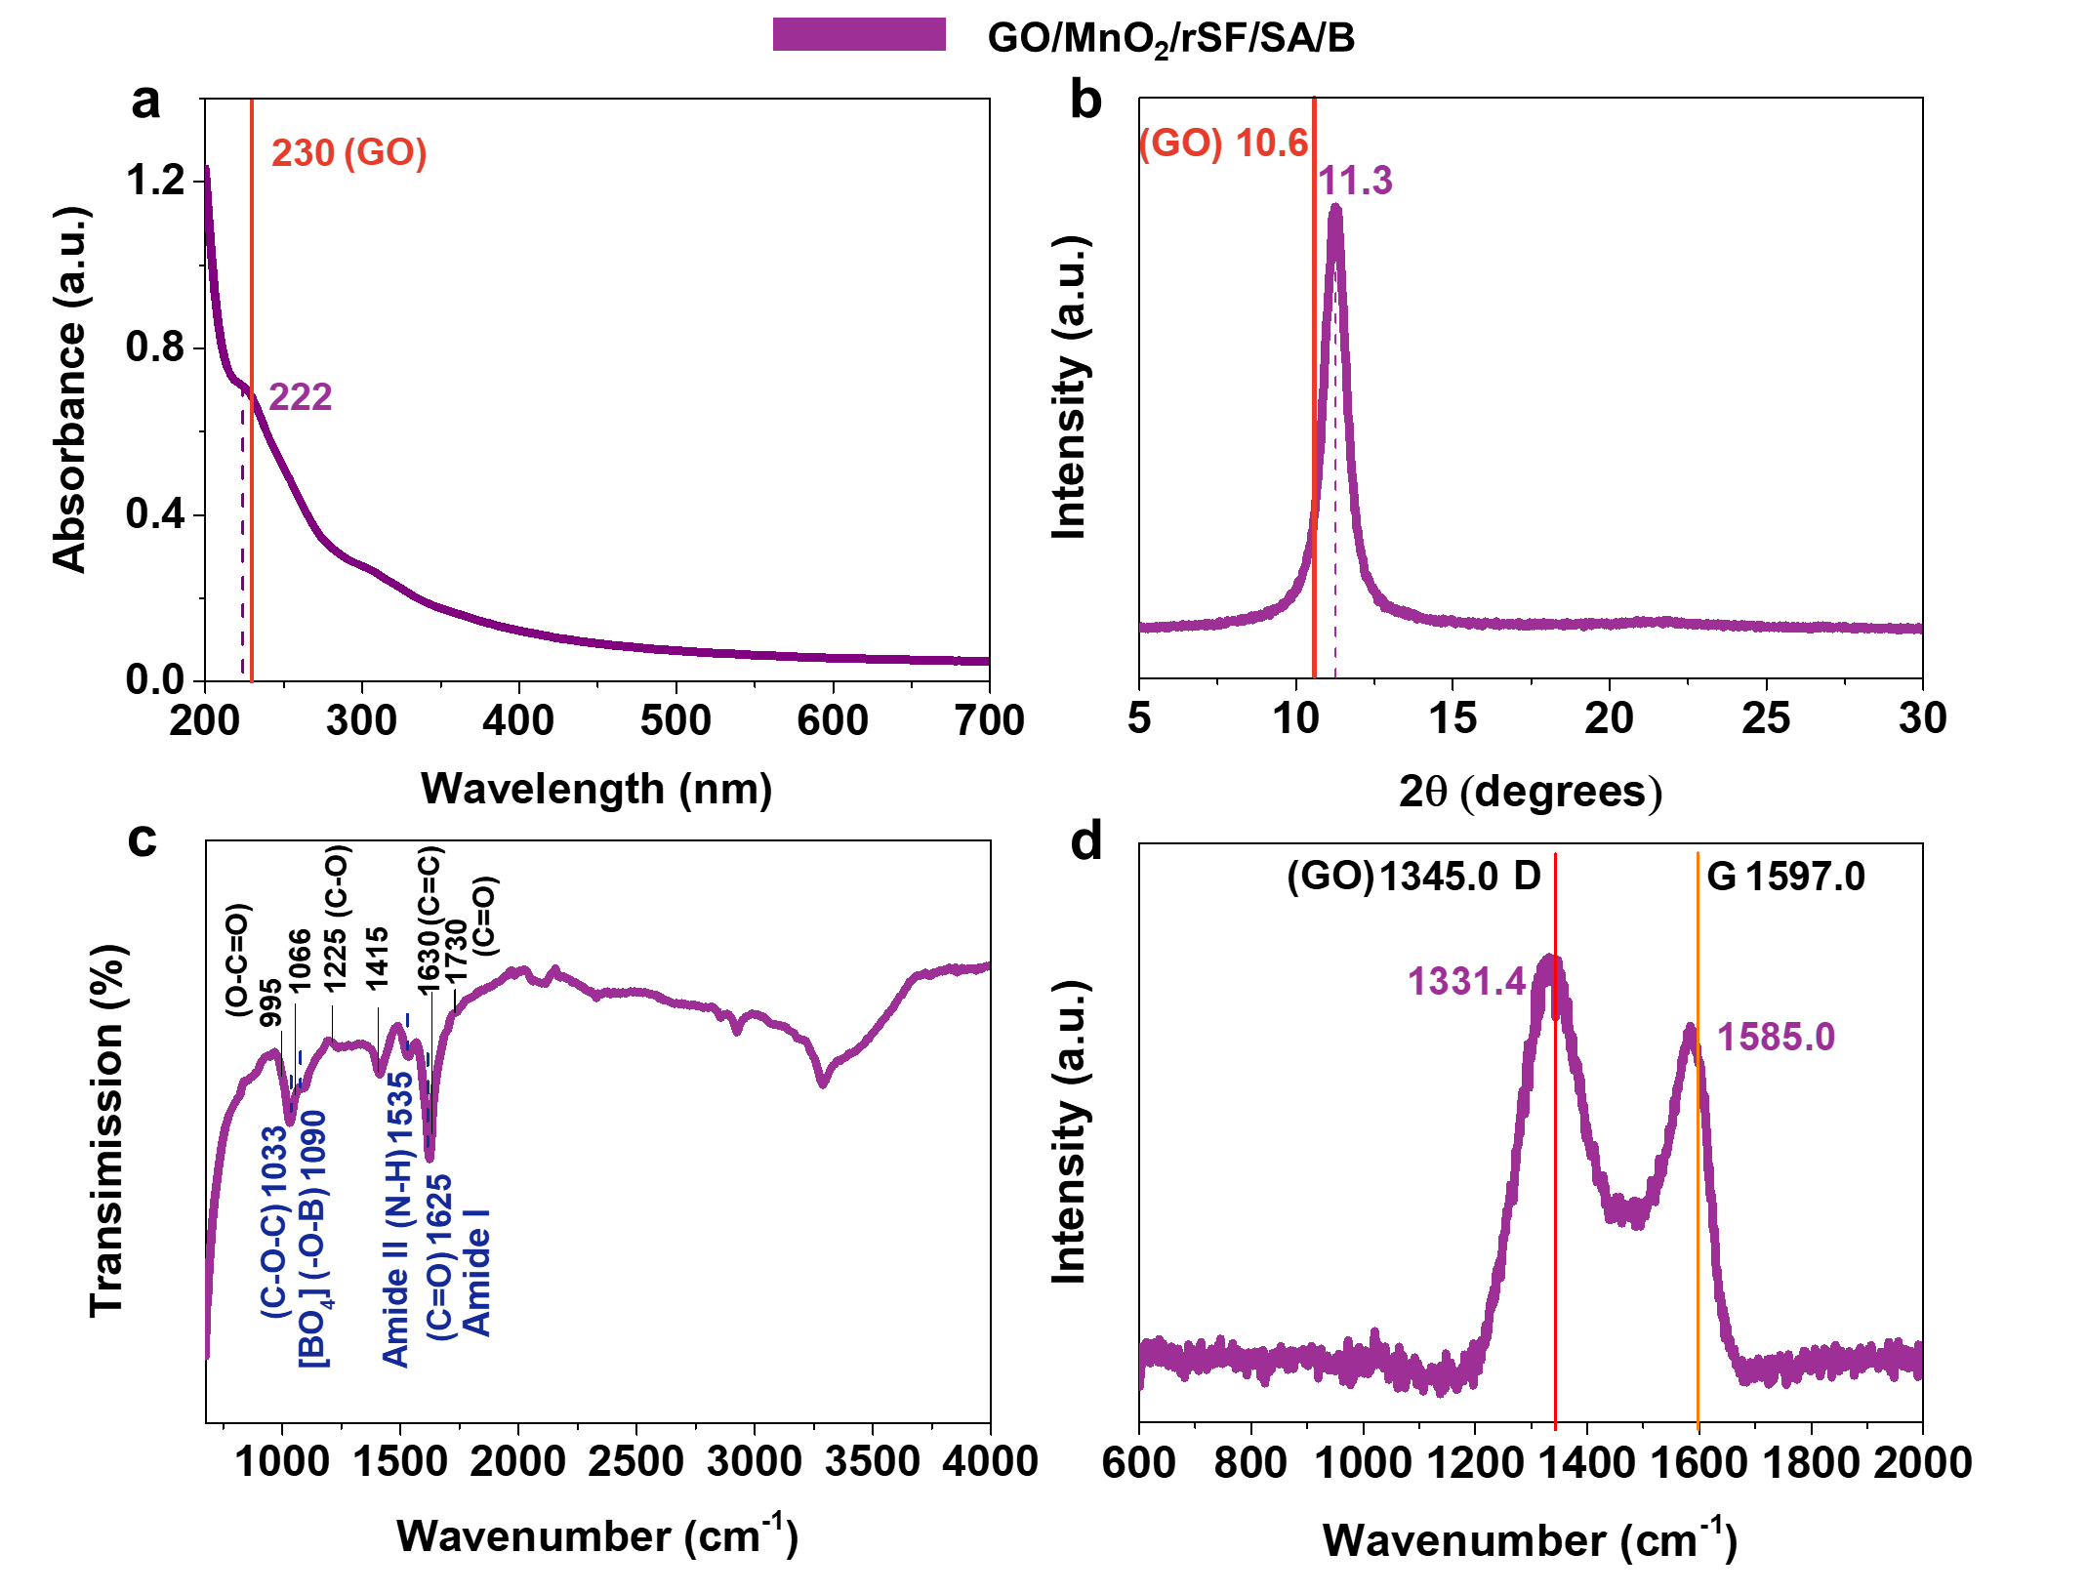
Supplementary Figure 15 | Characterization of quinary nanocomposite film such as GO/MnO₂/rSF/SA/B (74.1-24.8-0.3-0.5-0.3). (a) The UV-vis spectra. The position of the absorbance peak at 230 nm in pure GO is represented by a vertical, solid line. (b) XRD patterns. The position of the diffraction peak at 2θ = 10.6° in pure GO film is represented by a vertical, solid line. (c) FTIR spectra. These characteristic peak positions in pure GO film are expressed by vertical, solid lines. (d) Raman spectra. The positions of the typical G (1597 cm⁻¹) and D (1345 cm⁻¹) bands in pure GO are indicated by the vertical, solid lines.
As for UV-vis spectra (Supplementary Figs. 12a–15a), as a whole, these additives, including SA, rSF, MnO₂, and borate, into the GO system can give rise to a blue shift of the characteristic absorption band of GO. In the binary system, after incorporating some small amounts of the second phase material (e.g., A/C-LMH, rSF, and SA) into the GO system, forming hybrid structural units (such as GO/MnO₂, GO/rSF, and GO/SA), we consider that the typical absorption peak positions slightly shift from 230 nm in GO to 226, 224, and 228 nm in GO/MnO₂, GO/rSF, and GO/SA, respectively, as shown in Supplementary Fig. 12a, which may be primarily attributed to the reduction in the binary GO-based conjugated system of electrons by non-covalently crosslinking interactions (e.g., hydrogen bonding, physical entanglement), causing the blue shift of the characteristic absorption band. Furthermore, in the ternary system (Supplementary Figs. 13a), the characteristic absorption peaks for GO/MnO₂/rSF, GO/MnO₂/SA, and GO/rSF/SA are located at about 226, 226, and 224 nm, respectively. In the quaternary system (Supplementary Figs. 14a), these absorption peaks for GO/MnO₂/rSF/B, GO/MnO₂/SA/B, and GO/MnO₂/rSF/SA are at about 228, 226, and 222 nm, respectively. In the quinary system (Supplementary Figs. 15a), the absorption peak of GO/MnO₂/rSF/SA/B is at 224 nm. The synergistically (non-covalent and/or covalent) crosslinking interactions (e.g., hydrogen bonds, physical entanglement, and O-B bonds) between these chemicals and GO nanosheets may result in the change of the conjugated electron structure of GO nanosheets. Therefore, we presume that the difference in the value of shifted peak position may reflect the different bonding capabilities between different molecules and GO nanosheets^{11,26}.
XRD patterns (Supplementary Figs. 12b–15b) show that, in the binary system (Supplementary Fig. 12b), the gallery spacing (d-spacing) values of these binary films reduce from approximately 8.3 Å (2θ = 9.8°) for pure GO to about 8.1 Å (2θ = 10.9°) for GO/MnO₂, 8.2 Å (2θ = 10.7°) for GO/rSF, and 7.9 Å (2θ = 11.2°) for GO/SA. In the ternary system (Supplementary Fig. 13b), the d-spacing values of these ternary films are approximately 8.2 Å (2θ = 11.2°) for GO/MnO₂/rSF, 7.6 Å (2θ = 11.7°) for GO/MnO₂/SA, and 7.3 Å (2θ = 11.2°) for GO/SF/SA. In the quaternary system (Supplementary Fig. 14b), the d-spacing values of these quaternary films are about 8.0 Å (2θ = 11.0°) for GO/MnO₂/rSF/B, 8.1 Å (2θ = 10.9°) for GO/MnO₂/SA/B, and 7.2 Å (2θ = 12.2°) for GO/MnO₂/SA/rSF. In the quinary system (Supplementary Fig. 15b), the d-spacing value of GO/MnO₂/rSF/SA/B is 7.8 Å (2θ = 11.3°). Therefore, we consider that the d-spacing value reduction of these layered nanocomposite materials is also strong evidence for the synergetic intercalation of these additives (e.g., rSF, SA, A/C-LMH, and borate) into the d-spacing between GO nanosheets. For an initial d-spacing of 8.3 Å, the change ranges from 0.1 to 1.1 Å, which is much smaller than the van der Waal diameter of water, 2.82 Å²⁷.
FTIR curves further display that, in the binary system (Supplementary Fig. 12c), the peak centered at 1630 cm⁻¹ (corresponding to C=C stretching vibration) shifts to the lower wavenumbers (1608 cm⁻¹ for GO/MnO₂, 1620 cm⁻¹ for GO/rSF, and 1608 cm⁻¹ for GO/SA), and the intensity of the peak at 995 cm⁻¹ (corresponding to O-C=O stretching vibration) becomes very weak or even disappears. These facts indicate that active sites (such as oxygen and nitrogen-contained functional groups) of the filler (e.g., A/C-LMH, rSF, and SA) can react with oxygen-contained functional groups of GO nanosheets by non-covalent interactions, such as hydrogen bonding and physical entanglement. As for GO/rSF, two characteristic peaks at 1528 and 1246 cm⁻¹ exhibiting the N-H deformation (Amide II) and the stretching vibrations of O-C-N and N-H bonds, respectively, can be further proved by FTIR spectra.
In the ternary system (Supplementary Fig. 13c), the characteristic peak at approximately 1630 cm⁻¹ shifts to a relatively lower wavenumber of 1623 (corresponding to C=C and/or C=O stretching vibration, Amide I; GO/MnO₂/rSF), 1616 (corresponding to C=C stretching vibration, GO/MnO₂/SA), and 1616 cm⁻¹ (corresponding to C=C and/or C=O stretching vibration, Amide I; GO/rSF/SA), in comparison with the characteristic peaks of pure GO. In addition, the intensities of the three peaks centered at 995, 1066, and 1225 cm⁻¹, corresponding to O-C=O (carboxyl), C-O (alkoxyl/alkoxide), and C-O (epoxyl/ether) stretching vibrations, respectively, remarkably reduce or even disappear. As a whole, these phenomena demonstrate the synergetic crosslinking interactions between additives (two components) and GO nanosheets by the hydrogen bonding networks. As for GO/MnO₂/rSF, the methyl symmetrical deformation peak centered at 1380 cm⁻¹ can be attributed to alanine and the methylene vibration that occurred at 1408–1412 cm⁻¹ can be due to the glycine units²⁸. Simultaneously, the two characteristic peaks at approximately 1535 cm⁻¹ (corresponding to N-H deformation, Amide II) and 1730 cm⁻¹ (C=O, carboxyl/carbonyl) shift to the relatively higher wavenumber at 1554 and 1743 cm⁻¹, respectively, suggesting that active functional groups of rSF bonded with oxygen-containing functional groups of GO nanosheets by H-bonding interactions²⁰. For GO/MnO₂/SA and GO/SF/SA, the peak centered at 1033 cm⁻¹ can be due to the C-O-C stretching vibration of the SA molecule.
In the quaternary system (Supplementary Fig. 14c), for GO/MnO₂/rSF/B, these characteristic peaks at ~1380 (methyl symmetrical deformation) and around ~1233–1263 cm⁻¹ (O-C-N and N-H deformation, Amide III) further prove the existence of rSF in the nanocomposite. Similarly, these peaks located at about 1360 (asymmetric stretching vibration of [BO₃] triangle) and 1100 cm⁻¹ (the stretching vibration of B-O bond in [BO₄] tetrahedron) originate from the absorbance of borate in the layered nanocomposite²³. However, these several absorption peaks at 1730, 1630, 1415, and 995–1100 cm⁻¹ are similar to those of pure GO, possibly suggesting the relatively weak crosslinking interactions of the complex interfaces within these quaternary nanocomposite films. With regard to GO/MnO₂/SA/B and GO/MnO₂/SA/rSF, firstly, the peak centered at 1030 cm⁻¹ is assigned to the C-O-C stretching vibration derived from the SA molecule¹⁴. Next, the two peaks at approximately 1730 and 995 cm⁻¹ clearly reduce and even disappear, and the peaks located at 1630 cm⁻¹ (corresponding to C=C stretching vibration) shift to the lower wavenumber of 1608 cm⁻¹, in comparison with the peaks of GO. The results indicate that these active sites of these additives (e.g., rSF, SA, and borate) can react strongly with oxygen-contained functional groups of GO by hydrogen and/or covalent bonding interactions.
In the quinary system (Supplementary Fig. 15c), firstly, the existence of rSF can be proved by the characteristic peak at 1535 cm⁻¹ (corresponding to N-H deformation, Amide I)²⁰, the emergence of SA can be demonstrated by the typical peak at ~1030 cm⁻¹ (corresponding to the C-O-C stretching vibration of SA molecule)¹⁶, and the presence of borate can be confirmed by the typical peak at 1090 cm⁻¹ belonged to the stretching vibration of B-O bond in [BO₄] tetrahedron²³. Next, the two absorbance peaks centered at ~1730 and 995 cm⁻¹ obviously reduce or even disappear, indirectly indicating the cross-linking interactions between active sites of these additives and oxygen-contained functional groups of GO.
In addition, Raman spectroscopy can provide a powerful tool to detect the interactions between these additives and GO by estimating the change in the ratio of the Raman G to D bands of GO on these layered materials²⁹, as shown in Supplementary Figs. 12d–15d. As for the binary system, Supplementary Fig. 12d shows the ratio of Raman D to G bands (I_{D}/I_{G} = 1.6 (GO/MnO₂), 1.9 (GO/rSF), 1.5 (GO/SA)) grows in intensity as compared with pure GO material (I_{D}/I_{G} = 1.1). As in the case of the Raman spectra of our ternary nanocomposite films (Supplementary Fig. 13d), the I_{D}/I_{G} values of these ternary nanocomposite films are slightly lower than that of GO. With respect to the quaternary and quinary nanocomposite films (Supplementary Figs. 14d and 15d), specifically, the I_{D}/I_{G} values (I_{D}/I_{G} = 1.2 (GO/MnO₂/rSF/B), 1.4 (GO/MnO₂/SA/B), 1.2 (GO/MnO₂/SA/rSF), and 1.2 (GO/MnO₂/rSF/SA/B)) slightly enhance as compared with that of the pure GO film (I_{D}/I_{G} = 1.1). These results, together with the blue shift of the absorbance peak position in UV-vis spectra (Supplementary Figs. 12a–15a), the clear decrease of the interlayer spacing (Supplementary Figs. 12b–15b), and the characteristic peak shifts of FTIR (Supplementary Figs. 12c–15c), demonstrate the efficient crosslinking interactions between active sites of these additives (MnO₂ or rSF or SA) and oxygen-containing groups of GO nanosheets, giving rise to the change in sp²-associated π-electron structure of GO and higher disorder or much more defect sites in the these nanocomposite films compared with those of pure GO^{28,29}.
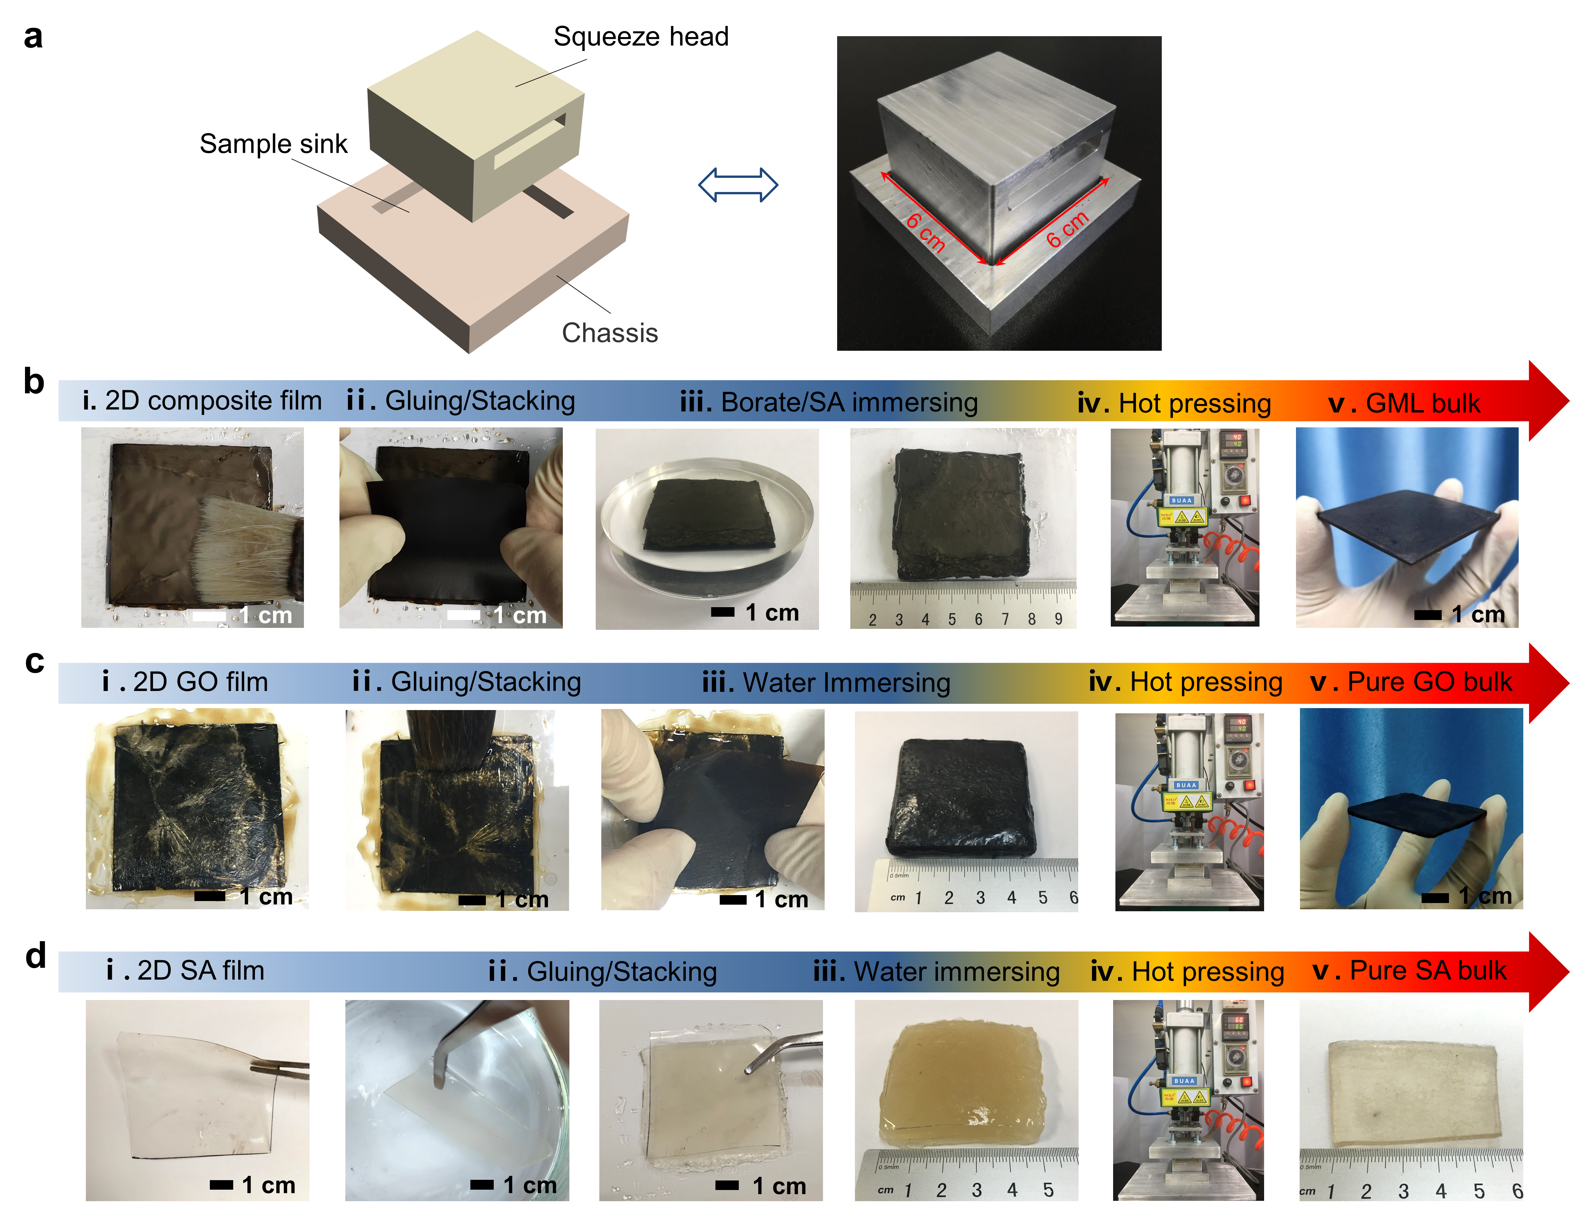
Supplementary Figure 16 | The home-made aluminium alloy mold and the continuous fabrication processes of these resultant 3D bulk materials. (a) Schematic and digital photo of a home-made aluminium alloy mold for assembling 2D films to 3D bulk material. (b-d) The continuous fabrication processes of the GML bulk (b), pure GO bulk (c), and pure SA bulk materials (d), with steps involving gluing/stacking films, immersing stacked bulk in aqueous Borate/SA solution or water, and hot pressing.

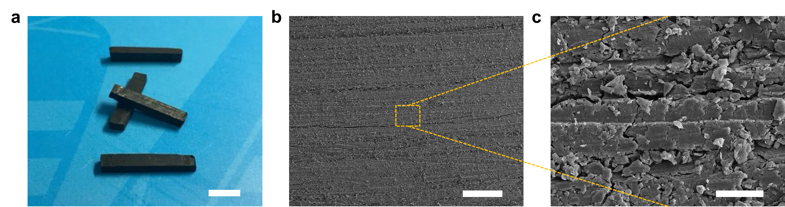
Supplementary Figure 17 | Characterization of the GML bulk specimen. (a) The digital photo of the cutting test specimens. Scale bar, 0.5 cm. (b) Cross-section morphology of the GBLB. Scale bar, 200 μm. (c) Corresponding magnified cross-section of the GML bulk in b. Scale bar, 20 μm. These images indicate the densely layered structure with some defects, like flaws and some voids within the GML bulk.

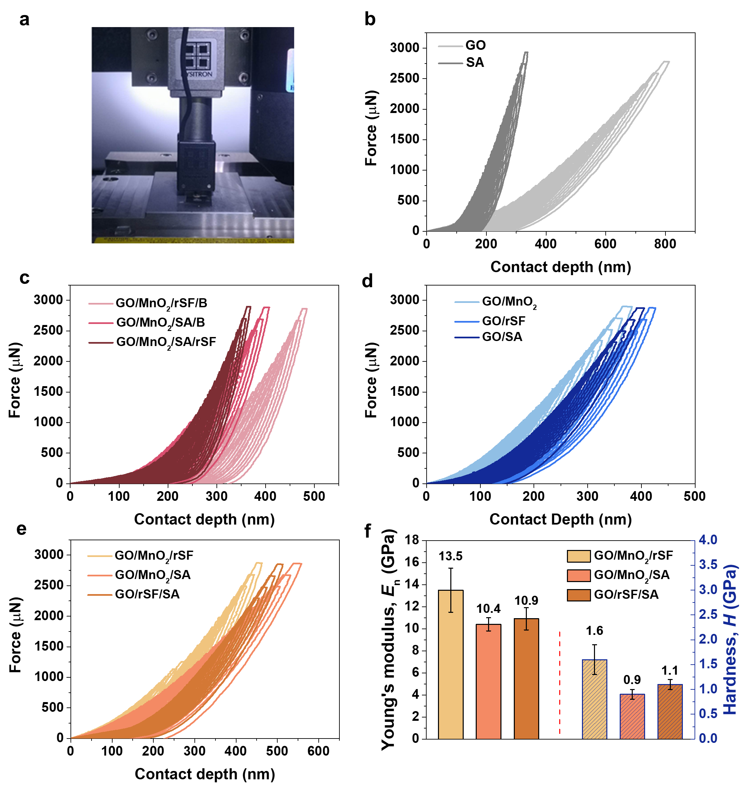
Supplementary Figure 18 | Partial loading-unloading curves performed by static nanoindentation tests in atmospheric condition under the force control mode (3000 μN) for obtaining the nanoindent Young’s modulus (E_{n}) and hardness (H) of the prepared layered films in this work at different contact depths. Full loading and then unloading were performed to obtain the maximum contact depth (h_{max}) and contact depth (h_{c}), respectively. (a) Digital photograph of the nanoindentor. (b) The force-displacement curves of GO and SA films. (c) The force-displacement curves of quaternary nanocomposite films, including GO/MnO₂/rSF/B (74.2-24.7-0.9-0.2), GO/MnO₂/SA/B (74.2-24.8-0.5-0.5), and GO/MnO₂/SA/rSF (74.2-24.8-0.5-0.3). (d) The force-displacement curves of binary layered films (c), including GO/MnO₂ (75.0-25.0), GO/rSF (99.6-0.4), and GO/SA (99.1-0.9). (e,f) The force-displacement curves of ternary nanocomposite films (e), referring to GO/MnO₂/rSF (74.4-24.7-0.9), GO/MnO₂/SA (74.0-24.6-1.4), and GO/rSF/SA (99.0-0.4-0.6), corresponding to their graphical comparison (f) of Young’s modulus (E_{n}) and hardness (H).

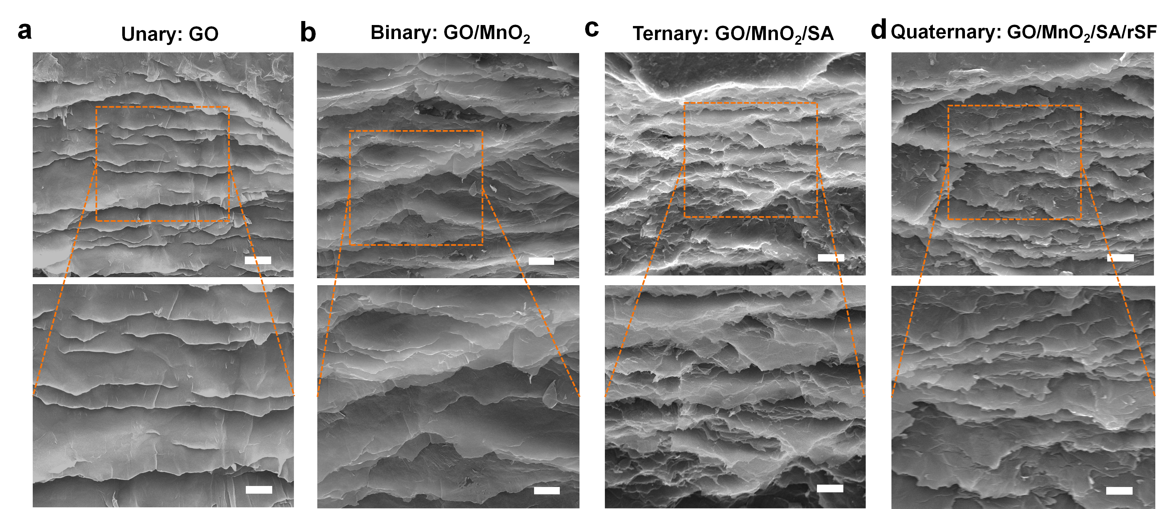
Supplementary Figure 19 | SEM images of fracture surfaces of these layered films, including GO (a), GO/MnO₂ (75.0-25.0) (b), GO/MnO₂/SA (74.0-24.6-1.4) (c), and GO/MnO₂/SA/rSF (74.4-24.8-0.5-0.3) (d). Scale bars: 2.5 µm (top) and 1.25 µm (bottom). Microstructural observation of these SEM images exhibits that, after incorporating A/C-LMH nanosheets and/or other additives into GO nanosheets, the relatively isolated GO nanosheets within these nanocomposite films are crosslinked or fixed to form the densely stacked layer, which can efficiently restrict the pull-out of GO nanosheets to a great degree, suggesting the efficient dissipation of fracture energy.

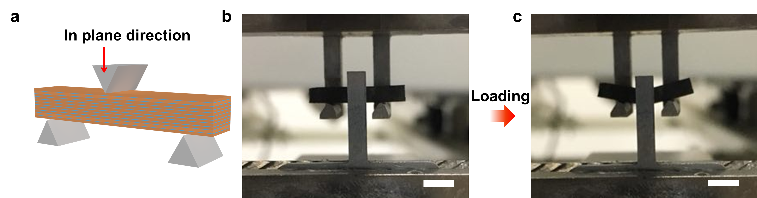
Supplementary Figure 20 | Three-point bending tests of the GML bulk. (a) Schematic of the three-point test in the plane direction. (b,c) The digital photographs showing the process of the three-point bending test in the plane direction. Scale bars, 0.5 cm.

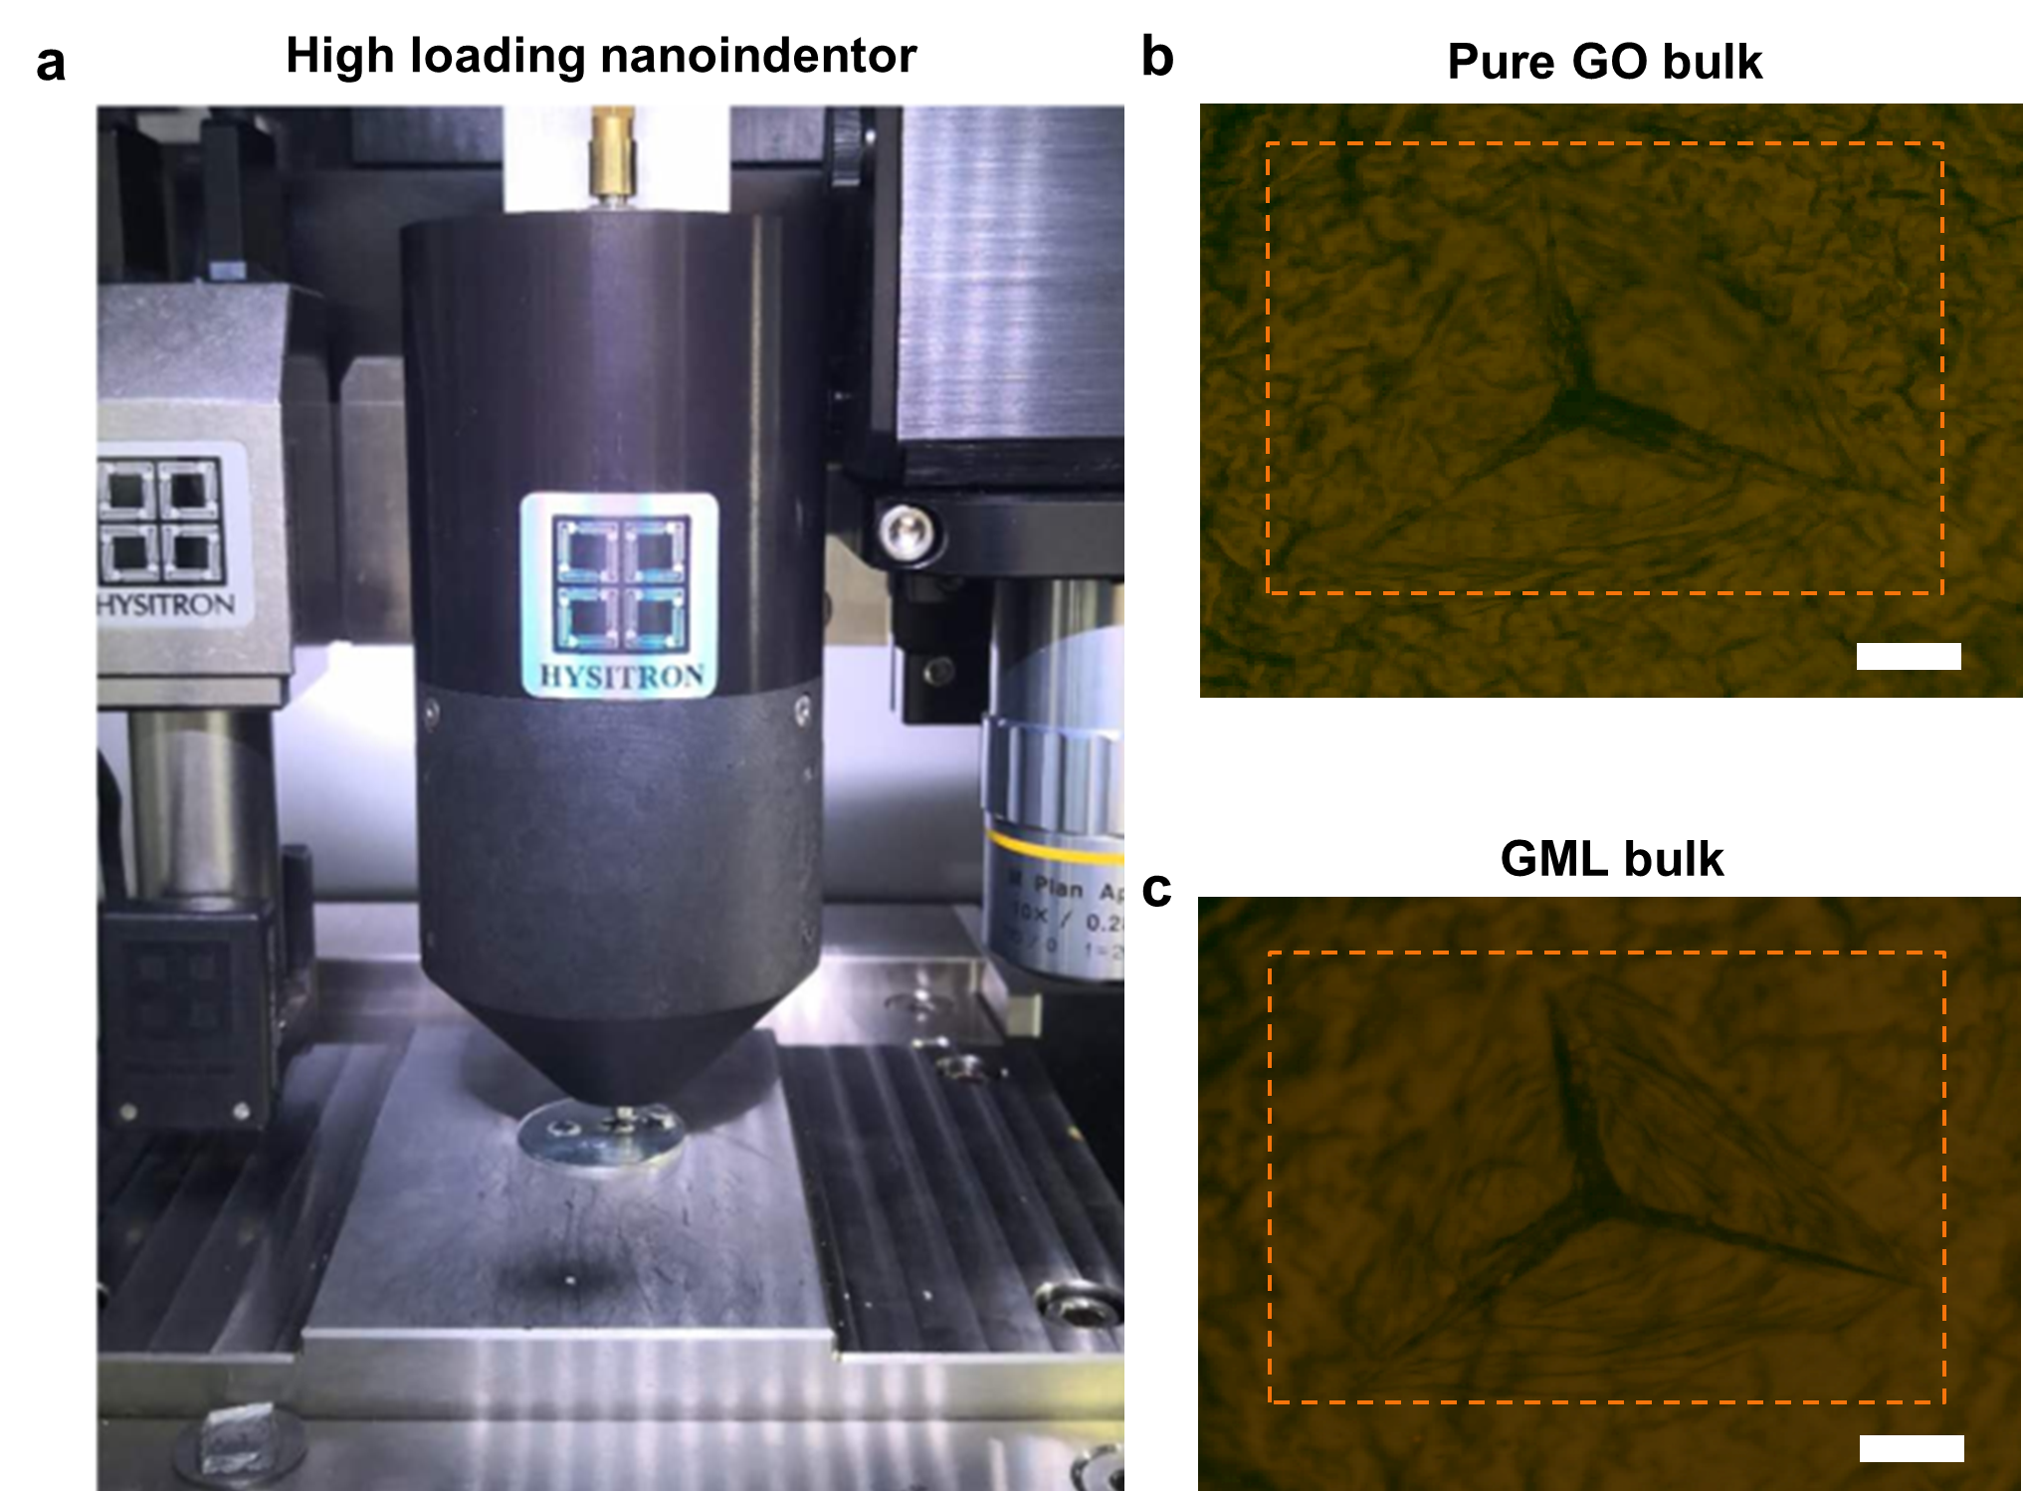
Supplementary Figure 21 | Comparison for post-indentation optical micrographs of typical 3D specimens by high loading nanoindentor (800 mN peak load). (a) The digital photo of nanoindentor with high loading. (b,c) Post-indentation microscopic optical photographs of pure GO (b) and GML bulk (c), respectively, corresponding to their post-indentation SEM images (Fig. 4d in the main manuscript). Scale bars, 20 μm.

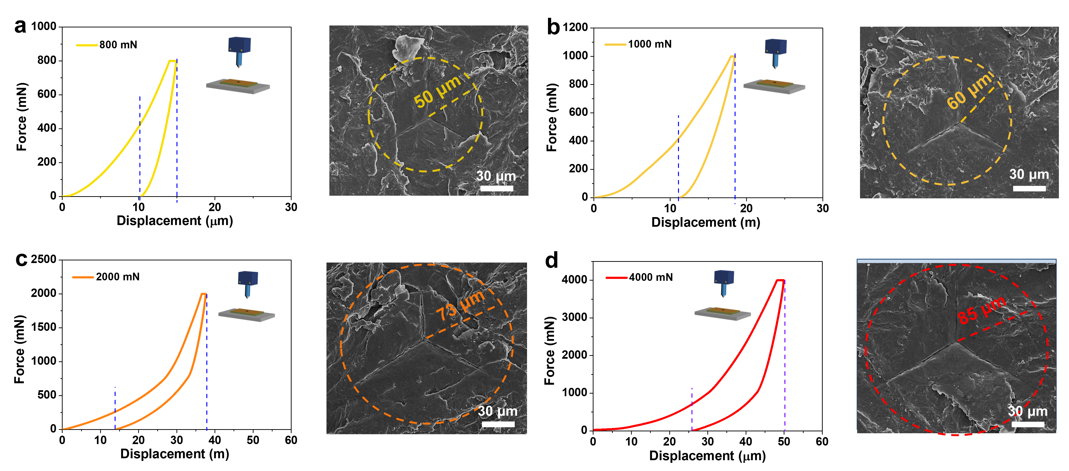
Supplementary Figure 22 | Indentation curves used for visualization of the surface damages of the GML bulk under different load conditions (left), corresponding to their post-indentation SEM images (right). (a) 800 mN. (b) 1000 mN. (c) 2000 mN. (d) 4000 mN.

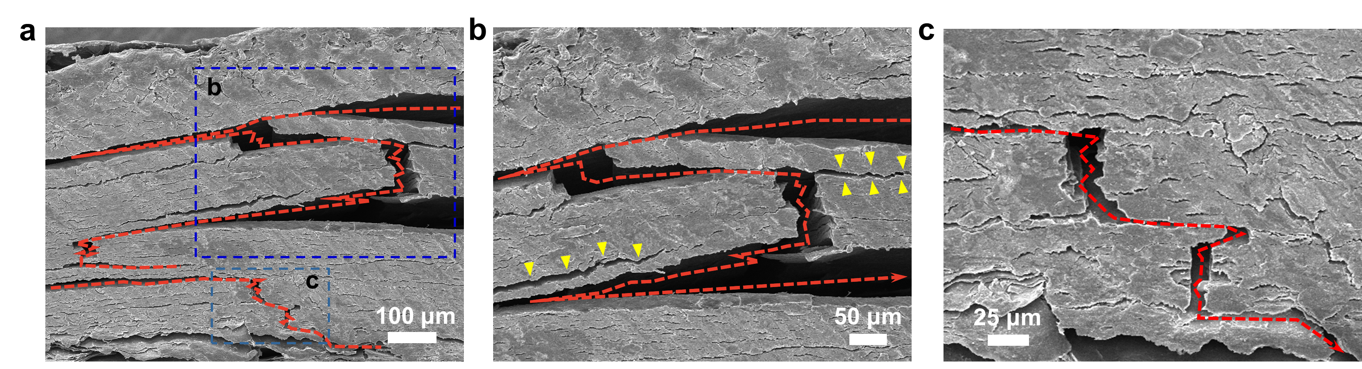
Supplementary Figure 23 | The in situ observing crack expansion of the GML bulk along the interfaces of the stacked lamellas at multiscale levels. (a) Low-magnification SEM image for the long-range main crack deflection at the first level. (b) High-magnification SEM image for the crack deflection, branching, and multiple second cracking at the second level. The yellow triangles indicate the extension direction of the second cracks. (c) Higher-magnification SEM image for the cracking situation shows the zigzag path in detail.

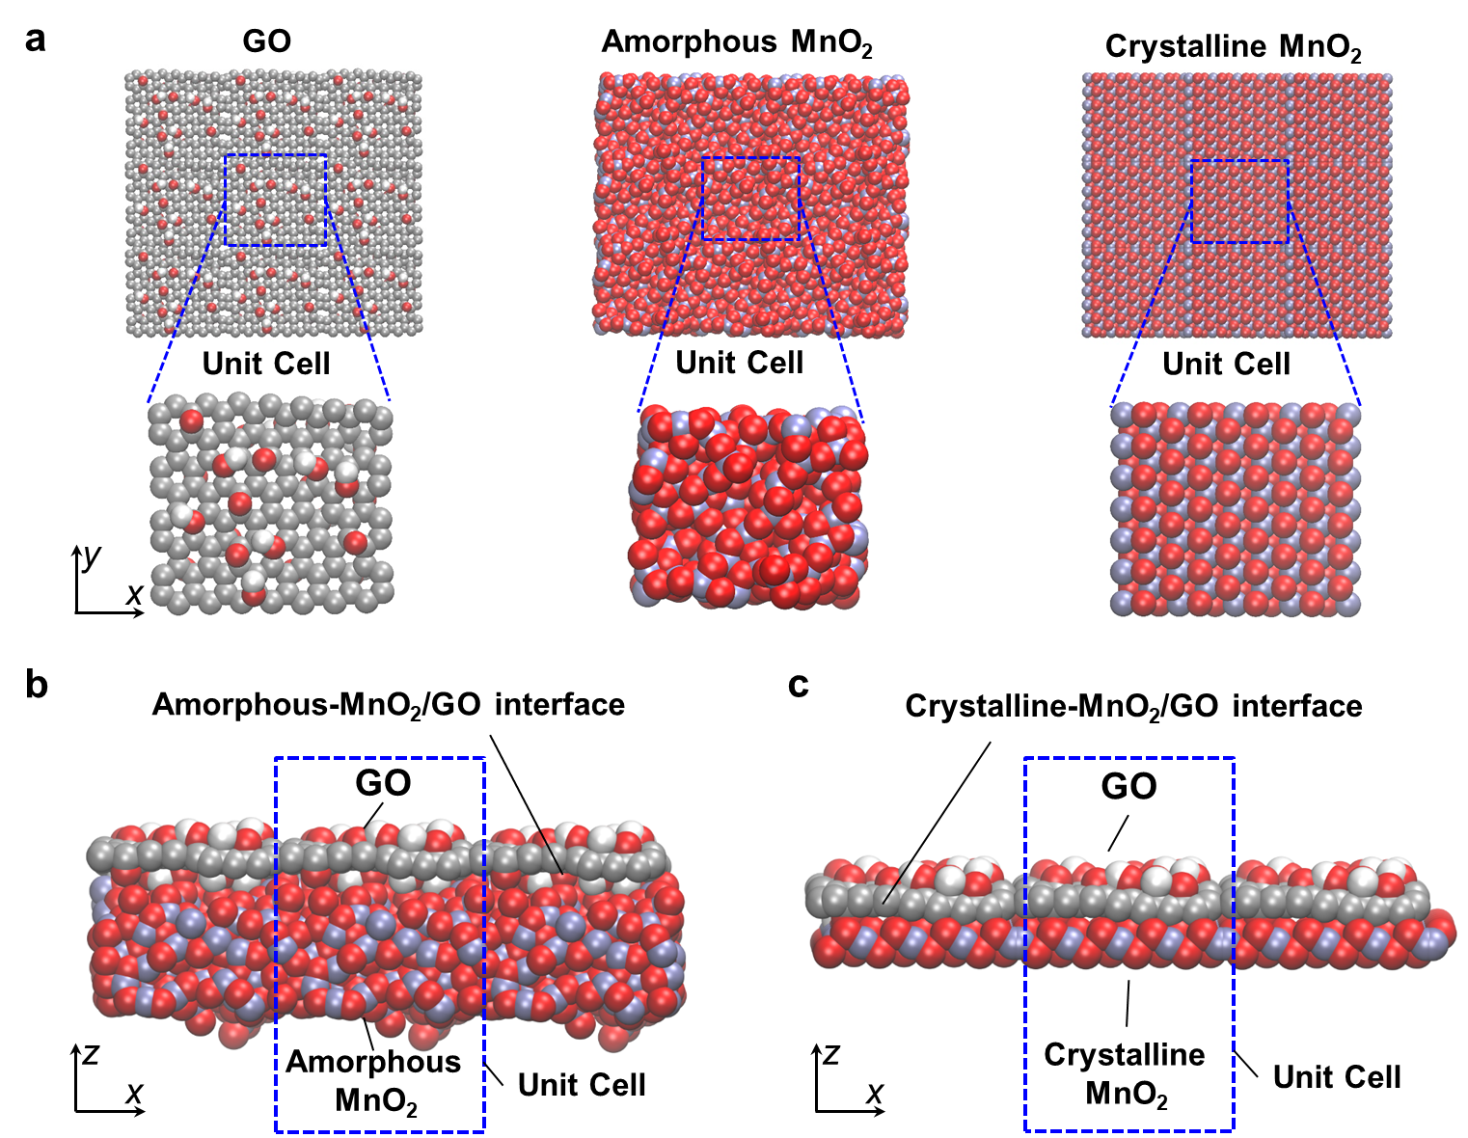
Supplementary Figure 24 | MD simulations for the interface interaction in the Amorphous-MnO₂/GO system and the Crystalline-MnO₂/GO system in the nanocomposite films, constructed separately in LAMMPS. (a) Left: the monolayer GO nanosheet model with stoichiometries of C₁₀O₁(OH)₁, selected as unit cell (19.5 × 17.6 × 6.4 Å); Middle: the amorphous MnO₂ structural model, selected as an amorphous-MnO₂ unit cell (20.7 × 17.1 × 18.3 Å); Right: The monolayer δ-MnO₂ model, selected as a crystalline-MnO₂ unit cell (21.2 × 18.1 × 7.0 Å). (b) The amorphous-MnO₂/GO interface system, selected as a unit cell (20.7 × 17.6 × 62.3 Å) to simulate the interface separation process (the opening mode and the sliding mode) by MD simulation. (c) The crystalline-MnO₂/GO interface system, selected as a unit cell (21.2 × 18.1 × 41.4 Å) to simulate the interface separation process (the opening mode and the sliding mode) by MD simulation.

In the present study, the tensile interface model (opening mode) and shear interface model (sliding mode) are considered for amorphous-MnO₂/GO and crystalline-MnO₂/GO interface systems, as shown in Supplementary Fig. 24, where the periodicity perpendicular to the interface is eliminated. The crystalline-MnO₂ and amorphous-MnO₂ are kept fixed, and not allowed to move in the separation process of the opening mode, while GO is allowed to move perpendicular to the interface, respectively. However, in the separation process of sliding mode, the crystalline-MnO₂ and amorphous-MnO₂ are similarly not allowed to move, but GO is allowed to move along the interface. As the periodicity only exists in the plane parallel to the interface, the single-peaked traction-displacement relationship is found in the opening mode separation of crystalline-MnO₂ and amorphous-MnO₂ interface systems (Fig. 5a in main manuscript), while the periodic traction-displacement relationship is observed in the sliding mode separation of these two interface systems (Fig. 5b in main manuscript).

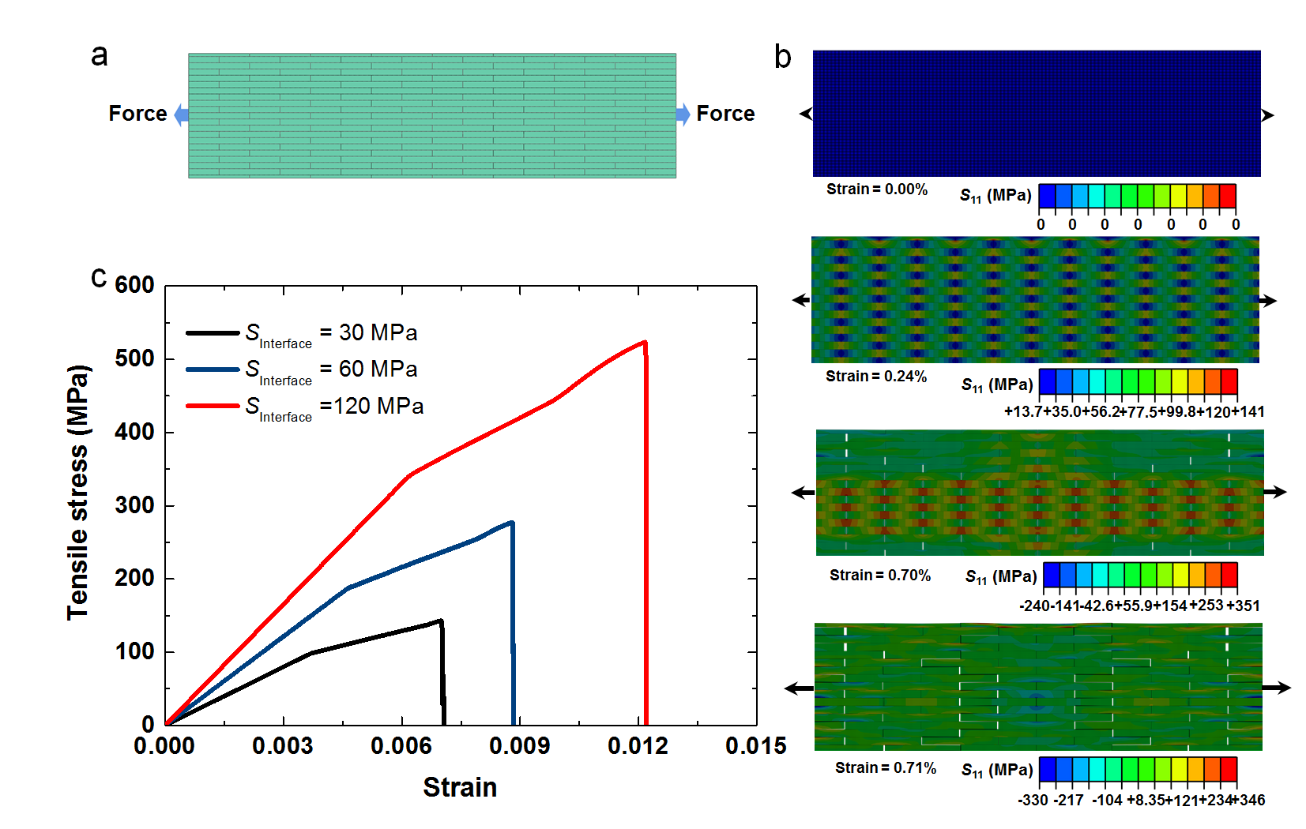
Supplementary Figure 25 | Finite element (FE) simulations for mechanical responses of the nanoscale heterophase reinforcing structure in the nanocomposite film under uniaxial tension. (a) FE model of the nanoscale heterophase reinforcing structure. (b) Stress nephograms of the nanoscale heterophase reinforcing structure in structural deformation and failure process fracture under uniaxial tension. (c) Variations of the effective tensile stress-strain curves of the nanoscale heterophase reinforcing structure dependent on different interface strengths.

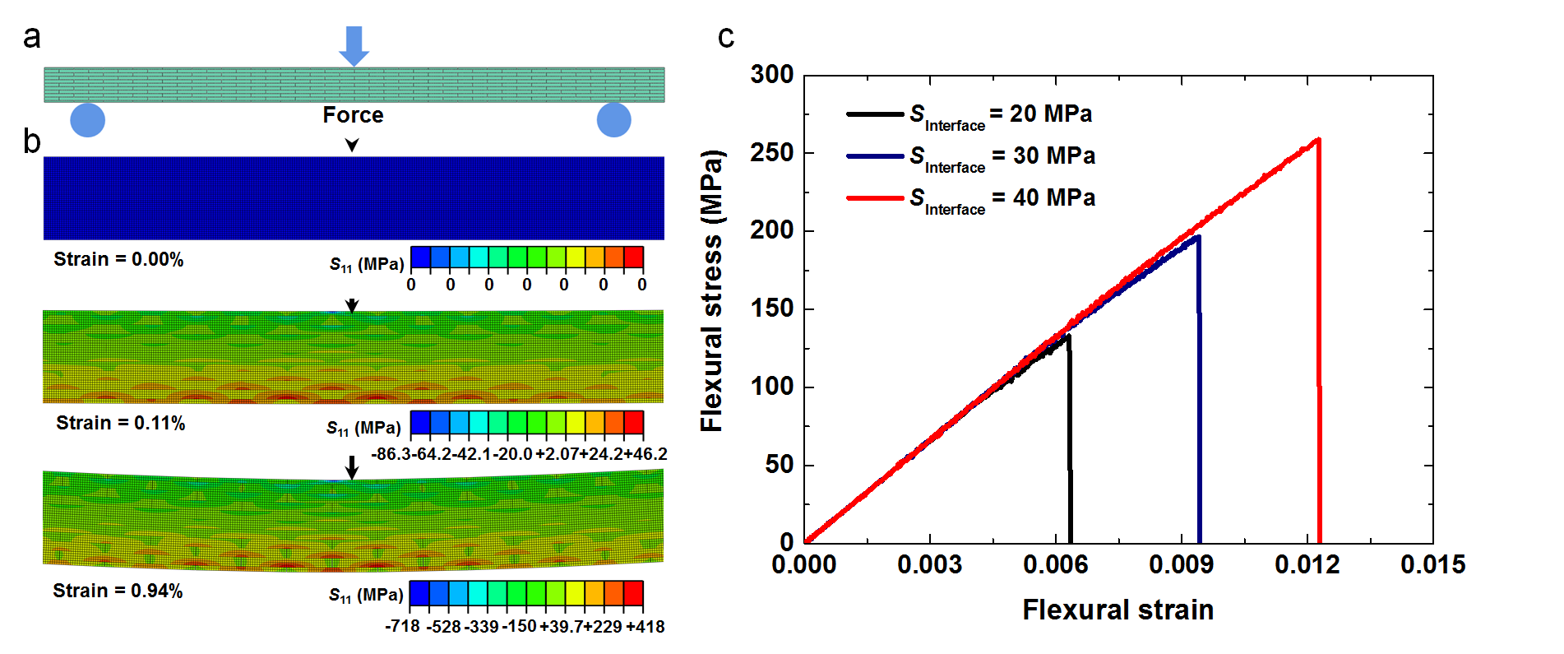
Supplementary Figure 26 | FE simulations for mechanical responses of the nanoscale heterophase reinforcing structure in the nanocomposite film under three-point bending. (a) FE model of nanoscale heterophase reinforcing structure under three-point bending. (b) Stress nephograms of the nanoscale heterophase reinforcing structure in structural deformation and failure process under three-point bending. (c) Variations of the effective flexural stress-strain curves of the nanoscale heterophase reinforcing structure dependent on different interface strengths.

The nanoscale heterophase reinforcing structural model in the nanocomposite film, as shown in Supplementary Figure 25a, is applied on a quasi-static tensile loading, and its deformation and failure process are illustrated in Supplementary Fig. 25b and Movie S1. During the whole process, the microcrack propagation path is tortuous along the interface of the soft organic phase and hard nanosheets, which can be attributed to microcrack deflection, branching, and multiple second microcracking in the nanoscale heterophase model, similar to those of natural nacre under uniaxial tension. In addition, our simulation quantitatively confirms the tensile strength of the nanoscale heterophase reinforcing model gradually increases from 143.5 to 276 to 525 MPa when the strength of the soft organic phase enhances from 30 to 60 to 120 MPa. Furthermore, the nanoscale heterophase reinforcing structural model in the 2D nanocomposite film, as displayed in Supplementary Fig. 26a, is carried out by a three-point bending (See Movie S2). The zigzag microcracks with daughter microcrack nucleation and branching, can be observed in Supplementary Fig. 26b, similar to microcracks observed in our experiments in Supplementary Fig. 23. Meanwhile, our simulation quantitatively indicates the flexural strength of the nanoscale heterophase reinforcing model can be improved largely from 133 to 196.6 to 259 MPa as the strength of the mortar increase from 20 to 30 to 40 MPa. Therefore, we can conclude that, the strength of the soft organic phase as the nanoscale interface has a significant influence on mechanical properties of the 2D nanocomposite film, where stronger interfaces result in superior strength and toughness of the film. In fact, the stronger crosslinked interfaces in our 2D nanocomposite film have been proven and observed by a series of characterizations (Supplementary Figs. 11-16), especially where closer distance (d-spacing value) suggests superior interfacial interactions between hard nanosheets.

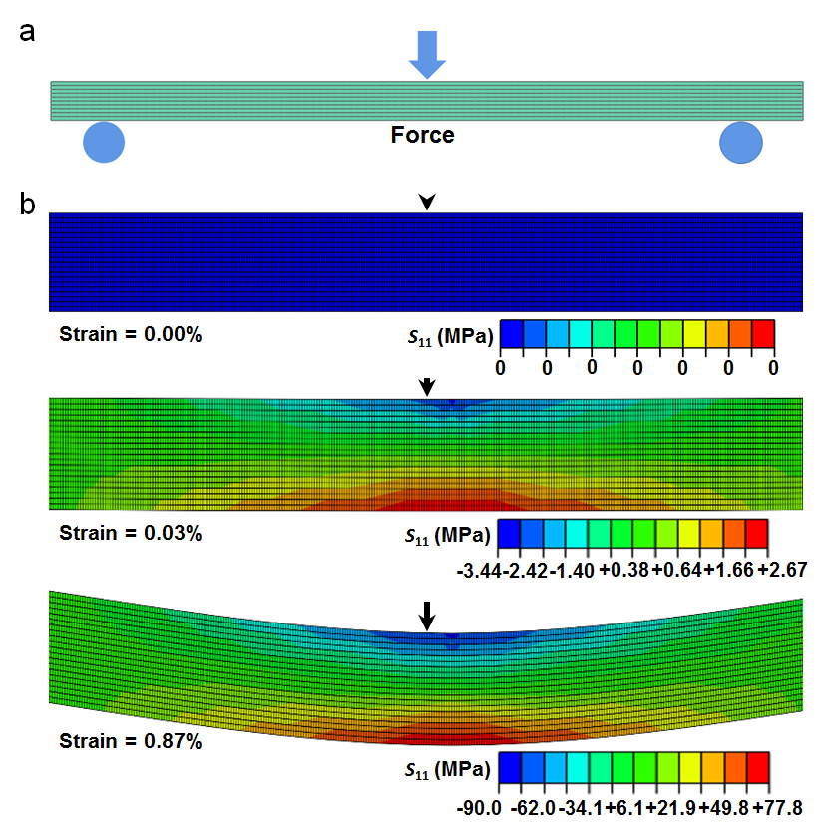
Supplementary Figure 27 | FE simulations for mechanical responses of microscale lamellar composite structure in the GML bulk with under three-point bending. (a) FE model of microscale lamellar structure. (b) Stress nephograms of microscale lamellar structure in structural deformation and failure process under three-point bending (see detailed process in Movie S3).

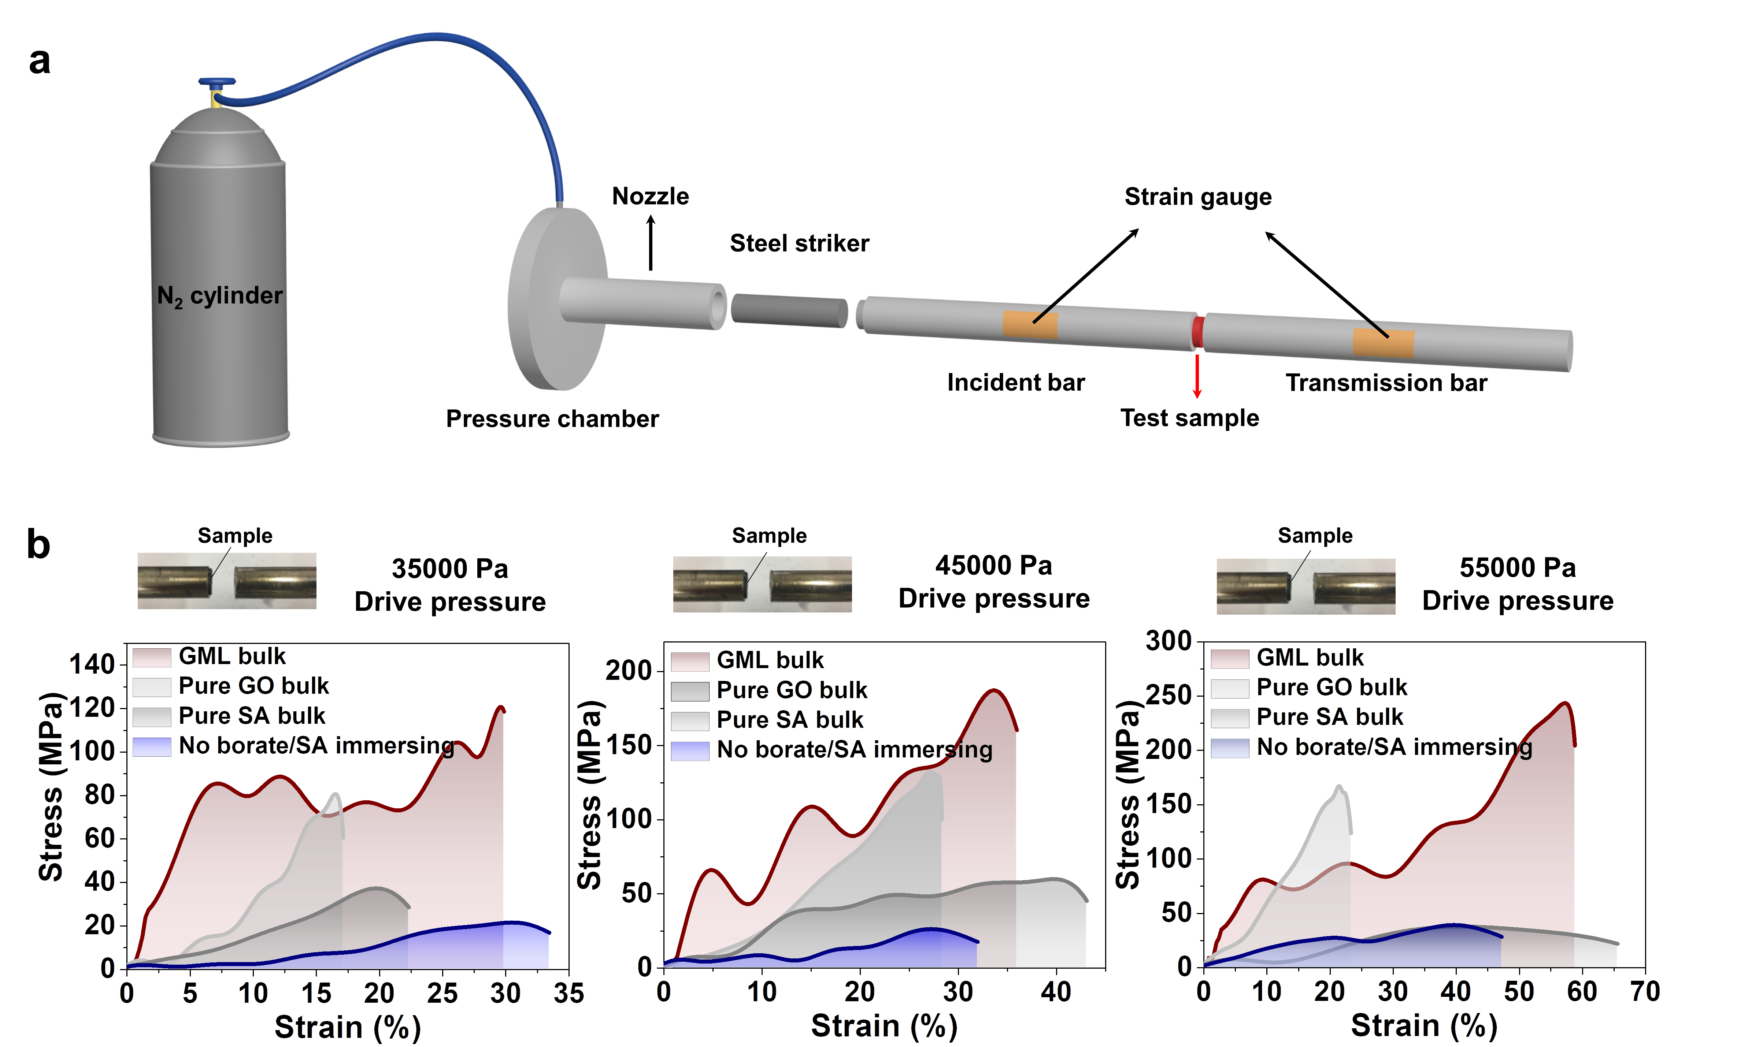
Supplementary Figure 28 | Schematic structure of split Hopkinson pressure bar (SHPB) and dynamic stress-strain curves of these obtained bulk materials measured by SHPB experiments under different initial drive pressures. (a) Schematic structure of the SHPB equipment. The strain gauge on the incident bar and the transmission bar can convert mechanical wave into electronic signal and yield the stress-strain curve. (b) Dynamic stress-strain curves under initial drive pressure of 35000 Pa (left), initial drive pressure of 45000 Pa (middle), and initial drive pressure of 55000 Pa (right). Inset photos showing the test sample between Hopkinson bars.

Supplementary Tables (Supplementary Tables 1-6)
Supplementary Table 1. Summary of the composition of the reaction solution, weight percentage, and tensile mechanical properties for all the 2D films. These 2D films are named based on their different compositions. The data shown are mean ± s.d.
System | Materials  Name | Aqueous  solution | Weight percentage | σ_{u},  (MPa) | E_{m},  (GPa) | E_{a},  (GPa) | W,  (MJ m⁻³)
System | Materials  Name | (v_{GO}, v_{MnO2}, v_{rSF}, v_{SA}, v_{Borate}) ml | (m_{GO}/m_{MnO2}/m_{rSF}/  m_{SA}/m_{Borate}) wt%
Unary | GO | 100 | 100 | 84.2 ± 15.1 | 4.5 ± 0.2 | 2.2 ± 0.6 | 2.4 ± 1.5
Unary | SA | 100 | 100 | 147.5 ± 13.2 | 3.1 ± 0.2 | 1.7 ± 0.5 | 10.0 ± 0.5
Binary | GO/MnO₂ (A/C-LMH) | 97.4, 2.6 | 88.2/11.8 | 155.6 ± 7.9 | 9.9 ± 1.9 | 3.7 ± 0.9 | 2.4 ± 1.0
Binary | GO/MnO₂ (A/C-LMH) | 97.0, 3.0 | 87.0/13.0 | 97.3 ± 6.4 | 5.9 ± 0.9 | 4.8 ± 0.8 | 1.2 ± 0.4
Binary | GO/MnO₂ (A/C-LMH) | 96.1, 3.9 | 83.3/16.7 | 119.3 ± 1.4 | 6.4 ± 1.0 | 4.6 ± 1.2 | 1.6 ± 0.2
Binary | GO/MnO₂ (A/C-LMH) | 93.8, 6.2 | 75.0/25.0 | 210.5 ± 27.6 | 8.6 ± 1.4 | 4.0 ± 1.4 | 2.8 ± 0.6
Binary | GO/MnO₂ (A/C-LMH) | 90.3, 9.7 | 65.2/34.8 | 82.9 ± 15.0 | 4.6 ± 0.2 | 2.7 ± 0.6 | 0.9 ± 0.3
Binary | GO/MnO₂ (A/C-LMH) | 89.3, 10.7 | 62.5/37.5 | 124.7 ± 24.5 | 12.4 ± 1.7 | 4.3 ± 1.2 | 1.0 ± 0.1
Binary | GO/MnO₂ (Full crystallization) | 93.8, 6.2* | 75.0/25.0* | 84.9 ± 8.7* | 1.5 ± 0.2* | 1.3 ± 0.3* | 2.1 ± 0.2*
Binary | GO/rSF | 99.6, 0.4 | 99.6/0.4 | 178.8 ± 13.9 | 4.6 ± 0.9 | 3.2 ± 0.3 | 4.4 ± 0.4
Binary | GO/rSF | 99.2, 0.8 | 99.2/0.8 | 153.8 ± 6.3 | 3.0 ± 0.1 | 2.3 ± 0.2 | 4.7 ± 0.6
Binary | GO/rSF | 98.9, 1.1 | 98.9/1.1 | 138.9 ± 8.7 | 4.1 ± 0.6 | 2.8 ± 0.5 | 3.3 ± 0.2
Binary | GO/rSF | 98.5, 1.5 | 98.5/1.5 | 155.5 ± 21.1 | 4.9 ± 0.7 | 3.1 ± 1.0 | 3.1 ± 1.0
Binary | GO/rSF | 98.1, 1.9 | 98.1/1.9 | 163.8 ± 23.5 | 4.4 ± 0.5 | 3.6 ± 0.5 | 3.7 ± 0.6
Binary | GO/rSF | 97.7, 2.3 | 97.7/2.3 | 138.0 ± 13.4 | 4.2 ± 0.6 | 3.4 ± 1.0 | 2.7 ± 0.3
Supplementary Table 1. Continued.
System | Materials  Name | Aqueous  solution | Weight percentage | σ_{u},  (MPa) | E_{m},  (GPa) | E_{a},  (GPa) | W,  (MJ m⁻³)
System | Materials  Name | (v_{GO}, v_{MnO2}, v_{rSF}, v_{SA}, v_{Borate}) ml | (m_{GO}/m_{MnO2}/m_{rSF}/  m_{SA}/m_{Borate}) wt%
Binary | GO/SA | 99.9, 0.1 | 99.7/0.3 | 120.9 ± 5.7 | 2.7 ± 0.3 | 2.3 ± 0.1 | 3.3 ± 0.2
Binary | GO/SA | 99.8, 0.2 | 99.4/0.6 | 132.8 ± 12.2 | 2.2 ± 0.1 | 2.3 ± 0.1 | 3.7 ± 0.8
Binary | GO/SA | 99.7, 0.3 | 99.1/0.9 | 234.1 ± 25.1 | 8.1 ± 2.1 | 5.7 ± 1.4 | 4.7 ± 0.6
Binary | GO/SA | 99.6, 0.4 | 98.8/1.2 | 109.2 ± 2.6 | 3.1 ± 1.2 | 2.3 ± 0.3 | 2.7 ± 0.4
Binary | GO/SA | 99.5, 0.5 | 98.5/1.5 | 190.5 ± 25.8 | 6.6 ± 1.9 | 3.8 ± 0.7 | 5.3 ± 0.8
Ternary | GO/MnO₂/rSF | 93.4, 6.2, 0.4 | 74.8/24.9/0.3 | 170.1 ± 10.7 | 7.4 ± 2.7 | 3.8 ± 1.5 | 3.8 ± 0.7
Ternary | GO/MnO₂/rSF | 93.1, 6.2, 0.7 | 74.6/24.8/0.6 | 166.1 ± 15.7 | 7.6 ± 1.4 | 4.5 ± 0.9 | 2.9 ± 1.1
Ternary | GO/MnO₂/rSF | 92.7, 6.2, 1.1 | 74.4/24.7/0.9 | 277.7 ± 3.7 | 8.9 ± 3.4 | 4.6 ± 0.8 | 9.2 ± 1.9
Ternary | GO/MnO₂/rSF | 92.3, 6.2, 1.5 | 74.2/24.6/1.2 | 274.4 ± 10.7 | 9.1 ± 2.2 | 4.6 ± 0.7 | 9.1 ± 2.1
Ternary | GO/MnO₂/rSF | 92.0, 6.2, 1.9 | 74.0/24.5/1.5 | 210.8 ± 20.2 | 9.3 ± 2.4 | 5.2 ± 1.4 | 4.6 ± 1.2
Ternary | GO/MnO₂/rSF | 91.7, 6.2, 2.1 | 73.8/24.4/1.8 | 211.7 ± 3.0 | 11.4 ± 2.2 | 4.7 ± 0.8 | 5.7 ± 1.0
Ternary | GO/MnO₂/SA | 93.6, 6.2, 0.2 | 74.6/24.9/0.5 | 150.2 ± 10.5 | 6.5 ± 0.8 | 6.4 ± 0.8 | 3.2 ± 0.7
Ternary | GO/MnO₂/SA | 93.4, 6.2, 0.4 | 74.3/24.8/0.9 | 224.2 ± 23.2 | 6.8 ± 0.9 | 6.1 ± 1.1 | 3.9 ± 1.1
Ternary | GO/MnO₂/SA | 93.2, 6.2, 0.6 | 74.0/24.6/1.4 | 248.1 ± 28.7 | 5.7 ± 0.6 | 5.1 ± 0.4 | 5.8 ± 1.5
Ternary | GO/MnO₂/SA | 93.0, 6.2, 0.8 | 73.6/24.5/1.9 | 227.9 ± 5.6 | 5.6 ± 0.6 | 5.2 ± 0.6 | 5.4 ± 0.7
Ternary | GO/MnO₂/SA | 92.8, 6.2, 1.0 | 73.3/24.4/2.3 | 227.4 ± 14.9 | 5.1 ± 0.3 | 4.2 ± 0.6 | 5.9 ± 0.5
Ternary | GO/MnO₂/SA | 92.6, 6.2, 1.2 | 72.9/24.3/2.8 | 213.9 ± 26.3 | 6.9 ± 1.2 | 6.9 ± 1.3 | 3.8 ± 1.1
Ternary | GO/SA/rSF | 99.6, 0.3, 0.1 | 99.0/0.9/0.1 | 207.7 ± 16.4 | 9.9 ± 1.0 | 4.9 ± 1.0 | 3.0 ± 0.1
Ternary | GO/SA/rSF | 99.5, 0.3, 0.2 | 98.9/0.9/0.2 | 279.6 ± 8.0 | 10.9 ± 0.2 | 6.2 ± 0.5 | 4.6 ± 0.3
Ternary | GO/SA/rSF | 99.4, 0.3, 0.3 | 98.8/0.9/0.3 | 140.5 ± 9.6 | 5.6 ± 0.4 | 2.2 ± 0.3 | 2.2 ± 0.3
Supplementary Table 1. Continued.
System | Materials  Name | Aqueous  solution | Weight percentage | σ_{u},  (MPa) | E_{m},  (GPa) | E_{a},  (GPa) | W,  (MJ m⁻³)
System | Materials  Name | (v_{GO}, v_{MnO2}, v_{rSF}, v_{SA}, v_{Borate}) ml | (m_{GO}/m_{MnO2}/m_{rSF}/  m_{SA}/m_{Borate}) wt%
Ternary | GO/SA/rSF | 99.3, 0.3, 0.4 | 98.7/0.9/0.4 | 260.2 ± 2.6 | 8.0 ± 0.4 | 4.8 ± 0.4 | 5.4 ± 0.7
Ternary | GO/SA/rSF | 99.2, 0.3, 0.5 | 98.6/0.9/0.5 | 237.6 ± 19.4 | 8.6 ± 0.8 | 4.7 ± 0.7 | 4.2 ± 0.6
Ternary | GO/SA/rSF | 99.1, 0.3, 0.6 | 98.5/0.9/0.6 | 208.4 ± 30.2 | 6.2 ± 1.5 | 3.8 ± 0.5 | 4.3 ± 0.6
Ternary | GO/rSF/SA | 99.5, 0.4, 0.1 | 99.3/0.4/0.3 | 258.6 ± 39.7 | 8.3 ± 0.6 | 4.1 ± 0.3 | 5.3 ± 1.4
Ternary | GO/rSF/SA | 99.4, 0.4, 0.2 | 99.0/0.4/0.6 | 321.1 ± 12.2 | 8.5 ± 1.9 | 6.1 ± 0.7 | 7.3 ± 1.4
Ternary | GO/rSF/SA | 99.3, 0.4, 0.3 | 98.4/0.4/1.2 | 200.4 ± 12.6 | 6.2 ± 0.7 | 3.9 ± 0.2 | 4.6 ± 0.8
Ternary | GO/rSF/SA | 99.2, 0.4, 0.4 | 98.1/0.4/1.5 | 210.3 ± 11.8 | 6.5 ± 0.9 | 4.0 ± 0.3 | 4.8 ± 0.6
Ternary | GO/rSF/SA | 99.1, 0.4, 0.5 | 97.8/0.4/1.8 | 189.5 ± 18.7 | 4.6 ± 0.8 | 3.6 ± 0.6 | 4.3 ± 0.3
Quaternary | GO/MnO₂/rSF/B | 92.6, 6.2, 1.1, 0.1 | 74.3/24.7/0.9/0.1 | 145.7 ± 11.5 | 7.3 ± 0.8 | 2.2 ± 0.5 | 2.0 ± 0.2
Quaternary | GO/MnO₂/rSF/B | 92.4, 6.2, 1.1, 0.3 | 74.2/24.7/0.9/0.2 | 220.0 ± 32.4 | 8.6 ± 3.1 | 2.6 ± 1.2 | 3.6 ± 0.2
Quaternary | GO/MnO₂/rSF/B | 92.4, 6.1, 1.1, 0.4 | 74.2/24.6/0.9/0.3 | 163.6 ± 2.8 | 6.7 ± 0.5 | 2.5 ± 0.5 | 2.3 ± 0.1
Quaternary | GO/MnO₂/rSF/B | 92.2, 6.2, 1.1, 0.5 | 74.1/24.6/0.9/0.4 | 148.1 ± 38.7 | 7.0 ± 1.2 | 1.9 ± 0.3 | 2.2 ± 0.8
Quaternary | GO/MnO₂/rSF/B | 92.1, 6.1, 1.2, 0.6 | 74.1/24.5/0.9/0.5 | 126.4 ± 2.2 | 7.7 ± 2.0 | 1.3 ± 0.3 | 1.9 ± 0.1
Quaternary | GO/MnO₂/SA/B | 93.0, 6.2, 0.2, 0.6 | 74.4/24.7/0.5/0.2 | 264.5 ± 9.0 | 10.2 ± 0.3 | 6.2 ± 0.5 | 5.9 ± 0.8
Quaternary | GO/MnO₂/SA/B | 92.9, 6.1, 0.4, 0.6 | 74.2/24.8/0.5/0.5 | 332.3 ± 5.0 | 13.0 ± 0.7 | 5.8 ± 0.7 | 12.1 ± 1.2
Quaternary | GO/MnO₂/SA/B | 92.6, 6.2, 0.2, 1 | 74.0/24.7/0.5/0.8 | 309.4 ± 14.3 | 13.5 ± 1.0 | 5.2 ± 1.3 | 10.1 ± 0.9
Quaternary | GO/MnO₂/SA/B | 92.3, 6.2, 0.2, 1.3 | 73.8/24.6/0.5/1.1 | 258.6 ± 28.4 | 11.1 ± 1.4 | 5.5 ± 1.7 | 9.2 ± 5.7
Quaternary | GO/MnO₂/SA/B | 91.9, 6.1, 0.2, 1.8 | 73.6/24.5/0.50/1.4 | 294.9 ± 39.7 | 13.6 ± 1.1 | 7.0 ± 1.6 | 6.8 ± 3.2
Quaternary | GO/MnO₂/SA/B | 91.5, 6.1, 0.2, 2.2 | 73.3/24.4/0.5/1.8 | 250.6 ± 12.6 | 13.8 ± 0.6 | 8.1 ± 1.7 | 3.8 ± 0.6
Supplementary Table 1. Continued.
System | Materials  Name | Aqueous  solution | Weight percentage | σ_{u},  (MPa) | E_{m},  (GPa) | E_{a},  (GPa) | W,  (MJ m⁻³)
System | Materials  Name | (v_{GO}, v_{MnO2}, v_{rSF}, v_{SA}, v_{Borate}) ml | (m_{GO}/m_{MnO2}/m_{rSF}/  m_{SA}/m_{Borate}) wt%
Quaternary | GO/MnO₂/rSF/SA | 92.6, 6.2, 1.1, 0.1 | 74.3/24.7/0.9/0.1 | 174.9 ± 16.4 | 5.3 ± 0.1 | 3.7 ± 0.4 | 3.3 ± 0.4
Quaternary | GO/MnO₂/rSF/SA | 92.5, 6.2, 1.1, 0.2 | 74.1/24.6/0.9/0.4 | 241.0 ± 11.2 | 6.2 ± 1.2 | 4.8 ± 0.6 | 5.6 ± 0.6
Quaternary | GO/MnO₂/rSF/SA | 92.4, 6.2, 1.1, 0.3 | 73.9/24.5/0.9/0.7 | 202.3 ± 11.5 | 7.4 ± 3.2 | 4.1 ± 2.9 | 3.8 ± 0.3
Quaternary | GO/MnO₂/rSF/SA | 92.3, 6.2, 1.1, 0.4 | 73.7/24.4/0.9/1.0 | 183.1 ± 16.2 | 8.1 ± 1.1 | 3.0 ± 1.1 | 3.1 ± 0.5
Quaternary | GO/MnO₂/rSF/SA | 92.2, 6.2, 1.1, 0.5 | 73.5/24.4/0.9/1.2 | 229.0 ± 5.6 | 11.4 ± 1.4 | 4.1 ± 0.7 | 3.0 ± 0.1
Quaternary | GO/MnO₂/SA/rSF | 93.4, 6.3, 0.2, 0.1 | 74.5/24.9/0.5/0.1 | 276.8 ± 18.0 | 5.1 ± 1.5 | 5.6 ± 0.9 | 10.4 ± 1.8
Quaternary | GO/MnO₂/SA/rSF | 93.2, 6.2, 0.2, 0.4 | 74.4/24.8/0.5/0.3 | 368.1 ± 9.9 | 9.5± 1.5 | 6.7 ± 1.8 | 13.8 ± 2.6
Quaternary | GO/MnO₂/SA/rSF | 93.1, 6.2, 0.2, 0.5 | 74.3/24.8/0.5/0.4 | 304.5 ± 12.6 | 7.6 ± 0.4 | 5.9 ± 0.9 | 8.8 ± 0.4
Quaternary | GO/MnO₂/SA/rSF | 92.9, 6.2, 0.2, 0.7 | 74.1/24.8/0.5/0.6 | 270.1 ± 11.5 | 5.3 ± 0.8 | 3.8 ± 0.7 | 9.5 ± 1.6
Quaternary | GO/MnO₂/SA/rSF | 92.7, 6.2, 0.2, 0.9 | 74.0/24.7/0.50/0.8 | 252.9 ± 15.1 | 4.3 ± 0.5 | 3.5 ± 0.6 | 7.7 ± 0.7
Quinary | GO/MnO₂/rSF/SA/B | 93.1, 6.2, 0.4, 0.2, 0.1 | 74.3/24.8/0.3/0.5/0.1 | 200.2 ± 11.8 | 6.7 ± 0.9 | 2.3 ± 0.4 | 9.5 ± 0.8
Quinary | GO/MnO₂/rSF/SA/B | 92.9, 6.2, 0.4, 0.2, 0.3 | 74.2/24.8/0.3/0.5/0.2 | 227.2 ± 11.4 | 8.0 ± 0.7 | 3.1 ± 0.5 | 8.1 ± 0.7
Quinary | GO/MnO₂/rSF/SA/B | 92.7, 6.2, 0.4, 0.2, 0.5 | 74.1/24.8/0.3/0.5/0.3 | 285.7 ± 18.5 | 8.4 ± 0.6 | 2.7 ± 0.2 | 17.2 ± 3.8
Quinary | GO/MnO₂/rSF/SA/B | 92.5, 6.2, 0.4, 0.2, 0.7 | 74.1/24.7/0.3/0.5/0.4 | 267.0 ± 9.8 | 11.6 ± 0.6 | 5.3 ± 0.6 | 6.5 ± 1.4
Quinary | GO/MnO₂/rSF/SA/B | 92.3, 6.2, 0.4, 0.2, 0.9 | 74.1/24.7/0.3/0.5/0.4 | 220.1 ± 16.6 | 10.4 ± 0.2 | 5.0 ± 1.2 | 4.2 ± 1.2
Quinary | GO/MnO₂/rSF/SA/B | 92.1, 6.2, 0.4, 0.2, 1.1 | 74.0/24.7/0.3/0.5/0.5 | 162.1 ± 20.1 | 4.7 ± 1.1 | 1.8 ± 0.1 | 7.2 ± 1.9
* The fully crystalline MnO₂ nanosheets were used to prepare the GO/MnO₂ nanocomposite film.
Supplementary Table 2. Constituent contents in various bulk materials constructed in this work calculated from the elemental analysis results.
Specimen | GO  (wt%) | MnO₂  (wt%) | SA  (wt%) | SF  (wt%) | Borate  (wt%) | Sum
GML bulk | ~69.4 | ~23.3 | ~6.5 | ~0.5 | ~0.3 | 100
Pure GO bulk | 100 | - | - | - | - | 100
Pure SA bulk | - | - | 100 | - | - | 100
No borate/SA bulk | ~70.1 | ~23.7 | ~5.4 | ~0.8 | - | 100

Supplementary Table 3. Comparison of density of the GML bulk with natural Cristaria plicata nacre and other nacre-mimetic 3D bulk materials.
Samples | Density (g cm⁻³)
Our GML bulk | 1.85 (s.d. = 0.03)
Natural Cristaria plicata nacre³⁰ | 2.58 (s.d. = 0.07)
Natural Haliotis rufescens nacre³⁰ | 2.68
Bulk artificial nacre³⁰ | 1.83 (s.d. = 0.02)
Synthetic nacre³¹ | 2.18
Alumina/PMMA³² | 2.52
Alumina/copper³² | 3.96
Nacre-like alumina³² | 3.94

Supplementary Table 4. Geometric characteristics of hierarchical structures of the GML bulk in the FE simulations.
moulds | Geometric characteristics | Symbols | Values
Heterophase structure  in nanoscale | Size of hard sheets | L_{sheet}×h_{sheet} | 100 nm × 100 nm
Heterophase structure  in nanoscale | Thickness of organic material | H_{organic} | 1 nm
Lamellar structure  in microscopic scale | Thickness of lamella | h_{lamella} | 20 µm
Lamellar structure  in microscopic scale | Thickness of interlayer | h_{interlayer} | 1 µm

Supplementary Table 5. Mechanical parameters of hierarchical structures of the GML bulk in the FE simulations.
Model | Mechanical parameters | Symbols | Values
Heterophase structure in nanoscale | Young’s modulus of hard heterophase | E_{heterophase} | 100 GPa
Heterophase structure in nanoscale | Young’s modulus of soft organic phase | E_{organic phase} | 100~400 MPa
Heterophase structure in nanoscale | Strength of soft organic phase | S_{organic phase} | 20~120 MPa
Lamellar structure  in microscopic scale | Young’s modulus of lamella | E_{lamella} | 9.5 GPa
Lamellar structure  in microscopic scale | Strength of lamella | S_{lamella} | 50~190 MPa
Lamellar structure  in microscopic scale | Young’s modulus of interlayer | E_{interlayer} | 1 GPa
Lamellar structure  in microscopic scale | Strength of interlayer | S_{interlayer} | 5~20 MPa

Supplementary Table 6. Summary of flexural mechanical properties for these previously reported bioinspired bulk composites.
Composites | Composition proportion | s_{f}  (MPa) | E_{a}  (Gpa) | K_{c}  (MPa m^{1/2}) | ρ  (g cm⁻³) | s_{f}/ρ  (MPa/  (Mg m⁻³) | K_{c}/ρ  (MPa m^{1/2}/(Mg m⁻³)) | Year^{Ref.}
Al₂O₃/PMMA | 80/20 | ~210 | ~45.0 | ~8.2 | ~4.21 | ~50.0 | ~1.9 | 2008³²
GF/epoxy | 0.2/99.8 | ~120 | ~3.8 | ~2.0 | ~0.96 | ~125.0 | ~2.1 | 2014³³
CaCO₃/CS/SF | 2.11/7.28/91.08  (water/organic/CaCO₃) | ~64 | ~18.3 | ~2.2 | ~2.18 | ~29.3 | ~1.1 | 2016³⁰
Brushite/SA/CS | 49.6/44.5/5.9 | ~275 | ~20.0 | ~8.7 | ~1.85 | ~152.8 | ~4.8 | 2017³⁴
Clay/PVA | 60/40 | ~225 | ~25.0 | ~3.4 | ~1.92 | ~118.4 | ~1.8 | 2017³⁵
Al₂O₃/SiC/epoxy | ~60vol%(Al₂O₃) | ~360 | ~186.0 | ~5.7 | ~3.23 | ~111.4 | ~1.8 | 2017³⁶
Al₂O₃/GO | 99.5/0.5 | ~380 | - | ~7.5 | ~3.56 | ~106.7 | ~2.1 | 2019³⁷
Al₂O₃/PEI | 12/88 | ~280 | - | ~6.4 | ~3.10 | ~90.3 | ~2.1 | 2019³⁸
Glass/PMMA/PHN | - | ~78 | ~24.0 | ~2.0 | ~1.42 | ~55.7 | ~1.4 | 2019³⁹
MTM/PVA/resol | 70/20/10 | ~228 | ~22.0 | ~5.8 | ~1.65 | ~138.2 | ~3.5 | 2019⁴⁰
PVA/GO | 0.6/99.4 | ~117.3 | ~6.8 | - | ~1.80 | ~65.2 | - | 2020⁴¹
PMMA: polymethyl methacrylate; GF: graphene foam; CS: chitosan; SF: silk fiber; SA: sodium alginate; PVA: polyvinyl alcohol; PEI: polyetherimide; PHN: phenanthrene.

Supplementary References
1. Tertuliano, O. A. & Greer, J. R. The nanocomposite nature of bone drives its strength and damage resistance. Nat. Mater. 15, 1195–1202 (2016).
2. Dikin, D. A., et al. Preparation and characterization of graphene oxide paper. Nature 448, 457–460 (2007).
3. Hummers, W. S. & Offeman, R. E. Preparation of graphitic oxide. J. Am. Chem. Soc. 80, 1339–1339 (1958).
4. Dimiev, A., Kosynkin, D. V., Alemany, L. B., Chaguine, P. & Tour, J. M. Pristine graphite oxide. J. Am. Chem. Soc. 134, 2815–2822 (2012).
5. Huang, L., Li, C., Yuan, W. & Shi, G. Strong composite films with layered structures prepared by casting silk fibroin-graphene oxide hydrogels. Nanoscale 5, 3780–3786 (2013).
6. Awasthi A. P., Lagoudas D. C. & Hammerand D. C. Modeling of graphene-polymer interfacial mechanical behavior using molecular dynamics. Modell. Simul. Mater. Sci. Eng. 17, 015002 (2009).
7. Maphanga R. R., Parker S. C. & Ngoepe P. E. Atomistic simulation of the surface structure of electrolytic manganese dioxide. Surf. Sci. 603, 3184–3190 (2009).
8. Xu Y., Wang M., Hu N., Bell J. & Yan C. Atomistic investigation into the mechanical behaviour of crystalline and amorphous TiO₂ nanotubes. RSC Adv. 6, 28121–28129 (2016).
9. Peng L., Peng X., Liu B., Wu C., Xie Y. & Yu G. Ultrathin two-dimensional MnO₂/graphene hybrid nanostructures for high-performance, flexible planar supercapacitors. Nano Lett. 13, 2151–2157 (2013).
10. Paliwal B., Lawrimore W. B., Chandler M. Q. & Horstemeyer M. F. Nanomechanical modeling of interfaces of polyvinyl alcohol (PVA)/clay nanocomposite. Philos. Mag. 97, 1179–1208 (2017).
11. Chen, K., et al. Bioinspired interfacial chelating-like reinforcement strategy toward mechanically enhanced lamellar materials. ACS Nano 12, 4269–4279 (2018).
12. Lambert, J. B., Shurvell, H. F., Lightner, D. A. & Cooks, R. G. Organic Structural Spectroscopy. 2 ed.; Prentice Hall: New York, 2001.
13. Park, S., et al. Graphene oxide papers modified by divalent ions-enhancing mechanical properties via chemical cross-linking. ACS Nano 2, 572–578 (2008).
14. Chen, K., et al. A general bioinspired, metals-based synergic cross-linking strategy toward mechanically enhanced materials. ACS Nano 11, 2835–2845 (2017).
15. Kudin, K. N., et al. Raman spectra of graphite oxide and functionalized graphene sheets. Nano Lett. 8, 36–41 (2008).
16. Chen, K., Shi, B., Yue Y., Qi, J. & Guo, L. Binary synergy strengthening and toughening of bio-inspired nacre-like graphene oxide/sodium alginate composite paper. ACS Nano 9, 8165–8175 (2015).
17. Rockwood, D. N., et al. Materials fabrication from Bombyx mori silk fibroin. Nat. Protoc. 6, 1612–1631 (2011).
18. Moraes, M. L., Lima, L. R., Silva, R. R., Cavicchioli, M. & Ribeiro, S. J. L. Immunosensor based on immobilization of antigenic peptide NS5A-1 from HCV and silk fibroin in nanostructured films. Langmuir 29, 3829–3834 (2013).
19. Dong, X., Zhao, Q., Xiao, L., Lu, Q. & Kaplan, D. L. Amorphous silk nanofiber solutions for fabricating silk-based functional materials. Biomacromolecules 17, 3000–3006 (2006).
20. Mathur, A. A. B., Tonelli, A., Rathke, T. & Hudson, S. The dissolution and characterization of bombyx mori silk fibroin in calcium nitrate-methanol solution and the regeneration of films. J. Pept. Sci., 42, 61–74 (1997).
21. Bhat, N. V. & Ahirrao, S. M. Investigation of the structure of silk film regenerated with lithium thiocyanate solution. J. Polym. Sci. Pol. Chem. 21, 1273–1280 (1983).
22. Bellamy, L. J. The infra-red Spectra of Complex Molecules. John Wiley & Son: New York, 1964.
23. Tang, Y., Pang, L. & Wang, D. Preparation and characterization of borate bioactive glass cross-linked PVA hydrogel. J. Non-Cryst. Solids 476, 25–29 (2017).
24. Gao, H. L., et al. Super-elastic and fatigue resistant carbon material with lamellar multi-arch microstructure. Nat. Commun. 27, 12920 (2016).
25. Claramunt, S., et al. The importance of interbands on the interpretation of the Raman spectrum of graphene oxide. J. Phys. Chem. C., 119, 10123–10129 (2015).
26. Yang, L., Liu, H. & Hu, N. Assembly of electroactive layer-by-layer films of myoglobin and small-molecular phytic acid. Electrochem. Commun. 9, 1057–1061 (2007).
27. Zhu, J., Zhang, H. & Kotov, N. A., Thermodynamic and structural insights into nanocomposites engineering by comparing two materials assembly techniques for graphene. ACS Nano 7, 4818–4829 (2013).
28. Ni, H., Xu, F., Tomsia, A. P., Saiz, E., Jiang, L. & Cheng, Q. Robust bioinspired graphene film via π-π cross-linking. ACS Appl. Mater. Inter. 9, 24987–24992 (2017).
29. Wan, S., Li, Y., Mu, J., Aliev, A. E. Kotov, N. A., Jiang, L., Cheng, Q. & Baughman, R. H. Sequentially bridged graphene sheets with high strength, toughness, and electrical conductivity. Proc. Natl. Acad. Sci. USA. 115, 5359–5364 (2018).
30. Mao, L. B., et al. Synthetic nacre by pre-designed matrix directed mineralization. Scinece 354, 107–110 (2016).
31. Bouville, F., et al. Strong, tough and stiff bioinspired ceramics from brittle constituents. Nat. Mater. 13, 508–514 (2014).
32. Munch, E., et al. Tough, bioinspired hybrid materials. Science 322, 1516–1520 (2008).
33. Jia, J., et al. Exceptional electrical conductivity and fracture resistance of 3D interconnected graphene foam/epoxy composites. ACS Nano 8, 5774–5783 (2014).
34. Gao, H. L. et al. Mass production of bulk artificial nacre with excellent mechanical properties. Nat. Commun. 8, 287 (2017).
35. Morits, M., et al. Toughness and fracture properties in nacre-mimetic clay/polymer nanocomposites. Adv. Funct. Mater. 27, 1605378 (2017).
36. Grossman, M., et al. Mineral nano-interconnectivity stiffens and toughens nacre-like composite materials. Adv. Mater. 29, 1605039 (2017).
37. Wang, L., et al. Microstructure and mechanical properties of nacre-like alumina toughened by graphene oxide. Ceram. Int. 45, 8081–8086 (2019).
38. Grossman, M., et al. Hierarchical toughening of nacre-like composites. Adv. Funct. Mater. 29, 1806800 (2019).
39. Magrini, T., et al. Transparent and tough bulk composites inspired by nacre. Nat. Commun. 10, 2794 (2019).
40. Chen, S. M., et al. Superior biomimetic nacreous bulk nanocomposites by a multiscale soft-rigid dual-network interfacial design strategy. Matter 1, 412–427 (2019).
41. Jia, H., Li, Y., Luan, Y., Zheng, Y., Yang, J., Wang, L., Guo, Z., Wu, X. Bioinspired nacre-like GO-based bulk with easy scale-up process and outstanding mechanical properties. Compos. Part A 132, 105829 (2020).

