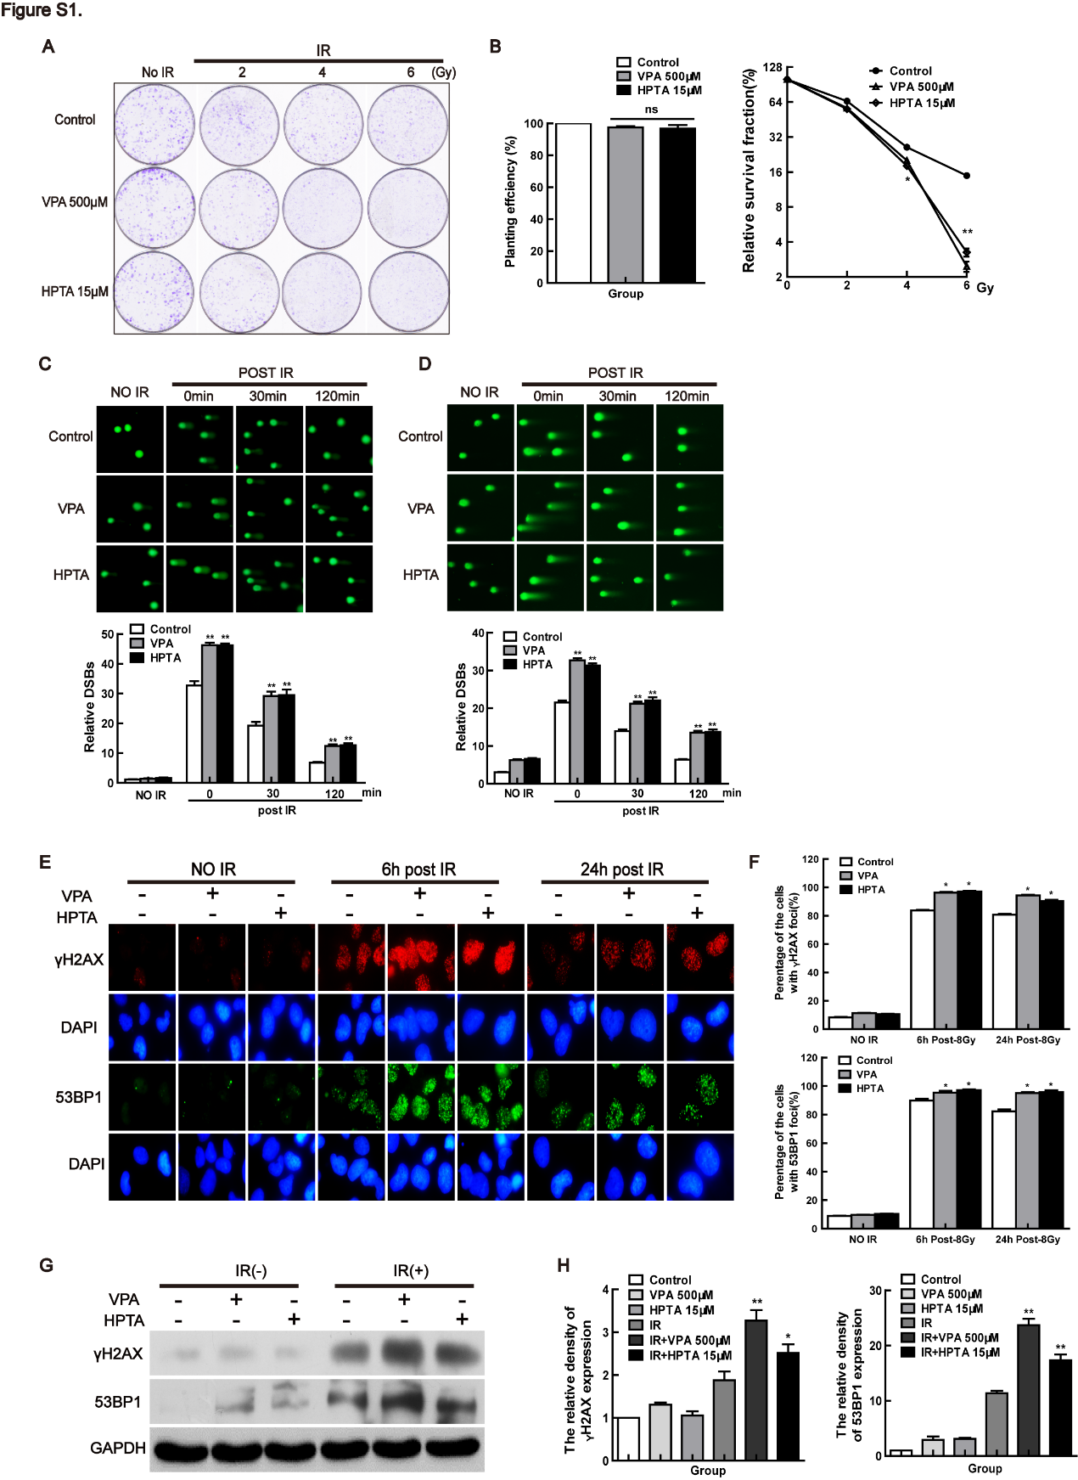
Supplementary Figure. 1 HPTA results in the accumulation of more DSBs in response to radiation
(A)Representative results of clonogenic survival in EUFA423 cells treated with VPA and HPTA alone or the combination treatment of VPA and HPTA with different doses of 0, 2, 4, or 6Gy. (B)The planting efficiency (left) and surviving fraction (right) of the clonogenic survival assay in EUFA423 cells. (C) The alkaline comet assay was used for the analysis of DNA DSBs in EUFA423 cells (upper) and the relative DSBs were analyzed after correcting the data (down). (D) The neutral comet assay was used for the analysis of DNA DSBs in EUFA423 cells (upper) and the relative DSBs were analyzed after correcting the data (down). (E) The dynamic change of IR-induced γH2AX and 53BP1 foci formation in EUFA423 cells treated with 500μM VPA and 15μM HPTA was observed after 8Gy treatment. The images represent γH2AX and 53BP1 foci formation in the VPA/HPTA-treated cells at pre-8Gy, 6 h and 24 h post-8Gy, DAPI was used for nuclear staining. (F) The percentage of γH2AX (upper) and 53BP1 (down) foci formation was evaluated. (G) The level of γH2AX and 53BP1 in EUFA423 cells was detected by immunoblotting. (H) The density was further analyzed by the Image J in EUFA423 cells. P-values were calculated by Student’s t-test (* P<0.05, ** P<0.01).

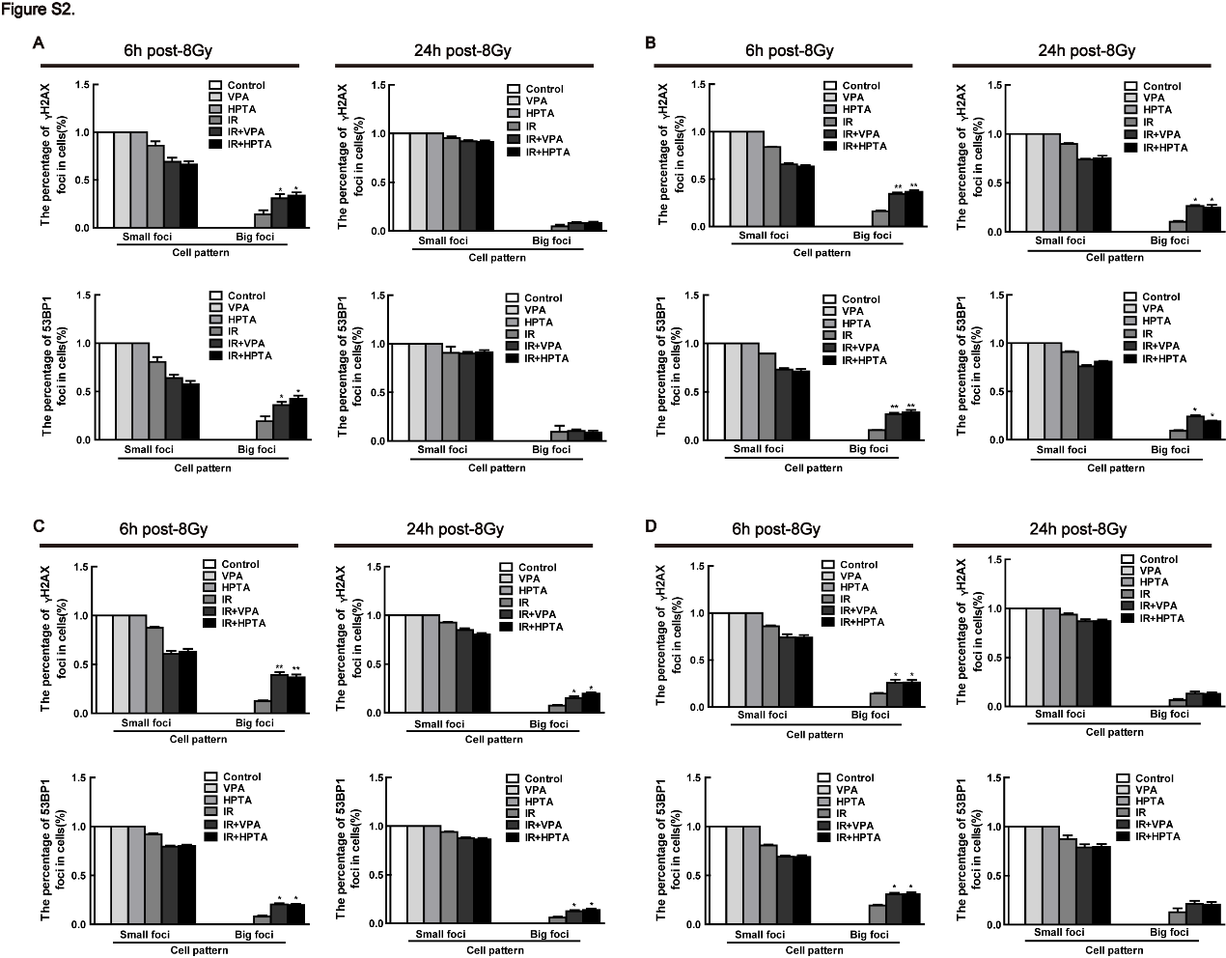
Supplementary Figure. 2 The cells were classified and counted according to the number of foci in immunofluorescence results
For the cells with foci in immunofluorescence experiments, we define the number of foci: ≥20 as big foci and <20 as small foci. (A) In MCF7 cells, cells with γH2AX and 53BP1 foci were analyzed for big or small foci at 6h and 24h after IR. (B) In EUFA423 cells, cells with γH2AX and 53BP1 foci were analyzed for big or small foci at 6h and 24h after IR. (C) In primary cells of the tissue from DMBA-induced breast cancer in rats, cells with γH2AX and 53BP1 foci were analyzed for big or small foci at 6h and 24h after IR. (D) In DMBA-induced transformed human normal breast cell line, cells with γH2AX and 53BP1 foci were analyzed for big or small foci at 6h and 24h after IR. Each data point in the graph was from three independent experiments (mean ± SD); P-Values were calculated by t-test (*P<0.05, ** P<0.01).

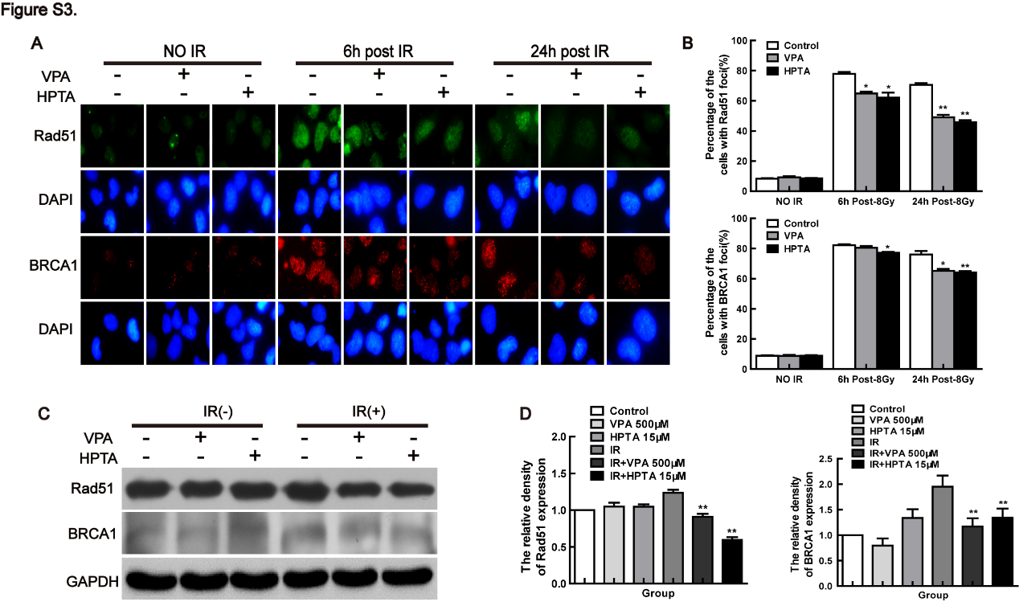
Supplementary Figure. 3 Low dose HPTA dysregulates DNA repair pathway in response to IR-induced DSBs
(A) The dynamic change of IR-induced Rad51 and BRCA1 foci formation in EUFA423 cells treated with 500μM VPA and 15μM HPTA was observed after 8Gy treatment. The images represent Rad51 and BRCA1 foci formation in the VPA/HPTA-treated cells at pre-8Gy, 6 h and 24 h post-8Gy, DAPI was used for nuclear staining. (B) The percentage of Rad51 (upper) and BRCA1 (down) foci formation was evaluated. (C) The level of Rad51 and BRCA1 in EUFA423 cells was detected by immunoblotting. (D) The density was further analyzed by the Image J in EUFA423 cells. Each data point in the graph was from three independent experiments (mean ± SD); P-Values were calculated by t-test (*P<0.05, ** P<0.01).

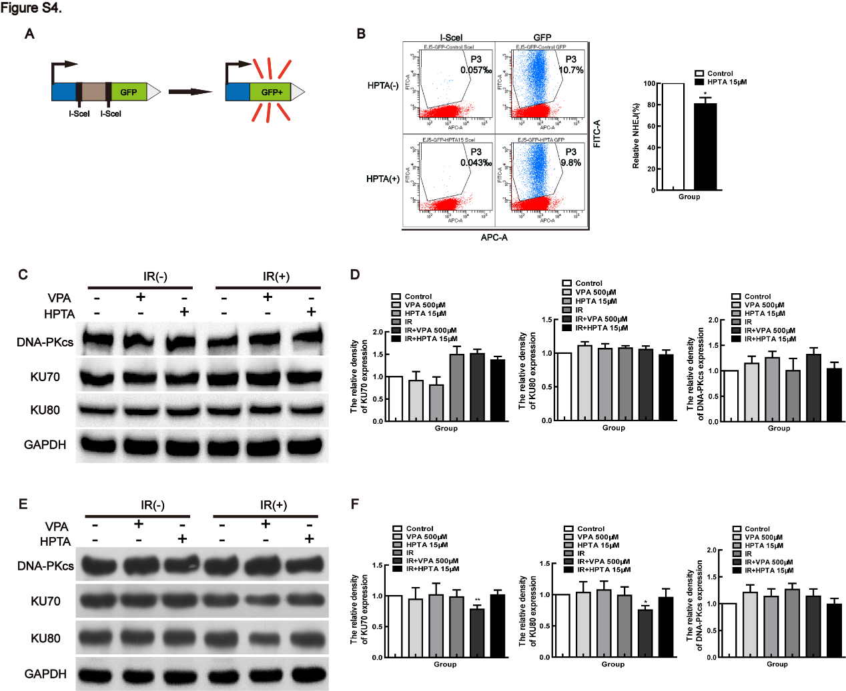Supplementary Figure. 4 The role of HPTA in NHEJ repair pathway in response to IR-induced DSBs
(A) The working schematic of the EJ5-GFP reporter for the NHEJ assay is presented. (B) U2OS cells expressing EJ5-GFP were transfected with the plasmid of I-SceI or GFP and then treated with 15μM HPTA for 24 h. GFP was used as a positive control to represent transfection efficiency. The results of NHEJ frequency in HPTA-treated cells as measured by flow cytometry are shown in the images. (C) The NHEJ-associated proteins, such as DNA-PKcs, Ku70 and Ku80, in VPA/HPTA-pretreated cells were detected before and after 8Gy treatment in MCF7 cells. GAPDH was used as a loading control. (D) The density was further analyzed by the Image J in MCF7 cells. (E) The NHEJ-associated proteins, such as DNA-PKcs, Ku70 and Ku80, in VPA/HPTA-pretreated cells were detected before and after 8Gy treatment in EUFA423 cells. GAPDH was used as a loading control. (F) The density was further analyzed by the Image J in EUFA423 cells. Each data point in the graph was from three independent experiments (mean ± SD); P-Values were calculated by t-test (*P<0.05, ** P<0.01).

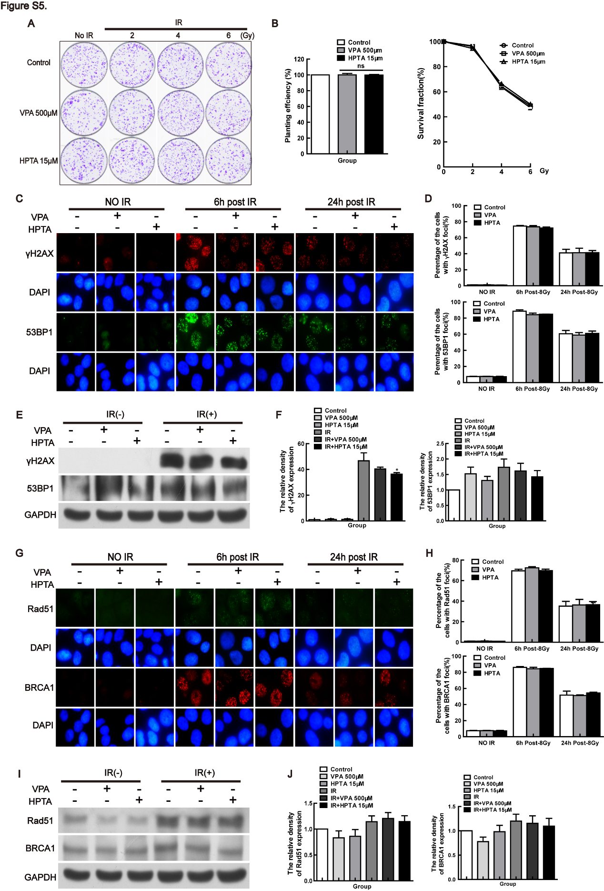
Supplementary Figure. 5 The role of HPTA on human normal breast cell line
(A) Representative results of clonogenic survival in MCF10A cells treated with VPA and HPTA alone or the combination treatment of VPA and HPTA with different doses of 0, 2, 4, or 6Gy. (B)The planting efficiency (left) and surviving fraction (right) of the clonogenic survival assay in MCF10A cells. (C) The dynamic change of IR-induced γH2AX and 53BP1 foci formation in MCF10A cells treated with 500μM VPA and 15μM HPTA was observed after 8Gy treatment. The images represent γH2AX and 53BP1 foci formation in the VPA/HPTA-treated cells at pre-8Gy, 6 h and 24 h post-8Gy, DAPI was used for nuclear staining. (D) The percentage of γH2AX (upper) and 53BP1 (down) foci formation was evaluated. (E) The level of γH2AX and 53BP1 in MCF10A cells was detected by immunoblotting. (F) The density was further analyzed by the Image J in MCF10A cells. (G) The dynamic change of IR-induced Rad51 and BRCA1 foci formation in MCF10A cells treated with 500μM VPA and 15μM HPTA was observed after 8Gy treatment. The images represent Rad51 and BRCA1 foci formation in the VPA/HPTA-treated cells at pre-8Gy, 6 h and 24 h post-8Gy, DAPI was used for nuclear staining. (H) The percentage of Rad51 (upper) and BRCA1 (down) foci formation was evaluated. (I) The level of Rad51 and BRCA1 in MCF10A cells was detected by immunoblotting. (J) The density was further analyzed by the Image J in MCF10A cells. Each data point in the graph was from three independent experiments (mean ± SD); P-Values were calculated by t-test (*P<0.05, ** P<0.01).

