Supplementary material

UV-Vis spectrophotometry coupled to chemometric analysis for the evaluation of atrazine photolysis and photocatalysis

Ailton. J. Moreira ^{1,2*}, Sherlan G. Lemos ³, Dyovani Coelho ¹, Lucia H. Mascaro ¹, Gian P. G. Freschi ², Ernesto C. Pereira ¹

¹Chemistry Dept. - Universidade Federal de São Carlos, São Carlos – SP, Brazil.
²Universidade Federal de Alfenas, Campus Poços de Caldas - MG, Brazil.
³Department of Chemistry, Federal University of Paraíba, João Pessoa – PB, Brazil

*Corresponding author. Tel.: +55 16 3351-8214.
E-mail address: aijomoquim@gmail.com (Ailton J. Moreira)

Calibration curve and figures of merit for atrazine and by-products after HPLC analyzes.
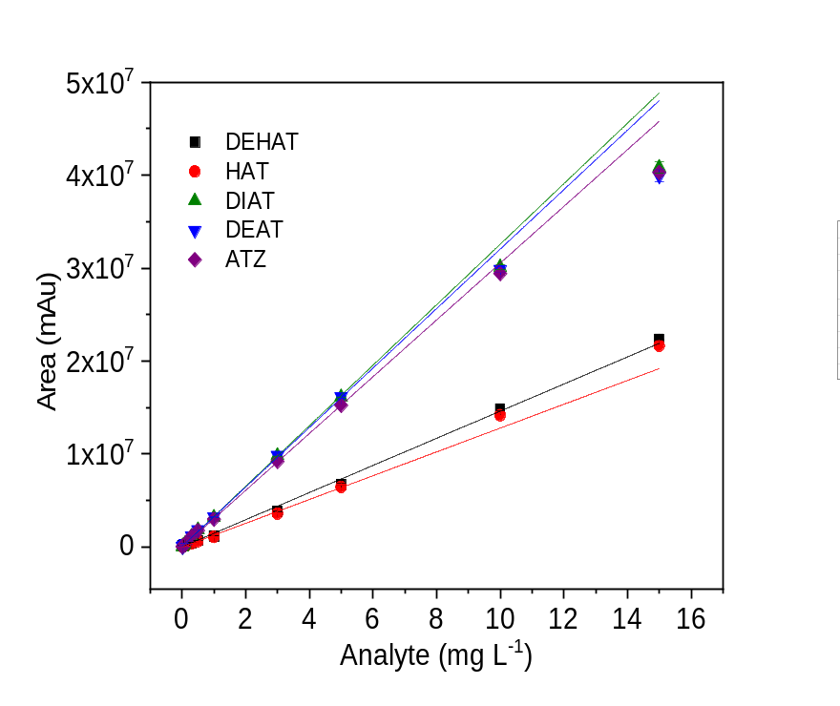
Analyte | intercept | slope | R² | LOD /LOQ (mg L⁻¹)
DEHAT | 17966.0277 ± 51536.49194 | 1.45929E6 ± 31170.10458 | 0.9959 | -
DIHAT* | - | - | - | -
HAT | -14625.53142 ± 29351.89647 | 1.28049E6 ± 45031.54675 | 0.9890 | 0.1444 / 0.4814
DIAT | 31909.12944 ± 28435.04123 | 3.25466E6 ± 74716.54484 | 0.9953 | 0.0133 /0.0442
DEAT | 63566.92368 ± 37407.03564 | 3.19861E6 ± 78054.74496 | 0.9947 | 0.0087 / 0.0290
ATZ | -3041.67496 ± 19885.77831 | 3.05391E6 ± 20424.07443 | 0.9996 | 0.1953 / 0.6510
* not calculated

Fig. S1. Chromatographic profile obtained after analysis of the (3 mg L⁻¹) standard solution of ATZ, HAT, DIAT, DEAT, DIHAT, DEHAT, or white of deionized water.

