Enhancing Tobacco Productivity and Phytochemical Quality through Optimized Nitrogen and Amino Acid Foliar Applications
Hayder Ramadhan Alhasnawi¹, Mahdi Ayyari¹, Hossein Dehghan², Arman Beyraghdar Kashkooli^{1*}
¹Department of Horticultural Science, Faculty of Agriculture, Tarbiat Modares University, PO Box 14115-336, Tehran, Iran
²Medicinal Plants Research Center, Shahed University, Tehran, Iran
Corresponding Author: Dr. Arman Beyraghdar Kashkooli
Email: a.beyraghdar@modares.ac.ir
ORCIDs:
Hayder Ramadhan Alhasnawi: 0009-0003-4830-8426: hr.ramazan73@gmail.com
Mahdi Ayyari: 0000-0001-9332-9574: m.ayyari@modares.ac.ir
Hossein Dehghan: 0000-0003-4250-7769: h.dehghan@shahed.ac.ir
Arman Beyraghdar Kashkooli: 0000-0002-4029-9671: a.beyraghdar@gmail.com, a.beyraghdar@modares.ac.ir

Enhancing Tobacco Productivity and Phytochemical Quality through Optimized Nitrogen and Amino Acid Foliar Applications
Abstract

Tobacco (Nicotiana tabacum), an economically and industrially important crop, was evaluated to determine the effects of foliar applications of nitrogen fertilizers and specific amino acids (arginine, ornithine, and aspartic acid) on yield, morphological, physiological, and phytochemical traits across four varieties (Burley, Basma, BT, and Virginia) over two growing seasons. Foliar treatments included urea, ammonium nitrate, and amino acids applied individually and in combinations at varying concentrations. Results demonstrated that nitrogen foliar application, particularly urea at 2%, significantly enhanced growth, chlorophyll content, and yield, especially in the Burley variety. In contrast, amino acid treatments, especially the combined application of arginine, ornithine, and aspartic acid, effectively increased secondary metabolites including essential oils, total phenolics, flavonoids, antioxidant activity, and nicotine content. The Basma variety showed the highest essential oil (0.28%) and nicotine concentration (16.1 mg/g), while Burley exhibited superior phenolic, flavonoid, and antioxidant levels under amino acid treatments. These findings indicate that integrating optimized nitrogen fertilization with targeted amino acid foliar applications can simultaneously improve both productivity and phytochemical quality, offering a sustainable strategy for enhancing the agronomic and industrial traits of tobacco.
Keywords: Amino acids, Essential oil content, Foliar application, Nicotine, Nitrogen fertilizers, Yield
Introduction
The Solanaceae family encompasses a wide range of species known for their pharmacological and industrial importance, offering diverse therapeutic and economic benefits ¹. Among them, Nicotiana tabacum L., commonly known as tobacco, represents one of the most significant cultivated species worldwide. Although more than 60 Nicotiana species have been identified, only N. tabacum and N. rustica are commercially cultivated for human use ². N. tabacum is an annual or short-lived perennial herbaceous plant and the primary natural source of nicotine. Beyond its use in smoking products, tobacco has long been recognized for its wide spectrum of medicinal properties, including antibacterial, antifungal, antinociceptive, antimicrobial, anthelmintic, and neuroprotective effects ³. The quality of cured tobacco leaves is determined by a complex interplay of visual, physical, and chemical traits ⁴. Morphological characteristics such as leaf size, color, texture, and aroma, together with chemical parameters like nicotine, nitrogen, nitrate, and phenolic contents, play a central role in defining both the functional quality and market value of tobacco ⁵. Species of the Nicotiana genus are rich in diverse phytochemical metabolites, including pyridine alkaloids (notably nicotine), terpenoids, aromatic compounds such as limonene and indole, and phytosterols ⁶. They also produce flavonoids, volatile cembranoid compounds, and hydroxygeranyllinalool diterpene glycosides ⁷, which contribute to the plant’s aroma, bioactivity, and pharmacological value.
Nicotine biosynthesis in tobacco is primarily driven by nitrogen metabolism, involving amino acids such as arginine, ornithine, and aspartate. Arginine is converted to ornithine by arginase, and through a series of enzymatic reactions particularly those catalyzed by nicotine synthase nicotine is synthesized ⁸. Aspartic acid and nitrogen availability further influence this pathway, linking nutrient status to secondary metabolite production ⁹. Therefore, nitrogen not only serves as a vital macronutrient for plant growth and metabolism but also plays a key role in the synthesis of bioactive compounds that define tobacco quality ¹⁰. Given the economic and pharmaceutical importance of tobacco, enhancing both its quantitative and qualitative attributes is a major agricultural goal, particularly in regions where domestic production cannot meet industrial demand ¹¹. Foliar application of nitrogen-based fertilizers and amino acids has emerged as a promising approach to improve morphological, physiological, and phytochemical traits. Amino acids such as ornithine, arginine, and aspartate may further stimulate nutrient uptake, stress tolerance, and secondary metabolite accumulation ¹². Despite growing evidence of these benefits, limited research has examined the combined effects of different nitrogen sources and amino acids on the morphology, physiology, nicotine concentration, total phenolic content, and antioxidant capacity of tobacco.
To address this gap, the present study investigates the effects of foliar application of various nitrogen forms (ammonium nitrate and urea) and selected amino acids (ornithine, arginine, and aspartate) on the morphological, physiological, and phytochemical traits of Nicotiana tabacum grown under field conditions over two consecutive growing seasons. The findings aim to provide valuable insights into optimizing nutrient management strategies that enhance plant growth, bioactive compound synthesis, and environmental sustainability.
Results and Discussion
Morphological analysis and yield
The maximum value of leaf length (LL), and leaf width (LW) between years of cultivation were observed in Y2 (second year) and maximum amount of stem height (SH), leaves number (LN) and yield (Y) were obtained in Y1 (first year) (Figure 1S A-G). The maximum value of LL, LW, SH, LN, and Y between tobacco verities were observed in Br (Burley) with 54.2 cm (Figure 2A), 26.3 cm (Figure 2B), 165.2 cm (Figure 2C), 28.2 (Figure 2D) and 6156.5 kg/ha-1 (Figure 2G), respectively. The highest level of leaf fresh weight (FW) and leaf dry weight (DW) between verities were observed in Vr (Virginia) with 1.18% (Figure 2E) and 0.36% (Figure 2F). The minimum values of LL (24.16 cm), LW (14.15 cm), and FW (0.94%) were obtained from Ba (Basma), also the lowest level of SH, DW, and Y related to BT (Figure 2).
The highest value of LL, SH, LN, FW and Y between types of treatments sprayed were observed in UR1 (Urea 2%) with 47.6 cm (Figure 3A), 177.8 cm (Figure 3C), 30.8 (Figure 3D), 1.18% (Figure 3E), and 6085.4 kg/ha-1 (Figure 3G), respectively. The maximum value of LW obtained in Mix2 (combination of Arginine, Ornithine and Aspartic acid 2 mg/lit) with 27.8 cm (Figure 3B) and the highest level of DW was belonged to N2 (Ammonium nitrate 4%) with 0.36% (Figure 3F). The lowest amounts of LL, LW, SH, LN, and FW belonged to the As1 sample (Aspartic acid 1 mg/lit) with 38.3 cm, 18.1 cm, 130.2 cm, 21.4 and 0.96 %, respectively (Figure 3). The minimum level of DW and Y were obtained in As2 (Aspartic acid 2 mg/lit) and Mix2 with 0.27% and 5833 kg/ha-1 (Figure 3).
The foliar application of N is one of the improved N management practices with least N loss to meet its requirement efficiently ¹³. Both inadequate N supply and inordinate N supply may significantly affect the yield and quality of tobacco ¹⁴. As the results show, LL, LW, SH, LN, FW, DW, and Y were increased significantly relative to the control plants by foliar Application of N in the form of urea and Ammonium nitrate. In fact, the main method to increase crop yields is the application of mineral fertilizers such as nitrogen. In similar study, N supply stimulated the growth of the plant, as reflecting by a significant increase in plant growth parameters such as plant height, stem dry weight, leaf dry weight and total biomass ^{14,15}. It was reported that the leaf length and leaf width are very responsive to nitrogen supply. On the other hand, nitrogen supply resulted in stimulation in stem height (SH) which is consistent with the results of Li, et al. ¹⁶. In pervious study, the foliar application of Urea (CH₄N₂O) significantly affected the number of leaves, fresh and dry weight of Burley variety of tobacco ¹⁷. The exogenous N is predominantly applied in the form of urea to plants and is rapidly absorbed from the surface of leaves with the help of specialized transporters such as degradation of urea (DUR3), it is hydrolyzed by urease into ammonia which in turn is assimilated into amino acids ¹⁸. In fact for morphological properties, Burley variety of tobacco showed the best performance in LL, LW, SH, LN, and yield.
Physiological analysis
The greatest amount of chlorophyll b (Chl b), total chlorophyll (Chl T), and SPAD between years of cultivation were observed in Y2 (Figure 4S B, C, E). The maximum value of Chl a, Chl b, Chl T, and Car (carotenoid) between tobacco verities were achieved in Burley with 5.65 (Figure 5A), 1.94 (Figure 5B), 6.9 (Figure 5C), and 1.83 (Figure 5D), respectively, while, Virginia showed the minimum value of Chl a, Chl b, Chl T, and Car. Also, the BT variety had a maximum amount of SPAD with 7.3 (Figure 5E). Chl a and Chl b ranged from 3.05 to 5.77 and 0.95 to 2.1 while Chl T, Car and SPAD varied from 5.2 to 7.94, 1.25 to 2.0 and 0.95 to 2.1 between types of treatments sprayed (Figure 6). The highest value of Chl a, Chl b, Chl T, and Car between types of treatments sprayed were observed in N1 with 5.77 (Figure 6A), 2.09 (Figure 6B), 7.94 (Figure 6C), and 2.0 (Figure 6D), respectively. The sample of N2 had the lowest amount of chlorophyll a and carotenoid with 3.05 and 1.25. Also, the minimum value of Chl b, Chl T, and SPAD were seen in As2, Ar2 (Arginine 2 mg/lit), and Con (control), respectively (Figure 6). As a results of physiological responses of N. tabacum cultivated in the field, the foliar application of N (Ammonium nitrate and Urea) significantly affected the chlorophyll a, b, T and carotenoid (Figure 6). The increase in chlorophyll content may be attributed to the roles of N in the synthesis of proteins and enzymes and the uptake of minerals including magnesium, among others ¹⁹. In pervious study, spraying with N resulted in improved chlorophyll content and inhibited chlorophyll degradation ²⁰. Increases in N availability have has been shown to correspond with increased leaf chlorophyll content ¹⁵. Nitrogen is a component of several metabolic compounds as well as chlorophyll, cell walls, enzymes, hormones, nucleic acids, proteins and vitamins. In fact, exogenous foliar spraying of N enhanced the chlorophyll content and improved the maximal quantum yield of photosystem II photochemistry (Zhang et al., 2019). In Chlorophyll content of leaves (SPAD values), the maximum amount was showed in Ar1 and Ar2 (Fig 6E). In a study of tomato, arginine significantly increased the mean of total chlorophyll concentration. This can be attributed to the fact that arginine is an important nitrogen source for the formation of chlorophyll ²¹. Observations in this study revealed that the application of foliar N can increase the chlorophyll content in N. tabacum leaves.
EOs content
The EOs content in plant samples was significantly influenced by both the plant variety and the applied foliar treatments. Hydrodistillation of N. tabacum leaves yielded essential oil in the range of 0.1–0.2% (w/w, based on dry weight) for the Burley variety, 0.2–0.28% for Basma, 0.11–0.2% for BT, and 0.1–0.16% for Virginia Figure 7A-H.
The essential oil yield in the Basma variety was approximately 50–70% higher than that of the Burley, BT, and Virginia varieties. In all three tobacco varieties, the highest essential oil content was generally observed in the amino acid foliar treatments compared to nitrogen treatments. Furthermore, in both years of tobacco cultivation, the EOs content under nitrogen foliar treatments was lower than in the control treatment. In the Basma variety, this reduction reached up to approximately 25% in some cases. A comparison of EOs across samples from the two cultivation years showed that the overall yield was lower in the second year compared to the first, although the trend remained relatively consistent. There are several studies on the essential oils of tobacco varieties. For instance, Palic, et al. ²² reported that the EO content of tobacco leaves ranged from 0.06% to 0.8% (w/w). The increase in essential oil production following amino acid treatments suggests that these treatments may have induced a stress response in the tobacco plants ²³. Previous studies also support the positive effects of amino acids on the content of essential oils in various plant species such as Petroselinum crispum, Nigella sativa and Satureja hortensis ²⁴. Consistent with our findings, ²⁵ revealed that foliar application of urea had no significant effect on EOs content in Ocimum basilicum L., whereas amino acid application led to a substantial increase in essential oil production. Similarly, Tarraf, et al. ²⁶ reported that foliar application of 1.25 g/L amino acids mixture in fenugreek led to an increase in essential oil production. In contrast to our findings, Abd El-Aal ²⁷ reported that foliar application of amino acids in soybean enhanced oil and fatty acid content, with a more pronounced effect in the second growing season, suggesting a possible influence of environmental or temporal factors. However, in our study, the EO content in the control treatment also showed a slight decrease in the second year compared to the first year. Given these findings, foliar application of amino acids can be recommended as an effective alternative to conventional soil fertilization, potentially reducing nitrogen leaching ²⁵. If the primary goal is to enhance essential oil production, amino acid spraying has shown significantly better results in tobacco compared to nitrogen-based fertilizers. This enhanced effect may be related to the involvement of amino acids in the biosynthetic pathways of secondary metabolites, contributing more directly to essential oil synthesis in N. tabacum ²⁸.

Content of total phenolic and flavonoids
Total phenolic compounds were significantly influenced by both the plant variety and the applied foliar treatments. The results of evaluating total phenol changes in different tobacco varieties during the first and second years of cultivation showed that foliar application treatments with amino acids, especially mixed amino acids (Mix), resulted in higher phenol levels compared to nitrogen treatments. In the Barley variety during the first year of cultivation, the highest TPC was observed in Mix1 and Mix2 treatments, with an average of 15.5 mg GAE/g DW (Table 1). This value was 50% higher than the control treatment and more than 100% higher compared to the urea and ammonium nitrate treatments. In the second year of cultivation, the Barley variety also showed the highest TPC in the Mix2 treatment, with an average of 18.1 mg GAE/g DW, while the urea treatment exhibited the lowest phenol content among all treatments. In the Basma variety, the highest TPC in the first year of cultivation was obtained in the Mix2 treatment with a value of 15 mg GAE/g DW, while in the second year, the highest value was recorded in the As2 treatment with 14.1 mg GAE/g DW (Table 2). In the BT variety, the highest TPC in the first year of cultivation was obtained in the Mix2 treatment with a value of 14.5 mg GAE/g DW, while in the second year, the highest value was recorded in the in the Mix2 treatment with 17.0 mg GAE/g DW (Table 3). In the Virginia variety, the highest TPC in the first year of cultivation was observed in the Mix and Ornithine 1 mg/lit treatments, both with a value of 13.5 mg GAE/g DW, while in the second year, the highest value was recorded in the Mix2 treatment with 12.5 mg GAE/g DW Table 4.
The results of flavonoid variation analysis in the Barley variety showed that the highest TFC was obtained in the Mix2 and Ornithine treatments, with an average of 12.6 mg QE/g DW in the first year and 11 mg QE/g DW in the second year of cultivation (Table 1). Notably, the difference between the highest TFC observed in the Mix and Ornithine treatments and the lowest level recorded in the nitrogen treatments was nearly twofold, indicating a substantial impact of treatment type on flavonoid accumulation. In the Basma variety, the TFC obtained in the first year of cultivation was approximately the same in the control and nitrogen treatments, with values around 7.5 QE/g DW. In contrast, the highest flavonoid levels were recorded in the Mix and Aspartic acid treatments during the same year (Table 2). In the BT variety, the highest flavonoid content in the first and second years of cultivation was obtained in the ornithine and mixed treatments (Table 3).
In the Virginia variety, the highest TFC was obtained in the Mix2 treatment, with an average of 12.1 mg QE/g DW in the first year and Mix2 and Ornithine treatments in the second year of cultivation (Table 4). A comparison of phenol content and flavonoid across the cultivated varieties over both years indicated a consistent trend, with amino acid treatments resulting in a significant increase in phenol and flavonoid levels in tobacco compared to both the control and nitrogen treatments. In a study conducted by ²⁹, the phenolic content in tobacco varied between 4.5 mg GAE/g DW and 23 mg GAE/g DW, depending on the plant organ. Based on the findings of Nasr, et al. ²⁹, the flavonoid content in tobacco ranged from 1.17 to 4.17 mg QE/g DW, showing considerable variation among different plant organs. In line with our study, Taraseviciene, et al. ³⁰ investigated the effects of foliar application of amino acids on M. piperita, and their results showed that total phenol content increased by 1.22- to 3.51- times, depending on the treatment and mint variety. In a similar study on brassica oleracea, foliar application of amino acids at 300 mg/L significantly increased phenolic compounds, flavonoids, and other biochemical traits compared to the control ³¹. Contrary to our results, Jahanbani, et al. ²⁵ reported that foliar application of urea at 1 g L⁻¹ increased total phenol and flavonoid contents in basil, while a higher concentration (2 g L⁻¹) had no further effect. These differences may be attributed to the physiological nature of the plant, environmental influences, interactions between the plant and the applied fertilizer, and climatic factors ³². Foliar application of amino acids like ornithine, arginine, and aspartate can enhance phenolic and flavonoid content more effectively than inorganic fertilizers due to their direct role as metabolic precursors and regulators in secondary metabolite biosynthesis ³³. Additionally, these amino acids improve nitrogen use efficiency and activate stress-related pathways that stimulate phenol production in plants ³⁴.
Antioxidant capacity
Analysis of antioxidant activity in tobacco cultivars over two consecutive years revealed that plants treated with the amino acid mixture (Mix) exhibited the highest free radical scavenging potential. In the first year of cultivation, the mean antioxidant activity was recorded as IC₅₀ 32.0 μg/ml using the DPPH assay and 47.0 mg Fe²⁺/g DW using the FRAP assay, whereas the lowest antioxidant potential was observed under the 4% urea (UR4%) treatment (Table 1). Similar to the first year, the highest AA in the barley variety during the second year of cultivation was again observed under the amino acid mix2, with mean values of approximately 29.4 IC₅₀ μg/ml and 53.1 mg Fe²⁺/g DW based on the DPPH and FRAP assays, respectively. In the Basma variety, antioxidant activity varied from 40 to 104 IC₅₀ in the DPPH assay and from 15.9 to 40.1 mg Fe²⁺/g in the FRAP assay (Table 2). In the BT variety, antioxidant activity varied from 33.7 to 87.5 IC₅₀ in the DPPH assay and from 18.9 to 45.3 mg Fe2⁺/g in the FRAP assay (Table 3). In the Virginia variety, as in the other two varieties, foliar treatments with amino acids demonstrated significantly higher radical scavenging activity (IC₅₀ 38.4 and 40.1 mg Fe²⁺/g DW in Mix) in tobacco plant extracts compared to both the control and nitrogen-based treatments (Table 4). Other research has determined that the tobacco metanolic extract were an excellent antioxidant that contains a strong ability to scavenge DPPH free radicals with 18.2 mg AAE/g DW, total phenolic content (24.82 mg GAE/g DW) and total flavonoid content (4.42 mg QE/g DW) ³⁵. Previous studies have reported a strong positive correlation between phenolic compounds, flavonoids, and antioxidant activity, suggesting that increases in these metabolites contribute significantly to the plant's overall antioxidant potential ³⁶. According to Aboalhaija, et al. ³⁷, a lower IC₅₀ value in the DPPH assay reflects stronger antioxidant activity, which is often associated with higher levels of phenolic compounds and flavonoids. In a similar study, foliar application of amino acids was found to enhance the levels of phenolic compounds, total flavonoids, and antioxidant activity in Achillea millefolium L. ³⁸ and lettuce leaves ³⁹. Amino acids like arginine, ornithine, and aspartate not only provide nitrogen but also act as signaling molecules that activate antioxidant pathways, unlike urea and nitrate which mainly support growth without triggering phenolic synthesis ⁴⁰. Amino acids contribute to enhancing plant resilience by supporting redox balance, acting as osmoprotectants, and modulating key pathways involved in secondary metabolite production and stress adaptation ⁴¹. It was the amino acid treatments that consistently enhanced the phenolic and flavonoid content in tobacco across both growing seasons, along with a notable increase in antioxidant capacity. These results suggest that amino acid application offers a more effective and sustainable alternative to conventional mineral fertilizers for improving the phytochemical quality of tobacco.
HPLC Analysis
The standard curve of nicotine standards showed linearity in the range of 1-50μg/ml (Figure 8A) with a linear equation of y = 404574.7x + 58782 as obtained in linear regression analysis. The coefficient of correlation was r=0.9999855 and godness of fit R2=0.9999711. This was in well agreement with USP recommendation of R2> 99%. The nicotine concentration of N. tabacum was significantly influenced by both the plant variety and the applied foliar treatments. During the first year of cultivation, nicotine levels in the Barley variety varied between 5.6 mg/g DW in the control treatment and 11.6 mg/g DW in the Mix2 treatment (Figure 10A). In the second year of cultivation, similar trends were observed, with nicotine content ranging from 4.9 mg/g DW in the control treatment to 9.2 mg/g in the Mix2 treatment (Figure 10B). In both cultivation years, amino acid foliar treatments significantly enhanced nicotine production, showing increases of over 100% compared to nitrogen treatments (Figure 9A-H). Outstanding results were observed in the Basma variety, with the highest nicotine content 16.1 mg/g DW recorded under the Mix2 treatment in the first year, exceeding all other treatments in both cultivation years (Figure 9). Additionally, the lowest nicotine content in both cultivation years was observed in the control treatment.
The changes in nicotine content in the BT variety under different foliar application treatments were very similar to those observed in the Basma variety (Figure 9E, 9F). Nicotine content analysis in the Virginia variety during the first cultivation year revealed that the lowest value occurred in the control treatment, whereas the Aspartic acid and Mix treatments resulted in the highest concentrations with 10.9 mg/g DW a trend that was also observed in the second year with slight variations (Figure 9). One of the observed results was the higher nicotine content in the Basma variety compared to the Barley and Virginia varieties, consistently showing the highest nicotine levels across both growing seasons.
In comparison with HPLC results, Shekhar ⁴² reported the amount of nicotine per tobacco leaf extract ranged from 1.34 to 2.22%. Also, the nicotine content of areal part tobacco was 15.4 mg/g DW ⁴³. As shown in Fig. 10, nicotine content showed a decreasing trend in the second growing season, which may be attributed to environmental conditions, seasonal variability, and other physiological or agronomic factors ⁴⁴. To the best of our knowledge, no prior studies have specifically examined the impact of foliar-applied amino acids on nicotine content in tobacco. Therefore, this research represents a novel contribution to understanding how amino acid treatments may influence alkaloid biosynthesis in this crop. In contrast to our findings, Xi, et al. ⁴⁵ reported that nitrogen fertilizer application under greenhouse conditions led to an increase in nicotine accumulation in tobacco tissues. The combined foliar application of arginine, ornithine, and aspartate likely enhances nicotine synthesis by providing key precursors and activating enzymes such as ornithine decarboxylase and putrescine N-methyltransferase ^{46,47}. These amino acids may by support polyamine and pyrrolidine ring formation, increasing metabolic flux toward nicotine biosynthesis more effectively than inorganic nitrogen sources. Foliar application of amino acids proved to be a practical and efficient approach for improving tobacco quality, particularly by enhancing leaf nicotine content. This method offers a promising alternative to traditional nitrogen fertilization with lower environmental impact.

Materials and Methods
Plant material and growing conditions
Tobacco variety Burley, Basma, Virginia BT, and Virginia were grown from seeds in Styrofoam trays with 2.5 × 2.5 cm cells containing a commercial potting mix and maintained in a greenhouse. After one-month seedlings were transplanted into the field and were cultivated. Each plot in the field consisted of a single row which was 3 × 2 m. The seedlings were planted at 46-cm spacing with 9 plants in a plot, and 1-m alleys were maintained between plots. A randomized complete block design was employed with five replications in the field of Tarbiat Modares University (TMU), Tehran, Iran (latitude 35◦44′ 27.227’’N, longitude 51◦9′ 56.737’’E, 1273 m above sea level) in spring of 2022 and 2023. Weeds were removed consecutively, and irrigation was conducted twice a week (Figure 10).
Treatments application
Each of the twelve treatments was replicated three times. The treatments include two forms of nitrogen: Ammonium nitrate (NH₄NO₃) and Urea (CH₄N₂O) in two levels including values 2 % and 4 % and three amino acids consist of Arginine, Ornithine and Aspartic acid in two levels including values 1 and 2 mg/lit along with an equal concentration of combination of three amino acids. The solutions were sprayed by a hand-pump sprayer and made sure each piece of leaf was evenly wet.
Morphological and physiological features
For study the morphological characteristics between different samples, traits such as leaf length (LL), leaf width (LW), stem height (SH), number of leaves (LN), leaf fresh weight (FW) and leaf dry weight (DW) had been measured. Morphological traits were measured under the same conditions and for this research, were used leaf area meter, ruler and balance ⁴⁸. The SPAD CCM-200 Chlorophyll Meter was used in order to determine chlorophyll content (Jiang et al., 2022). Also, the yield (Y) of tobacco was calculated for first and second years ⁴⁹.
Extraction of pigments was carried out in stoppered tubes. Fresh leaves of samples were prepared with a laboratory homogenizer using about 1 g fresh material. Three extraction solutions were used for each sample 90% aqueous methanol solution. Homogenized mixture is separated by centrifugation at 3000 rpm, for 15 minutes. The analytical determination was performed with spectrophotometer at the following wavelengths: 645, 653, 662 and 664 nm, for chlorophyll a and b (according to each extraction solvent) and 470 nm for carotenoid ⁵⁰.
Essential oil content (EOs content)
For determination of essential oil, 50 g of dried leaves of Nicotiana tabacum were extracted by hydrodistillation method using a Clevenger-type for 3 h. EOs content was calculated in percentage (w/w) per air-dried material ⁵¹.
Extraction Methodology
Thirty grams of plant material, previously ground using a laboratory mill were (model: AG 500 g) mixed with 250 mL of 80% methanol. The mixture was subjected to ultrasonic extraction for 60 minutes using an ultrasonic bath (WUC-A03H, Witeg Labortechnik, and Wertheim, Germany). The extract was kept protected from light, filtered through Whatman No. 4 filter paper and concentrated using a vacuum evaporator at a maximum temperature of 40 °C. The resulting thick extract was transferred to Petri dishes and dried in a vacuum desiccator until a constant weight was achieved. Finally, the dried extract was re-dissolved in 80% mthanol for subsequent analyses. Extracts were filtered using filter paper and used for antioxidant capacity, total phenolics and flavonoids.
Quantification of Total Phenolics and Flavonoids
The total phenolic content (TPC) of the extract was measured by a Folin-Ciocalteu assay by partial modifications ⁵² and expressed as mg of Gallic acid equivalents per gram of dry weight of extract (mg GAE/g DW ext). The total flavonoid content (TFC) was determined by the aluminium chloride colorimetric method ⁵³ and expressed as mg of quercetin equivalents dry per gram dried weight of extract (mg QE/g DW Ext).
Antioxidant capacity (DPPH method)
The antioxidant activity (AA) of the methanolic extracts was assessed using the DPPH radical scavenging assay ⁵⁴. Absorbance was measured at 517 nm using a microplate reader (Epoch, BioTek). Radical scavenging capacity (RSC) was calculated using the formula:
Inhibition (%) = [(Ab − As) / Ab] × 100 (1)
Where Ab is the absorbance of the blank and As is that of the sample. The IC₅₀ value, representing the concentration required to inhibit 50% of DPPH radicals, was determined from the dose response curve.
Antioxidant capacity (FRAP method)
The antioxidant capacity of the extracts was measured using the FRAP method ⁵⁵. A mixture of 40 μL extract and 2.5 mL FRAP reagent was incubated at 37 °C for 30 minutes in the dark. Absorbance was read at 593 nm using a microplate reader (Epoch, BioTek). Results were expressed as mg Fe2⁺/g dry weight (DW) based on a standard curve of FeSO4.
Chemicals
High-performance liquid chromatography (HPLC) grade methanol and standards of Nicotine were purchased from Merck (Darmstadt, Germany) and Sigma (Sigma-Aldrich Corporation, MO, USA). Methanol and phosphoric acid of analytical grade were obtained from Merck (Darmstadt, Germany). HPLC grade water was used throughout the analysis.
Extraction and HPLC analysis
Dried leaves of tobacco were extracted for the HPLC analyses according to the method previously reported by Xia, Feng ⁵⁶. The extract was dissolved in HPLC grade methanol (10 mL), filtered through a Millipore filter (0.45 mm) and stored in a refrigerator until analysis. HPLC using a Waters HPLC systemwith empower software, a pump (Waters 600), a Rheodyne7125i six-way injector with 20 μL sample loop and a UV-visdetector (Waters model 2487). A column (Prontosil 120-5C18 AQ 250 × 4.6 mm with precolumn; Knauer, Berlin,Germany) was used for separation20. Chromatogram, retention time, response and other parameters were estimated by Waters breeze 2 software (Figure 8B).
Statistical analysis
Data were analyzed using ANOVA based on a randomized complete block design (RCBD) with five replications in SAS version 9.0. The PROC UNIVARIATE procedure confirmed normality of residuals. Means were compared using the least significant difference (LSD) test at a 5% significance level. Pearson’s correlation analysis was conducted using the SAS 9.0 software.
Conclusion
This integrated analysis highlights the crucial role of foliar nutrition in modulating both the physiological performance and phytochemical composition of tobacco. Foliar application of nitrogen at 2% and 4% concentrations significantly improved growth and yield parameters, particularly in the Burley variety. However, amino acid treatments—especially the combined application of arginine, ornithine, and aspartic acid at 1–2 mg/L—were more effective in enhancing secondary metabolites such as essential oils, total phenolics, flavonoids, and antioxidant activity. Among the studied varieties, Basma exhibited the highest essential oil content and nicotine concentration, indicating its greater responsiveness to amino acid treatments compared with nitrogen-based fertilization. Overall, while foliar nitrogen application supports vegetative growth and productivity, amino acid-based foliar feeding offers superior improvement in phytochemical quality. Therefore, integrating optimized nitrogen and amino acid treatments could provide a balanced and sustainable approach for improving both yield and quality in tobacco cultivation.
Conflict of interest statement
The authors report that there are no competing interests to declare.
Funding
This research received no external funding.
Acknowledgments
We kindly acknowledge Tarbiat Modares University Research Council for supporting this research work.
Author’s contribution statement
H.R.A., A.B.K., and M.A. designed the study. H.D., and M.A. performed the field and laboratory experiments. H.R.A and A.B.K. performed Methodology. A.B.K., M.A., and H.D. analyzed the data. M.A., and H.R.A. wrote the paper with input from all authors.
Data availability
Data are available from the corresponding author and the first author upon reasonable request.

References
1. Zhang, F. et al. Revealing evolution of tropane alkaloid biosynthesis by analyzing two genomes in the Solanaceae family. Nature Communications 14, 1446 (2023).
2. Mehmood, F. et al. Plastid genomics of Nicotiana (Solanaceae): insights into molecular evolution, positive selection and the origin of the maternal genome of Aztec tobacco (Nicotiana rustica). PeerJ 8, e9552 (2020).
3. Balewa, A. T. Phytochemical, antimicrobial and proximate composition of Nicotiana tabacum leaves extract. International Journal of Innovative Science and Research Technology 4, 406-410 (2019).
4. Karaivazoglou, N., Tsotsolis, N. & Tsadilas, C. Influence of liming and form of nitrogen fertilizer on nutrient uptake, growth, yield, and quality of Virginia (flue-cured) tobacco. Field crops research 100, 52-60 (2007).
5. Duangsri, P., Juntarapun, K. & Satirapipathkul, C. in International Conference: Textiles & Fashion. 3-4.
6. Banožić, M., Babić, J. & Jokić, S. Recent advances in extraction of bioactive compounds from tobacco industrial waste-a review. Industrial Crops and Products 144, 112009 (2020).
7. Ge, L. et al. Study progress of radiomics with machine learning for precision medicine in bladder cancer management. Frontiers in Oncology 9, 1296 (2019).
8. Zou, X. et al. Screening of polyphenols in tobacco (Nicotiana tabacum) and determination of their antioxidant activity in different tobacco varieties. ACS omega 6, 25361-25371 (2021).
9. Makhdum, I., Nawaz, A., Shabab, M., Ahmad, F. & Illahi, F. Physiological response of cotton to methanol foliar application. Journal of Research (Science) 13, 37-43 (2002).
10. Raina, R. & Mazahar, S. in Advances in Plant Nitrogen Metabolism 19-27 (CRC Press, 2022).
11. McDaniel, P. A., Smith, E. A. & Malone, R. E. The tobacco endgame: a qualitative review and synthesis. Tobacco Control 25, 594-604 (2016).
12. Kaya, C. & Ashraf, M. Foliar fertilization: a potential strategy for improving plant salt tolerance. Critical Reviews in Plant Sciences 43, 94-115 (2024).
13. Parrey, Z. A. et al. Nitrogen supplementation modulates morphological, biochemical, yield and quality attributes of peppermint. Plants 12, 809 (2023).
14. Jiang, C., Zu, C. & Wang, H. Effect of nitrogen fertilization on growth and photosynthetic nitrogen use efficiency in tobacco (Nicotiana tabacum L.). Journal of Life Sciences 9, 373-380 (2015).
15. Li, Y., Yang, X., Ren, B., Shen, Q. & Guo, S. Why nitrogen use efficiency decreases under high nitrogen supply in rice (Oryza sativa L.) seedlings. Journal of Plant Growth Regulation 31, 47-52 (2012).
16. Li, J.-z., Li, B., Guan, Q. & Gao, J.-m. Signal molecules controlling nitrate uptake by roots. Journal of Plant Interactions 17, 301-308 (2022).
17. Moradi, S., Pasari, B. & Talebi, R. Study of the effects of mycorrhiza, fulvic acid, seaweed extract and urea on physiological traits and leaf yield of tobacco (Burley 21). European Journal of Environmental Sciences 9, 33-40 (2019).
18. Beier, M. P. & Kojima, S. The function of high‐affinity urea transporters in nitrogen‐deficient conditions. Physiologia Plantarum 171, 802-808 (2021).
19. Ali, A. Y. A. et al. Interactive impacts of soil salinity and jasmonic acid and humic acid on growth parameters, forage yield and photosynthesis parameters of sorghum plants. South African Journal of Botany 146, 293-303 (2022).
20. Zhang, R. et al. Foliar applications of urea and melatonin to alleviate waterlogging stress on photosynthesis and antioxidant metabolism in sorghum seedlings. Plant Growth Regulation, 1-10 (2021).
21. Hamid, Z. H., Amer, M. & Wahab, A. Effect of arginine on growth and yield of tomato plant (Lycopersicon esculentum) under drought stress. Plant Arch 19, 4441-4444 (2019).
22. Palic, R., Stojanovic, G., Alagic, S., Nikolic, M. & Lepojevic, Z. Chemical composition and antimicrobial activity of the essential oil and CO2 extracts of the oriental tobacco, Prilep. Flavour and fragrance Journal 17, 323-326 (2002).
23. Fung, T. K., Lau, B. W., Ngai, S. P. & Tsang, H. W. Therapeutic effect and mechanisms of essential oils in mood disorders: Interaction between the nervous and respiratory systems. International Journal of Molecular Sciences 22, 4844 (2021).
24. EL-Zefzafy, M. M., Shahhat, I. M., Yousef, R. S. & Elsharkawy, E. R. Influence of foliar application with amino acids and citric acid on physiological and phytochemical responses of Artemisia abrotanum produced by in vitro culture. Bioscience Biotechnology Research Communications 9, 702-711 (2016).
25. Jahanbani, S., Mumivand, H., Zahedi, B. & Argento, S. Foliar Application of Urea and Amino Acids Regulates Growth, Photosynthesis, Pigments, Antioxidant Activity, and the Essential Oil Content and Composition of Basil (Ocimum basilicum L.). Agronomy 14, 2950 (2024).
26. Tarraf, S. A., Talaat, I. M., El-Sayed, A. E.-K. B. & Balbaa, L. K. Influence of foliar application of algae extract and amino acids mixture on fenugreek plants in sandy and clay soils. Nusantara Bioscience 7 (2015).
27. Abd El-Aal, M. Effect of foliar spray with lithovit and amino acids on growth, bioconstituents, anatomical and yield features of soybean plant. Annals of Agricultural Science, Moshtohor 56, 187-202 (2018).
28. Begum, N. et al. Arbuscular mycorrhizal fungi improve growth, essential oil, secondary metabolism, and yield of tobacco (Nicotiana tabacum L.) under drought stress conditions. Environmental Science and Pollution Research 28, 45276-45295 (2021).
29. Nasr, S. B., Aazza, S., Mnif, W. & Miguel, M. Phenol content and antioxidant activity of different young and adult plant parts of tobacco from Tunisia, dried at 40 and 70 C. Journal of Applied Pharmaceutical Science 4, 023-031 (2014).
30. Taraseviciene, Ž., Velicka, A. & Paulauskiene, A. Impact of foliar application of amino acids on total phenols, phenolic acids content of different mints varieties under the field condition. Plants 10, 599 (2021).
31. Haghighi, M., Barzegar Sadeghabad, A. & Abolghasemi, R. Effect of exogenous amino acids application on the biochemical, antioxidant, and nutritional value of some leafy cabbage cultivars. Scientific reports 12, 17720 (2022).
32. Kanta, C., Kumar, A., Chauhan, A., Singh, H. & Sharma, I. P. in Plant functional traits for improving productivity 41-58 (Springer, 2024).
33 Cheng, J. et al. (2024).
34. Kumar, K., Debnath, P., Singh, S. & Kumar, N. An overview of plant phenolics and their involvement in abiotic stress tolerance. Stresses 3, 570-585 (2023).
35. Wang, H., Zhao, M., Yang, B., Jiang, Y. & Rao, G. Identification of polyphenols in tobacco leaf and their antioxidant and antimicrobial activities. Food Chemistry 107, 1399-1406 (2008).
36. Ahmadi, S. Z., Zahedi, B., Ghorbanpour, M. & Mumivand, H. Comparative morpho-physiological and biochemical responses of Capsicum annuum L. plants to multi-walled carbon nanotubes, fullerene C60 and graphene nanoplatelets exposure under water deficit stress. BMC Plant Biology 24, 116 (2024).
37. Aboalhaija, N. H., Hajjo, R., Afifi, F., Syaj, H. & Abu-Dahab, R. Phytochemical characterization and bioinformatics guided evaluation of antioxidant and cytotoxic effects of Psoralea bituminosa. Scientific Reports 15, 19075 (2025).
38. Shafie, F., Bayat, H., Aminifard, M. H. & Daghighi, S. Biostimulant effects of seaweed extract and amino acids on growth, antioxidants, and nutrient content of yarrow (Achillea millefolium L.) in the field and greenhouse conditions. Communications in Soil Science and Plant Analysis 52, 964-975 (2021).
39. Zhou, W. et al. Foliar application of pig blood-derived protein hydrolysates improves antioxidant activities in lettuce by regulating phenolic biosynthesis without compromising yield production. Scientia Horticulturae 291, 110602 (2022).
40. Tariq, A. et al. Regulation of metabolites by nutrients in plants. Plant ionomics: sensing, signaling, and regulation, 1-18 (2023).
41. Khan, N. Exploring plant resilience through secondary metabolite profiling: Advances in stress response and crop improvement. Plant, Cell & Environment 48, 4823-4837 (2025).
42. Shekhar, R. Estimation of Nicotine in Tobacco Extract Using C8 Column in High Performance Liquid Chromatography. International Journal of Human and Health Sciences (IJHHS) (2023).
43. Vlase, L., Filip, L., Mindrutau, I. & Leucuta, S. Determination of nicotine from tobacco by LC–MS–MS. Studia Universitatis Babes-Bolyai Physica 4, 19-24 (2005).
44. Shahin, M. G. et al. Physiological and agronomic responses and nutrient uptake of soybean genotypes cultivated under various sowing dates. Journal of Soil Science and Plant Nutrition 23, 5145-5158 (2023).
45. Xi, X., Li, C. & Zhang, F. Nitrogen supply after removing the shoot apex increases the nicotine concentration and nitrogen content of tobacco plants. Annals of botany 96, 793-797 (2005).
46. Cai, J., Li, D. & Aharoni, A. The role of long‐distance mobile metabolites in the plant stress response and signaling. The Plant Journal 114, 1115-1131 (2023).
47. Mahmoudi, P., Mohajel Kazemi, E., Mohajjel Shoja, H. & Kolahi, M. Investigating growth responses and expression patterns of nicotine biosynthesis genes in tobacco plants treated with cadmium. Acta Physiologiae Plantarum 47, 1-11 (2025).
48. Partap, M., Gupta, R. C. & Pradhan, S. K. Comparative analysis of morphology and phytochemical constituents in different populations and morphotypes of Datura innoxia Mill. and Datura metel L. from Punjab plains. Asian J Pharm Clin Res 12, 193-199 (2019).
49. Berbeć, A. K. & Matyka, M. Biomass characteristics and energy yields of tobacco (Nicotiana tabacum L.) cultivated in eastern Poland. Agriculture 10, 551 (2020).
50. Costache, M. A., Campeanu, G. & Neata, G. Studies concerning the extraction of chlorophyll and total carotenoids from vegetables. Romanian Biotechnological Letters 17, 7702-7708 (2012).
51. Norani, M., Crowford, A., Tahamtani, Y., Ebadi, M. & Ayyari, M. Extraction and Essential Oils Profiling of Different Dorema ammoniacum D. Don. Organs and Evaluation of Antioxidant Capacity. Journal of Agricultural Science and Technology 25, 701-717 (2023).
52. Michiu, D. et al. Implementation of an analytical method for spectrophotometric evaluation of total phenolic content in essential oils. Molecules 27, 1345 (2022).
53. Sultana, S., Lawag, I. L., Lim, L. Y., Foster, K. J. & Locher, C. A Critical Exploration of the Total Flavonoid Content Assay for Honey. Methods and protocols 7, 95 (2024).
54. Ibrahim, E. A., Omran, A. A. & Salama, Z. A. Evaluation of turkish delight prepared with pigments and essential oils extracted from clementine (Citrus clementine) peels as natural antioxidants. Baghdad Science Journal 19, 9 (2022).
55. Tomasina, F., Carabio, C., Celano, L. & Thomson, L. Analysis of two methods to evaluate antioxidants. Biochemistry and Molecular Biology Education 40, 266-270 (2012).
56. Xia, B. et al. Investigation of the chemical compositions in tobacco of different origins and maturities at harvest by GC–MS and HPLC–PDA-QTOF-MS. Journal of Agricultural and Food Chemistry 62, 4979-4987 (2014).

Table 1. Effect of foliar application of different concentrations of nitrogen and various amino acids includes Arginine, Ornithine and Aspartic acid and an equal concentration of combination of amino acids on total phenolic content (TPC), flavonoid (TFC) and antioxidant activity (DPPH and FRAP) of Burley variety of N. tabacum. Y1: first year of cultivation, Y2: Second year of cultivation, N2%: Ammonium nitrate 2%, N4%: Ammonium nitrate 4%, UR2%: Urea 2%, UR4%: Urea 4%, Ar1: Arginine 1 mg/L, Ar2: Arginine 2 mg/L, Or1: Ornithine 1 mg/L, Or2: Ornithine 2 mg/L, As1: Aspartic acid 1 mg/L, As2: Aspartic acid 2 mg/L, Mix1: Combination of amino acids 1 mg/L, Mix2: Combination of amino acids 2 mg/L.
Variety | Year | Treatments | TPC  (mg GAE/g DW) | TFC  (mg QE/g DW) | DPPH  (IC₅₀ μg/ml) | FRAP  (mg Fe²⁺/g DW)
Burley | Y1 | Control | 10.0^{c} | 9.4^{c} | 50.0^{d} | 30.0^{c}
Burley | Y1 | N2% | 8.1^{d} | 7.4^{d} | 61.7e | 24.3^{d}
Burley | Y1 | N4% | 8.0^{d} | 6.9^{d} | 65.2e | 23.0^{d}
Burley | Y1 | UR2% | 6.4e | 6.5^{d} | 71.4^{f} | 21.0^{d}
Burley | Y1 | UR4% | 5.6e | 5.5^{d} | 84.7^{g} | 17.5e
Burley | Y1 | Ar1 | 12.0^{b} | 11.3^{b} | 44.1^{c} | 34.0^{c}
Burley | Y1 | Ar2 | 12.9^{b} | 11.2^{b} | 40.5^{c} | 37.0^{c}
Burley | Y1 | Or1 | 13.4^{b} | 12.5ª | 36.6^{b} | 41.0^{b}
Burley | Y1 | Or2 | 14.1^{ab} | 12.6ª | 36.1^{b} | 41.5^{b}
Burley | Y1 | As1 | 13.9^{ab} | 11.9^{ab} | 35.7^{b} | 42.0^{b}
Burley | Y1 | As2 | 13.8^{ab} | 11.8^{ab} | 36.2^{b} | 41.4^{b}
Burley | Y1 | Mix1 | 15.4ª | 12.4ª | 31.8ª | 47.1ª
Burley | Y1 | Mix2 | 15.6ª | 12.6ª | 32.0ª | 46.9ª
Burley | Y2 | Control | 12.2^{c} | 8.4^{b} | 44.5^{c} | 33.3^{d}
Burley | Y2 | N2% | 10.1^{d} | 6.6^{c} | 52.0^{d} | 26.9e
Burley | Y2 | N4% | 10.0^{d} | 6.1^{c} | 56.7e | 25.5e
Burley | Y2 | UR2% | 8.2e | 5.9^{c} | 61.6e | 23.3e
Burley | Y2 | UR4% | 7.7e | 4.9^{c} | 72.3^{f} | 18.9^{f}
Burley | Y2 | Ar1 | 14.4^{b} | 10.0ª | 39.8^{b} | 37.7^{cd}
Burley | Y2 | Ar2 | 15.4^{b} | 10.0ª | 36.9^{b} | 41.0^{c}
Burley | Y2 | Or1 | 15.9^{b} | 11.1ª | 33.8^{ab} | 45.5^{b}
Burley | Y2 | Or2 | 16.0^{b} | 11.0ª | 33.4^{ab} | 46.0^{b}
Burley | Y2 | As1 | 16.1^{b} | 10.6ª | 33.1^{ab} | 45.9^{b}
Burley | Y2 | As2 | 15.9^{b} | 10.5ª | 33.5^{ab} | 45.9^{b}
Burley | Y2 | Mix1 | 18.0ª | 11.0ª | 30.0ª | 52.4ª
Burley | Y2 | Mix2 | 18.1ª | 10.9ª | 29.4ª | 53.1ª
Significant differences at P < 0.05 have been indicated with different letters.

Table 2. Effect of foliar application of different concentrations of nitrogen and various amino acids includes Arginine, Ornithine and Aspartic acid and an equal concentration of combination of amino acids on total phenolic content (TPC), flavonoid (TFC) and antioxidant activity (DPPH and FRAP) of Basma variety of N. tabacum.
Variety | Year | Treatments | TPC  (mg GAE/g DW) | TFC  (mg QE/g DW) | DPPH  (IC₅₀ μg/ml) | FRAP  (mg Fe²⁺/g DW)
Basma | Y1 | Control | 9.0^{d} | 7.5^{c} | 61.5^{c} | 27.0^{f}
Basma | Y1 | N2% | 9.0^{d} | 7.3^{c} | 75.9^{d} | 21.9^{g}
Basma | Y1 | N4% | 9.5^{d} | 7.5^{c} | 80.2^{d} | 20.7^{g}
Basma | Y1 | UR2% | 9.5^{d} | 7.5^{c} | 87.9e | 18.9^{g}
Basma | Y1 | UR4% | 10.5^{cd} | 6.9^{c} | 104.2^{f} | 15.9^{h}
Basma | Y1 | Ar1 | 11.5^{c} | 8.4^{b} | 54.3^{b} | 30.6e
Basma | Y1 | Ar2 | 11.4^{c} | 8.5^{b} | 52.0^{b} | 33.3^{d}
Basma | Y1 | Or1 | 11.0^{c} | 8.9^{b} | 42.6ª | 36.9^{b}
Basma | Y1 | Or2 | 11.0^{c} | 8.2^{b} | 44.5ª | 37.3^{ab}
Basma | Y1 | As1 | 12.8^{b} | 10.1ª | 43.9ª | 36.0^{b}
Basma | Y1 | As2 | 12.9^{b} | 10.0ª | 44.6ª | 35.0^{c}
Basma | Y1 | Mix1 | 13.9^{b} | 10.2ª | 40.0ª | 40.1ª
Basma | Y1 | Mix2 | 15.0ª | 10.1ª | 40.1ª | 38.0^{ab}
Basma | Y2 | Control | 10.5^{c} | 7.5^{c} | 56.0^{c} | 7.2^{d}
Basma | Y2 | N2% | 11.0^{c} | 7.3^{c} | 69.1^{d} | 9.1^{c}
Basma | Y2 | N4% | 11.2^{c} | 7.5^{c} | 73.0^{d} | 9.1^{c}
Basma | Y2 | UR2% | 11.0^{c} | 7.5^{c} | 80.0e | 8.6^{c}
Basma | Y2 | UR4% | 11.1^{c} | 6.9^{c} | 94.9^{f} | 8.5^{c}
Basma | Y2 | Ar1 | 12.5^{b} | 8.4^{b} | 50.0^{b} | 11.4^{b}
Basma | Y2 | Ar2 | 12.5^{b} | 8.5^{b} | 48.9^{b} | 11.9^{b}
Basma | Y2 | Or1 | 11.0^{c} | 8.9^{b} | 38.8ª | 12.9^{ab}
Basma | Y2 | Or2 | 12.5^{b} | 8.2^{b} | 40.5ª | 12.4^{ab}
Basma | Y2 | As1 | 14.0ª | 10.1ª | 41.0ª | 13.4ª
Basma | Y2 | As2 | 14.1ª | 10.0ª | 39.1ª | 13.9ª
Basma | Y2 | Mix1 | 12.9^{b} | 10.2ª | 38.0ª | 13.9ª
Basma | Y2 | Mix2 | 13.0^{b} | 10.1ª | 37.0ª | 14.1ª
Significant differences at P < 0.05 have been indicated with different letters.

Table 3. Effect of foliar application of different concentrations of nitrogen and various amino acids includes Arginine, Ornithine and Aspartic acid and an equal concentration of combination of amino acids on total phenolic content (TPC), flavonoid (TFC) and antioxidant activity (DPPH and FRAP) of BT variety of N. tabacum.
Variety | Year | Treatments | TPC  (mg GAE/g DW) | TFC  (mg QE/g DW) | DPPH  (IC₅₀ μg/ml) | FRAP  (mg Fe²⁺/g DW)
BT | Y1 | Control | 9.0^{c} | 8.3^{c} | 53.1^{d} | 28.1^{c}
BT | Y1 | N2% | 7.2^{d} | 6.4^{d} | 64.7e | 26.1^{d}
BT | Y1 | N4% | 7.1^{d} | 5.8^{d} | 68.1e | 26.0^{d}
BT | Y1 | UR2% | 5.5e | 5.6^{d} | 73.3^{f} | 23.1^{d}
BT | Y1 | UR4% | 4.6e | 4.5^{d} | 87.5^{g} | 18.9e
BT | Y1 | Ar1 | 11.0^{b} | 10.2^{b} | 48.0^{c} | 32.0^{c}
BT | Y1 | Ar2 | 11.8^{b} | 10.2^{b} | 42.5^{c} | 35.0^{c}
BT | Y1 | Or1 | 12.4^{b} | 11.4ª | 39.1^{b} | 38.0^{b}
BT | Y1 | Or2 | 13.0^{ab} | 11.4ª | 39.0^{b} | 42.2^{b}
BT | Y1 | As1 | 12.9^{ab} | 10.9^{ab} | 37.5^{b} | 43.0^{b}
BT | Y1 | As2 | 12.7^{ab} | 10.8^{ab} | 39.1^{b} | 40.4^{b}
BT | Y1 | Mix1 | 14.2ª | 11.4ª | 33.7ª | 45.2ª
BT | Y1 | Mix2 | 14.5ª | 11.5ª | 35.1ª | 45.3ª
BT | Y2 | Control | 10.9^{c} | 7.2^{b} | 47.5^{c} | 30.2^{d}
BT | Y2 | N2% | 9.1^{d} | 5.5^{c} | 55.1^{d} | 24.9e
BT | Y2 | N4% | 9.0^{d} | 5.1^{c} | 59.2e | 24.0e
BT | Y2 | UR2% | 7.8e | 4.9^{c} | 62.6e | 21.0e
BT | Y2 | UR4% | 7.0e | 3.7^{c} | 74.1^{f} | 17.1^{f}
BT | Y2 | Ar1 | 13.3^{b} | 9.0ª | 42.7^{b} | 35.2^{cd}
BT | Y2 | Ar2 | 14.4^{b} | 9.0ª | 38.7^{b} | 39.0^{c}
BT | Y2 | Or1 | 14.8^{b} | 10.0ª | 35.7^{ab} | 43.7^{b}
BT | Y2 | Or2 | 15.1^{b} | 10.0ª | 36.2^{ab} | 44.1^{b}
BT | Y2 | As1 | 15.1^{b} | 9.6ª | 36.1^{ab} | 43.9^{b}
BT | Y2 | As2 | 14.9^{b} | 9.6ª | 37.0^{ab} | 43.7^{b}
BT | Y2 | Mix1 | 16.1ª | 10.1ª | 33.1ª | 50.4ª
BT | Y2 | Mix2 | 17.0ª | 10.2ª | 32.2ª | 50.2ª
Significant differences at P < 0.05 have been indicated with different letters.

Table 4. Effect of foliar application of different concentrations of nitrogen and various amino acids includes Arginine, Ornithine and Aspartic acid and an equal concentration of combination of amino acids on total phenolic content (TPC), flavonoid (TFC) and antioxidant activity (DPPH and FRAP) of Virginia variety of N. tabacum.
Variety | Year | Treatments | TPC  (mg GAE/g DW) | TFC  (mg QE/g DW) | DPPH  (IC₅₀ μg/ml) | FRAP  (mg Fe²⁺/g DW)
Virginia | Y1 | Control | 9.1e | 8.1^{c} | 63.5^{c} | 25.2^{d}
Virginia | Y1 | N2% | 8.0e | 8.0^{c} | 75.9^{d} | 21.0e
Virginia | Y1 | N4% | 8.5e | 8.0^{c} | 77.0^{d} | 20.1e
Virginia | Y1 | UR2% | 9.0e | 7.4^{d} | 91.5e | 16.9^{f}
Virginia | Y1 | UR4% | 10.1^{d} | 7.1^{d} | 98.4^{f} | 15.4^{f}
Virginia | Y1 | Ar1 | 11.0^{c} | 8.4^{c} | 48.0^{b} | 28.6^{c}
Virginia | Y1 | Ar2 | 10.9^{c} | 8.5^{c} | 49.0^{b} | 29.1^{c}
Virginia | Y1 | Or1 | 13.1ª | 8.9^{c} | 43.0ª | 35.0^{b}
Virginia | Y1 | Or2 | 13.5ª | 8.4^{c} | 44.5ª | 34.9^{b}
Virginia | Y1 | As1 | 12.5^{b} | 11.5ª | 44.1ª | 34.9^{b}
Virginia | Y1 | As2 | 12.5^{b} | 12.1ª | 43.9ª | 34.8^{b}
Virginia | Y1 | Mix1 | 13.5ª | 10.5^{b} | 41.5ª | 39.6ª
Virginia | Y1 | Mix2 | 13.0ª | 10.3^{b} | 40.1ª | 40.1ª
Virginia | Y2 | Control | 10.0^{b} | 8.0^{b} | 60.1^{d} | 23.5e
Virginia | Y2 | N2% | 11.0^{b} | 7.1^{c} | 73.5e | 22.0e
Virginia | Y2 | N4% | 11.2^{b} | 7.1^{c} | 73.0e | 21.9e
Virginia | Y2 | UR2% | 10.9^{b} | 6.9^{c} | 97.4^{f} | 22.5e
Virginia | Y2 | UR4% | 10.8^{b} | 7.1^{c} | 100.1^{g} | 22.5e
Virginia | Y2 | Ar1 | 11.0^{b} | 8.9^{b} | 46.3^{c} | 26.4^{d}
Virginia | Y2 | Ar2 | 11.2^{b} | 8.0^{b} | 45.9^{c} | 27.1^{d}
Virginia | Y2 | Or1 | 11.5^{b} | 10.1ª | 39.9^{b} | 30.0^{c}
Virginia | Y2 | Or2 | 11.1^{b} | 10.0ª | 40.9^{b} | 31.0^{c}
Virginia | Y2 | As1 | 12.2ª | 10.8ª | 41.2^{b} | 35.0^{b}
Virginia | Y2 | As2 | 12.0ª | 11.0ª | 41.7^{b} | 35.4^{b}
Virginia | Y2 | Mix1 | 12.2ª | 11.0ª | 38.4ª | 37.0ª
Virginia | Y2 | Mix2 | 12.5ª | 11.0ª | 36.9ª | 37.1ª
Significant differences at P < 0.05 have been indicated with different letters.

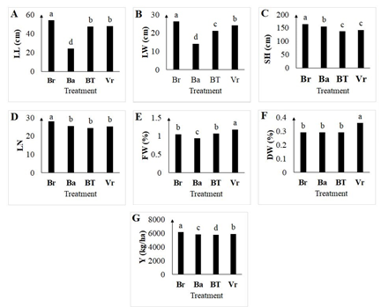

Fig. 2. Comparison of the effect of foliar application of different concentrations of nitrogen and various amino acids includes Arginine, Ornithine and Aspartic acid and an equal concentration of combination of amino acids on leaf length (A), leaf width (B), stem height (C), leaf number (D), leaf fresh weight (E), leaf dry weight (F) and yield (G) of N. tabacum varieties (Burley (Br), Basma (Ba), Virginia BT (BT) and Virginia (Vr)) cultivated in the field. Significant differences at P < 0.05 have been indicated with different letters.

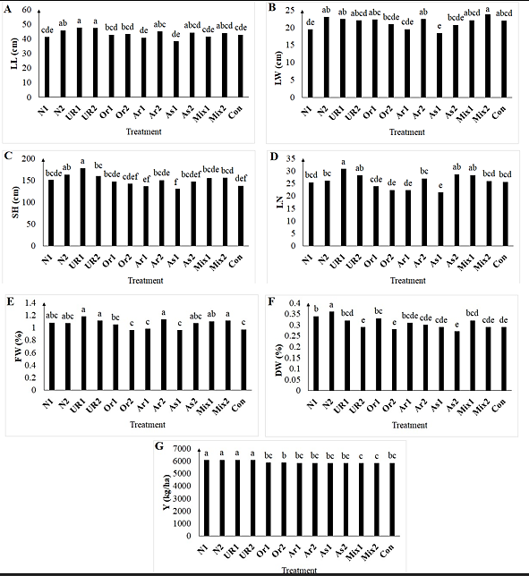

Fig. 3. Effect of foliar application of different concentrations of nitrogen and various amino acids includes Arginine, Ornithine and Aspartic acid and an equal concentration of combination of amino acids on leaf length (A), leaf width (B), stem height (C), leaf number (D), leaf fresh weight (E), leaf dry weight (F), and yield (G) of N. tabacum cultivated in the field. Significant differences at P < 0.05 have been indicated with different letters.

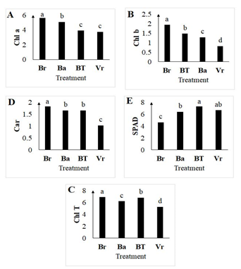

Fig. 5. Comparison of the effect of foliar application of different concentrations of nitrogen and various amino acids includes Arginine, Ornithine and Aspartic acid and an equal concentration of combination of amino acids on Chlorophyll a (A), Chlorophyll b (B), total chlorophyll (C), Carotenoid (D) and SPAD (E) of N. tabacum varieties (Burley (Br), Basma (Ba), Virginia BT (BT) and Virginia (Vr)) cultivated in the field. Significant differences at P < 0.05 have been indicated with different letters.

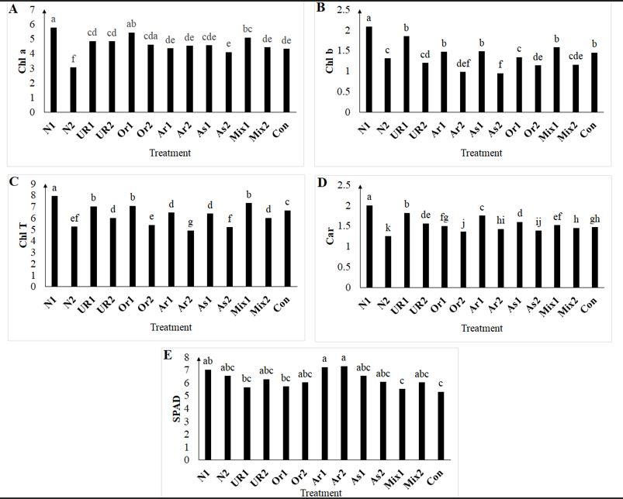
Fig. 6. Effect of foliar application of different concentrations of nitrogen and various amino acids includes Arginine, Ornithine and Aspartic acid and an equal concentration of combination of amino acids on Chlorophyll a (A), Chlorophyll b (B), total chlorophyll (C), Carotenoid (D), and SPAD (E) of N. tabacum cultivated in the field. Significant differences at P < 0.05 have been indicated with different letters.
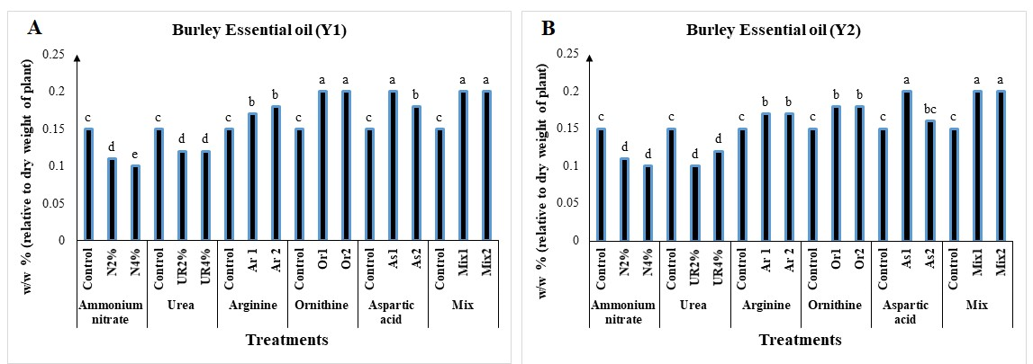

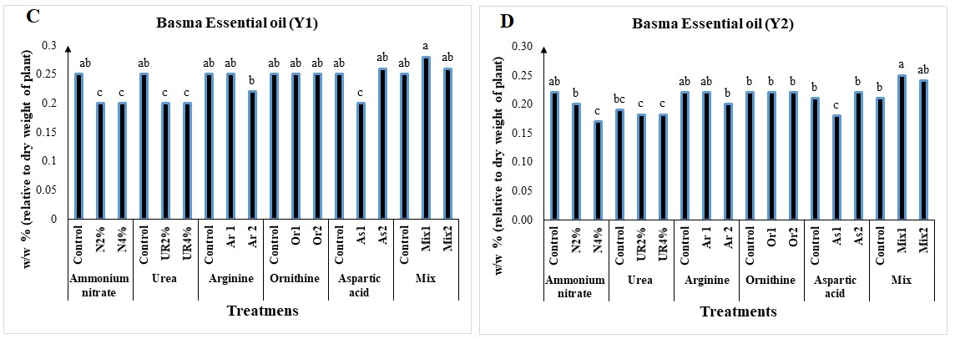

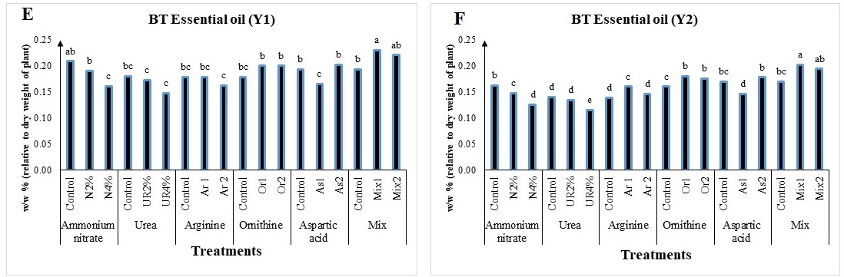

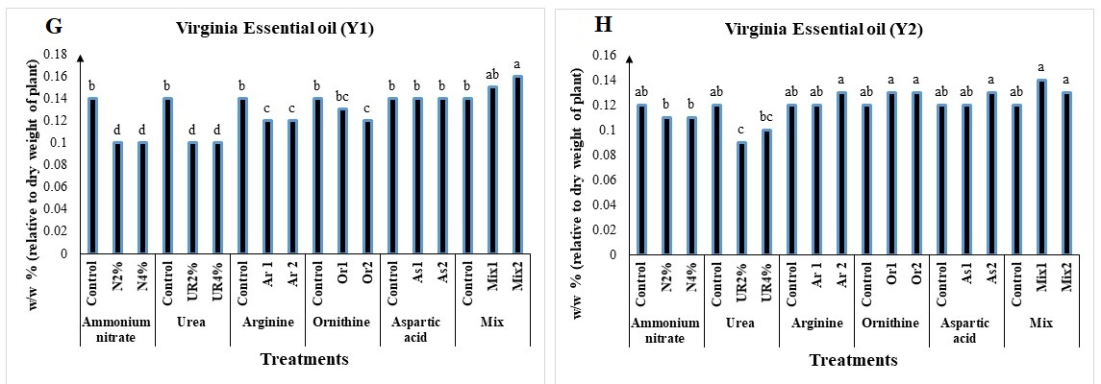

Fig. 7. Effect of foliar application of different concentrations of nitrogen and various amino acids includes Arginine, Ornithine and Aspartic acid and an equal concentration of combination of amino acids on essential oil content of N. tabacum. Significant differences at P < 0.05 have been indicated with different letters. A: Burley variety in first year of cultivation, B: Burley variety in second year of cultivation, C: Basma variety in first year of cultivation, D: Basma variety in second year of cultivation, E: BT variety in first year of cultivation, F: BT variety in second year of cultivation, G: Virginia variety in first year of cultivation, H: Virginia variety in second year of cultivation.

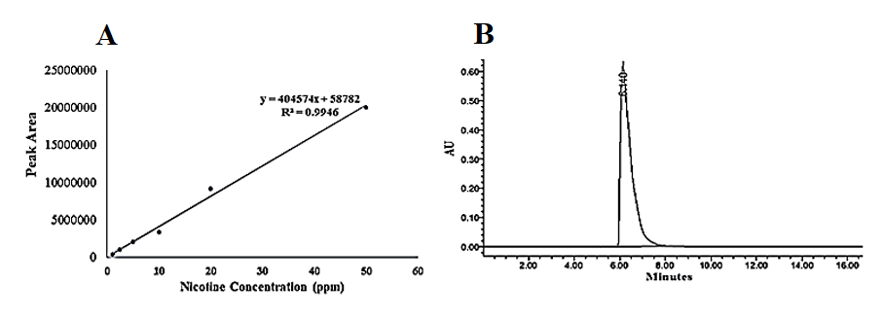

Fig. 8. HPLC chromatograms of Nicotine standard curve (A) and nicotine in standard solutions (B).

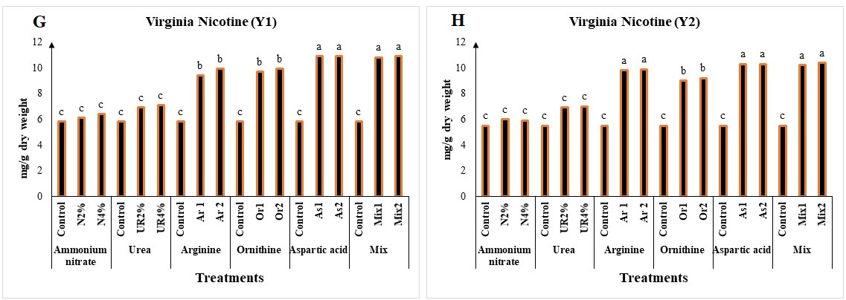
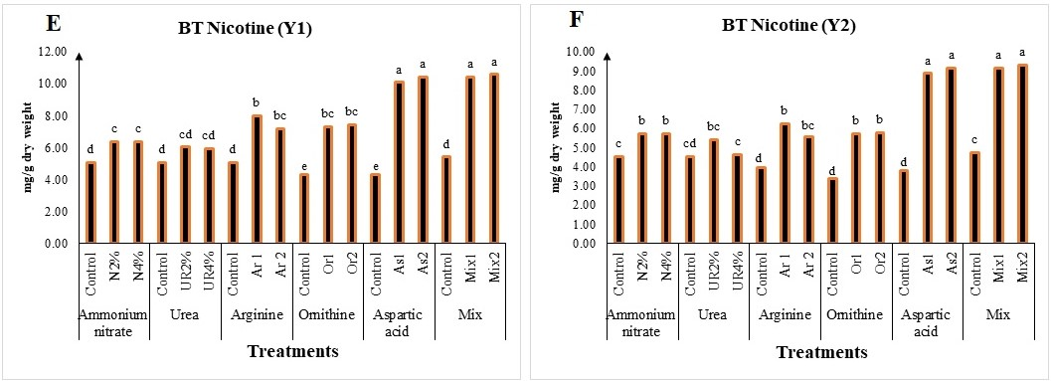
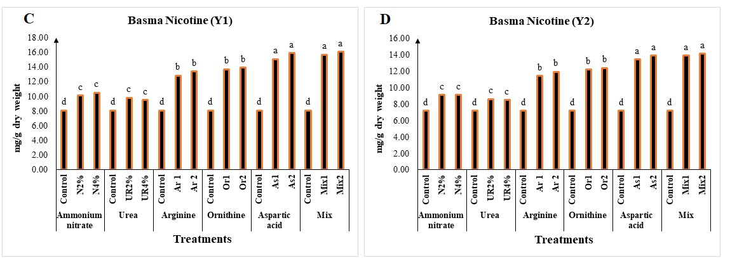
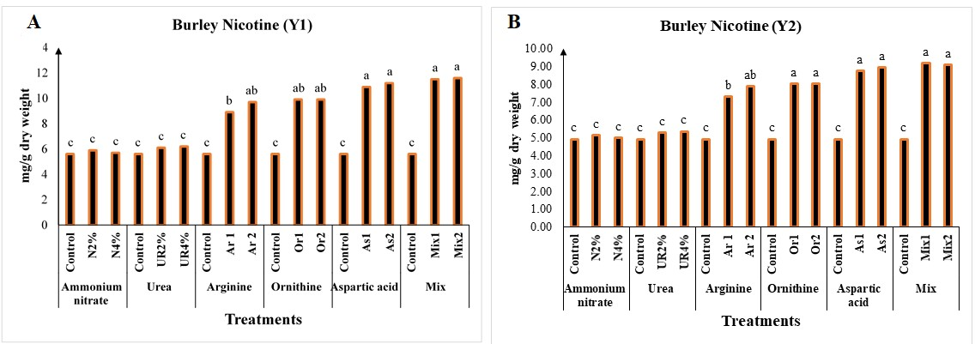

Fig. 9. Effect of foliar application of different concentrations of nitrogen and various amino acids includes Arginine, Ornithine and Aspartic acid and an equal concentration of combination of amino acids on nicotine content of N. tabacum. Significant differences at P < 0.05 have been indicated with different letters. A: Burley variety in first year of cultivation, B: Burley variety in second year of cultivation, C: Basma variety in first year of cultivation, D: Basma variety in second year of cultivation, E: BT variety in first year of cultivation, F: BT variety in second year of cultivation, G: Virginia variety in first year of cultivation, H: Virginia variety in second year of cultivation.

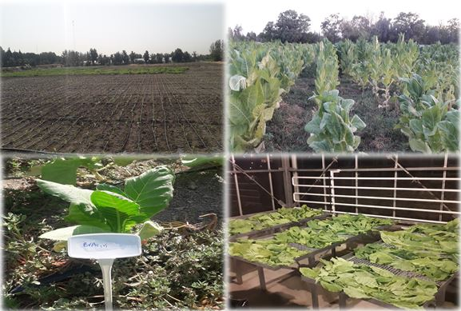

Fig. 10. Planting seedlings, growing and harvesting N. tabacum plants grown in the field condition.

