ANNEXES

Table 1S.

Hospital admissions due to infectious pathology by type of breastfeeding and visit.

 |  | Tipo de lactancia
 |  | EBF | MF | FF_postBF | FF_initial
< 15 days | n | 1384 | 448 | 53 | 161
< 15 days | % admissions | 0.43 | 2.01 | 0.00 | 0.00
1 months | n | 1215 | 404 | 118 | 167
1 months | % admissions | 1.73 | 1.24 | 3.39 | 2.40
2 months | n | 1152 | 332 | 212 | 162
2 months | % admissions | 2.60 | 1.81 | 4.72 | 4.32
6 months | n | 677 | 401 | 481 | 170
6 months | % admissions | 1.62 | 1.25 | 2.29 | 2.32
 |  | BF_ complemented |  | Formula feeding
12 months | n | 628 |  | 908
12 months | % admissions | 2.55 |  | 3.41
18 months | n | 390 |  | 887
18 months | % admissions | 2.05 |  | 2.03
24 months | n | 244 |  | 848
24 months | % admisisons | 1.23 |  | 2.24

Table 2S.
Visit-by-Visit Income
 | Visit-by-Visit Income
 | No ajusted |  | Ajusted
 | OR [CI95%] | p | OR [CI95%] | p
<15 days
EBF (ref) | - | - | - | -
FF_initial | - | - | - | -
FF_postBF | - | - | - | -
MF | 4.71 [1.69 - 14.10] | 0.003 | 3.59 [1.17 – 11.36] | 0.024
1 month
EBF (ref) | - | - | - | -
FF_initial | 1.08 [0.32 – 2.80] | 0.889 | 1.07 [0.31 – 2.77] | 0.905
FF_postBF | 1.56 [0.45 – 4.07] | 0.417 | 1.57 [0.46 – 4.11] | 0.407
MF | 0.89 [0.37 – 1.88] | 0.771 | 0.91 [0.38 – 1.95] | 0.827
2 months
EBF (ref) | - | - | - | -
FF_initial | 1.44 [0.58 – 3.11] | 0.388 | 1.66 [0.66 – 3.64] | 0.237
FF_postBF | 2.25 [1.15 – 4.18] | 0.013 | 2.70 [1.36 – 5.10] | 0.003
MF | 0.79 [0.34 – 1.63] | 0.547 | 1.01 [0.43 – 2.12] | 0.989
6 months
EBF (ref) | - | - | - | -
FF_initial | 1.46 [0.40 – 4.33] | 0.522 | 1.41 [0.38 – 4.19] | 0.565
FF_postBF | 1.42 [0.60 – 3.34] | 0.418 | 1.21 [0.50 - 2.92] | 0.665
MF | 0.76 [0.24 – 2.12] | 0.621 | 0.71 [0.22 – 1.99] | 0.537
12 months
BF_complemented a (ref) | - | - | - | -
Formula feeding | 1.35 [0.74 – 2.55] | 0.334 | 1.25 [0.67 - 2.42] | 0.490
18 months
BF_complemented (ref) | - | - | - | -
Formula feeding | 0.99 [0.44 – 2.43] | 0.980 | 0.90 [0.40 – 2.23] | 0.806
24 months
BF_complemented (ref) | - | -
Formula feeding | 1.84 [0.62 – 7.88] | 0.329 | 1.92 [0.64 – 8.25] | 0.300
Abbreviation: Exclusive breastfeeding (EBF), Formula feeding from birth (FF_initial); Formula feeding After BF discontinuation (FF_postBF); Mixed feeding (MF); complementary breastfeeding (BF_complemented); formula feeding (FF). Ref: reference category; OR: Odds Ratio. CI: 95% confidence interval for the OR; p = p-value (α = 0.05). (-) Number of pathologies very low, not measurable. All coefficients are adjusted for having siblings (yes/no) and attending a childcare centre (yes/no).

Table 3S.
Most frequent processes by visits and in relation to the type of feeding

. | Common conditions
 | General |  | Colic |  | Constipation |  | Regurgitation
 | OR [CI95%] | p | OR [CI95%] | p | OR [CI95%] | p | OR [CI 95%] | p
<15 days
EBF (ref) | - | - | - | - | - |  | - | -
FF_initial | 1.59 [1.11, 2.26] | 0.010 | 1.44 [0.83-2.35] | 0.169 | 10.96 [4.82 – 25.39] | <0.001 | 0,91 [0,51-1,53] | 0,748
FF_postBF | 2.08 [1.16, 3.65] | 0.012 | 3.85 [1.97-7.14] | <0.001 | 13.00 [3.97 – 37.28] | <0.001 | 1,06 [0,40-2,33] | 0,898
MF | 1.51 [1.19, 1.92] | 0.001 | 1.60 [1.14-2.22] | 0.006 | 2.56 [1.03 – 6.22] | 0.038 | 1,02 [0,72-1,45] | 0,919
1 months
EBF (ref) | - | - | - | - | - | - | - | -
FF_initial | 1.27 [0.92, 1.76] | 0.144 | 1.32 [0.91 – 1.89] | 0.139 | 9.28 [5.38 – 16.07] | <0.001 | 0,49 [0,28-0,80] | 0,007
FF_postBF | 1.44 [0.98, 2.10] | 0.059 | 1.71 [1.13 – 2.55] | 0.010 | 5.25 [2.56 – 10.25] | <0.001 | 0,88 [0,52-1,42] | 0,614
MF | 1.06 [0.84, 1.33] | 0.615 | 1.04 [0.79 – 1.35] | 0.792 | 3.52 [2.09 – 5.98] | <0.001 | 0,81 [0,59-1,09] | 0,175
2 months
EBF (ref) | - | - | - | - | - | - | - | -
FF_initial | 0.88 [0.58, 1.30] | 0.535 | 1.89 [0.99 – 3.38] | 0.042 | 1.89 [0.99, 3.38] | 0.042 | 0,88 [0,58-1,30] | 0,535
FF_postBF | 1.31 [0.94, 1.81] | 0.109 | 2.08 [1.19 – 3.49] | 0.007 | 2.08 [1.19, 3.49] | 0.007 | 1,31 [0,94- 1,81] | 0,109
MF | 0.82 [0.60, 1.11] | 0.205 | 2.20 [1.39 – 3.43] | 0.001 | 2.20 [1.39, 3.43] | 0.001 | 0,82 [0,60- 1,11] | 0,205
6 months
EBF (ref) | - | - | - | - | - | - | - | -
FF_initial | 1.50 [1.01, 2.21] | 0.042 | 1.86 [0.83 – 3.91] | 0.113 | 1.50 [0.79 – 2.73] | 0.197 | 1,28 [0,70- 2,23] | 0,396
FF_postBF | 1.64 [1.25, 2.16] | <0.001 | 1.50 [0.82 – 2.73] | 0.186 | 1.41 [0.89 -2.21] | 0.139 | 1,74 [1,19- 2,56] | 0,005
MF | 1.31 [0.97, 1.77] | 0.074 | 1.24 [0.63 – 2.37] | 0.525 | 1.58 [0.99 – 2.50] | 0.054 | 1,14 [0,73-1,76] | 0,566
12 months
EBF (ref) | - | - | - | - | - | - | - | -
Formula feeding | 0.85 [0.66, 1.11] | 0.238 | - | - | 0.79 [0.52, 1.21] | 0.280 | 1,51 [0,79- 3,02] | 0,229
18 months
EBF (ref) | - | - | - | - | - | - | - | -
Formula feeding | 1.19 [0.86, 1.66] | 0.302 | - | - | 2.23 [1.28, 4.18] | 0.008 | - | -
24 months
EBF (ref) | - | - | - | - | - | - | - | -
Formula feeding | 1.14 [0.66, 2.08] | 0.643 | - | - | 1.14 [0.66, 2.08] | 0.643 | - | -

Table 4S.

Influence of exclusive breastfeeding on different conditions at 12, 18, and 24 months (not adjusted for confounding variables).

 | 12 months |  |  |  | 18 months |  |  |  |  | 24 months
 | EBF (%) |  | RR CI95% |  | EBF (%) |  | RR | CI95% |  | EBF (%) |  | RR | CI95%
Diseases | YES | NO |  | p | YES | NO |  |  | p | YES | NO |  |  | p
General | 34.21 | 65.79 | 0.79 [0.75;0.84] | <0.001 | 37.83 | 62.17 | 0.86 [0.82; 0.92] |  | <0.001 | 36.82 | 63.18 | 0.88 [0.82; 0.94] |  | <0.001
Bronchiolitis | 30.82 | 69.18 | 0.67 [0.52; 0.86] | 0.002 | 38.18 | 61.82 | 0.88 [0.59; 1.28] |  | 0.505 | 34.15 | 65.85 | 0.78 [0.49; 1.22] |  | 0.288
Bronchitis | 24.87 | 75.13 | 0.50 [0.36; 0.69] | <0.001 | 33.67 | 66.33 | 0.72 [0.53; 0.97] |  | 0.031 | 40.80 | 59.20 | 1.04 [0.76; 1.40] |  | 0.808
Conjunctivitis | 33.80 | 66.20 | 0.77[0.62; 0.96] | 0.021 | 34.66 | 65.34 | 0.75 [0.60; 0.94] |  | 0.015 | 28.07 | 71.93 | 0.59 [0.44; 0.78] |  | <0.001
Contact/allergic dermatitis | 37.80 | 62.20 | 0.93 [0.75; 1.14] | 0.470 | 39.86 | 60.14 | 0.94 [0.74; 1.19] |  | 0.613 | 39.5 | 60.5 | 0.98 [0.77; 1.25] |  | 0.890
Exanthematous diseases | 41.06 | 58.94 | 1.06 [0.80; 1.39] | 0.704 | 41.70 | 58.30 | 1.02 [0.78; 1.32] |  | 0.905 | 36.77 | 63.23 | 0.88 [0.63; 1.21] |  | 0.426
Dental/gum diseases | 34.48 | 65.52 | 0.80 [0.46; 1.35] | 0.412 | 41.51 | 58.49 | 1.01 [0.58; 1.73] |  | 0.977 | 46.55 | 53.45 | 1.31 [0.78; 2.20] |  | 0.303
Wheezing ep | 25.11 | 74.89 | 0.51 [0.37; 0.68] | <0.001 | 32.29 | 67.71 | 0.68 [0.51; 0.89] |  | 0.007 | 39.35 | 60.65 | 0.98 [0.74; 1.28] |  | 0.868
Acute pharyngotonsillitis | 32.20 | 67.80 | 0.72 [0.48; 1.05] | 0.095 | 42.13 | 57.87 | 1.03 [0.77; 1.39] |  | 0.823 | 36.41 | 63.59 | 0.86 [0.64; 1.16] |  | 0.334
AGE | 32.15 | 67.85 | 0.72 [0.58; 0.88] | 0.002 | 37.12 | 62.88 | 0.84 [0.69; 1.01] |  | 0.069 | 38.11 | 61.89 | 0.93 [0.75; 1.14] |  | 0.481
Laryngitis | 33.96 | 66.04 | 0.78 [0.43; 1.39] | 0.389 | 34.88 | 65.12 | 0.76 [0.40; 1.41] |  | 0.396 | 42.11 | 57.89 | 1.10 [0.57; 2.08] |  | 0.778
Pneumonia | 32.35 | 67.65 | 0.72 [0.34; 1.45] | 0.379 | 55.56 | 44.44 | 1.78 [0.83; 3.87] |  | 0.138 | 43.33 | 56.67 | 1.15 [0.55; 2.36] |  | 0.702
AOM | 27.6 | 72.4 | 0.58 [0.46; 0.72] | <0.001 | 34.61 | 65.39 | 0.75 [0.62; 0.91] |  | 0.004 | 34.12 | 65.88 | 0.78 [0.62; 0.97] |  | 0.030
Common cold | 37.6 | 62.4 | 0.91 [0.83; 0.99] | 0.043 | 38.43 | 61.57 | 0.89 [0.81; 0.97] |  | 0.012 | 36.26 | 63.74 | 0.86 [0.77; 0.95] |  | 0.005
Abbreviations: RR: Relative Risk; 95% CI: 95% Confidence Interval for the RR; p = p-value (α = 0.05).

Table 5S.
Multivariate analysis at 18-month visit: pathologies / EBF_6m.
Diseases (total)
 | RR | CI | p
Intercept | 3,81 | 3,63-4,00 | <0,001
Feeding: EBF 6m | 0,88 | 0,82-0,93 | <0,001
Siblings (yes) | 1,07 | 1,01-1,13 | 0,027
Daycare attendance (yes) | 1,17 | 1,09-1,27 | <0,001

Table 6S.
Multivariate analysis at 24-month visit: pathologies / EBF_6m.

Diseases (total)
 | RR | CI | p
Intercept | 3,90 | 3,70-4,11 | <0,001
Feeding: EBF 6m | 0,87 | 0,81-0,93 | <0,001
Siblings (yes) | 0,99 | 0,93-1,06 | 0,875
Daycare attendance (yes) | 0,92 | 0,84-1,01 | 0,094

Fig 1S.

Percentage of cases grouped by processes in all visits
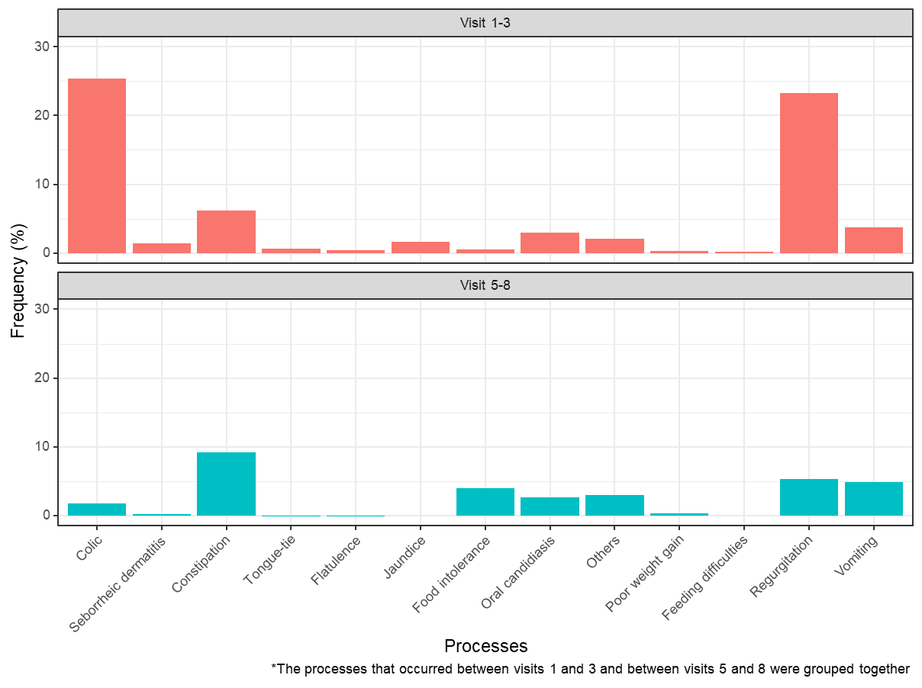

Figure 2S.

Frequency of each condition out of the total at the 12-, 18-, and 24-month visits.

