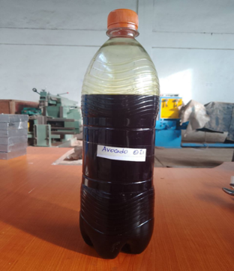
Figure 1. Synthesized avocado oil used for an experimentation
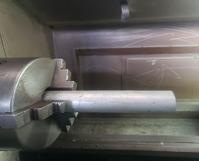
Figure 2. Photographic view of Aluminium Alloy 075-T651 work piece.
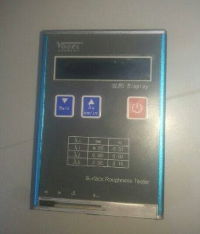
Figure 3. Photographic view of vogel surface roughness tester

