Unedited original gel diagram for Figure1-B WB was conducted to evaluate Kat2a protein levels

Unedited original gel diagram for Figure1-C WB was conducted to evaluate Pan-Kla protein levels
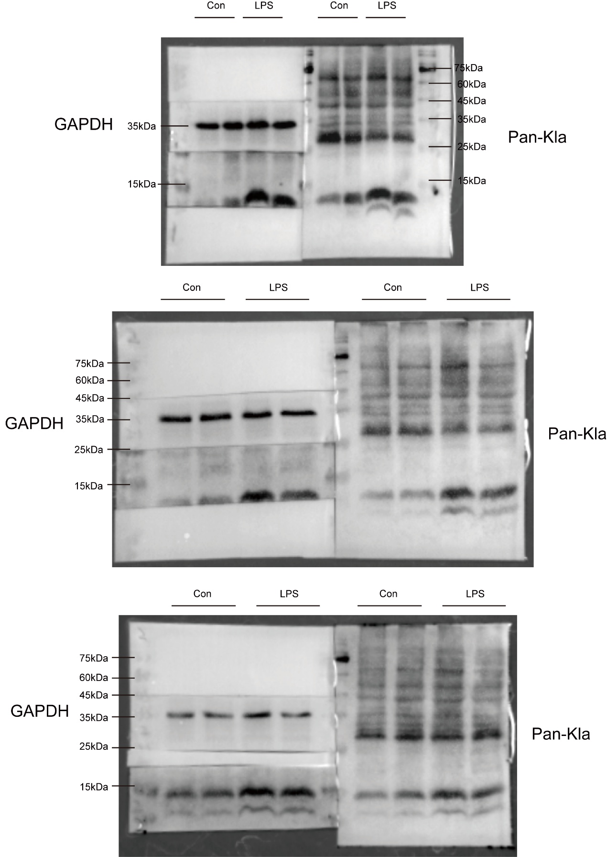

Unedited original gel diagram for Figure1-E, Figure 6-F WB was conducted to evaluate H3K18la protein levels

Unedited original gel diagram for Figure1-F WB was conducted to evaluate Kat2a protein levels

Unedited original gel diagram for Figure1-H, Figure 6-G WB was conducted to evaluate H3K18la and Kat2a protein levels

Unedited original gel diagram for Figure3-B WB was conducted to evaluate NLRP3、Caspase-1 and IL-1β protein levels

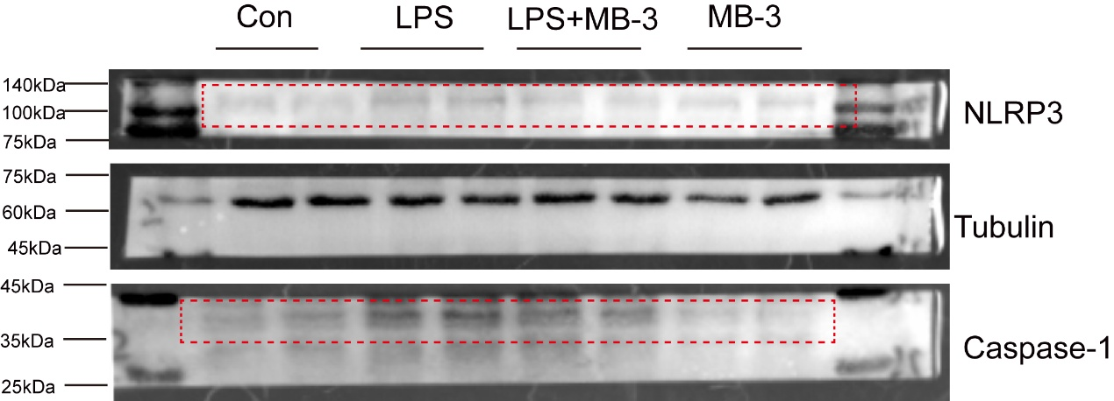

Unedited original gel diagram for Figure3-F and J WB was conducted to evaluate NLRP3、Caspase-1 、IL-1β and INOS protein levels

Unedited original gel diagram for Figure3-M WB was conducted to evaluate CH25H protein levels

Unedited original gel diagram for Figure4-C WB was conducted to evaluate Slc7a11 and GPX4 protein levels

Unedited original gel diagram for Figure4-F WB was conducted to evaluate Tfrc、Slc7a11 and GPX4 protein levels
Unedited original gel diagram for Figure5A-B WB was conducted to evaluate H3K18la protein levels
Unedited original gel diagram for Figure5-C WB was conducted to evaluate H3K18la protein levels

Unedited original gel diagram for Figure5-D WB was conducted to evaluate Tfrc、Slc7a11 and GPX4 protein levels

Unedited original gel diagram for Figure5-F WB was conducted to evaluate Tfrc、Slc7a11 and GPX4 protein levels

Unedited original gel diagram for Figure5-JWB was conducted to evaluate Tfrc、Slc7a11 protein levels
Unedited original gel diagram for Figure6-C WB was conducted to evaluate HK2 protein levels

Unedited original gel diagram for Figure6-I WB was conducted to evaluate Tfrc、Slc7a11 and GPX4 protein levels
Unedited original gel diagram for FigureS2-A WB was conducted to evaluate CH25H protein levels

Unedited original gel diagram for FigureS2-C WB was conducted to evaluate CH25H protein levels

Unedited original gel diagram for FigureS2-D WB was conducted to evaluate CH25H protein levels

