Supplementary Material for
Braiding the past and present for desirable futures: Insights from the Kilimanjaro social-ecological system
Neema R. Kinabo^{a,b,c}, Dominic A. Martin^{d}, Berta Martín-López^{e}, Sophie Peter^{a,f}, John Sanya^{b,e}, Milena Gross^{e}, Katrin Böhning-Gaese^{g}, Markus Fischer^{h}, Peter Manning^{i,j}
ª Senckenberg Biodiversity and Climate Research Centre, Frankfurt am Main, Germany
^{b} Department of Wildlife Management, College of African Wildlife Management, Mweka Moshi, Tanzania
^{c} Department of Biological Sciences, Institute for Ecology, Evolution and Diversity, Goethe University, Frankfurt, Germany
^{d} Department of Environmental Sciences, Wageningen University and Research, Wageningen, Netherlands
^{e} Faculty of Sustainability, Social-Ecological Systems Institute, Leuphana University of Lüneburg, Germany
^{f} Institute for Social-Ecological Research, Frankfurt am Main, Germany
^{g} Helmholtz Centre for Environmental Research - UFZ, Leipzig, Germany
^{h} Institute of Plant Sciences, University of Bern
^{i} Department of Biological Sciences, University of Bergen, Bergen, Norway
^{j} Centre for Sustainable Area Management (CeSAM), University of Bergen, Bergen, Norway
*Corresponding author: neemarobertk@gmail.com

Table S1: Actors' group description and the number of research participants.
Actor group | Description | Workshop 1  (n=15) | Workshop 2  (n=15) | Workshop 3  (n=15)
Smallholder farmers (SF) | This group includes farmers who participated in the initial social survey exploring NCP demand by SP3. Local community participants were selected to represent the study area's elevational and latitudinal gradients. | 4 | 4 | 4
Nature conservationists (NC) | This category includes representatives from government institutions responsible for conservation, research, agriculture, forestry, water management, and conservation and development NGOs. | 6 | 6 | 6
Business owners (BS) | This group comprises individuals involved in tourism operations (tour operators and guides) and commercial farmers, such as those from coffee plantations. | 5 | 5 | 5
Nature conservationists and business owners | This included administrative officials (n = 3) from the nature conservationist group and business owners (n = 2) who were unable to attend the workshop. Their input was gathered through semi-structured interviews, both physical and online.

Supplementary Material S1: Questions posed during the workshops to engage participants in scenario development and management action identification.
Workshop 1
- What key social and ecological elements shape Kilimanjaro's SES according to your knowledge and experience?
- For the most important five elements, we asked how these elements were in the past 40 years (from 1975 to 2015).
- How are these elements currently (between 2016 and 2024), and if there are changes, what drivers have caused the perceived changes?
- Which actors fostered the changes, and who became the winners and losers?
- Which NCP were negatively and positively affected?

Workshop 2
- Which elements of all scenarios do you prefer for fostering human-nature relationships and maximizing desired NCP and quality of life?
- What actions can help us achieve the desirable elements in the scenarios?
Workshop 3
- Which actions do you think are effective and achievable? To assess effectiveness and achievability, we guided the participants through these sub-questions: -
i). How likely do you think this action is to achieve its intended objectives? Evaluate the action's likelihood of success based on understanding of the context in which the action will be implemented.
ii). To what extent will this action address the identified challenges or issues? Consider the relevance of the action to the identified problems, its potential to mitigate or resolve those issues, and any unintended consequences it may have.
iii). How impactful do you perceive this action to be in creating positive outcomes?
iv). How feasible is implementing this action within the given resources (e.g., time, money, personnel)?
v). Can the necessary support and cooperation from relevant actors be secured to implement this action?
vi). How compatible is this action with existing policies, regulations, or cultural norms?

- What are the enabling conditions for the success of the actions?
- What barriers prevent the desirable future scenario from being realized? Examples include degradation of ecosystems, overexploitation, lack of access, and lack of financial investment.
- Are these actions (as well as their barriers and enablers) within the local, regional, national, or international scales?
- What are the pathways to implementation? e.g., Who should be consulted to affect the proposed actions? Who can positively or negatively influence the action? What is the role of each actor group in the proposed changes?
- Are these actions feasible within the context of climate change?
Demographic information
In which year were you born? [Variable: Age]
Were you born and raised in Kilimanjaro? Yes/No [Variable: Born and raised in Kilimanjaro]
What is your highest level of formal education? [Variable: Education]
Gender of the participant [Variable: Gender]

Supplementary Material S2: Workshop feedback-seeking questions.
ACTORS’ PERSPECTIVE ON FUTURE SCENARIOS AND SUSTAINABILITY FOR THE KILIMANJARO SOCIAL-ECOLOGICAL SYSTEM

Thank you for participating in our workshop!
Your feedback is valuable to us as we strive to improve the workshops. Please take a moment to answer the following questions. All responses will be kept anonymous.
Questions
- Were you informed in enough time about the workshop?
- Did you know the goal of the workshop?
- Do you think the workshop was useful for expressing your opinion?
- Do you feel that you could express your opinion freely during the workshop? If not, why?
- What would you suggest to express yourself freely in the workshop?
- Do you think your scenarios’ final results reflect everyone’s opinion?
- Do you think the different actors have been adequately represented in the workshop? If not, who else should have been invited?
- What did you enjoy learning most in the workshop?
- What could be improved for future workshops?
- Do you have any other comments?

Supplementary Material S3: Feedback survey responses
The workshop participant responses on feedback survey generated three main themes: 1) perceptions of the workshop process and its outcomes, which included participant satisfaction, representation, and inclusivity; 2) mode of engagement, which covered aspects such as free expression and facilitation quality; and 3) system understanding and learning, which focused on shared understanding developed during the workshops (Table S2). The feedback showed that the approach was important in engaging diverse actors: smallholder farmers, nature conservationists, and business owners in collaborative exploration of the past, present, and future conditions of the SES and management actions to achieve desirable futures. Participants noted it was pivotal to ensure continued actor engagement in finding solutions to challenges facing Kilimanjaro SES (Table S2). Participants also noted that the process fostered an understanding of the conflicting but important land uses within the Kilimanjaro SES.

Table S2: Summary of the feedback-seeking survey reflecting participant perceptions of the workshop process and its outcomes, mode of engagement, and system understanding and learning during the workshops.
Theme: Perceptions of the workshop process and its outcomes
Code | Example extract | Example quote
Participant satisfaction | This workshop has been an eye-opener for land use challenges, such as agriculture and conservation.
Participant satisfaction | The workshops helped us think deeply about our role in shaping the future of Kilimanjaro.
Representation and inclusivity | Similar workshops should be held often with other people
Representation and inclusivity | Invite a government representative to provide insights into policy
Theme: Mode of engagement
Free expression | Encourage facilitators to manage group discussions better
Free expression | The timeframe for the plenary sessions was short
Facilitation quality | The facilitators provided clarifications very well
Facilitation quality | Continue facilitating open dialogue and allow time for questions
Theme: System understanding and learning during the workshops
Shared understanding | Seeing how traditional practices influence sustainability | “As we build more houses and clear the homegardens, we are bound to be food insecure, and if we do not care for the environment now as did our forefathers, our grandchildren and we will suffer the consequences”, CN07.
Shared understanding | The connection between homegarden conservation and biodiversity
Shared understanding | Recalling past experiences
Shared understanding | The final workshop report should be shared with all actors, including the environment department in the district council for implementation
Shared understanding | The government should consider all opinions presented

Supplementary Material S4: Interview guiding questions
ACTORS’ PERSPECTIVE ON FUTURE SCENARIOS AND SUSTAINABILITY FOR THE KILIMANJARO SOCIAL-ECOLOGICAL SYSTEM
I am Neema Robert Kinabo, lecturer at the College of African Wildlife Management, Mweka, and a Ph.D. student under the Kilimanjaro social-ecological System Project (<project name removed for peer-review> project <project website removed for peer-review>). I am pleased to invite you to participate in this interview to identify management action and transformative pathways for the Kilimanjaro Social-Ecological System. We have engaged other actors in workshops exploring past-to-present social-ecological system conditions, visioning future scenarios, and actions to make the social-ecological system sustainable. As one of the key actors, I will very much appreciate your contribution to this study.
Guiding questions related to workshop 1
- What key social-ecological elements shape and define the Kilimanjaro SES?
- How have the key SES elements changed in the past?
- What are the main drivers of the changes you have mentioned?
- What are the current conditions for the SES elements?
- Which actors fostered the changes, and who became the winners and losers?
- Which NCP were negatively and positively affected?
Guiding questions related to workshop 2
- Which elements of all scenarios do you prefer for fostering human-nature relationships and maximizing desired NCP and quality of life?
- What actions can help us achieve the desired elements in the scenarios? Consider actions and measures to achieve the desired and avoid undesirable components in the short term (5 years) and the long term (15 years).
Demographic information
In which year were you born? [Variable: Age]
Were you born and raised in Kilimanjaro? Yes/No [Variable: Born and raised in Kilimanjaro]
What is your highest level of formal education? [Variable: Education]
Gender of the participant [Variable: Gender]

Supplementary Material S5: The workshop summary in Swahili delivered as an internal report to research participants.
RIPOTI YA MTAZAMO WA WADAU KUHUSU MAZINGIRA YA BAADAYE YA MFUMO WA KIJAMII NA KIKIOLOJIA ENDELEVU WA KILIMANJARO
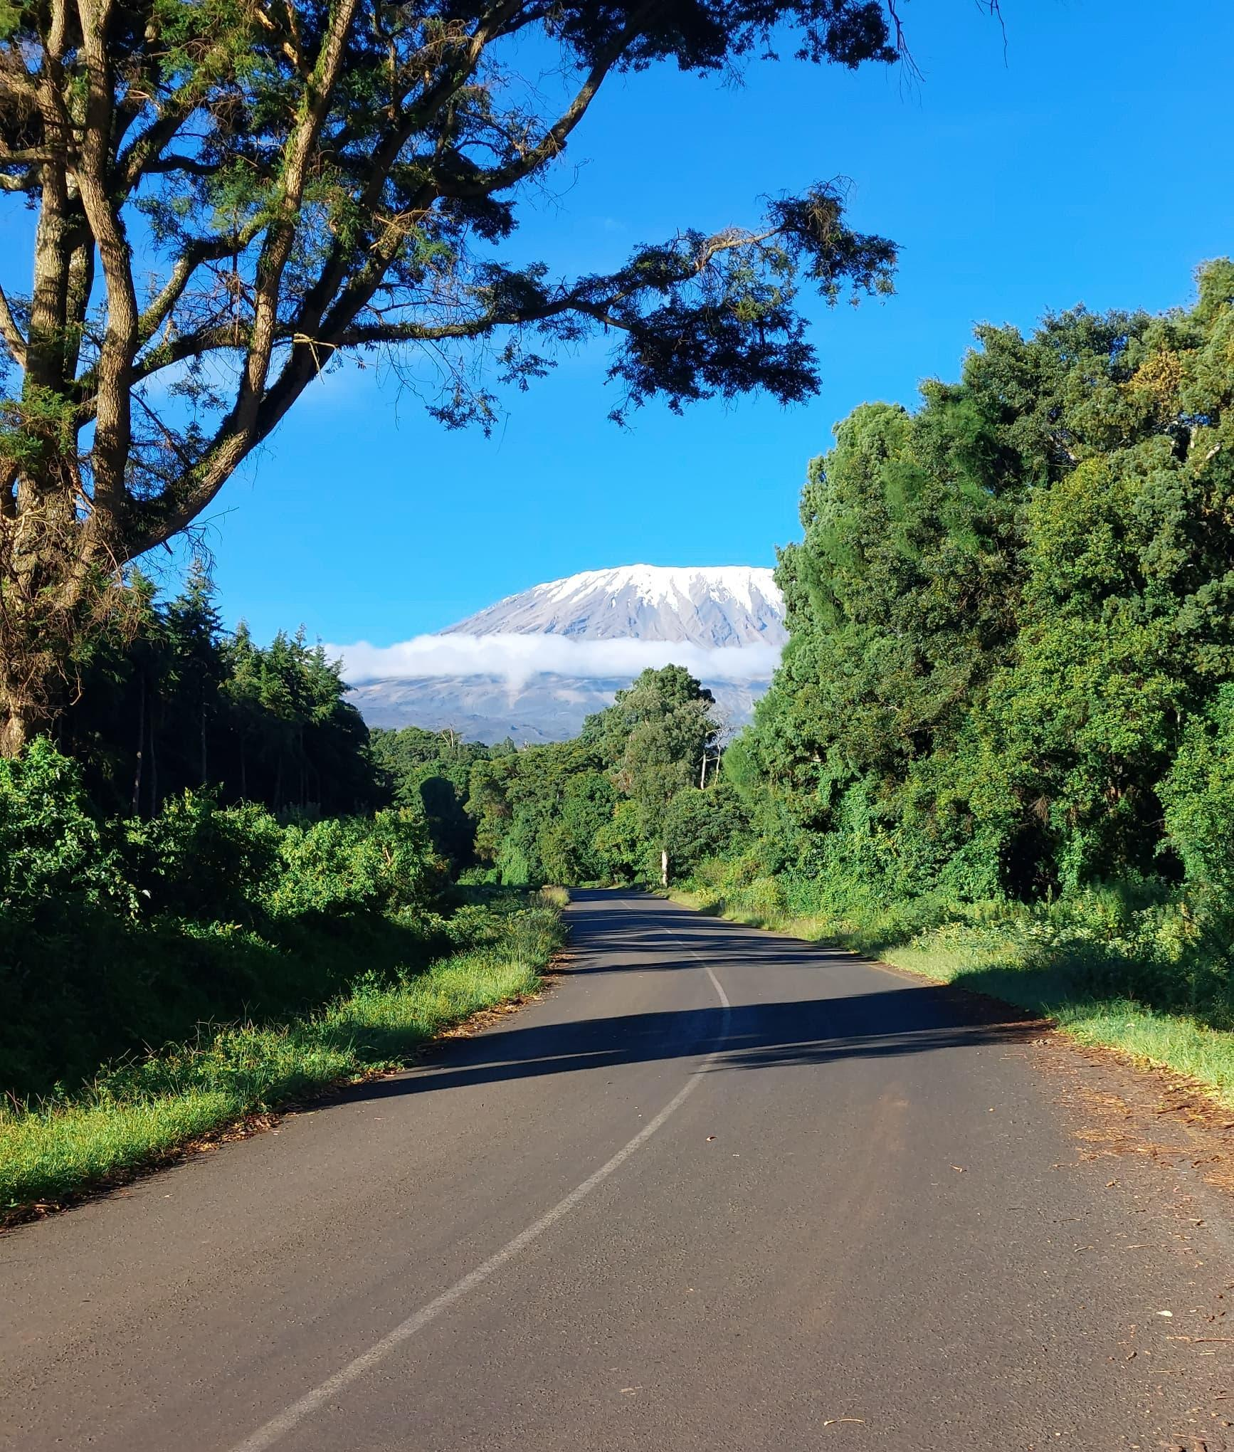
Picha kwa hisani ya Thobias Tomeka
Imetayarishwa na Neema Robert Kinabo
Barua pepe: neemarobertk@gmail.com
June 2024
Mfumo wa kijamii na kiikolojia wa mlima Kilimanjaro hutoa michango mbalimbali ya asili kwa binanadamu ili kukidhi mahitaji mbalimbali kama vile chakula, upatikanjaji wa mvua, maji n.k. Lakini mabadiliko ya kimazingira pamoja na matumizi mabaya ya kibinadamu yamepelekea kwa mfumo huu kushindwa kuhimili mahitaji ya binadamu na hivyo kuhatarisha upatikanaji wa mahitaji hayo kwa vizazi vijavyo. Kupunguza mabadiliko haya tunahitaji kukabiliana na changamoto kwa kuleta pamoja mitazamo na maslahi ya wadau mbalimbali. .
Tulialika makundi matatu ya wadau— wakulima, wamiliki wa biashara mf. Utalii, mashamba ya kahawa, na wahifadhi kutoka mamlaka za serikali na taasisi za kijamii katika mfululizo wa warsha tatu mwaka 2024. Katika warsha hizo tuliwashirikisha wadau katika kufikiria kwa pamoja kuhusu hali ya sasa na ya baadaye ya mfumo wa kijamii na wa kiikolojia wa mlima Kilimanjaro unaotupa faida mbalimbali kama inavyooshea katika kielelezo namba 1.
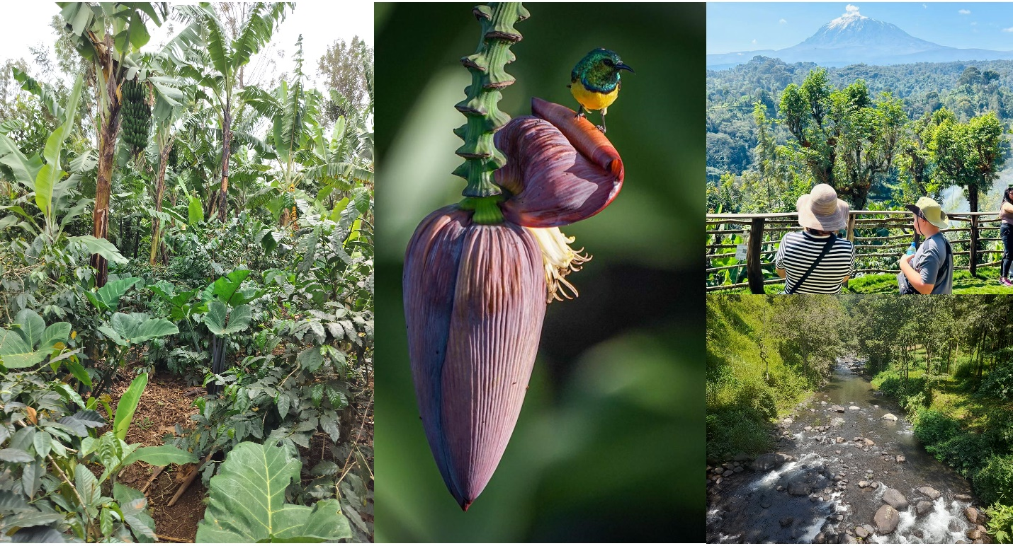
Kilelezo 1: Shughuli za kilimo, bioanuai, utalii, na vyanzo vya maji kutoka katika mteremko wa kusini mwa mlima Kilimanjaro. Picha kwa hisani ya Neema Kinabo, Victor Kinyaiya, Elisante Shirima na Frank Shagega.
Katika warsha ya kwanza wadau waliainisha rasilimali za muhimu katika mfumo wa kijamii na kiikolojia wa Kilimanjaro, ikiwemo rasilimali za maji, bayoanuai, matumizi ya ardhi na kilimo, utalii, na mila na utamaduni. Kisha wakaeleza kwa namna rasilimali hizi zilivyobadilika katika miaka 40 iliyopita. Walieleza sababu za mabadiliko haya kwa kiasi kikubwa ni pamoja na ongezeko la watu, kupotea kwa maarifa ya jadi ya kiikolojia, maendeleo ya kiteknolojia na mabadiliko ya tabianchi. Matokeo ya warsha hii yalionyesha mtazamo wa mabadiliko hasi katika rasilimali za maji, viumbe hai, matumizi ya ardhi, na utamaduni wakati utalii ukiwa na mabadiliko chanya mfano waendesha biashara za utalii walifaidika kutokana na kuongezeka kwa biashara ya utalii. Warsha hii ilisaidia kujenga uelewa wa pamoja, kujua mabadiliko yaliyotokea mpaka hali ilivyo kwasasa.
Kisha katika warsha ya pili, wadau walibuni mpangilio wa matukio-bunifu yajayo (scenarios) kwa kutumia sababu zifuatazo. Kwa kila tukio-bunifu, wadau walionyesha aina za mifumo ya ikolojia (kwa mfano, misitu na bustani za nyumbani) ambazo zinaweza kuathiriwa na matokeo ya athari hizo kwa wadau mbalimbali. Pia walielezea mabadiliko yanayotarajiwa katika upatikanaji wa faida zinazotokana na mazingira ya asili kwa watu (Nature’s Contributions to People). Walifanya vivyo hivyo kwa vipengele mbalimbali vya ubora wa maisha (Quality of Life) kama vile afya, elimu, na fursa za ajira. Wadau walibainisha vipengele muhimu vya mustakabali unaotamaniwa: ulinzi wa mazingira, usimamizi wa matumizi ya ardhi na kilimo, na uhifadhi wa utamaduni. Wadau walipendekeza ili kufikia mustakabali unaotamaniwa lazima kuwepo na elimu ya mazingira, ushirikishwaji wa jamii kuanzia ngazi ya familia, usimamizi endelevu wa ardhi, kilimo endelevu, na kusimamia vema utekelezaji wa sera na sheria zinazosimamia mazingira. Hatua hizi za usimamizi zilizopendekezwa zilihusisha viwango tofauti vya utawala, kutoka zile zinazohitaji hatua za pamoja za jamii hadi zile zinazohitaji utekelezaji kitaifa katika ngazi ya wizara.
Mrejesho wa wadau kuhusu warsha hizi ulionyesha kuwa warsha hizi zilikuwa muhimu katika kuleta Pamoja mitizamo ya wadau mbalimbali kuhusu vichocheo vya mabadiliko na hatua za usimamizi za kufikia hali bora ya baadaye. Washiriki walibainisha kuwa mchakato wa warsha uliimarisha uelewa wa pamoja wa changamoto za mifumo ya kijamii na kiikolojia ya Kilimanjaro katika kuoanisha maendeleo ya kijamii na kiuchumi na uhifadhi wa mazingira. Washiriki waliona kuwa ni muhimu kuwepo kwa mipango jumuishi ili kulinda mazingira na ushiriki wa jamii katika kulinda na kutunza mfumo wa kijamii na kiikolojia wa Kilimanjaro.
Tunashukuru wadau wote walioshiriki katika warsha hizi.

Supplementary Material S6: Overview of context-specific Nature’s Contributions to People (NCP) with illustrative images (Meyer et al., 2023).
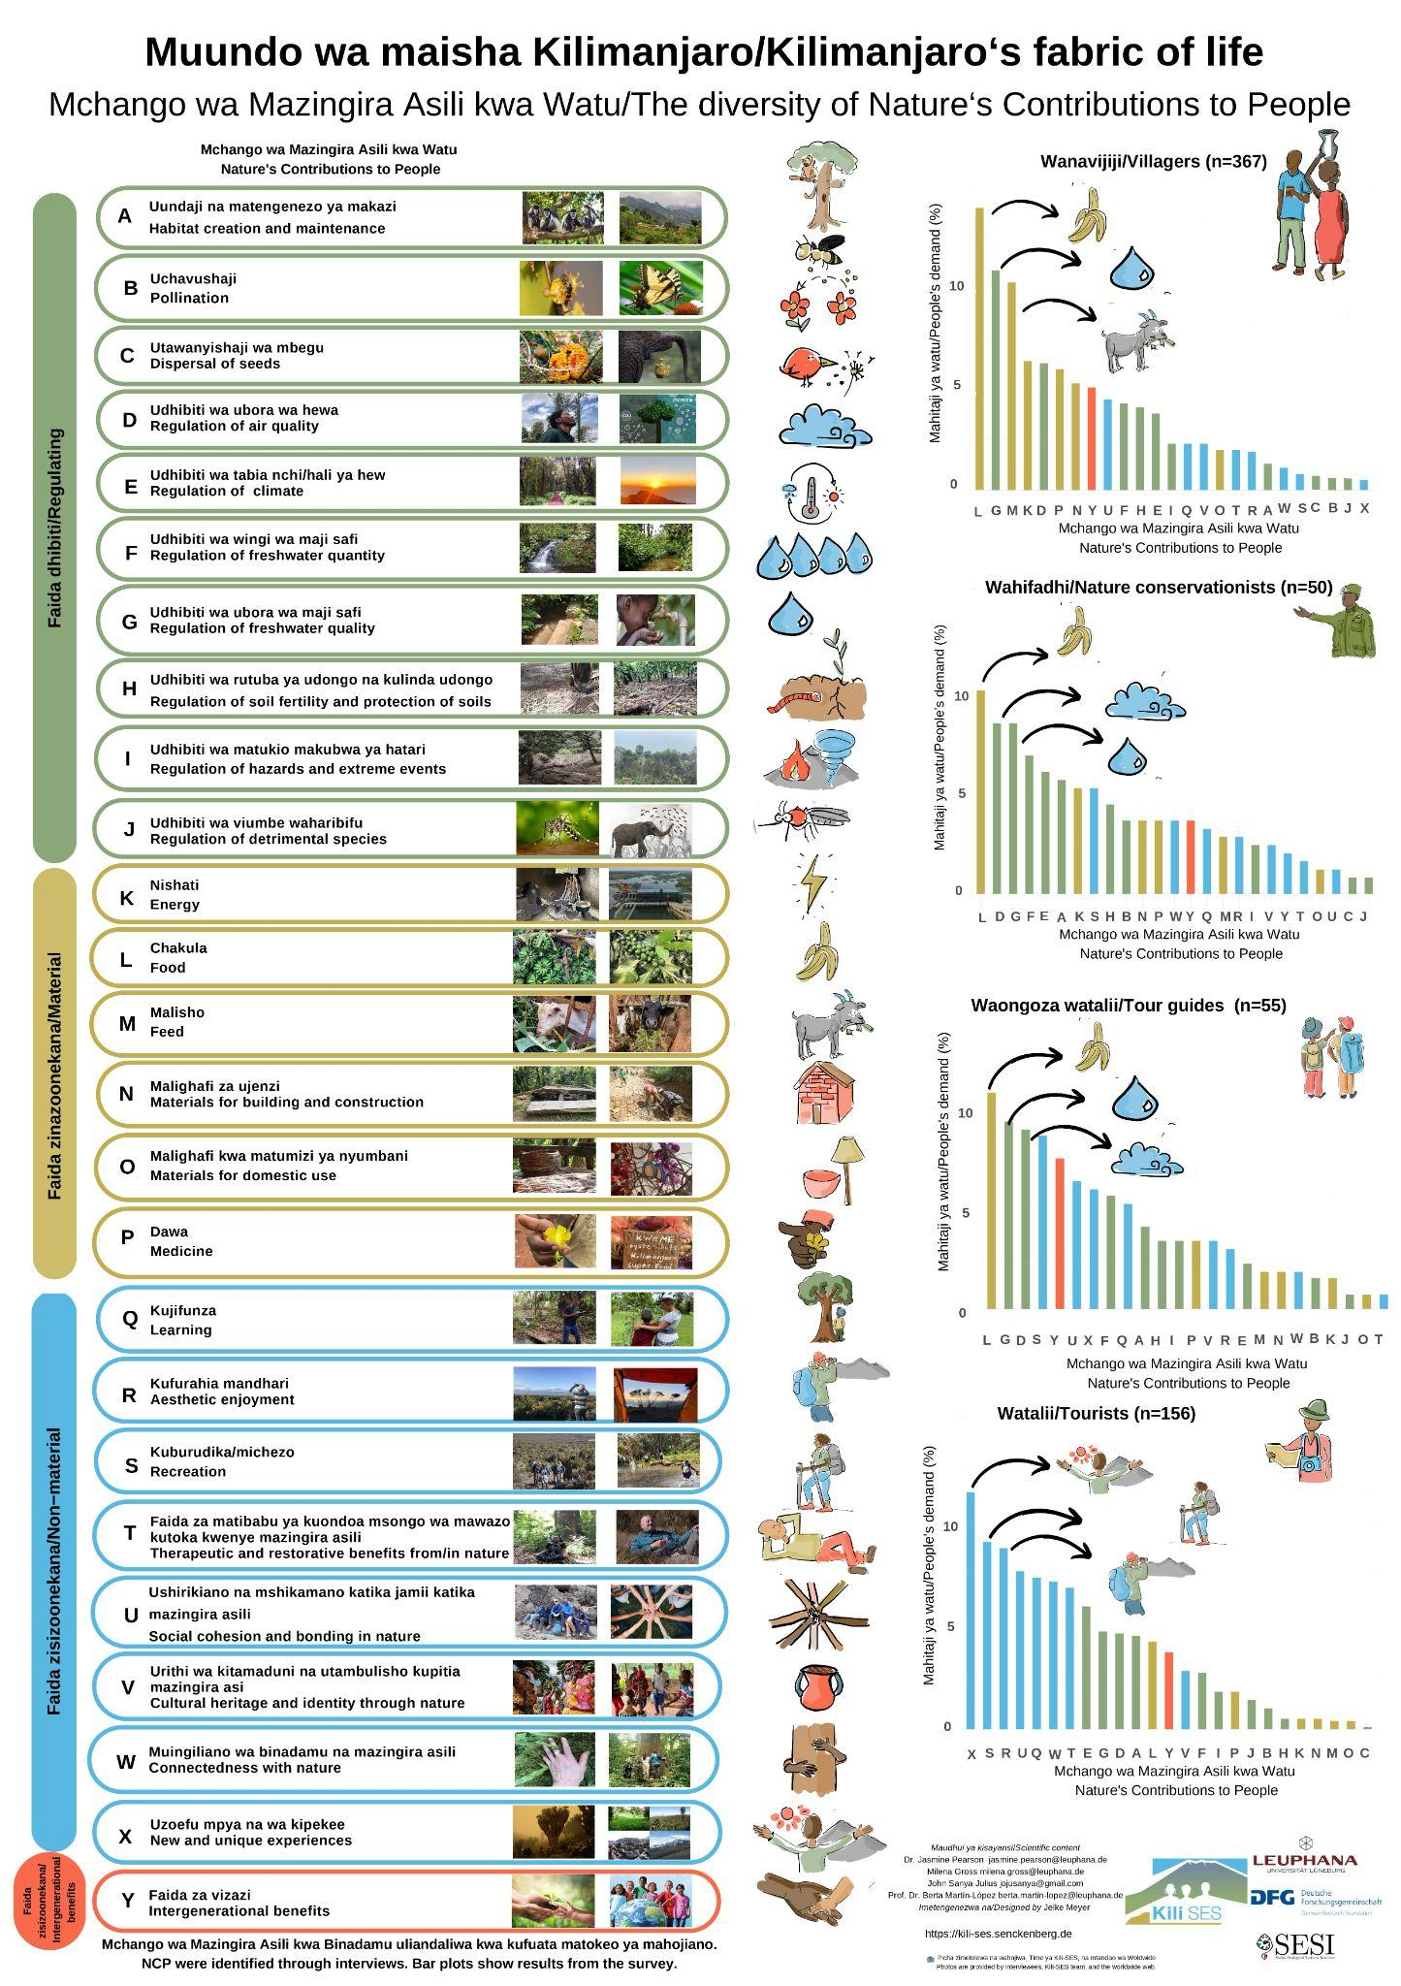
Reference
Meyer J, Gross M, Martín-López B, Pearson J, Sanya J. 2023. Outreach Posters for the Preliminary Results of the Project ‘Demand and Values of Nature’s Contributions to People (NCP)’embedded within the DFG Research Unit ‘The role of nature for human well-being in the Kilimanjaro Social-Ecological System (Kili-SES)’. Germany. Leuphana University of Lüneburg. 10.48548/pubdata-78.

Figure S1: A mind map summary of key social-ecological elements, drivers of change, and their relationship, including actors within the Kilimanjaro social-ecological system (SES). The mind map was developed during the workshop based on the inputs and discussions of participants.

Table S3: Demographic profile of workshop participants (n= 20)
Variable | Count | Percentage (%)
Age (years)
18-24 | - | -
25-34 | 4 | 10
35-44 | 9 | 50
45-54 | 3 | 20
55-64 | 2 | 10
65-74 | 1 | 5
75 and older | 1 | 5
Gender
Male | 18 | 90
Female | 2 | 10
Education
Primary | 1 | 10
Secondary | 3 | 15
Vocational training & Undergraduate | 13 | 65
Postgraduate | 3 | 15
Born and raised in Kilimanjaro
Yes | 13 | 65
No | 7 | 35
Number of years lived in Kilimanjaro
< 5 | 1 | 10
6-10 | 2 | 20
11-15 | 1 | 10
>15 | 16 | 80

Table S4: The past (1975 - 2015) and current (2016 - 2024) conditions of the key social-ecological system elements, their drivers of change, winners (+) and losers (-), and the effect on NCP supply (increase +, decrease -) as perceived by participants in workshop 1.
Element | Past condition | Current condition | Drivers of change | Actors: winners/losers | Effect on context-specific NCP provision
Water resources | - Abundant  - Low demand  - Protected water sources  - Good quality  - Enough rainfall | - High demand  - Shortage of water  - Improved water supply infrastructures  - Low quality  - Dried water sources, e.g., springs | - Increased population & industrial use  - Deforestation  - Agriculture activities and settlements near water sources  - Lack of adherence to laws/ by-laws  - Poverty  - Climatic change | - Smallholder farmers, downstream communities short term (+) long term (-)  - Commercial farmers short term (+) but long term (-) | - Water quantity (-)  - Food (-)
Biodiversity | - High biodiversity | - Reduced number of species, e.g., birds  - Loss of some native tree species  - Increased invasive species | - Deforestation  - Unsustainable farming practices | - Smallholder farmers (-)  - Timber, charcoal, and firewood sellers (+) | - Food (-)  - Pollination (-)  - Regulation of hazard (-)  - Soil protection (-)
Land use and agriculture | - Sparse settlement  - Less development  - Traditional practices  - Sustainable farming practices  - Diverse crops, rainfed and irrigated | - Reduced land per capita  - Dense population  - Investment for commercial purposes  - Unsustainable farming practices | - Increase in population and urbanization.  - Agriculture expansion due to technological advancement  - Change of customs and culture  - Climatic change  - Market-driven economy | - Private sector industries (+)  - Local non-farmers (+)  - Commercial and smallholder farmers (+) | - Food (+)  - Water quantity (-)  - Water quality (-)  - Soil fertility (-)
Tourism | - Low visitor numbers  - Poor infrastructure (internet, roads, accommodation)  - Untapped tourism activity opportunities | - High visitor numbers  - Improved tourism facilities and infrastructure  - Diversified tourism products | - Education and awareness  - Change in lifestyles  - Government initiatives to diversify and promote tourism attractions  - Network of protected areas  - Tourism development  - Technological advancement  - Global economic growth | - Government (+)  - Smallholder farmers—through income (+) but (-) due to cultural erosion  - Investors in tourism (+)  - Tourists (+) | - Recreation (+)  - Therapeutic and restorative experience (+)
Traditions & Culture | - Respect for the traditional leadership system  - Nature protection- Dracaena fragrans is planted around Kihamba to demarcate the area and reduce soil erosion.  - In harmony with nature—Trees were sacred, e.g., Neutonia buchananii  - Harmony in society— Dracaena fragrans is also used to resolve conflicts and maintain peace in society | - Abandonment of traditions and culture | - Westernization is causing negative shifts in the younger generation’s morals and values  - Technological advancement  - Emigration to towns and cities  - New religions  - Change in lifestyles | Smallholder farmers (-) | Connectedness with nature (-)  Cultural heritage and identity (-)

Table S5: Themes and quotes from thematic analysis of qualitative information from workshops and semi-structured interviews. Participants' quotes are anonymized using actor group codes and a random two-digit number: SF15- Smallholder farmers, NC08 -Nature conservationists, BS17 -Business owners.
Key social-ecological elements that shape and define the Southern slopes of Kilimanjaro
Theme | Description | Example extract/quote from workshop 1 representing this theme
Water resources | Water resources in the lower slopes of Kilimanjaro | “Water resources have declined. When I grew up in a shanty town in the late 1980s, we even had a little channel (Mfongo in Chagga) running through our backyard, but now there is no water to flow in these channels” (CN08).  The landscape is less hydrated.  Water is becoming increasingly scarce.
Biodiversity | Diversity of wildlife species, habitats, and ecosystems | In the past, when driving after some time, you would have to clean your screen as you would have killed many bugs/insects; these days, it is not like that  As a child, I remember seeing porcupines in our garden. We also used to hunt pigeons, but now you rarely see such wildlife.  Vegetation and forests
Land use and agriculture | Practices, changes in land use, and agricultural activities | Chagga, the known organic farmers, are using more and more chemicals on all their crops. Use of pesticides and herbicides  There is heavy soil disturbance. More mechanization of ploughing  Going up the mountain, you see that the landscape has become more fragmented. Because over generations, lands get split among family members, and it becomes more and more fragmented  Agriculture has become more extractive, not a cyclical system
Tourism | Activities related to mountain climbing, cultural tours, visits to waterfalls and caves, and wildlife safaris | There has definitely been an increase in tourism. I am not giving that as a negative, but also not necessarily as a positive.  I think tourism has created a lot of revenue to protect the national parks very well  For the environment, tourism development is not always good if there is no good underlying land use plan
Traditions and culture | Chagga people's practices and deep connection to the land and nature, including maintaining homegardens, folklore, and traditional ecological knowledge. | “You had an attachment, like ‘oh my Kihamba’, you look after it, you have a sense of ownership and custodianship, especially on the mountain, these are resources supplied by God” (BS17).  People have moved away from more traditional ways of land use  Adoption of technology and gradual social changes  Youths detached from the land became less interested in agriculture.
Drivers of change and trends in social-ecological elements
Theme | Example extract
Population increase | Significant population growth has densified the slopes of Kilimanjaro over the last two decades  Shrinking agricultural land
Climate change | Prolonged drought  Change in rainfall patterns  Increased demand for water and climate variability
Urbanization | Rural areas are turning urban  Some family members migrated to other cities, like Dar es Salaam, and then invested in land on the slopes for residential purposes or turned their Kihamba into settlements rather than using them for agriculture.  Growing middle class
Lack of a land use plan | Without any land use plan, ecologically sensitive areas are slowly turning into residential areas, and rural areas are turning into urban areas  Abandonment of traditions and culture
Pollution | I would go swimming with friends in the Karanga River. I would not do that anymore.  People have moved away from more traditional ways of land use  Pollution from industrial activities and transportation  Adoption of chemical-intensive farming methods among smallholder farmers
Deforestation | The visual assessment suggests deforestation is a primary driver of ecological degradation.  Conversion of forests into settlements, farms, and other infrastructures, e.g., roads  A decrease in hydration levels was observed, with water features like furrows drying up over time  Soil erosion due to decreased vegetation cover
Abandonment of traditions and culture | Clearing of homegardens for settlement
Management actions to achieve the desirable future
Action category | Action(s) | Example extract | Example quote
Political support and conservation enforcement | Effective enforcement of conservation policies, rules, and implementation strategies  Effective environmental protection implementation strategies  Political willingness and commitment to environmental issues | Restoration of Riparian areas – proper enforcement of the Act pertaining to protection of the Riparian belt (I believe this is covered in the Forest Act);  Better management of water use and pollution of water bodies  Implementation of conservation policies is not participatory with local communities  The 60-meter rule of not farming near a water source is overseen by village leaders. It is seen as a government-related official role to oversee the rules.
Sustainable agriculture and diversification | Agriculture diversification  Sustainable agriculture practices  Off-farm livelihood alternatives  Youth involvement in agriculture | There is a need to think of an alternative cash crop to coffee and manage its market chain to ensure all segments of society can still achieve the desired economic prosperity. Vanilla and improved varieties of avocados are possibilities.  Promote initiatives such as the Kweme project, which is oyster nut cultivation. This project supports tree preservation, as oyster nuts require trees for growth, offering benefits such as reduced deforestation, soil erosion control, habitats for biodiversity, economic benefits, and health advantages. An additional advantage is beekeeping because trees are used to hang the traditional beehives  Introduction and promotion of sustainable farming practices, focusing on key principles such as limiting disturbance of soils (mechanical or chemical disturbance), keeping ground covered, maximum diversity, etc.
Conservation education and awareness | Education and Awareness  Use social media and celebrities to advocate for nature conservation | I am not suggesting going against synthetic fertilizers and pesticides, but I would encourage the public to be made aware that this can come with problems if pesticide residues remain in the food we eat.  Country-wide campaign – involving famous musicians, athletes, and other public figures – on the importance of environmental protection as well as sustainable farming practices
Community-led environmental stewardship | Local community involvement in decision-making  Participatory protection of the environment | Community-based targeted rehabilitation of heavily degraded areas, potentially creating temporary public exclusion zones until areas have sufficiently recovered. | “We need a balanced ecosystem where human needs from nature can be met while we conserve, but accessing the half-mile strip forest in Kilimanjaro National Park is banned, people should focus on planting trees to meet their demand for fodder, poles, and timber in their lands” (NC09).  “We could engage our children in conservation through activities such as planting trees and making sure to report progress to the teacher. Children have faith in their teachers and can abide by their words rather than their parents” (NC05).
Reforestation programs | Reforestation of degraded areas  Tree plantation establishment | Targeted protection – and potentially re-afforestation – of all significant water catchment areas;  Restoration of Riparian areas – proper enforcement of the Act pertaining to the protection of the Riparian belt (I believe this is covered in the Forest Act
Traditions and culture preservation | Documentation and museum-living village exhibit | Ensure the correct corrective measures for the respective ecosystem, not trying to convert a natural grassland into a rainforest  Respecting by-laws and rules for conserving the environment, for example, not cutting down trees when given Kihamba, or cutting one tree and planting three trees for replacement.  Planting trees for fodder, shade, and fruits rather than planting fast-growing ornamental trees, as is currently observed. | “Having a museum displaying Chagga traditional way of life and artifacts would not be enough to counteract the rate at which we are losing our culture... It will be important to make conscious decisions as a community to showcase our culture and preserve our traditions in our everyday life” (SF15).
Land use planning |  | Holistic and comprehensive land use planning (LUP) exercises involving reputable experts from various disciplines  There should be a consensus that such a plan should be ratified and implemented.  Land between Moshi is becoming more arid and heavily infested with invasive weeds such as Parthenium

Figure S2. a: Participants' scenarios, which formed the basis of the scenario visualization by the artist. Participants' names of the scenarios were Wrong Turn; Greater life; Happy Life, and All is Well.” b: Post-it by participants to identify desirable (green) and undesirable (pink) components within each scenario based on their perceived impacts on the relationship between people and nature, NCP supply, and quality of life elements. c: Backcasting exercise showing management actions to help achieve the desirable futures.
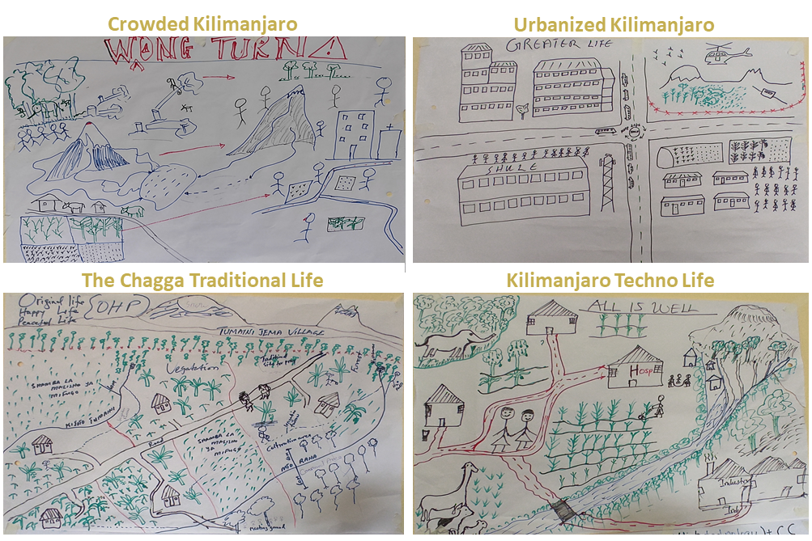
a

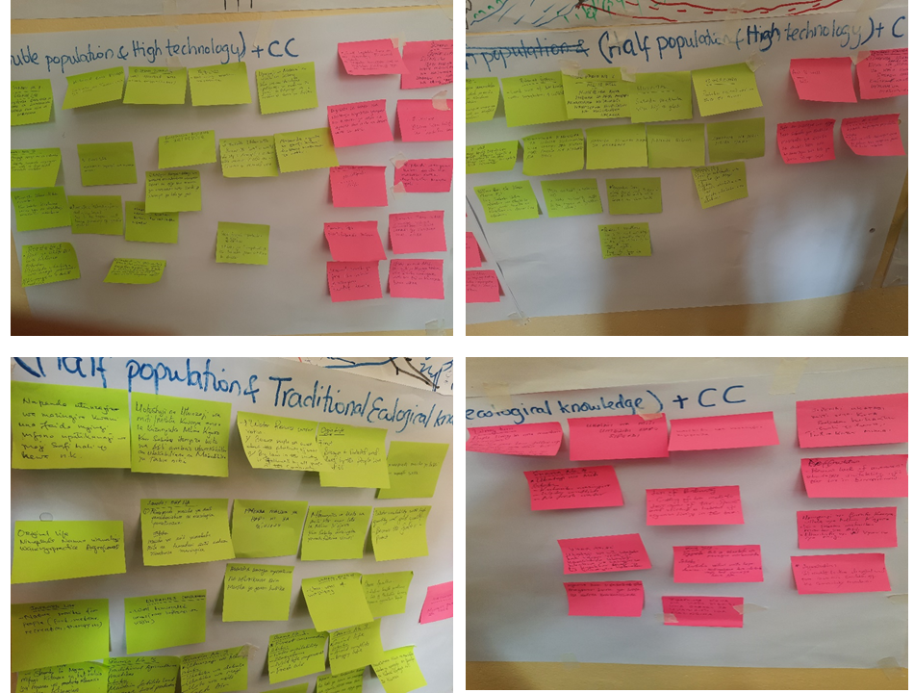
b

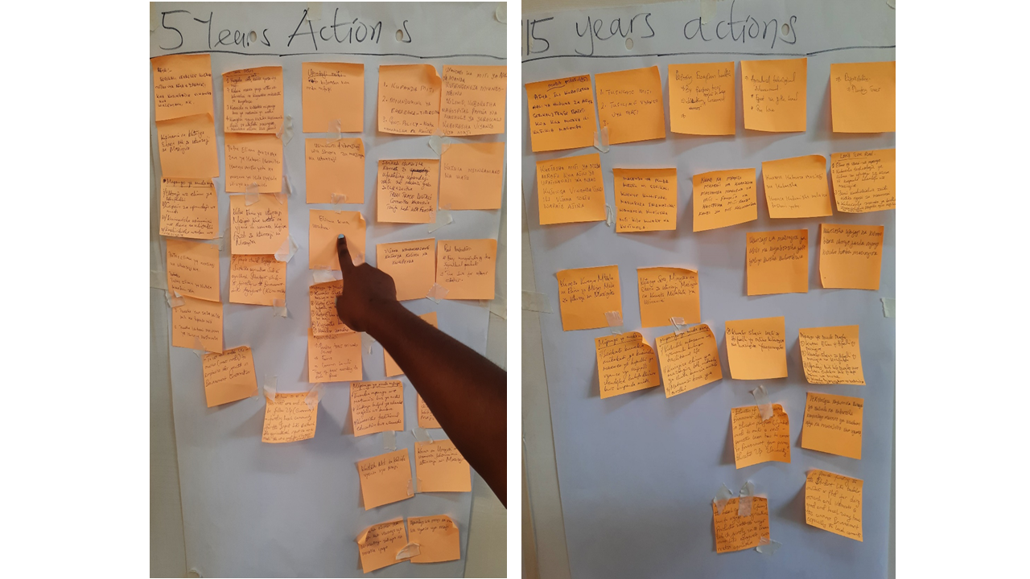
c

Table S6: Summary of the components identified as desirable and undesirable for the future social-ecological system of Kilimanjaro, alongside exemplary quotes from the discussions and the scenarios in which each component was identified: Scenario 1: Crowded Kilimanjaro; Scenario 2: Urbanized Kilimanjaro; Scenario 3: The Chagga traditional Life; and Scenario 4: Kilimanjaro Techno Life.
Desirable components of the future social-ecological system of Kilimanjaro
Component | Code | Exemplary extract from workshop 2 transcripts | Scenario(s)
Environmental protection | Biodiversity conservation | Wild animals and their environment  Well-demarcated areas enhance conservation  Forest – because people around it protects and value it  Plant species such as the Alangium chinense or Mringonu in Swahili, which disappeared many years ago due to deforestation, will return. | The Chagga Traditional Life  Kilimanjaro Techno Life
Environmental protection | Improved ecosystems | Balanced system – a good mix of development with vegetation and wildlife  Increase in vegetation cover  Rainfall availability and restoration of the environment | The Chagga Traditional Life;  Kilimanjaro Techno Life
Environmental protection | Reforestation and conservation | Forest conservation promotes water availability, fresh air, and wildlife conservation.  Reforestation and conservation of forests around Mount Kilimanjaro help regulate climatic conditions. | The Chagga Traditional Life
Environmental protection | Water resources conservation and management | The good environment of Mount Kilimanjaro, which is the source of water  Water availability, which results in an improvement in agriculture and industries | The Chagga traditional life;  Kilimanjaro Techno Life
Land use and agriculture management | Sustainable agriculture | Sustainable farming methods include greenhouse farming, for example. This approach uses a small area and returns a high yield.  Water conservation techniques, such as irrigation are used in agriculture. | Urbanized Kilimanjaro;  Kilimanjaro Techno Life
Land use and agriculture management | Land use planning | Enough land for agriculture  Available land will be divided for different human activities like agriculture, livestock, industries, and conservation. | Urbanized Kilimanjaro;  The Chagga traditional life
Land use and agriculture management | Socioeconomic development | Good health services whereby pregnant women give birth safely  Good road infrastructure  Tourism activities are growing because of increased safety and technology.  For instance, multipurpose cable cars could provide opportunities for visitors who do not want to climb up to Uhuru Peak but want a day trip. Cable cars could also be used for rescue services when the weather does not allow helicopters to land for rescues. | Urbanized Kilimanjaro;  Kilimanjaro Techno Life
Cultural  preservation | Social Harmony | Peaceful conditions—The availability of land and low population result in peace in the community (reducing conflicts), which is a peaceful, happy, and good life.  Peace and safety due to enough food supply | The Chagga Traditional Life
Cultural  preservation | Traditional life and practices | Cultural respect – areas of worshipping  Organic agriculture reduces health problems and loss of production by using expensive agricultural inputs  Following traditions and customs because our ancestors, when there was no rain, they fasted and prayed, and we got rain  Traditional agricultural activities will maintain soil fertility and hence increase food productivity.  Follow the bylaws established by traditional leaders. | The Chagga Traditional Life
Undesirable components of the future social-ecological system of Kilimanjaro
Environmental degradation | Biodiversity loss | Cutting down trees causes the loss of some tree species and disturbs the habitat of animals living in trees.  Encroachment and shrinkage of the protected area, which pose threats to biodiversity conservation and nature’s contributions to people | Crowded Kilimanjaro
Environmental degradation | Deforestation | Deforestation results in drought and poor economic conditions for the community members.  I don’t like cutting down trees because it destroys the climate, and we will lack rain | Crowded Kilimanjaro
Environmental degradation | Degradation of the environment | I dislike the state of environmental destruction that continues because it threatens our prosperity in this world, the lack of food, water, and fresh air  Fragmentation and eventually a decrease in arable land for agriculture | Crowded Kilimanjaro
Environmental degradation | Loss of the ice cap on Kilimanjaro | Deforestation will make the situation more difficult, cause serious environmental damage, and lead to the loss of glaciers.  I do not like the ice loss on the top of Mount Kilimanjaro because it decreases water availability. | Crowded Kilimanjaro
Environmental degradation | Pollution from industries | Industries should not be located near people’s settlements because the smoke from industries pollutes the environment. | Kilimanjaro Techno Life
Socioeconomic conditions | Low population | Community vulnerability (the whole population may disappear in case of disasters or pandemics)  Reducing population growth is not safe for our communities in the future, the existence of the next generation, especially in the event of disasters. | The Chagga Traditional Life;  Kilimanjaro Techno Life
Socioeconomic conditions | Overpopulation | This scenario causes conflicts between members of the community and leads to misunderstandings.  I do not like to have a double population because of the destruction of the environment. | Urbanized Kilimanjaro
Socioeconomic conditions | Displacement | People will be forced out of Kilimanjaro to other places like Handeni | Crowded Kilimanjaro
Socioeconomic conditions | Loss of traditions and culture | A decline in social interaction and community cohesion, attributed to various factors such as urbanization, technology, and cultural shifts | The Chagga Traditional Life
Socioeconomic conditions | Limited development and external linkages | No proper connection with the external world (primitive ways of life). | The Chagga Traditional Life
Socioeconomic conditions | Limited financial resources | You can be happy, but you might not have money, which is sometimes not good. For example, you might need a hundred dollars and ask the whole village for help, but you will not receive it  Per capita income decreases, possibly due to economic challenges, resource constraints, or market fluctuations. | The Chagga Traditional Life
Socioeconomic conditions | Limited transportation infrastructure | Poor roads make taking agricultural products to the market difficult. | The Chagga Traditional Life
Socioeconomic conditions | Unemployment | Mechanization in agriculture and technology use in tourism, such as cable cars, will cause unemployment | Urbanized Kilimanjaro

Table S7: Changes in future scenarios key SES elements, NCP supply, quality of life indicators, and the actors—winners (+) or losers (-) as perceived by workshop participants. ↓↓ strong decrease, ↓ decrease, ↔ no change, ↑ increase, ↑↑ strong increase.
 |  | Scenario 1:  Crowded Kilimanjaro | Scenario 2: Urbanized Kilimanjaro | Scenario 3: The Chagga Traditional Life | Scenario 4: Kilimanjaro Techno Life
Social-ecological elements | Forest | ↓↓ Conversion to settlements | ↓↓ Conversion to settlements, farms, and other infrastructures, e.g., roads | ↑↑ Conservation | ↑↑ No encroachment in protected forest
Social-ecological elements | Coffee plantations | ↓ Shrinking land available for agricultural activities | ↓↓ Shrinking agricultural land | ↑↑ Sufficient cultivation land | ↑↑ Available land
Social-ecological elements | Homegardens
Social-ecological elements | Maize fields
Social-ecological elements | Savannas | ↓ Shrinking land available for agricultural activities | ↓↓ Conversion to settlements or other infrastructures
Social-ecological elements | Biodiversity | ↓↓ Overexploitation of resources- Tragedy of the commons | ↓↓ Deforestation and habitat fragmentation | ↑↑ Restoration of biodiversity | ↑↑ No encroachment in protected forest, enough land for biodiversity to thrive
Social-ecological elements | Soil | ↓ Soil erosion due to decreased vegetation cover | ↓ Intensive use of agrochemicals | ↑↑ Traditional farming practices | ↑ Fallowing as there is enough land
Social-ecological elements | Tourism | ↓ Environmental degradation | ↑ High-tech, diversified tourism products | ↑↑ Many attractions | ↑ Increased biodiversity and geodiversity
Social-ecological elements | Markets | ↓ Low agricultural production | ↑ Increase local due to high population | ↑ For organic-produced crops | ↑ Local and regional markets will improve.
Social-ecological elements | Water resources | ↓↓ Increased demand for water and climate variability | ↓↓ Increased demand | ↑↑ Strong traditional environmental conservation and protection of water  sources. | ↑↑ No farming near water sources
 | Traditions and culture | ↓ Disappearance of some areas with cultural value. | ↓↓ Detachment from nature and increased Chagga traditions abandonment e.g., Kihamba | ↑↑Less influence of Western culture | ↓↓ Abandonment of traditions and culture
Nature's Contributions to People (NCP) | Material | Food | ↓ Shrinking land for cultivation | ↓ Improved farming technology, which will improve agricultural yields but in smaller parcel of land | ↑↑ Available land for production. | ↑↑ Available land increased agricultural technology.
Nature's Contributions to People (NCP) | Material | Feed | ↓ Deforestation and shrinking land for growing fodder | ↓ Shrinking grazing land/ area to grow feed | ↑↑ Sufficient green pastures and crop remains | ↑↑ Available land for pastures
Nature's Contributions to People (NCP) | Material | Energy |  | ↓ Increased demand |  | ↑↑ Available technology for energy production
Nature's Contributions to People (NCP) | Material | Materials for building | ↓↓ Deforestation | ↓ Cleared forests | ↔ Building materials availability | ↑↑ Available trees and iron sheets from industries
Nature's Contributions to People (NCP) | Material | Medicine | ↓↓ Overexploitation of resources like forests |  | ↑↑ Reduced cutting of trees, some of which are medicinal plants | ↑↑ Available western medication

 | Regulating | Regulation of water quality |  | ↓↓ Pollution of water sources | ↑↑ Conservation of water resources | ↑↑ Few people around water sources, less water pollution
 | Regulating | Regulation of water quantity | ↓↓ Deforestation | ↓↓ Increased demand for multiple uses | ↑↑ Decrease of water use conflict | ↑↑ No deforestation, hence stable rainfall
 | Regulating | Regulation of air quality | ↓↓ Pollution | ↓ Pollution from industrial activities and transportation | ↑↑ Protected environment | ↑↓ Improve with reforestation decrease with more industries.
 | Regulating | Regulation of soil fertility | ↓↓ Degraded soil | ↓↓ Erosion as a result of deforestation | ↑↑ High vegetation cover | ↑↑ Enough vegetation cover
 | Regulating | Habitat creation and maintenance | ↓↓ Land degradation | ↓↓ Deforestation and habitat fragmentation
 | Regulating | Pollination |  | ↓ Decrease natural habitat
 | Regulating | Regulations of hazards and extreme events |  |  | ↑ Implementation of laws to protect nature and avoid drought
 | Non-material | Social cohesion and bonding | ↓↓ Pressure on shared resources |  | ↑ Traditional lifestyle strengthens bonds and relationships | ↑↑ No conflicts among people
 | Non-material | Recreation | ↓ Degraded environment | ↑↑Accessibility to the mountain via cable cars | ↑ The presence of tourist attractions and nature
 | Non-material | Cultural Heritage and identity |  | ↓↓ Disappearance of some areas with cultural value. | ↑↑ Preservation of traditions and culture
 | Non-material | Connectedness with nature |  | ↓↓ Deforestation for settlement, and there will be less or no area where people can visit | ↑↑ Protection of nature
 | Non-material | Intergenerational benefits |  | ↓ Environmental degradation, denying benefits to the future generation | ↑↑ Preservation of biodiversity

Quality of life dimensions | Health | ↓ Decrease in air and water quality due to deforestation | ↑ Use of modern medicine | ↑↑ Traditional medicines and organic food consumption | ↑↑ Sufficient social services and food security
Quality of life dimensions | Housing situation | ↓ Overpopulation | ↑↑ Modern housing | ↑↑ Good traditional houses | ↑ Available building materials
Quality of life dimensions | Financial situation | ↓ Decline in agricultural products, such as food, as a result of the decrease in arable land for agriculture | ↔ No new job opportunities created rather may even lead to unemployment | ↑ Batter trade | ↑↑ Diversified livelihoods activities
Quality of life dimensions | Employment opportunities | ↓ Decrease due to shrinking arable land for agriculture | ↓ Machines will replace human labor | ↑ In agriculture and local processing units | ↑ Presence of industries
Quality of life dimensions | Road access |  | ↑↑ Well-planned road network | ↓ Poor road infrastructures | ↑ Available land for planned road infrastructures
Quality of life dimensions | Market opportunities | ↑ High demand for food in the local market. | ↑ Increase in manufactured goods | ↑ Increased market value of products | ↑↓ Increase if exporting decreases if the market is local.
Quality of life dimensions | Water availability | ↓↓ Pollution of water sources, increased demand for water, and climate variability | ↔ Necessitating water treatment and recycling innovations | ↑ water resources conservation | ↑ Lower demand
Quality of life dimensions | Safety | ↓ Unemployment will boost criminal activities. | ↑↑ Advanced technology will help control theft behavior | ↑ Strong social bonds | ↑ Enough resources for everyone
Quality of life dimensions | Education | ↓ Focus on survival rather than long-term learning | ↑ Use of technology in teaching | ↓ More informal education | ↑↑ Increased technology and infrastructure
Quality of life dimensions | Social relationships | ↓ Urbanization and cultural shifts | ↑ Increased social interactions | ↑↑ Communal life | ↑ No land use conflicts

Actor—winner (+), looser (-) | Government | (-) Degradation of resources | (+) Increased revenue collection | (+) Life in harmony with nature | (+) Increased social services
Actor—winner (+), looser (-) | Industries & Business | (+) Utilize resources, e.g., lumbering. | (+) Diversified economies through technology | (-) Prioritized traditional ways | (+) Value-addition industries, e.g., wood  (-) Traditional medicine usage
Actor—winner (+), looser (-) | Local farmers | (-) Displacement | (-) Shrinking agricultural land | (+) Productive agriculture in harmony with nature | (+) Improved agriculture technologies
Actor—winner (+), looser (-) | Locals non-farmers | (-) Displacement | (+) Improved social services | (+) Harmonious life within the community | (+) Improved infrastructures
Actor—winner (+), looser (-) | Tourists | (-) Degraded tourism attractions | (+) Diversified tourism experience | (+) Protection of nature | (+) Improved facilities and infrastructures
Actor—winner (+), looser (-) | Tour guides | (-) Unemployment | (-) Unemployment due to cable car system | (+) Increased tourism revenue | (+) Increased tourism revenue
Actor—winner (+), looser (-) | Conservationists | (-) Loss of biodiversity | (-) Loss of biodiversity | (+) Biodiversity conservation through TEK | (+) Biodiversity conservation

