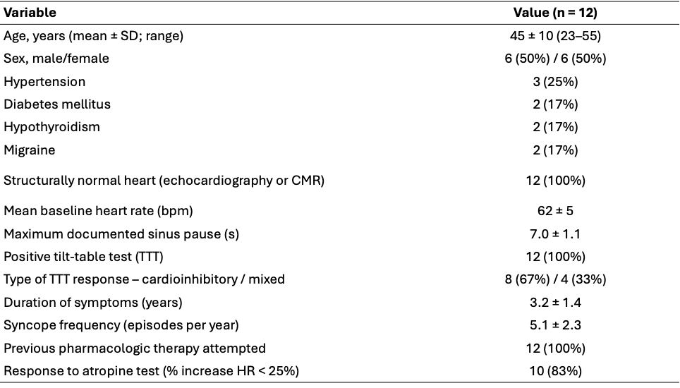
Table I: Baseline demographic and clinical characteristics of the study population.
Abbreviations: SD = standard deviation; bpm = beats per minute; HR = heart rate; CMR = cardiac magnetic resonance; TTT = tilt-table test.

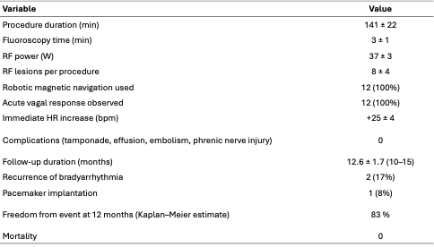Table II: Procedural characteristics and clinical outcomes. Continuous variables are expressed as mean ± SD with 95% confidence intervals (CI). Categorical variables are shown as proportions with exact (Clopper–Pearson) 95% CIs.
Abbreviations: RF = radiofrequency; bpm = beats per minute; HR = heart rate; CI = confidence interval.
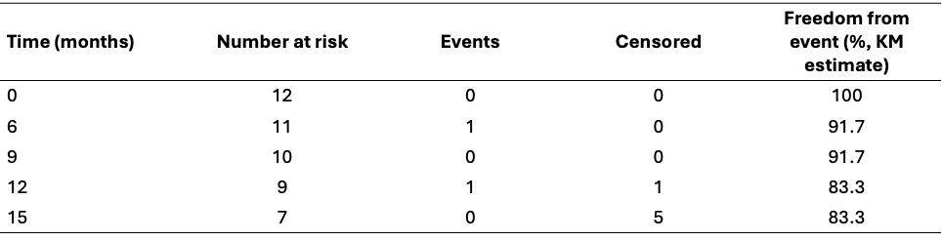
Table III: Time-to-event analysis (Kaplan–Meier summary).
Abbreviations: KM = Kaplan–Meier estimate of freedom from clinically significant bradyarrhythmia or pacemaker implantation.

