Supplementary Information for
All-solid passive organic optical limiter via
coordination-bond anchoring strategy
Dan Chen*‡, Yuang Chen‡, Zhihong Zhu, Qingwei Zhou, Fang Luo, Fan Wu, Chucai Guo
College of Advanced Interdisciplinary Studies & Hunan Provincial Key Laboratory of Novel NanoOptoelec-tronic Information Materials and Devices, National University of Defense Technology, Changsha, Hunan 410073, China
Nanhu Laser Laboratory, National University of Defense Technology, Changsha, Hunan 410073, China
These authors contributed equally: Dan Chen, Yuang Chen.
* Corresponding author: 18874050884@163.com
Experimental Information
All density functional theory (DFT) calculations were performed using the Gaussian 09 program to obtain the ground-state electronic structures. The exchange-correlation effects were treated with the PBE0 functional¹. A mixed basis set approach was employed: the 6-31G(d,p)²⁻⁴ basis set was used for C, H, O, N, and Cl atoms, while the Stuttgart-Dresden effective core potential (SDD)⁵ was applied for the In atom. To account for van der Waals interactions, the D3BJ dispersion correction⁶ was incorporated.
The third-order NLO properties of the OL devices were investigated by using the Z-scan technique. The OL devices were positioned on a motorized translation stage for precise Z-axis scanning. A 532 nm Nd:YAG laser (pulse duration = 8 ns) served as the excitation source and the output beam was split into two paths by a beam splitter. Energy detectors E1 and E2 independently monitored the pulse energies before and after sample interaction. Ambient temperature was maintained throughout all measurements. The Nonlinear absorption coefficients and the nonlinear Z-scan transmittance of the OL devices were obtained by fitting the experimental data. The equation fits for the nonlinear adsorption coefficient β_{eff} as follows:
$$T\left(Z, S=1\right)=\frac{1}{\sqrt{π}q\left(\frac{z}{z_{0}}\right)}\int_{-∞}^{+∞}{\ln\left[1+q\left(\frac{z}{z_{0}}\right)e^{-r^{2}}\right]dr}$$
$$q\left(z, t\right)=β_{eff}I_{0}(t)\frac{L_{eff}}{1+\frac{z^{2}}{z_{0}^{2}}}$$
$$L_{eff}=\frac{1-e^{-αl}}{α}$$
In these equations, L_{eff} is the effective thickness of the sample, I₀ is the axial intensity at the focus, z₀ is the diffraction length of the beam, z is the position of the sample, α is the linear absorption coefficient, and l is the sample thickness.
The transient absorption spectroscopy measurements were performed on a Helios (Ultrafast systems) spectrometers using a regeneratively amplified femtosecond Ti:sapphire laser system (Spitfire Pro-F1KXP, Spectra-Physics; frequency, 1 kHz; max pulse energy, ~8 mJ; pulse width, 120 fs) at room temperature. Finally, analyze the data through commercial software (Surface Xplorer, Ultrafast Systems).
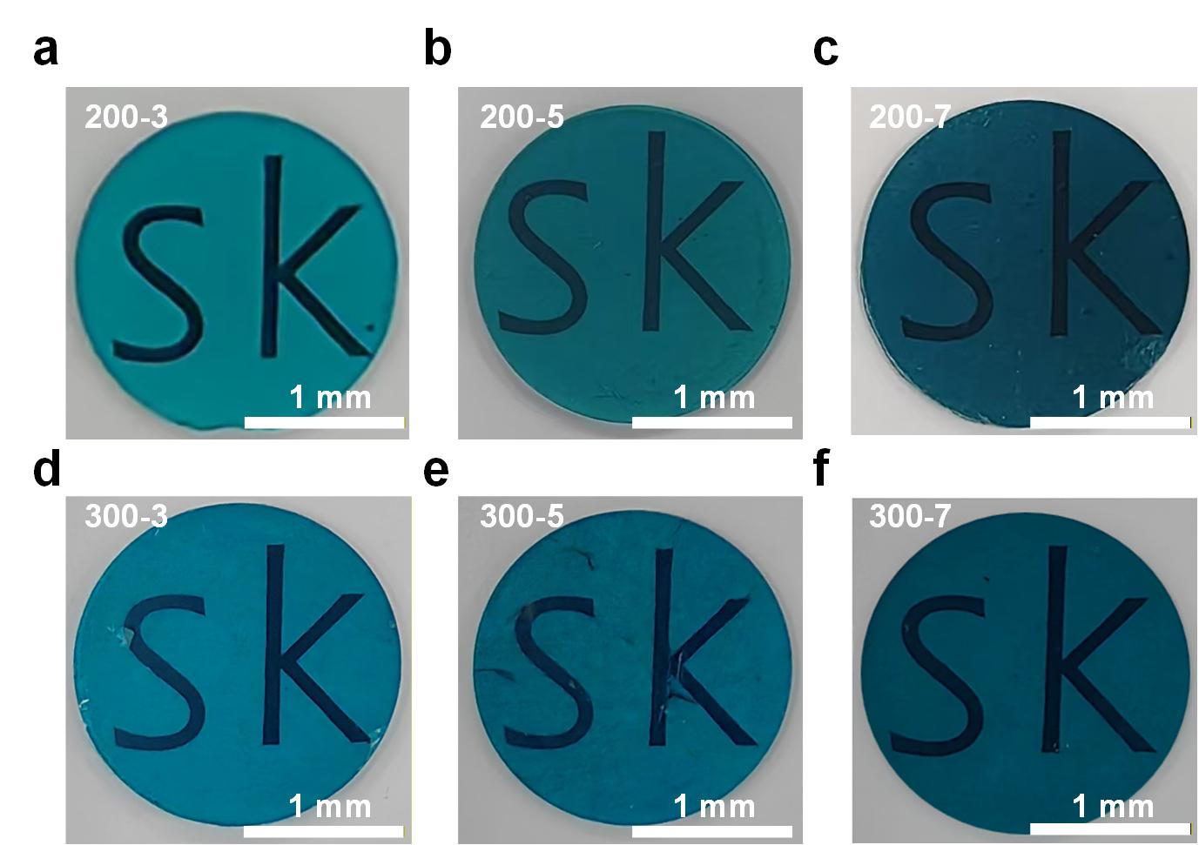
Supplementary Figure 1. PMOL. (a) 200-3, (b) 200-5, (c) 200-7, (d) 300-3, (e) 300-5, (f) 300-7.
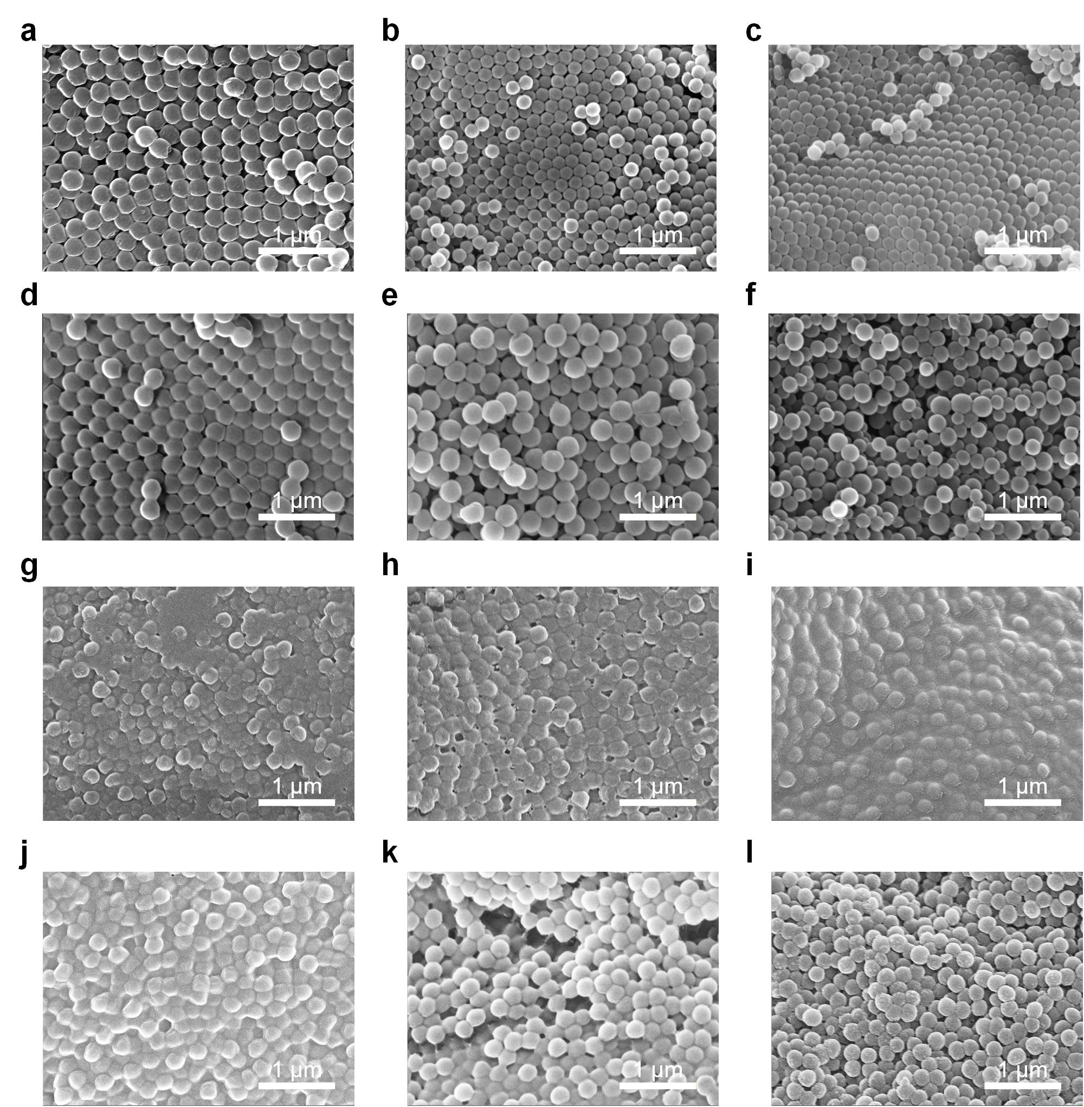
Supplementary Figure 2. The SEM of OL microsphere before thermo-compression under high-elastic-state. (a) 200-3, (b) 200-5, (c) 200-7, (d) 300-3, (e) 300-5, (f) 300-7. The SEM of PMOL. (g) 200-3, (h) 200-5, (i) 200-7, (j) 300-3, (k) 300-5, (l) 300-7.
Temperature governed microspheres growth thermodynamics by modulating micellar stability and molecular diffusion rates, while stirring speed kinetically regulated microsphere formation through shear force control, mixing efficiency, and heat transfer. Under this dual regulation, microspheres with varied dimensions were yielded. During high-elastic-state thermo-compression processing, microspheres underwent morphological reconstruction and cross-linking effects. Compared to monodispersed OL microspheres, PMOL microspheres exhibited partial collapse of spherical contours under dynamic compressive stress. Discrete microspheres developed interconnected 3D networks via entanglement of peripheral molecular chains under elevated temperature and pressure, enhancing microsphere connectivity and mechanical properties of PMOL.
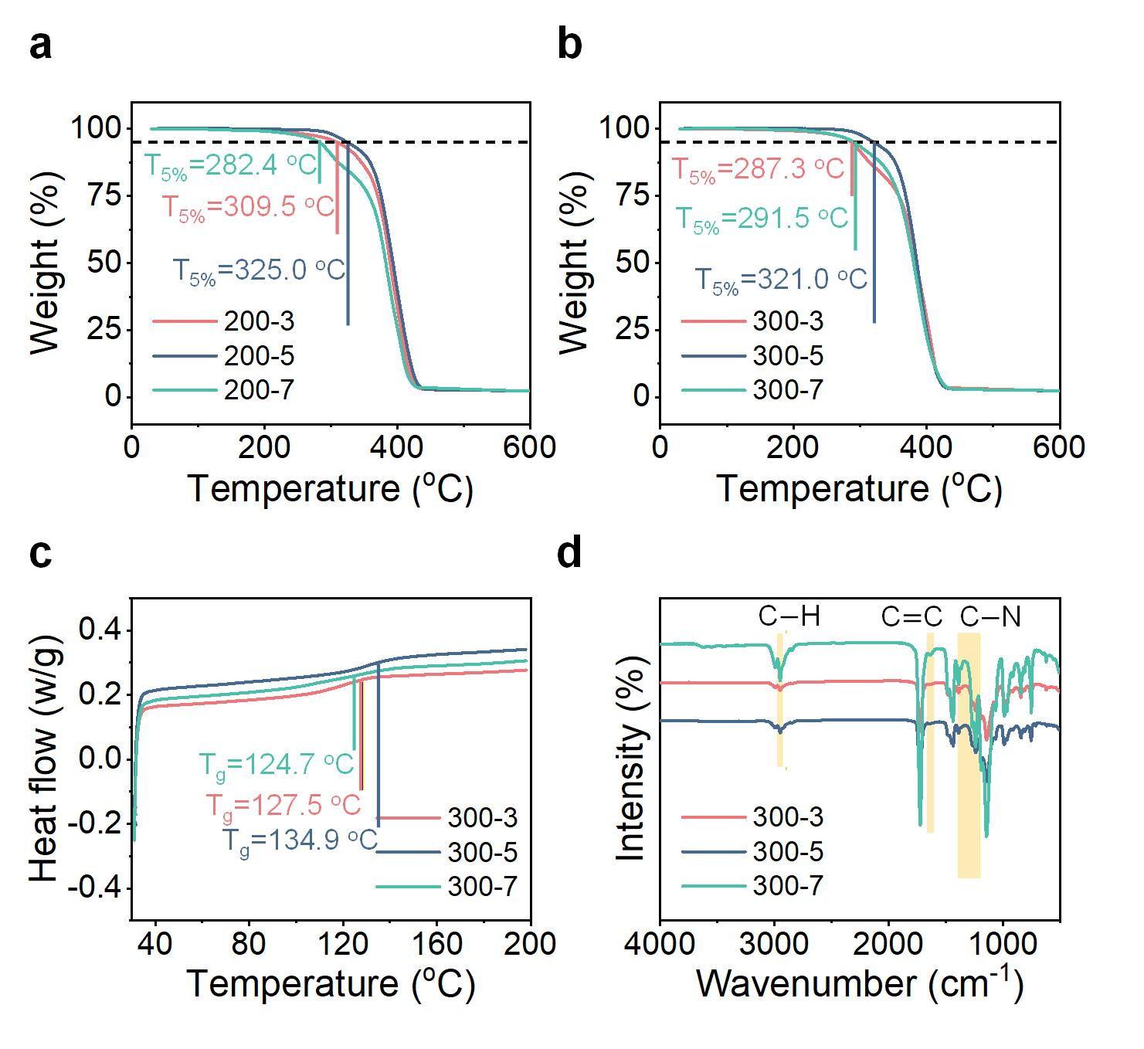
Supplementary Figure 3. (a) TG analysis curves of the 200-x OL microspheres, ranging from 30 to 600 ℃. (b) TG analysis curves of the 300-x OL microspheres, ranging from 30 to 600 ℃. (c) DSC curves of the 300-x OL microspheres analyzing the glass transition temperature, ranging from room temperature to 200 ℃. (d) FT-IR curves ranging from 500 to 4000 cm⁻¹.
Competing intermolecular forces and heat conduction effects leaded to optimal thermal stability occurring at 0.5 wt% InPc content. Higher InPc content led to more densely packed microspheres with stronger intermolecular forces, increasing the T_{5%}. Conversely, the enhanced thermal conductivity of densely packed microspheres accelerated heat dissipation, promoting decomposition at lower temperatures and thereby driving faster weight loss. Nono size effect may affect the Thermal performance of the OL microspheres. Small-volume microspheres exhibited large surface area and more surface atoms, with relatively high degree movement freedom, which made the surface part liable to occur glassy transition, thus T_{g} declined. From the FT-IR spectra, the high intensity characteristic peaks curves were 2953, 1725, 1435, 1145, and 1060 cm⁻¹, indicating the presence of C-H, C=O, CH₃, -O-CH₃, and C-O-C bonds, respectively.
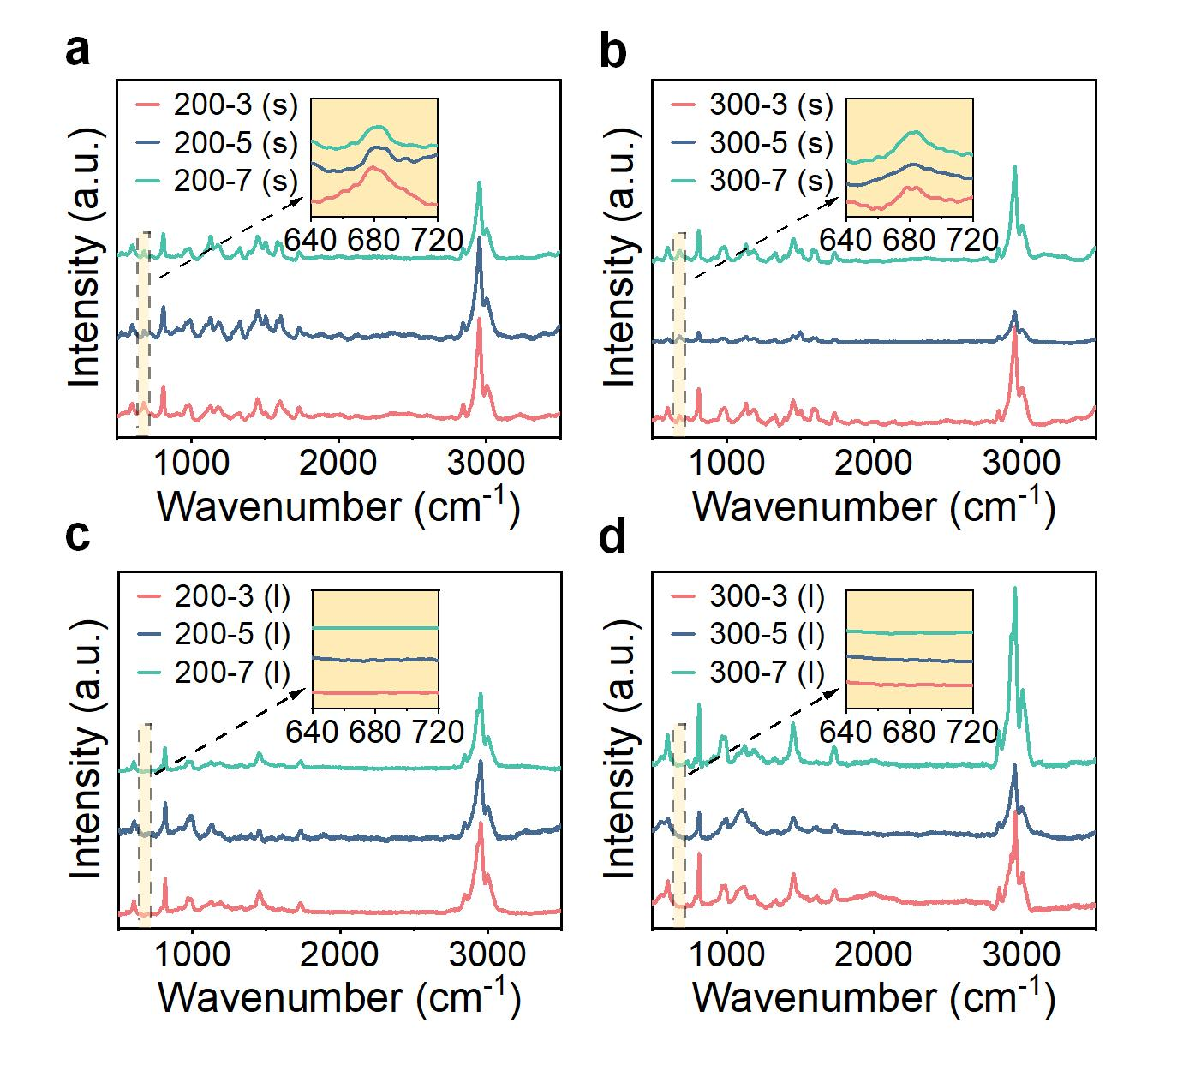
Supplementary Figure 4. Raman curves of the PMOL and OL microspheres in solution, ranging from 500 to 3500 cm⁻¹. (a) the 200-x PMOL, (b) the 300-x PMOL, (c) the 200-x OL microspheres in solution, (d) the 300-x OL microspheres in solution.
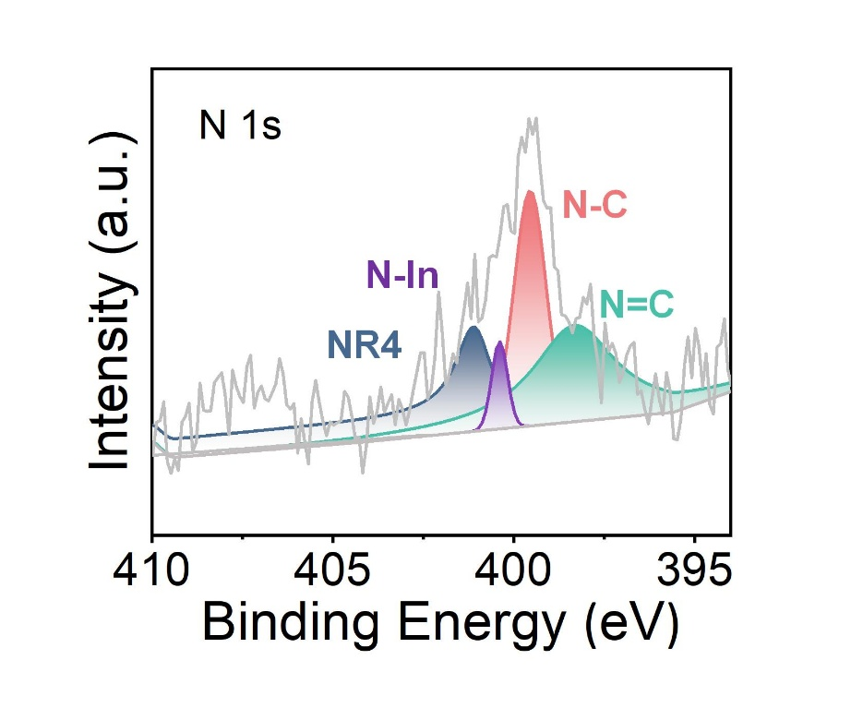
Supplementary Figure 5. XPS spectra of N 1s in PMOL.
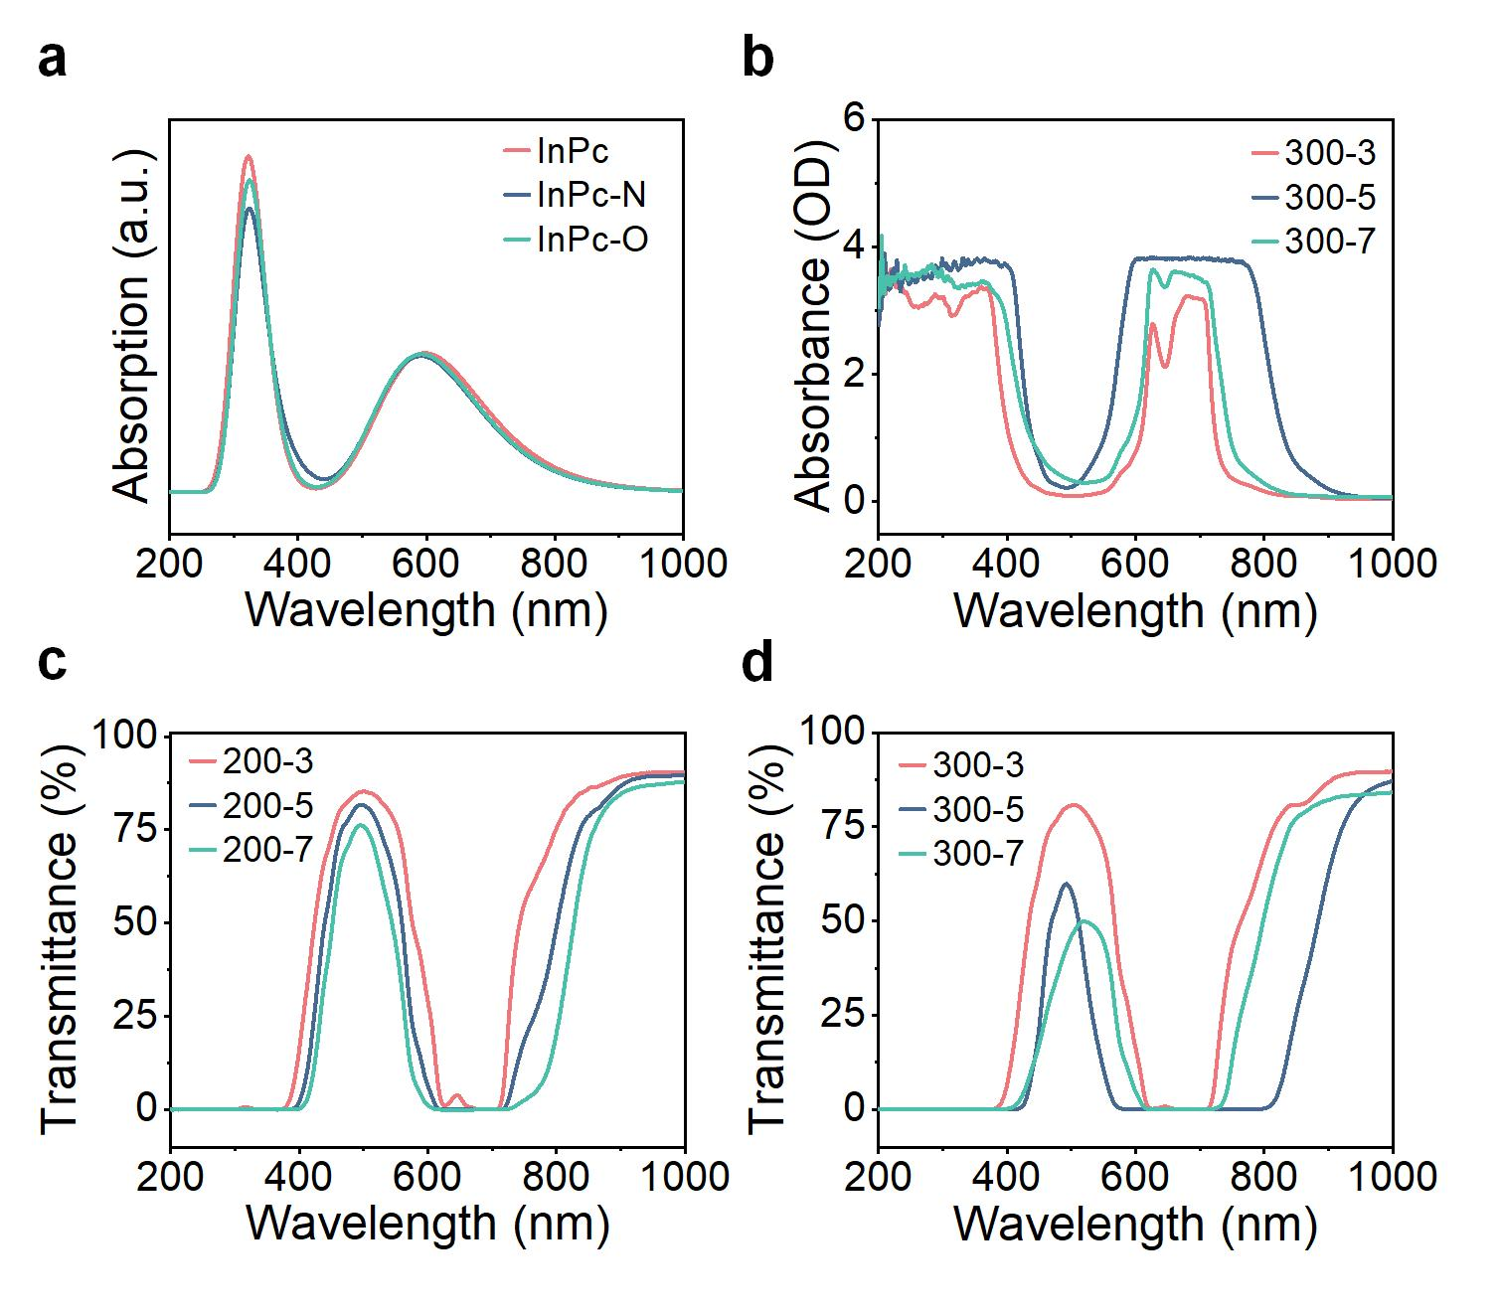
Supplementary Figure 6. (a) The DFT-calculated transmittance curves of InPc, InPc-N, and InPc-O range from 0 to 1000 nm. (b) Absorbance curves of 300-x PMOL ranging from 200 to 1000 nm. (c) Transmittance curves of 200-x PMOL ranging from 200 to 1000 nm. (d) Transmittance curves of 300-x PMOL ranging from 200 to 1000 nm.
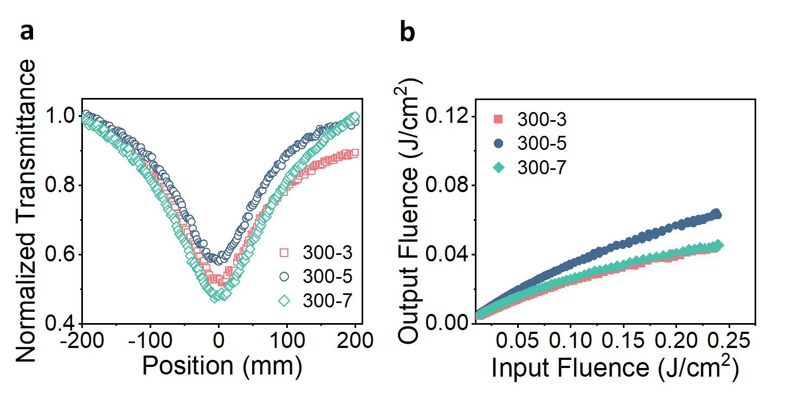
Supplementary Figure 7. (a) Normalized transmittance curves of open aperture Z-scan for the 300-x PMOL at 532 nm wavelength. (b) Input-output energy density curves of 300-x PMOL ranging from 0.013 J/cm² to 0.24 J/cm².
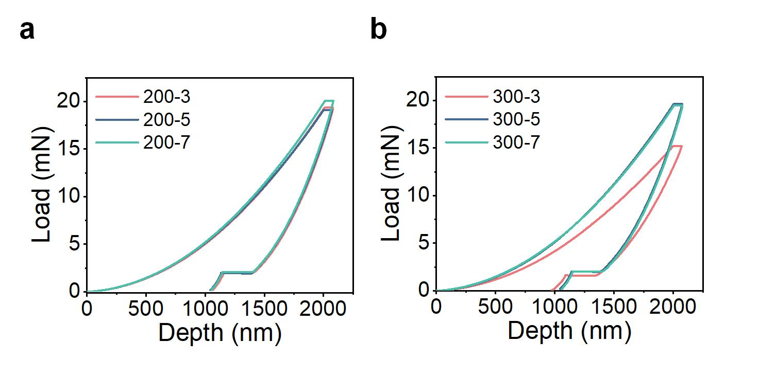
Supplementary Figure 8. (a) Nanoindentation analysis of load-displacement curves of the 200-x PMOL. (b) Nanoindentation analysis of load-displacement curves of the 200-x PMOL.
An identical indentation depth of 2000 nm was applied to the indentations of each PMOL, the corresponding load curves were shown in Supplementary Fig. 8. The load differences among different devices were also manifested in hardness, when indented to the same depth, a higher required load indicates greater hardness of the device.
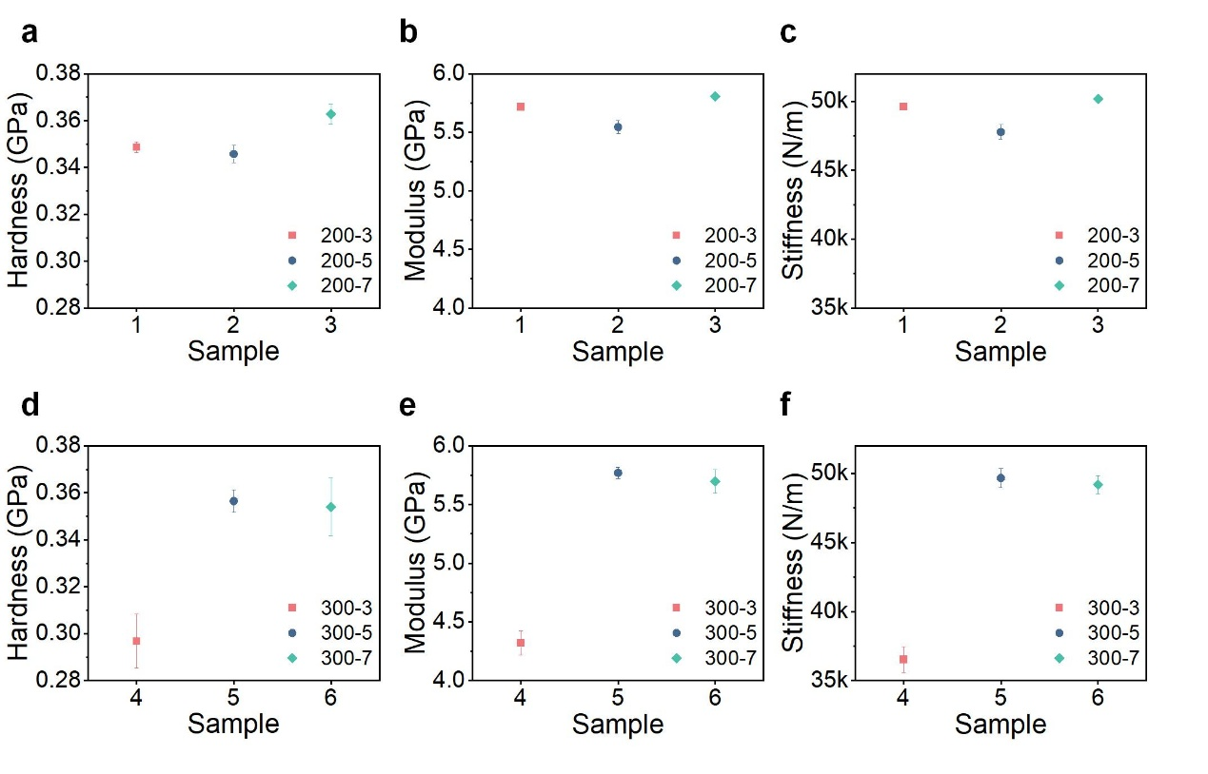
Supplementary Figure 9. Mechanical properties of the 200-x PMOL. (a) Hardness, (b) Modulus, (c) Stiffness. Mechanical properties of the 300-x PMOL. (d) Hardness, (e) Modulus, (f) Stiffness.
Obviously, as indicated by the data in the hardness, modulus and stiffness of the PMOL shown Supplementary Fig. 9, the standard deviations of 300-x PMOL were larger than those of 200-x PMOL at same InPc concentration. Moreover, the 200-7 PMOL exhibited optimal properties (Hardness = 0.36 GPa, Modulus = 5.8 GPa, Stiffness = 5.02 × 10⁴ N/m) owing to the close-packed arrangement of microspheres and weak-stress concentration.

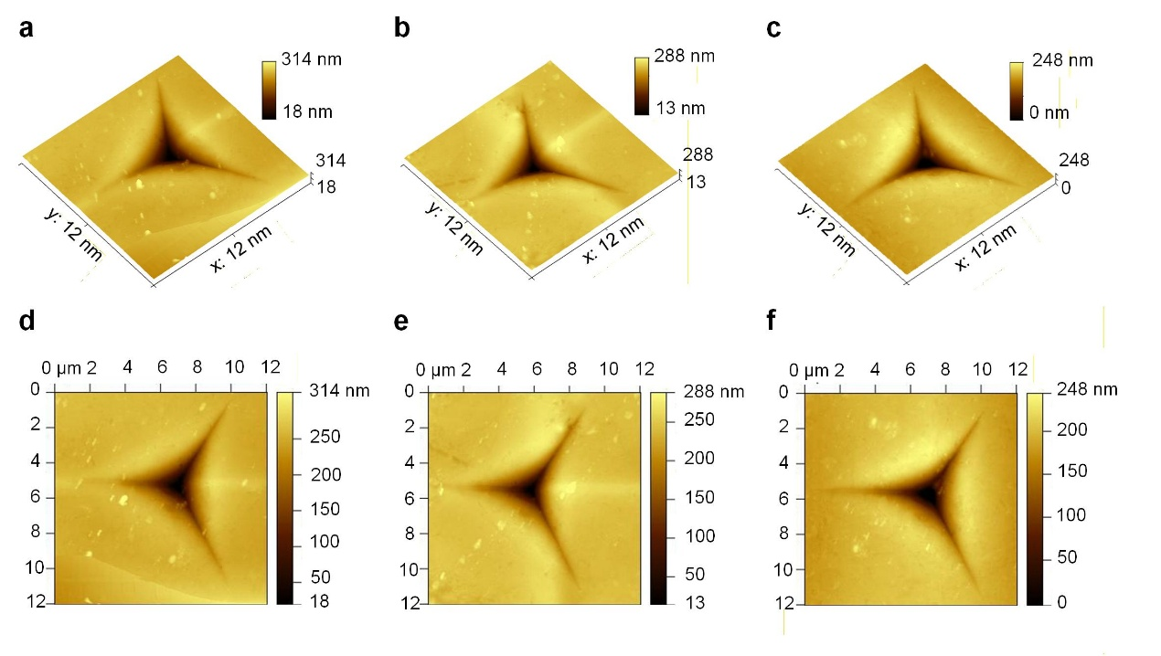
Supplementary Figure 10. 3D AFM images of 200-x PMOL. (a) 200-3, (b) 200-5, (c) 200-7. 2D AFM images of 200-x PMOL. (d) 200-3, (e) 200-5, (f) 200-7.
Atomic force microscopy (AFM) images acquired in contact mode under ambient atmosphere revealed, residual indentation patterns on the 200-3, 200-5, and 200-7 PMOL in 3D and 2D The indentation depths measured via AFM analysis were approximately 240-310 nm, with the smallest depth (248 nm) observed on the 200-7 PMOL exhibiting the most outstanding mechanical properties. In addition, the indentation depths were much smaller than those during the loading process shown in Supplementary Figure 8 (over 2000 nm), indicating more than 85% elastic recovery during unloading. The difference in depth between the nanoindentation test and AFM images could be ascribed to the resilience process during unloading, illustrating the excellent elasticity and the close-packed OL microspheres to resist high pressure. Therefore, the PMOL was able to maintain its mechanical strength properties during operations such as bending, stretching, and extrusion in the manufacturing process owing to the excellent resilience and compressibility of the OL microspheres, demonstrating promising industrial applications prospects.
Supplementary Table S1. XPS peak positions of OL microspheres and PMOL.
C 1s
 | C-C | C-N | C-O | C=N | C=O
OL microspheres (eV) | 284.8 | 286.21 | 286.90 | 288.08 | 288.72
PMOL (eV) | 284.8 | 286.22 | 286.99 | 288.42 | 288.86
O 1s
 | O-In | O=C | O-C
OL microspheres (eV) | 529.73 | 531.88 | 533.45
PMOL (eV) | 530.22 | 532.07 | 533.67
N 1s
 | N=C | N-C | N-In | NR4
PMOL (eV) | 398.32 | 399.55 | 400.39 | 401.11
In 3d
 | In 3d_{5/2} | In 3d_{3/2}
OL microspheres (eV) | 444.69 | 452.26
PMOL (eV) | 445.19 | 452.74

Supplementary Table S2. Nonlinear absorption coefficient.
 | 200-3 | 200-5 | 200-7 | 300-3 | 300-5 | 300-7
β_{eff}（W/m） | 2.72 × 10⁻⁵ | 3.76 × 10⁻⁵ | 4.89 × 10⁻⁵ | 5.45 × 10⁻⁵ | 4.91 × 10⁻⁵ | 6.14 × 10⁻⁵
Interesting, the PMOL with large-sized microspheres exhibited higher β_{eff} at the same InPc concentration, the reason might be that the larger scattering cross-section of the 300-x PMOL induced multiple scattering events that prolonged the effective path of light within the device (increase in the equivalent optical path) and thereby enhanced the interaction between InPc and the 532 nm laser.
Supplementary Table S3. Linear transmittance and OL threshold.
 | 200-3 | 200-5 | 200-7 | 300-3 | 300-5 | 300-7
T_{lin} (%) | 81.53 | 71.64 | 59.13 | 76.14 | 25.4 | 48.96
F_{OL} (J/cm²) | > 0.24 | 0.17 | < 0.013 | < 0.013 | > 0.24 | 0.13
From the results, the 200-7 PMOL demonstrated discernibly superior performance among all samples. A probable reason was that the high InPc concentration and potent heat-dissipation capacity provided by the microspheres with a high specific surface area enabled the maintenance of a stable NLO response under high intensity laser irradiation.
Supplementary Table S4. The Nonlinear absorption coefficient (β_{eff}) of some reported NLO materials and PMOL.
Samples | β_{eff} (m/W) | Wavelength (nm) | references
The 200-7 PMOL | 4.89× 10⁻⁵ | 532 | This work
CuPc-PI-COF-1 | 3.274 × 10⁻¹⁰ | 532 | ⁷
Annealed F₁₂PcZn–BP film | 2.63 × 10^{–9} | 532 | ⁸
F₁₂NH₂PcZn | 6.78 × 10^{–10} | 532 | ⁸
Nonannealed F₁₂PcZn–BP film | 1.77 × 10^{–9} | 532 | ⁸
LaPc-4(C₆₀)/PMMA | 2.9 × 10^{–8} | 532 | ⁹
poly[(MMA)168-co-(NPMA)5.2-co-(ZnPc)1.2] / PMMA film | 6.1 × 10^{–11} | 532 | ¹⁰
MA-VA-PcInCl | 2.5 × 10^{–10} | 532 | ¹¹
TA-VA-PcInCl | 6.5 × 10^{–11} | 532 | ¹¹
PMMA-PDA-InPc | 2.2 × 10^{–9} | 532 | ¹²
PMMA-InPc | 1.0 × 10^{–9} | 532 | ¹²
PcEuOAc | 1.22 ×10⁻¹⁰ | 532 | ¹³
PcTbOAc | 4.0 ×10⁻¹⁰ | 532 | ¹³
PcLuOAc | 2.5 ×10⁻¹⁰ | 532 | ¹³
LaPc | 1.86 ×10⁻¹⁰ | 532 | ¹⁴
ZnPc-AuNPs | 6.3 × 10^{–9} | 532 | ¹⁵
InPc-AuNPs | 1.39 × 10^{–8} | 532 | ¹⁵
ZnPc(THdT)-GO | 2.51 × 10^{–9} | 532 | ¹⁶
InPc(THdT)-GO | 2.73 × 10^{–9} | 532 | ¹⁶
ZnPc-CdTe/ZnSe/ZnO | 7.41 × 10^{–10} | 532 | ¹⁷
InPc | 2.22 × 10^{–9} | 532 | ¹⁸
InPc-SWCNT | 3.0 × 10^{–9} | 532 | ¹⁸
Cu-HHTP[001] film | 3.84 × 10⁻⁵ | 532 | ¹⁹
ZnTPyP-1/ PDMS | 3.61 × 10⁻⁵ | 532 | ²⁰
ZnTPyP-2/PDMS | 1.12 × 10⁻⁵ | 532 | ²⁰
ZnTPyP(Cu) film | 5.7 × 10⁻⁶ | 532 | ²¹
ZnTPyP(Ni) film | 1.8 × 10⁻⁶ | 532 | ²¹
ZnTPyP(Mn) film | 1.2 × 10⁻⁶ | 532 | ²¹
ZnTPyP(H2) film | 5.1 × 10⁻⁷ | 532 | ²¹
PIZA-1 thin film | 1.9 × 10⁻⁶ | 532 | ²²
C60@PIZA-1 thin film | 2.8 × 10⁻⁶ | 532 | ²²
GO | 5.3 × 10⁻⁶ | 532 | ²³
RGO | 8.3 × 10^{–6} | 532 | ²³
GO-ZnO | 3.6 × 10^{–5} | 532 | ²³
RGO-ZnO | 8.4 × 10^{–5} | 532 | ²³
PbS₂/C₈ | 1.04 × 10^{–7} | 800 | ²⁴
SnS₂/CTA | 9.847 × 10^{–8} | 800 | ²⁵
(MA)₂CuCl₄ | 1.5 × 10^{–6} | 800 | ²⁶
Dual-type II CQWs | 3.31 × 10^{–9} | 532 | ²⁷
021-InTCPP (Fe³⁺Cl⁻) film | 2.64 × 10^{–6} | 532 | ²⁸
011-InTCPP (Fe³⁺Cl⁻) film | 6.35 × 10^{–6} | 532 | ²⁸
Cu₃VSe₄ nanocrystals | 1.0 × 10^{–7} | 532 | ²⁹
Fullerenols-metal complexation | 1.8 × 10^{–6} | 532 | ³⁰

Supplementary Table S5. The OL threshold (F_{OL}) comparison of some reported NLO materials and PMOL.
Samples | F_{OL} (J/cm²) | Wavelength /pulse width | References
The 200-7 PMOL | < 0.013 | 532 nm/8 ns | This work
CuPc-PI-COF-1 | 9.55 | 532 nm/ns level | ⁷
ZnTPyP-1/ PDMS | 0.32 | 532 nm/5 ns | ²⁰
ZnTPyP-2/PDMS | 0.57 | 532 nm/5 ns | ²⁰
PIZA-1 thin film | 5.04 | 532 nm/5 ns | ²²
C60@PIZA-1 thin film | 5.51 | 532 nm/5 ns | ²²
Fullerenols/Ni²⁺ p-OIHs | 0.0308 | 532 nm/5 ns | ³⁰
MFs film | 0.00625 | 532 nm/5 ns | ³¹
HPH film | 0.00834 | 532 nm/5 ns | ³¹
5PCH-ZnS | 1.99 | 532 nm/7 ns | ³²
MoS₂/PMMA | 0.315 | 800 nm/100 fs | ³³
MoS₂/PMMA | 0.629 | 800 nm/10 ps | ³³
Cu₃HHTP₂ | 1.83 | 532 nm/15 ns | ³⁴
Co₃HHTP₂ | 3.03 | 532 nm/15 ns | ³⁴
Ni₃HHTP₂ | 4.19 | 532 nm/15 ns | ³⁴
CTS@CuBDC | 0.92 | 532 nm/5 ns | ³⁵
Photonic crystals@LiNbO3 | 0.062 | 1064 nm/8 ns | ³⁶
SiO2@CsPbBr3 QDs | 1.68 | 532 nm/7 ns | ³⁷
SWNT^{d}-TPP^{e} | 0.07 | 532 nm/5 ns | ³⁸
Graphene-Cu-porphyrin | 0.1 | 532 nm/6 ns | ³⁹
Au₁₄₄ | 3 | 532 nm/5 ns | ⁴⁰
MQD-TPP/PMMA film | 1.62 | 532 nm/6 ns | ⁴¹
BP: C₆₀ | 4.5 | 532 nm/6 ns | ⁴²

References
1. Adamo, C. & Barone, V. Toward reliable density functional methods without adjustable parameters: The PBE0 model. J. Chem. Phys. 110, 6158 (1999).
2. Hariharan, P. C. & Pople, J. A. The influence of polarization functions on molecular orbital hydrogenation energies. Theor. Chem. Acc. 28, 213-222 (1973).
3. Gordon, M. S. The isomers of silacyclopropane. Chem. Phys. Lett. 76, 163-168 (1980).
4. Jr., R. C. B. & Curtiss, L. A. Compact contracted basis-sets for 3rd-row atoms - Ga-Kr. J. Comput. Chem. 11, 1206-1216 (1990).
5. Andrae, D., Häußermann, U., Dolg, M., Stoll, H. & Preuß, H. Energy-adjustedab initio pseudopotentials for the second and third row transition elements: molecular test for M2 (M=Ag, Au) and MH (M=Ru, Os). Theor. Chem. Acc. 78, 247-266 (1991).
6. Grimme, S., Ehrlich, S. & Goerigk, L. Effect of the damping function in dispersion corrected density functional theory. J. Comput. Chem. 32, 1456-1465 (2011).
7. Han, B. et al. Phthalocyanine covalent organic frameworks: dimensionality effect on third-order nonlinear optical properties. Adv. Funct. Mater. 34, 2404289 (2024).
8. Liu, Z. et al. Fabrication and nonlinear optical characterization of fluorinated zinc phthalocyanine covalently modified black phosphorus/pmma films using the nanosecond Z-scan technique. J. Mater. Chem. C 7, 10789-10794 (2019).
9. Xu, R., Zhu, M., Li, W., Ding, J. L. & Zhang, Y. H. Excellent nonlinear optical limiting behavior of tetra (C₆₀) lanthanum phthalocyanine in solid poly(methyl methacrylate) films. J. Phys. Chem. C 127, 4258-4265 (2023).
10. Wang, J., Dong, W., Gao, B., Liu, D. & Duan, Q. Syntheses and characterizations of Zn (II) phthalocyanines & naphthopyrans based polymers for improved nonlinear optical properties. Dyes Pigm. 182, 108662 (2020).
11. Chen, J. et al. Strong reverse saturable absorption effect of a nonaggregated phthalocyanine-grafted MA-VA polymer. J. Mater. Chem. C 6, 9767-9777 (2018).
12. Zhang, H. et al. Phthalocyanine covalent frameworks doped in pmma matrix as high performance nonlinear optical limiter. Dyes Pigm. 219, 111553 (2023).
13. Kuzmina, E. A. et al. Novel octabromo-substituted lanthanide(III) phthalocyanines-prospective compounds for nonlinear optics. Dyes Pigm. 185, 108871 (2021).
14. Ou, C. et al. Structural, photophysical and nonlinear optical limiting properties of sandwich phthalocyanines with different rare earth metals. Dyes Pigm. 184, 108862 (2021).
15. Bankole, O. M. & Nyokong, T. Azide-derivatized gold nanosphere "clicked" to indium and zinc phthalocyanines for improved nonlinear optical limiting. J. Mol. Struct. 1136, 309-320 (2017).
16. Zu, Y., He, C., Liu, D. & Chen, L. Synthesis of hybrid structures based on metal phthalocyanines/graphene oxide towards nonlinear optical applications. Dyes Pigm. 173, 107841 (2020).
17. Mgidlana, S., Sen, P. & Nyokong, T. Direct nonlinear optical absorption measurements of asymmetrical zinc(II) phthalocyanine when covalently linked to semiconductor quantum dots. J. Mol. Struct. 1220, 128729 (2020).
18. Sanusi, K., Amuhaya, E. K. & Nyokong, T. Enhanced optical limiting behavior of an indium phthalocyanine single-walled carbon nanotube composite: an investigation of the effects of solvents. J. Phys. Chem. C 118, 7057-7069 (2014).
19. Ma, Z., Li, Q., Wang, Z., Gu, Z. & Zhang, j. Electrically regulating nonlinear optical limiting of metal-organic framework film. Nat. Commun. 13, 6347 (2022).
20. Li, D. et al. Interpenetrated metal-porphyrinic framework for enhanced nonlinear optical limiting. J. Am. Chem. Soc. 143, 17162-17169 (2021).
21. Li, D., Li, Q., Gu, Z. & Zhang, J. Oriented assembly of 2D metal-pyridylporphyrinic framework films for giant nonlinear optical limiting. Nano Lett. 21, 10012-10018 (2021).
22. Li, D., Gu, Z. & Zhang, J. Auto-controlled fabrication of a metal-porphyrin framework thin film with tunable optical limiting effects. Chem. Sci. 11, 1935-1942 (2020).
23. Naghani, M. E., Neghabi, M., Zadsar, M. & Ahangar, H. A. Synthesis and characterization of linear/nonlinear optical properties of graphene oxide and reduced graphene oxide-based zinc oxide nanocomposite. Sci. Rep. 13, 1496 (2023).
24. Yang, L. et al. Lead-sulfide-based hybrid inorganic-organic superlattice particles for prominent nonlinear optical absorption. Adv. Opt. Mater. 12, 2401453 (2024).
25. Li, H. et al. Prominent nonlinear optical absorption in SnS₂-based hybrid inorganic-organic superlattice. Adv. Funct. Mater. 34, 2400077 (2024).
26. Li, B. Y. et al. Unlocking giant third-order optical nonlinearity in (MA)₂CuX₄ through introducing Jahn-Teller distortion. Angew. Chem., Int. Ed. 63, e202406941 (2024).
27. Yu, J. H. et al. Dual type-II colloidal quantum wells for efficient nonlinear optical limiting. ACS Nano 19, 9273-9281 (2025).
28. Tian, Y., Li, Q., Wang, Z., Gu, Z. & Zhang, J. Coordination-induced symmetry breaking on metal-porphyrinic framework thin films for enhanced nonlinear optical limiting. Nano Lett. 23, 3062-3069 (2023).
29. Zhai, X. et al. Flexible optical limiters based on Cu₃VSe₄ nanocrystals. Nanoscale 15, 10606-10613 (2023).
30. Li, J. et al. Porous organic-inorganic hybrids with nonlinear optical properties from fullerenols-metal complexation. Carbon 191, 555-562 (2022).
31. Li, J., Li, H. & Hao, J. Fullerene supertattices containing charge transfer complexes for an improved nonlinear optical performance. Nanoscale 14, 2344-2351 (2022).
32. Praseetha, K. P., Shiju, E., Chandrasekharan, K. & Varghese, S. Intense nonlinear optical properties of ZnS quantum dot doped nematic liquid crystal compounds. J. Mol. Liq. 328, 115347 (2021).
33. Liang, G. et al. Optical limiting properties of a few-layer MoS₂/pmma composite under excitation of ultrafast laser pulses. J. Mater. Chem. C 7, 495-502 (2019).
34. Sun, Y. et al. Superb nonlinear absorption of triphenylene-based metal-organic frameworks associated with abundant metal d electrons. Adv. Opt. Mater. 9, 2100622 (2021).
35. Zhu, Y., Kang, Y., Gu, Z. & Zhang, J. Step by step bisacrificial templates growth of bimetallic sulfide QDs-attached MOF nanosheets for nonlinear optical limiting. Adv. Opt. Mater. 9, 2002072 (2021).
36. Xu, G., Lu, Z., Yuan, J. & Tan, J. A 1064 nm laser adaptive limiter with visible light transparency based on one dimensional photonic crystals of LiNbO₃ defects. Nanoscale 16, 6033-6040 (2024).
37. Li, W., Wang, T., Zheng, C., Guo, L. & Chen, W. Composition-dependent optical limiting behavior of all-inorganic halide perovskite quantum dots. Opt. Mater. 110, 110521 (2020).
38. Liu, Z.-B. et al. Enhanced optical limiting effects in porphyrin-covalently functionalized single-walled carbon nanotubes. Adv. Mater. 20, 511-515 (2008).
39. Krishna, M. B. M., Kumar, V. P., Venkatramaiah, N., Venkatesan, R. & Rao, D. N. Nonlinear optical properties of covalently linked graphene-metal porphyrin composite materials. Appl. Phys. Lett. 98, 081106 (2011).
40. Philip, R., Chantharasupawong, P., Qian, H., Jin, R. & Thomas, J. Evolution of nonlinear optical properties: from gold atomic clusters to plasmonic nanocrystals. Nano Lett. 12, 4661-4667 (2012).
41. Jiang, P., Zhang, B., Liu, Z. & Chen, Y. MoS₂ quantum dots chemically modified with porphyrin for solid-state broadband optical limiters. Nanoscale 11, 20449-20455 (2019).
42. Shi, M. et al. Donor-acceptor type blends composed of black phosphorus and C₆₀ for solid-state optical limiters. Chem. Commun. 54, 366-369 (2018).

