Language-Based Detection of Depression with Machine Learning: Systematic Review and Meta-Analysis

Supplementary Tables and Figures

Table S1. PRISMA checklist
Section and Topic | Item # | Checklist item | Location where item is reported
TITLE
Title | 1 | Identify the report as a systematic review. | Title p.1
ABSTRACT
Abstract | 2 | See the PRISMA 2020 for Abstracts checklist. | Abstract p. 2
INTRODUCTION
Rationale | 3 | Describe the rationale for the review in the context of existing knowledge. | Intro p. 3
Objectives | 4 | Provide an explicit statement of the objective(s) or question(s) the review addresses. | Intro p. 3
METHODS
Eligibility criteria | 5 | Specify the inclusion and exclusion criteria for the review and how studies were grouped for the syntheses. | Methods pp. 4-5
Information sources | 6 | Specify all databases, registers, websites, organisations, reference lists and other sources searched or consulted to identify studies. Specify the date when each source was last searched or consulted. | Methods p. 4
Search strategy | 7 | Present the full search strategies for all databases, registers and websites, including any filters and limits used. | Methods p. 4
Selection process | 8 | Specify the methods used to decide whether a study met the inclusion criteria of the review, including how many reviewers screened each record and each report retrieved, whether they worked independently, and if applicable, details of automation tools used in the process. | Methods p. 4
Data collection process | 9 | Specify the methods used to collect data from reports, including how many reviewers collected data from each report, whether they worked independently, any processes for obtaining or confirming data from study investigators, and if applicable, details of automation tools used in the process. | Methods pp. 5-6
Data items | 10a | List and define all outcomes for which data were sought. Specify whether all results that were compatible with each outcome domain in each study were sought (e.g. for all measures, time points, analyses), and if not, the methods used to decide which results to collect. | Methods pp. 6-7
Data items | 10b | List and define all other variables for which data were sought (e.g. participant and intervention characteristics, funding sources). Describe any assumptions made about any missing or unclear information. | Methods pp. 6-7
Study risk of bias assessment | 11 | Specify the methods used to assess risk of bias in the included studies, including details of the tool(s) used, how many reviewers assessed each study and whether they worked independently, and if applicable, details of automation tools used in the process. | Methods pp. 5-6
Effect measures | 12 | Specify for each outcome the effect measure(s) (e.g. risk ratio, mean difference) used in the synthesis or presentation of results. | Methods pp. 6-7
Synthesis methods | 13a | Describe the processes used to decide which studies were eligible for each synthesis (e.g. tabulating the study intervention characteristics and comparing against the planned groups for each synthesis (item #5)). | Methods pp. 7-8
Synthesis methods | 13b | Describe any methods required to prepare the data for presentation or synthesis, such as handling of missing summary statistics, or data conversions. | Methods pp. 7-8
Synthesis methods | 13c | Describe any methods used to tabulate or visually display results of individual studies and syntheses. | Methods pp. 7-8
Synthesis methods | 13d | Describe any methods used to synthesize results and provide a rationale for the choice(s). If meta-analysis was performed, describe the model(s), method(s) to identify the presence and extent of statistical heterogeneity, and software package(s) used. | Methods pp. 7-8
Synthesis methods | 13e | Describe any methods used to explore possible causes of heterogeneity among study results (e.g. subgroup analysis, meta-regression). | Methods pp. 7-8
Synthesis methods | 13f | Describe any sensitivity analyses conducted to assess robustness of the synthesized results. | Methods pp. 7-8
Reporting bias assessment | 14 | Describe any methods used to assess risk of bias due to missing results in a synthesis (arising from reporting biases). | Methods pp. 7-8
Certainty assessment | 15 | Describe any methods used to assess certainty (or confidence) in the body of evidence for an outcome. | Methods pp. 7-8
RESULTS
Study selection | 16a | Describe the results of the search and selection process, from the number of records identified in the search to the number of studies included in the review, ideally using a flow diagram. | Results p. 8
Study selection | 16b | Cite studies that might appear to meet the inclusion criteria, but which were excluded, and explain why they were excluded. | Figure 1
Study characteristics | 17 | Cite each included study and present its characteristics. | Results pp. 8-11 and Tables 1 and 2
Risk of bias in studies | 18 | Present assessments of risk of bias for each included study. | Table S2
Results of individual studies | 19 | For all outcomes, present, for each study: (a) summary statistics for each group (where appropriate) and (b) an effect estimate and its precision (e.g. confidence/credible interval), ideally using structured tables or plots. | Tables 1 and 2, all figures
Results of syntheses | 20a | For each synthesis, briefly summarise the characteristics and risk of bias among contributing studies. | Results pp. 8-12
Results of syntheses | 20b | Present results of all statistical syntheses conducted. If meta-analysis was done, present for each the summary estimate and its precision (e.g. confidence/credible interval) and measures of statistical heterogeneity. If comparing groups, describe the direction of the effect. | Results pp. 10-12
Results of syntheses | 20c | Present results of all investigations of possible causes of heterogeneity among study results. | Results pp. 10-12
Results of syntheses | 20d | Present results of all sensitivity analyses conducted to assess the robustness of the synthesized results. | Results pp. 10-11
Reporting biases | 21 | Present assessments of risk of bias due to missing results (arising from reporting biases) for each synthesis assessed. | Results pp. 10-12
Certainty of evidence | 22 | Present assessments of certainty (or confidence) in the body of evidence for each outcome assessed. | Results pp. 10-12
DISCUSSION
Discussion | 23a | Provide a general interpretation of the results in the context of other evidence. | Discussion pp. 12-13
Discussion | 23b | Discuss any limitations of the evidence included in the review. | Discussion pp. 13-14
Discussion | 23c | Discuss any limitations of the review processes used. | Discussion pp. 13-14
Discussion | 23d | Discuss implications of the results for practice, policy, and future research. | Discussion p. 14-15
OTHER INFORMATION
Registration and protocol | 24a | Provide registration information for the review, including register name and registration number, or state that the review was not registered. | Methods p. 4
Registration and protocol | 24b | Indicate where the review protocol can be accessed, or state that a protocol was not prepared. | Methods p. 4
Registration and protocol | 24c | Describe and explain any amendments to information provided at registration or in the protocol. | Methods p. 4
Support | 25 | Describe sources of financial or non-financial support for the review, and the role of the funders or sponsors in the review. | Acknowledgements p. 16
Competing interests | 26 | Declare any competing interests of review authors. | Competing Interests p. 16
Availability of data, code and other materials | 27 | Report which of the following are publicly available and where they can be found: template data collection forms; data extracted from included studies; data used for all analyses; analytic code; any other materials used in the review. | p. 8 and p. 16

Table S2. Quality Assessment of Studies Included in the Systematic Review and Meta-Analyses
Study | Sample Size | Balanced Sample | Ground Truth
Abilkaiyrkyzy 2024²⁹ | - | + | +
Aloshban 2021³⁰ | - | + | +
Antoniou 2022³¹ | + | + | -
Banerjee 2021³² | + | + | +
Boian 2025³³ | + | + | +
Burkhardt 2022³⁴ | + | ?/- | +
Cao 2025³⁵ | - | + | +
Chen 2024³⁶ (CMDC)  (Same as Zou 2023) | - | + | +
Chen 2024³⁶ (EATD)  (Same as Shen 2022)* | + | + | +
Cohen 2023³⁷ | - | + | +
Cook 2016³⁸ | + | + | +
deHond 2024³⁹ | + | - | +
Demiroglu 2020⁴⁰ | - | + | +
Demiroglu 2020⁴⁰ | - | + | +
Gao 2024a⁴¹ | + | + | +
Guo 2024⁴² | + | + | +
Hayati 2022⁴⁴ | - | + | +
He 2022 (same data as Yuan 2021)⁴⁴ | + | + | +
Howes 2014⁴⁵ | + | ? | +
Iyortsuun 2024⁴⁶  (Same as Shen 2022) | + | + | +
Joharee 2023⁴⁷ | + | + | +
Krishnamurti 2022⁴⁸ | + | - | +
Li 2023⁴⁹ | + | + | +
Liu 2022⁵⁰ | + | + | +
Morales 2016⁸⁰ | - | N/A | +
Munthuli 2023⁵¹ | - | + | +
Nobles 2018⁵² | - | + | -
Oh 2024⁵³ | - | + | +
Ohse 2024⁵⁴ | - | + | +
Orhan 2019⁵⁵ | - | + | +
Ozkanca 2018⁸¹ | - | N/A | +
Parkeaw⁵⁶ | + | + | +
Pérez-Toro 2022⁵⁷ | - | + | -
Podina 2025⁵⁸ | + | + | +
Qin 2025¹⁵ | - | + | +
Ren 2024⁵⁹ | - | + | +
Resnik 2013⁶⁰ | + | + | +
Rutowski 2020⁶¹ | + | + | +
Shen 2022⁶² | + | + | +
Shin 2022⁶³ | + | + | +
Shin 2024⁶⁴ | - | + | +
Smirnova 2018⁶⁵ | + | + | +
Smirnova 2019⁶⁶ | + | + | +
Sood 2023⁶⁷ | + | + | +
Tao 2023⁶⁸ | + | + | +
Tlachac 2020⁶⁹ | + | + | +
Tlachac 2022⁷⁰ | + | + | +
Tlachac 2022⁷¹ | ? | ? | +
Tlachac 2022⁷² | - | + | +
Weber 2025⁷³ | - | N/A | +
Wright-Berryman 2023⁷⁴ | + | + | +
Xue 2024⁷⁵  (Same as Shen 2022) | + | + | +
Ye 2021⁷⁶ | + | + | +
Yuan 2021⁷⁷ | + | + | +
Zhang 2024⁷⁸ | + | + | +
Zou 2023⁷⁹ | - | + | +
Note. N/A indicates studies using continuous predictions or item-level classifications rather than binary group outcomes, for which a balanced sample is not applicable. Each quality assessment criterion was rated as either positive (+) when fulfilled or negative (-) when not fulfilled.

Table S3. Leave-One-Out Sensitivity Analyses for Pooled Classification Accuracy

Study |  | Accuracy | 95% CI low | 95% CI high
Abilkaiyrkyzy | 2024 | 0.802 | 0.765 | 0.835
Aloshban | 2021 | 0.802 | 0.764 | 0.834
Antoniou | 2022 | 0.801 | 0.763 | 0.834
Boian | 2025 | 0.799 | 0.761 | 0.832
Cook | 2016 | 0.805 | 0.770 | 0.836
deHond | 2024 | 0.795 | 0.758 | 0.828
Demiroglu | 2020a | 0.803 | 0.766 | 0.835
Demiroglu | 2020b | 0.799 | 0.761 | 0.832
Gao | 2023 | 0.795 | 0.759 | 0.827
Guo | 2024 | 0.799 | 0.761 | 0.832
Hayati | 2022 | 0.802 | 0.765 | 0.834
Iyortsuun | 2024 | 0.804 | 0.768 | 0.836
Joharee | 2023 | 0.802 | 0.765 | 0.835
Li | 2023 | 0.799 | 0.761 | 0.832
Munthuli | 2023 | 0.797 | 0.760 | 0.830
Nobles | 2018 | 0.803 | 0.765 | 0.835
Oh | 2024 | 0.800 | 0.763 | 0.833
Ohse | 2024 | 0.797 | 0.760 | 0.830
Orhan | 2019 | 0.798 | 0.761 | 0.831
Parkeaw | 2025 | 0.801 | 0.763 | 0.834
Pérez-Toro | 2022 | 0.803 | 0.766 | 0.835
Podina | 2025 | 0.799 | 0.761 | 0.832
Qin | 2025 | 0.800 | 0.763 | 0.833
Ren | 2024 | 0.804 | 0.768 | 0.836
Resnik | 2013 | 0.800 | 0.763 | 0.833
Rutowski | 2020 | 0.801 | 0.764 | 0.834
Shin | 2022 | 0.800 | 0.762 | 0.833
Shin | 2024 | 0.797 | 0.760 | 0.830
Smirnova | 2019 | 0.793 | 0.758 | 0.825
Sood | 2023 | 0.797 | 0.760 | 0.830
Tao | 2023 | 0.803 | 0.766 | 0.835
Tlachac | 2020 | 0.800 | 0.763 | 0.833
Tlachac | 2022a | 0.805 | 0.769 | 0.836
Tlachac | 2022b | 0.802 | 0.765 | 0.835
Tlachac | 2023 | 0.802 | 0.765 | 0.835
Weber | 2025 | 0.799 | 0.762 | 0.832
Wright-Berryman | 2023 | 0.803 | 0.766 | 0.835
Ye | 2021 | 0.798 | 0.760 | 0.831
Yuan | 2021 | 0.803 | 0.766 | 0.835
Zhang | 2020a | 0.799 | 0.762 | 0.832
Zhang | 2024a | 0.803 | 0.767 | 0.836
Zhang | 2024c | 0.797 | 0.760 | 0.830
Zou | 2022 | 0.797 | 0.760 | 0.829

Table S4. Leave-One-Out Sensitivity Analyses for Pooled Classification Precision
Study |  | Accuracy | 95% CI low | 95% CI high
Cao | 2025 | 0.782 | 0.720 | 0.834
Gao | 2023 | 0.768 | 0.706 | 0.821
Guo | 2024 | 0.787 | 0.731 | 0.835
Iyortsuun | 2024 | 0.777 | 0.712 | 0.830
Li | 2023 | 0.768 | 0.706 | 0.821
Tao | 2023 | 0.780 | 0.716 | 0.833
Yuan | 2021 | 0.780 | 0.716 | 0.833
Zhang | 2024a | 0.781 | 0.718 | 0.834
Zou | 2022 | 0.773 | 0.709 | 0.826
Burkhardt | 2022 | 0.782 | 0.720 | 0.834
deHond | 2024 | 0.767 | 0.705 | 0.820
Nobles | 2018 | 0.780 | 0.716 | 0.833
Resnik | 2013 | 0.785 | 0.724 | 0.835
Sood | 2023 | 0.775 | 0.710 | 0.829
Tlachac | 2020 | 0.779 | 0.715 | 0.832
Tlachac | 2022a | 0.785 | 0.724 | 0.835
Wright-Berryman | 2023 | 0.780 | 0.717 | 0.833
Zhang | 2024c | 0.776 | 0.712 | 0.830
Aloshban | 2021 | 0.763 | 0.705 | 0.812
Boian | 2025 | 0.776 | 0.711 | 0.830
Cook | 2016 | 0.782 | 0.719 | 0.834
Demiroglu | 2020a | 0.777 | 0.713 | 0.831
Demiroglu | 2020b | 0.772 | 0.708 | 0.825
Munthuli | 2023 | 0.769 | 0.706 | 0.822
Ohse | 2024 | 0.774 | 0.710 | 0.828
Parkeaw | 2025 | 0.777 | 0.712 | 0.831
Podina | 2025 | 0.778 | 0.714 | 0.831
Shin | 2024 | 0.778 | 0.714 | 0.832

Table S5. Leave-One-Out Sensitivity Analyses for Pooled Classification Recall
Study |  | Accuracy | 95% CI low | 95% CI high
Cao | 2025 | 0.767 | 0.682 | 0.834
Gao | 2023 | 0.751 | 0.668 | 0.820
Guo | 2024 | 0.766 | 0.681 | 0.833
Iyortsuun | 2024 | 0.768 | 0.684 | 0.835
Li | 2023 | 0.757 | 0.671 | 0.826
Tao | 2023 | 0.764 | 0.679 | 0.833
Yuan | 2021 | 0.768 | 0.684 | 0.835
Zhang | 2024a | 0.766 | 0.682 | 0.834
Zou | 2022 | 0.755 | 0.670 | 0.823
Burkhardt | 2022 | 0.771 | 0.689 | 0.836
deHond | 2024 | 0.779 | 0.708 | 0.838
Nobles | 2018 | 0.761 | 0.676 | 0.830
Qin | 2025 | 0.761 | 0.676 | 0.830
Resnik | 2013 | 0.770 | 0.687 | 0.836
Rutowski | 2020 | 0.763 | 0.678 | 0.832
Sood | 2023 | 0.761 | 0.675 | 0.830
Tlachac | 2020 | 0.755 | 0.670 | 0.824
Tlachac | 2022a | 0.749 | 0.667 | 0.817
Tlachac | 2023 | 0.755 | 0.670 | 0.824
Wright-Berryman | 2023 | 0.769 | 0.685 | 0.835
Zhang | 2024c | 0.759 | 0.674 | 0.829
Aloshban | 2021 | 0.771 | 0.689 | 0.836
Boian | 2025 | 0.762 | 0.676 | 0.831
Cook | 2016 | 0.774 | 0.695 | 0.837
Demiroglu | 2020a | 0.765 | 0.681 | 0.833
Demiroglu | 2020b | 0.763 | 0.678 | 0.832
Munthuli | 2023 | 0.759 | 0.673 | 0.828
Oh | 2024 | 0.751 | 0.668 | 0.819
Ohse | 2024 | 0.760 | 0.674 | 0.829
Pérez-Toro | 2022 | 0.768 | 0.684 | 0.835
Podina | 2025 | 0.755 | 0.670 | 0.824
Shin | 2022 | 0.765 | 0.680 | 0.833
Shin | 2024 | 0.766 | 0.682 | 0.834

Table S6. Leave-One-Out Sensitivity Analyses for Pooled Classification AUC
Study |  | Accuracy | 95% CI low | 95% CI high
Antoniou | 2022 | 0.789 | 0.698 | 0.859
Burkhardt | 2022 | 0.795 | 0.707 | 0.862
Cohen | 2023 | 0.800 | 0.720 | 0.861
deHond | 2024 | 0.801 | 0.722 | 0.861
Krishnamurti | 2022 | 0.778 | 0.687 | 0.849
Liu | 2022 | 0.792 | 0.701 | 0.860
Oh | 2024 | 0.781 | 0.689 | 0.852
Pérez-Toro | 2022 | 0.792 | 0.703 | 0.860
Qin | 2025 | 0.777 | 0.689 | 0.846
Ren | 2024 | 0.797 | 0.710 | 0.862
Rutowski | 2020 | 0.784 | 0.691 | 0.855
Shin | 2022 | 0.773 | 0.686 | 0.842
Wright-Berryman | 2023 | 0.789 | 0.697 | 0.858
Zou | 2022 | 0.759 | 0.689 | 0.817

Table S7. Leave-One-Out Sensitivity Analyses for Pooled Classification Balanced Accuracy

Study |  | Accuracy | 95% CI low | 95% CI high
Shin | 2022.000 | 0.705 | 0.620 | 0.778
Oh | 2024.000 | 0.721 | 0.637 | 0.792
Rutowski | 2020.000 | 0.712 | 0.625 | 0.785
Wright-Berryman | 2023.000 | 0.738 | 0.675 | 0.792
Pérez-Toro | 2022.000 | 0.716 | 0.631 | 0.788
deHond | 2024.000 | 0.725 | 0.643 | 0.794
Shin | 2024.000 | 0.708 | 0.622 | 0.782
Munthuli | 2023.000 | 0.699 | 0.618 | 0.769
Boian | 2025.000 | 0.708 | 0.622 | 0.781
Cook | 2016.000 | 0.724 | 0.642 | 0.794
Podina | 2025.000 | 0.702 | 0.619 | 0.774
Tlachac | 2020.000 | 0.705 | 0.620 | 0.777
Li | 2023.000 | 0.708 | 0.622 | 0.781
Nobles | 2018.000 | 0.716 | 0.630 | 0.789
Tlachac | 2023.000 | 0.717 | 0.632 | 0.789
Tlachac | 2022a | 0.723 | 0.640 | 0.793

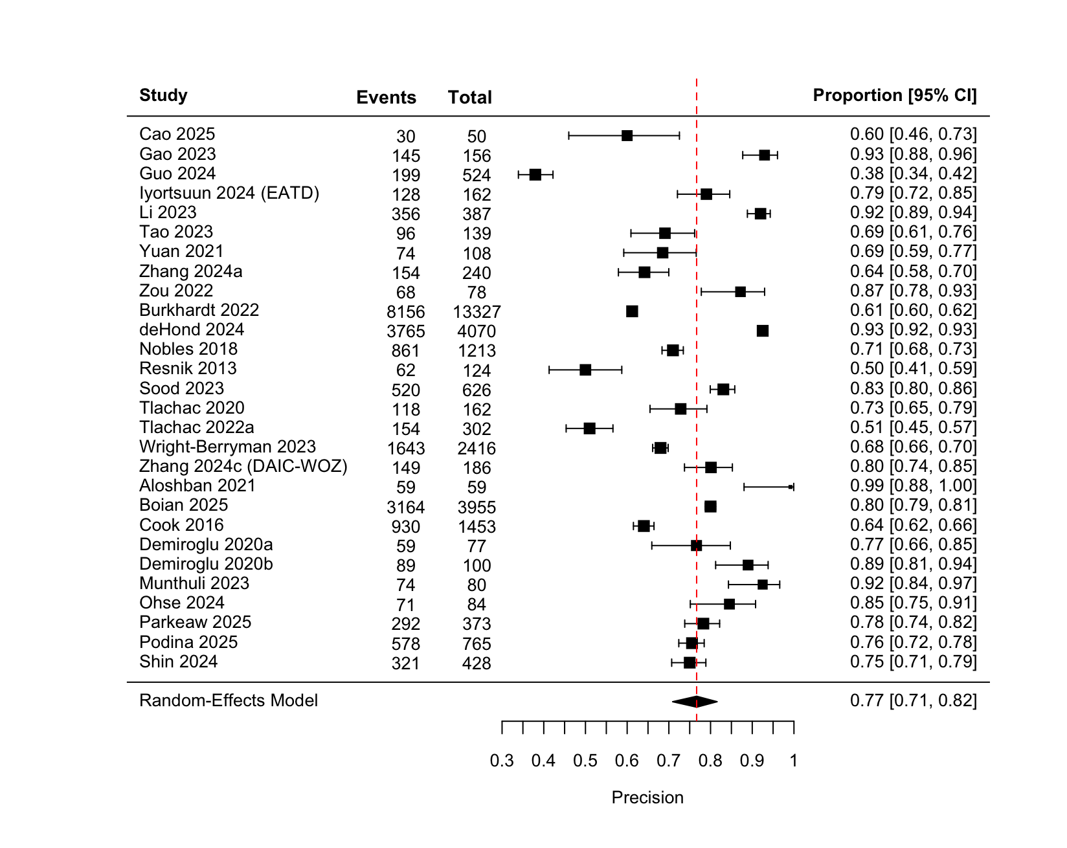
Figure S1. Forest Plot of Study-Level Classification Precision with Pooled Random-Effects Estimate

Figure S2. Forest Plot of Study-Level Classification Recall with Pooled Random-Effects Estimate
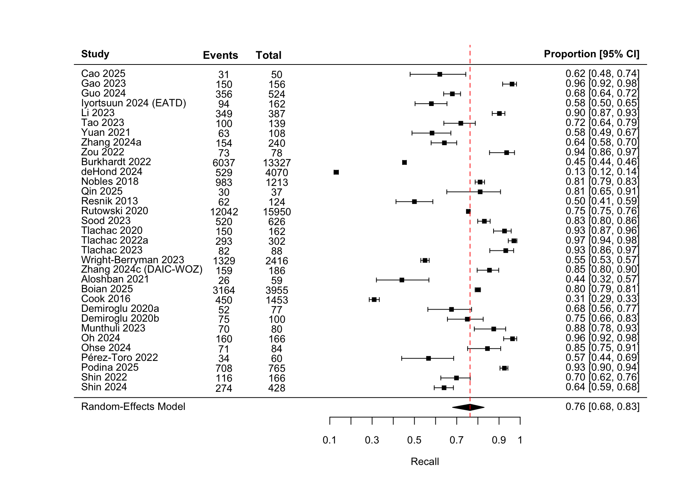

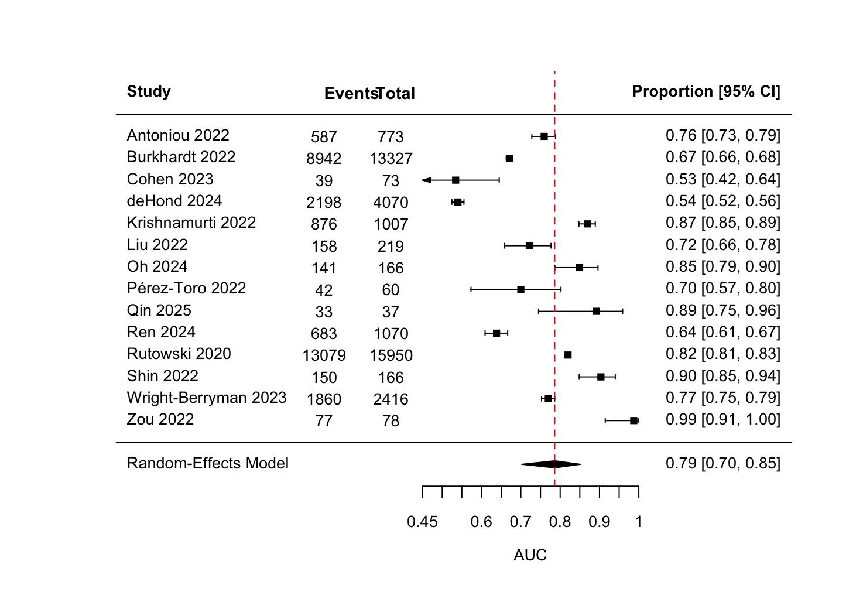
Figure S3. Forest Plot of Study-Level Classification AUC With Pooled Random-Effects Estimate

Figure S4. Forest Plot of Study-Level Classification AUC With Pooled Random-Effects Estimate
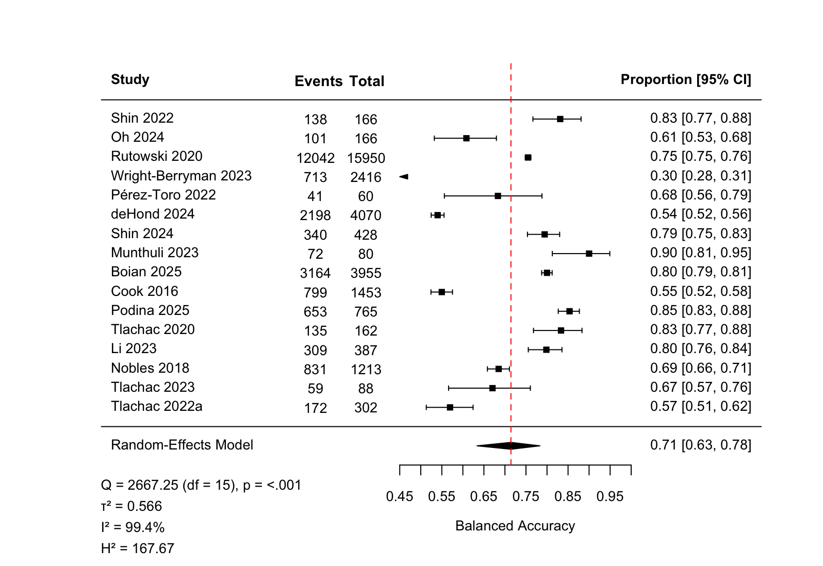

Figure S5. Funnel Plot of Study-Level Classification Balanced Accuracy
