Supplementary Materials
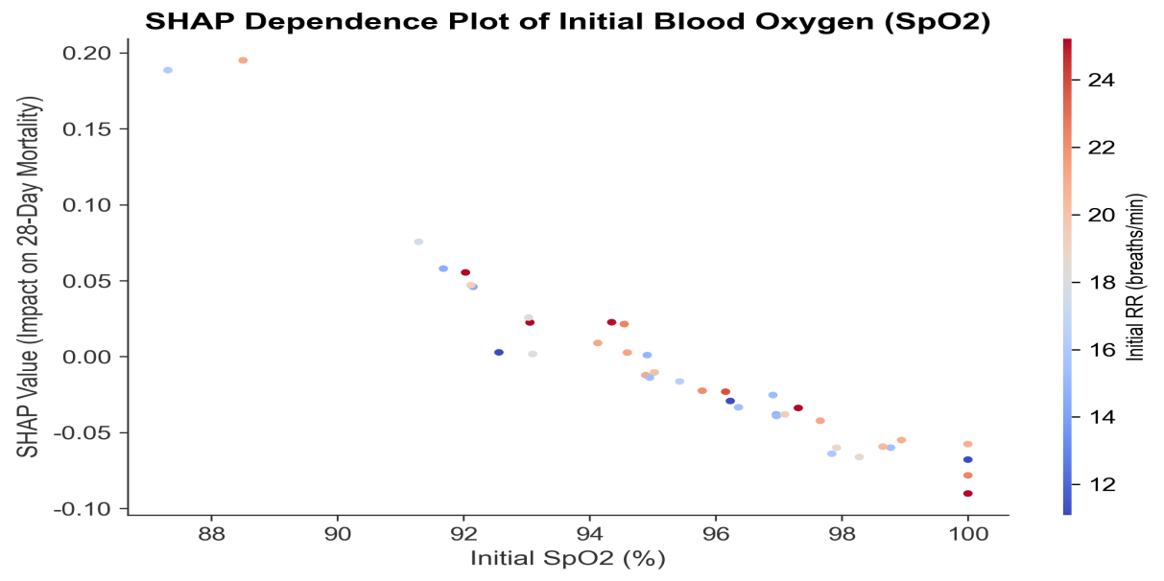
Figure S1: SHAP Dependence Plot of Initial Blood Oxygen (SpO₂)
Note：SHAP dependence plot of initial blood oxygen (SpO₂). As SpO₂ decreases, SHAP values increase linearly, indicating a steady rise in mortality risk. The red line is the partial dependence line; dots are colored by initial RR (low = blue, high = red).

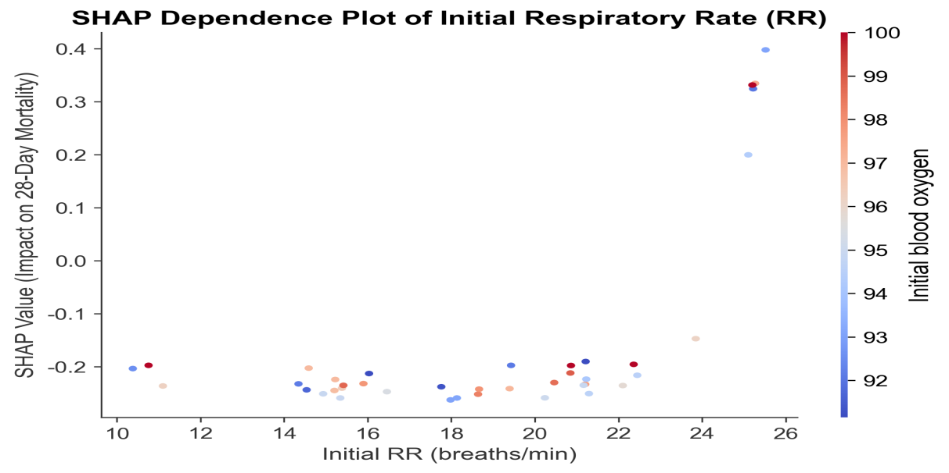
Figure S2: SHAP Dependence Plot of Initial Respiratory Rate (RR)
Note：SHAP dependence plot of initial respiratory rate (RR). As RR increases, SHAP values increase linearly, reflecting elevated mortality risk. The red line is the partial dependence line; dots are colored by initial SpO₂ (low = red, high = blue).

