Supplementary Figure S1. PRISMA flowchart of included studies.
Identification of studies via other methods
Identification of studies via databases and registers

Records identified from:
Grey literature sources (n = 0)
Citation searching (n = 2)
Records removed before screening:
Duplicate records removed (n = 1389)
Records identified from:
Databases (n = 2185)
Registers (n = 48)

Identification

Records screened
(n = 844)
Records excluded
(n = 831)

Reports not retrieved
(n = 0)
Reports sought for retrieval
(n = 2)
Reports sought for retrieval
(n = 13)
Reports not retrieved
(n = 0)

Screening

Reports assessed for eligibility
(n = 2)
Reports excluded (n = 2)
Reports assessed for eligibility
(n = 13)
Reports excluded (n=8):
Wrong study design (n = 3)
Wrong intervention or control (n = 5)

Studies included in review
(n = 5)
Reports of included studies
(n = 5)
Included

Supplementary Figure S2. Quality assessment of included trials.
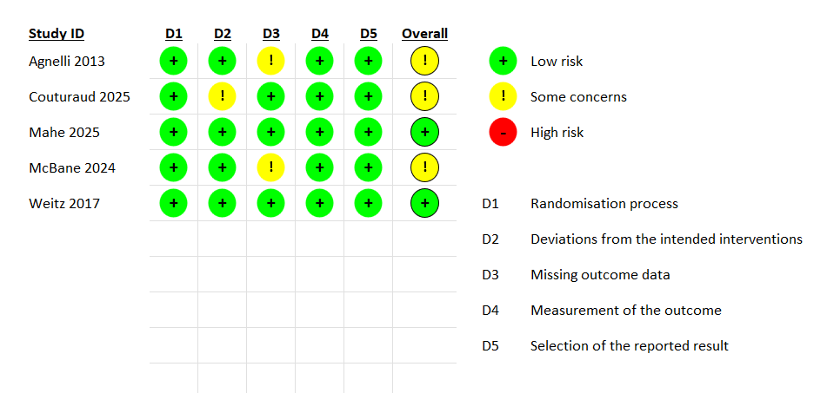
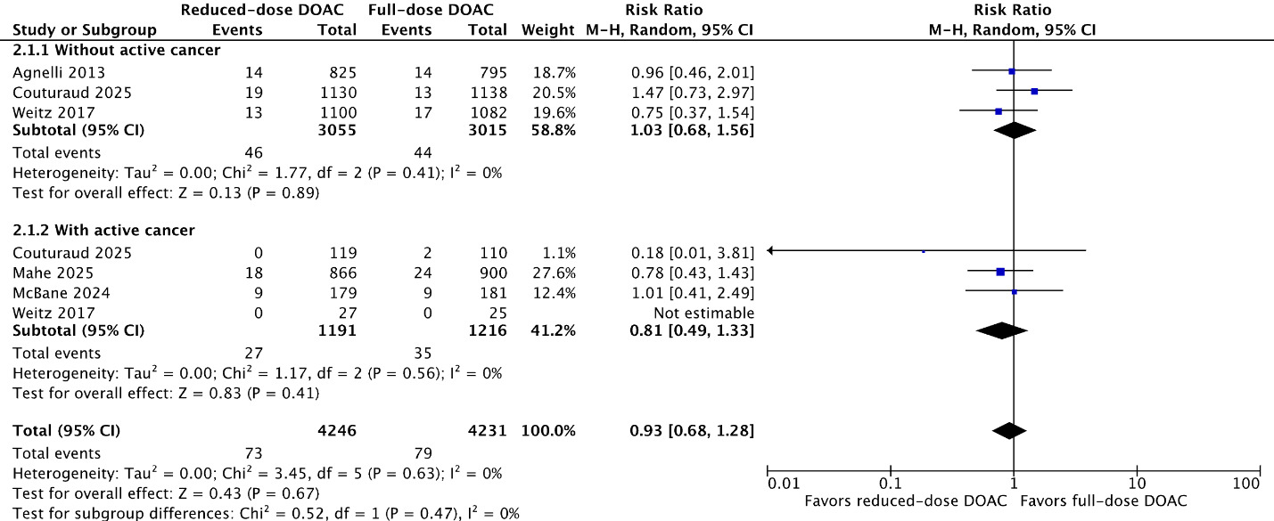
Figure S3: Reduced-dose DOAC vs Full-Dose DOAC. Outcome: Recurrent VTE. Subgroup: cancer status.

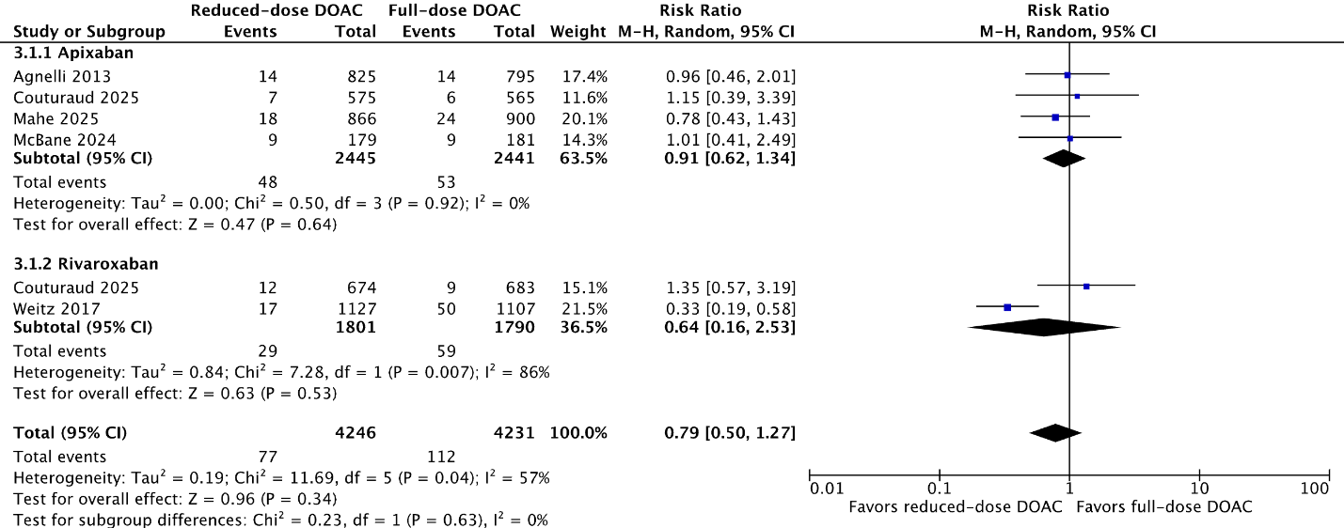
Figure S4: Reduced-dose DOAC vs Full-Dose DOAC. Outcome: Recurrent VTE. Subgroup: Type of DOAC.

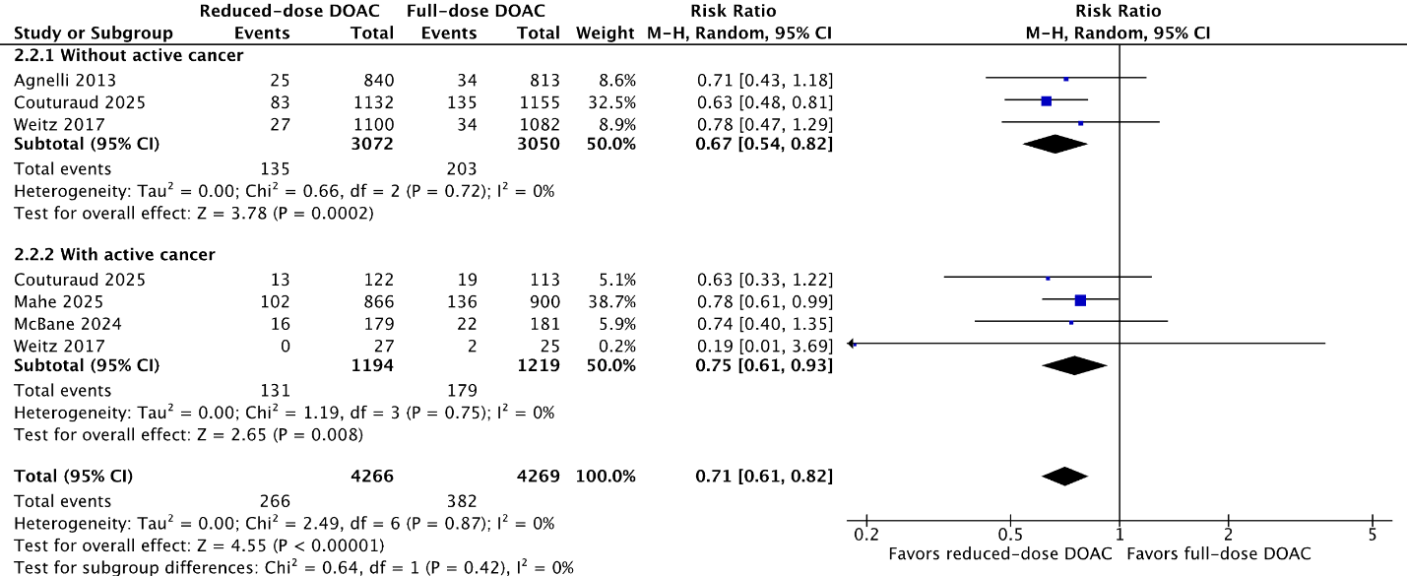
Figure S5: Reduced-dose DOAC vs Full-Dose DOAC. Outcome: Major or clinically relevant non-major bleeding. Subgroup: cancer status.

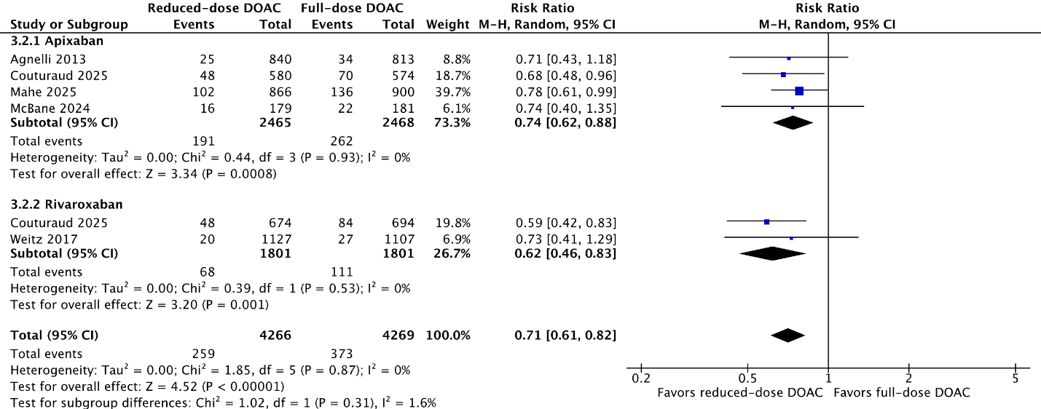
Figure S6: Reduced-dose DOAC vs Full-Dose DOAC. Outcome: Major or clinically relevant non-major bleeding. Subgroup: Type of DOAC.

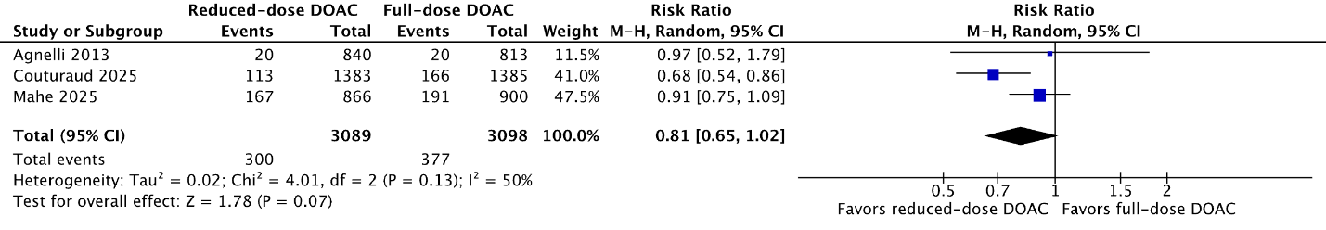
Figure S7: Reduced-dose DOAC vs Full-Dose DOAC. Outcome: Net clinical benefit

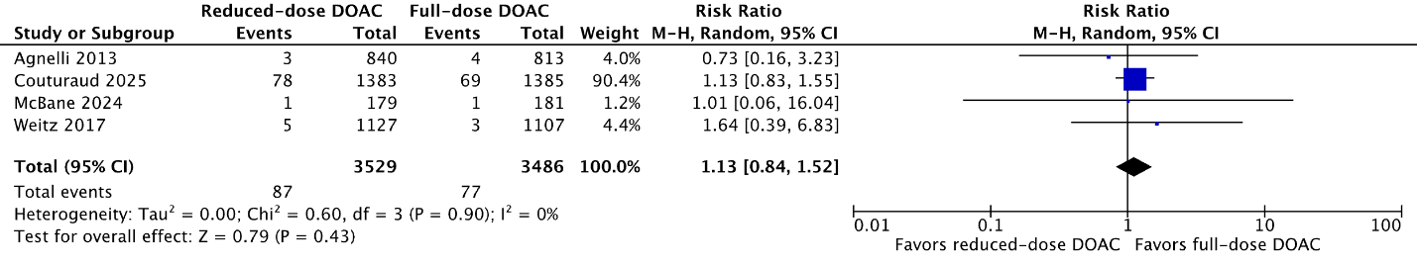
Figure S8: Reduced-dose DOAC vs Full-Dose DOAC. Outcome: Arterial thromboembolism

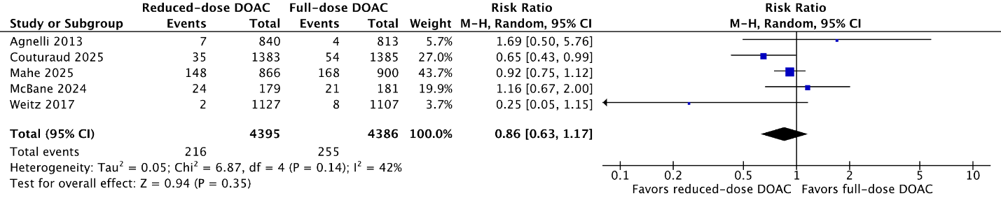
Figure S9: Reduced-dose DOAC vs Full-Dose DOAC. Outcome: All-Cause Mortality

