ADDITIONAL FILE 1
Table S1. STROBE statement.
STROBE Statement—Checklist of items that should be included in reports of cohort studies

 | Item No | Recommendation | Page No
Title and abstract | 1 | (a) Indicate the study’s design with a commonly used term in the title or the abstract | 1, line 3
Title and abstract | 1 | (b) Provide in the abstract an informative and balanced summary of what was done and what was found | 2, lines 29-36
Introduction
Background/rationale | 2 | Explain the scientific background and rationale for the investigation being reported | 4-5, lines 55-85
Objectives | 3 | State specific objectives, including any prespecified hypotheses | 5, lines 86-91
Methods
Study design | 4 | Present key elements of study design early in the paper | 5, line 94
Setting | 5 | Describe the setting, locations, and relevant dates, including periods of recruitment, exposure, follow-up, and data collection | 5, lines 95-100
Participants | 6 | (a) Give the eligibility criteria, and the sources and methods of selection of participants. Describe methods of follow-up | 5, lines 102-107
Participants | 6 | (b) For matched studies, give matching criteria and number of exposed and unexposed
Variables | 7 | Clearly define all outcomes, exposures, predictors, potential confounders, and effect modifiers. Give diagnostic criteria, if applicable | 6-7, lines118-154
Data sources/ measurement | 8* | For each variable of interest, give sources of data and details of methods of assessment (measurement). Describe comparability of assessment methods if there is more than one group | 6-7, lines118-154
Bias | 9 | Describe any efforts to address potential sources of bias | 8, lines185-187
Study size | 10 | Explain how the study size was arrived at | 7, lines157-162
Quantitative variables | 11 | Explain how quantitative variables were handled in the analyses. If applicable, describe which groupings were chosen and why | 7, lines 166-169
Statistical methods | 12 | (a) Describe all statistical methods, including those used to control for confounding | 7-8, lines 163-195
Statistical methods | 12 | (b) Describe any methods used to examine subgroups and interactions
Statistical methods | 12 | (c) Explain how missing data were addressed
Statistical methods | 12 | (d) If applicable, explain how loss to follow-up was addressed
Statistical methods | 12 | (e) Describe any sensitivity analyses
Results
Participants | 13* | (a) Report numbers of individuals at each stage of study—eg numbers potentially eligible, examined for eligibility, confirmed eligible, included in the study, completing follow-up, and analysed | 8, line 198
Participants | 13* | (b) Give reasons for non-participation at each stage
Participants | 13* | (c) Consider use of a flow diagram
Descriptive data | 14* | (a) Give characteristics of study participants (eg demographic, clinical, social) and information on exposures and potential confounders | Table 1
Descriptive data | 14* | (b) Indicate number of participants with missing data for each variable of interest
Descriptive data | 14* | (c) Summarise follow-up time (eg, average and total amount)
Outcome data | 15* | Report numbers of outcome events or summary measures over time | 8-9, lines 198-203

Main results | 16 | (a) Give unadjusted estimates and, if applicable, confounder-adjusted estimates and their precision (eg, 95% confidence interval). Make clear which confounders were adjusted for and why they were included | 9-10, lines 212-242, Tables 2-4, Figures 1-4
Main results | 16 | (b) Report category boundaries when continuous variables were categorized
Main results | 16 | (c) If relevant, consider translating estimates of relative risk into absolute risk for a meaningful time period
Other analyses | 17 | Report other analyses done—eg analyses of subgroups and interactions, and sensitivity analyses | NA
Discussion
Key results | 18 | Summarise key results with reference to study objectives | 10, lines 245-258
Limitations | 19 | Discuss limitations of the study, taking into account sources of potential bias or imprecision. Discuss both direction and magnitude of any potential bias | 14, lines 355-363
Interpretation | 20 | Give a cautious overall interpretation of results considering objectives, limitations, multiplicity of analyses, results from similar studies, and other relevant evidence | 14, lines 365-372
Generalisability | 21 | Discuss the generalisability (external validity) of the study results | 13, lines 344-354
Other information
Funding | 22 | Give the source of funding and the role of the funders for the present study and, if applicable, for the original study on which the present article is based | 14, line 380

Table S2.
The following results present the analysis of plasma renin concentrations over time with preoperative beta-blocker treatment (BETA) using a linear mixed-effects model.

Type III ANOVA Results
The Type III ANOVA with Satterthwaite approximation for degrees of freedom revealed the following significant effects:
Type III ANOVA results for the effect of TIME, BETA, and their interaction on renin levels
Sum Sq | Mean Sq | NumDF | DenDF | F value | Pr(>F)
824,875.0 | 412,437.5 | 2 | 202.0 | 1.8 | 0.2
335,715.8 | 335,715.8 | 1 | 101.0 | 1.4 | 0.2
910,224.4 | 455,112.2 | 2 | 202.0 | 1.9 | 0.1
n: 3

Estimated Marginal Means
The estimated marginal means for renin levels across time points and BETA treatment groups:
Estimated marginal means for renin levels by TIME and BETA treatment
TIME | BETA | emmean | SE | df | lower.CL | upper.CL
0 | No BETA | 710.1277 | 153.1168 | 135.4263 | 407.31838 | 1,012.9369
6 | No BETA | 629.7021 | 153.1168 | 135.4263 | 326.89285 | 932.5114
24 | No BETA | 668.1915 | 153.1168 | 135.4263 | 365.38221 | 971.0008
0 | With BETA | 360.8214 | 140.2742 | 135.4263 | 83.41016 | 638.2327
6 | With BETA | 375.4643 | 140.2742 | 135.4263 | 98.05302 | 652.8756
24 | With BETA | 582.4107 | 140.2742 | 135.4263 | 304.99945 | 859.8220

Post Hoc Comparisons for TIME within BETA Groups
Tukey-adjusted post hoc comparisons for TIME within each BETA treatment group:
Post hoc comparisons of TIME within each BETA treatment group
contrast | BETA | estimate | SE | df | t.ratio | p.value | BETA_Group
TIME0 - TIME6 | No BETA | 80.42553 | 100.03857 | 202 | 0.8039453 | 0.70101355 | No BETA
TIME0 - TIME24 | No BETA | 41.93617 | 100.03857 | 202 | 0.4192000 | 0.90773602 | No BETA
TIME6 - TIME24 | No BETA | -38.48936 | 100.03857 | 202 | -0.3847452 | 0.92168298 | No BETA
TIME0 - TIME6 | With BETA | -14.64286 | 91.64787 | 202 | -0.1597730 | 0.98602629 | With BETA
TIME0 - TIME24 | With BETA | -221.58929 | 91.64787 | 202 | -2.4178335 | 0.04338333 | With BETA
TIME6 - TIME24 | With BETA | -206.94643 | 91.64787 | 202 | -2.2580604 | 0.06420784 | With BETA

Post Hoc Comparisons for BETA within TIME Points
Tukey-adjusted post hoc comparisons for BETA treatment within each time point:
Post hoc comparisons of BETA treatment within each time point
contrast | TIME | estimate | SE | df | t.ratio | p.value | Time_Point
No BETA - With BETA | 0 | 349.30623 | 207.6574 | 135.4263 | 1.682127 | 0.09484853 | 0
No BETA - With BETA | 6 | 254.23784 | 207.6574 | 135.4263 | 1.224314 | 0.22295940 | 6
No BETA - With BETA | 24 | 85.78078 | 207.6574 | 135.4263 | 0.413088 | 0.68019549 | 24

Estimated Marginal Means by BETA Group
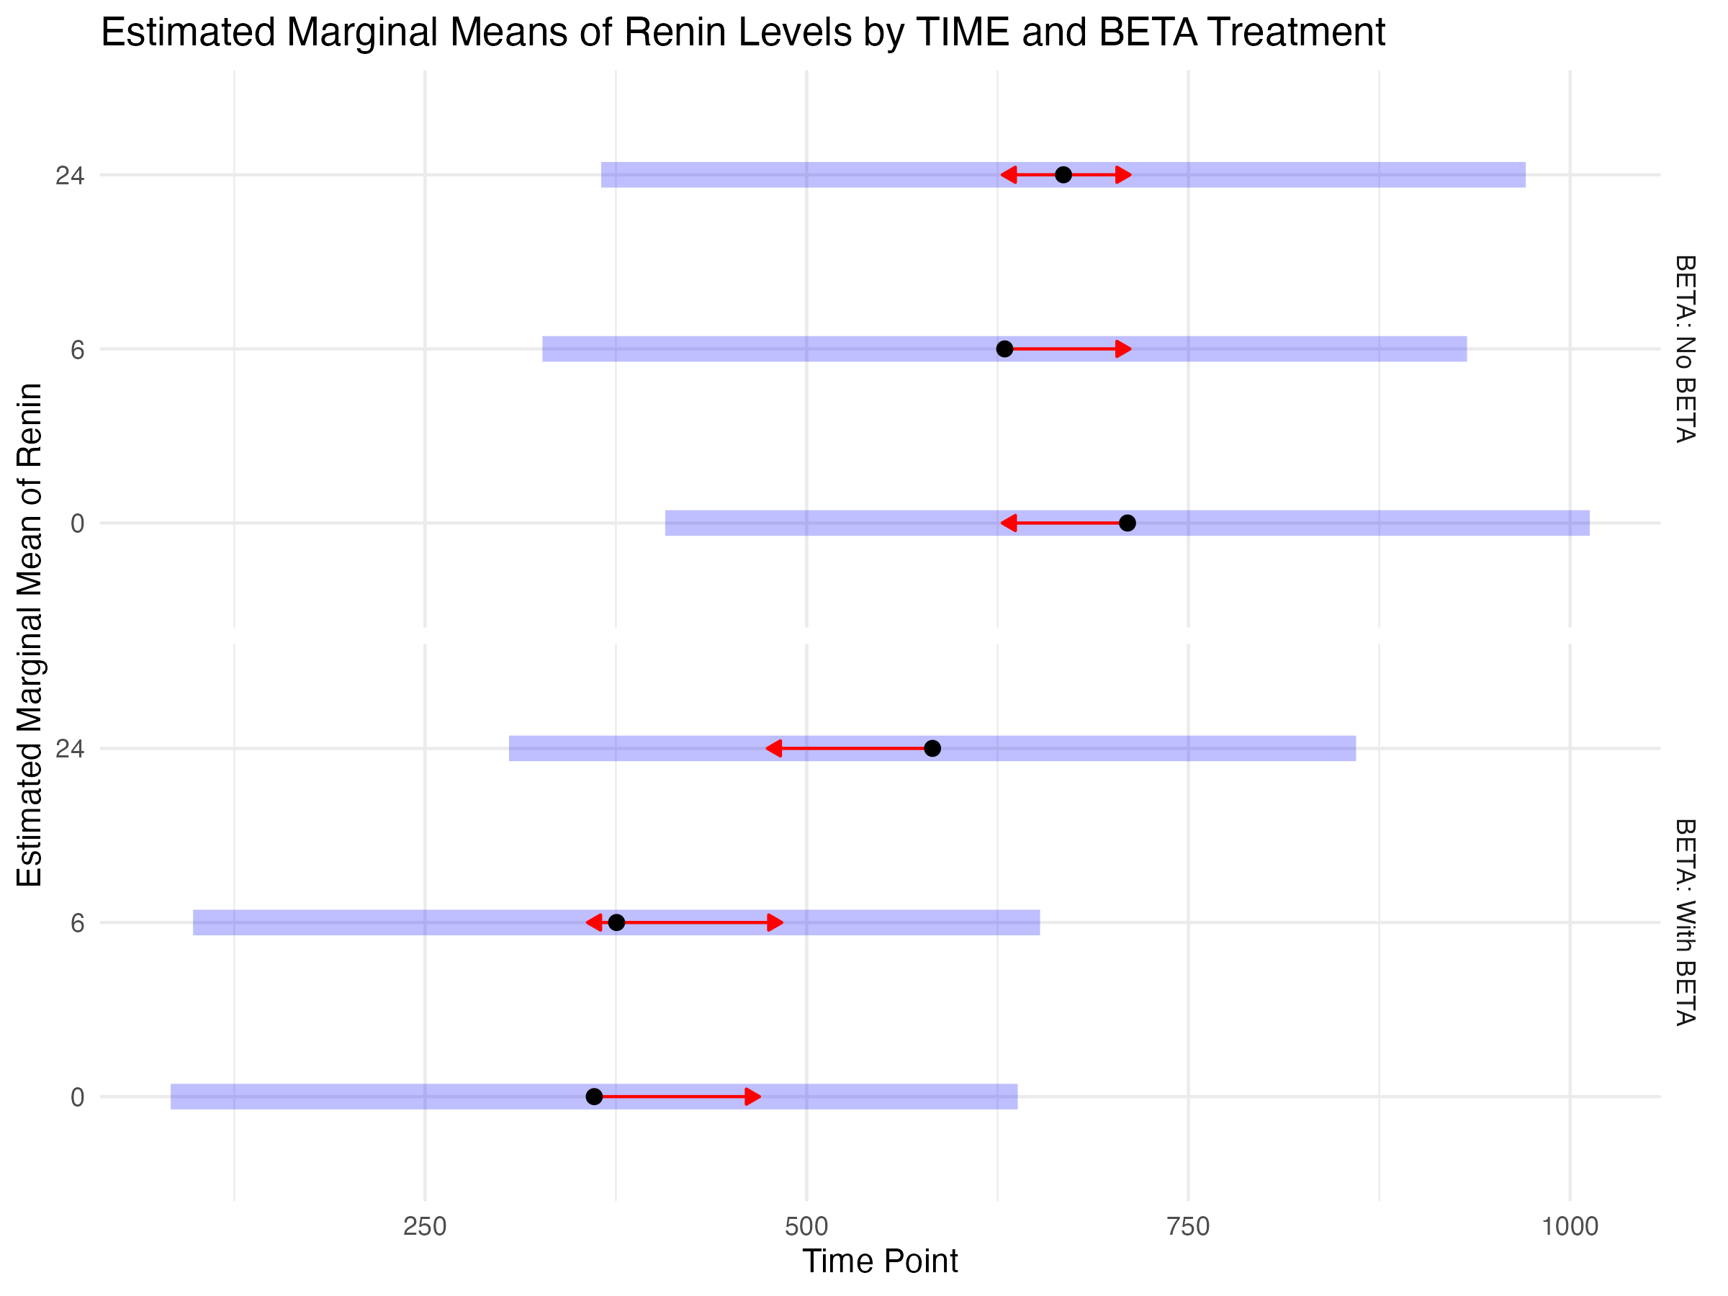

Post Hoc Comparisons for TIME within BETA Groups
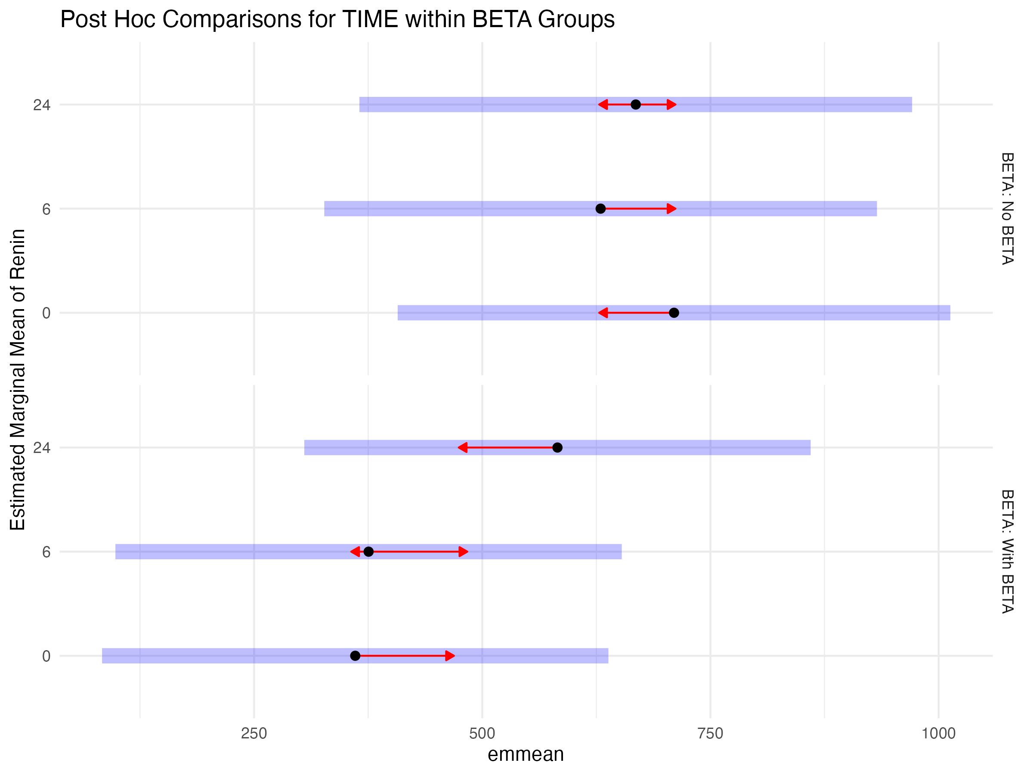

Post Hoc Comparisons for BETA within TIME Points
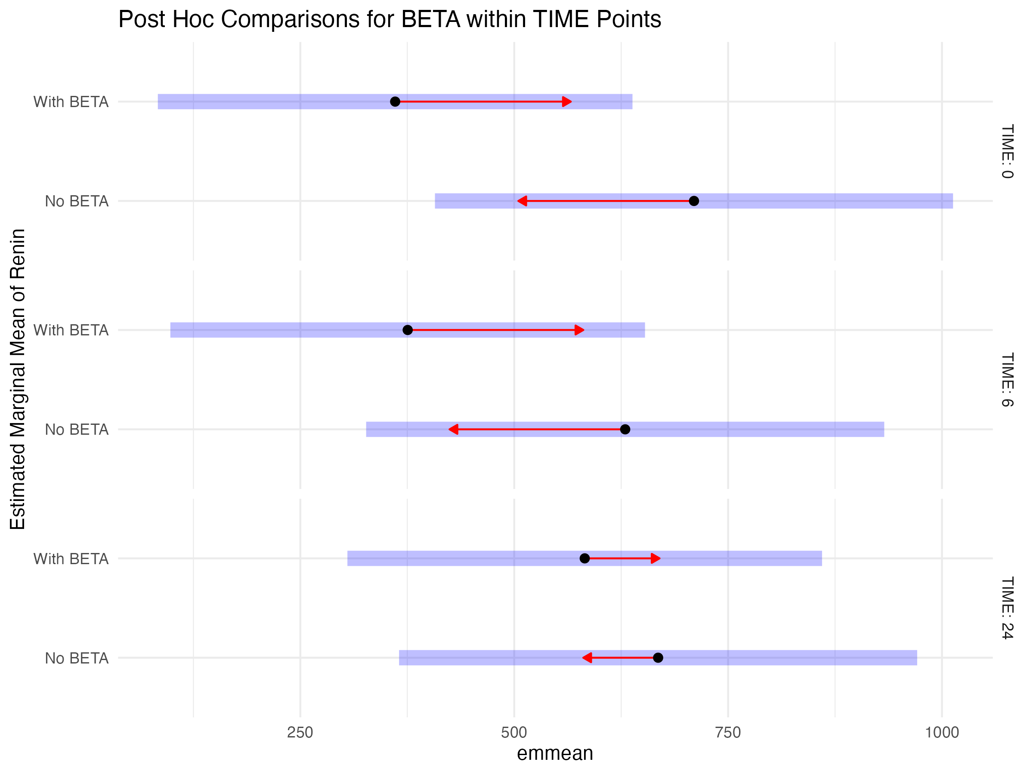

Table S3.
The following results present the analysis of plasma renin concentrations over time with preoperative angiotensin converting enzyme inhibitor (ACEI) using a linear mixed-effects model.

Type III ANOVA Results
The Type III ANOVA with Satterthwaite approximation for degrees of freedom revealed the following significant effects:
Type III ANOVA results for the effect of TIME, ACEI, and their interaction on renin levels
Sum Sq | Mean Sq | NumDF | DenDF | F value | Pr(>F)
numeric | numeric | integer | numeric | numeric | numeric
1,856,071.2 | 928,035.6 | 2 | 202.0 | 4.0 | 0.0
71,604.2 | 71,604.2 | 1 | 101.0 | 0.3 | 0.6
1,066,156.0 | 533,078.0 | 2 | 202.0 | 2.3 | 0.1
n: 3

Estimated Marginal Means
The estimated marginal means for renin levels across time points and ACEI treatment groups:
Estimated marginal means for renin levels by TIME and ACEI treatment
TIME | ACE | emmean | SE | df | lower.CL | upper.CL
0 | No ACEI | 577.6250 | 117.8906 | 134.9313 | 344.47250 | 810.7775
6 | No ACEI | 534.9625 | 117.8906 | 134.9313 | 301.81000 | 768.1150
24 | No ACEI | 606.2875 | 117.8906 | 134.9313 | 373.13500 | 839.4400
0 | With ACEI | 320.5217 | 219.8672 | 134.9313 | -114.30991 | 755.3534
6 | With ACEI | 340.2174 | 219.8672 | 134.9313 | -94.61426 | 775.0490
24 | With ACEI | 674.6522 | 219.8672 | 134.9313 | 239.82052 | 1,109.4838

Post Hoc Comparisons for TIME within ACEI Groups
Tukey-adjusted post hoc comparisons for TIME within each ACE treatment group:
Post hoc comparisons of TIME within each ACEI treatment group
contrast | ACE | estimate | SE | df | t.ratio | p.value | ACE_Group
TIME0 - TIME6 | No ACEI | 42.66250 | 76.55216 | 202 | 0.5572997 | 0.84284205 | No ACE
TIME0 - TIME24 | No ACEI | -28.66250 | 76.55216 | 202 | -0.3744179 | 0.92566998 | No ACE
TIME6 - TIME24 | No ACEI | -71.32500 | 76.55216 | 202 | -0.9317176 | 0.62088576 | No ACE
TIME0 - TIME6 | With ACEI | -19.69565 | 142.77052 | 202 | -0.1379532 | 0.98956342 | With ACE
TIME0 - TIME24 | With ACEI | -354.13043 | 142.77052 | 202 | -2.4804170 | 0.03696263 | With ACE
TIME6 - TIME24 | With ACEI | -334.43478 | 142.77052 | 202 | -2.3424638 | 0.05235514 | With ACE

Post Hoc Comparisons for ACEI within TIME Points
Tukey-adjusted post hoc comparisons for ACEI treatment within each time point:
Post hoc comparisons of ACEI treatment within each time point
contrast | TIME | estimate | SE | df | t.ratio | p.value | Time_Point
No ACEI - With ACEI | 0 | 257.10326 | 249.479 | 134.9313 | 1.0305606 | 0.3045906 | 0
No ACEI - With ACEI | 6 | 194.74511 | 249.479 | 134.9313 | 0.7806071 | 0.4364009 | 6
No ACEI - With ACEI | 24 | -68.36467 | 249.479 | 134.9313 | -0.2740297 | 0.7844808 | 24

Estimated Marginal Means by ACEI Group
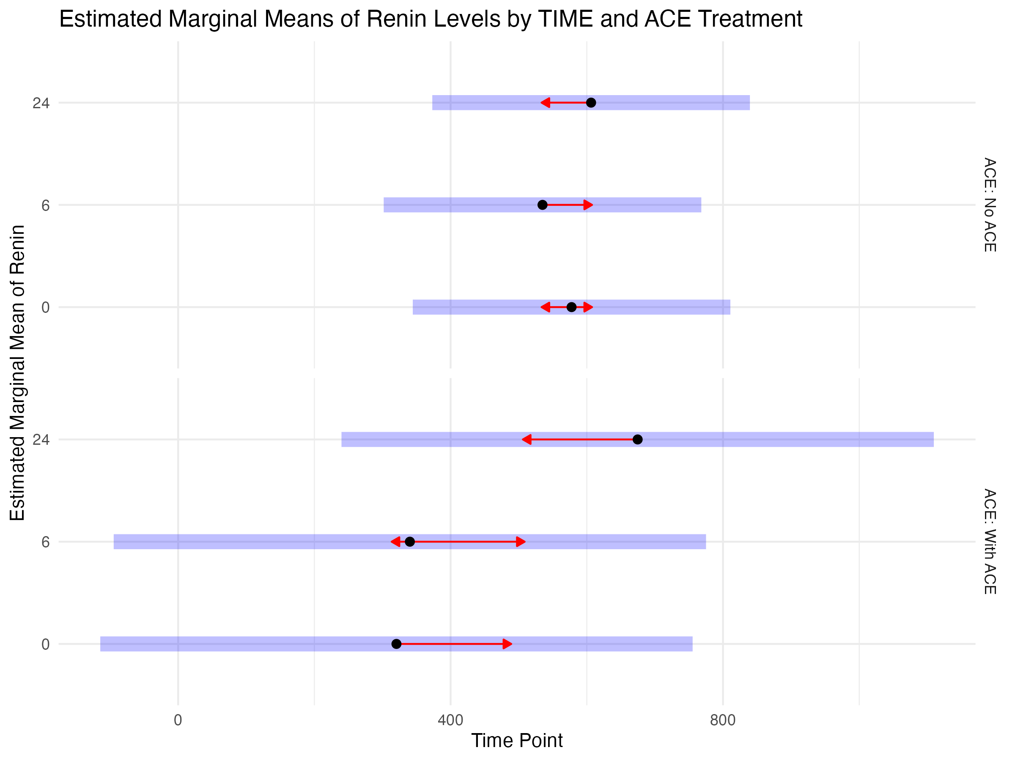

Post Hoc Comparisons for TIME within ACEI Groups
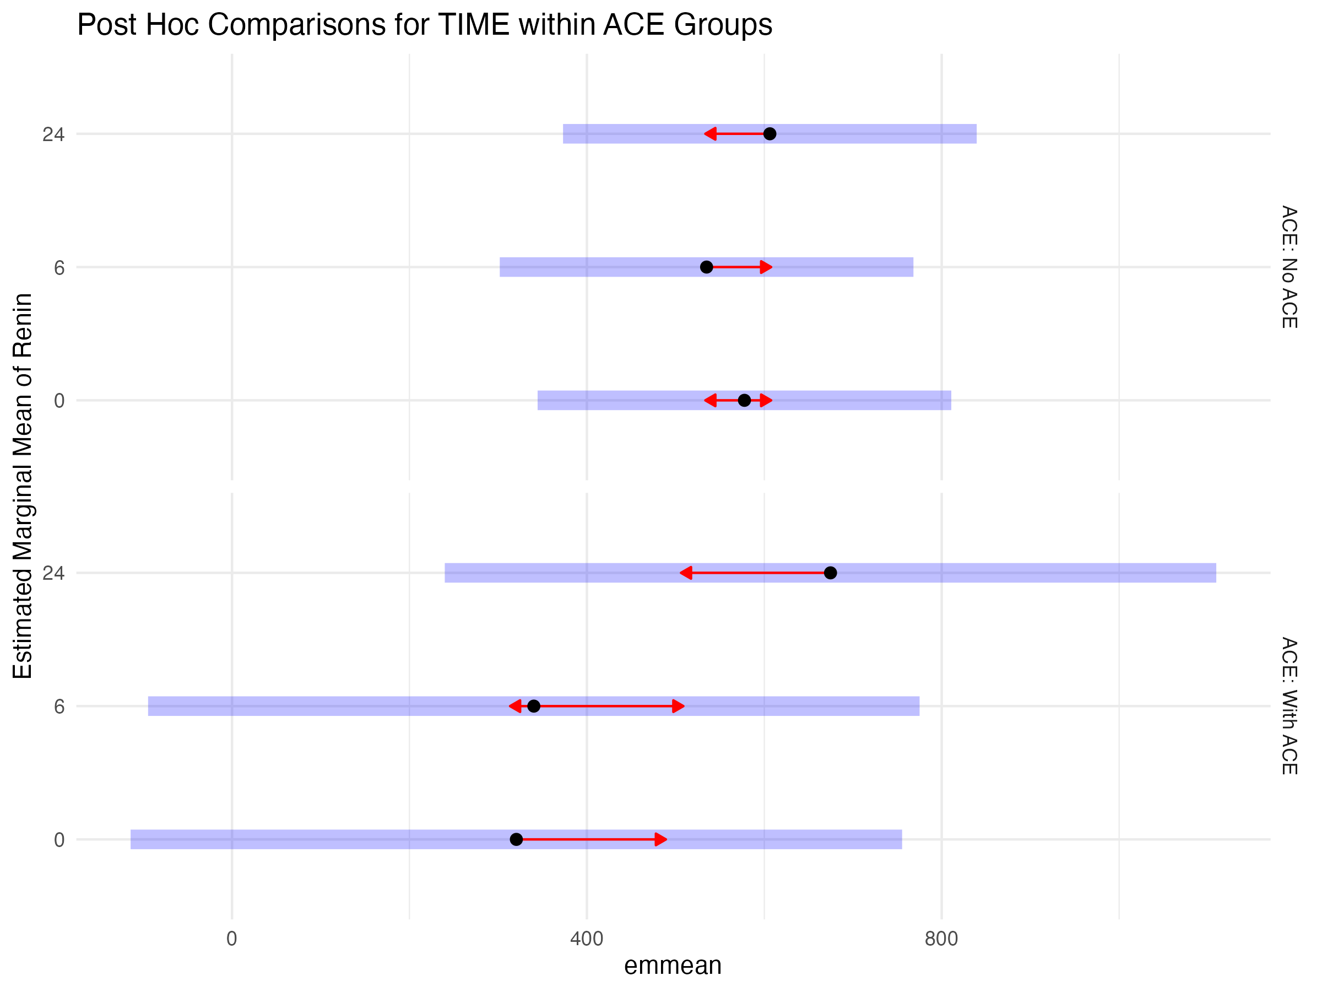

Post Hoc Comparisons for ACEI within TIME Points
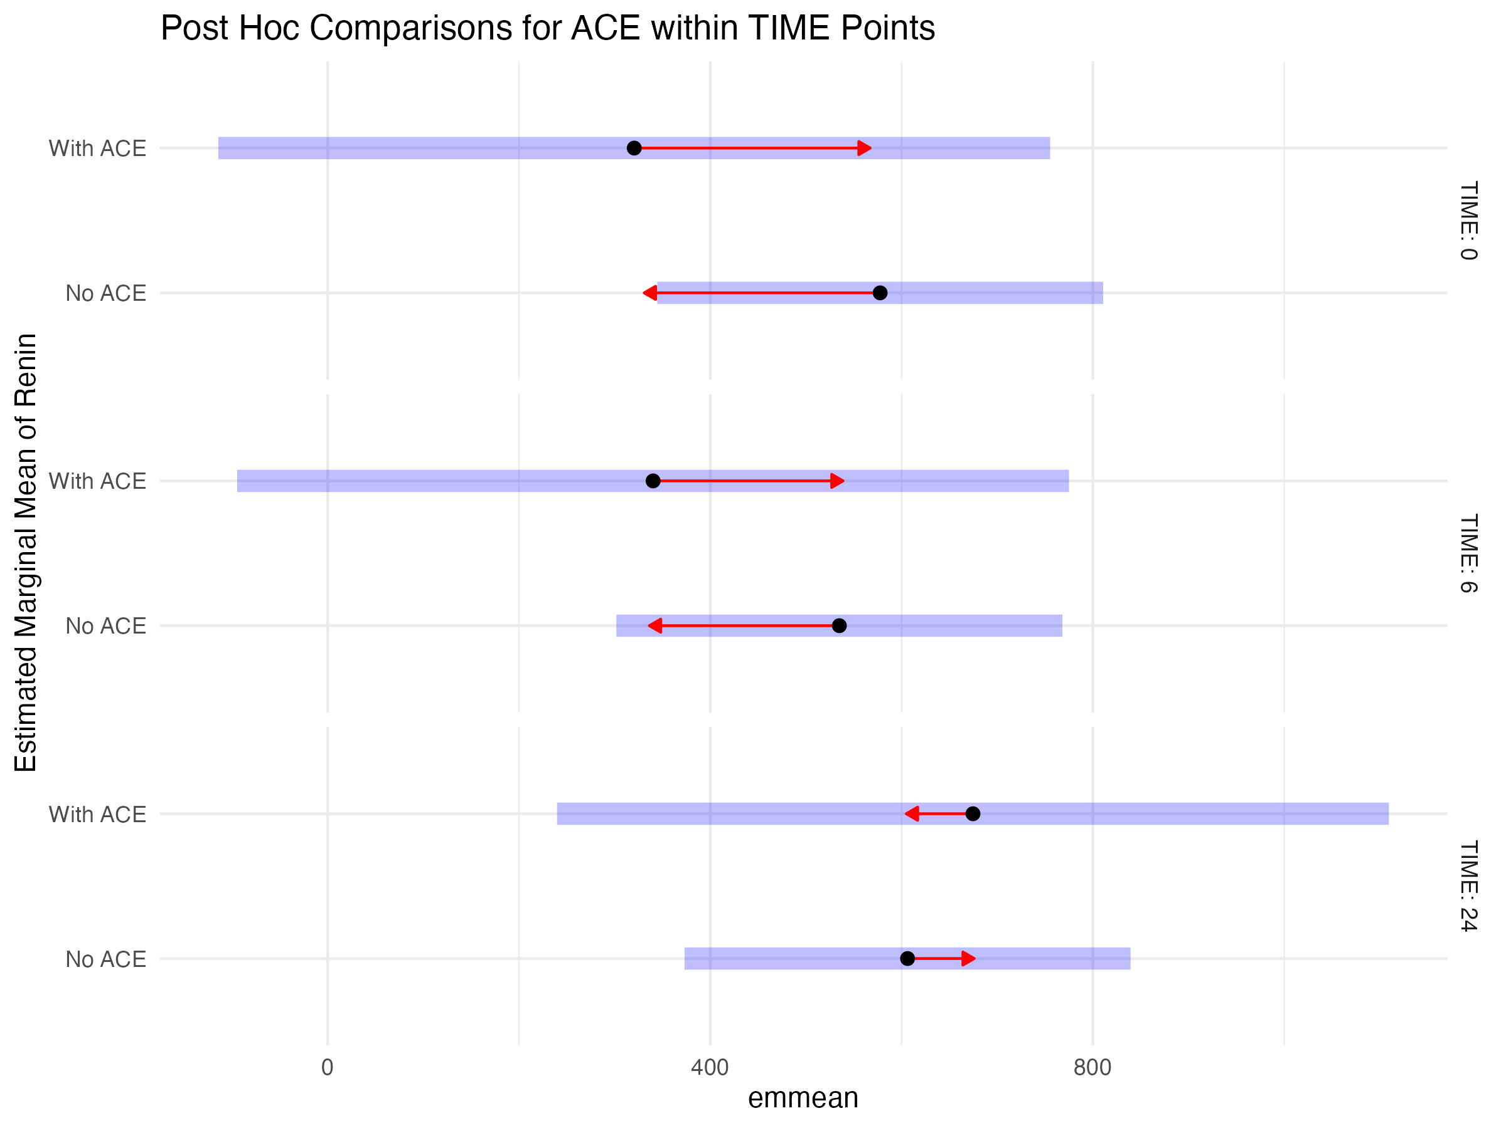
Table S4.
The following results present the analysis of plasma renin concentrations over time with preoperative angiotensin receptor blocker (ARB) using a linear mixed-effects model.

Type III ANOVA Results
The Type III ANOVA with Satterthwaite approximation for degrees of freedom revealed the following significant effects:
Type III ANOVA results for the effect of TIME, ARB, and their interaction on renin levels
Sum Sq | Mean Sq | NumDF | DenDF | F value | Pr(>F)
numeric | numeric | integer | numeric | numeric | numeric
678,619.0 | 339,309.5 | 2 | 202.0 | 1.4 | 0.2
3,459,231.4 | 3,459,231.4 | 1 | 101.0 | 14.5 | 0.0
258,540.4 | 129,270.2 | 2 | 202.0 | 0.5 | 0.6
n: 3

Estimated Marginal Means
The estimated marginal means for renin levels across time points and ARB treatment groups:
Estimated marginal means for renin levels by TIME and ARB treatment
TIME | ARB | emmean | SE | df | lower.CL | upper.CL
0 | No ARB | 237.7077 | 123.8494 | 140.4161 | -7.142841 | 482.5582
6 | No ARB | 217.6769 | 123.8494 | 140.4161 | -27.173610 | 462.5275
24 | No ARB | 389.7077 | 123.8494 | 140.4161 | 144.857159 | 634.5582
0 | With ARB | 1,003.4474 | 161.9790 | 140.4161 | 683.214479 | 1,323.6803
6 | With ARB | 959.8158 | 161.9790 | 140.4161 | 639.582900 | 1,280.0487
24 | With ARB | 1,018.1316 | 161.9790 | 140.4161 | 697.898689 | 1,338.3645

Post Hoc Comparisons for TIME within ARB Groups
Tukey-adjusted post hoc comparisons for TIME within each ARB treatment group:
Post hoc comparisons of TIME within each ARB treatment group
contrast | ARB | estimate | SE | df | t.ratio | p.value | ARB_Group
TIME0 - TIME6 | No ARB | 20.03077 | 85.6482 | 202 | 0.2338726 | 0.9703022 | No ARB
TIME0 - TIME24 | No ARB | -152.00000 | 85.6482 | 202 | -1.7747017 | 0.1807109 | No ARB
TIME6 - TIME24 | No ARB | -172.03077 | 85.6482 | 202 | -2.0085743 | 0.1127338 | No ARB
TIME0 - TIME6 | With ARB | 43.63158 | 112.0168 | 202 | 0.3895093 | 0.9198132 | With ARB
TIME0 - TIME24 | With ARB | -14.68421 | 112.0168 | 202 | -0.1310894 | 0.9905713 | With ARB
TIME6 - TIME24 | With ARB | -58.31579 | 112.0168 | 202 | -0.5205987 | 0.8613740 | With ARB

Post Hoc Comparisons for ARB within TIME Points
Tukey-adjusted post hoc comparisons for ARB treatment within each time point:
Post hoc comparisons of ARB treatment within each time point
contrast | TIME | estimate | SE | df | t.ratio | p.value | Time_Point
No ARB - With ARB | 0 | -765.7397 | 203.9016 | 140.4161 | -3.755437 | 0.0002527299 | 0
No ARB - With ARB | 6 | -742.1389 | 203.9016 | 140.4161 | -3.639691 | 0.0003827636 | 6
No ARB - With ARB | 24 | -628.4239 | 203.9016 | 140.4161 | -3.081996 | 0.0024753553 | 24

Estimated Marginal Means by ARB Group
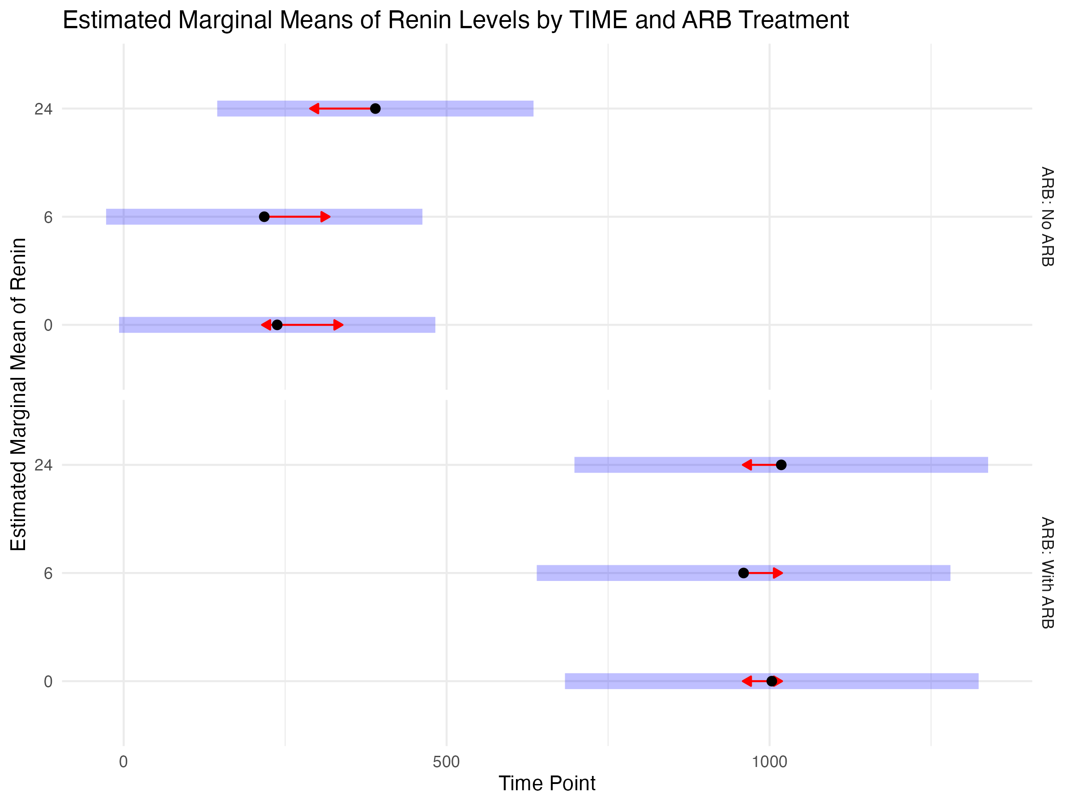

Post Hoc Comparisons for TIME within ARB Groups
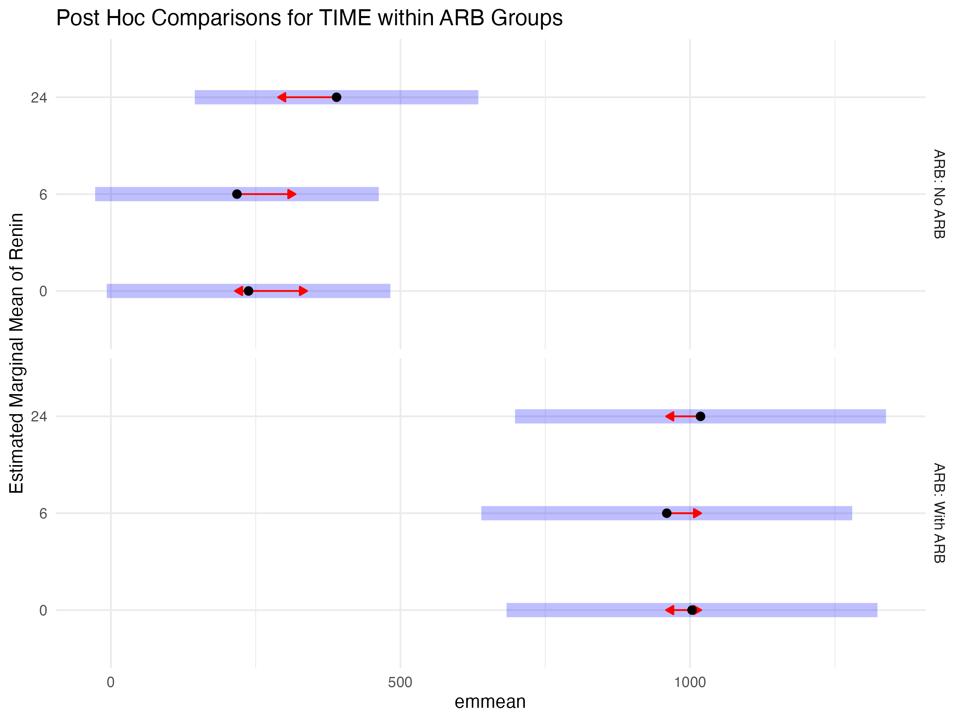

Post Hoc Comparisons for ARB within TIME Points
