Supplementary Table 1: Clinical parameters in subgroups of LYM＞0.8 vs LYM≤0.8
Variable | LYM＞0.8  (N=191) | LYM≤0.8  (N=113) | P value
clinical parameters median(IQR)
WBC, (1×109/L) | 5.2(4.2-6.8) | 6.6(4.4-9.7) | 0.001
NEU,(1×109/L) | 3.5(2.3-4.8) | 5.8(3.5-9.0) | <0.001
MON,(1×109/L) | 0.5(0.4-0.7) | 0.3(0.2-0.5) | <0.001
PLT,(1×109/L) | 188.0(148.0-241.0) | 163.0(124.0-215.5) | 0.008
IL-6,(pg/ml) | 14.9(7.6-32.9) | 24.8(8.6-67.3) | 0.012
PCT,(ng/ml) | 0.1(0-0.1) | 0.1(0.1-0.2) | <0.001
CRP,(mg/L) | 16.4(6.0-42.7) | 45.6(19.4-82.3) | <0.001
ALT, (U/L) | 23.0(15.6-35.0) | 28.0(19.0-49.0) | 0.001
TBIL, (umol/L) | 10.1(7.1-14.2) | 13.0(9.6-18.8) | <0.001
CREA, (µmol/L) | 65.1(52.1-80.0) | 66.0(52.5-83.5) | 0.608
Lac, (mmol/L) | 1.4(1.1-1.9) | 1.9(1.4-2.6) | <0.001
Pa0₂/FiO₂ | 250.0(206.0-291.4) | 179.0(118.0-261.1) | <0.001
APACH II sore, median(IQR) | 5.0(3.0-8.0) | 8.0(5.0-10.0) | <0.001
SOFA sore, median(IQR) | 2.0(1.0-3.0) | 3.0(2.0-5.0) | <0.001
ª Total course of disease：Time from illness onset to death or discharge, days ;APACHE II: Acute Physiology and Chronic Health Evaluation II score; SOFA: Sequential Organ Failure Assessment; WBC: White blood cell count; NEU: Neutrophil ; LYM :Lymphocyte count ; MON: Monocytes; PLT:Platelet count; HGB: Hemoglobin; FIB: Fibrinogen; IL-6: Interleutin-6; PCT: Procalcitonin; CRP: C-reactive protein; ALT: Alanine aminotransferase; TBIL: Total bilirubin; DBIL: Direct bilirubin; CREA: Creatine; Lac: lactic acid

Supplementary Table 2: Clinical parameters in subgroups of SOFA＞3.0 vs SOFA≤3.0
Variable | SOFA＞3.0  (N=78) | SOFA≤3.0  (N=233) | P value
clinical parameters median(IQR)
WBC, (1×109/L) | 8.7(5.1-11.6) | 5.2(4.0-6.7) | <0.001
NEU,(1×109/L) | 7.2(4.3-10.1) | 5.5(2.4-5.1) | <0.001
MON,(1×109/L) | 0.4(0.2-0.7) | 0.4(0.3-0.6) | 0.876
LYM,(1×109/L) | 0.7(0.5-1.0) | 1.1(0.7-1.5) | <0.001
PLT,(1×109/L) | 159.0(114.0-226.5) | 184.0(149.0-235.0) | 0.004
IL-6,(pg/ml) | 36.8(10.5-74.1) | 16.2(6.9-33.0) | 0.001
PCT,(ng/ml) | 0.2(0.1-0.3) | 0.1(0-0.1) | <0.001
CRP,(mg/L) | 13.9(5.6-39.7) | 17.4(7.5-40.6) | <0.001
ALT, (U/L) | 27.8(19.0-43.9) | 24.0(15.7-37.0) | 0.029
TBIL, (umol/L) | 14.6(10.1-21.9) | 10.7(7.4-14.4) | <0.001
CREA, (µmol/L) | 72.3(57.4-98.0) | 63.0(51.0-78.0) | <0.001
Lac, (mmol/L) | 1.9(1.3-2.8) | 1.5(1.1-2.0) | 0.002
Pa0₂/FiO₂ | 153.0(94.5-241.1) | 259.7(210.0-297.1) | <0.001
APACH II sore, median(IQR) | 5.0(4.0-9.0) | 7.0(5.0-10.0) | <0.001
APACHE II: Acute Physiology and Chronic Health Evaluation II score; SOFA: Sequential Organ Failure Assessment; WBC: White blood cell count; NEU: Neutrophil ; LYM :Lymphocyte count ; MON: Monocytes; PLT:Platelet count; HGB: Hemoglobin; FIB: Fibrinogen; IL-6: Interleutin-6; PCT: Procalcitonin; CRP: C-reactive protein; ALT: Alanine aminotransferase; TBIL: Total bilirubin; DBIL: Direct bilirubin; CREA: Creatine; Lac: lactic acid

Supplementary Table 3: Clinical parameters in subgroups of APACHE II＞7.0 vs APACHEII≤7.0
Variable | APACHE II＞7.0  (N=102) | APACHEII≤7.0  (N=200) | P value
clinical parameters median(IQR)
WBC, (1×109/L) | 7.4(5.0-10.7) | 5.2(4.0-6.8) | <0.001
NEU,(1×109/L) | 5.9(3.5-8.9) | 3.4(2.3-5.1) | <0.001
MON,(1×109/L) | 0.4(0.3-0.7) | 0.4(0.3-0.6) | 0.988
LYM,(1×109/L) | 0.7(0.5-1.1) | 1.1(0.7-1.5) | <0.001
PLT,(1×109/L) | 163.0(119.0-216.5) | 190.0(151.0-240.0) | 0.002
IL-6,(pg/ml) | 40.1(15.4-88.0) | 13.0(6.6-24.8) | <0.001
PCT,(ng/ml) | 0.1(0.1-0.2) | 0.1(0-0.1) | <0.001
CRP,(mg/L) | 46.7(15.3-88.7) | 18.0(7.5-44.6) | <0.001
ALT, (U/L) | 27.8(18.5-43.0) | 23.0(15.0-36.0) | 0.033
TBIL, (umol/L) | 12.1(9.1-18.0) | 10.9(7.4-15.0) | 0.043
CREA, (µmol/L) | 68.4(53.4-92.3) | 63.0(52.0-76.5) | 0.056
Lac, (mmol/L) | 1.8(1.3-2.3) | 1.5(1.1-2.1) | 0.078
Pa0₂/FiO₂ | 178.0(118.0-262.0) | 248.6(201.0-285.9) | <0.001
SOFA sore, median(IQR) | 4.0(2.0-7.0) | 2.0(1.0-3.0) | <0.001
APACHE II: Acute Physiology and Chronic Health Evaluation II score; SOFA: Sequential Organ Failure Assessment; WBC: White blood cell count; NEU: Neutrophil ; LYM :Lymphocyte count ; MON: Monocytes; PLT:Platelet count; HGB: Hemoglobin; FIB: Fibrinogen; IL-6: Interleutin-6; PCT: Procalcitonin; CRP: C-reactive protein; ALT: Alanine aminotransferase; TBIL: Total bilirubin; DBIL: Direct bilirubin; CREA: Creatine; Lac: lactic acid

Supplementary Table 4: Clinical parameters in subgroups of Pa0₂/FiO₂＞200 vs Pa0₂/FiO₂≤200
Variable | Pa0₂/FiO₂＞200  (N=140) | Pa0₂/FiO₂≤200  (N=75) | P value
clinical parameters median(IQR)
WBC, (1×109/L) | 5.4(4.3-7.0) | 7.6(5.1-10.5) | <0.001
NEU,(1×109/L) | 3.7(2.6-5.3) | 6.0(3.7-9.1) | <0.001
MON,(1×109/L) | 0.4(0.3-0.6) | 0.4(0.2-0.6) | 0.154
LYM,(1×109/L) | 1.1(0.8-1.5) | 0.7(0.5-0.9) | <0.001
PLT,(1×109/L) | 176.0(138.8-231.0) | 177.5(147.3-239.5) | 0.934
IL-6,(pg/ml) | 13.6(5.0-37.7) | 48.1(16.4-83.0) | <0.001
PCT,(ng/ml) | 0.1(0-0.2) | 0.1(0.1-0.3) | <0.001
CRP,(mg/L) | 25.1(8.6-46.4) | 52.4(24.3-109.0) | <0.001
ALT, (U/L) | 24.0(16.0-36.7) | 31.7(19.7-50.3) | 0.006
TBIL, (umol/L) | 12.0(7.9-16.4) | 13.0(9.2-19.2) | 0.164
CREA, (µmol/L) | 66.0(52.6-81.6) | 67.0(55.0-90.5) | 0.492
Lac, (mmol/L) | 1.5(1.1-2.1) | 1.8(1.3-2.5) | 0.009
APACHEII sore, median(IQR) | 6.0(3.3-8.0) | 9.0(6.0-12.0) | <0.001
SOFA sore, median(IQR) | 2.0(2.0-3.0) | 4.0(3.0-6.0) | <0.001
APACHE II: Acute Physiology and Chronic Health Evaluation II score; SOFA: Sequential Organ Failure Assessment; WBC: White blood cell count; NEU: Neutrophil ; LYM :Lymphocyte count ; MON: Monocytes; PLT:Platelet count; HGB: Hemoglobin; FIB: Fibrinogen; IL-6: Interleutin-6; PCT: Procalcitonin; CRP: C-reactive protein; ALT: Alanine aminotransferase; TBIL: Total bilirubin; DBIL: Direct bilirubin; CREA: Creatine; Lac: lactic acid

Supplementary Table 5: Clinical parameters in subgroups of IL-6＞120vs IL-6≤120
Variable | IL-6＞120  (N=11) | IL-6≤120  (N=175) | P value
clinical parameters median(IQR)
WBC, (1×109/L) | 6.1(5.0-10.6) | 5.3(4.0-7.9) | 0.239
NEU,(1×109/L) | 4.0(2.7-8.8) | 3.7(2.4-6.0) | 0.522
LYM,(1×109/L) | 0.9(0.7-1.3) | 0.9(0.6-1.4) | 0.710
MON,(1×109/L) | 0.5(0.2-0.8) | 0.4(0.3-0.6) | 0.633
PLT,(1×109/L) | 167.0(80.0-195.0) | 175.0(144.8-233.3) | 0.178
PCT,(ng/ml) | 0.2(0.1-0.2) | 0.1(0-0.1) | 0.001
CRP,(mg/L) | 71.6(38.8-95.7) | 22.4(8.7-60.2) | 0.018
ALT, (U/L) | 30.0(18.0-51.0) | 25.5(16.7-36.9) | 0.704
DBIL, (umol/L) | 4.7(3.0-7.1) | 3.5(2.1-4.9) | 0.079
CREA, (µmol/L) | 80.0(75.0-106.0) | 65.5(54.0-81.2) | 0.014
Lac, (mmol/L) | 1.4(1.0-1.6) | 1.5(1.1-2.1) | 0.334
Pa0₂/FiO₂ | 148.6(100.2-254.3) | 244.0(168-283.1) | 0.065
APACH II sore, median(IQR) | 11.0(10.0-28.0) | 6.0(4.0-8.5) | <0.001
SOFA sore, median(IQR) | 4.0(2.0-12.0) | 2.0(2.0-3.0) | 0.030
APACHE II: Acute Physiology and Chronic Health Evaluation II score; SOFA: Sequential Organ Failure Assessment; WBC: White blood cell count; NEU: Neutrophil ; LYM :Lymphocyte count ; MON: Monocytes; PLT:Platelet count; HGB: Hemoglobin; FIB: Fibrinogen; IL-6: Interleutin-6; PCT: Procalcitonin; CRP: C-reactive protein; ALT: Alanine aminotransferase; TBIL: Total bilirubin; DBIL: Direct bilirubin; CREA: Creatine; Lac: lactic acid

Supplementary Table 6: Clinical parameters in subgroups of CRP＞52 vs CRP≤52
Variable | CRP＞52  (N=81) | CRP≤52  (N=215) | P value
clinical parameters median(IQR)
WBC, (1×109/L) | 6.8(5.0-10.6) | 5.3(4.0-7.1) | <0.001
NEU,(1×109/L) | 5.4(3.6-9.1) | 3.5(2.3-5.4) | <0.001
LYM,(1×109/L) | 0.7(0.5-1.0) | 1.1(0.7-1.6) | <0.001
MON,(1×109/L) | 0.4(0.2-0.7) | 0.4(0.3-0.6) | 0.311
PLT,(1×109/L) | 171.0(126.0-215.0) | 181.0(145.0-237.8) | 0.070
IL-6,(pg/ml) | 48.1(21.6-90.3) | 12.4(6.5-27.8) | <0.001
PCT,(ng/ml) | 0.2(0.1-0.3) | 0.1(0-0.1) | <0.001
ALT, (U/L) | 30.0(19.5-43.4) | 23.0(15.6-36.0) | 0.011
TBIL, (umol/L) | 13.8(10.1-18.7) | 10.5(7.4-14.5) | <0.001
CREA, (µmol/L) | 69.0(54.8-87.3) | 63.3(52.0-80.0) | 0.088
Lac, (mmol/L) | 1.7(1.3-2.3) | 1.5(1.1-2.2) | 0.241
Pa0₂/FiO₂ | 176.5(130.0-250.0) | 248.8(201.5-290.7) | <0.001
APACH II sore, median(IQR) | 8.0(6.0-11.0) | 5.0(3.0-8.0) | <0.001
SOFA sore, median(IQR) | 4.0(2.0-6.0) | 2.0(1.0-3.0) | <0.001
APACHE II: Acute Physiology and Chronic Health Evaluation II score; SOFA: Sequential Organ Failure Assessment; WBC: White blood cell count; NEU: Neutrophil ; LYM :Lymphocyte count ; MON: Monocytes; PLT:Platelet count; HGB: Hemoglobin; FIB: Fibrinogen; IL-6: Interleutin-6; PCT: Procalcitonin; CRP: C-reactive protein; ALT: Alanine aminotransferase; TBIL: Total bilirubin; DBIL: Direct bilirubin; CREA: Creatine; Lac: lactic acid

Supplementary Table 7: Clinical parameters in subgroups of Crtical type vs Severe type
Variable | Critical type  (N=103) | Severe type  (N=222) | P value
clinical parameters median(IQR)
WBC, (1×109/L) | 7.8(5.6-11.0) | 5.0(4.0-6.6) | <0.001
NEU,(1×109/L) | 6.5(4.2-9.1) | 3.2(2.3-4.9) | <0.001
LYM,(1×109/L) | 0.7(0.5-1.0) | 1.1(0.7-1.6) | <0.001
MON,(1×109/L) | 0.4(0.3-0.6) | 0.4(0.3-0.6) | 0.843
PLT,(1×109/L) | 173.0(119.0-215.0) | 183.0(146.0-236.5) | 0.047
IL-6,(pg/ml) | 30.3(9.6-75.6) | 16.0(7.6-33.0) | 0.003
PCT,(ng/ml) | 0.1(0.1-0.2) | 0.1(0-0.1) | <0.001
CRP,(mg/L) | 47.3(24.9-92.4) | 15.5(6.3-42.2) | <0.001
ALT, (U/L) | 25.0(18.0-39.0) | 24.0(16.0-37.1) | 0.462
TBIL, (umol/L) | 13.8(10.2-20.6) | 10.0(7.3-14.5) | <0.001
CREA, (µmol/L) | 72.4(56.6-94.6) | 62.5(51.2-76.3) | <0.001
Lac, (mmol/L) | 2.1(1.5-2.7) | 1.4(1.1-1.8) | <0.001
Pa0₂/FiO₂ | 195.4(130.5-289.0) | 247.7(204.6-283.1) | 0.003
APACH II sore, median(IQR) | 8.0(6.0-18.0) | 5.0(3.0-7.0) | <0.001
SOFA sore, median(IQR) | 4.0(3.0-7.3) | 2.0(1.0-2.0) | <0.001
APACHE II: Acute Physiology and Chronic Health Evaluation II score; SOFA: Sequential Organ Failure Assessment; WBC: White blood cell count; NEU: Neutrophil ; LYM :Lymphocyte count ; MON: Monocytes; PLT:Platelet count; HGB: Hemoglobin; FIB: Fibrinogen; IL-6: Interleutin-6; PCT: Procalcitonin; CRP: C-reactive protein; ALT: Alanine aminotransferase; TBIL: Total bilirubin; DBIL: Direct bilirubin; CREA: Creatine; Lac: lactic acid

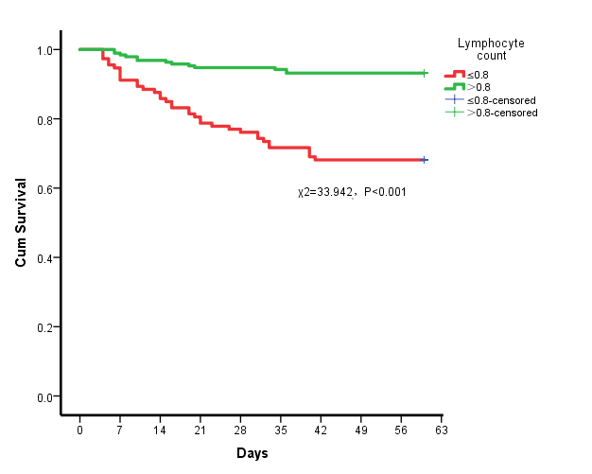
Supplementary figure1: Survival curves of 60-day mortality in all patients with LYM＞0.8 vs LYM≤0.8

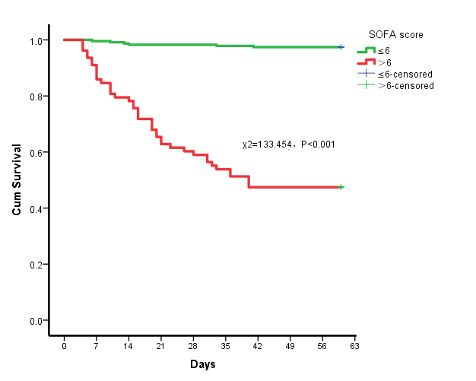

Supplementary figure2: Survival curves of 60-day mortality in all patients with SOFA＞3.0 vs SOFA≤3.0

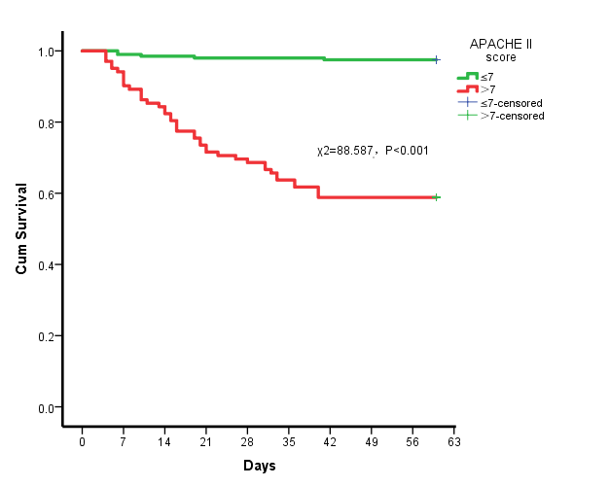
Supplementary figure3: Survival curves of 60-day mortality in all patients with APACHEII＞7.0 vs APACHEII≤7.0

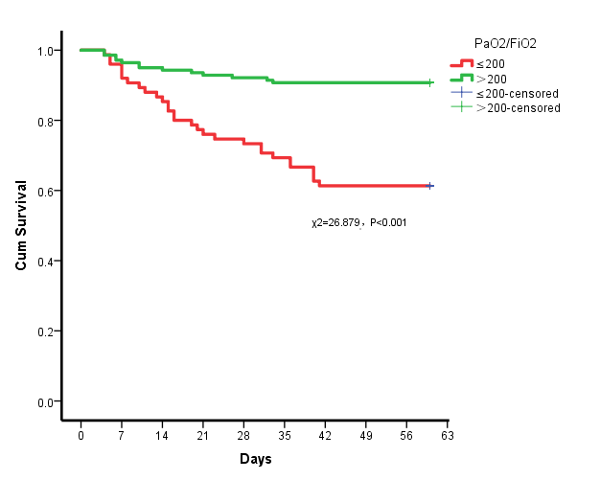
Supplementary figure4: Survival curves of 60-day mortality in all patients with Pa0₂/FiO₂＞200 vs Pa0₂/FiO₂≤200

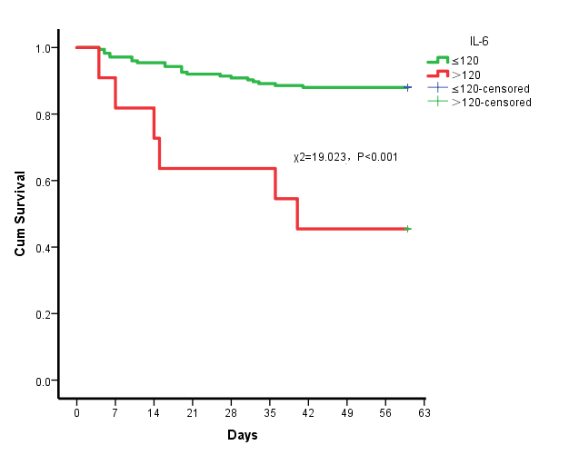
Supplementary figure5: Survival curves of 60-day mortality in all patients with IL-6＞120 vs IL-6≤120

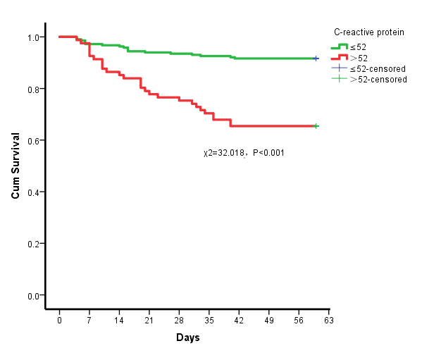
Supplementary figure6: Survival curves of 60-day mortality in all patients with CRP＞52 vs CRP≤52

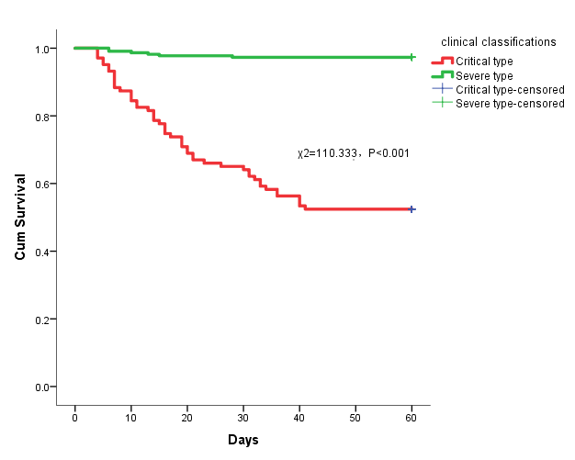
Supplementary figure7: Survival curves of 60-day mortality in all patients with different clinical classifications.

